1. Browse to [www.vodafone.co.uk](http://www.vodafone.co.uk) :-

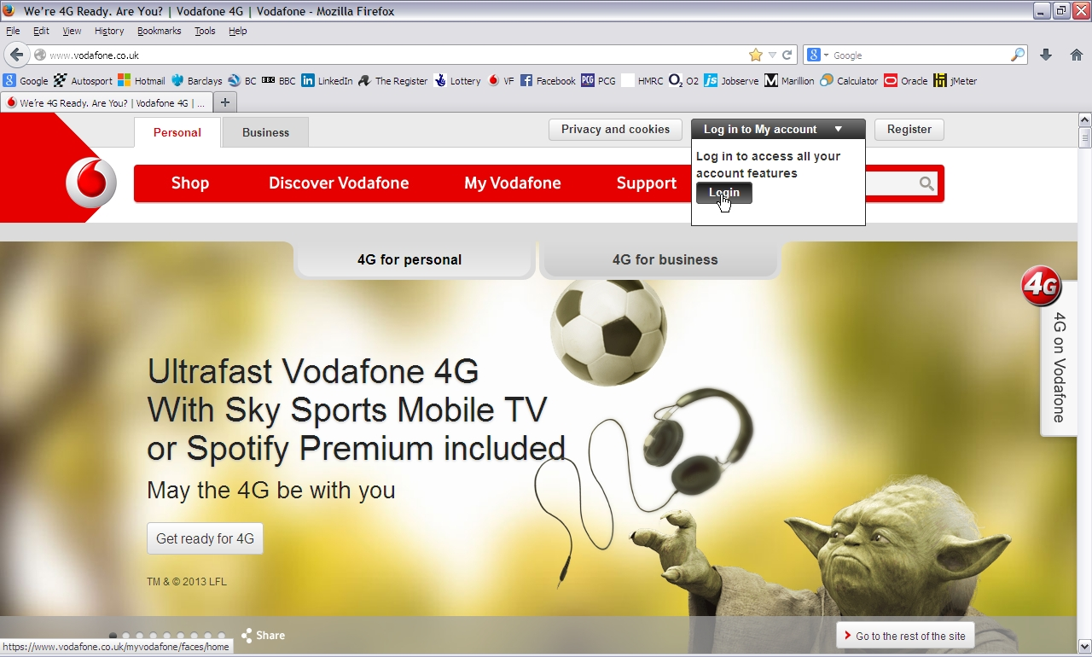

1. Login Darren’s personal pay monthly account – morg0888 / Cardiff12 :-

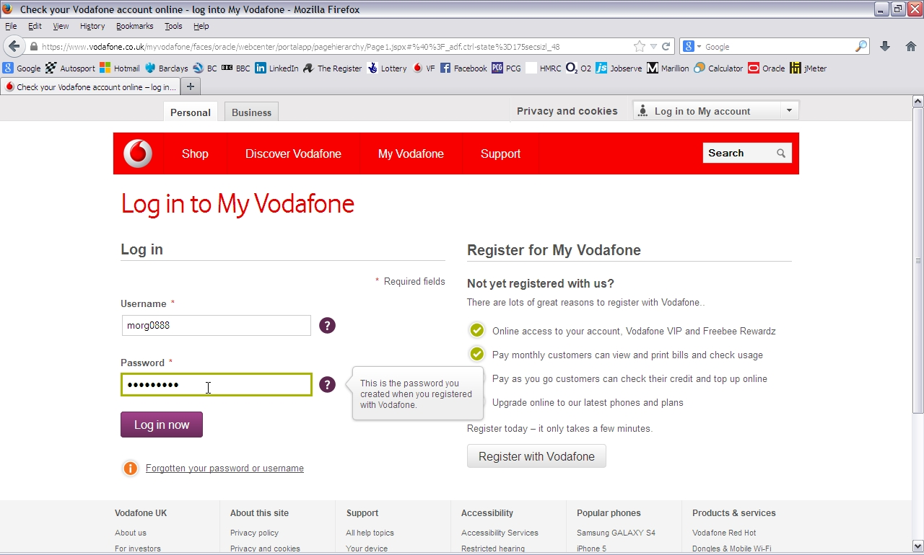

1. Click on “Manage my settings” :-

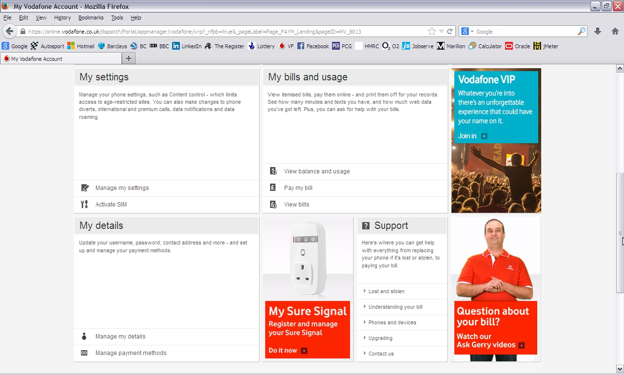

1. Click on “My Account”

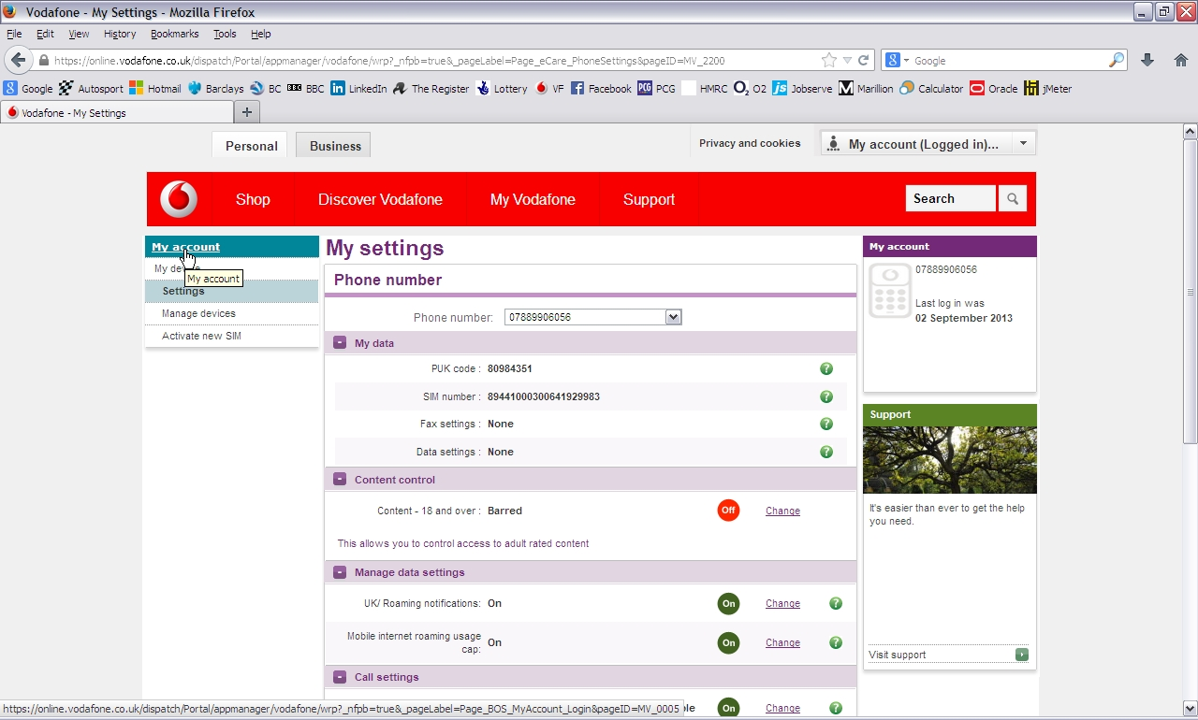

1. Click on “Manage my details”:

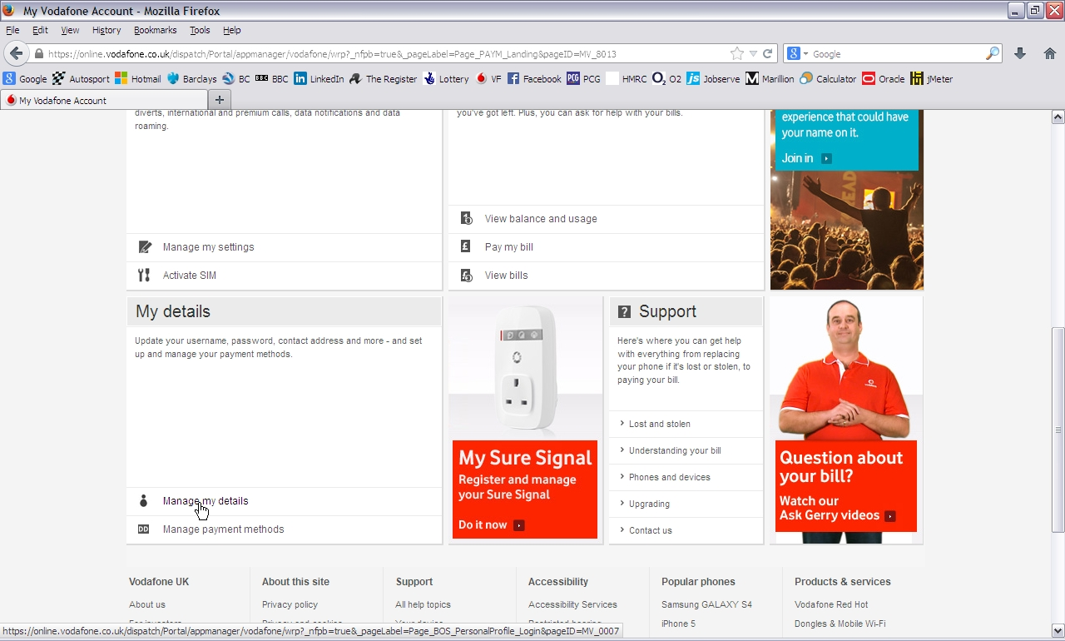

Repeat steps 3, 4 & 5 in a loop.

And logout:

