Team 20:

Sr.No. Name TAP ID Track Comments
------ ------------------ ------------------ ------------------- --------------------
1 Vatsala Swaroop 1044 Java Project Lead
2 Indranil Chandra 1045 ETL Project Manager
3 Ayush Goyal 2014 C#
4 Parag Khandait 2058 Java
5 Gaurav Choudhary 2040 Java
6 Abhishek Padhi 1033 Java
7 Srishti Sharma 2003 Java
8 Sushrut Shendre 1011 Java

Problem Statement:

Create a unified Market Data Analyzing platform that can be used by Traders and similar Institutional Clients of Citi for viewing and comparing Market Data so as to facilitate them to buy stocks at Lower Prices and sell stocks at Higher Prices.

Requirements Analysis:

The end product would be containing the following features -

* Ability to list all stocks with their tickers and indicators if the market price has increased/decreased
* Ability to view details of a particular stock (eg.variation in stock price etc.) over a period of time
* Ability to compare two stocks

Additional : Filtering the list as per additional criteria (market segment, geography, exchanges etc.)

Entity Relationship Diagram:

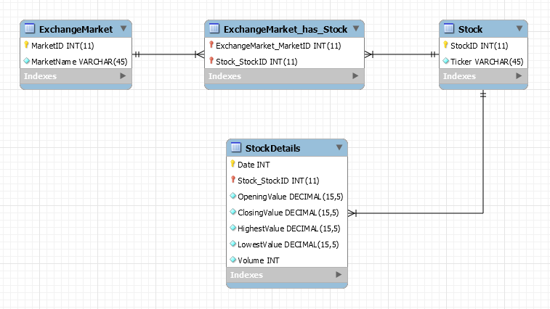

Class Diagram:

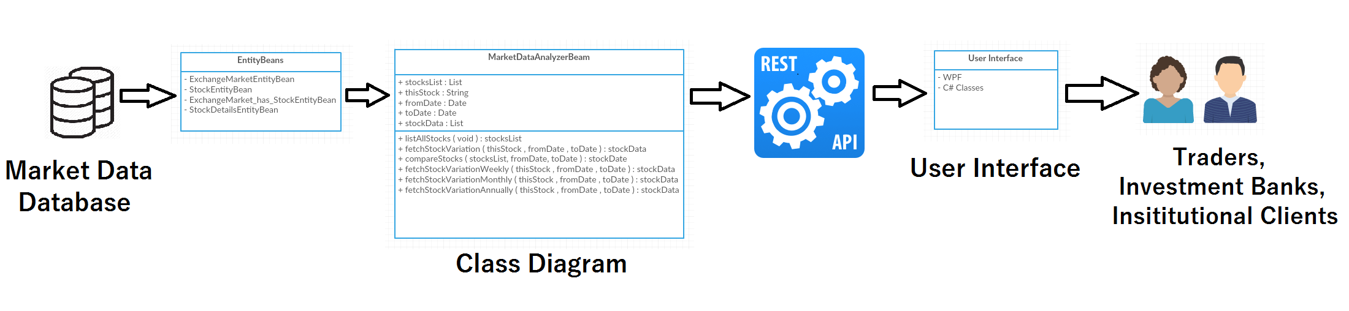
Individual class diagram details:

Entity beans:

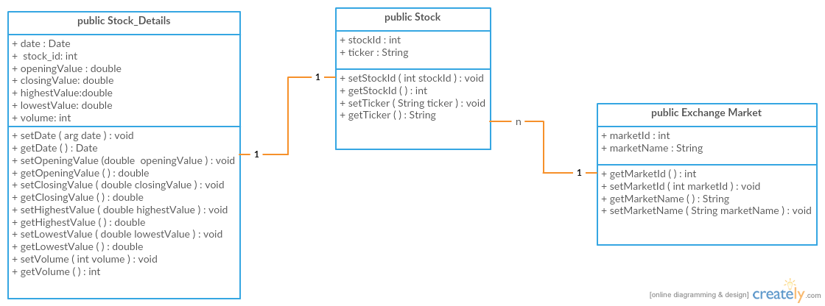

Session Bean:

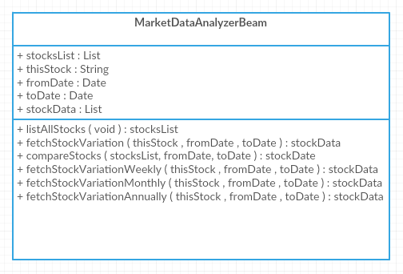

User Interface:

