The power of plain text
a.k.a. a gentle introduction to personal knowledge management using Zettlr
Alan CASTELLINO (author), Benjamin ABEL (facilitator)
2024-04-11

Goal and overview

Objectives
- Figure out why you should get familiar with knowledge management and content publishing
- Figure out the advantages of plain text and multi-format exporting
- Get familiar with Markdown and basic exporting using a simple tool
- Start to elaborate personal KM practices
- Experience how a tool like Zettlr can help with the PKM process

Overview
Have a look at what you can get with a bit of practical knowledge of plain text workflows (quarto) and GitHub: https://smart-edtech.github.io/smarties/
- Automatic build of the website
- Multi-format exporting avairable

Basics

Raison d’être of Personal Knowledge Management (PKM)
- We live in an information society. We are overloaded with information of diverse nature and quality.
- There is more than information overload: tools overload, social overload and reference overload.
- Most individuals are passive against these concerns. However, the digital medium has its very own characteristics we need to embrace to develop a personal.

What is PKM?
PKM is the field that precisely studies that issue: how, as individuals, can we thrive in the informational age? How can we make the most out of information technologies without feeling overwhelmed?

A plethora of tools
Notion, Roam, Tana, Obsidian, Logseq, AnyType, Affine, TiddlyWiki, Zettlr…
- Local vs Web-aware vs Web-based
- FOSS vs Freeware vs Paid
- Specific ↔ Extensible ↔ Malleable
- User-friendly?

Advantages of plain text editing
- Lightweight: you can work with just a simple text editor. You can store your files anywhere.
- Easily readable and writable: a whole range of apps work with plain text. It is also easy to manipulate programmatically.
- No lock-in: you can use your text files in different apps for different purposes. You can switch to a new app that better fits your needs seamlessly.
- Teaches you about computing and the hacker mindset in a hands-on way.

Meet Zettlr
Zettlr is:
- Designed with simplicity in mind
- Free and Open-Source
- Web-aware
- Supported by a community (Discord, Reddit)
- Specific but plays nicely with other tools (bibliography, export)

Install Zettlr
- Simply go to the official website: zettlr.com/download
- Install and open it.
- If you write academic articles, you will need LaTeX at some point. Simply use MikTeX (this is not the point today).

Markdown syntax
- # Section heading
## Subsection heading…
- This is _emphasized_ and this is **strong**
- This is a - List item
- This is a 1. Numberred item
- This is a [link](https://zettlr.com)
- This is an ![image](cat.png)
- YAML: metadata and options

Basics and Exporting
- Create a new file
- Fill it up with some headings and content.
- You have some shortcut icons (e.g. links and images)
- Left pane: files explorer
- Right pane: outline and more
- Export button: select one of the available formats (except LaTeX)

Diving deeper

Key skills in PKM
- Management
- Lifelong learning
- Communication and interpersonal skills
- Technological fluency
- Forecasting and anticipating

Key skills in PKM (cont’d)
- Use frameworks, models and conceptual tools to build upon your current KM practices.
- Implement PKM strategies using digital technologies.
- PKM practices are ultimately personal and evolving constructs.
- Reflect about the process, iterate, exchange with others

Some concrete insights
- Find an equilibrium between content consumption and content creation
- Move from note-taking to note-making: think about your notes, not just their content
- Showcase your learning: learn in public, build a digital garden
- View digital tools as opportunities to design new workflows

The GUSC model
We will use the GUSC model. It can be seen as a concretization of the SECI model.
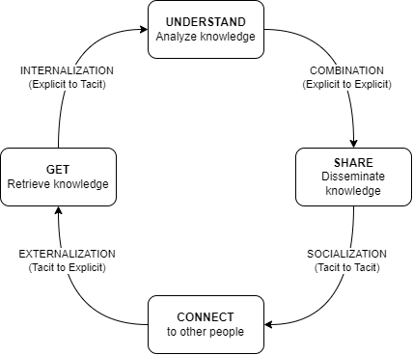
→ A simple yet powerful model. We need to associate concrete actions to each phase.

The GUSC model in more details
- Get: gather information from different sources
- Understand: interpret, combine information into a (personal) whole
- Share: produce artifacts to make the learning process visible
- Connect: collaborate and exchange with others

Back to practice
→ We will see how Zettlr can help us implement strategies for the first 3 steps of the GUSC model (Get, Understand, Share).

GUSC in Zettlr
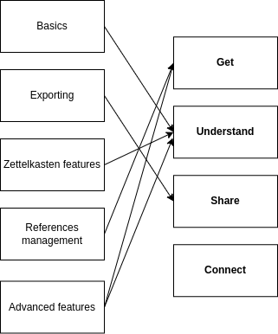

Get phase: referencing with Zotero and Zettlr
- Install Zotero. You will manage all your references from here.
- Install the BetterBibTeX plugin for Zotero
- Export your Zotero library
- Open it in Zettlr
- Type in @ and select one of your refs.
Example [@resnickLifelongKindergartenCultivating2017] and others emphasize the need to develop creativity in computing education.
[@morPracticalDesignPatterns2014] have developed design patterns for implementing technology-enhanced pedagogy.

References

Understand phase: Zettelkasten in Zettlr
A methodology to make sense of your notes.
Some insights:
- Use #tags.
- Link to other files, such as in [[about_tags]].
- Give unique IDs to files such as [[20231216180452]] Another file

Understand phase: the Graph view:
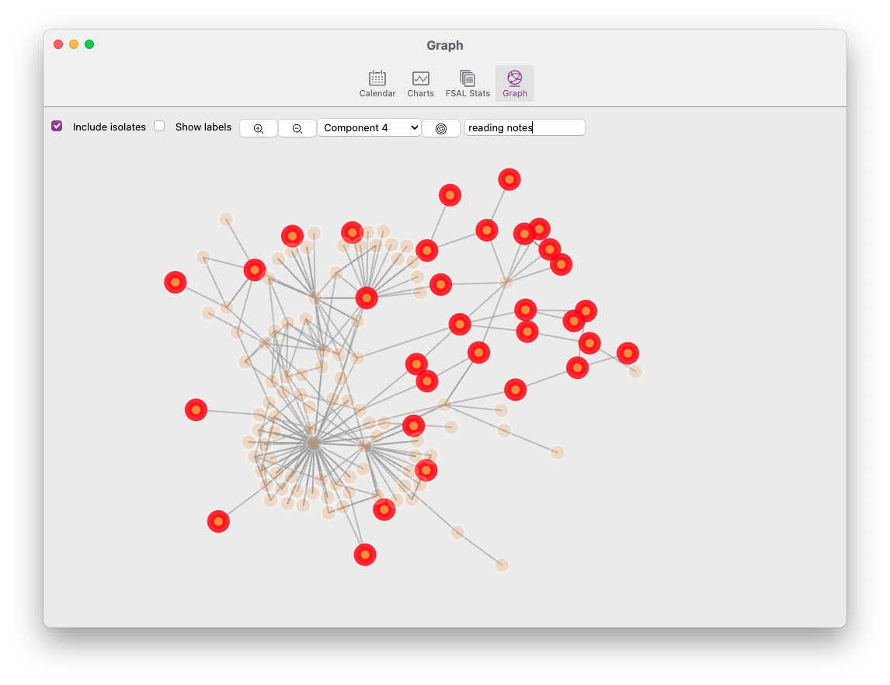

Share phase: extending export capabilities
- Change how things look
- Add new export possibilities thanks to Pandoc
We will use the Assets dialog: File > Preferences > Manage assets
Challenge 1: use custom CSS to style HTML output
- The given file is custom.css.
- Select the HTML profile. On line 46, add custom.css between the brackets.
- You can also add css: custom.css to the YAML on each file you want to export with custom.css.

Share phase: extending export capabilities (cont’d)
Challenge 2: enable export to PowerPoint presentations
- By default, Zettlr offers no possibility to export to .pptx (PowerPoint). However, pandoc can do it.
- Create a new profile with reader: markdown and writer: pptx
Challenge 3: modify how things look in docx, pptx, odt
- You can specify a template by adding reference_doc: template.pptx to the corresponding profile.
- We provide custom.docx, custom.odt and custom.pptx
- Modify the slide masters in the provided template
- For docx/odt, modify the styles.

Thank you!

