The power of plain text

a.k.a. a gentle introduction to personal knowledge management using Zettlr

Alan CASTELLINO (author), Benjamin ABEL (facilitator)

# Goal and overview

## Objectives

* Figure out why you should get familiar with knowledge management and content publishing
* Figure out the advantages of plain text and multi-format exporting
* Get familiar with Markdown and basic exporting using a simple tool
* Start to elaborate personal PKM practices
* Experience how a tool like Zettlr can help with the PKM process

## Overview

Have a look at what you can get with a bit of practical knowledge of plain text workflows (quarto) and GitHub: <https://smart-edtech.github.io/smarties/>

* Automatic build of the website
* Multi-format exporting avairable

# Basics

## *Raison d’être* of Personal Knowledge Management (PKM)

* We live in an information society. We are overloaded with information of diverse nature and quality.
* There is more than *information overload*: *tools overload*, *social overload* and *reference overload*.
* Most individuals are passive against these concerns. However, the digital medium has its very own characteristics we need to embrace to develop a personal.

## What is PKM?

PKM is the field that precisely studies that issue: how, as individuals, can we thrive in the informational age? How can we make the most out of information technologies without feeling overwhelmed?

## A plethora of tools

Notion, Roam, Tana, Obsidian, Logseq, AnyType, Affine, TiddlyWiki, Zettlr…

* Local vs Web-aware vs Web-based
* FOSS vs Freeware vs Paid
* Specific ↔ Extensible ↔ Malleable
* User-friendly?

## Advantages of plain text editing

* Lightweight: you can work with just a simple text editor. You can store your files anywhere.
* Easily readable and writable: a whole range of apps work with plain text. It is also easy to manipulate programmatically.
* No lock-in: you can use your text files in different apps for different purposes. You can switch to a new app that better fits your needs seamlessly.
* Teaches you about computing and the *hacker mindset* in a hands-on way.

## Meet Zettlr

Zettlr is:

* Designed with simplicity in mind
* Free and Open-Source
* Web-aware
* Supported by a community (Discord, Reddit)
* Specific but plays nicely with other tools (bibliography, export)

## Install Zettlr

* Simply go to the official website: [zettlr.com/download](https://zettlr.com/download)
* Install and open it.
* If you write academic articles, you will need LaTeX at some point. Simply use MikTeX (this is not the point today).

## Markdown syntax

* # Section heading
* ## Subsection heading…
* This is _emphasized_ and this is **strong**
* This is a - List item
* This is a 1. Numberred item
* This is a [link](https://zettlr.com)
* This is an ![cute_cat.png](image)
* YAML: metadata and options

## Basics and Exporting

* Create a new file
* Fill it up with some headings and content.
* You have some shortcut icons (e.g. links and images)
* Left pane: files explorer
* Right pane: outline and more
* Export button: select one of the available formats (except LaTeX)

# Diving deeper

## Key skills in PKM

* Management
* Lifelong learning
* Communication and interpersonal skills
* Technological fluency
* Forecasting and anticipating

## Key skills in PKM (cont’d)

* Use frameworks, models and conceptual tools to build upon your current KM practices.
* Implement PKM strategies using digital technologies.
* PKM practices are ultimately personal and evolving constructs.
* Reflect about the process, iterate, exchange with others

## Some concrete insights

* Find an equilibrium between *content consumption* and *content creation*
* Move from *note-taking* to *note-making*: think about your notes, not just their content
* Showcase your learning: *learn in public*, build a *digital garden*
* View digital tools as opportunities to design new workflows

## The GUSC model

We will use the GUSC model. It can be seen as a concretization of the SECI model.

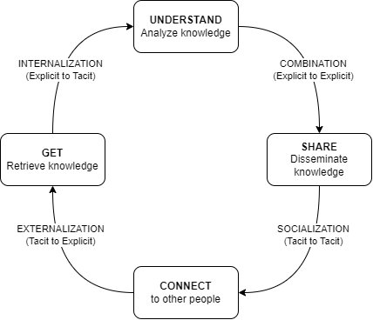

→ A simple yet powerful model. We need to associate concrete actions to each phase.

## The GUSC model in more details

* **Get**: gather information from different sources
* **Understand**: interpret, combine information into a (personal) whole
* **Share**: produce artifacts to make the learning process visible
* **Connect**: collaborate and exchange with others

## Back to practice

→ We will see how Zettlr can help us implement strategies for the first 3 steps of the GUSC model (**Get**, **Understand**, **Share**).

## GUSC in Zettlr

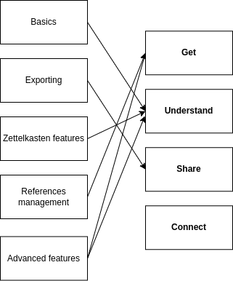

## **Get** phase: referencing with Zotero and Zettlr

1. Install Zotero. You will manage all your references from here.
2. Install the BetterBibTeX plugin for Zotero
3. Export your Zotero library
4. Open it in Zettlr
5. Type in @ and select one of your refs.

**Example** [@resnickLifelongKindergartenCultivating2017] and others emphasize the need to develop creativity in computing education.

[@morPracticalDesignPatterns2014] have developed design patterns for implementing technology-enhanced pedagogy.

## References

## **Understand** phase: Zettelkasten in Zettlr

A methodology to make sense of your notes.

Some insights:

* Use #tags.
* Link to other files, such as in [[about_tags]].
* Give unique IDs to files such as [[20231216180452]] Another file

## **Understand** phase: the Graph view:

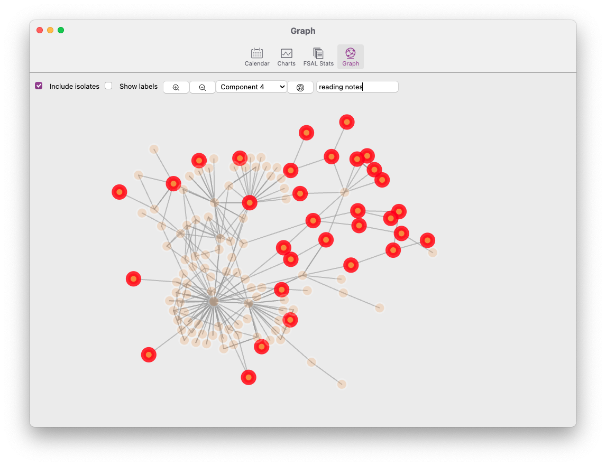

## **Share** phase: extending export capabilities

* Change how things look
* Add new export possibilities thanks to Pandoc

We will use the Assets dialog: File > Preferences > Manage assets

**Challenge 1: use custom CSS to style HTML output**

* The given file is custom.css.
* Select the HTML profile. On line 46, add custom.css between the brackets.
* You can also add css: custom.css to the YAML on each file you want to export with custom.css.

## **Share** phase: extending export capabilities (cont’d)

**Challenge 2: enable export to PowerPoint presentations**

* By default, Zettlr offers no possibility to export to .pptx (PowerPoint). However, pandoc can do it.
* Create a new profile with reader: markdown and writer: pptx

**Challenge 3: modify how things look in docx, pptx, odt**

* You can specify a template by adding reference_doc: template.pptx to the corresponding profile.
* We provide custom.docx, custom.odt and custom.pptx
* Modify the slide masters in the provided template
* For docx/odt, modify the styles.

# Thank you!