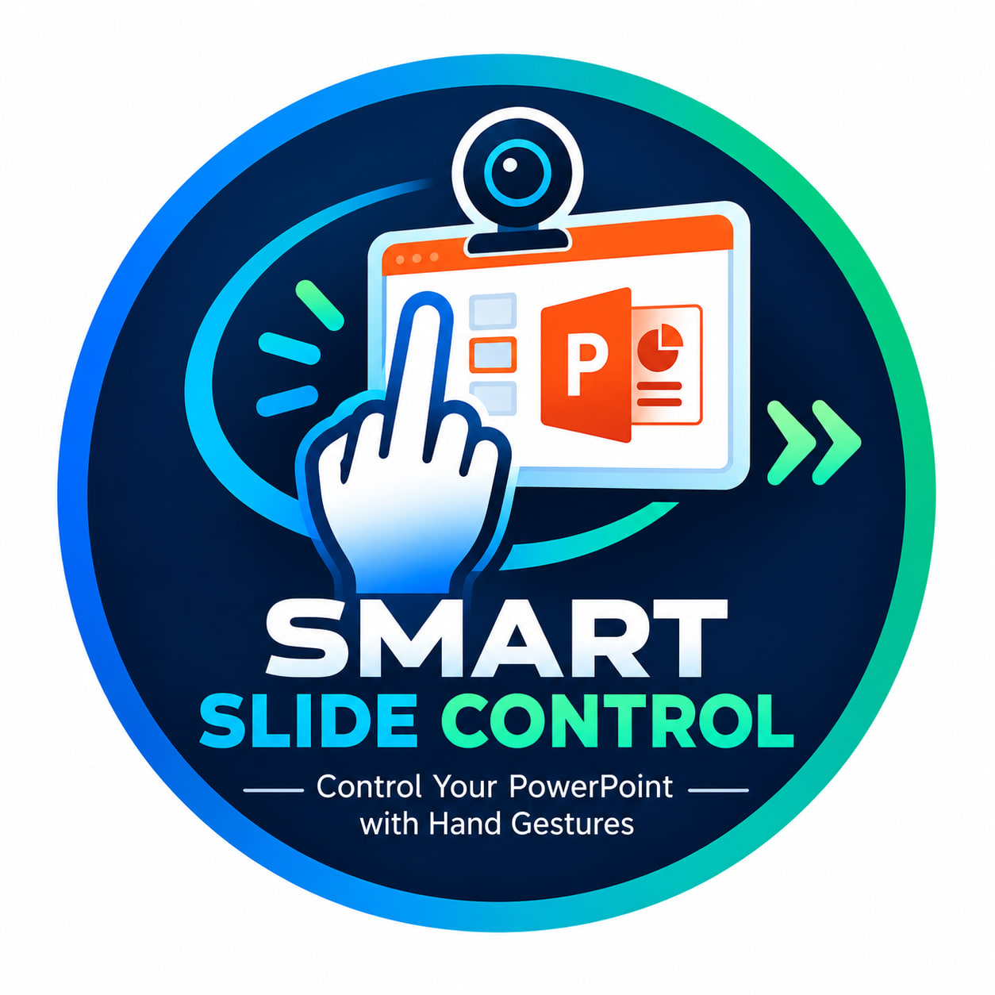

SMART SLIDE CONTROL
A Hand-Gesture-Based PowerPoint Controller
PROJECT TYPE  Group Member | Smart Slide  Yasmin Toyeb, Setha Chan, Kunthea Hoeun.

1. Introduction
Smart Slide Control is a Python-based project that lets users control a PowerPoint presentation with hand gestures detected by a webcam. Instead of using a keyboard or mouse for every slide action, the presenter can use simple hand movements.

2. Project Objectives
The main objective is to make presentations easier, more convenient, and more interactive.
- Recognize hand gestures using a webcam.
- Move to the next or previous slide with simple gestures.
- Start and exit a slideshow without touching the keyboard.
- Apply computer vision technology to a practical, real-world task.

3. Technologies Used
Technology | Purpose
Python | Main programming language
OpenCV | Captures webcam frames and displays the camera window
MediaPipe | Detects the hand and its landmark positions
PyAutoGUI | Sends keyboard commands to control PowerPoint

4. How the System Works
01 Capture | The webcam captures an image of the user's hand.
02 Detect | MediaPipe detects the hand and identifies its landmarks.
03 Recognize | Python checks finger positions and classifies the gesture.
04 Control | PyAutoGUI sends the matching keyboard command.
05 Display | The program shows the camera feed and recognized gesture.

5. Gesture Controls
Hand Gesture | Action | Keyboard Command
Index finger raised | Next slide | Right Arrow
Index + middle raised | Previous slide | Left Arrow
Four fingers raised | Start slideshow | F5
Four fingers lowered | Exit slideshow | Esc
Note: The program checks the index, middle, ring, and pinky fingers. The thumb is not used in the current gesture rules. The keyboard commands work in the application that currently has keyboard focus, so PowerPoint should be active during the demonstration.

6. Benefits of the Project
- Makes slide navigation more convenient during presentations.
- Reduces the need to touch a keyboard or mouse while presenting.
- Provides practical experience with Python and computer vision.
- Demonstrates how gesture recognition can be used in everyday applications.

7. Conclusion
In conclusion, Smart Slide Control combines Python, OpenCV, MediaPipe, and PyAutoGUI to create a simple hands-free presentation controller. Through this project, our group learns how computer vision can be used to solve a practical problem and make presentations more interactive.

