SMART-GUI (SMART Graphic User Interface)

SMART-GUI was made to make easier the use of SMART. It allow to view all the results of the tests in real-time in a graph and to compare all the made old experiments and all the single algorithms through the tabs.

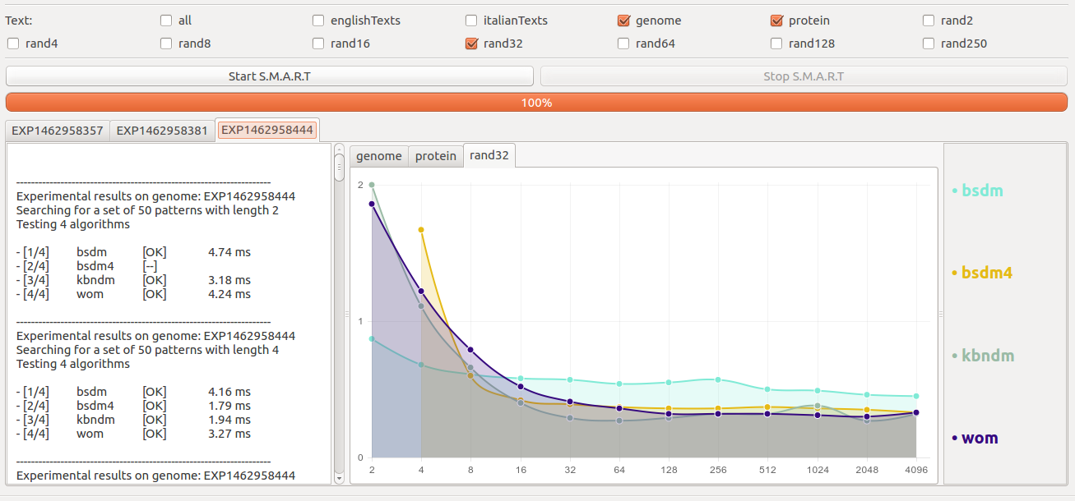

How it works

