Research/Review Article
Title
Firstname Lastname ¹, Firstname Lastname ², and Firstname Lastname ^{2,*}
Received: date
Revised: date
Accepted: date
Published: date


Copyright: © 2026 by the authors. Submitted for possible open access publication under the terms and conditions of the Creative Commons Attribution (CC BY) licenses (https://creativecommons.org/licenses/by/4.0/)
¹ Affiliation 1; e-mail : xxx@xxx.com
² Affiliation 2; e-mail : xxx@xxx.com
* Corresponding Author : name 
Abstract: A single paragraph, maximum 300 words. Abstract content must contain (1) an overview of the object of research, (2) problems, and research objectives, (3) proposed methods, (4) main findings and results and synthesis of main ideas, and (5) conclusions.
Keywords: Enter five until eight keywords and separate them with a semicolon (;)

0. How to Use This Template
Each section has a corresponding style, which can be found in Word's “Styles” menu. Use a Style menu like Fig. 1.
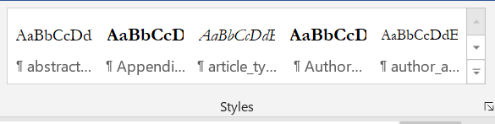
Figure 1. Style menu in MS Word.

1. Introduction
The Journal of Computing Theories and Applications (JCTA) accepts research or review articles with no strict minimum or maximum page limit; however, the ideal length is 12–20 pages for research papers and 20–30 pages for review papers. JCTA also accepts submissions that have been previously posted as preprints. For accepted and published articles, authors are required to include the URL, DOI, or other identifier of the original preprint in the Acknowledgement section.
The Introduction section must be written briefly, concisely, and clearly, and should include the following components:
- The research object;
- The methods that have been used in previous studies;
- The strengths and weaknesses of these methods, or a brief reference to related works and/or hypotheses;
- The research problems being addressed;
- The proposed solutions and/or approaches;
- A list of main contributions; and
- A summary of the paper structure (the rest of the paper).
The introduction must be scientifically written and well-supported by citations. Please apply Use “maintext_JCTA” style for this paragraph.

2. Preliminaries or Related Work or Literature Review
This section must contain a state-of-the-art explanation. It can be explained in several ways. First, you can discuss several related papers, both about objects, methods, and their results. From there, you can explain and emphasize research gaps or differences in your research with previous research. The second way, you can combine theory with related literature and explain each theory in one sub-chapter.

2.1. Subsection 1

2.2 Subsection 2

3. Proposed Method
In this section, you need to describe the proposed method step by step. Explanations accompanied by equations and flow diagrams as illustrations will make it easier for readers to understand your research.

3.1. Algorithm/Pseudocode
Writing algorithms or pseudocode can be an alternative for explaining scientific paper content. The algorithm must be cited in the main text. Below is an example of writing an Algorithm. You need to use "Algorithm_head_JCTA" and "algorithm_step_JCTA" styles.

Algorithm 1. Algortihm Title
INPUT: xxx, yyy
OUTPUT: zzz
- Step 1
- Step 2
- Step 3
- Step n

3.1.1. Subsubsection
Bulleted lists look like this:
- First bullet;
- Second bullet;
- Third bullet.
Numbered lists can be added as follows:
- First item;
- Second item;
- Third item.
The text continues here.

3.2. Formatting of Mathematical Components
Equations, theorems, and proofs must be cited in the main text. For example, the author could write the sentence: “Eq. (1) is used to calculate blablabla". This is example 1 of an equation:
$$a = 1,$$ | (1)
the text following an equation need not be a new paragraph. Use “punctuate_text_JCTA” style.
This is example 2 of an equation:
$$a = b + c + d + e + f + g + h + i + j + k + l + m + n + o + p + q + r + s + t + u$$ | (2)
the text following an equation need not be a new paragraph. Use “punctuate_text_JCTA” style.

Theorem-type environments (including propositions, lemmas, corollaries etc.) can be formatted as follows:
Theorem 1. Example text of a theorem. Theorems, propositions, lemmas, etc. should be numbered sequentially (i.e., Proposition 2 follows Theorem 1). Examples or Remarks use the same formatting, but should be numbered separately, so a document may contain Theorem 1, Remark 1 and Example 1.
The text continues here. Proofs must be formatted as follows:
Proof of Theorem 1. Text of the proof. Note that the phrase “of Theorem 1” is optional if it is clear which theorem is being referred to. Always finish a proof with the following symbol.
The text continues here.

4. Results and Discussion
In this section the author needs to explain the hardware and software used, dataset sources, initial data analysis, results, and results analysis/discussion. Presenting the results with pictures, graphs and tables is highly recommended. Formulas or evaluation measuring tools also need to be included here. There must be discussion/analysis, and you can't just rewrite the results in sentence form, but you need to provide an explanation of their relationship to the initial hypothesis. In addition, this section needs to discuss and elaborate on important findings.

4.1. Figures and Tables
Place figures and tables at the top and bottom of columns. Avoid placing them in the middle of columns. Large figures and tables may span across both columns. Figure captions should be below the figures; table heads should appear above the tables. Insert figures and tables after they are cited in the text. Use the abbreviation “Fig. 1”, even at the beginning of a sentence.

Figure 2. This is a figure. Schemes follow the same formatting.
Table 1. This is a table. Tables should be placed in the main text near to the first time they are cited.
Title 1 | Title 2 | Title 3
entry 1 | data | data
entry 2 | data | data
entry 3 | data | data
entry 4 | data | data
entry 5 | data | data
entry 6 | data | data
entry 7 | data | data ¹
¹ Tables may have a footer.
The text continues here (Figure 2 and Table 2).
 | 
Figure 3. This is a figure. Schemes follow another format. If there are multiple panels, they should be listed as (a) a Description of what is contained in the first panel; (b) a Description of what is contained in the second panel. Figures should be placed in the main text near the first time they are cited.
Table 2. This is a table. Tables should be placed in the main text near the first time they are cited.
Title 1 | Title 2 | Title 3 | Title 4
entry 1 * | data | data | data
 | data | data | data
entry 2 | data | data | data
 | data | data | data
entry 3 | data | data | data
 | data | data | data
entry 4 | data | data | data
 | data | data | data
* Tables may have a footer.

5. Comparison
Comparison with state-of-the-art is an important part. This section can provide a more measurable illustration of your research contribution. This section can also be added to a brief discussion. If you feel that this section is insufficient and unsuitable to be a separate section, the author(s) can integrate this section with section four (Results and Discussion).

6. Conclusions
Sections must summarize briefly and concisely the contents of the document or essay. This section may contain (1) A summary of the main results, findings, and evidence from your research or analysis. (2) Synthesis of findings, namely the relationship between findings and research objectives, and show how these findings support arguments or hypotheses. (3) The author may also be able to discuss the implications of research findings for research benefits. What is the contribution or impact on the field of knowledge or topic discussed? (4) Limitations and suggestions for further research.

Author Contributions: A short paragraph specifying their individual contributions must be provided for research articles with several authors (mandatory for more than 1 author). The following statements should be used “Conceptualization: X.X. and Y.Y.; Methodology: X.X.; Software: X.X.; Validation: X.X., Y.Y. and Z.Z.; Formal analysis: X.X.; Investigation: X.X.; Resources: X.X.; Data curation: X.X.; Writing—original draft preparation: X.X.; Writing—review and editing: X.X.; Visualization: X.X.; Supervision: X.X.; Project administration: X.X.; funding acquisition: Y.Y. All authors have read and agreed to the published version of the manuscript”
Funding: Please add: “This research received no external funding” or “This research was funded by NAME OF FUNDER, grant number XXX”. Check carefully that the details given are accurate and use the standard spelling of funding agency names. Any errors may affect your future funding (mandatory).
Data Availability Statement: We encourage all authors of articles published in JCTA journals to share their research data. This section provides details regarding where data supporting reported results can be found, including links to publicly archived datasets analyzed or generated during the study. Where no new data were created or data unavailable due to privacy or ethical restrictions, a statement is still required.
Acknowledgments: In this section, you can acknowledge any support given which is not covered by the author contribution or funding sections. This may include administrative and technical support or donations in kind (e.g., materials used for experiments). Additionally, A statement of AI tools usage transparency has been included in the Acknowledgement section, if applicable.
Conflicts of Interest: Declare conflicts of interest or state (mandatory), “The authors declare no conflict of interest.” Authors must identify and declare any personal circumstances or interests that may be perceived as inappropriately influencing the representation or interpretation of reported research results. Any role of the funders in the study's design; in the collection, analyses or interpretation of data; in the writing of the manuscript; or in the decision to publish the results must be declared in this section. If there is no role, please state, “The funders had no role in the design of the study; in the collection, analyses, or interpretation of data; in the writing of the manuscript; or in the decision to publish the results”.
Appendix A
The appendix is an optional section that can contain details and data supplemental to the main text—for example, explanations of experimental details that would disrupt the flow of the main text but nonetheless remain crucial to understanding and reproducing the research shown; figures of replicates for experiments of which representative data is shown in the main text can be added here if brief, or as Supplementary data. Mathematical proofs of results not central to the paper can be added as an appendix.
Appendix B
All appendix sections must be cited in the main text. In the appendices, Figures, Tables, etc. should be labeled starting with “A”—e.g., Figure A1, Figure A2, etc.

References
References must follow the IEEE style. We highly recommend preparing references with a bibliography software package like Mendeley, EndNote, or Zotero to avoid typos and duplicate entries. All references must include a DOI or other persistent identifier whenever available. If a reference does not have a DOI or identifier, authors are required to provide a valid URL to ensure that the cited work is accessible and verifiable online. Below is an example of a bibliography:
[1] D. R. I. M. Setiadi, S. Rustad, P. N. Andono, and G. F. Shidik, “Digital image steganography survey and investigation (goal, assessment, method, development, and dataset),” Signal Processing, vol. 206, p. 108908, May 2023, doi: 10.1016/j.sigpro.2022.108908.
[2] D. R. I. M. Setiadi, T. Sutojo, E. H. Rachmawanto, and C. A. Sari, “Fast and efficient image watermarking algorithm using discrete tchebichef transform,” in 2017 5th International Conference on Cyber and IT Service Management (CITSM), Aug. 2017, pp. 1–5. doi: 10.1109/CITSM.2017.8089229.
[3] A. Vyas, S. Yu, and J. Paik, “Fundamentals of Digital Image Processing,” in A John Wiley & Sons, 2018, pp. 3–11. doi: 10.1007/978-981-10-7272-7_1.
[4] ICCC FBI, “Internet Crime Report 2021,” 2022. [Online]. Available: https://www.ic3.gov/Media/PDF/AnnualReport/2021_IC3Report.pdf
[5] USC Viterbi School of Engineering, “SIPI Image Database.” http://sipi.usc.edu/database/ (accessed Mar. 27, 2019).

Since Volume 3 Issue 3 (2026), use at least 25 references from journal articles or conferences for a research paper, and at least 60 references for a review paper. References from books are better used in general theories. Avoid references from the website, except for data reports or dataset sources, or other data sources.
After doing the citation correctly, insert the bibliography then use the "References_JCTA" Style, see Fig. 5.

It is important to do a lookup based DOI (if any) on the reference manager, see Figure 4.

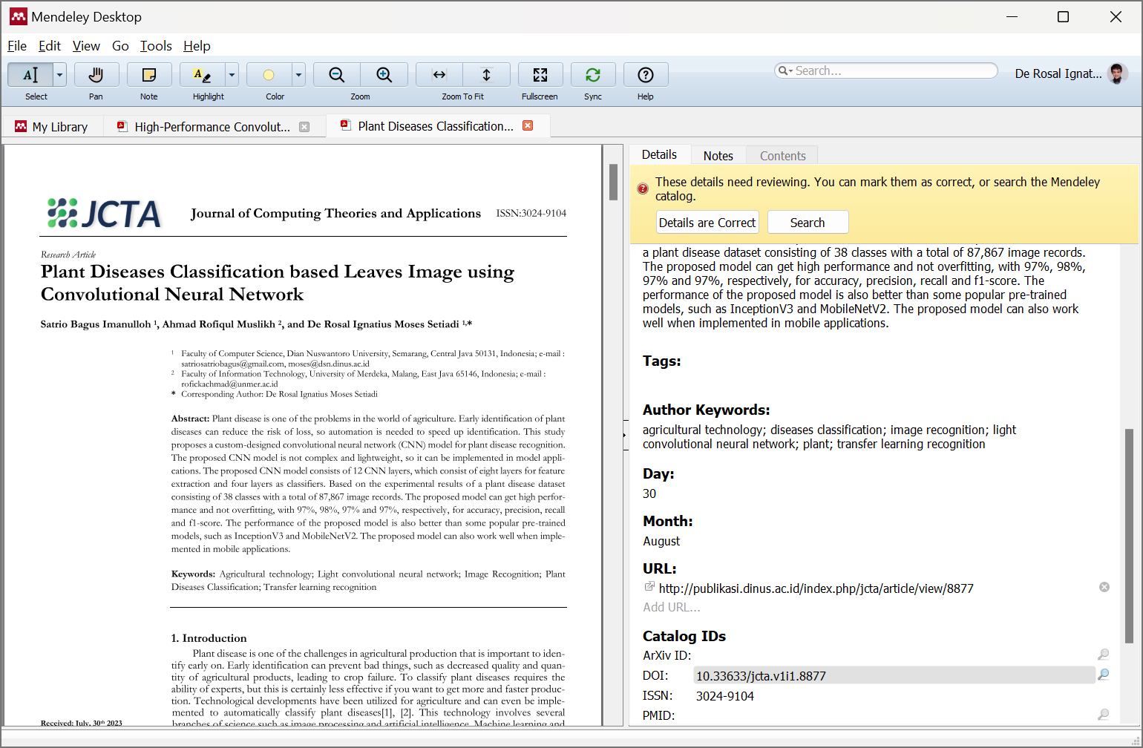
Figure 4. DOI lookup button in Mendeley Software

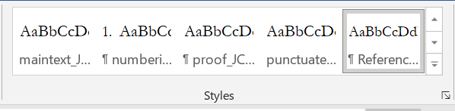
Figure 5. Use “References_JCTA” Style for Bibliography

