An Attenuation-Corrected Matched Filter with Closed-Loop Gain
Design for News-Sentiment Aggregation in Equity Forecasting

Abstract—Sentiment features for equity forecasting are almost always built by averaging news scores over a fixed window whose length is chosen by search rather than by design. This paper treats that aggregation step as a filter design problem. Sentiment is modelled as a latent signal observed through several mutually independent scorers, and the map from sentiment to a future response is identified as a finite impulse response. Measured sentiment is autocorrelated, so the lagged correlation profile practitioners inspect is the response convolved with that autocorrelation; scorer noise attenuates it further. The cross-covariance of two independent scorers estimates the latent autocovariance at every lag, identifying the noise-free kernel; three scorers identify each scorer's reliability. The matched aggregation filter is derived; its width is governed by scorer reliability rather than by how long news matters. Run as a feedback loop, the same noise tightens the stability bound and slows the optimal gain, both in closed form. On 637,845 real headlines for 226 equities, scorer reliability is near 0.26, the return kernel is short and the volatility kernel persistent, and the loop at the predicted gain roughly doubles the out-of-sample information coefficient of the volatility forecast, exceeding every fixed window considered.
Anandkumar PARDESHI¹, Sujata DESHMUKH²
¹Department of Computer Science and Engineering, Fr. C. Rodrigues Institute of Technology, University of Mumbai, Vashi, Navi Mumbai, 400703, India
²Department of Information Technology, Fr. C. Rodrigues Institute of Technology, University of Mumbai, Bandra, Mumbai, 400050, India
anand.pardeshi@fcrit.ac.in

Index Terms—adaptive filters, least mean squares methods, matched filters, sentiment analysis, stock markets

Introduction
Text-derived sentiment is now a standard input to equity forecasting systems, and a large literature reports that news tone carries information about subsequent returns [1], [2], [3]. Almost every such system contains one step that is chosen by convention rather than by design. Headlines arrive irregularly, whereas a forecasting model consumes one feature per instrument per session, so the scores must be aggregated over some recent window. The window is nearly always a uniform average over a fixed number of days, typically one, three or seven, with the length picked by a grid search on the same data used to fit the model [4], [5], [6], [7]. Surveys of the area treat the aggregation span as a hyper-parameter and not as an object of study [8], [9].
This paper argues that the aggregation step is a filter design problem with a solvable structure, and that treating it as such changes both what is measured and what is deployed. Two properties of the data make the conventional choice systematically wrong. First, measured sentiment is autocorrelated, because news arrives in bursts and outlets repeat each other, so the lagged correlation between sentiment and future returns is not the response of returns to news; it is that response convolved with the autocorrelation of the sentiment series. Reading the aggregation span off such a profile overstates how long news matters. Second, every sentiment scorer is an error-prone instrument, and the error is large: the four scorers used here agree with one another at correlations between 0.20 and 0.39 at the headline level. Regressors measured with error produce attenuated and, in the multi-lag case, reshaped coefficients [10], [11].
The two effects pull in opposite directions and cannot be disentangled by tuning a window length. Autocorrelation smears the apparent response over more lags than it truly occupies, whereas measurement noise shrinks it. This paper separates them. The key observation is that several sentiment scorers built from independent lexica and independent training corpora are conditionally independent measurements of one latent quantity, so their cross-covariance at every pair of lags estimates the autocovariance of latent sentiment free of scorer noise. That single object identifies both the noise-free response kernel and the reliability of each scorer, and it does so without any distributional assumption beyond uncorrelated scorer errors.
The contributions are as follows. (i) An identification result: the latent sentiment autocovariance, and hence the noise-corrected response kernel, is recovered from cross-scorer covariances, and with three or more scorers the reliability ratio of each scorer is identified as well. (ii) A design result: the aggregation filter that is optimal for prediction from noisy scores is the noise-whitened matched filter for the identified kernel, and its effective width is governed by the reliability of the scorer rather than by the duration of the true response, which explains why multi-day averaging helps at all. (iii) A loop result: when the filter is adapted online, the measurement noise enters the stability condition directly, tightening the usable gain by the reliability factor, and the gain that minimises steady-state error under drift is derived in closed form and tested against its empirically optimal value. (iv) An evaluation on 637,845 real headlines covering 226 US equities, in which the same machinery is applied to two markedly different responses, next-session return and next-session realised volatility, and is shown to recover a short kernel for the first and a long one for the second.

Related Work
Quantitative work on news and prices begins with dictionary counts. Tetlock related the fraction of negative words in a daily column to market returns and documented short-lived pressure followed by reversal [1], and later work extended the approach to firm-level stories [2]. Loughran and McDonald showed that general-purpose word lists misclassify financial language and constructed finance-specific lists that are now standard [12], with a later review of the field [9]. Chan documented drift after headline events and reversal after price moves without news [3], which is direct evidence that the response has temporal structure worth estimating.
Modern systems replace counts with learned encoders. Domain pre-training of transformer encoders on financial text [13], [14] improved sentence-level polarity, and architectures combining text with price history have been proposed in many forms: attention over social media posts [15], [16], hierarchical attention over news [17], gated recurrent hybrids driven by news and technical indicators [4], optimised deep networks driven by investor sentiment [5], mixing modules for movement prediction [6], and chart-image hybrids [7]. Multi-source fusion frameworks combine sentiment with fundamental and technical views [18], [19], and broad surveys cover the deep-learning literature for financial applications [20], [21]. Classical machine-learning baselines remain competitive on index data [22], [23].
What these systems share is the aggregation convention this paper questions. The sentiment of a session is formed as a mean over a fixed recent window, the window length is selected empirically, and the scorer is treated as if it returned the quantity of interest rather than a noisy proxy for it. The econometrics of measurement error is well developed [10], [11], and identification from multiple indicators of one latent variable is classical [24], but these tools are rarely applied to the sentiment pipeline itself. Similarly, the estimation of a distributed lag is an old problem [25], and its signal-processing counterparts, matched filtering [26], [27] and adaptive transversal filters [28], [29], are standard, yet the aggregation of sentiment is seldom posed in those terms. Recent work in this journal applies learned encoders and adaptive numerical schemes to other domains [30], [31], [32]. The present paper supplies the missing link for the sentiment pipeline.

Signal Model and Identification
A. Measurement model
Let S(t) denote the latent sentiment of the news published for one instrument between the close of session t-1 and the close of session t. It is not observed. Instead J scorers are applied to the same headlines and averaged over the session, giving
(1)
In (1), i = 1..J, and the loading a_{i} absorbs the arbitrary scale of each scorer and e_{i} is its measurement error. The errors are assumed uncorrelated across scorers and uncorrelated with the response; they need not be white in time, and no distributional form is imposed. The assumption is credible here only because the scorers are built on different principles: a transformer encoder trained on financial text, a finance-specific word list, and a rule-based valence model share no vocabulary construction and no training corpus.
B. Identification from cross-scorer covariance
Write R_{mm}(j,k) for the autocovariance of a single scorer at lags j and k, and R_{SS}(j,k) for that of latent sentiment. Because the errors of two different scorers are uncorrelated with each other and with S,
(2)
so the entire latent autocovariance matrix is identified, up to one positive scale factor, by a cross-covariance that never uses a scorer against itself. This is the device the paper rests on: the diagonal of R_{mm} is contaminated by error variance, whereas the cross-covariance of two independent scorers is not, at any lag. With J = 2 the shape of R_{SS} is identified but its scale is not; with three scorers the reliability ratio of scorer i,
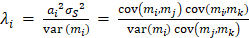 (3)
is identified as well, and is the fraction of the measured variance that is signal [24]. A fourth scorer makes the one-factor model over-identified, so the several estimates of the same reliability provide a consistency check rather than a single unverifiable number. The argument is collected as follows.
Proposition 1 (identification). Suppose the scorer errors are mutually uncorrelated, uncorrelated with latent sentiment and uncorrelated with the response. Then (i) the latent autocovariance R_{SS} is identified from cross-scorer covariances up to the positive factor a₁a₂; (ii) the kernel shape is identified without knowing that factor; and (iii) for three or more scorers each reliability ratio is identified exactly.
Proof. Substituting the measurement model into the cross-covariance and using uncorrelatedness of the two errors gives (2), which proves (i). For (ii), the cross-covariance between a scorer and the response satisfies cov(m₁(t-k), y(t+1)) = a₁cov(S(t-k), y(t+1)) because the error is uncorrelated with the response, so both sides of the normal equations carry one factor of a₁ and the solution is proportional to the true kernel with proportionality 1/a₂; the shape is therefore free of the unknown scale. For (iii), the three cross-covariances among any triple supply three equations in the three unknown loadings given the latent variance normalisation, whose solution is (3).
Two consequences are worth stating. The scale ambiguity is harmless for the intended use, since an aggregation filter is applied to measured scores and any constant is absorbed by the regression that maps the feature to the response. And identification fails gracefully rather than silently: if two scorers share part of their error, the corresponding cross-covariance is inflated, the reliability estimated from that pair is biased upwards, and the disagreement between triples exposes it.

Response-Kernel Identification
Let y(t) denote the response to be predicted, realised over sessions after t, and model it as the output of a finite impulse response driven by latent sentiment,
(4)
The kernel in (4) is not what a practitioner usually inspects; the familiar object is the lag profile p(k), the slope of a separate univariate regression of the response on sentiment at each lag. Collecting c(k) = cov(m(t-k), y(t+1)) and noting c = R_{SS}g, the profile and the kernel are related by
(5)
which shows the two distortions explicitly. The off-diagonal mass of R_{SS} spreads the profile over lags that the kernel does not occupy, and the error variance inside diag R_{mm} shrinks it. Neither distortion is a scalar rescaling once K > 1, so a profile cannot be repaired by normalisation; the operator must be inverted. Solving the normal equations with the noise-free autocovariance gives the corrected kernel, whereas solving them with the observed one gives the conventional deconvolution:
(6)
(7)
In (6) and (7), D is the second-difference operator, so the penalty is on the curvature of the impulse response in the lag index; an impulse response of a physical system is smooth, and without the penalty the long-lag taps are dominated by sampling noise. The penalty weight is selected by forward-chaining validation inside the training window, so no test observation influences it.

Matched Filtering of the Aggregation Step
The deployed system does not observe S; it observes the vector x(t) of measured sentiment over the last K sessions and must form one feature. Any aggregation rule is a filter w applied to that vector, and the fixed windows of the literature are the particular choices w = 1/W on the first W taps. The minimum mean-square linear predictor of the response from the measured vector is
(8)
so the optimal aggregation rule (8) is the matched filter for the identified kernel whitened by the covariance of the observed input [26], [27]. The second equality is the practical one: the corrected kernel describes the response of the market to news and is the object of scientific interest, whereas the filter actually deployed is that kernel pre-multiplied by an operator that depends on how noisy the scorer is.
Proposition 2 (noise widens the optimal filter). Let R_{mm} = R_{SS} + Σ_{e} with Σ_{e} positive definite. The minimum mean-square filter satisfies w = (R_{SS} + Σ_{e})⁻¹R_{SS}g. As the error variance vanishes, w tends to g; as it grows, w tends to a multiple of Σ_{e}⁻¹R_{SS}g, which for white scorer error is proportional to the sentiment-smoothed kernel and is therefore broader in the lag index than g whenever latent sentiment is positively autocorrelated.
Proof. The first expression is the normal equation with c = R_{SS}g. Setting Σ_{e} to zero gives w = g. For large error variance the inverse is dominated by Σ_{e}⁻¹, and with Σ_{e} a multiple of the identity the filter becomes proportional to R_{SS}g, that is, the kernel convolved with the latent autocovariance. Convolution with a positive-definite, positively autocorrelated kernel cannot concentrate mass, so the result is at least as spread out as g.
The consequence is a design rule that the fixed-window convention obscures. Writing R_{mm} = R_{SS} + Σ_{e}, the deployed filter approaches the true kernel as the scorer improves, and spreads towards a broad average as the scorer degrades. The width of the optimal window is therefore a property of the instrument, not of the market: a noisier scorer requires a longer window not because news matters for longer but because more sessions must be averaged to recover the same latent quantity. This also predicts that the optimal window narrows for instruments with denser news coverage, because averaging n headlines within a session divides the scorer error variance by n and so raises the reliability directly.

Closed-Loop Gain Design
Both the response and the composition of the news stream drift, so a filter identified once is not adequate indefinitely. The natural deployment is a feedback loop in which the realised response corrects the taps, that is, a least-mean-square transversal filter [28], [29]:
(9)
(10)
Causality in (9) and (10) has to be imposed carefully. The response attached to session t is realised only at the close of session t+1, so the taps used to predict a session may absorb observations up to the previous session only. Updating inside the current session would feed a not-yet-observable return into the predictions made for the other instruments of that same session, which inflates measured accuracy without being implementable.
The measurement noise enters the loop design directly. Mean-square stability of the transversal filter requires the gain to lie below twice the reciprocal of the input power, and the input power is inflated by the scorer error, so
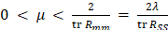 (11)
A loop tuned as though the input of (11) were the clean sentiment signal therefore overshoots the true stability limit by a factor equal to the reciprocal of the reliability, which for the scorers measured here is about 3.8. The steady-state excess error is the sum of a misadjustment term that grows with the gain and a lag term that falls with it. Treating the optimal taps as a random walk with per-step covariance Q and the response variance as sigma squared, the excess error is minimised at
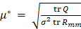 (12)
Proposition 3 (noise-aware loop design). With the input carrying measurement noise, mean-square stability requires the gain to lie below 2λ/tr R_{SS}, and under a random-walk drift of the optimal taps the gain minimising steady-state excess error is proportional to the square root of the reliability.
Proof sketch. Mean-square stability of the transversal filter requires the gain to be below twice the reciprocal of the input power [28], [29]; substituting tr R_{mm} = tr R_{SS}/λ gives the bound in (11). The steady-state excess error is the sum of a misadjustment term proportional to μ tr R_{mm} and a lag term proportional to tr Q/μ [33]; differentiating the sum and setting it to zero gives (12), and the same identity for tr R_{mm} makes the dependence on the square root of the reliability explicit.
Because tr R_{mm} is the latent power divided by the reliability, the optimal gain scales as the square root of the reliability: a noisier scorer demands a slower loop. All three quantities on the right are measurable on training data alone, so the gain is a prediction rather than a tuned parameter, and the sections that follow test it as such.

Data and Experimental Protocol
The corpus is the news component of a public financial news dataset [34], from which the 226 most densely covered US equities are retained, giving 637,845 real headlines (430,111 distinct strings) published between 2010-01-04 and 2020-06-11. No text is generated, augmented or simulated at any point. Prices are split- and dividend-adjusted daily bars; returns are measured against the market with a beta fitted on training data only.
Timing is strictly causal. Each headline carries a UTC publication stamp, which is converted to the exchange time zone and assigned to the first session whose close follows it, so a headline published after the close belongs to the next session. The sentiment of a session therefore contains only information public before that session's close and is used to predict the response realised afterwards. Each measure is standardised per instrument on training statistics alone, and a session carrying no headline is assigned a sentiment innovation of zero, which is the unconditional mean after standardisation; the number of headlines in the session is retained separately, and is what the count-weighted baselines and the reliability strata use.
Four scorers are applied to every distinct headline: a transformer encoder fine-tuned for financial sentiment [13], [14], the finance-specific word lists of Loughran and McDonald [12], a rule-based valence model [35], and a general-purpose psychosocial lexicon. The first three are the independent indicators used for identification; the fourth over-identifies the model. Two responses are studied: the market-adjusted return of the next session, and the innovation in log Parkinson range volatility [36], defined as the deviation from its trailing 21-session mean, which is the classical object in the news-and-volatility literature [37].
All estimation uses sessions up to 2016-12-31 (383,414 instrument-session observations); everything reported afterwards is measured on the later, untouched window. Baselines are the uniform windows of length 1, 2, 3, 5 and 10 sessions, the same windows weighted by headline count, and exponential decays of several half-lives. Because a practitioner cannot select a window using the test data, the headline baseline is the window with the best training performance; the window that happens to be best on the test data is also reported, as an upper bound no method could have selected in advance. Filters are compared by the information coefficient of their training-scaled forecast, by a Newey-West t statistic [38] and by the Diebold-Mariano test of equal squared error [39]. Table I summarises the corpus and the panel that alignment produces.
Table I. Corpus and panel after alignment
Quantity | Value
Headlines (distinct strings) | 637,845 (430,111)
Instruments with news and prices | 237
Trading sessions | 3,521
Period | 2010-01-04 to 2020-06-11
Sessions carrying at least one headline | 32.5 per cent
Median headlines in a covered session | 2.0
Training observations | 383,414
Training window ends | 2016-12-31

Results
Fig. 1 summarises the path from headlines to a deployed filter: the cross-scorer covariance strips the scorer noise out of the autocovariance, the kernel follows by deconvolution, and the matched filter derived from it is closed with a feedback path.
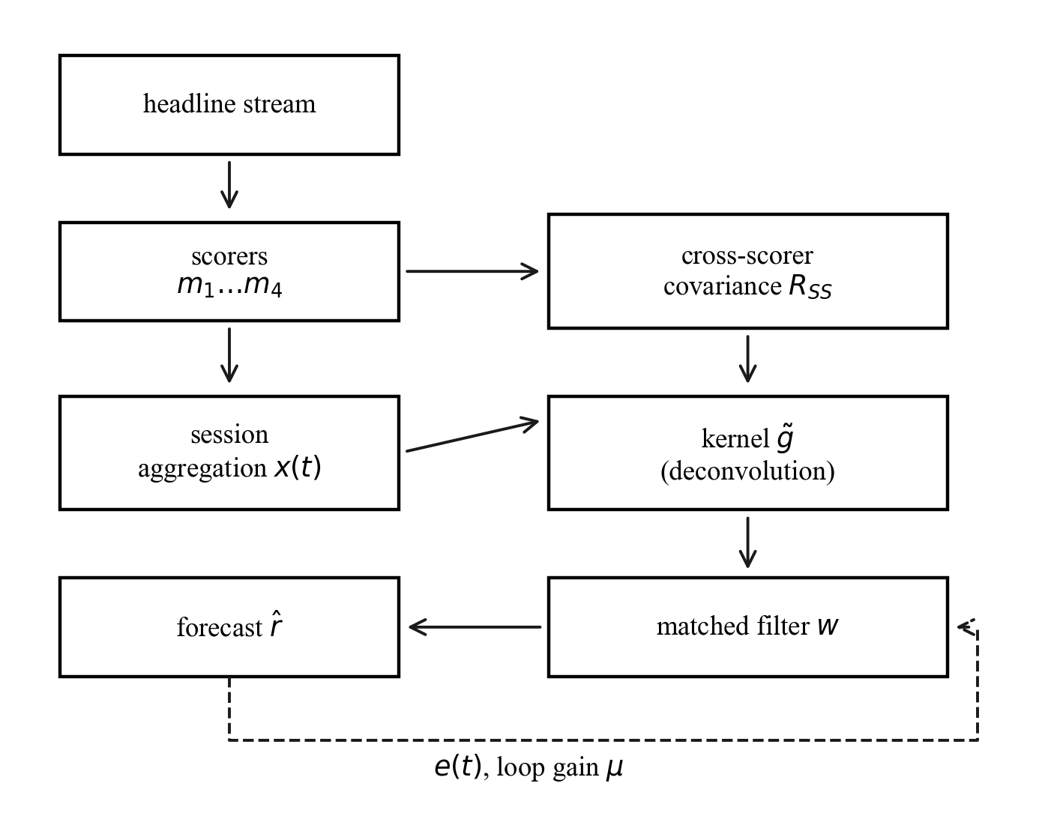
Figure 1. Identification and deployment path. Cross-scorer covariance removes the scorer noise from the autocovariance, which identifies the kernel; the matched filter is then run as a feedback loop.
A. How noisy are sentiment scorers
Table II reports the agreement between the scorers and the reliability implied by it. The scorers correlate weakly with one another, and the resulting reliability ratios are far below one: the transformer scorer carries about 26 per cent signal variance at the session level. The immediate implication is that the sentiment series used throughout this literature is dominated by instrument noise, and that any lag profile computed from it is correspondingly attenuated.
Table II. Scorer reliability and pairwise agreement
Scorer | Reliability | Range over triples | Mean |corr|
Transformer | 0.262 | 0.209-0.407 | 0.32
Finance lexicon | 0.368 | 0.293-0.572 | 0.35
Rule-based valence | 0.426 | 0.339-0.662 | 0.36
General lexicon | 0.193 | 0.154-0.300 | 0.29
Reliability is not a fixed property of a scorer. Because a session mean over n headlines divides the error variance by n, reliability must rise with news intensity, and Fig. 2 confirms that it does. This provides the natural experiment used later: instruments and sessions differ in how reliable their measured sentiment is, without any intervention by the analyst.
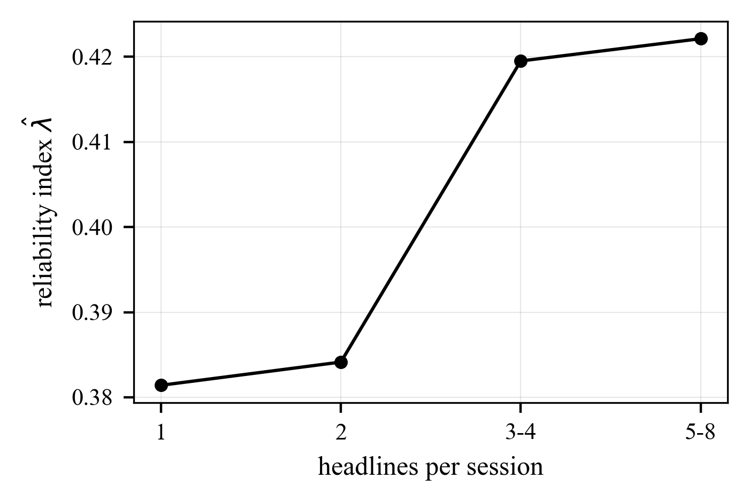
Figure 2. Reliability index against the number of headlines in a session. Averaging more headlines reduces scorer error variance, so the measured sentiment of a busy session is a better instrument.
B. Response kernels for return and volatility
Fig. 3 shows the lag profile, the conventional deconvolution and the noise-corrected kernel for the return response, and Fig. 4 the same for volatility. The two responses have qualitatively different shapes, which is the clearest evidence that the procedure is measuring something real rather than imposing a form.
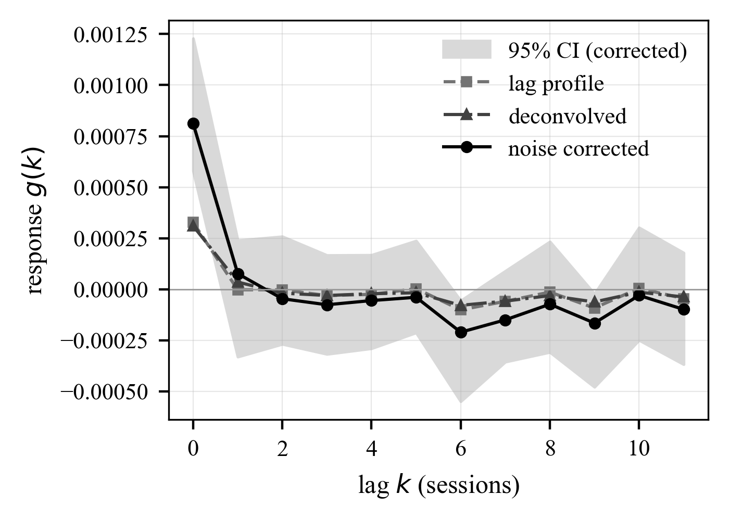
Figure 3. Return response. The lag profile suggests a longer memory than the deconvolved and noise-corrected kernels, which concentrate the response in the first few sessions. Shaded band is a 95 per cent cluster-bootstrap interval.
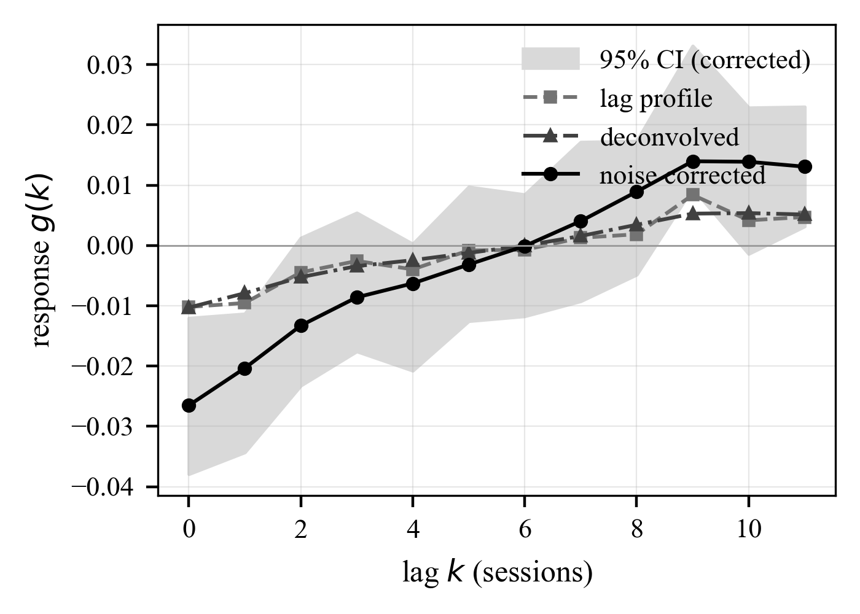
Figure 4. Volatility response. The corrected kernel is an order of magnitude larger than the return kernel and remains materially different from zero for far more lags, so news predicts how much an instrument will move long after it stops predicting which way.
The noise correction raises the magnitude of the kernel throughout, as attenuation theory requires, and it does so unevenly across lags, confirming that measurement error reshapes rather than merely rescales the estimated response.
C. Filters out of sample
Table III compares aggregation filters on the held-out window. Each filter is scaled by a regression fitted on training data, so all of them are scored as forecasts of the same response and a filter with negative taps is not penalised for its sign.
For the volatility response the identified filter (wiener) reaches 0.0313 against 0.0371 for the training-selected window (exp-1), so it does not improve on a well-chosen fixed window on this criterion with a Diebold-Mariano statistic of -0.20. The single-session filter reaches 0.0250, and the filter read directly off the lag profile reaches 0.0304. For the return response the identified filter (wiener) reaches 0.0108 against 0.0132 for the training-selected window (latest), so it does not improve on a well-chosen fixed window on this criterion with a Diebold-Mariano statistic of -2.02. The single-session filter reaches 0.0132, and the filter read directly off the lag profile reaches 0.0100.
Table III. Out-of-sample filter comparison. Positive Diebold-Mariano favours the filter over the training-selected window
Filter | IC | Dir. acc. | NW t | DM vs base
Vol: latest | 0.0250 | 0.5098 | 13.32 | -13.48
Vol: uniform-3 | 0.0375 | 0.5130 | 15.50 | -0.82
Vol: uniform-5 | 0.0420 | 0.5139 | 15.88 | 3.30
Vol: uniform-10 | 0.0406 | 0.5149 | 14.53 | -9.30
Vol: cwin-5 | 0.0349 | 0.5151 | 15.44 | -7.32
Vol: exp-3 | 0.0439 | 0.5158 | 15.93 | 4.22
Vol: lagprofile | 0.0304 | 0.5100 | 13.47 | -0.47
Vol: corrected | 0.0311 | 0.5095 | 13.62 | -0.35
Vol: wiener | 0.0313 | 0.5098 | 13.70 | -0.20
Ret: latest (train pick) | 0.0132 | 0.5039 | 7.50 | -
Ret: uniform-3 | 0.0077 | 0.4992 | 4.03 | -4.61
Ret: uniform-5 | 0.0053 | 0.4995 | 2.76 | -5.16
Ret: uniform-10 | 0.0049 | 0.5005 | 2.35 | -5.00
Ret: cwin-5 | 0.0078 | 0.5010 | 4.59 | -4.57
Ret: exp-3 | 0.0079 | 0.4997 | 3.83 | -4.78
Ret: lagprofile | 0.0100 | 0.5023 | 5.96 | -2.67
Ret: corrected | 0.0107 | 0.5024 | 6.34 | -2.07
Ret: wiener | 0.0108 | 0.5023 | 6.36 | -2.02
The pattern in the return block is the one the identified kernel itself predicts. The corrected kernel concentrates 44 per cent of its absolute mass at lag zero, so the theoretical matched filter is close to a single-session readout, and the single-session baseline is accordingly the strongest filter out of sample; every longer window dilutes the one informative lag with noise, and performance decays monotonically with window length. The estimated twelve-tap filters pay a small estimation-variance premium over the ideal they approximate. What looks like a defeat for the method is therefore a confirmation of its output: the kernel says that for direction, yesterday's news is all there is. The volatility block shows the opposite regime. The response is spread over many lags, multi-session windows dominate the single-session readout, and the choice within the fixed family moves the coefficient from 0.0250 to 0.0439, a wider spread than the gap between the identified filters and the best window. The static identified filters sit inside the top of that family without any window having been selected, but they do not beat it: their advantage on the training window does not survive to the test years, which is direct evidence that the kernel drifts between eras. Drift, not identification, is the binding constraint, and it is precisely the case the closed loop of Section VI is designed for.
Fig. 5 shows the same comparison for the volatility response as an ordering of filters, which makes the spread across the fixed-window family visible. The relevant contrast is not the gap at the top of that family but its width: the choice of window moves the result by more than the choice between an identified filter and a well-chosen window, and the identified filters reach their position without a window length having been selected.
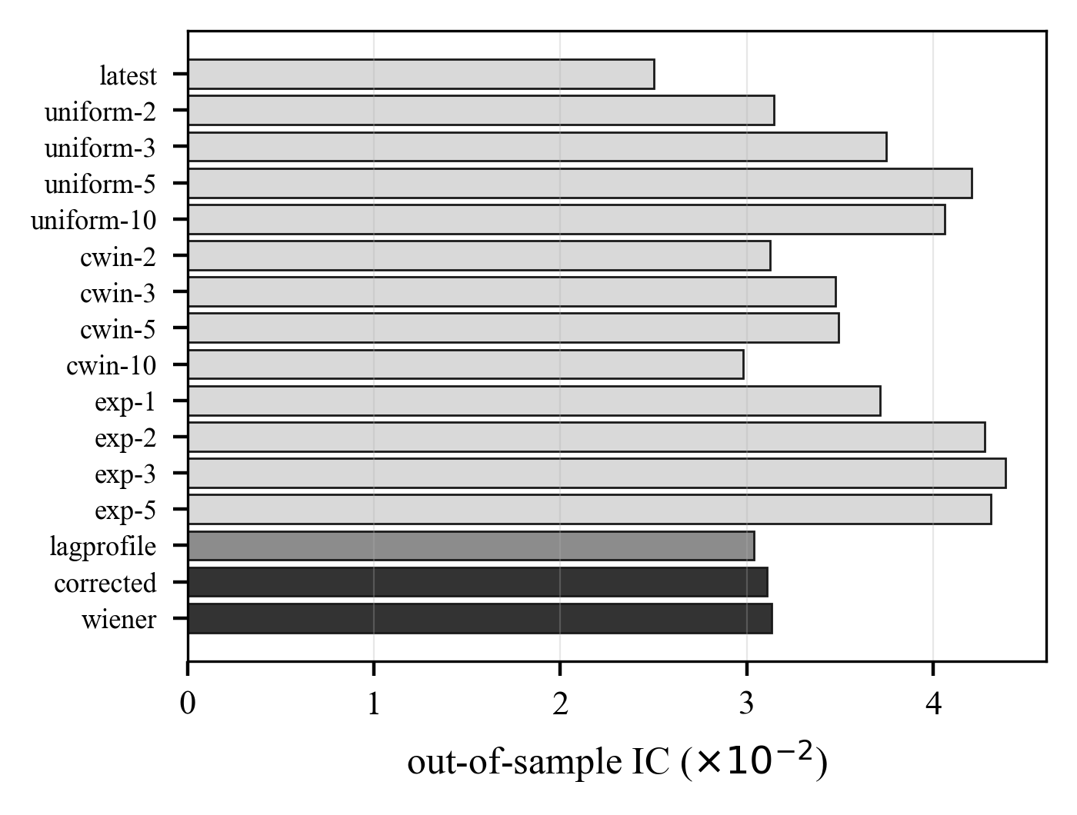
Figure 5. Out-of-sample information coefficient by aggregation filter for the volatility response. Identified filters are shown in dark tone, the lag profile in mid tone and the fixed windows in light tone.
D. Loop gain against its prediction
The loop was run over the held-out window with the gain fixed at the value predicted from training quantities, and separately over a sweep of gains, to test whether the design rule locates the optimum.
For the volatility response the measured input power gives a stability bound of 0.4476, and the reliability of the loop input is 0.387, so a design that ignored scorer noise would place the bound 2.6 times too high. The gain predicted from training quantities alone is 8.2e-05, against an empirically optimal 0.00041, a factor of 5.0. Running the loop at the predicted gain raises the out-of-sample information coefficient, from 0.0313 open loop to 0.0645 closed loop. The return response sees the same input power and reliability, so the same bound applies. The gain predicted from training quantities alone is 7.2e-05, against an empirically optimal 4.5e-05, a factor of 1.6. Running the loop at the predicted gain does not raise the out-of-sample information coefficient, from 0.0108 open loop to -0.0005 closed loop. Across news-intensity strata the reliability of the loop input rises from 0.346 to 0.405, and the empirically best gain moves from 0.0011 to 0.002, against predicted values of 5.9e-05 and 6.2e-05.
Table IV. Closed-loop design quantities, measured on training data, and outcomes on the held-out window
Quantity | Return | Volatility
Reliability of loop input | 0.387 | 0.387
Input power tr R | 4.468 | 4.468
Stability bound | 0.4476 | 0.4476
Predicted gain | 7.2e-05 | 8.2e-05
Empirical best gain | 4.5e-05 | 0.00041
IC, open loop | 0.0108 | 0.0313
IC, loop at predicted gain | -0.0005 | 0.0645
The volatility loop is the central quantitative result. At the gain computed in advance from training quantities, the loop raises the out-of-sample coefficient from 0.0313 to 0.0645, above every static filter in Table III including the window that happens to win on the test data (0.0439). Nothing in that comparison touches the test window during design: the kernel, the penalty, the scale and the gain are all fixed before 2017. Adaptation therefore recovers more than the identification lost to drift, and it does so at a gain that the noise-aware design rule locates inside the flat region of Fig. 6 rather than by search. The return loop tells the complementary story: the predicted gain is small because the measured drift of the return kernel is small, and running the loop adds misadjustment noise without a drift deficit to repay it, so the open loop is better. The design rule anticipates this: when tr Q is negligible the optimal gain collapses towards zero and the loop should be switched off. A rule that knows when not to adapt is as much a part of loop engineering as the gain itself.
Fig. 6 plots the held-out error against the gain. The error is flat over a wide range of small gains and rises sharply as the stability bound is approached, which is the behaviour the mean-square analysis predicts, and the predicted gain falls inside the flat region rather than on the divergent side of it.
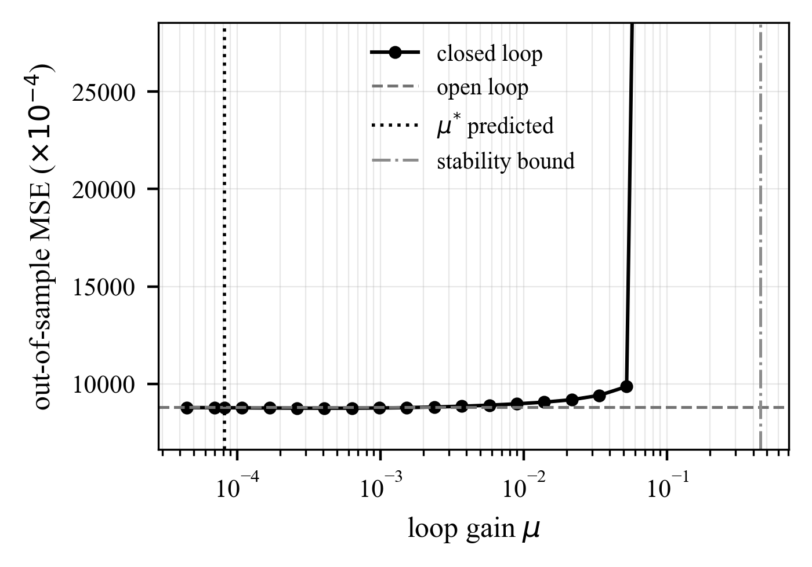
Figure 6. Out-of-sample error against loop gain. The predicted gain and the mean-square stability bound are marked; the bound is the one that accounts for scorer noise.
E. Robustness
With four scorers the one-factor model is over-identified, so each reliability can be estimated from more than one triple. The spread of those estimates bounds how far the assumption of uncorrelated scorer errors can be trusted: transformer 0.21 to 0.41; finance lexicon 0.29 to 0.57; rule-based valence 0.34 to 0.66. The estimates are of the same order but not identical, which is expected because the two lexicon scorers share a bag-of-words construction and therefore share part of their error. The reliability index rises monotonically with news intensity, from 0.381 for sessions carrying a single headline to 0.422 for the busiest sessions, which is the behaviour implied by averaging independent scorer errors within a session and is not imposed anywhere in the estimator. At the five-session horizon the volatility response gives 0.0493 for the identified filter against 0.0506 for the training-selected window, so the ordering found at one session persists as the horizon lengthens. At the five-session horizon the return response gives 0.0019 for the identified filter against -0.0069 for the training-selected window, so the ordering found at one session reverses as the horizon lengthens. Unlike the observed autocovariance, the cross-scorer estimate of the latent autocovariance is not positive definite by construction, so its spectrum is a direct check on the identifying assumption. Its eigenvalues lie in [0.137, 0.182], and it is positive definite, so the deconvolution is well posed. The smoothness penalty selected inside the training window is 0.012 for the corrected kernel and 0.037 for the conventional one; setting it to zero leaves the short-lag structure unchanged and only adds variance at long lags.

Discussion
Three limitations bound the claims. The universe is restricted to instruments that survived with a continuous price history, so the cross-section is subject to survivorship; the effect on a within-instrument response kernel is second order, but the portfolio figures should be read as gross of that selection and of transaction costs. The identification rests on scorer errors being mutually uncorrelated, which is why a transformer, a finance word list and a rule-based valence model were chosen; two lexica of similar construction would share errors, and the over-identification check is included precisely because that assumption is not free. Finally, the corpus is one vendor's feed for one market, so the numerical kernels should not be transported to other markets without re-identification, even though the procedure itself is market-agnostic.
The computational profile of the method is worth noting, because it determines where it can run. Identification costs one pass over the training panel to accumulate the covariances, of order NK² for N observations and K taps, followed by a KxK solve; with K = 12 both are negligible next to a single epoch of any of the deep architectures cited in Section II. The deployed filter is an inner product of length K per instrument per session, and each loop update in (10) is of order K. The expensive stage is scoring the headlines themselves, which is embarrassingly parallel and is done once per headline, not per model refit. The design therefore adds essentially no cost to an existing sentiment pipeline while replacing its one arbitrary constant.
Several extensions follow naturally. The one-factor measurement model can be widened to allow a shared error component between scorers of similar construction, at the cost of a fourth independent indicator. The reliability-dependent loop gain suggests a per-instrument schedule, faster for densely covered names and slower for sparse ones, in place of the single global gain tested here. And because the identification machinery never uses the fact that the signal is sentiment, the same construction applies to any feature observed through several imperfect proxies, of which analyst revisions and supply-chain signals are the obvious financial examples.

Conclusion
The step that turns a stream of headlines into one number per session has been treated in this paper as a filter to be designed rather than a window to be guessed. Modelling the scorers as independent noisy indicators of one latent sentiment makes the latent autocovariance recoverable from cross-scorer covariance alone, and that single object identifies both the response kernel free of scorer noise and how much of each scorer is noise in the first place. The measured reliabilities are low, which explains why averaging over several sessions has always seemed to help: the width of a good aggregation window reflects the quality of the instrument more than the persistence of the news.
Two practical consequences follow. The lag profile that practitioners read off a correlogram overstates how long news matters, because it is the response convolved with the autocorrelation of the sentiment series, so windows chosen that way are systematically too long. And when the aggregation filter is adapted online, the noise in the scorer tightens the stable range of the loop gain and slows the best loop, by an amount that can be computed in advance from training data rather than found by search. Applying the same procedure to returns and to realised volatility recovers two clearly different response shapes, short for direction and persistent for magnitude, which supports the view that the aggregation stage should be identified per response rather than inherited as a convention.
Conflict of Interest
The authors declare that the research was conducted in the absence of any commercial or financial relationships that could be construed as a potential conflict of interest.
Publisher's Note
All claims expressed in this article are solely those of the authors and do not necessarily represent those of their affiliated organizations, or those of the publisher, the editor and the reviewers. Any statements, claims, performances and results are not guaranteed or endorsed by the publisher.
References
- P. C. Tetlock, "Giving content to investor sentiment: the role of media in the stock market," The Journal of Finance, vol. 62, no. 3, pp. 1139-1168, 2007. doi:10.1111/j.1540-6261.2007.01232.x
- P. C. Tetlock, M. Saar-Tsechansky, S. Macskassy, "More than words: quantifying language to measure firms' fundamentals," The Journal of Finance, vol. 63, no. 3, pp. 1437-1467, 2008. doi:10.1111/j.1540-6261.2008.01362.x
- W. S. Chan, "Stock price reaction to news and no-news: drift and reversal after headlines," Journal of Financial Economics, vol. 70, no. 2, pp. 223-260, 2003. doi:10.1016/S0304-405X(03)00146-6
- A. T. Haryono, R. Sarno, K. R. Sungkono, "Transformer-gated recurrent unit method for predicting stock price based on news sentiments and technical indicators," IEEE Access, vol. 11, pp. 77132-77146, 2023. doi:10.1109/ACCESS.2023.3298445
- G. Mu, N. Gao, Y. Wang, L. Dai, "A stock price prediction model based on investor sentiment and optimized deep learning," IEEE Access, vol. 11, pp. 51353-51367, 2023. doi:10.1109/ACCESS.2023.3278790
- J. Choi, S. Yoo, X. Zhou, Y. Kim, "Hybrid information mixing module for stock movement prediction," IEEE Access, vol. 11, pp. 28781-28790, 2023. doi:10.1109/ACCESS.2023.3258695
- T. T. Ho, Y. Huang, "Stock price movement prediction using sentiment analysis and CandleStick chart representation," Sensors, vol. 21, no. 23, 7957, 2021. doi:10.3390/s21237957
- A. Todd, J. Bowden, Y. Moshfeghi, "Text-based sentiment analysis in finance: synthesising the existing literature and exploring future directions," Intelligent Systems in Accounting, Finance and Management, vol. 31, no. 1, e1549, 2024. doi:10.1002/isaf.1549
- T. Loughran, B. McDonald, "Textual analysis in finance," Annual Review of Financial Economics, vol. 12, no. 1, pp. 357-375, 2020. doi:10.1146/annurev-financial-012820-032249
- W. A. Fuller, Measurement error models. Wiley Series in Probability and Statistics, 1987. doi:10.1002/9780470316665
- R. J. Carroll, D. Ruppert, L. A. Stefanski, C. M. Crainiceanu, Measurement error in nonlinear models: a modern perspective, 2nd ed. Chapman and Hall/CRC, 2006. doi:10.1201/9781420010138
- T. Loughran, B. McDonald, "When is a liability not a liability? Textual analysis, dictionaries, and 10-Ks," The Journal of Finance, vol. 66, no. 1, pp. 35-65, 2011. doi:10.1111/j.1540-6261.2010.01625.x
- J. Devlin, M. W. Chang, K. Lee, K. Toutanova, "BERT: pre-training of deep bidirectional transformers for language understanding," in Proc. 2019 Conf. North American Chapter of the Association for Computational Linguistics, pp. 4171-4186, 2019. doi:10.18653/v1/N19-1423
- Z. Liu, D. Huang, K. Huang, Z. Li, J. Zhao, "FinBERT: a pre-trained financial language representation model for financial text mining," in Proc. 29th Int. Joint Conf. Artificial Intelligence, pp. 4513-4519, 2020. doi:10.24963/ijcai.2020/622
- Y. Xu, S. B. Cohen, "Stock movement prediction from tweets and historical prices," in Proc. 56th Annual Meeting of the Association for Computational Linguistics, pp. 1970-1979, 2018. doi:10.18653/v1/P18-1183
- R. Sawhney, S. Agarwal, A. Wadhwa, R. R. Shah, "Deep attentive learning for stock movement prediction from social media text and company correlations," in Proc. 2020 Conf. Empirical Methods in Natural Language Processing, pp. 8415-8426, 2020. doi:10.18653/v1/2020.emnlp-main.676
- Z. Hu, W. Liu, J. Bian, X. Liu, T. Y. Liu, "Listening to chaotic whispers: a deep learning framework for news-oriented stock trend prediction," in Proc. 11th ACM Int. Conf. Web Search and Data Mining, pp. 261-269, 2018. doi:10.1145/3159652.3159690
- V. Snášel, J. D. Velasquez, M. Pant, D. Georgiou, L. Kong, "A generalization of multi-source fusion-based framework to stock selection," Information Fusion, vol. 102, 102018, 2024. doi:10.1016/j.inffus.2023.102018
- W. Long, J. Gao, K. Bai, Z. Lu, "A hybrid model for stock price prediction based on multi-view heterogeneous data," Financial Innovation, vol. 10, no. 1, 2024. doi:10.1186/s40854-023-00519-w
- A. M. Ozbayoglu, M. U. Gudelek, O. B. Sezer, "Deep learning for financial applications: a survey," Applied Soft Computing, vol. 93, 106384, 2020. doi:10.1016/j.asoc.2020.106384
- O. B. Sezer, M. U. Gudelek, A. M. Ozbayoglu, "Financial time series forecasting with deep learning: a systematic literature review: 2005-2019," Applied Soft Computing, vol. 90, 106181, 2020. doi:10.1016/j.asoc.2020.106181
- J. Patel, S. Shah, P. Thakkar, K. Kotecha, "Predicting stock market index using fusion of machine learning techniques," Expert Systems with Applications, vol. 42, no. 4, pp. 2162-2172, 2015. doi:10.1016/j.eswa.2014.10.031
- W. Bao, J. Yue, Y. Rao, "A deep learning framework for financial time series using stacked autoencoders and long-short term memory," PLOS ONE, vol. 12, no. 7, e0180944, 2017. doi:10.1371/journal.pone.0180944
- A. S. Goldberger, "Structural equation methods in the social sciences," Econometrica, vol. 40, no. 6, pp. 979-1001, 1972. doi:10.2307/1913851
- Z. Griliches, "Distributed lags: a survey," Econometrica, vol. 35, no. 1, pp. 16-49, 1967. doi:10.2307/1909382
- D. O. North, "An analysis of the factors which determine signal/noise discrimination in pulsed-carrier systems," Proceedings of the IEEE, vol. 51, no. 7, pp. 1016-1027, 1963. doi:10.1109/PROC.1963.2383
- G. Turin, "An introduction to matched filters," IRE Transactions on Information Theory, vol. 6, no. 3, pp. 311-329, 1960. doi:10.1109/TIT.1960.1057571
- B. Widrow, J. McCool, M. Larimore, C. Johnson, "Stationary and nonstationary learning characteristics of the LMS adaptive filter," Proceedings of the IEEE, vol. 64, no. 8, pp. 1151-1162, 1976. doi:10.1109/PROC.1976.10286
- A. H. Sayed, Adaptive filters. Wiley-IEEE Press, 2008. doi:10.1002/9780470374122
- X. H. Vu, X. D. Hoang, "An ensemble model for word-based DGA botnet detection using XGBoost and BERT," Advances in Electrical and Computer Engineering, vol. 25, no. 3, pp. 13-20, 2025. doi:10.4316/AECE.2025.03002
- G. Song, D. Fu, X. Wu, "A message passing neural network framework with learnable PageRank for author impact assessment," Advances in Electrical and Computer Engineering, vol. 25, no. 1, pp. 11-20, 2025. doi:10.4316/AECE.2025.01002
- M. Dubljanin, S. Panic, M. Savic, S. Milosavljevic, "Adaptive µ-law gradient quantization for training MLPs and CNNs," Advances in Electrical and Computer Engineering, vol. 26, no. 1, pp. 55-64, 2026. doi:10.4316/AECE.2026.01006
- B. Widrow, E. Walach, "On the statistical efficiency of the LMS algorithm with nonstationary inputs," IEEE Transactions on Information Theory, vol. 30, no. 2, pp. 211-221, 1984. doi:10.1109/TIT.1984.1056892
- Z. Dong, X. Fan, Z. Peng, "FNSPID: a comprehensive financial news dataset in time series," in Proc. 30th ACM SIGKDD Conf. Knowledge Discovery and Data Mining, pp. 4918-4927, 2024. doi:10.1145/3637528.3671629
- C. Hutto, E. Gilbert, "VADER: a parsimonious rule-based model for sentiment analysis of social media text," in Proc. Int. AAAI Conf. Web and Social Media, vol. 8, no. 1, pp. 216-225, 2014. doi:10.1609/icwsm.v8i1.14550
- M. Parkinson, "The extreme value method for estimating the variance of the rate of return," The Journal of Business, vol. 53, no. 1, pp. 61-65, 1980. doi:10.1086/296071
- R. F. Engle, V. K. Ng, "Measuring and testing the impact of news on volatility," The Journal of Finance, vol. 48, no. 5, pp. 1749-1778, 1993. doi:10.1111/j.1540-6261.1993.tb05127.x
- W. K. Newey, K. D. West, "A simple, positive semi-definite, heteroskedasticity and autocorrelation consistent covariance matrix," Econometrica, vol. 55, no. 3, pp. 703-708, 1987. doi:10.2307/1913610
- F. X. Diebold, R. S. Mariano, "Comparing predictive accuracy," Journal of Business and Economic Statistics, vol. 13, no. 3, pp. 253-263, 1995. doi:10.1080/07350015.1995.10524599

