Timber Work

1. Pre-Requisite
2. Unreal 5.5
3. Edit CleanBuildProject.bat file & RunGame.bat

CleanBuildProject.bat

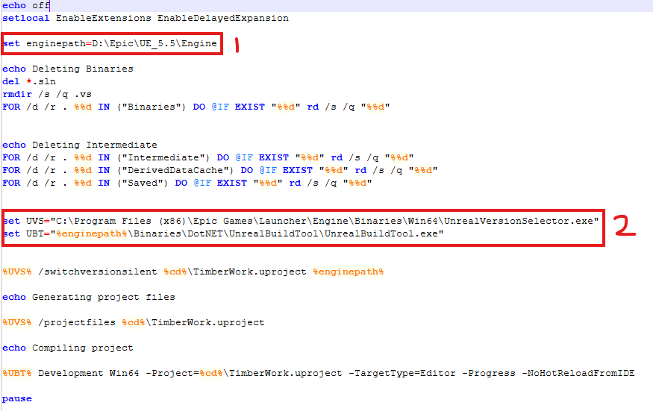

RunGame.bat

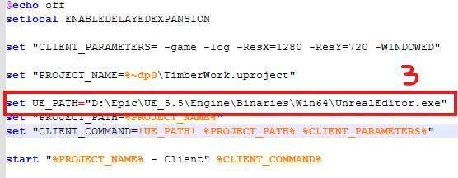

* 1 & 3 – Set engine path
* 2 – Verify if Exe available at the location

1. To Compile Run - CleanBuildProject.bat
2. To Run game – Run RunGame.bat
3. Controls
   1. Normal Mode
      1. Move – W/A/S/D
      2. Look – Mouse
      3. God Mode – G
   2. God Mode
      1. Move – W/A/S/D
      2. Zoom – Z/X
      3. Rotate – Q/E
      4. Spectate Start/Stop– LMB
      5. Spline – P
      6. Exit God Mode – G
4. Architecture

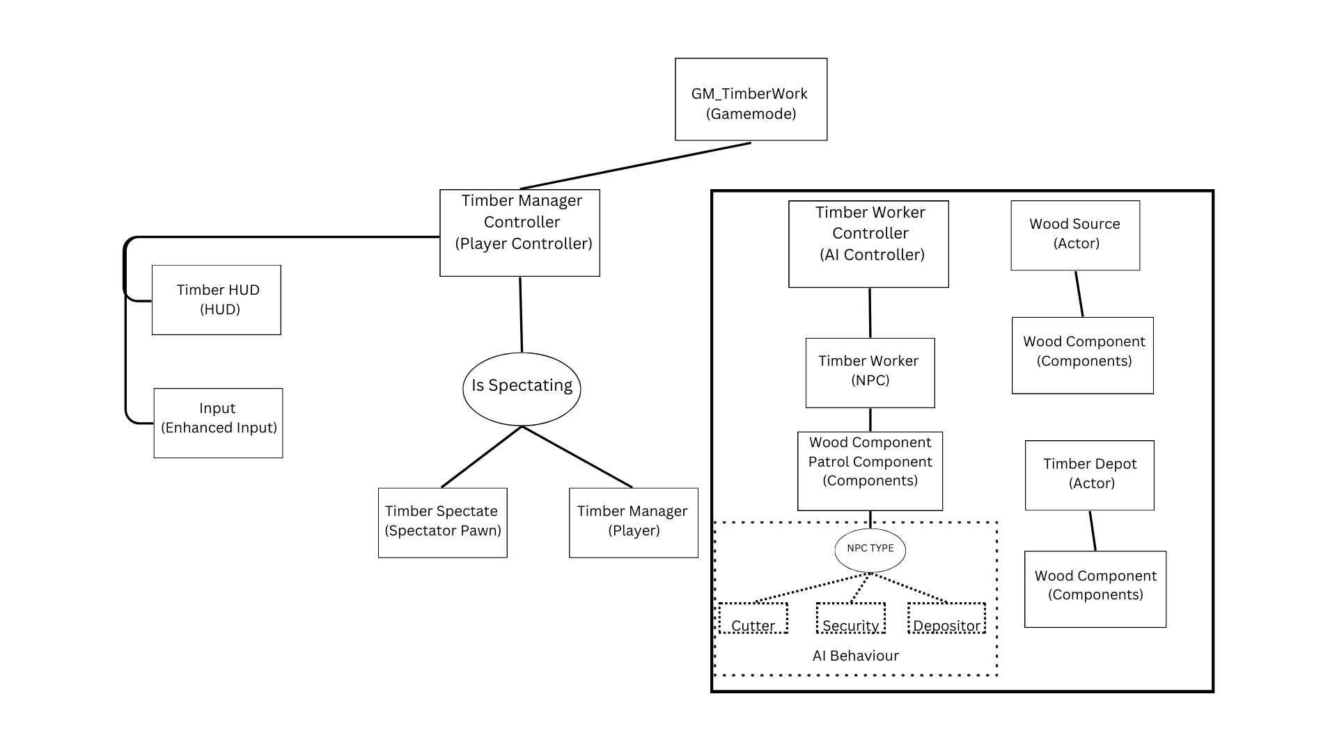

* **Components:**
  + **Wood Component**: Handles all transactions related to wood.
  + **Patrol Component**: Manages NPC patrol routes, storing and calculating the next patrol points.
* **NPC:**
  + NPC behaviour is determined by type (Security, Cutter, Depositor), each with its own behaviour tree.
    - **BT_Security**:
      * Retrieves the next patrol point from the patrol component and navigates to it.
    - **BT_Cutter**:
      * Locates a wood source in the environment.
      * Moves to the wood source and performs the designated action for a set duration.
      * Transfers a specified amount of wood to the worker via the Wood Component.
      * Identifies the depositor in the environment.
      * Moves to the depositor and transfers wood via the Wood Component upon arrival.
      * Returns to the wood source.
    - BT_Depositor
      * Retrieves the next patrol point from the patrol component and moves toward it.
      * If wood is received from the cutter, locates the depot in the environment.
      * Proceeds to the depot and transfers the wood.
      * Returns to the patrol point.