Survey data:  
Summary of responses

|  |  |
| --- | --- |
| Creation date | 2020-09-08 |
| Version | 01 |
| Author | Ellen Webborn |
| Project | Smart Energy Research Lab (SERL) |
| Organisation | University College London (UCL) |

Table of Contents

Introduction 3

Section A Questions: “About your energy use and heating” 3

A1: Before we contacted you about this study, did you know you had a smart meter? 3

A2: To what extent, if at all, would you say that having a smart meter has affected the way you use gas or electricity in your accommodation? 4

A3: What type of central heating does your accommodation have? 5

A4: Which, if any, of the following controls does your central heating system have? 6

A5: What temperature do you set your controller to in the winter months for the late afternoons or evenings? 6

A6: Other than central heating, does your household use any standalone heaters in your accommodation? 7

A7: Do any of your standalone heaters have their own source of fuel? 8

A8: In your opinion, during very cold winter weather, how often are these standalone heaters typically used in your household? 8

A9: Does your household adjust your heating for any of the following reasons? 9

A10: When your accommodation is unoccupied for more than a day or so, how often will your household adjust the heating controls to ensure the heating either won’t, or is much less likely to come on? 10

A11: During the winter months, are there any living spaces (e.g. bedrooms, living/dining rooms, kitchens) in your accommodation that your household does not normally heat? 10

A12: We would now like you to tell us about the main way in which water from your hot water taps and shower, if you have one, is heated. 11

A13: How often do you personally do each of the following? 12

A14: How much effort, if any, would you say your household makes to limit or reduce the amount of gas or electricity used? 14

A15: How often will your household open the windows in your accommodation on the following types of days? On a typical cold day, on a typical warm day. 14

A16: Which of the following, if any, is your household considering replacing or adding to your heating or energy supply in the next 12 months? 16

Section B Questions: “About your accommodation” 17

B1: What type of accommodation do you live in? 17

B2: Is your accommodation self-contained? 17

B3: How many other households do you share with at the moment? 18

B4: Do you (or your household) own or rent this accommodation? 18

B5: How many rooms are available for use only by this household? 20

B6: How many of these rooms are bedrooms? 20

B7: During the cold winter weather, can you normally keep comfortably warm in your living room? 21

B8: Do you have any problems with condensation, damp or mould in your home? 22

B9: Approximately when do you think your accommodation was built? 22

B10: Can we check if you have any of the following appliances in your accommodation? 23

Section C questions 24

C1: How many people currently live in your household, including you? 24

C2: Including you, how many males and females are there in each of the following age groups in your household? 24

C3: Thinking about the working situation of each member of your household aged 16 and over, including you, how many would you say fall into each category below? 26

C4: Including you, how many people in your household hold a degree (e.g. BA, BSc) or higher qualification (e.g. MA, PhD, PGCE)? 27

C5: Does your household have a plug-in electric vehicle? 27

C6: When does your household tend to charge your electric vehicle at home? 28

Section D Questions: “About you” 29

D1: Which of these age groups do you fall into? 29

D2: Which of the following best describes how you think of yourself? 29

D3: Which best describes your current employment situation? 30

D4: How well would you say you are managing financially these days? 31

## Introduction

This document reports on the responses to SERL pilot study survey. The pilot study recruited 1711 participants (9.5% overall response rate), of which 1313 completed all survey questions (76.7%), and only 38 did not answer any survey questions (2.2%). The questions are presented in the order in which they appear in the survey. One online survey automatically skips questions that are not applicable due to previous answers; the postal survey relies on respondents to follow the instructions to skip where necessary. The data has been cleaned to remove (or replace where obvious) clearly erroneous responses and to make the postal and online survey data as consistent with one another as possible.

## Section A Questions: “About your energy use and heating”

### 

### A1: Before we contacted you about this study, did you know you had a smart meter?

*Tick one answer only.*

Table 1: Awareness of their smart meter. Almost all answered and almost all knew they had a smart meter.

| Response | Number | Percent |
| --- | --- | --- |
| Yes | 1633 | 97.61 |
| No | 19 | 1.14 |
| No answer | 21 | 1.26 |

### A2: To what extent, if at all, would you say that having a smart meter has affected the way you use gas or electricity in your accommodation?

*Tick one answer only, not applicable if answered ‘no’ to A1.*

Figure 1: Impact of smart meter on energy consumption. Most people were only affected a little or not at all by having a smart meter. Almost 8% were affected ‘a lot’ and 17% were affected ‘some’. 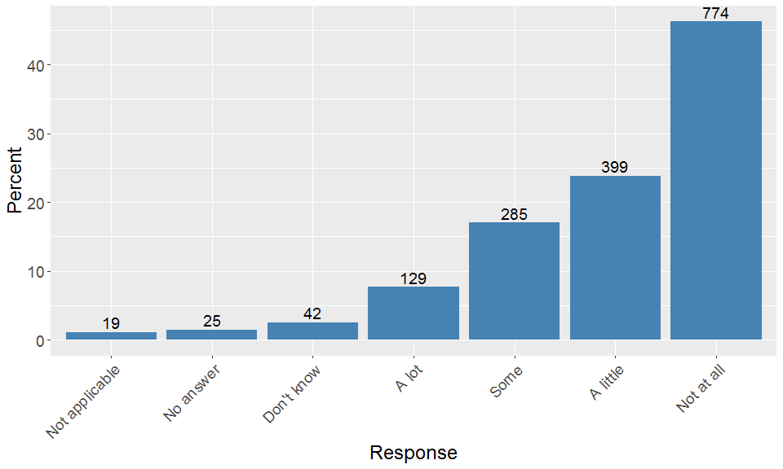

### A3: What type of central heating does your accommodation have?

*By central heating we mean a central system that generates heat for multiple rooms. Tick all that apply whether or not you use it.*

Figure 2: Types of central heating 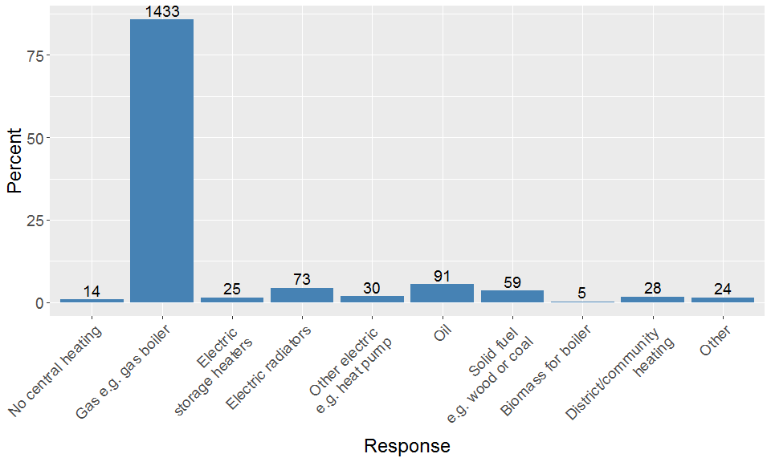

### A4: Which, if any, of the following controls does your central heating system have?

*Please include all controls, even if you don’t use them to control the central heating. Tick all that apply whether or not you use it. Not applicable if ‘no central heating’ was ticked in A3.*

Figure 3: Types of central heating controllers. Timers and temperature settings were very common (81.4% and 78.0% respectively). 15.5% had a smart device. 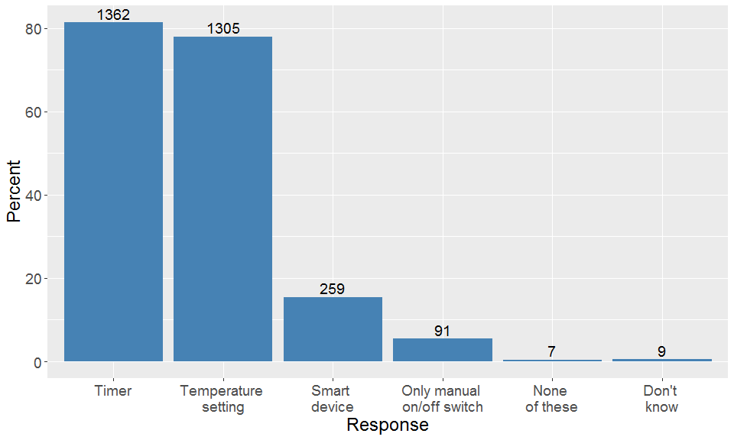

### A5: What temperature do you set your controller to in the winter months for the late afternoons or evenings?

*If you have more than one controller, choose what you would consider the main one. Write in number below.*

Despite the degrees C symbol next to the box, looking at the data showed that it was highly likely that some participants chose to respond in degrees Fahrenheit. Therefore all responses strictly greater than 35 were treated as temperatures in Fahrenheit and converted into Celsius (23 responses converted). The question was not applicable to 275 participants, a further 32 did not provide an answer, and a further 92 selected the “Don’t know/doesn’t apply” box. Figure 4 shows the temperatures provided for the remaining participants. There are still some anomalies but the majority of the data is clustered around 20 degrees C which is as expected.

Figure 4: Responses to question A5 excluding not applicable, non-response and ‘don’t know’. Some responses have been converted from apparent Fahrenheit to Celsius. 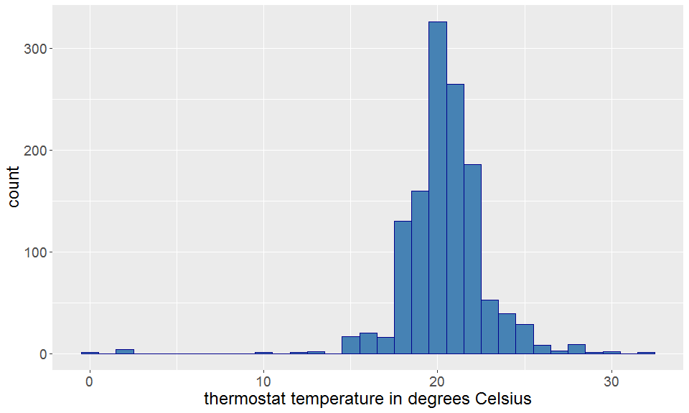

### A6: Other than central heating, does your household use any standalone heaters in your accommodation?

*This could be an electric heater, fireplace and so on. Tick one answer only.*

Table 2: Responses to question A6.

| Response | Number | Percent |
| --- | --- | --- |
| Yes | 840 | 50.21 |
| No | 801 | 47.88 |
| No answer | 32 | 1.91 |

### 

### A7: Do any of your standalone heaters have their own source of fuel?

*(E.g. from logs, coal or bottled gas). Tick one answer only. Not applicable if answered ‘no’ to A6*.

This data was cleaned so that anyone selecting no standalone heaters in question A6 automatically had their answer recorded as not applicable to question A7 (which always occurred in the online survey but not always on paper). Since the paper survey couldn’t provide automatic quetion skipping, this led to 3 apparently non-existent heaters having their own source of fuel, and 38 non-existent heaters not having their own source of fuel. In both cases these were removed in cleaning to align with the online survey responses.

Table 3: Responses to question A7. Note that the full ‘yes’ and ‘no’ options were ‘Yes, some or all have their own source of fuel (e.g. logs, coal, bottled gas, etc.)’ and ‘No, all are powered by mains gas or electric’.

| Response | Number | Percent |
| --- | --- | --- |
| Yes | 247 | 14.76 |
| No | 600 | 35.86 |
| No answer | 25 | 1.49 |
| Not applicable | 801 | 47.88 |

### 

### A8: In your opinion, during very cold winter weather, how often are these standalone heaters typically used in your household?

*Tick one answer only. Not applicable if answered ‘no’ to A6 or to A7.*

This question was not applicable to most of the respondents (1401 out of 1673) and a further 22 chose not to respond.

Figure 5: Responses to question A8 (percentages do not include those who didn’t respond or for whom the question was not applicable. 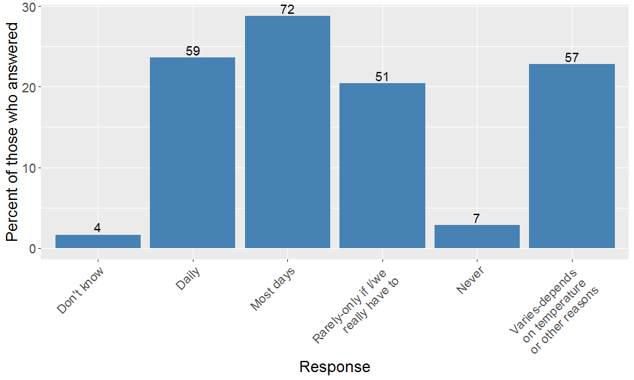

### A9: Does your household adjust your heating for any of the following reasons?

*Tick all that apply.*

Figure 6: Responses to question A9 (applicable to all participants). 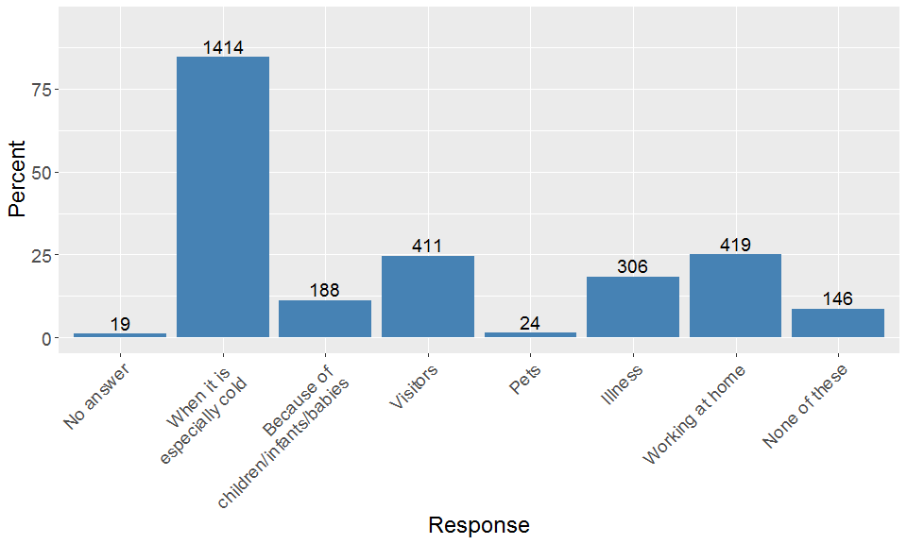

### A10: When your accommodation is unoccupied for more than a day or so, how often will your household adjust the heating controls to ensure the heating either won’t, or is much less likely to come on?

*Tick one answer only.*

In addition to the responses shown in the plot below, 100 participants (approximately 6%) responded “Not applicable, cannot do this”. 16 did not answer.

Figure 7: Adjusting heating for absence (excluding no answer and ‘not applicable/cannot do this’). 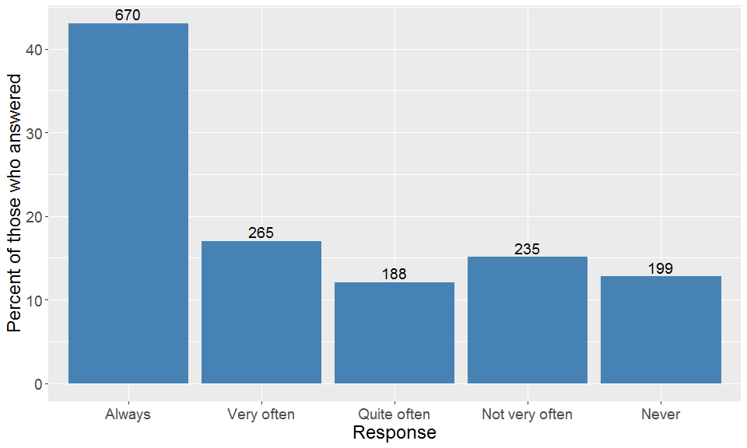

### A11: During the winter months, are there any living spaces (e.g. bedrooms, living/dining rooms, kitchens) in your accommodation that your household does not normally heat?

*Tick one answer only.*

Table 4: Unheated living spaces in winter.

| Response | Number | Percent |
| --- | --- | --- |
| Yes | 612 | 36.58 |
| No | 1048 | 62.64 |
| No answer | 13 | 0.78 |

### A12: We would now like you to tell us about the main way in which water from your hot water taps and shower, if you have one, is heated.

*Note: ‘electric heater’ includes heat pump, immersion heater, other electric heating sources. Tick all that apply.*

Participants were offered the chance to select multiple options for how their hot water is heated for their taps and shower (if they have one). Table 5 shows the number of participants that selected each option. Table 6 shows how many participants selected 0, 1, 2 or 3 sources in each case (3 was the most selected).

Table 5: Number of participants who selected each source for their hot water taps and shower.

| Source | Taps | Shower |
| --- | --- | --- |
| Gas Boiler | 1422 | 1085 |
| Electric Heater | 163 | 479 |
| Solar water heater | 33 | 22 |
| Other | 97 | 83 |
| Not applicable | 8 | 14 |
| Don't know | 15 | 18 |

Table 6: Frequency data for selection of multiple hot water sources in A12 for each of taps and shower.

| Number of options selected | Taps | Shower |
| --- | --- | --- |
| 0 | 22 | 92 |
| 1 | 1565 | 1464 |
| 2 | 85 | 114 |
| 3 | 1 | 3 |

### 

### A13: How often do you personally do each of the following?

*Tick one answer only for each action below*

#### Switch off lights in rooms that aren’t being used?

22 participants did not answer this question, while 1 participant responded ‘Not applicable, cannot do this’. The other responses are shown in the figure below, which includes a comparison with the Understanding Society Wave 4 data.

Figure 8: How often do you personally switch off lights in rooms that aren’t being used? 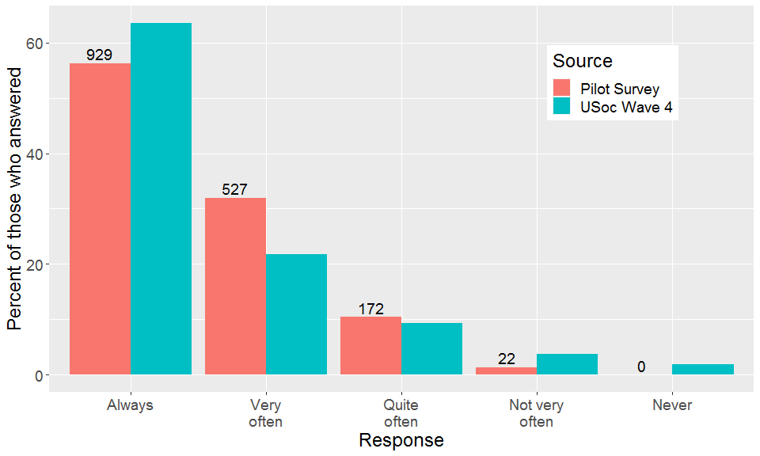

#### Put more clothes on when feeling cold rather than putting the heating on or turning it up?

19 participants did not answer this question, while 4 participants responded ‘Not applicable, cannot do this’. The other responses are shown in the figure below, which includes a comparison with the Understanding Society Wave 4 data.

Figure 9: How often do you personally put more clothes on when feeling cold rather than putting the heating on or turning it up? 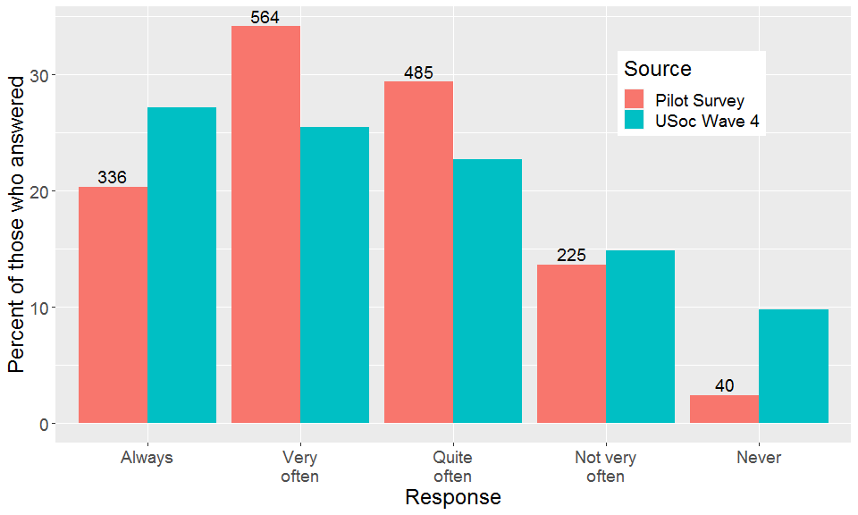

### A14: How much effort, if any, would you say your household makes to limit or reduce the amount of gas or electricity used?

*Tick one answer only*

17 participants did not answer this question. The figure below shows the results for those who did. Nearly half of respondents reported making some effort to limit/reduce energy consumption and nearly one quarter reported making a great deal of effort.

Figure 8: How often do you personally switch off lights in rooms that aren’t being used? 

### A15: How often will your household open the windows in your accommodation on the following types of days? On a typical cold day, on a typical warm day.

*Tick one answer for each column.*

33 participants did not respond about opening windows on cold days, 21 did not respond about opening windows on warm days.

Figure 11: How often windows are opened on a typical cold day 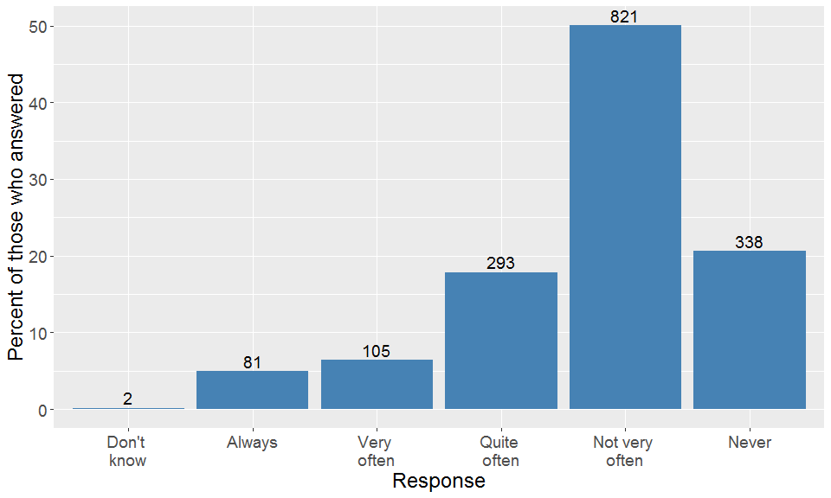

Figure 12: How often windows are opened on a typical warm day 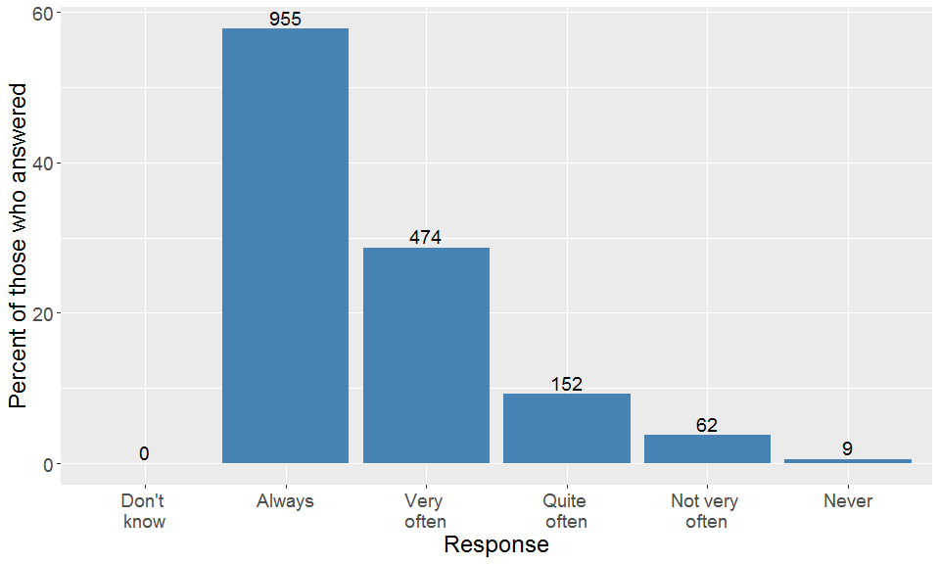

### A16: Which of the following, if any, is your household considering replacing or adding to your heating or energy supply in the next 12 months?

*Tick all that apply.*

Table 7: Number of responses to each option in A16 excluding ‘Other, please specify’

| Possible change | Number | Percent |
| --- | --- | --- |
| Not considering any changes | 1390 | 83.08 |
| Not applicable - cannot do this | 115 | 6.87 |
| Gas boiler | 61 | 3.65 |
| Solar panels for electricity | 37 | 2.21 |
| Solar water heating | 11 | 0.66 |
| Wood or solid fuel burning stove | 20 | 1.20 |
| Heat pump | 8 | 0.48 |
| Micro combined heat and power unit | 2 | 0.12 |
| Wind turbine | 2 | 0.12 |

In addition, 47 participants selected ‘Other, please specify’. What might be considered ‘valid’ responses included: electric shower, electric heater, oil boiler, wall-mounted energy efficient panel heater, new thermostat, battery storage and electric storage heater. Some responses focused on how the energy is consumed rather than generated, such as loft insulation, heated porch floors, heated towel rail, new fireplace for electric fire and smart radiator valves.

In addition, just under 10 took the opportunity to mention already having solar panels. Not all text was legible, and some was in Welsh (to be translated). Some mentioned changing supplier or tariff, some mentioned that they rent. Mentioning recent changes was also a popular comment.

## Section B Questions: “About your accommodation”

### B1: What type of accommodation do you live in?

*Tick one answer only*

21 participants did not answer this question. For those who did, we can compare their responses with the 2011 Census.

Figure 13: Responses to B1 compared with Census data. 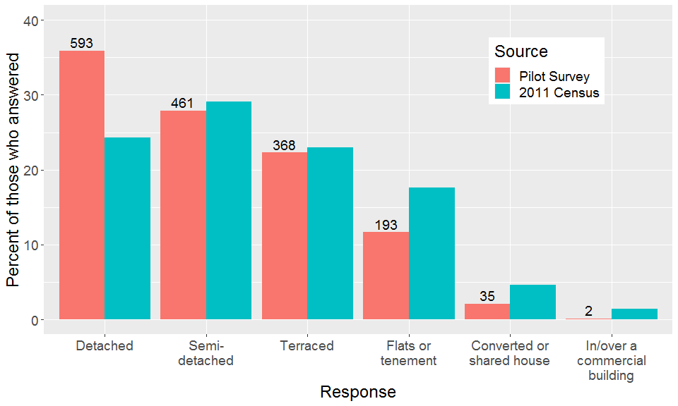

### B2: Is your accommodation self-contained?

*By this we mean that all the rooms, including the kitchen, bathroom and toilet, are behind a door that only your household can use. Tick one answer only.*

Table 8: Responses to B2. Note that the full ‘Yes’ option reads ‘Yes, all the rooms are behind a door that only my household can use’.

| Response | Number | Percent |
| --- | --- | --- |
| Yes | 1641 | 98.09 |
| No | 11 | 0.66 |
| No Answer | 21 | 1.26 |

### B3: How many other households do you share with at the moment?

*Write in number below. Not applicable to those who said their accommodation was self-contained.*

Surprisingly around 50 households responded to this question despite having answered that their accommodation was self-contained. Some had a very high number (in the tens), possibly relating to other flats in a building. These responses were removed to align with the online survey which automatically skips the question in this case. Despite 11 households reportedly living in non-self-contained accommodation, 6 went on to report sharing with no other households.

Table 9: Number of other households sharing the dwelling.

| Response | Number |
| --- | --- |
| Not applicable | 1642 |
| No answer | 20 |
| 0 | 6 |
| 1 | 3 |
| 3 | 2 |

### B4: Do you (or your household) own or rent this accommodation?

*Tick one answer only.*

Figure 14: Responses to B4. 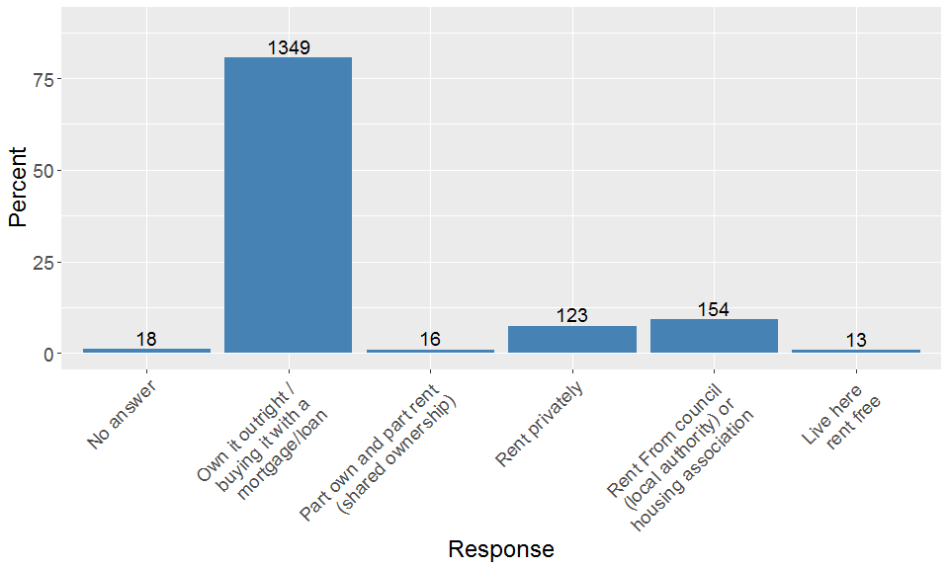

The Census and Understanding Society aggregate their data differently, so we’ve reduce our data to either owning (including part own and part rent) and renting (including living rent-free).

Figure 15: Comparing owning versus renting with Census and Understanding Society Wave 9 data. 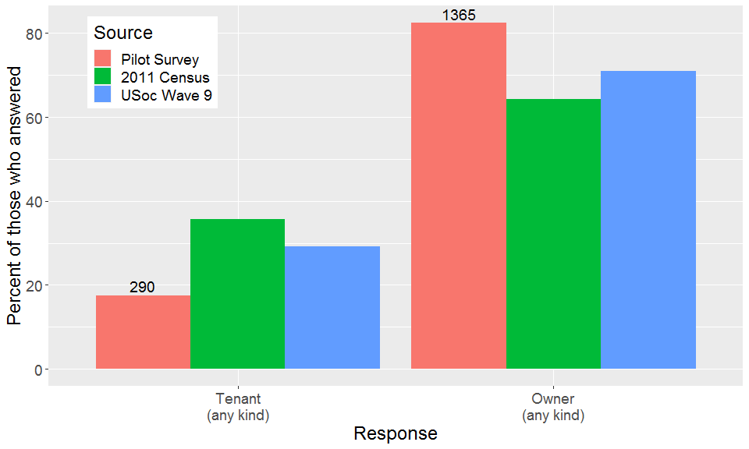

### B5: How many rooms are available for use only by this household?

*Do NOT count bathrooms, toilets, halls or landings, rooms that can only be used for storage such as cupboards. Count all other rooms, for example kitchens, living rooms, utility rooms, bedrooms, studies, conservatories. If two rooms have been converted into one, count them as one room. Write in number below.*

22 participants did not answer this question. 6 responses were deemed invalid due to reporting fewer rooms in B5 than bedrooms in question B6. One reported 0 rooms and this was cleaned to no response. The most number of rooms reported was 21.

Figure 16: Responses to B5 excluding no answer and invalid answers. 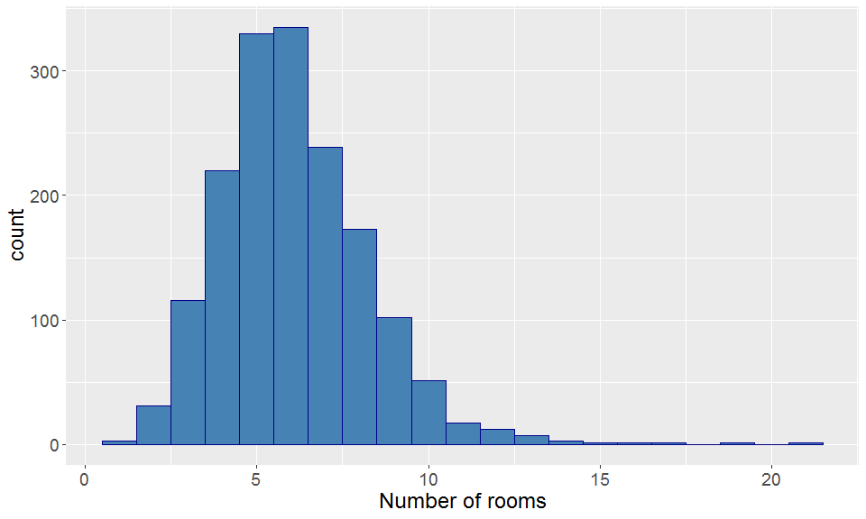

### B6: How many of these rooms are bedrooms?

*Include all rooms built or converted for use as bedrooms, even if they are not currently used as bedrooms. Write in number below.*

20 participants did not answer this question. Those 6 who had ‘invalid’ responses recorded for B5 also had their B6 responses recorded as invalid (more bedrooms than rooms). The most bedrooms recorded was 8. Anyone recording 0 bedrooms (2 participants) had their response changed to 1 bedroom as this is the approach taken in the Census.

Figure 17: Responses to B6 excluding no answer and invalid answers. 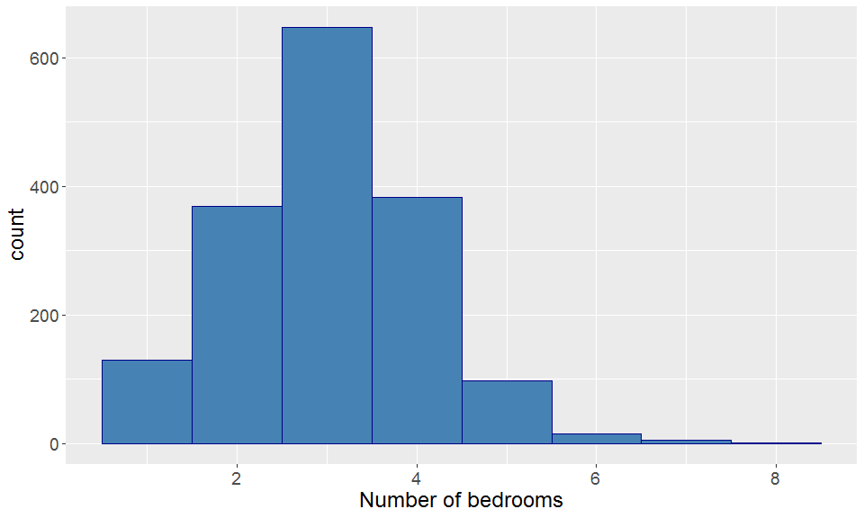

### B7: During the cold winter weather, can you normally keep comfortably warm in your living room?

*Tick one answer only.*

Table 10 shows the responses to this question. Of those who answered yes or no, 93.7% answered yes, only a little lower than the Understanding Society sample, of which 95.7% answered yes.

Table 10: Responses to question B7.

| Response | Number | Percent |
| --- | --- | --- |
| Yes | 1567 | 93.66 |
| No | 61 | 3.65 |
| Don't know | 20 | 1.20 |
| No answer | 25 | 1.49 |

### B8: Do you have any problems with condensation, damp or mould in your home?

*Tick one answer only.*

This question was also asked in the 2017 English Housing Survey (EHS). 3.8% of their sample reported problems with condensation, damp or mould (percentage includes non-response etc.), much lower than our 18.5%. The EHS is a face-to-face survey, so it is possible that the assessor talked to the participant about what constitutes a problem with damp or mould and discounted issues that people report on a self-completion survey, but this is only a hypothesis.

Table 11: Responses to question B8.

| Response | Number | Percent |
| --- | --- | --- |
| Yes | 309 | 18.47 |
| No | 1306 | 78.06 |
| Don't know | 34 | 2.03 |
| No answer | 24 | 1.43 |

### B9: Approximately when do you think your accommodation was built?

*Tick one answer only.*

Figure 18: Response to B9. 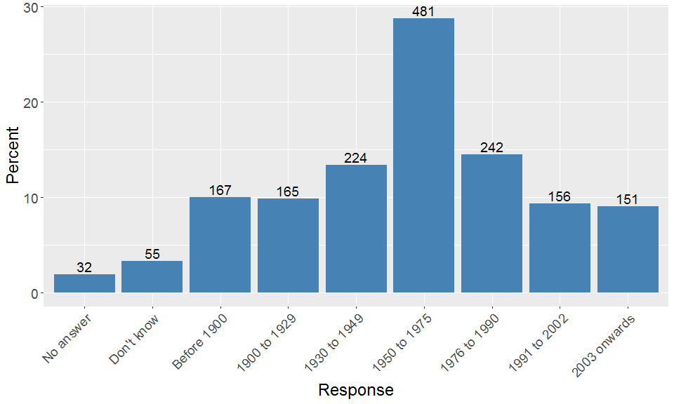

### B10: Can we check if you have any of the following appliances in your accommodation?

*Tick all that apply.*

Table 12: Appliance ownership.

| Appliance | Number | Percent |
| --- | --- | --- |
| Electric oven | 1355 | 80.99 |
| Gas oven | 327 | 19.55 |
| Electric hob | 666 | 39.81 |
| Gas hob | 836 | 49.97 |
| Dishwasher | 1000 | 59.77 |
| Fridge or combined fridge freezer | 1610 | 96.23 |
| Separate stand-alone freezer | 659 | 39.39 |
| Combined clothes washer dryer | 229 | 13.69 |
| Washing machine | 1395 | 83.38 |
| Tumble dryer | 800 | 47.82 |
| Laptop/computer | 1448 | 86.55 |
| TV | 1592 | 95.16 |
| Air conditioning unit | 62 | 3.71 |
| Cooling fan | 637 | 38.08 |

## Section C questions

### C1: How many people currently live in your household, including you?

*Please include all those who are there regularly, even if not every day, including children who live away from home during term time. Write in number below.*

29 participants did not answer this question. The responses are shown in the plot below. The most occupants reported was 9 (reported by 1 household).

Figure 19: Number of occupants 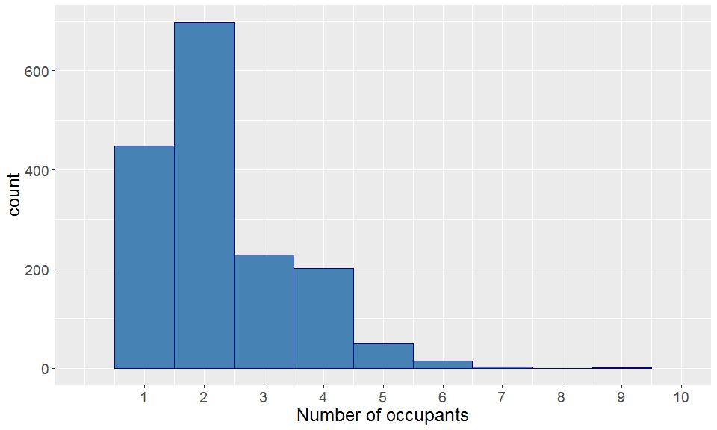

### C2: Including you, how many males and females are there in each of the following age groups in your household?

*Write in numbers below for each (if there is nobody in a category you can leave it blank).*

There are many ways of summarising this data. Three tables are presented, describing the number of children, number of adults and number of people in the 65+ yrs category. This question has more data quality issues than other questions, for example, 12 households report having no one aged 16+, yet clearly this cannot be the case.

The average number of males per household is 1.09 and the average number of females is 1.11.

Table 13: Number of children (under 16yrs) in each household.

| Number of children | Number | Percent |
| --- | --- | --- |
| No answer | 68 | 4.06 |
| 0 | 1296 | 77.47 |
| 1 | 150 | 8.97 |
| 2 | 136 | 8.13 |
| 3 | 15 | 0.90 |
| 4 | 7 | 0.42 |
| 5 | 1 | 0.06 |

Table 14: Number of adults (16+ yrs) in each household.

| Number of adults | Number | Percent |
| --- | --- | --- |
| No answer | 68 | 4.06 |
| 0 | 12 | 0.72 |
| 1 | 443 | 26.48 |
| 2 | 873 | 52.18 |
| 3 | 189 | 11.30 |
| 4 | 70 | 4.18 |
| 5 | 16 | 0.96 |
| 6 | 1 | 0.06 |
| 7 | 1 | 0.06 |

Table 15: Number of people aged 65+ in each household.

| Number aged 65+ yrs | Number | Percent |
| --- | --- | --- |
| No answer | 80 | 4.78 |
| 0 | 842 | 50.33 |
| 1 | 422 | 25.22 |
| 2 | 325 | 19.43 |
| 3 | 4 | 0.24 |

### C3: Thinking about the working situation of each member of your household aged 16 and over, including you, how many would you say fall into each category below?

*Write in numbers below for each row (if there is nobody in a category you can leave it blank).*

This question also had more data quality issues than most. Some errors were easy to correct, such as the number of hours worked per week given instead of the number of people working 30+ hours. Or double-tapping a number key. The sum of people reported in this question was compared with the number of occupants stated in C1.

Table 16 shows the number of households reporting each number of occupants by working status. For example, 851 households do not have anyone working more than 30 hours per week. One household has 5 occupants who are all students.

Table 16: Number of households with each number of people reported in each working status category. 76 did not respond with any status, 70 responses were classed as errors.

| Employment status | 0 | 1 | 2 | 3 | 4 | 5 |
| --- | --- | --- | --- | --- | --- | --- |
| Working (paid or unpaid): 30 hours a week or more | 851 | 380 | 319 | 41 | 12 | 1 |
| Working (paid or unpaid): less than 30 hours a week | 1319 | 261 | 23 | 1 | 0 | 0 |
| Not working because of long term sickness or disability | 1536 | 61 | 7 | 0 | 0 | 0 |
| Unemployed but seeking work | 1574 | 29 | 1 | 0 | 0 | 0 |
| Student | 1478 | 91 | 30 | 3 | 1 | 1 |
| Retired/at home/not seeking work* | 818 | 436 | 347 | 3 | 0 | 0 |
| Other | 1585 | 18 | 1 | 0 | 0 | 0 |

*(including looking after the home or family)

### C4: Including you, how many people in your household hold a degree (e.g. BA, BSc) or higher qualification (e.g. MA, PhD, PGCE)?

*Write in number below (if nobody has this qualification you can write in zero).*

Two households reported data deemed invalid (with 4 and 7 qualified people respectively, greater than the number of occupants). This indicates that other data may be invalid that is not clear from the data, such as writing the number of qualifications of one person, rather than the number of qualified people.

Figure 20: Number of households with each number of qualified people. 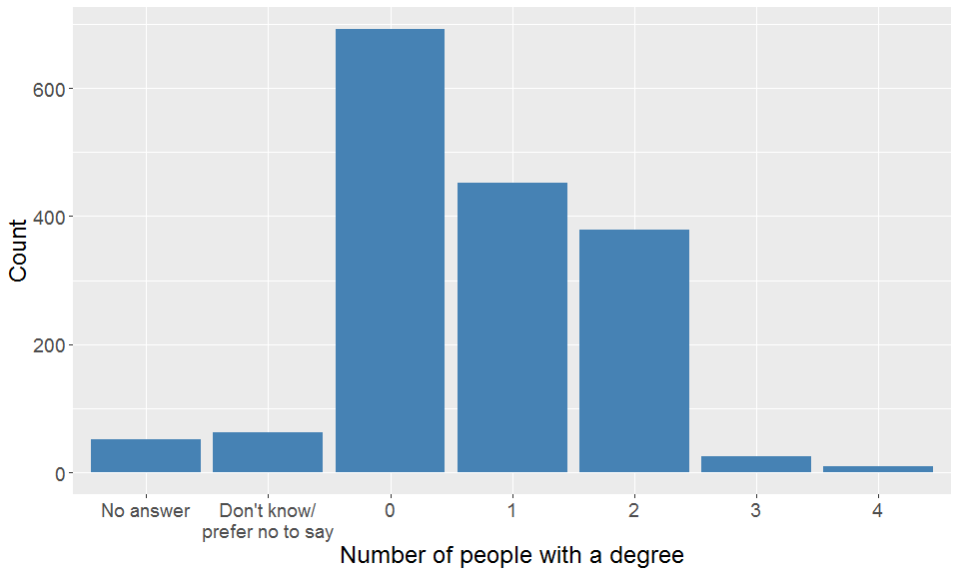

### C5: Does your household have a plug-in electric vehicle?

*This does not include hybrid cars which are not plugged-in to charge. Tick one answer only.*

Table 17: Presence of a plug-in electric vehicle.

| Response | Number | Percent |
| --- | --- | --- |
| Yes | 44 | 2.63 |
| No | 1601 | 95.70 |
| Don't know | 1 | 0.06 |
| No answer | 27 | 1.61 |

### C6: When does your household tend to charge your electric vehicle at home?

*Not applicable if respondent answered ‘no’ or ‘don’t know’ to C5 (do you have a plug-in electric vehicle). Tick one answer only.*

Figure 21: Charging times for plug-in electric vehicles. 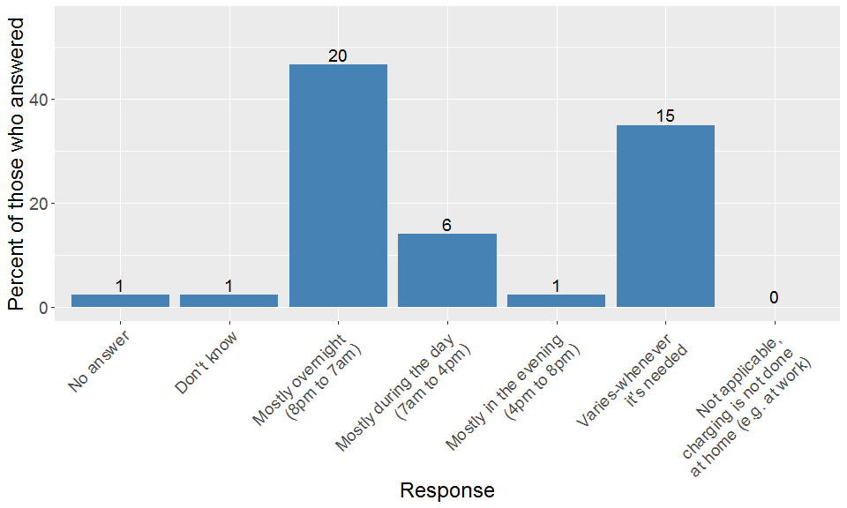

## Section D Questions: “About you”

Single-occupancy households could skip questions D1 - D3 as the information had been previously collected.

### D1: Which of these age groups do you fall into?

*Tick one answer only.*

The data for this question includes data provided by single-occupancy households to question C2 where available.

Figure 22: Age of survey respondent. 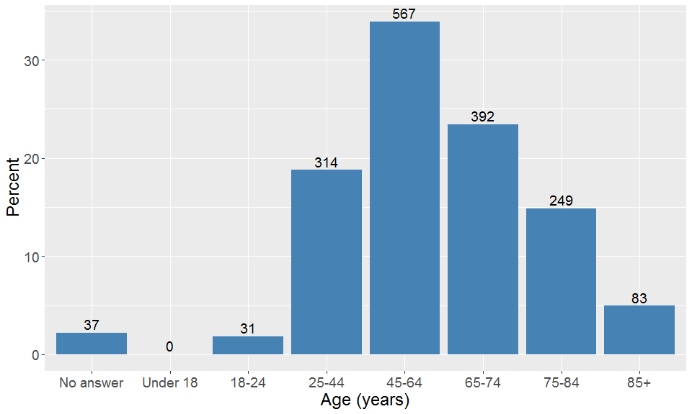

### D2: Which of the following best describes how you think of yourself?

*Tick one answer only*

This data includes the male/female answer provided in C2 for single-occupancy households (if they did not answer D2). Note that the online survey automatically skipped D2 for single-occupancy. Where this data was missing or invalid and no response was given for D2, this is recorded as ‘no response’ here. Males were more likely to be the person completing the survey than females, despite there being slightly more females in the sample (1826 females compared to 1786 males - excluding missing and invalid responses to question C2).

Figure 23: Gender reporting of survey respondent. 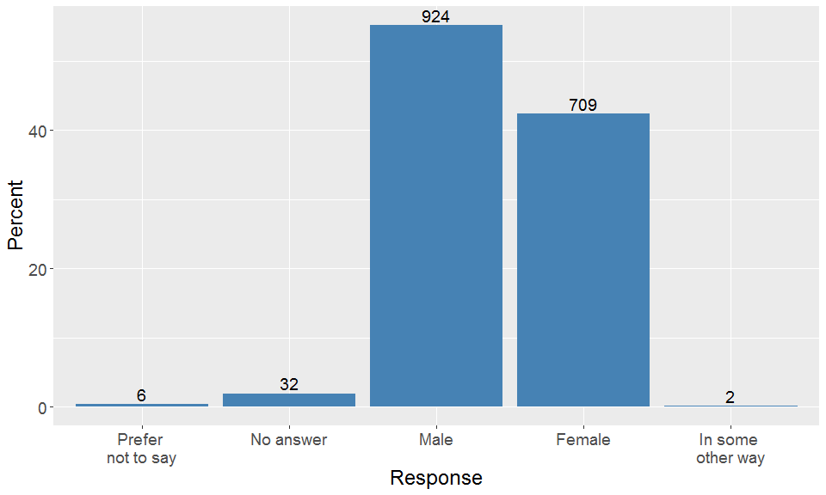

### D3: Which best describes your current employment situation?

*Tick one answer only.*

Figure 24: Employment situation reporting of survey respondent. 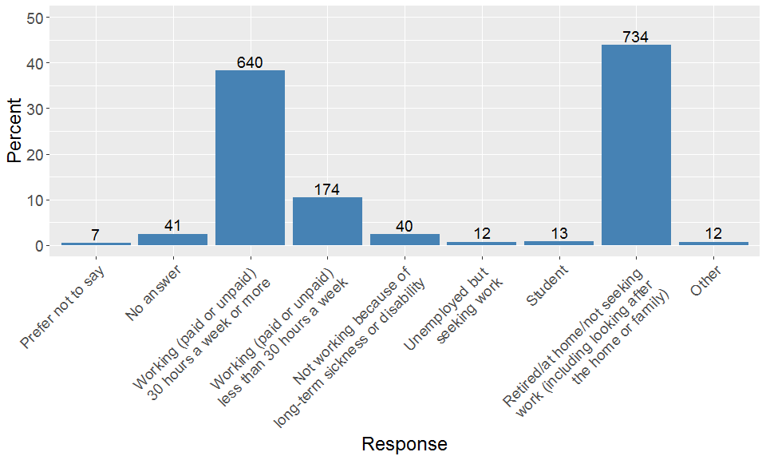

### D4: How well would you say you are managing financially these days?

*Tick one answer only. Would you say you are…*

Figure 25: How well would you say you yourself are managing financially? 