Norms/Exp1 bias-removed serial dependence (DoG) report
Generated at: 2026-02-05 01:15:33

Analysis parameters
k_values: [1, 2, 3, 5, -1, -2, -3, -5]
n_permutations: 1000
random_seed: 123
bias_method: knn_kernel

Overview (k=1)
run_tag | mode | stimulus_source | dimension | model | which | n_words | half_amp(k=1) | p(k=1) | match_rate
20251212_203849_both_valence_n400 | exp1 | exp1_mean | valence | gpt-4o | both | 400 | 3.60695 | 0.00599401 | 1
20251212_203849_both_valence_n400 | norms | warriner_norms | valence | gpt-4o | both | 400 | 1.30163 | 0.619381 | 0.318
20251212_203916_both_arousal_n400 | exp1 | exp1_mean | arousal | gpt-4o | both | 400 | 2.47058 | 0.0739261 | 1
20251212_203916_both_arousal_n400 | norms | warriner_norms | arousal | gpt-4o | both | 400 | 6.15766 | 0.046953 | 0.318
20251213_010833_both_arousal_n400 | exp1 | exp1_mean | arousal | gpt-4o | both | 400 | 6.35896 | 0.003996 | 1
20251213_010833_both_arousal_n400 | norms | warriner_norms | arousal | gpt-4o | both | 400 | 2.4066 | 0.346653 | 0.318
20251213_133659_both_concreteness_n400 | norms | warriner_norms | concreteness | deepseek-r1-0528 | both | 400 | 19.4116 | 0.034965 | 0.318
20251213_133742_both_concreteness_n400 | norms | warriner_norms | concreteness | gemini-2.0-flash | both | 400 | 24.7452 | 0.033966 | 0.318
20251217_213039_both_concreteness_n400 | norms | warriner_norms | concreteness | gemini-2.0-flash | both | 400 | 24.3048 | 0.035964 | 0.318
20251218_170111_both_concreteness_n400 | norms | warriner_norms | concreteness | claude-sonnet-4-5-20250929-cc | both | 400 | 2.84854 | 0.74026 | 0.318
20251218_170152_both_concreteness_n400 | norms | warriner_norms | concreteness | qwen-max-latest | both | 400 | 13.4366 | 0.107892 | 0.318
20251218_193433_both_concreteness_n400 | norms | warriner_norms | concreteness | gemini-2.5-flash | both | 400 | 19.9796 | 0.0599401 | 0.318
20251221_131659_both_concreteness_n400 | exp1 | exp1_mean | concreteness | gpt-4o-mini | both | 400 | 0.95089 | 0.649351 | 1
20251221_131659_both_concreteness_n400 | norms | warriner_norms | concreteness | gpt-4o-mini | both | 400 | 25.7649 | 0.021978 | 0.318
20251221_135907_both_concreteness_n400 | exp1 | exp1_mean | concreteness | gpt-4o-mini | both | 400 | 1.84518 | 0.260739 | 1
20251221_135907_both_concreteness_n400 | norms | warriner_norms | concreteness | gpt-4o-mini | both | 400 | 24.6658 | 0.030969 | 0.318
20251221_135911_both_arousal_n400 | exp1 | exp1_mean | arousal | gpt-4o-mini | both | 400 | 0.879054 | 0.47952 | 1
20251221_135911_both_arousal_n400 | norms | warriner_norms | arousal | gpt-4o-mini | both | 400 | 0.476417 | 0.942058 | 0.318
20251221_144236_both_concreteness_n400 | norms | warriner_norms | concreteness | gpt-4.1 | both | 400 | 25.5931 | 0.026973 | 0.318
20251221_144304_both_arousal_n400 | norms | warriner_norms | arousal | gpt-4.1 | both | 400 | 0.223982 | 0.985015 | 0.318
20251221_172610_both_concreteness_n400 | exp1 | exp1_mean | concreteness | gpt-4o | both | 400 | 1.50394 | 0.123876 | 1
20251221_172610_both_concreteness_n400 | norms | warriner_norms | concreteness | gpt-4o | both | 400 | 19.0067 | 0.045954 | 0.318
20251224_103903_gpt-4o_exp2_concreteness_n1000 | norms | warriner_norms | concreteness | gpt-4o | exp2 | 1000 | 9.82081 | 0.026973 | 0.337
20260107_145719_gpt-4o_both_concreteness_n2000 | exp1 | exp1_mean | concreteness | gpt-4o | both | 2000 | 1.82271 | 0.00599401 | 1
20260107_145719_gpt-4o_both_concreteness_n2000 | norms | warriner_norms | concreteness | gpt-4o | both | 2000 | 5.61659 | 0.0549451 | 0.336
20260112_001408_gpt-4o_both_concreteness_n1000 | exp1 | exp1_mean | concreteness | gpt-4o | both | 1000 | 1.4986 | 0.0549451 | 1
20260112_001408_gpt-4o_both_concreteness_n1000 | norms | warriner_norms | concreteness | gpt-4o | both | 1000 | 2.00226 | 0.591409 | 0.333
20260113_162650_gpt-4o_both_concreteness_n1000 | exp1 | exp1_mean | concreteness | gpt-4o | both | 1000 | 1.82026 | 0.046953 | 1
20260113_162650_gpt-4o_both_concreteness_n1000 | norms | warriner_norms | concreteness | gpt-4o | both | 1000 | 0.854998 | 0.848152 | 0.316
20260122_222005_gpt-4o_both_concreteness_n1000 | exp1 | exp1_mean | concreteness | gpt-4o | both | 1000 | 0.812269 | 0.342657 | 1
20260122_222005_gpt-4o_both_concreteness_n1000 | norms | warriner_norms | concreteness | gpt-4o | both | 1000 | 2.49197 | 0.634366 | 0.333
20260126_174821_gpt-4o_exp2_concreteness_n2000 | norms | warriner_norms | concreteness | gpt-4o | exp2 | 2000 | 2.66041 | 0.406593 | 0.33
20260126_174922_gpt-4o_exp2_valence_n1000 | norms | warriner_norms | valence | gpt-4o | exp2 | 1000 | 1.09993 | 0.518482 | 0.339
20260126_192052_gpt-4o_exp2_concreteness_n1000 | norms | warriner_norms | concreteness | gpt-4o | exp2 | 1000 | 0.84742 | 0.884116 | 0.357
20260127_225919_gpt-4o_exp2_concreteness_n1000 | norms | warriner_norms | concreteness | gpt-4o | exp2 | 1000 | 4.77728 | 0.197802 | 0.346
20260127_230016_gpt-4o_exp2_valence_n1000 | norms | warriner_norms | valence | gpt-4o | exp2 | 1000 | 0.0972654 | 0.987013 | 0.327
20260128_002209_gpt-4o_exp2_valence_n1000 | norms | warriner_norms | valence | gpt-4o | exp2 | 1000 | 2.11447 | 0.195804 | 0.338
20260128_002256_gpt-4o_exp2_concreteness_n1000 | norms | warriner_norms | concreteness | gpt-4o | exp2 | 1000 | 0.402068 | 0.966034 | 0.311
20260129_145137_gpt-4o_both_valence_n1000 | exp1 | exp1_mean | valence | gpt-4o | both | 1000 | 2.84859 | 0.001998 | 1
20260129_145137_gpt-4o_both_valence_n1000 | norms | warriner_norms | valence | gpt-4o | both | 1000 | 1.03297 | 0.507493 | 0.347
20260202_004249_gpt-4o_exp2_valence_n1000 | norms | warriner_norms | valence | gpt-4o | exp2 | 1000 | 2.03639 | 0.016983 | 1
20260202_005410_gpt-4o_exp2_valence_n1000 | norms | warriner_norms | valence | gpt-4o | exp2 | 1000 | 0.242878 | 0.833167 | 1
20260202_114143_gpt-4o_exp2_valence_n1000 | norms | warriner_norms | valence | gpt-4o | exp2 | 1000 | 2.092 | 0.012987 | 1
20260202_121450_gpt-4o_exp2_valence_n1000 | norms | warriner_norms | valence | gpt-4o | exp2 | 1000 | 0.918106 | 0.196803 | 1
20260202_124834_gpt-4o_exp2_valence_n1000 | norms | warriner_norms | valence | gpt-4o | exp2 | 1000 | 1.08226 | 0.136863 | 1

20251212_203849_both_valence_n400

Mode: exp1 (stimulus=exp1_mean)
model: gpt-4o
which: both
dimension: valence
uses_warriner_word_source: False
n_words: 400
match_rate_vs_exp2: 1
k=1 half_amp: 3.60695
k=1 sigma: 200
k=1 p (permutation): 0.00599401
best p over ks: 0.00599401 (k=1)
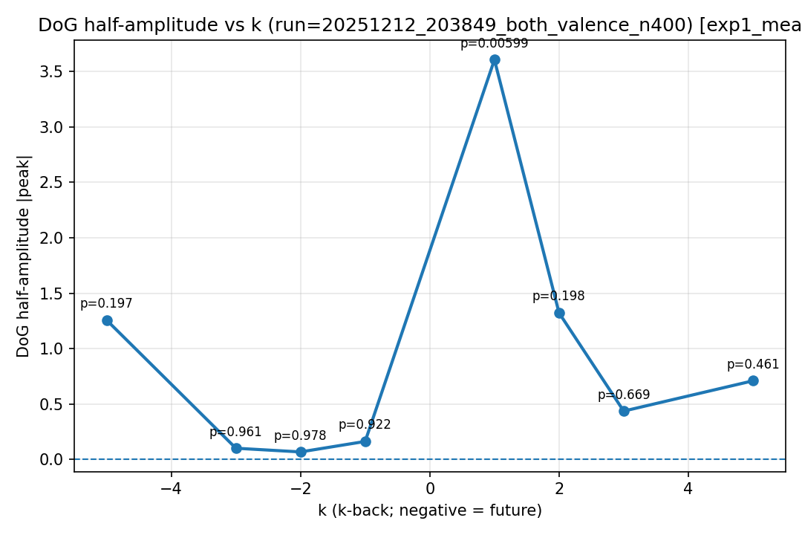
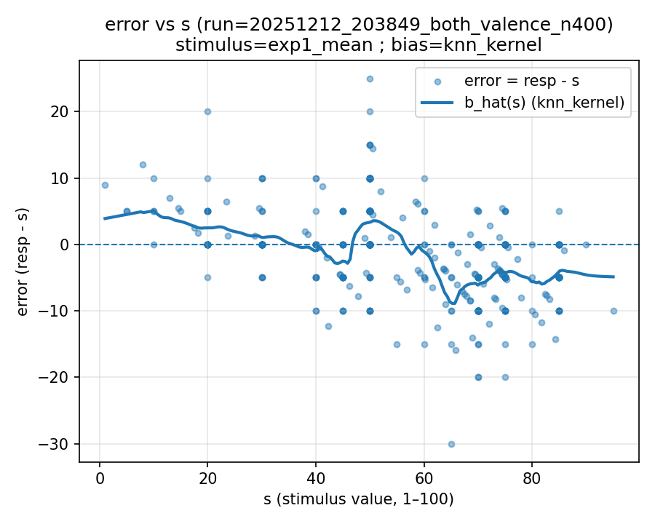 | 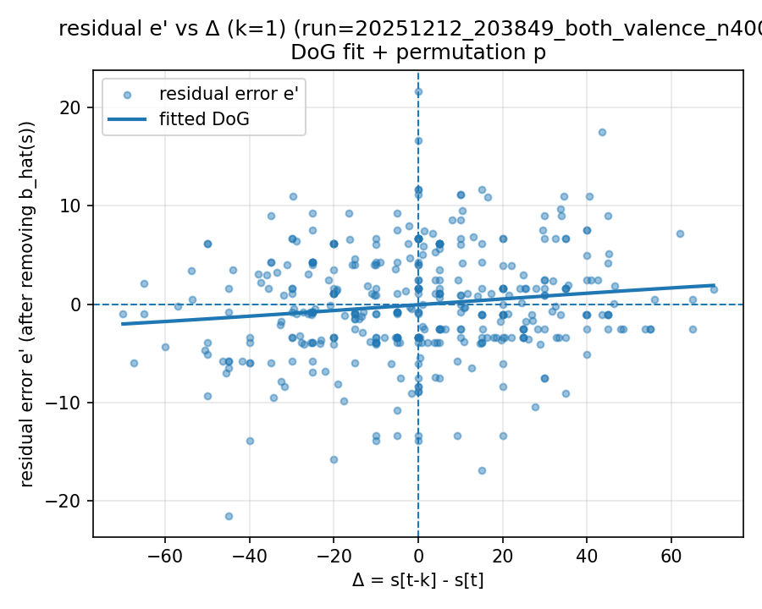 | 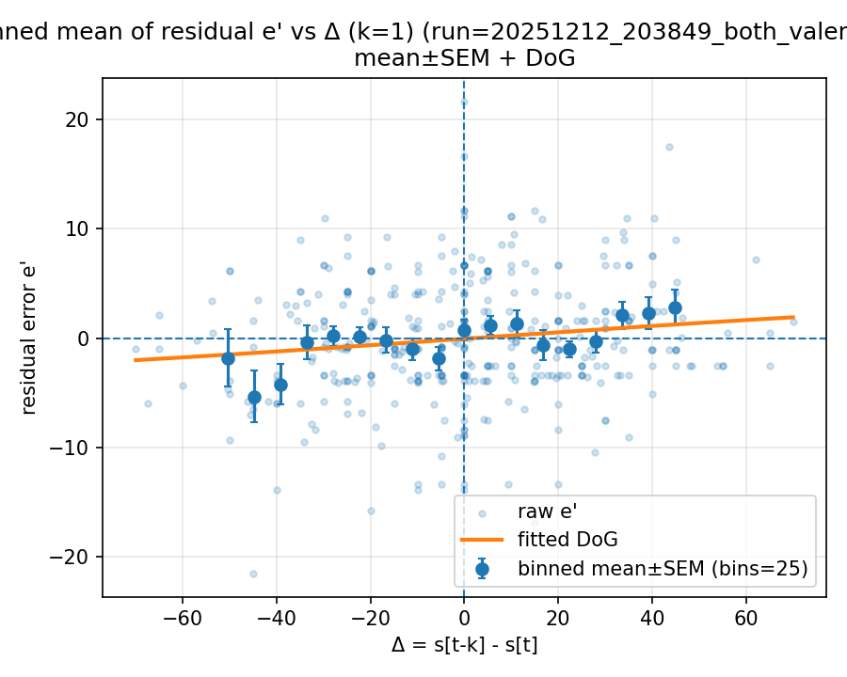

Mode: norms (stimulus=warriner_norms)
model: gpt-4o
which: both
dimension: valence
uses_warriner_word_source: False
n_words: 400
match_rate_vs_exp2: 0.3175
k=1 half_amp: 1.30163
k=1 sigma: 8.79369
k=1 p (permutation): 0.619381
best p over ks: 0.041958 (k=-5)
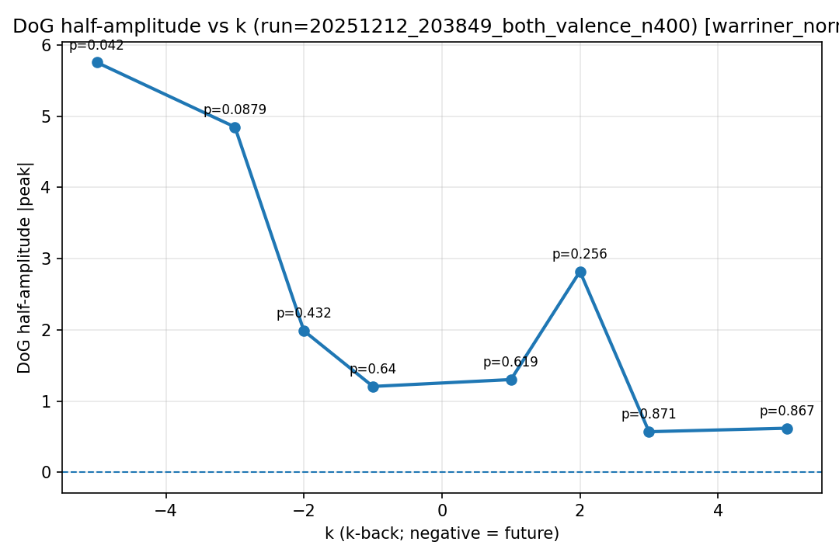
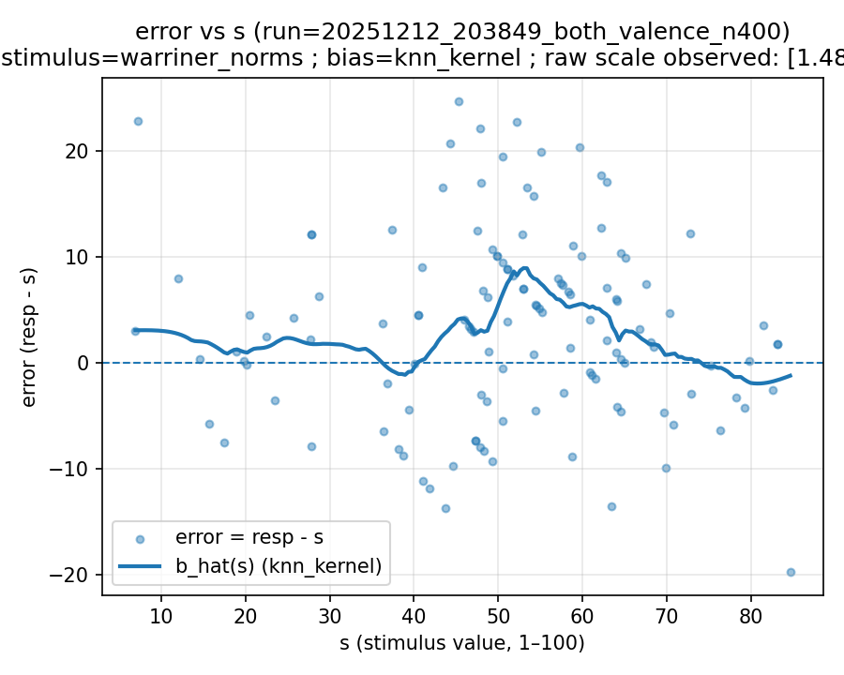 | 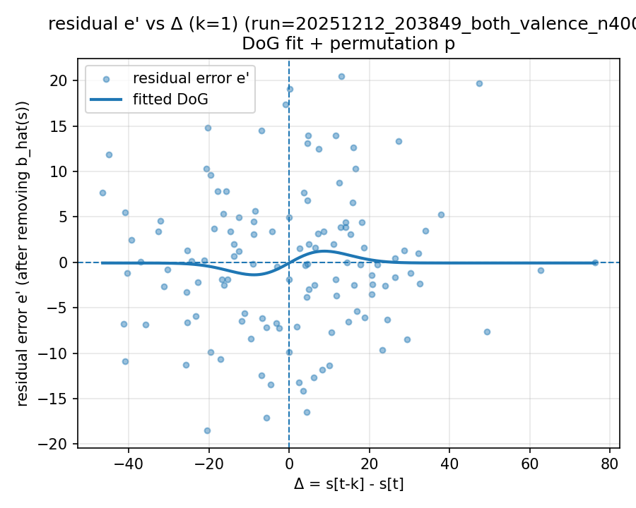 | 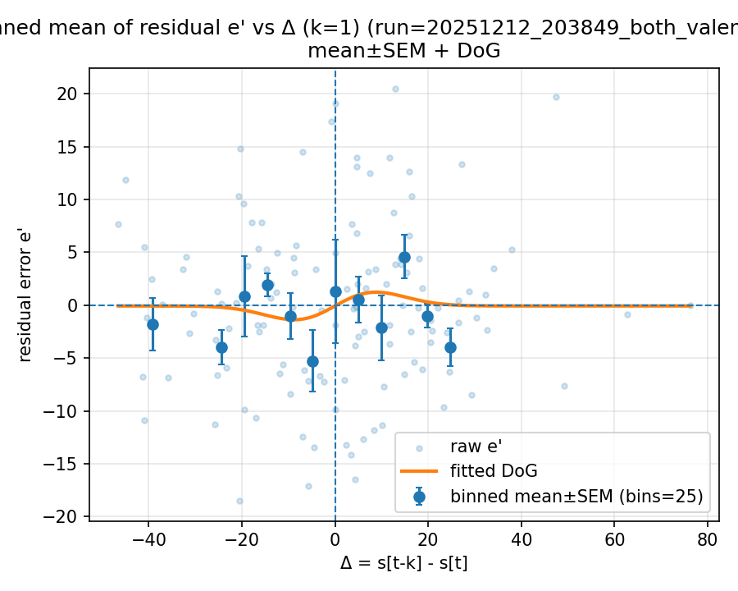

20251212_203916_both_arousal_n400

Mode: exp1 (stimulus=exp1_mean)
model: gpt-4o
which: both
dimension: arousal
uses_warriner_word_source: False
n_words: 400
match_rate_vs_exp2: 1
k=1 half_amp: 2.47058
k=1 sigma: 200
k=1 p (permutation): 0.0739261
best p over ks: 0.027972 (k=3)
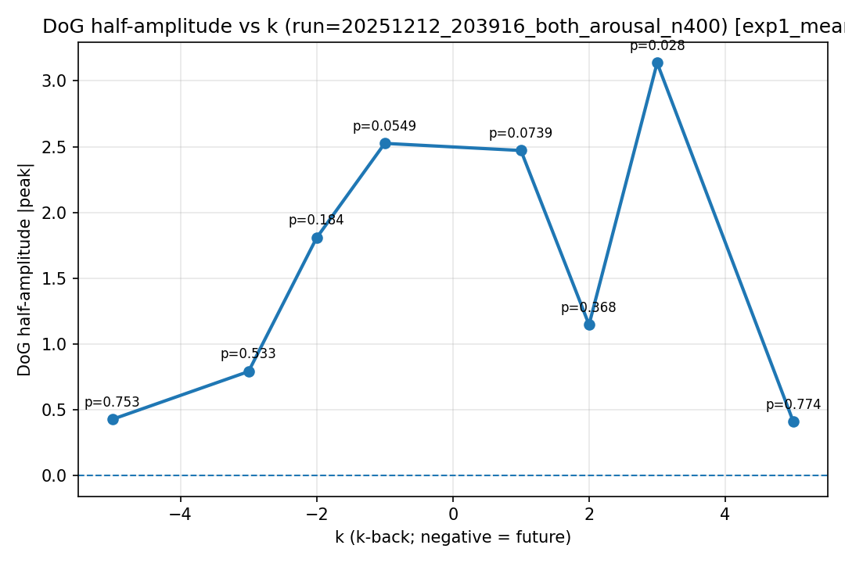
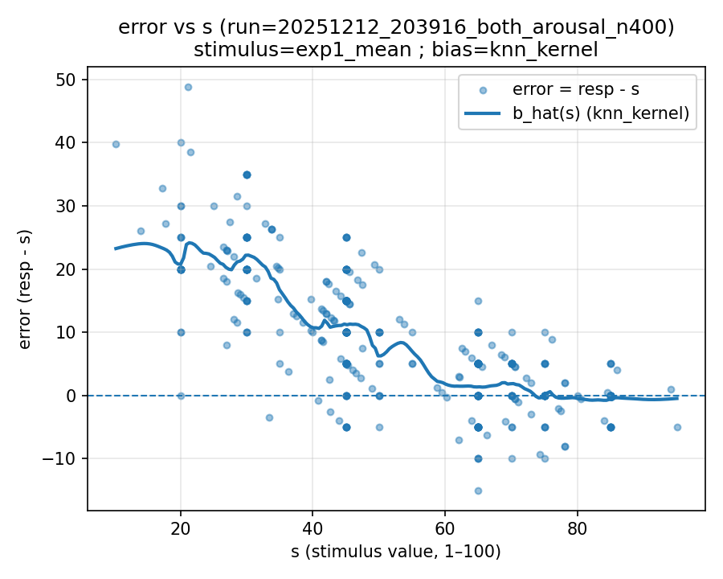 | 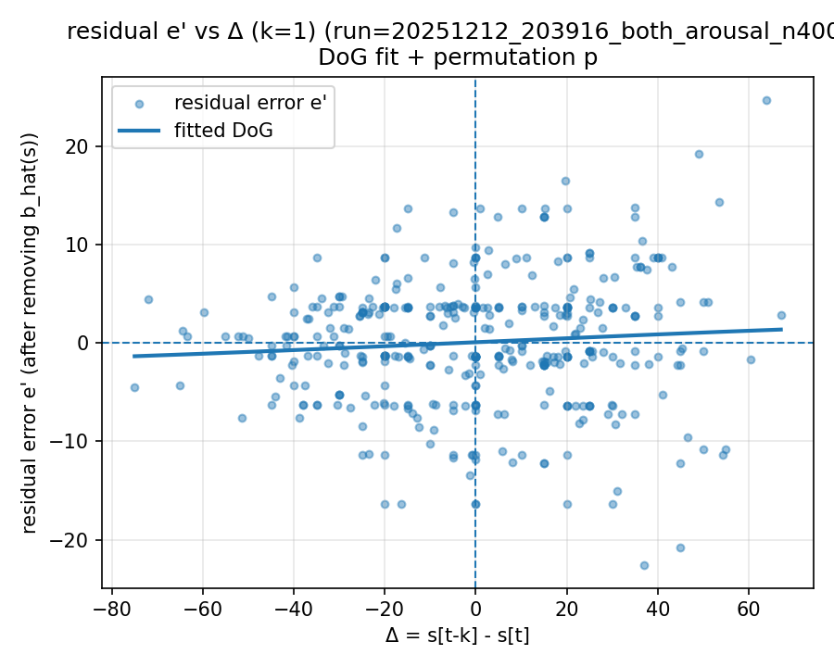 | 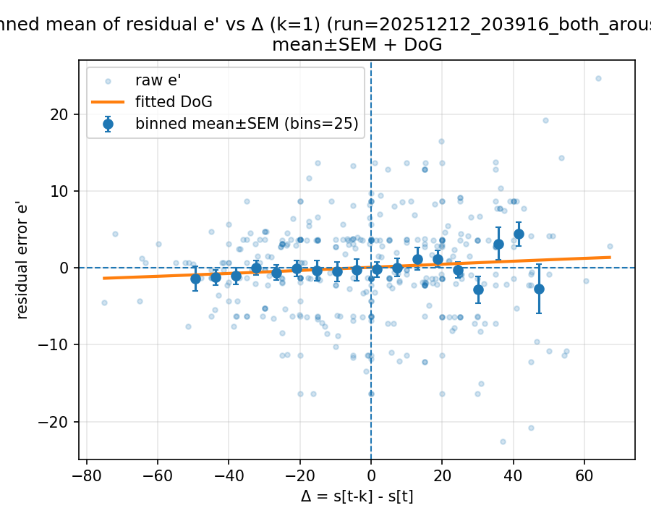

Mode: norms (stimulus=warriner_norms)
model: gpt-4o
which: both
dimension: arousal
uses_warriner_word_source: False
n_words: 400
match_rate_vs_exp2: 0.3175
k=1 half_amp: 6.15766
k=1 sigma: 200
k=1 p (permutation): 0.046953
best p over ks: 0.046953 (k=1)
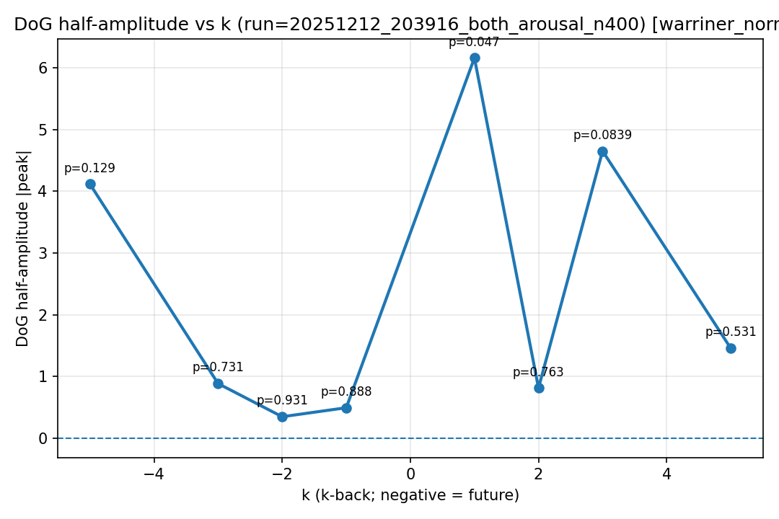
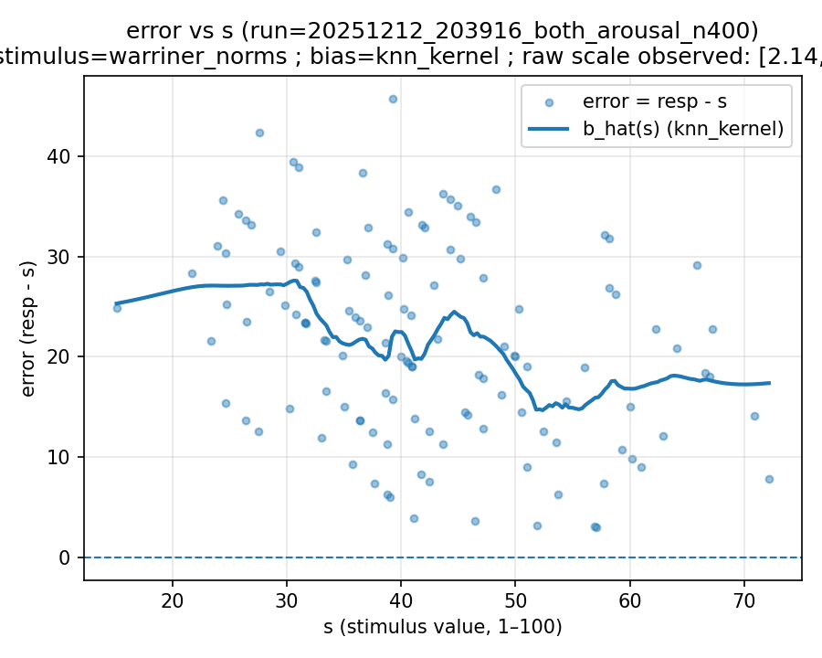 | 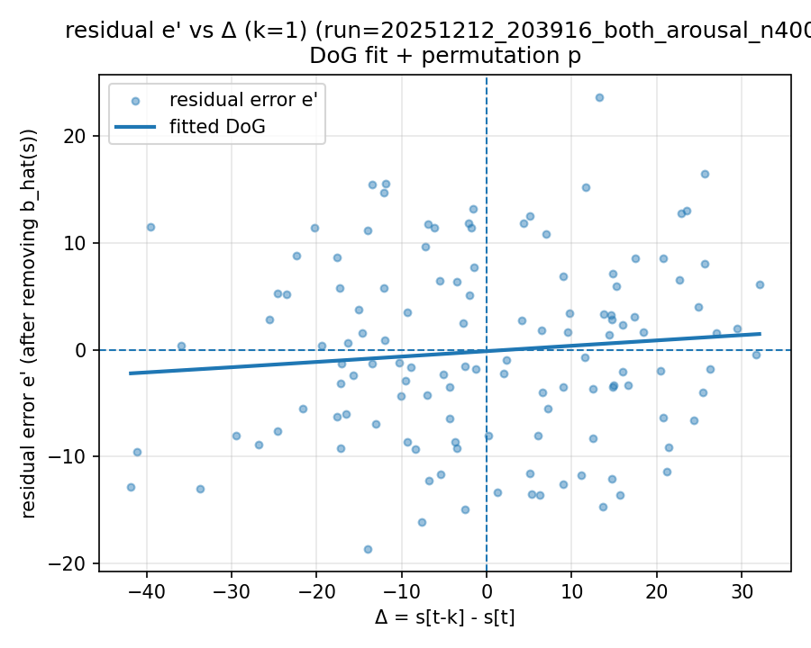 | 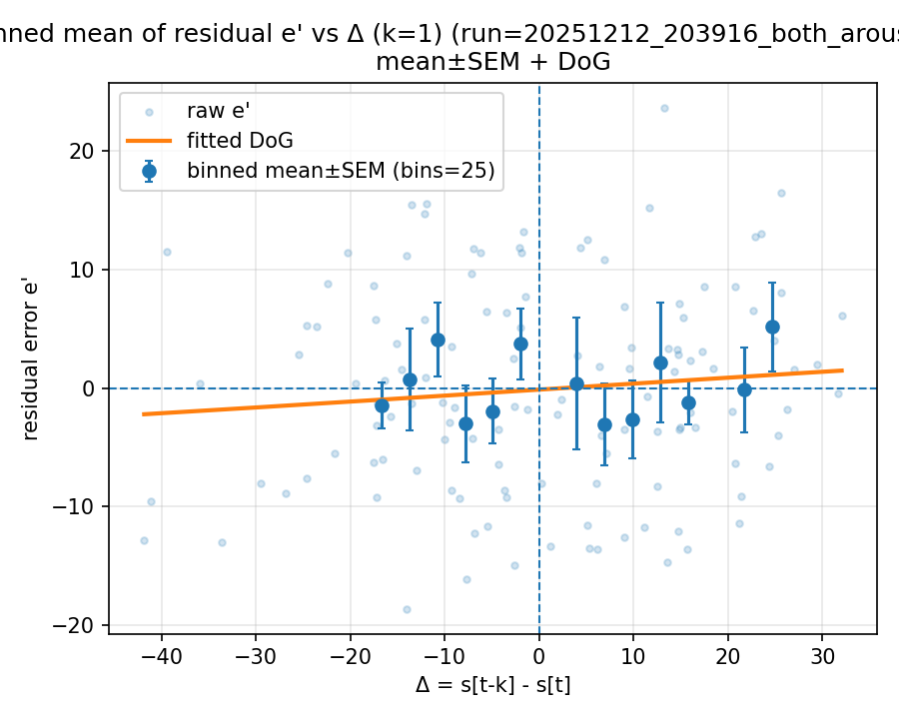

20251213_010833_both_arousal_n400

Mode: exp1 (stimulus=exp1_mean)
model: gpt-4o
which: both
dimension: arousal
uses_warriner_word_source: False
n_words: 400
match_rate_vs_exp2: 1
k=1 half_amp: 6.35896
k=1 sigma: 200
k=1 p (permutation): 0.003996
best p over ks: 0.003996 (k=1)
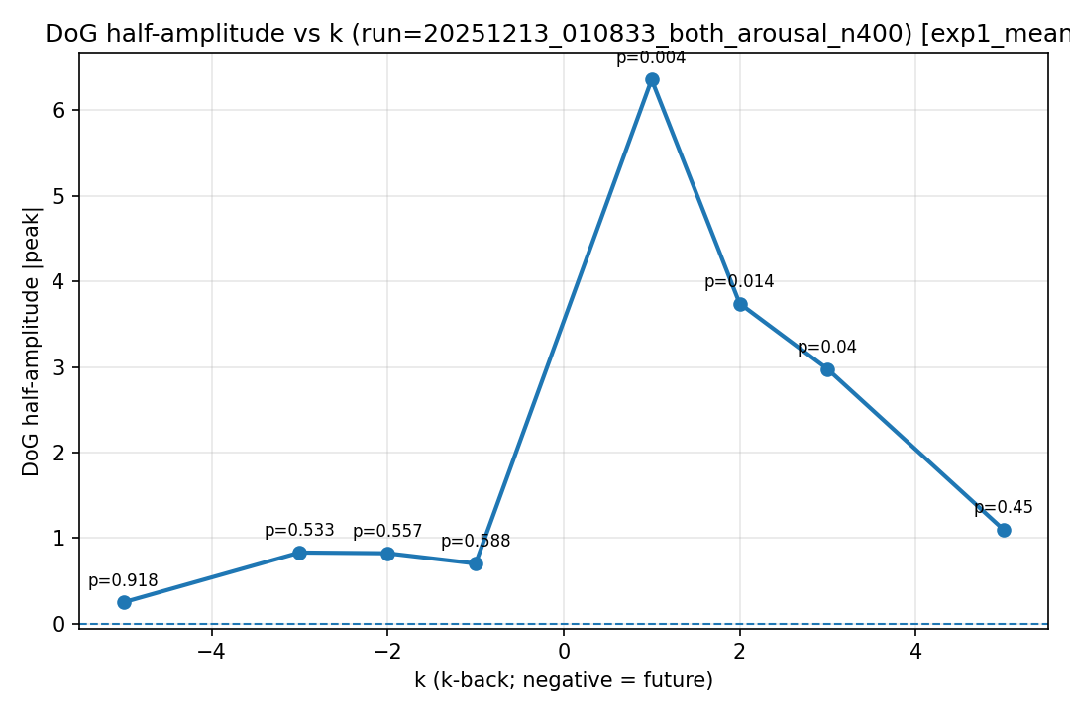
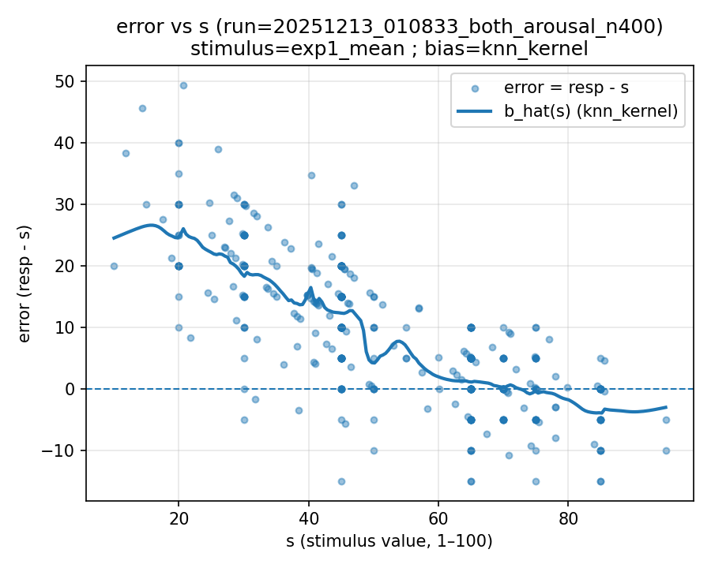 | 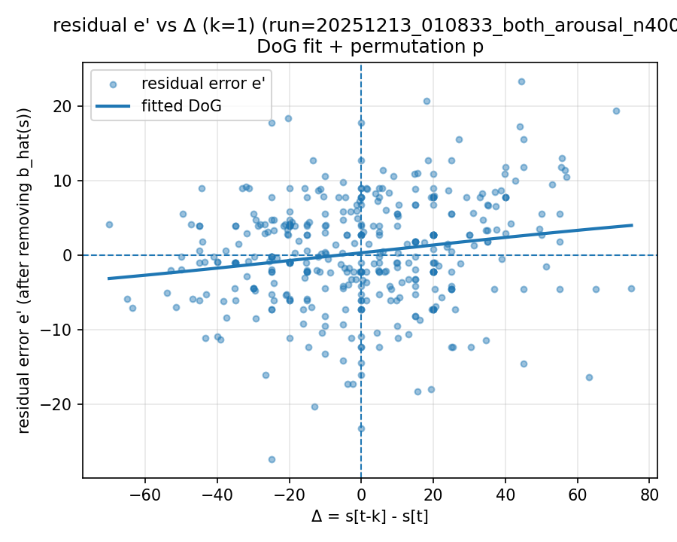 | 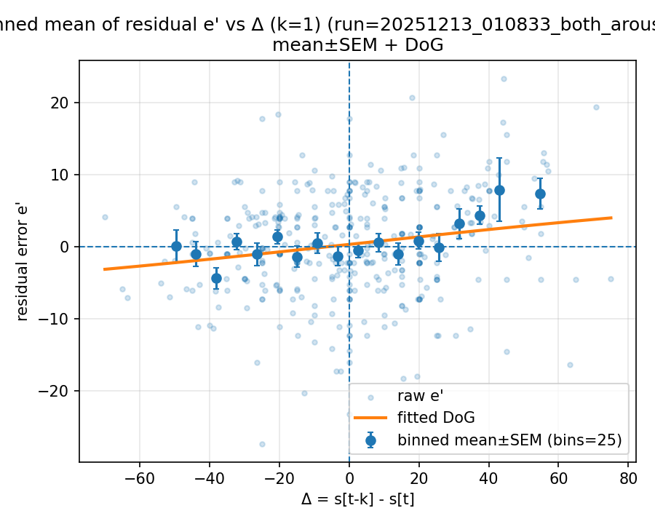

Mode: norms (stimulus=warriner_norms)
model: gpt-4o
which: both
dimension: arousal
uses_warriner_word_source: False
n_words: 400
match_rate_vs_exp2: 0.3175
k=1 half_amp: 2.4066
k=1 sigma: 42.534
k=1 p (permutation): 0.346653
best p over ks: 0.0949051 (k=2)
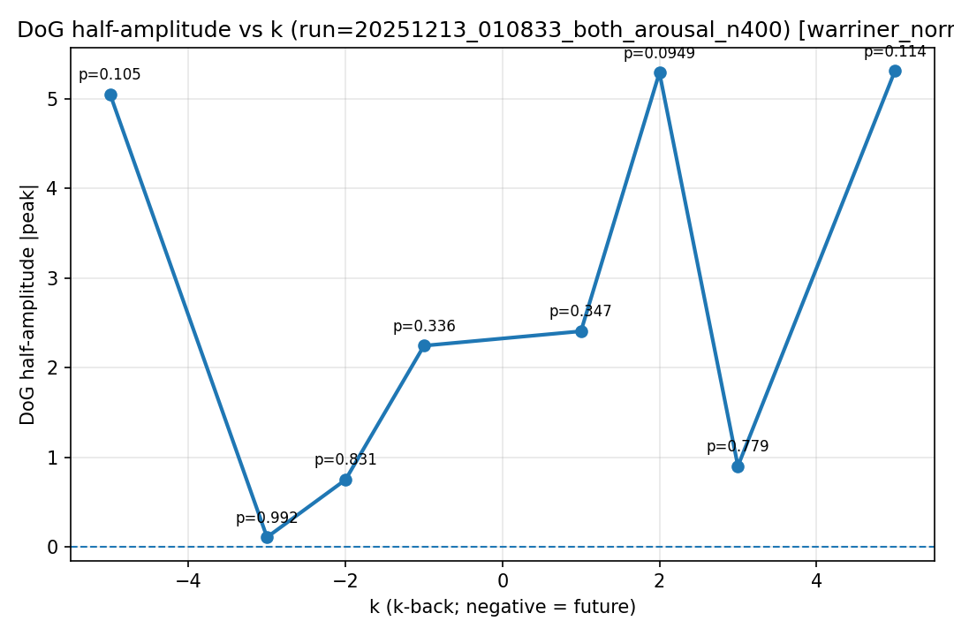
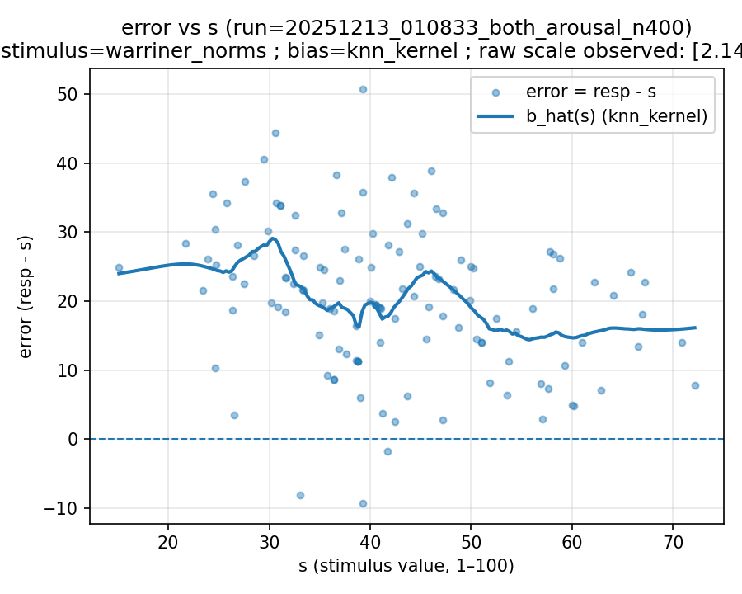 | 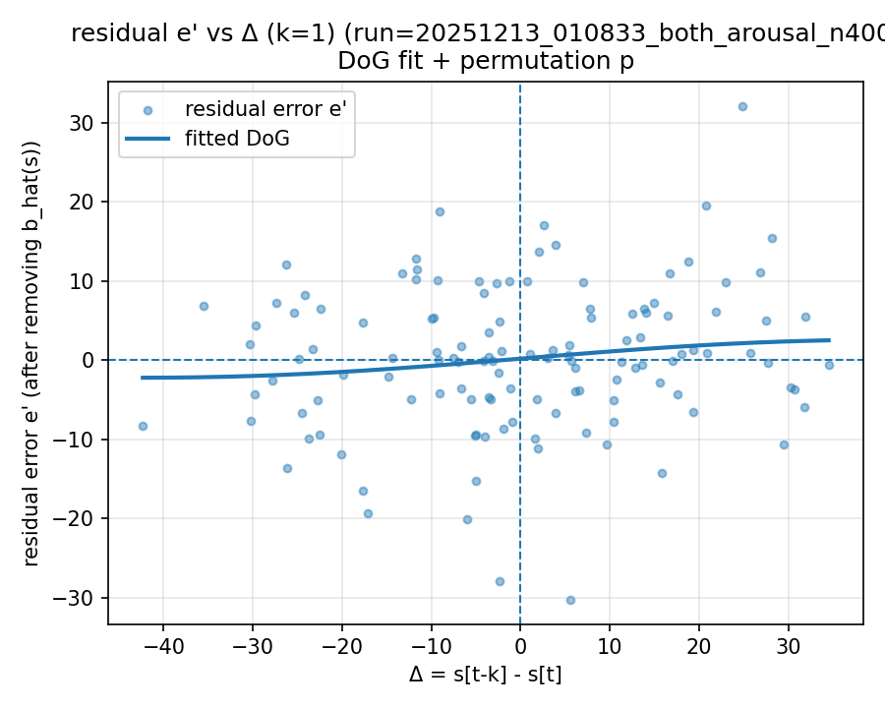 | 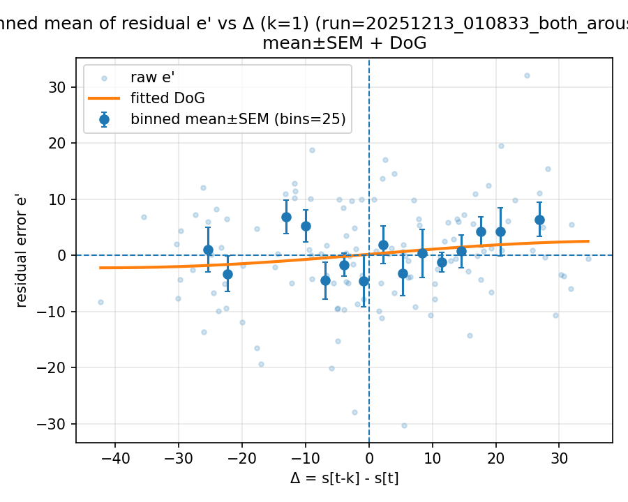

20251213_133659_both_concreteness_n400

Mode: norms (stimulus=warriner_norms)
model: deepseek-r1-0528
which: both
dimension: concreteness
uses_warriner_word_source: False
n_words: 400
match_rate_vs_exp2: 0.3175
k=1 half_amp: 19.4116
k=1 sigma: 200
k=1 p (permutation): 0.034965
best p over ks: 0.022977 (k=3)
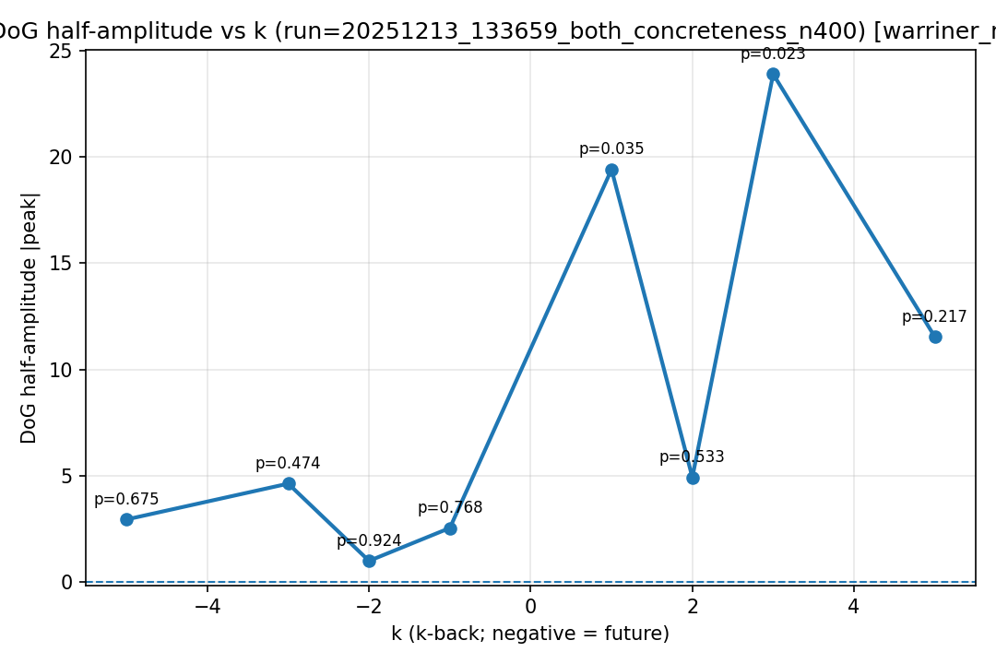
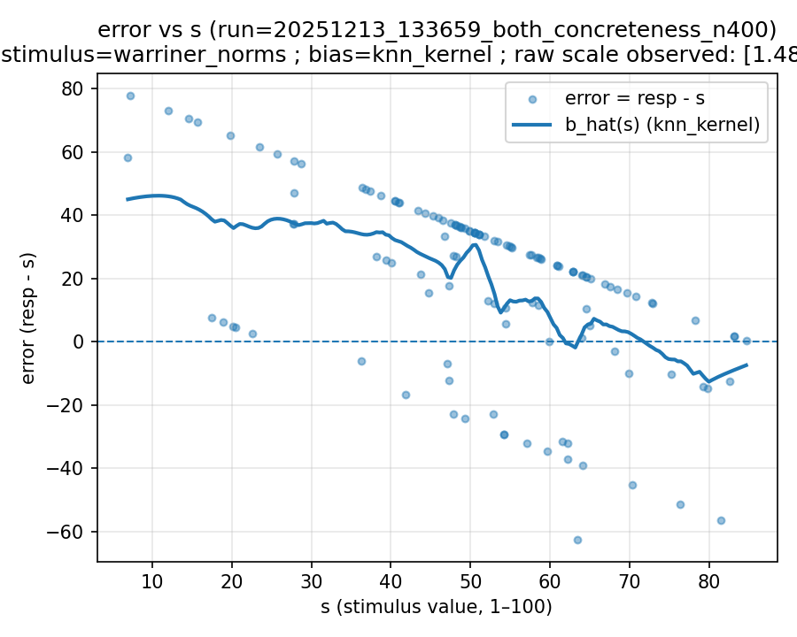 | 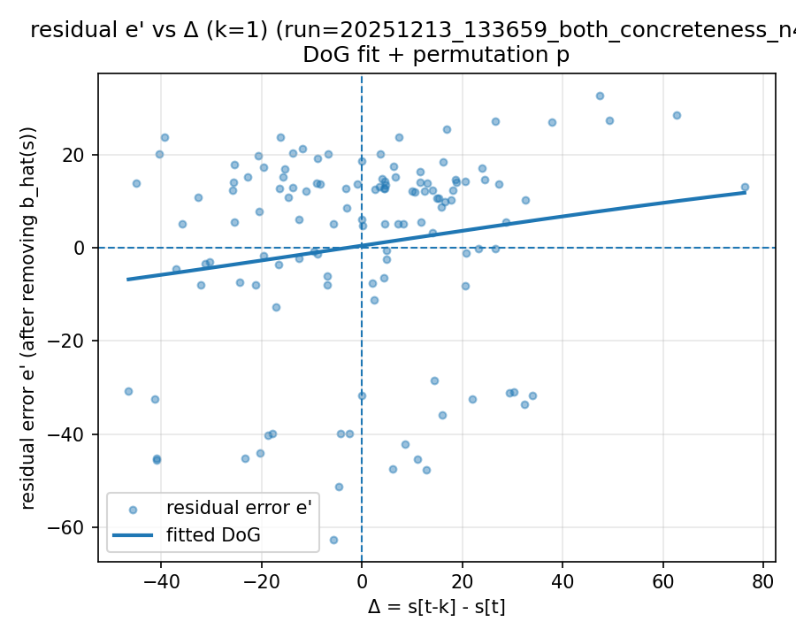 | 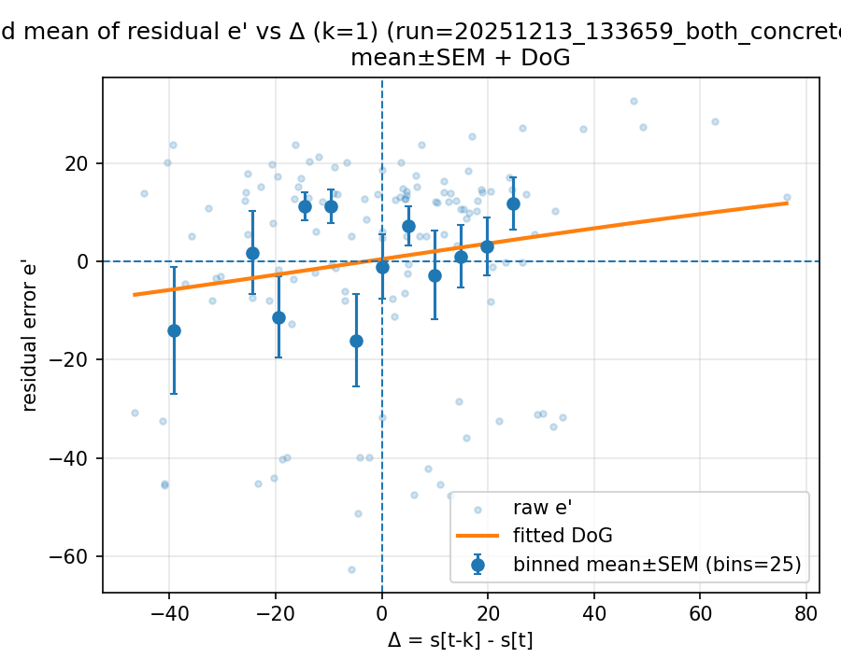

20251213_133742_both_concreteness_n400

Mode: norms (stimulus=warriner_norms)
model: gemini-2.0-flash
which: both
dimension: concreteness
uses_warriner_word_source: False
n_words: 400
match_rate_vs_exp2: 0.3175
k=1 half_amp: 24.7452
k=1 sigma: 200
k=1 p (permutation): 0.033966
best p over ks: 0.033966 (k=1)
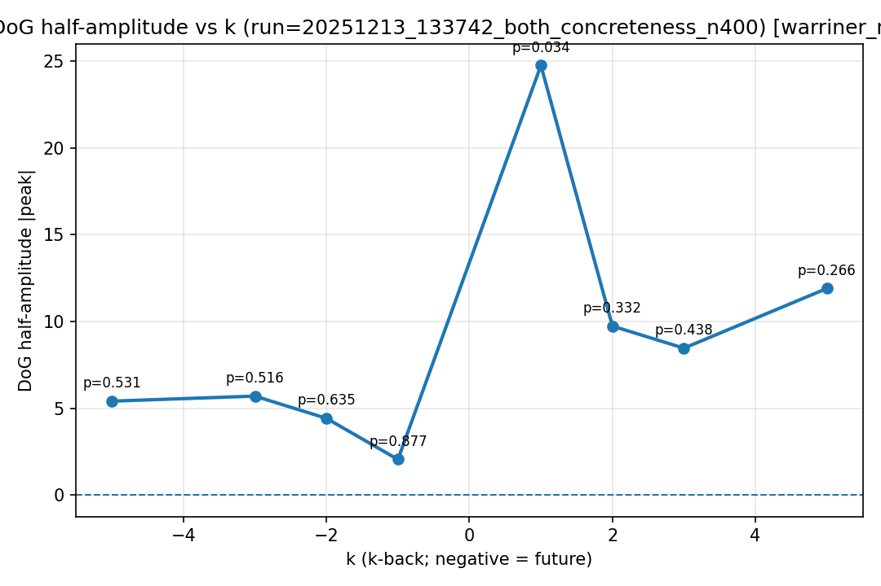
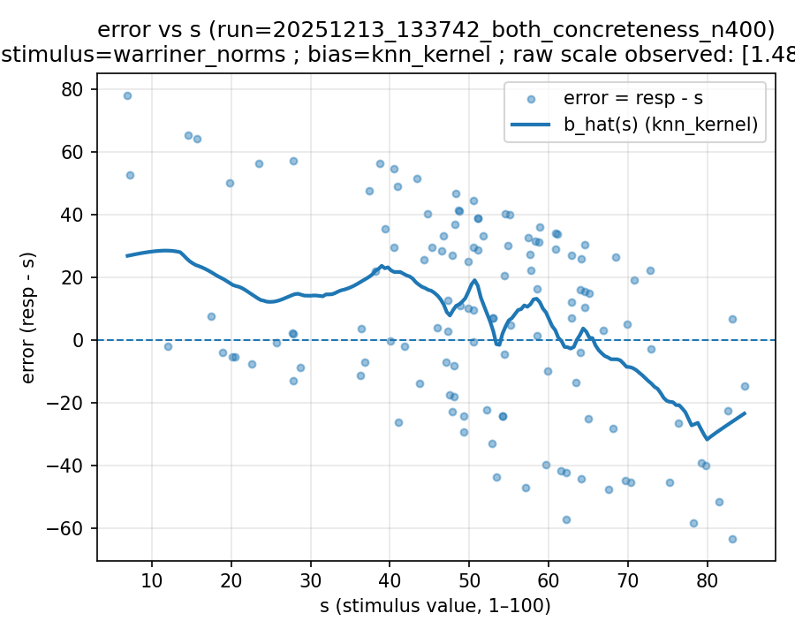 | 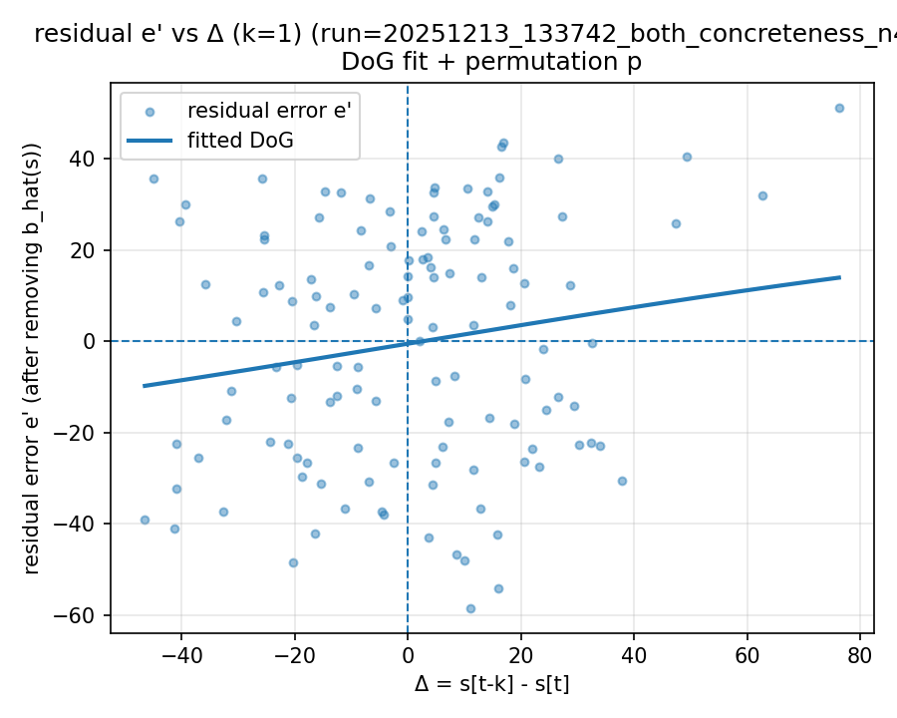 | 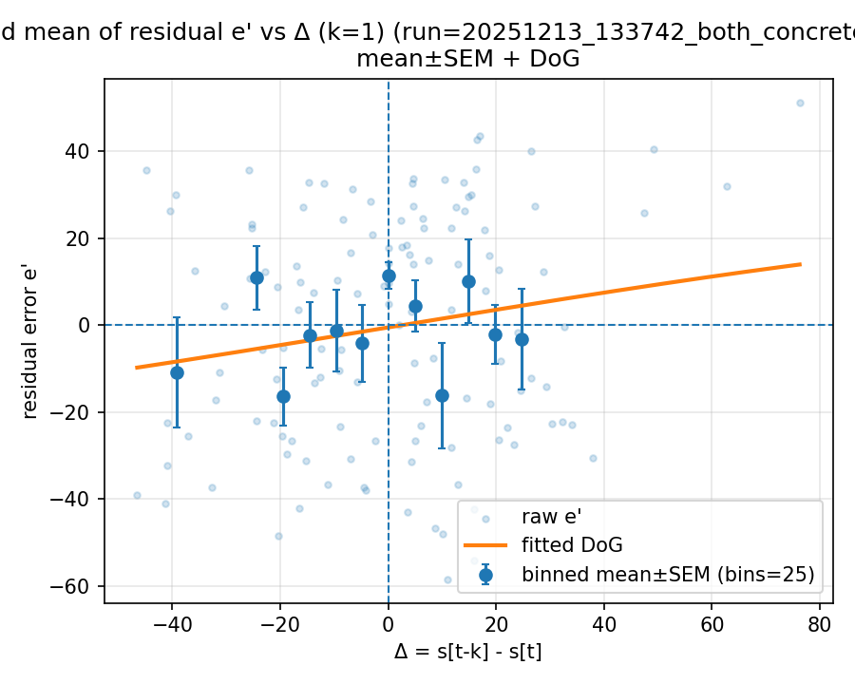

20251217_213039_both_concreteness_n400

Mode: norms (stimulus=warriner_norms)
model: gemini-2.0-flash
which: both
dimension: concreteness
uses_warriner_word_source: False
n_words: 400
match_rate_vs_exp2: 0.3175
k=1 half_amp: 24.3048
k=1 sigma: 200
k=1 p (permutation): 0.035964
best p over ks: 0.035964 (k=1)
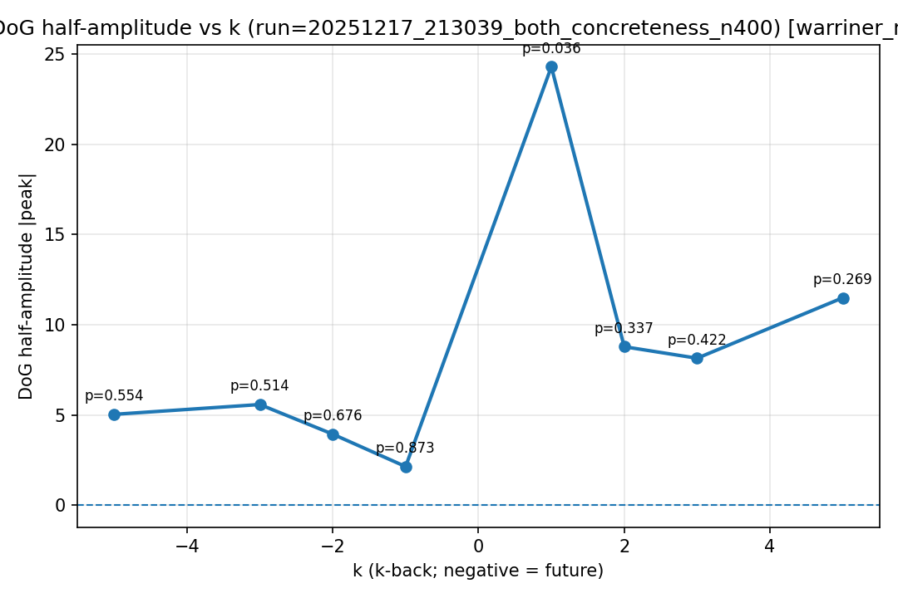
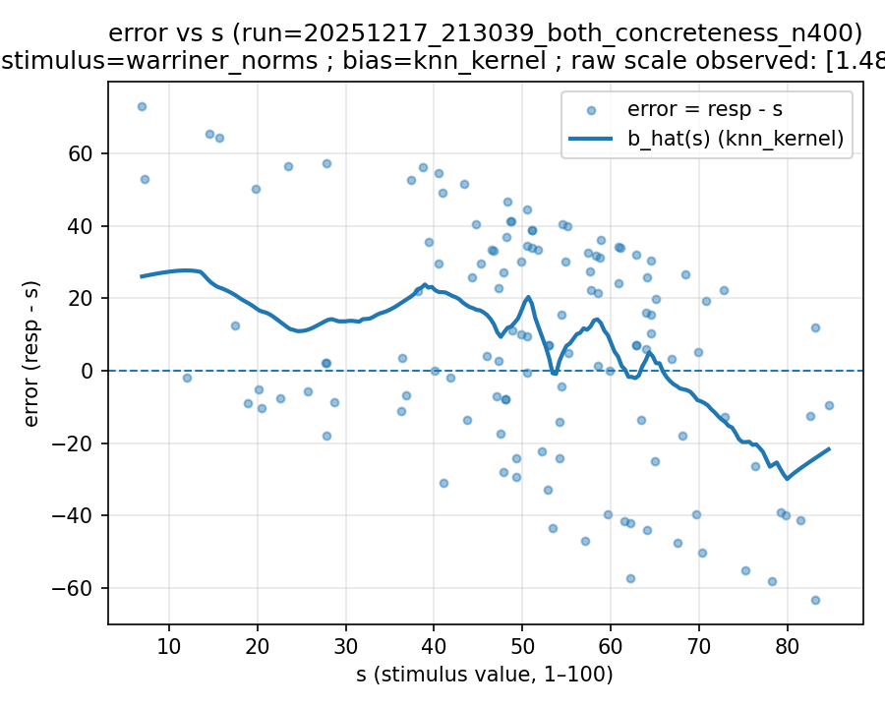 | 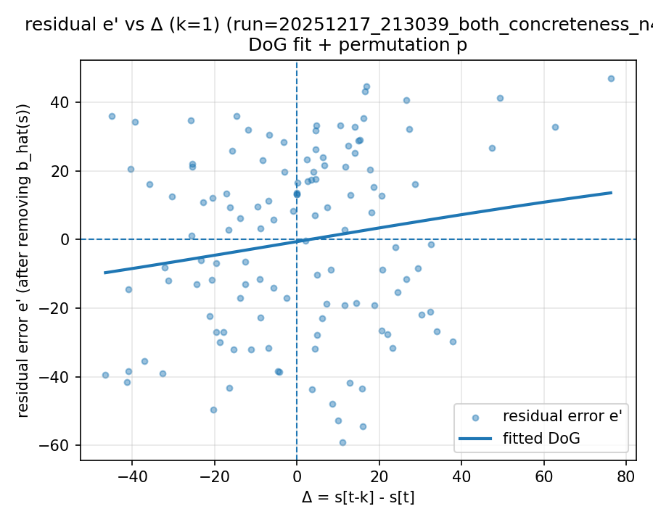 | 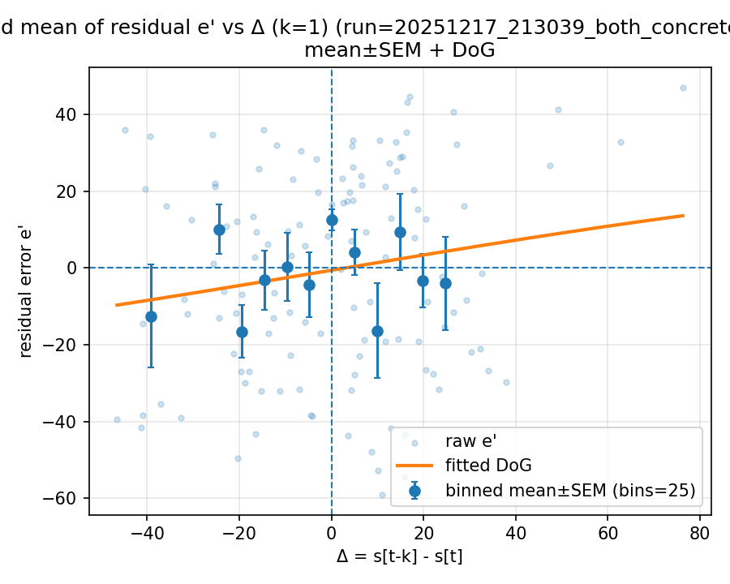

20251218_170111_both_concreteness_n400

Mode: norms (stimulus=warriner_norms)
model: claude-sonnet-4-5-20250929-cc
which: both
dimension: concreteness
uses_warriner_word_source: False
n_words: 400
match_rate_vs_exp2: 0.3175
k=1 half_amp: 2.84854
k=1 sigma: 12.6629
k=1 p (permutation): 0.74026
best p over ks: 0.127872 (k=-5)
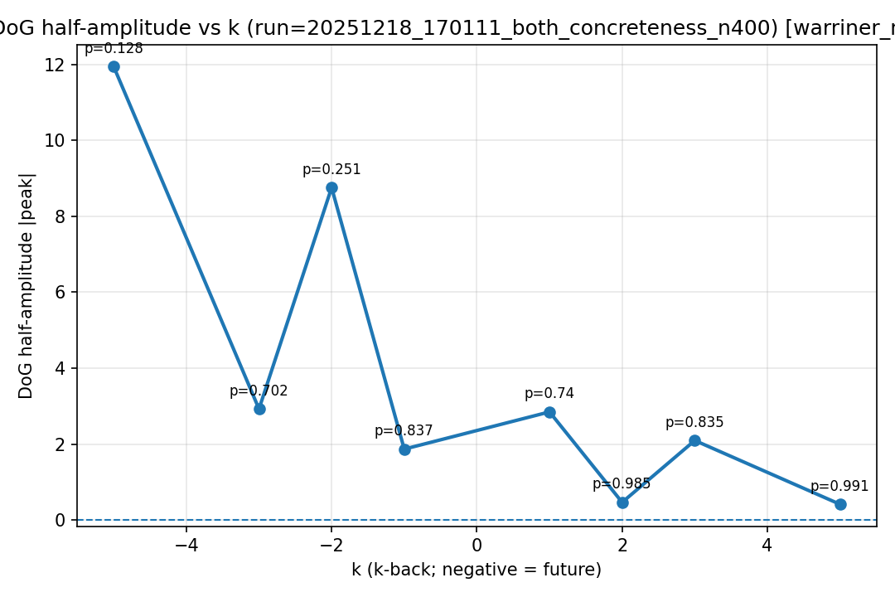
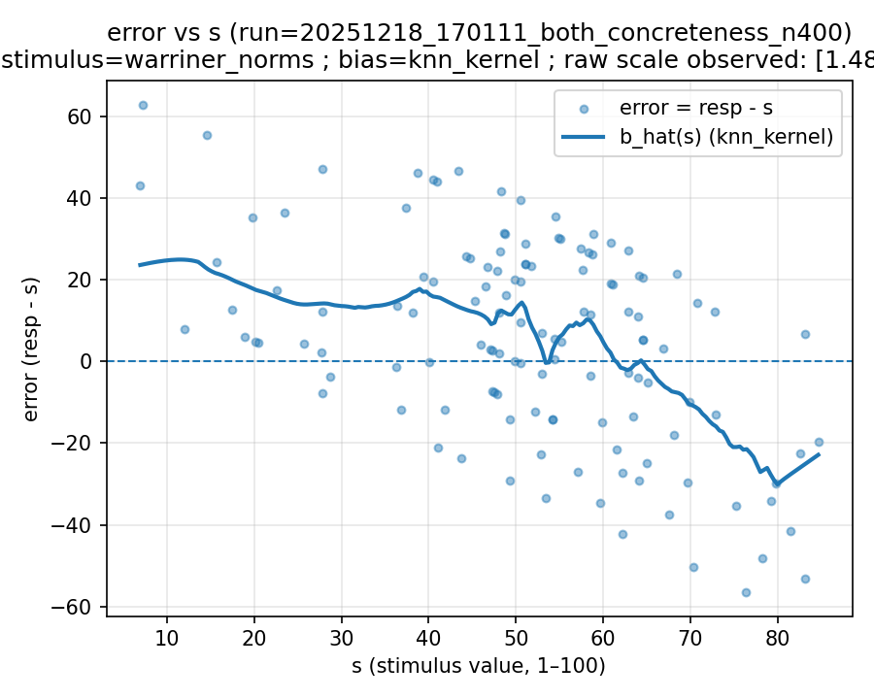 | 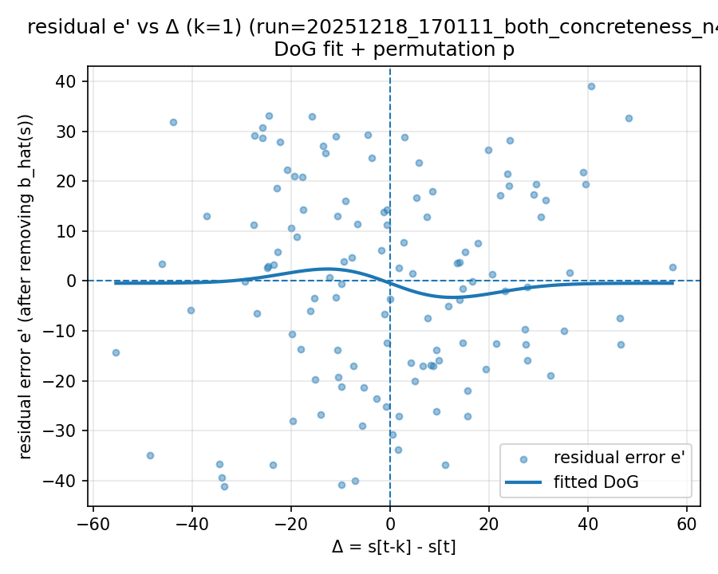 | 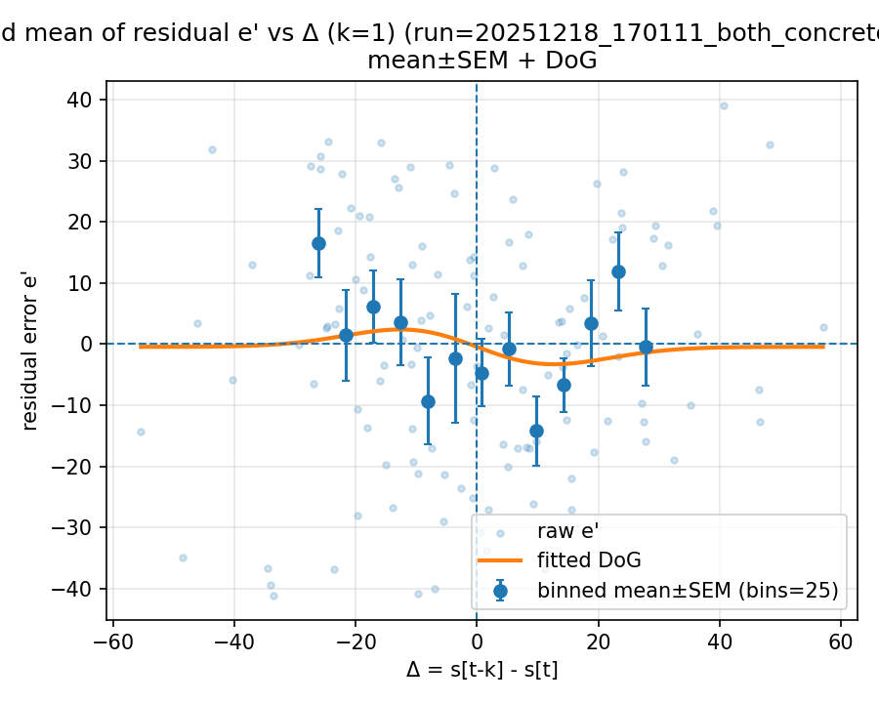

20251218_170152_both_concreteness_n400

Mode: norms (stimulus=warriner_norms)
model: qwen-max-latest
which: both
dimension: concreteness
uses_warriner_word_source: False
n_words: 400
match_rate_vs_exp2: 0.3175
k=1 half_amp: 13.4366
k=1 sigma: 200
k=1 p (permutation): 0.107892
best p over ks: 0.0899101 (k=-3)
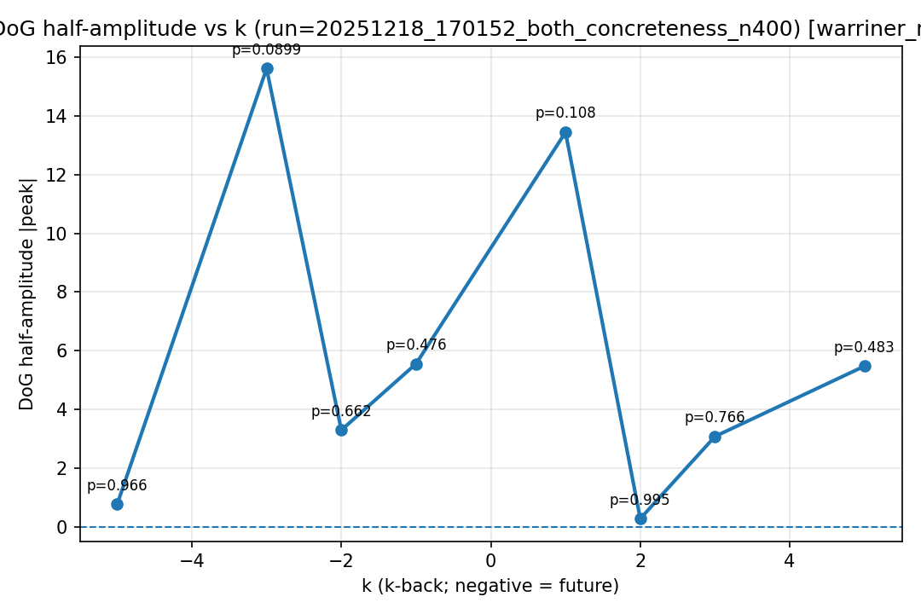
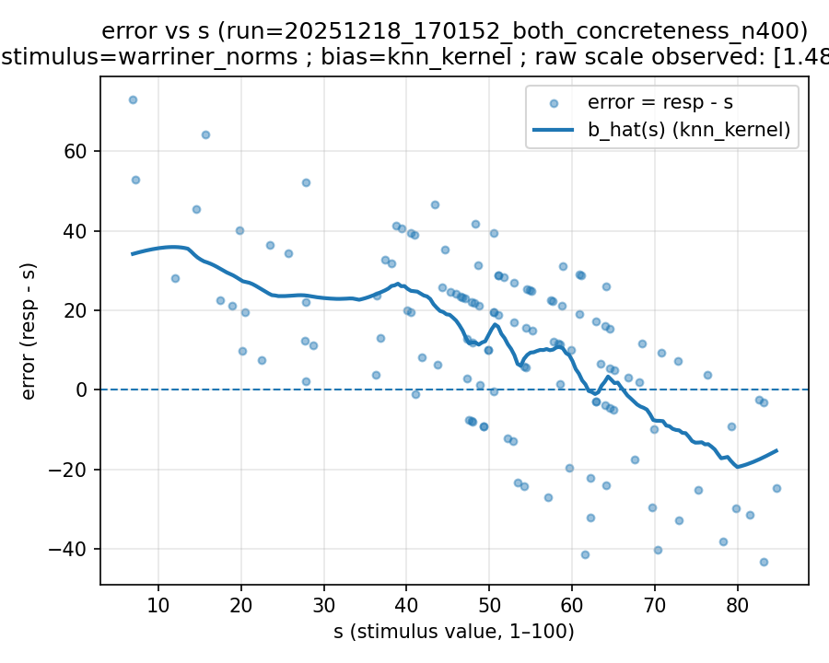 | 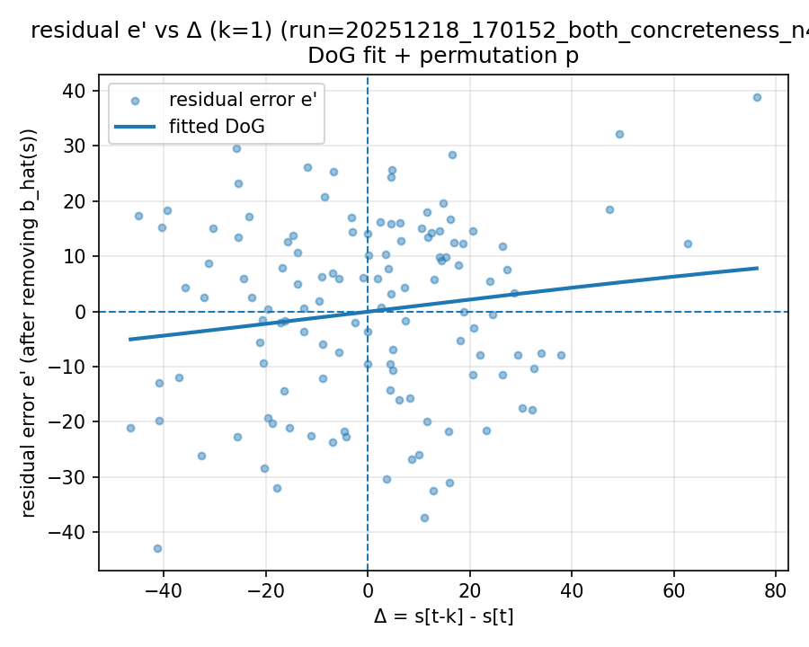 | 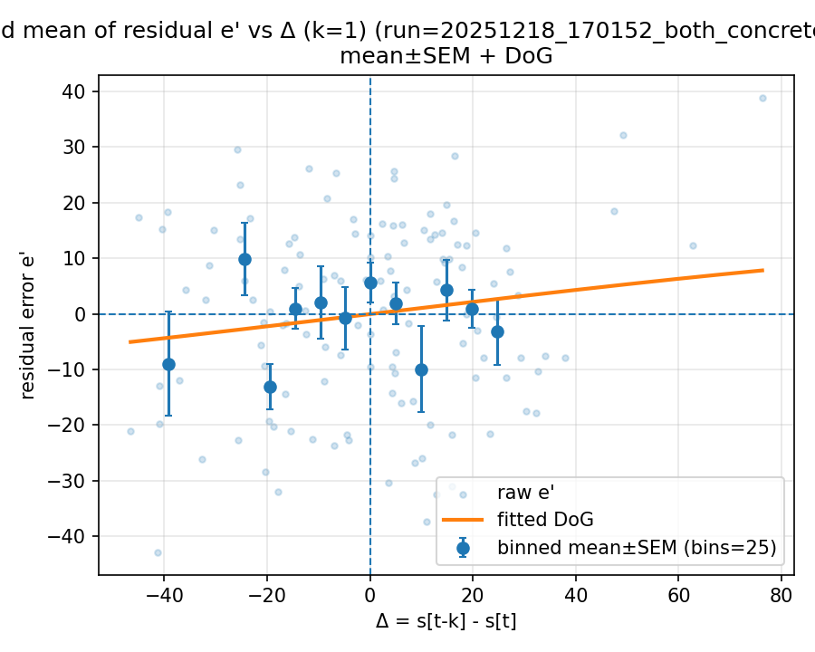

20251218_193433_both_concreteness_n400

Mode: norms (stimulus=warriner_norms)
model: gemini-2.5-flash
which: both
dimension: concreteness
uses_warriner_word_source: False
n_words: 400
match_rate_vs_exp2: 0.3175
k=1 half_amp: 19.9796
k=1 sigma: 200
k=1 p (permutation): 0.0599401
best p over ks: 0.0599401 (k=1)
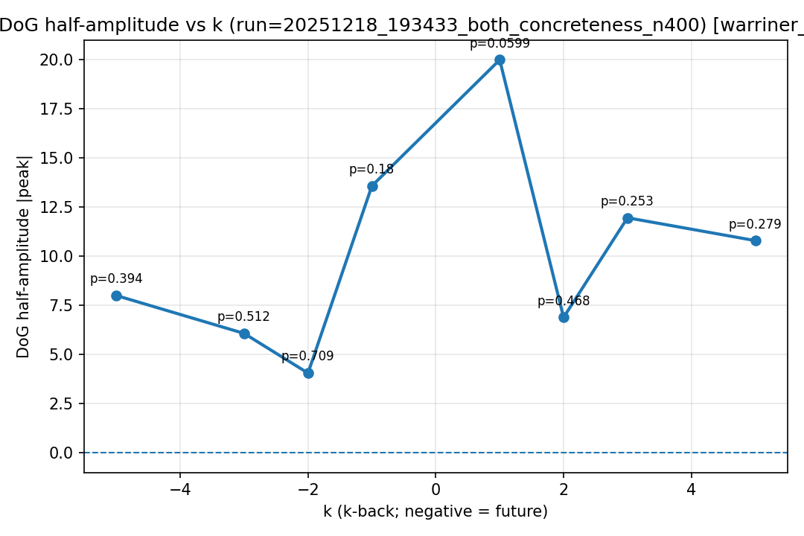
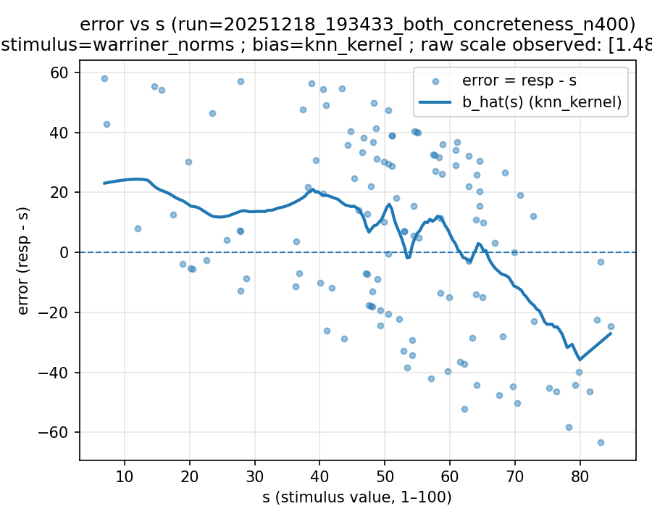 | 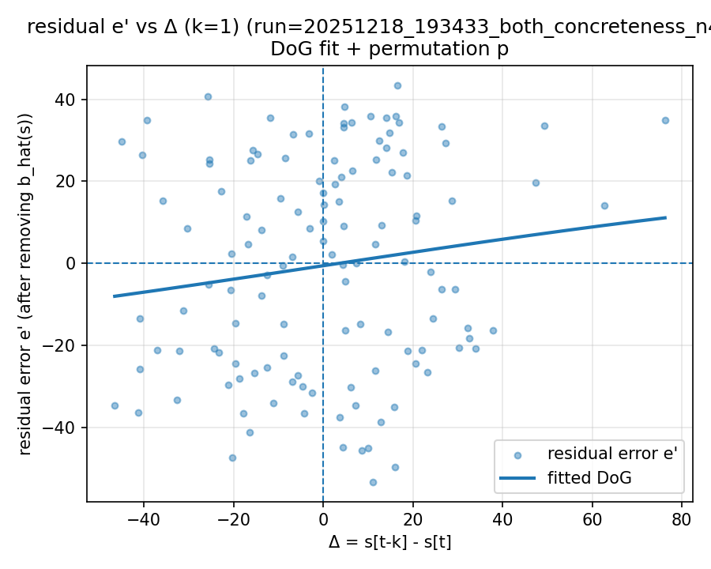 | 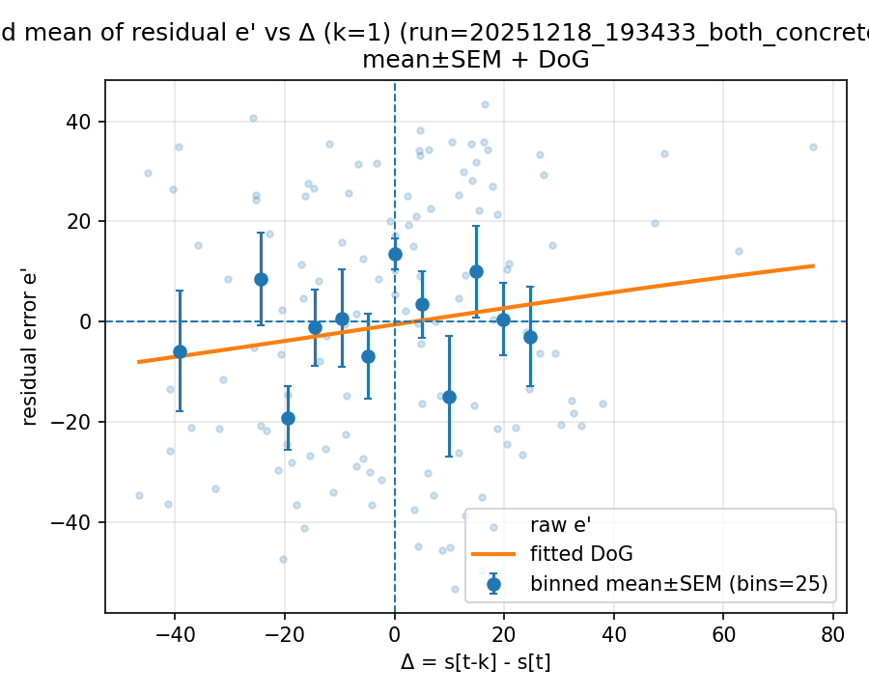

20251221_131659_both_concreteness_n400

Mode: exp1 (stimulus=exp1_mean)
model: gpt-4o-mini
which: both
dimension: concreteness
uses_warriner_word_source: False
n_words: 400
match_rate_vs_exp2: 1
k=1 half_amp: 0.95089
k=1 sigma: 20.5044
k=1 p (permutation): 0.649351
best p over ks: 0.0699301 (k=-2)
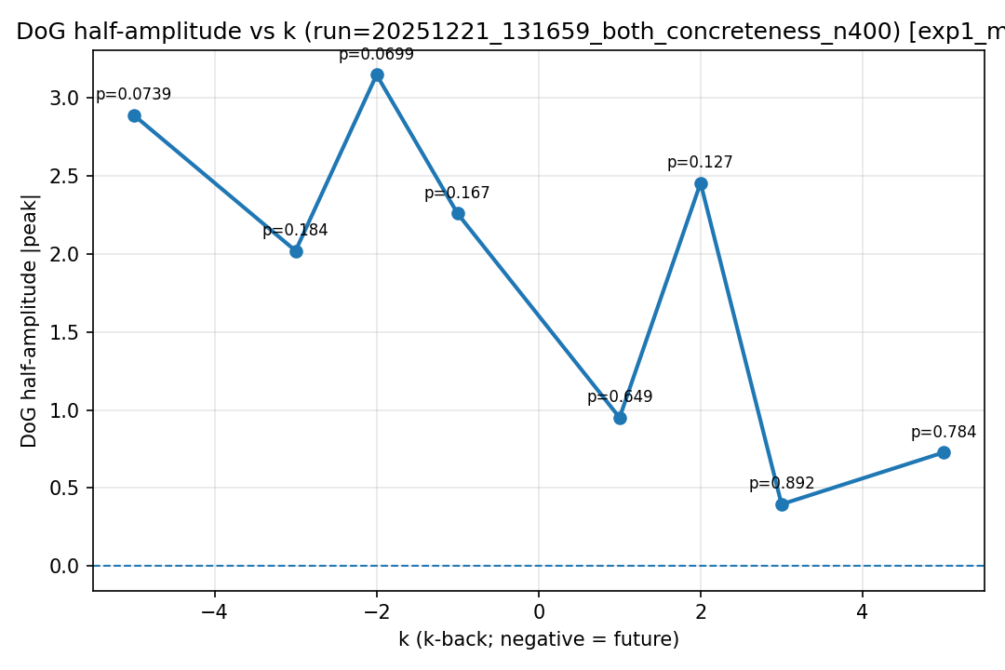
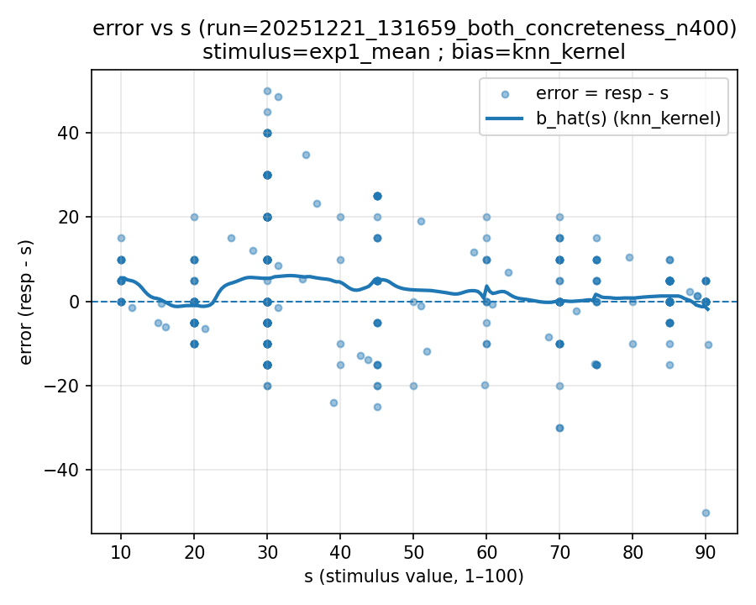 | 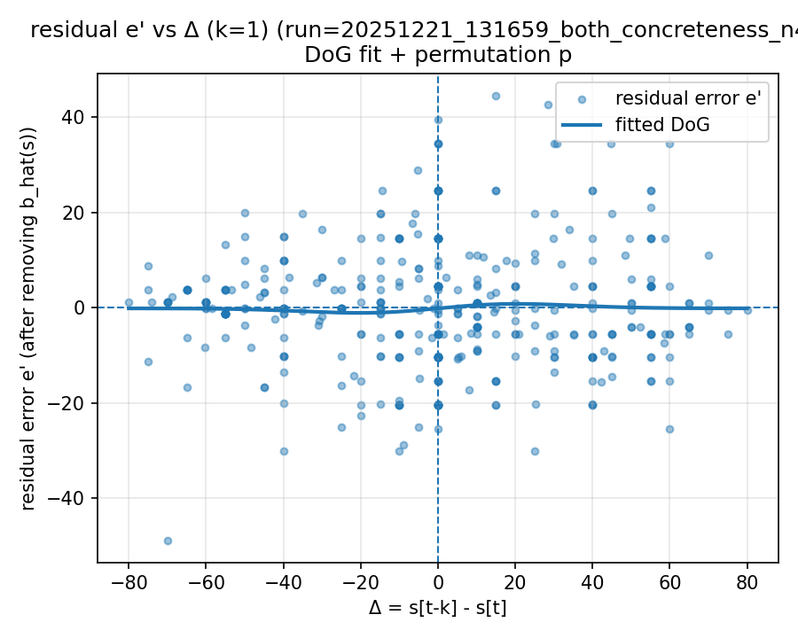 | 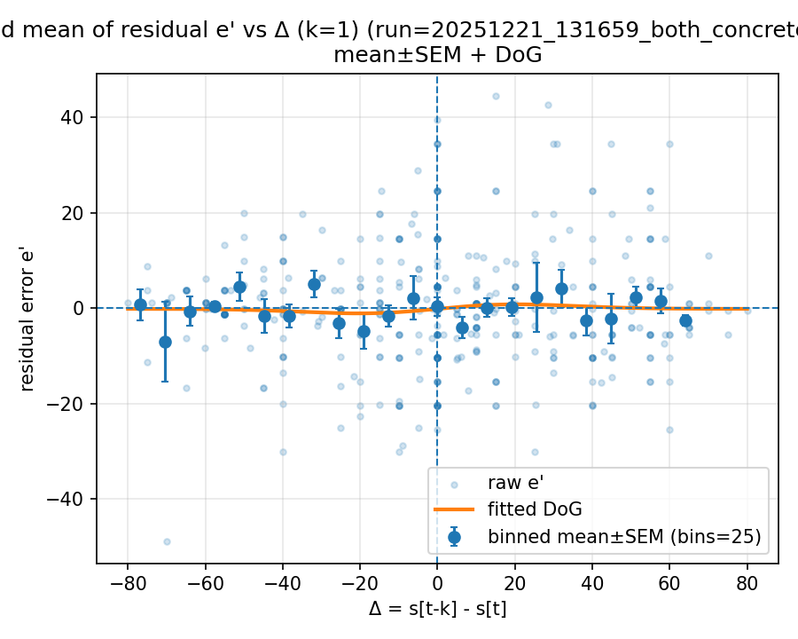

Mode: norms (stimulus=warriner_norms)
model: gpt-4o-mini
which: both
dimension: concreteness
uses_warriner_word_source: False
n_words: 400
match_rate_vs_exp2: 0.3175
k=1 half_amp: 25.7649
k=1 sigma: 200
k=1 p (permutation): 0.021978
best p over ks: 0.021978 (k=1)
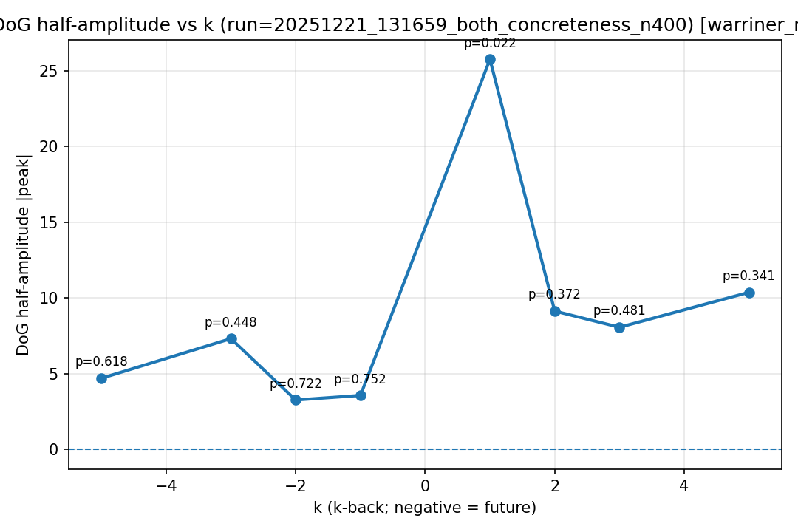
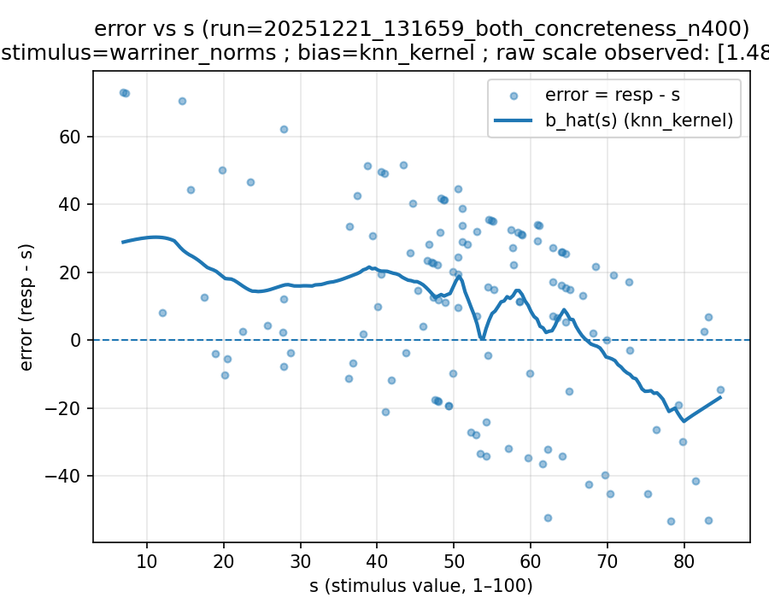 | 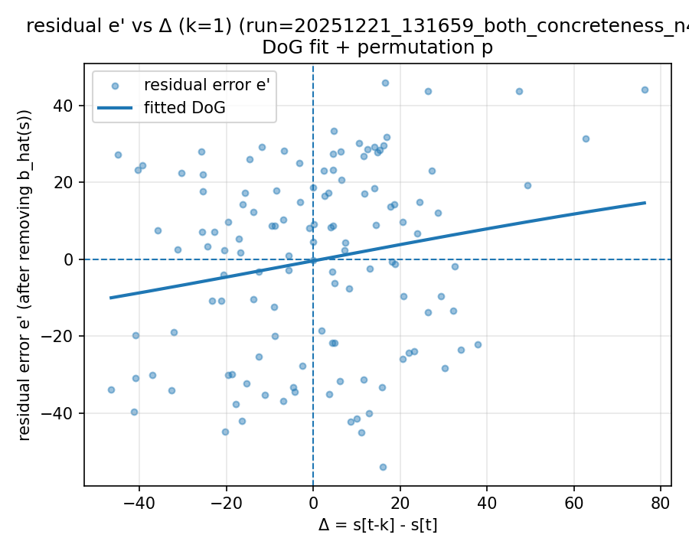 | 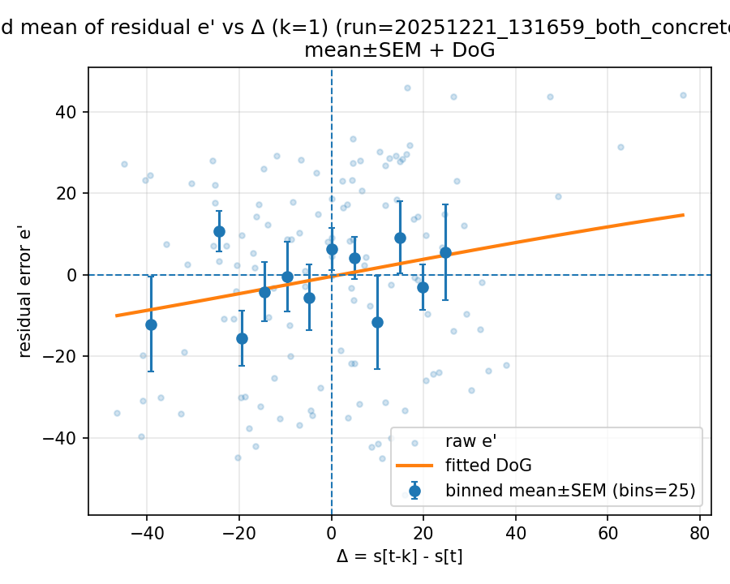

20251221_135907_both_concreteness_n400

Mode: exp1 (stimulus=exp1_mean)
model: gpt-4o-mini
which: both
dimension: concreteness
uses_warriner_word_source: False
n_words: 400
match_rate_vs_exp2: 1
k=1 half_amp: 1.84518
k=1 sigma: 6.14686
k=1 p (permutation): 0.260739
best p over ks: 0.030969 (k=-5)
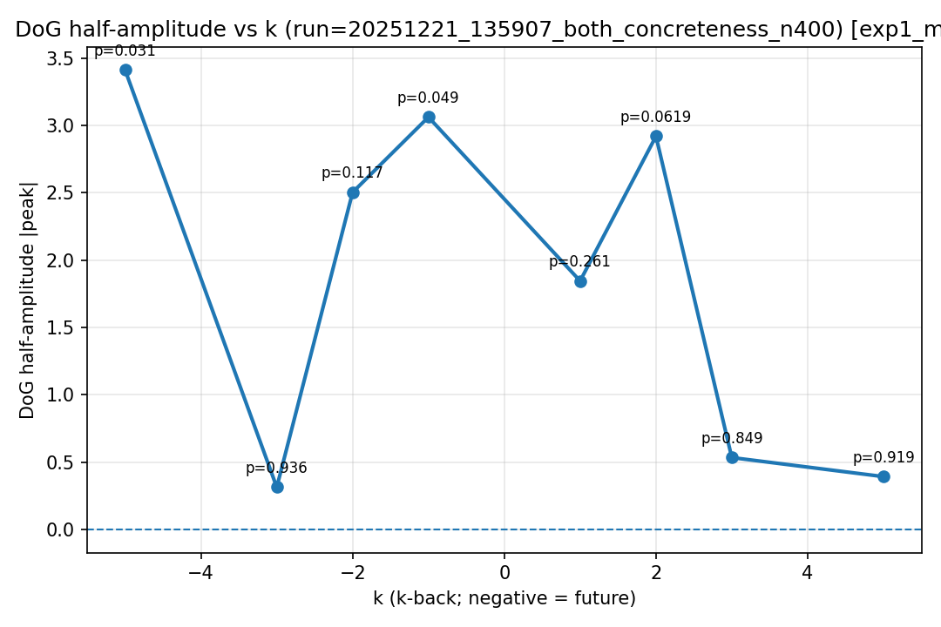
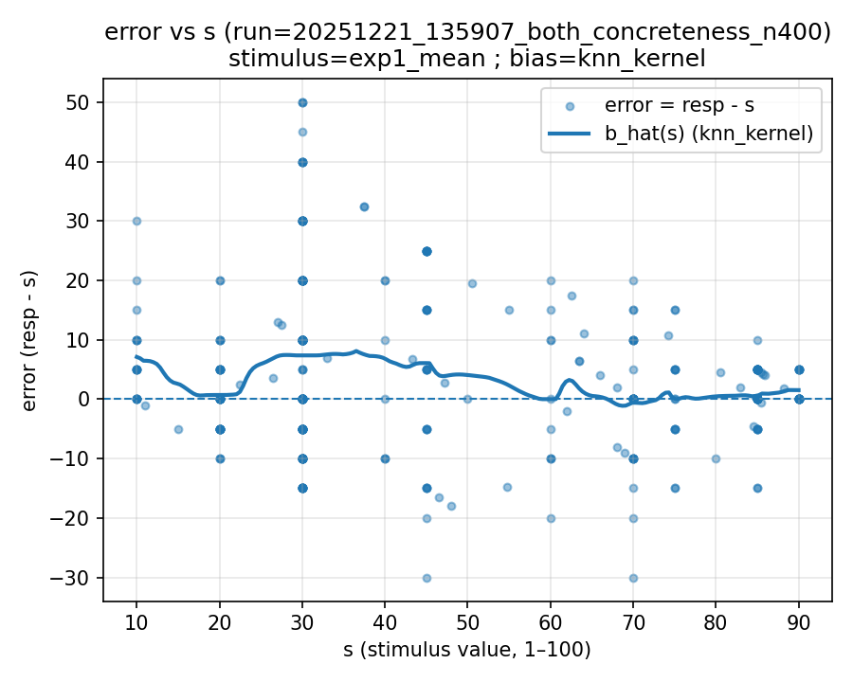 | 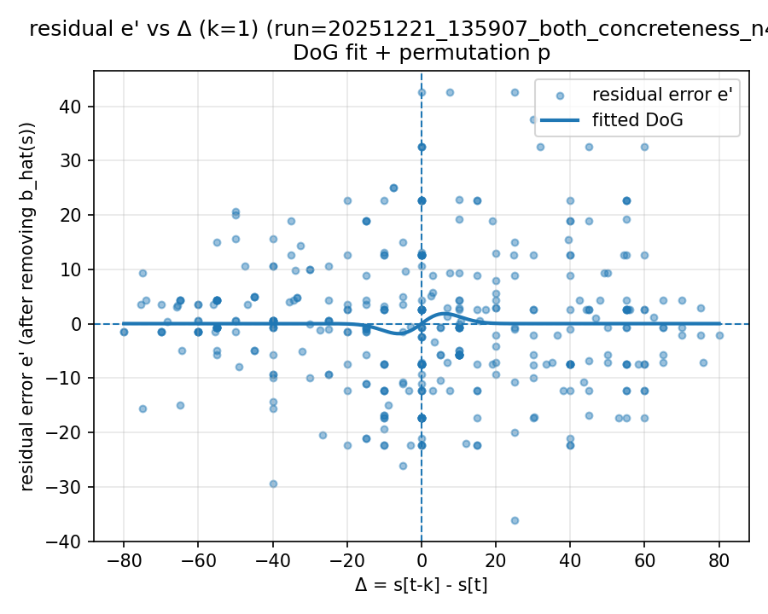 | 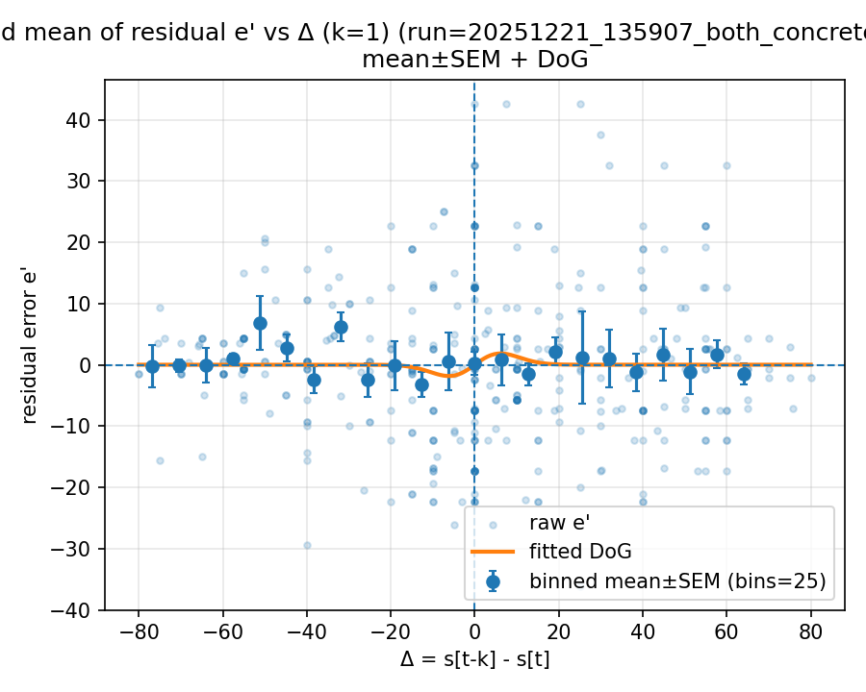

Mode: norms (stimulus=warriner_norms)
model: gpt-4o-mini
which: both
dimension: concreteness
uses_warriner_word_source: False
n_words: 400
match_rate_vs_exp2: 0.3175
k=1 half_amp: 24.6658
k=1 sigma: 200
k=1 p (permutation): 0.030969
best p over ks: 0.030969 (k=1)
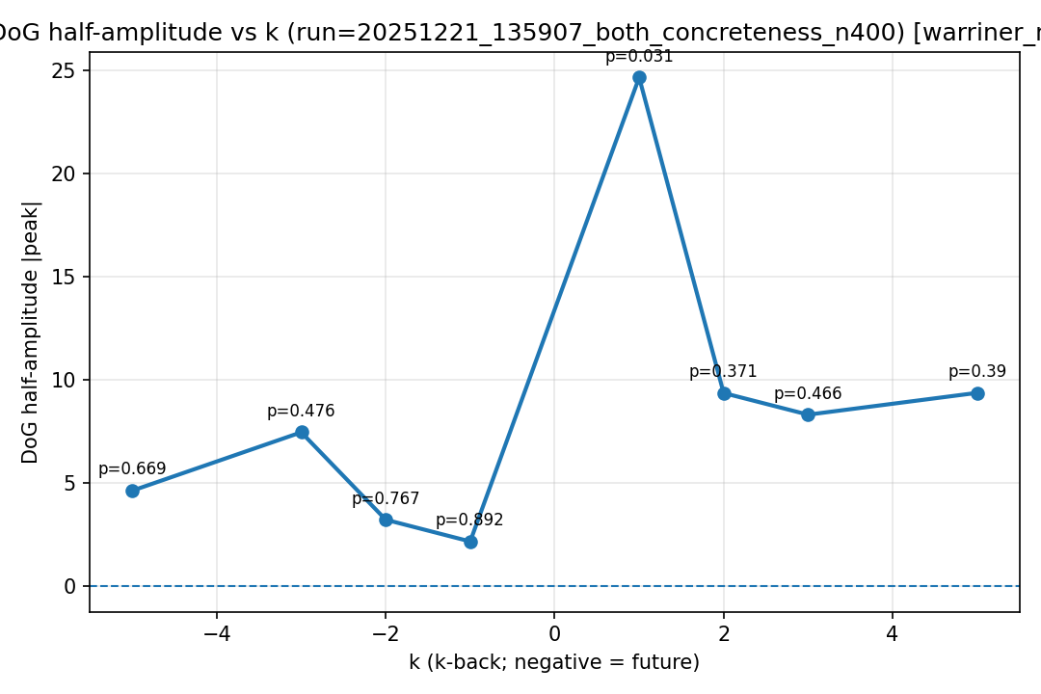
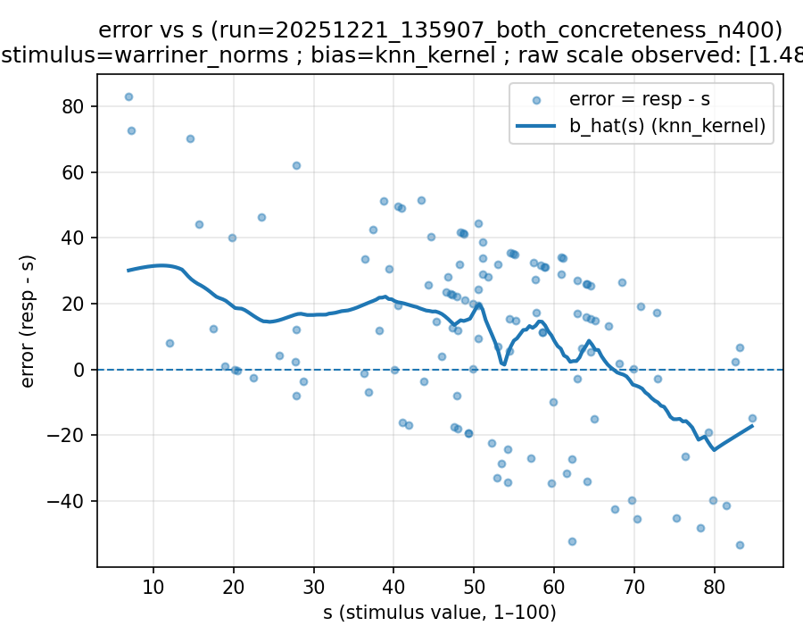 | 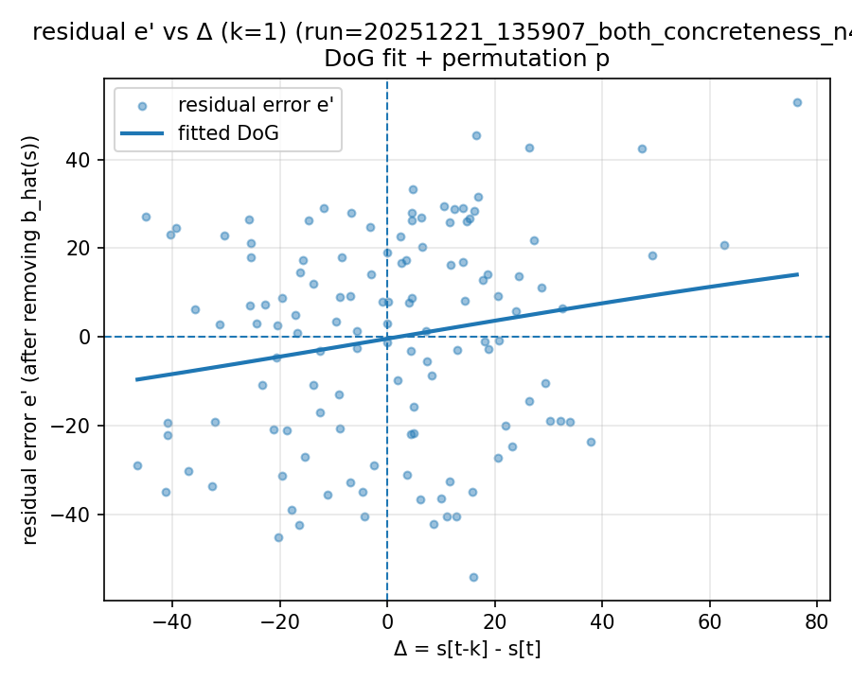 | 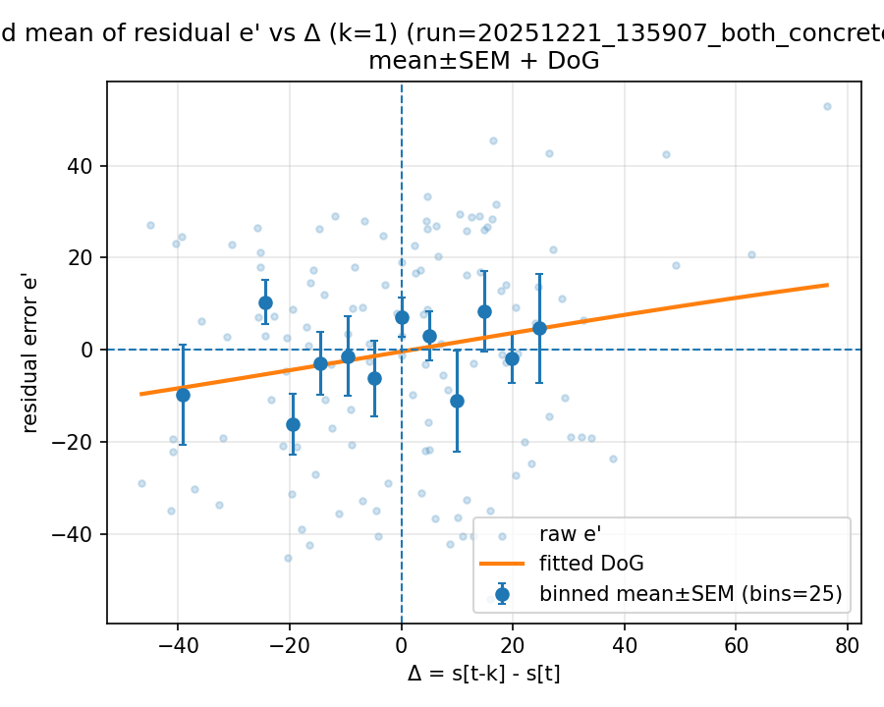

20251221_135911_both_arousal_n400

Mode: exp1 (stimulus=exp1_mean)
model: gpt-4o-mini
which: both
dimension: arousal
uses_warriner_word_source: False
n_words: 400
match_rate_vs_exp2: 1
k=1 half_amp: 0.879054
k=1 sigma: 24.0153
k=1 p (permutation): 0.47952
best p over ks: 0.47952 (k=1)
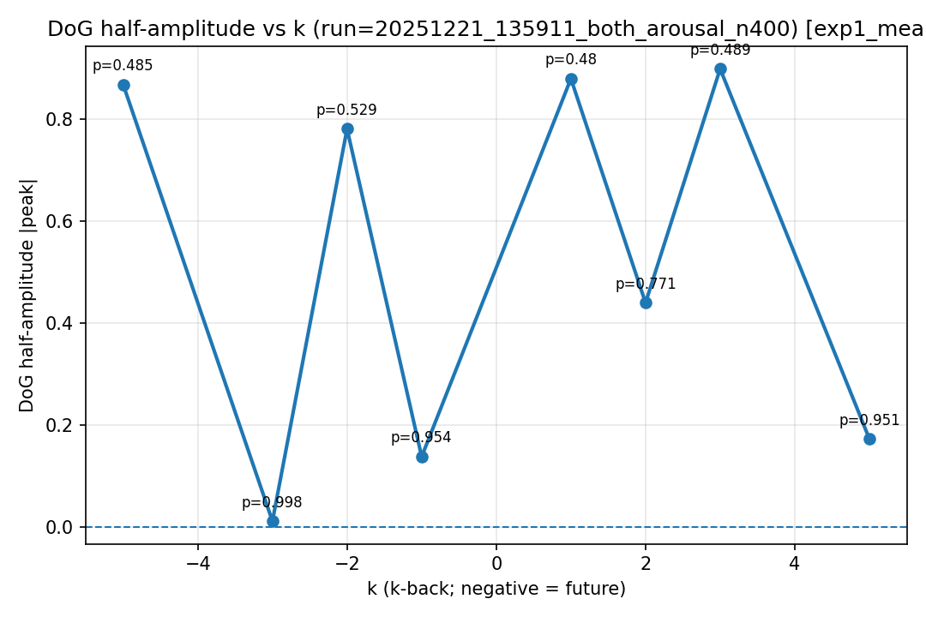
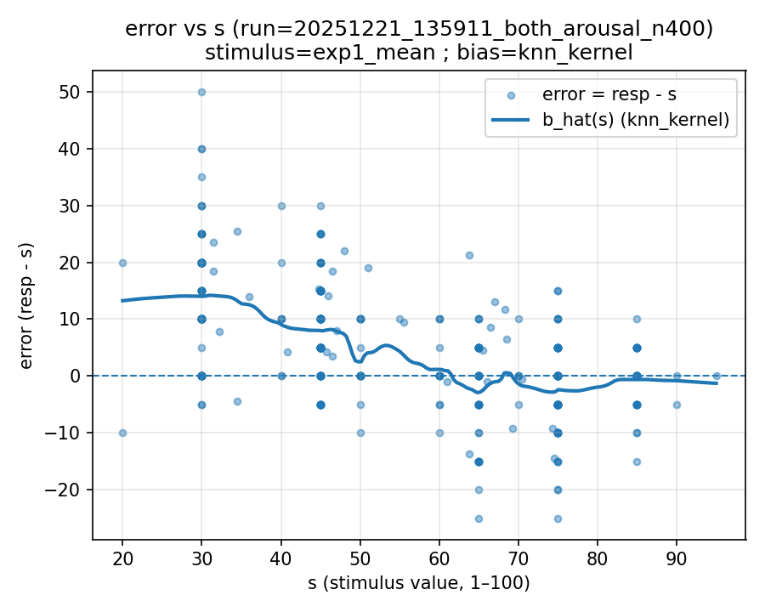 | 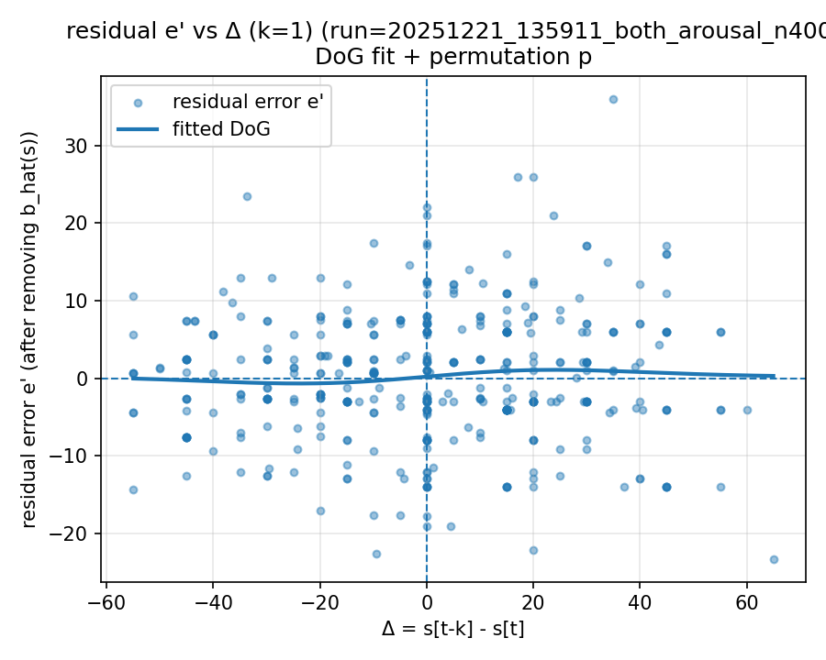 | 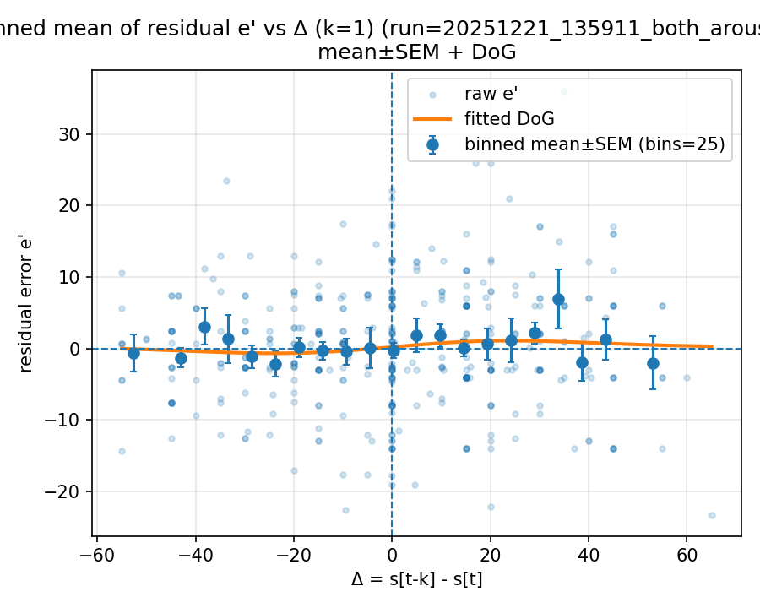

Mode: norms (stimulus=warriner_norms)
model: gpt-4o-mini
which: both
dimension: arousal
uses_warriner_word_source: False
n_words: 400
match_rate_vs_exp2: 0.3175
k=1 half_amp: 0.476417
k=1 sigma: 15.9653
k=1 p (permutation): 0.942058
best p over ks: 0.171828 (k=2)
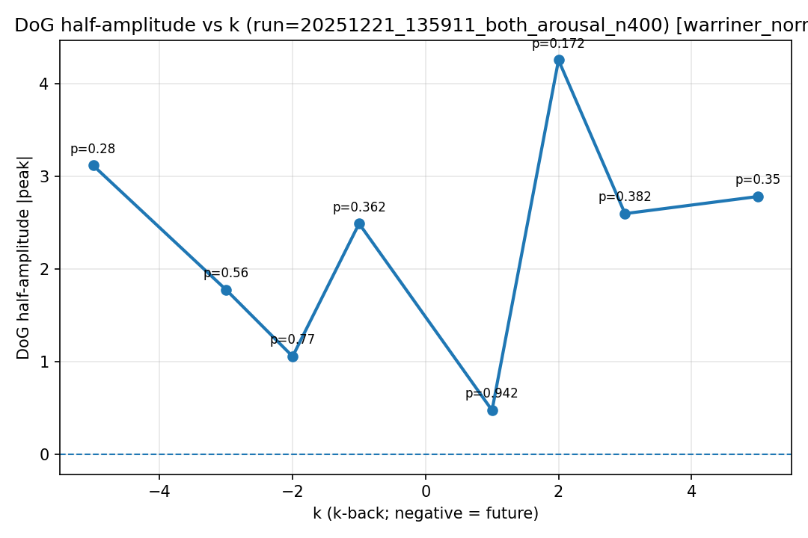
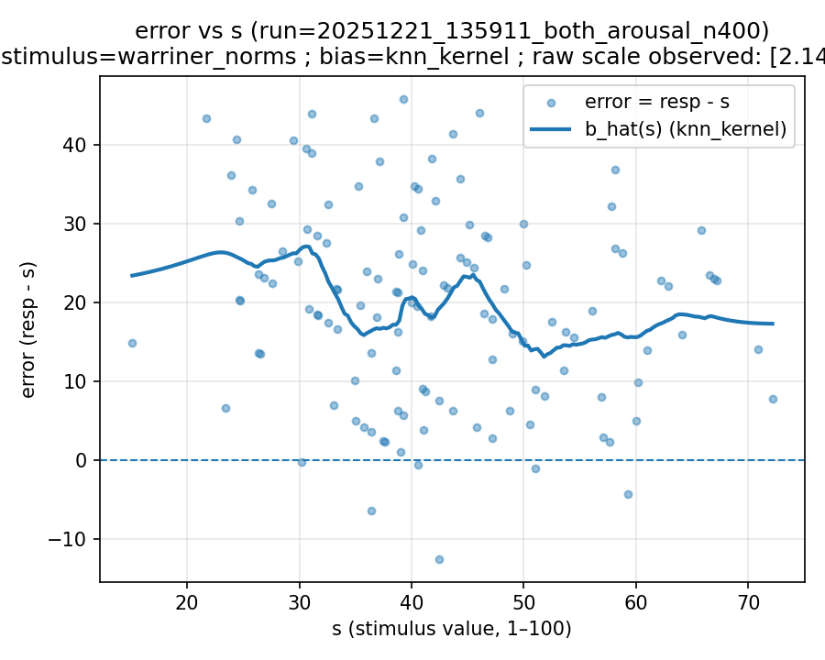 | 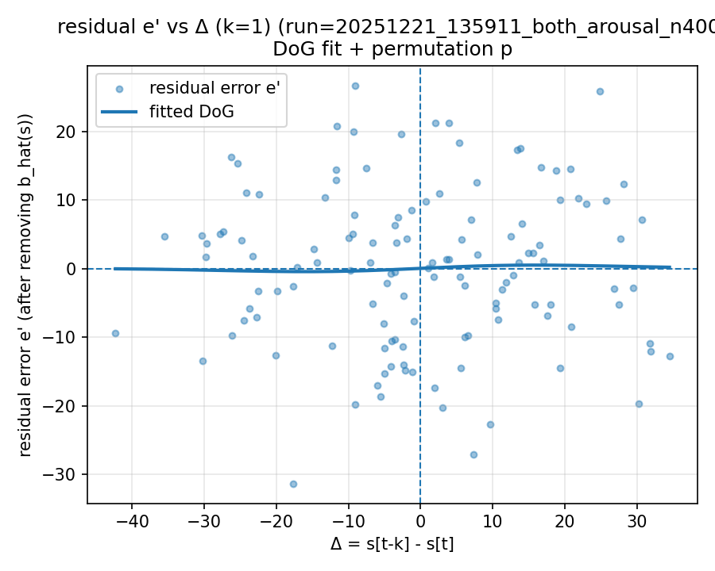 | 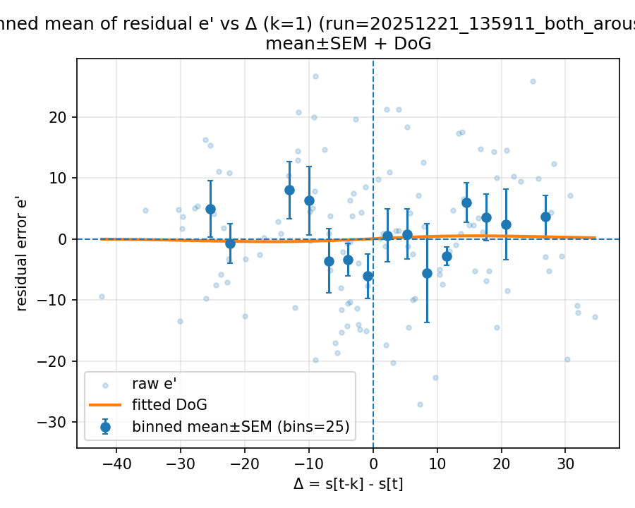

20251221_144236_both_concreteness_n400

Mode: norms (stimulus=warriner_norms)
model: gpt-4.1
which: both
dimension: concreteness
uses_warriner_word_source: False
n_words: 400
match_rate_vs_exp2: 0.3175
k=1 half_amp: 25.5931
k=1 sigma: 200
k=1 p (permutation): 0.026973
best p over ks: 0.026973 (k=1)
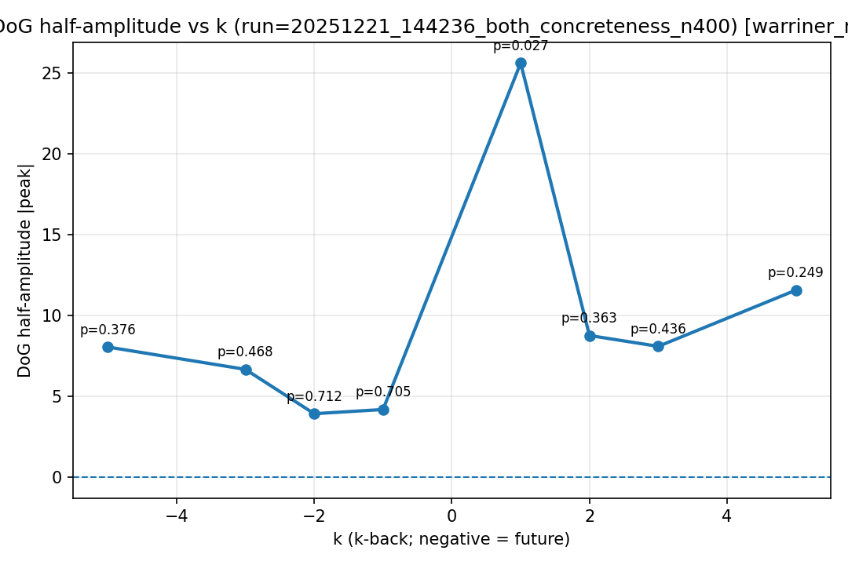
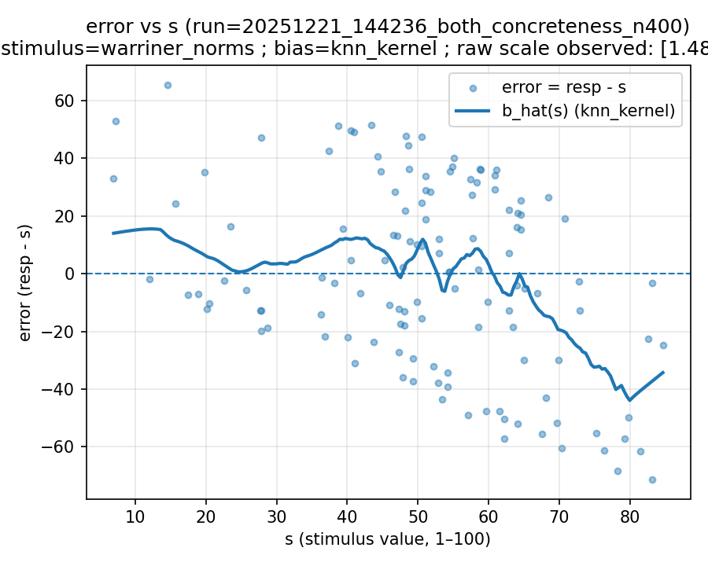 | 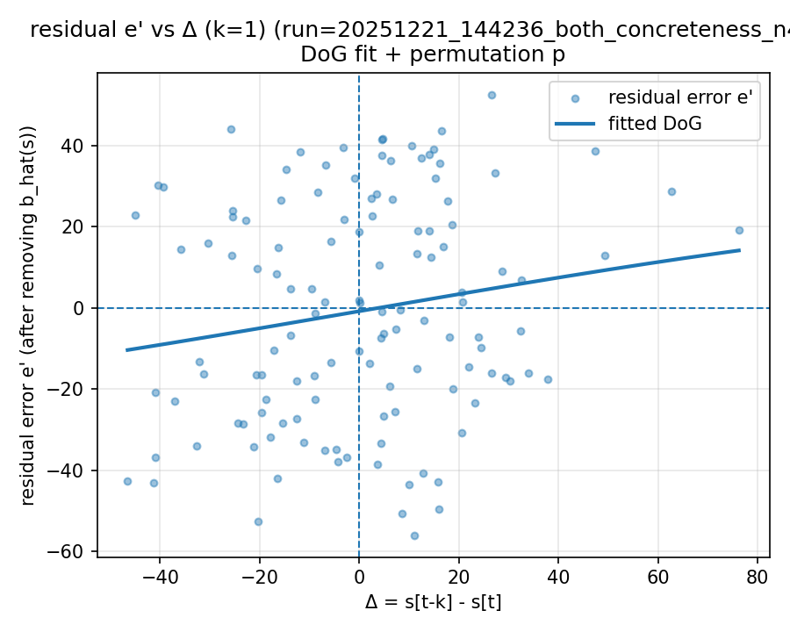 | 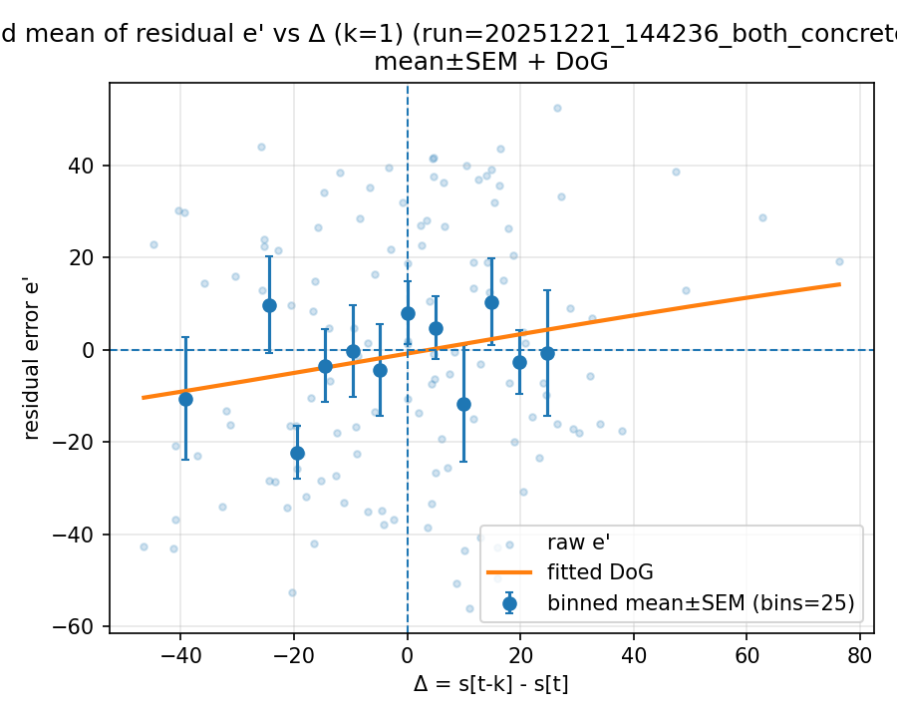

20251221_144304_both_arousal_n400

Mode: norms (stimulus=warriner_norms)
model: gpt-4.1
which: both
dimension: arousal
uses_warriner_word_source: False
n_words: 400
match_rate_vs_exp2: 0.3175
k=1 half_amp: 0.223982
k=1 sigma: 22.3008
k=1 p (permutation): 0.985015
best p over ks: 0.22977 (k=5)
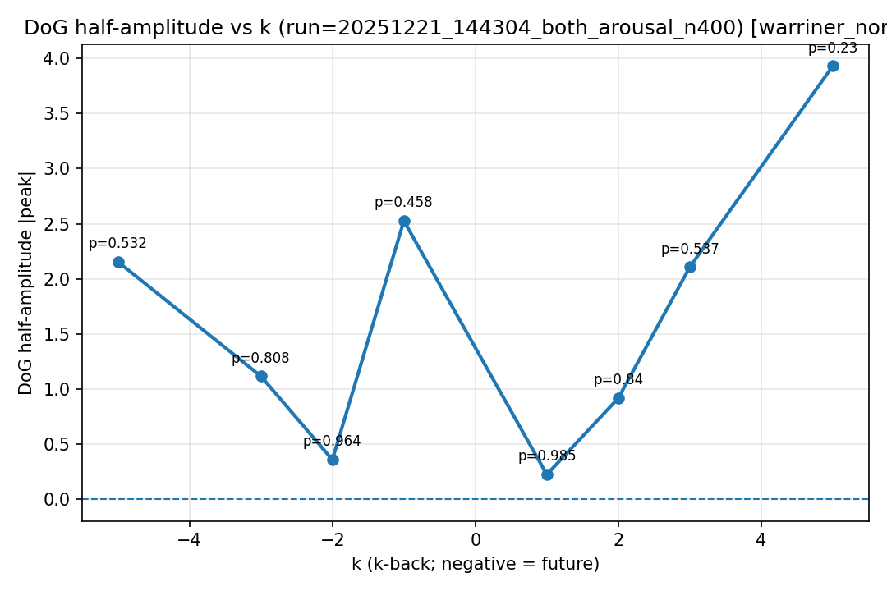
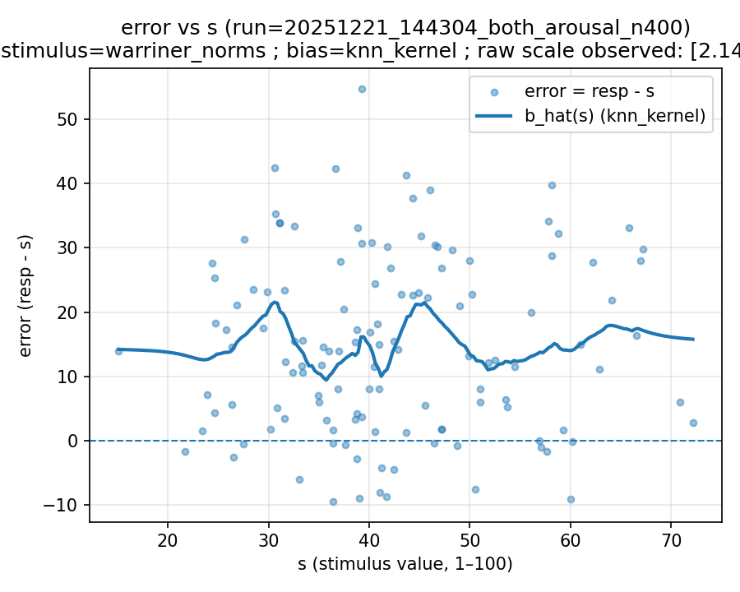 | 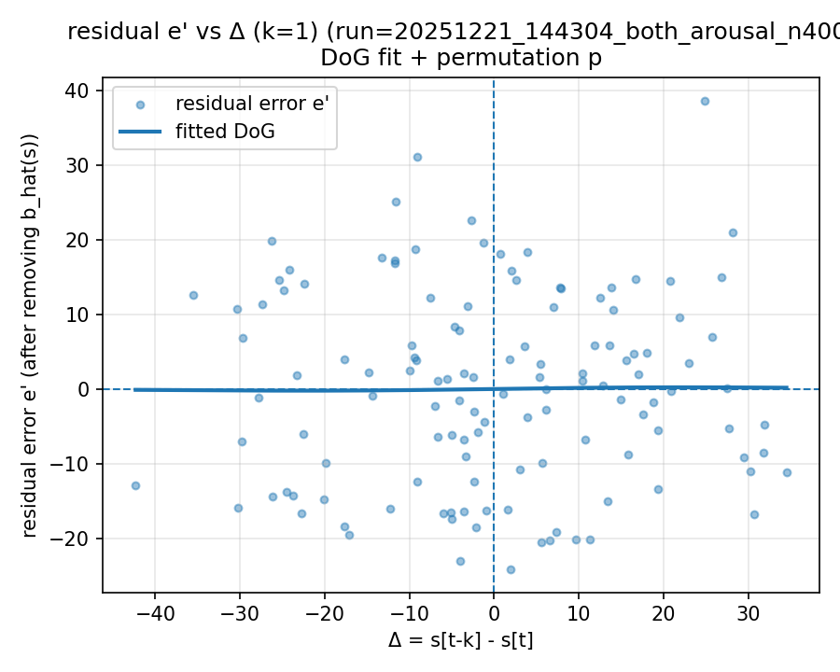 | 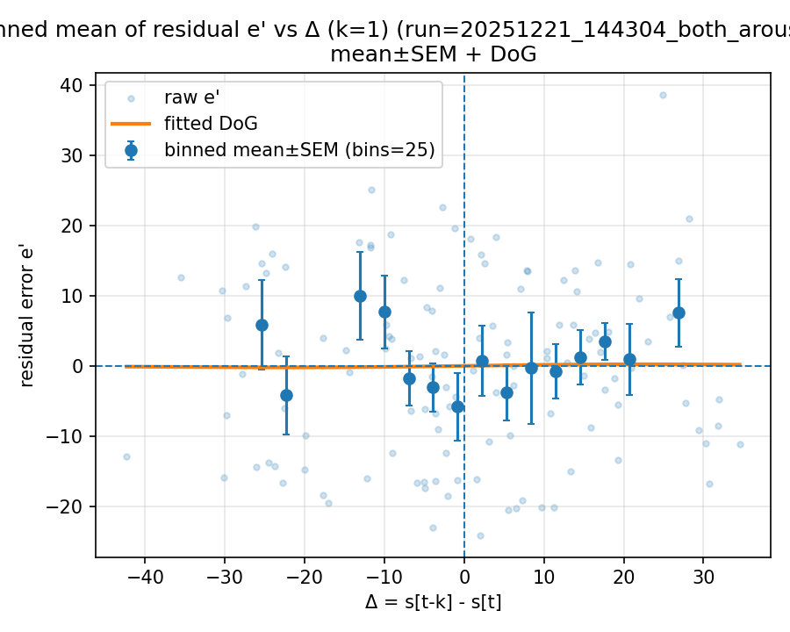

20251221_172610_both_concreteness_n400

Mode: exp1 (stimulus=exp1_mean)
model: gpt-4o
which: both
dimension: concreteness
uses_warriner_word_source: False
n_words: 400
match_rate_vs_exp2: 1
k=1 half_amp: 1.50394
k=1 sigma: 77.7491
k=1 p (permutation): 0.123876
best p over ks: 0.01998 (k=-1)
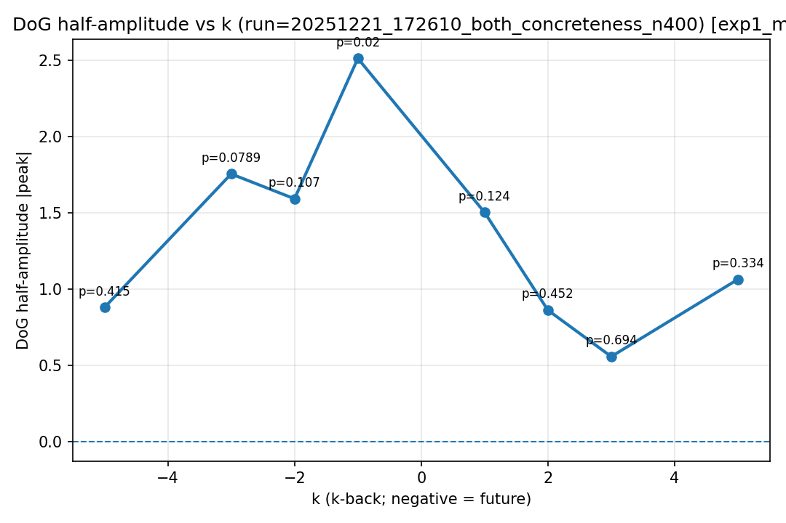
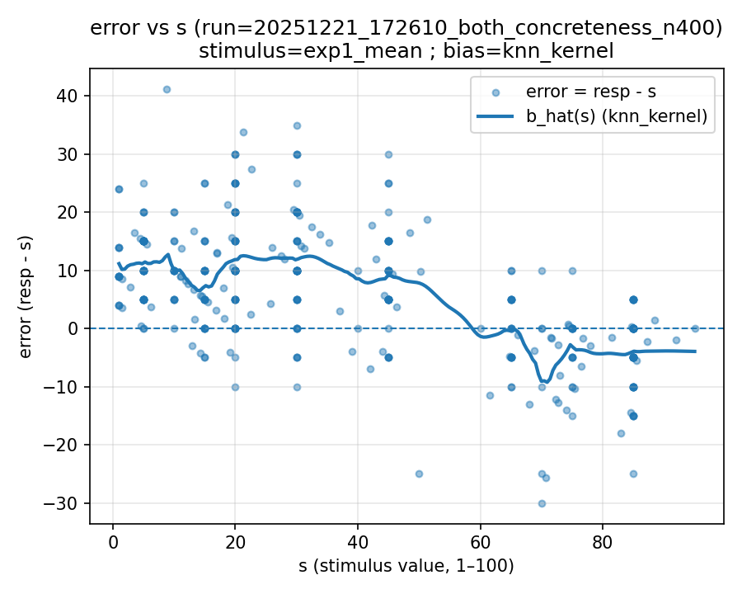 | 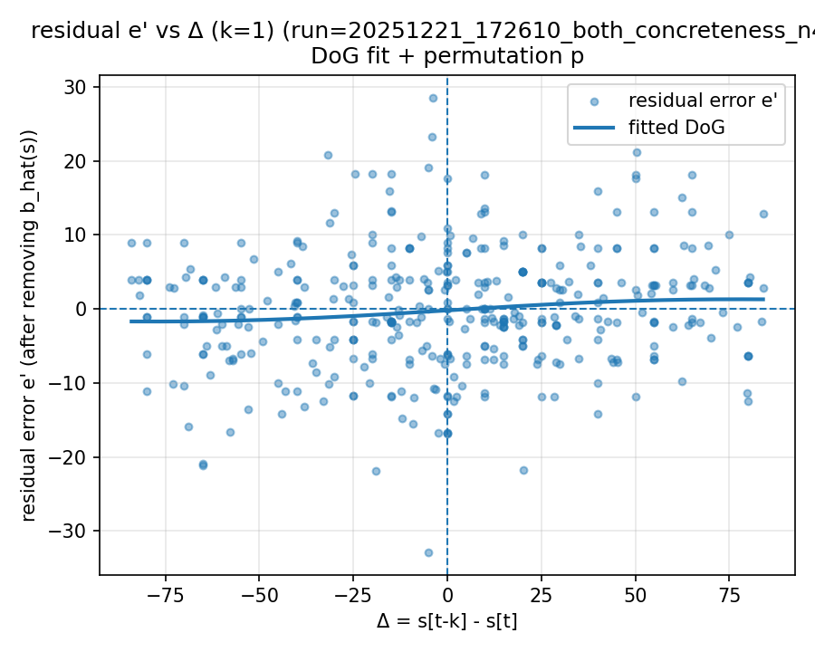 | 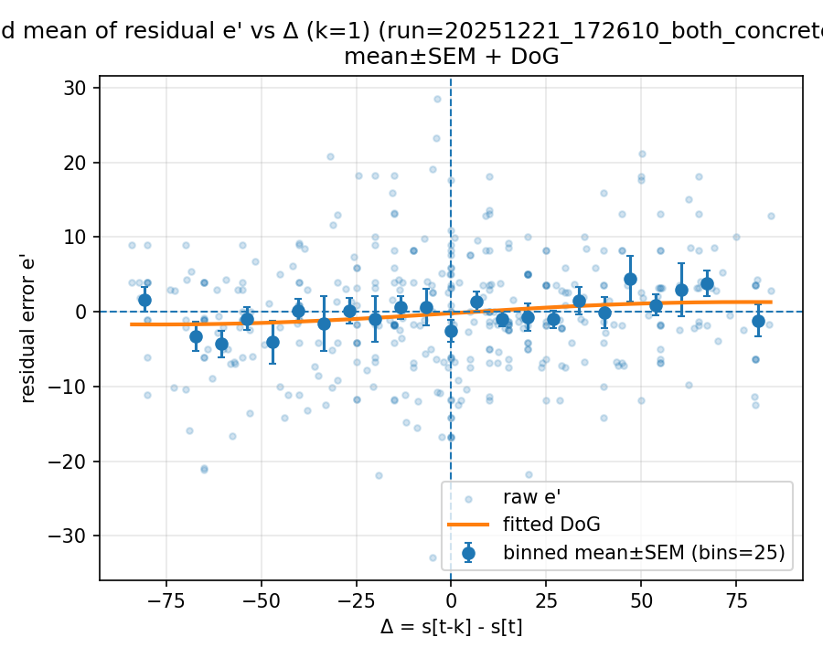

Mode: norms (stimulus=warriner_norms)
model: gpt-4o
which: both
dimension: concreteness
uses_warriner_word_source: False
n_words: 400
match_rate_vs_exp2: 0.3175
k=1 half_amp: 19.0067
k=1 sigma: 200
k=1 p (permutation): 0.045954
best p over ks: 0.045954 (k=1)
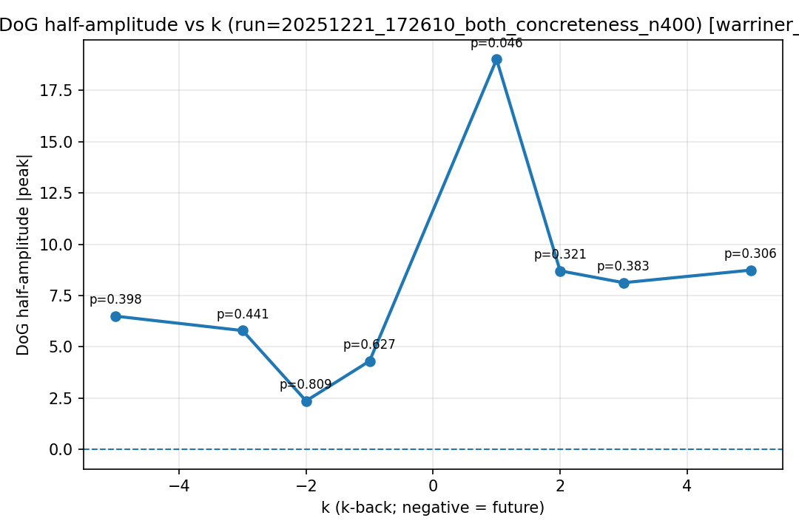
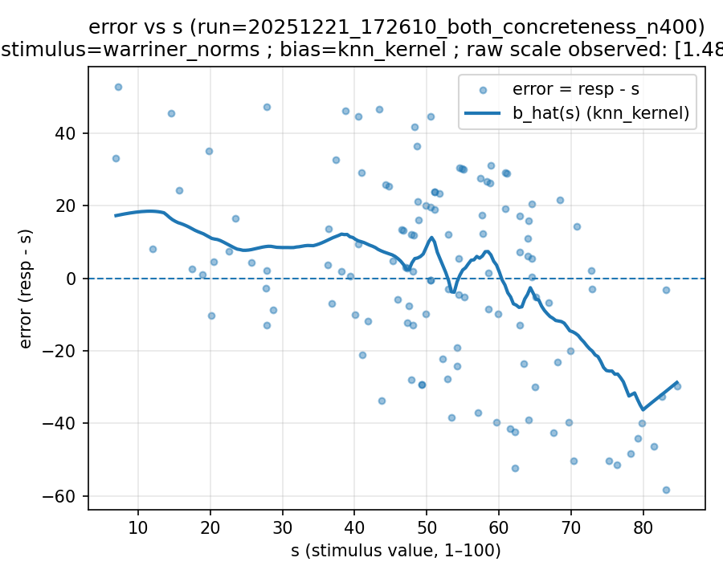 | 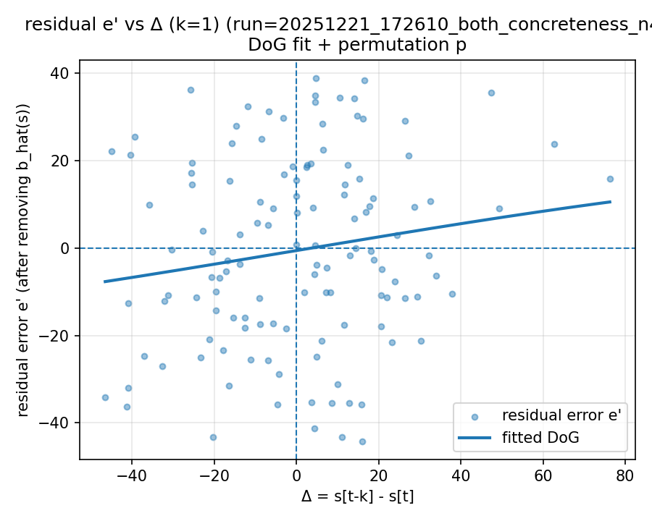 | 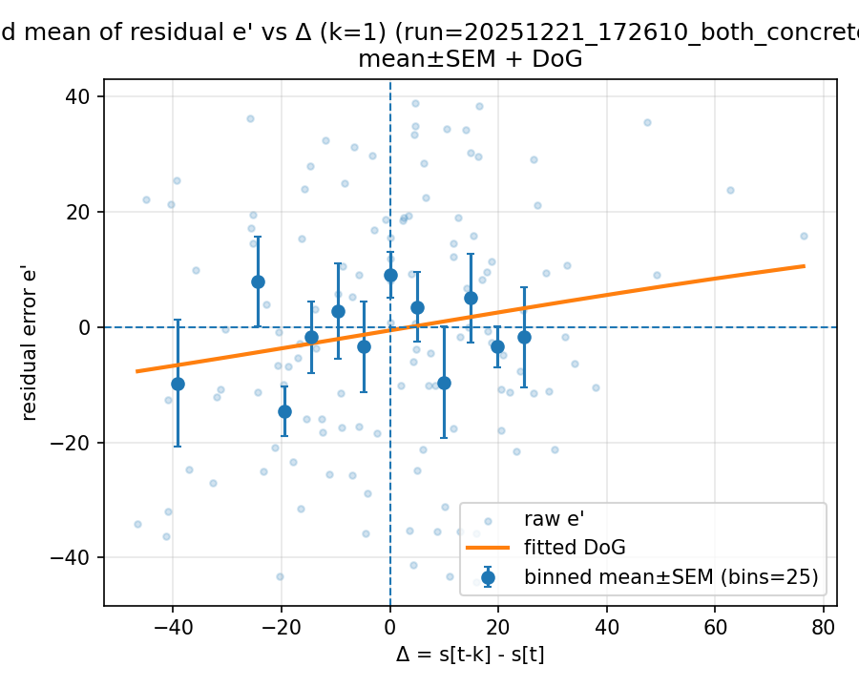

20251224_103903_gpt-4o_exp2_concreteness_n1000

Mode: norms (stimulus=warriner_norms)
model: gpt-4o
which: exp2
dimension: concreteness
uses_warriner_word_source: False
n_words: 1000
match_rate_vs_exp2: 0.337
k=1 half_amp: 9.82081
k=1 sigma: 200
k=1 p (permutation): 0.026973
best p over ks: 0.026973 (k=1)
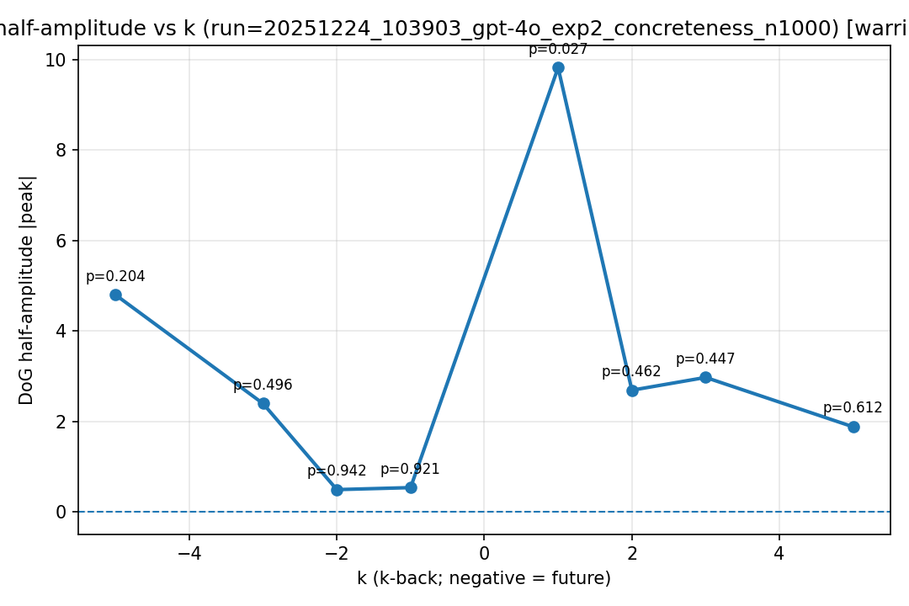
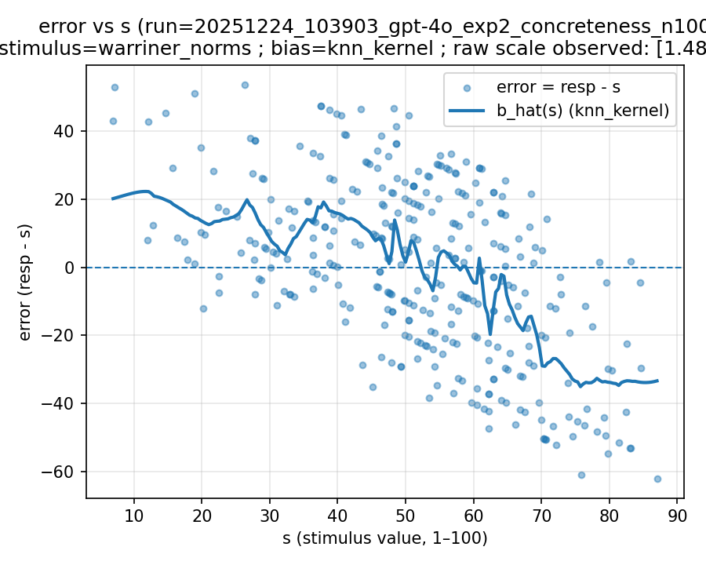 | 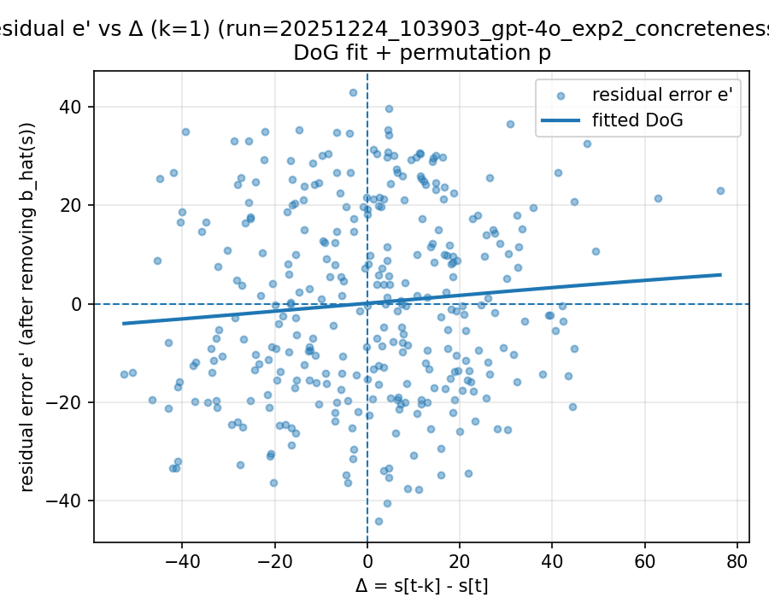 | 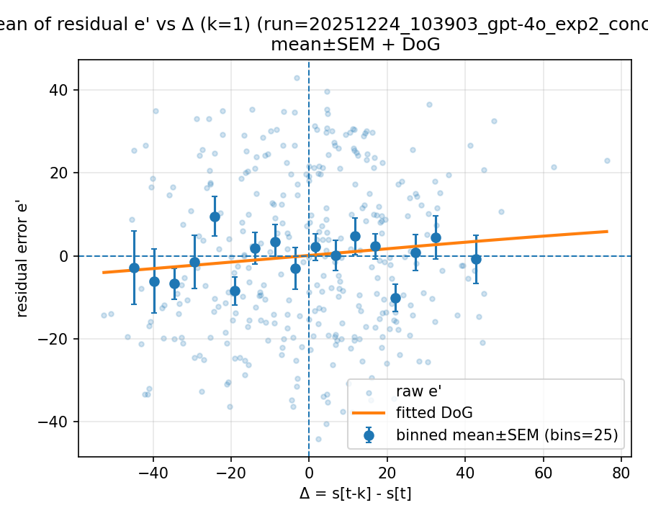

20260107_145719_gpt-4o_both_concreteness_n2000

Mode: exp1 (stimulus=exp1_mean)
model: gpt-4o
which: both
dimension: concreteness
uses_warriner_word_source: False
n_words: 2000
match_rate_vs_exp2: 1
k=1 half_amp: 1.82271
k=1 sigma: 200
k=1 p (permutation): 0.00599401
best p over ks: 0.00599401 (k=1)
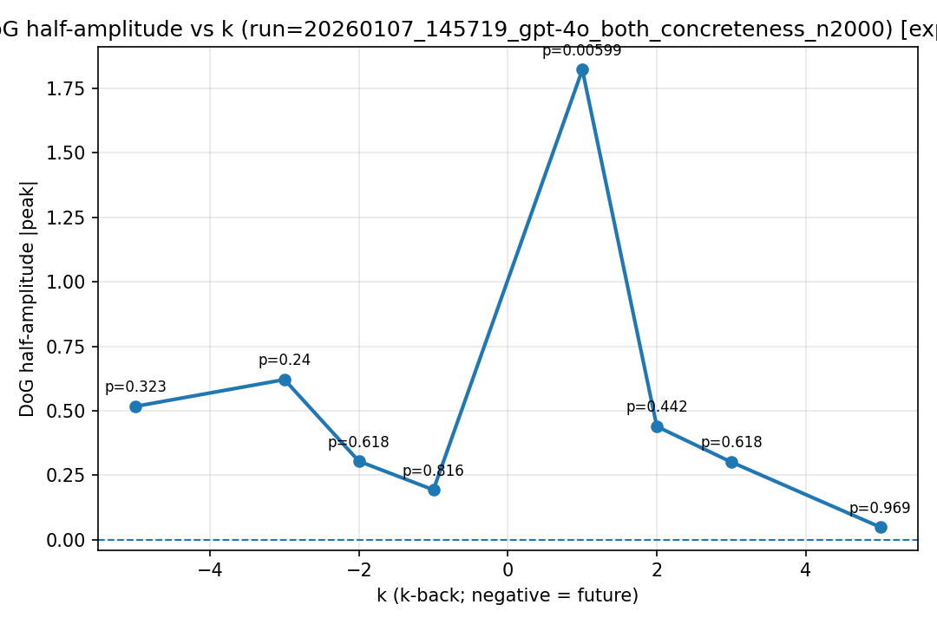
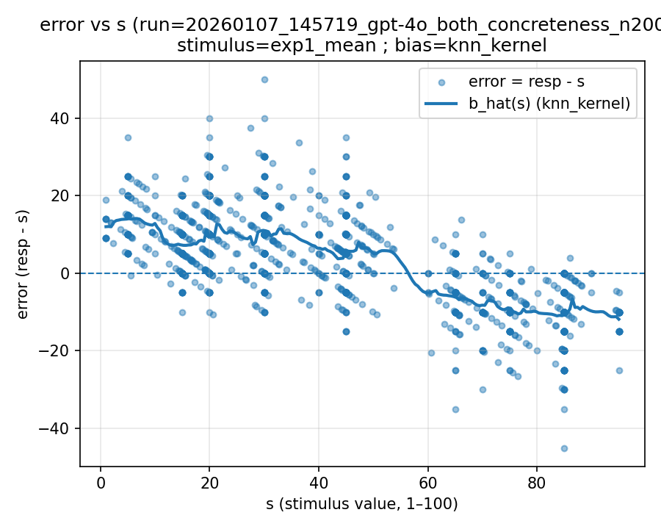 | 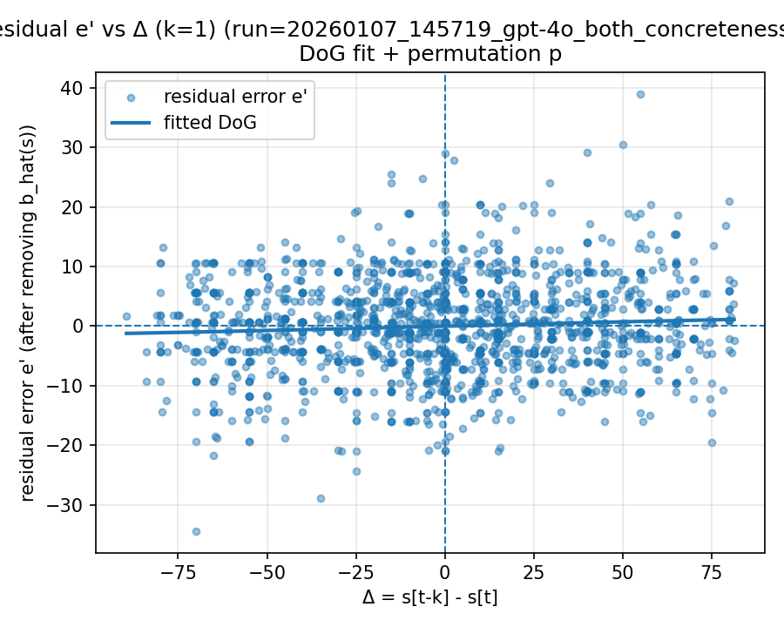 | 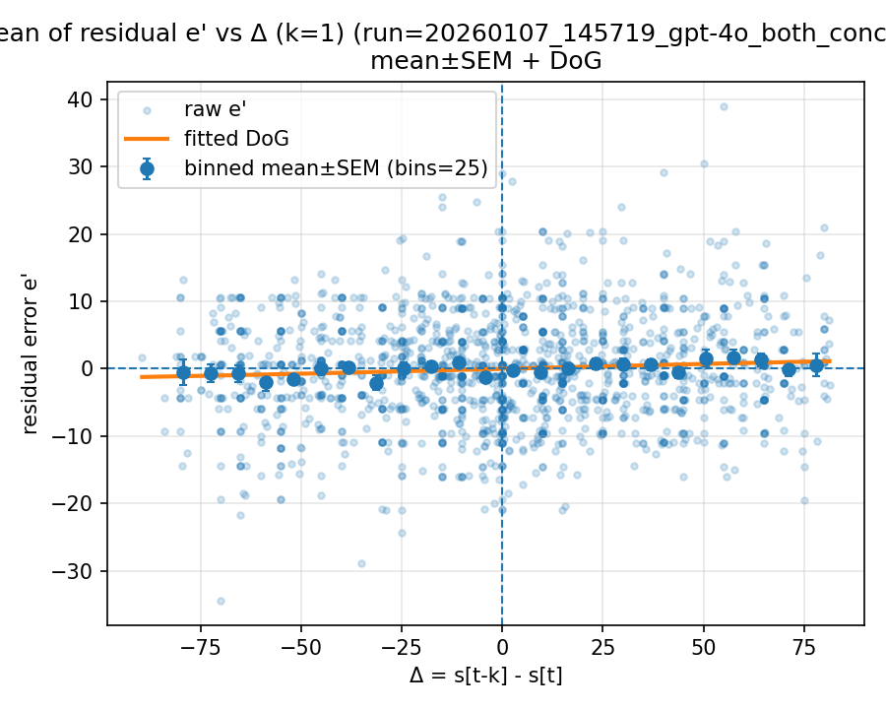

Mode: norms (stimulus=warriner_norms)
model: gpt-4o
which: both
dimension: concreteness
uses_warriner_word_source: False
n_words: 2000
match_rate_vs_exp2: 0.3362
k=1 half_amp: 5.61659
k=1 sigma: 200
k=1 p (permutation): 0.0549451
best p over ks: 0.0549451 (k=1)
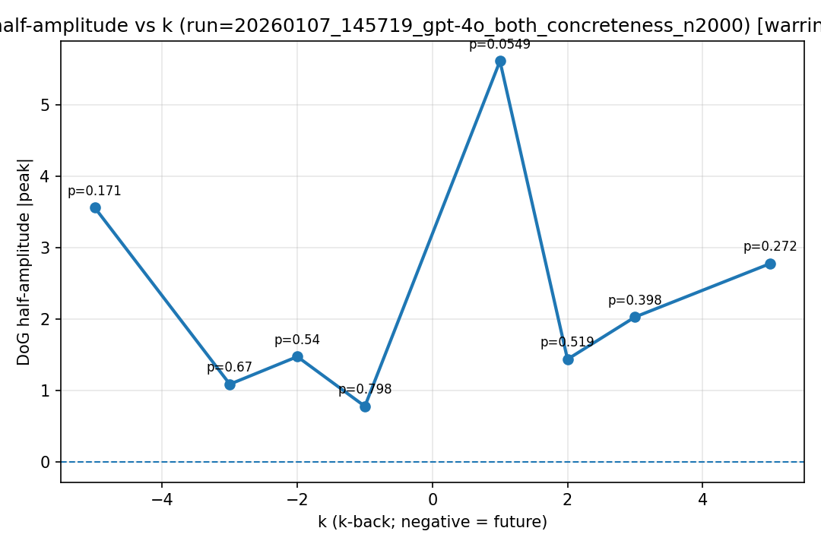
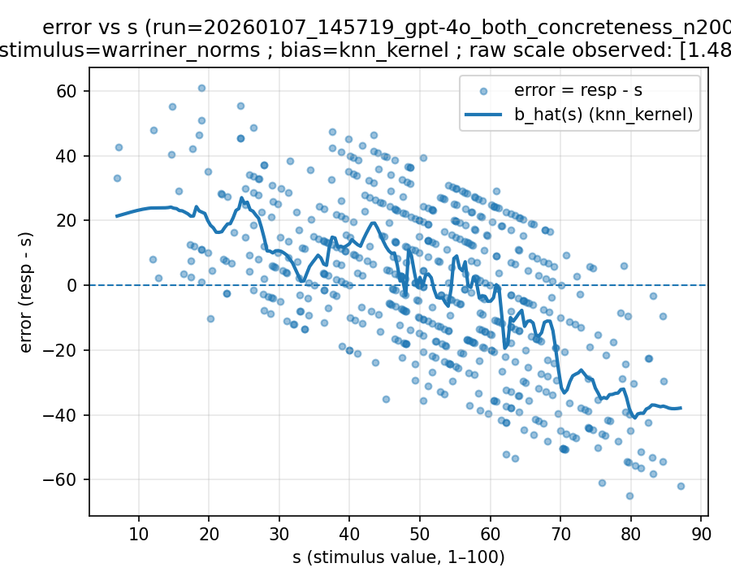 | 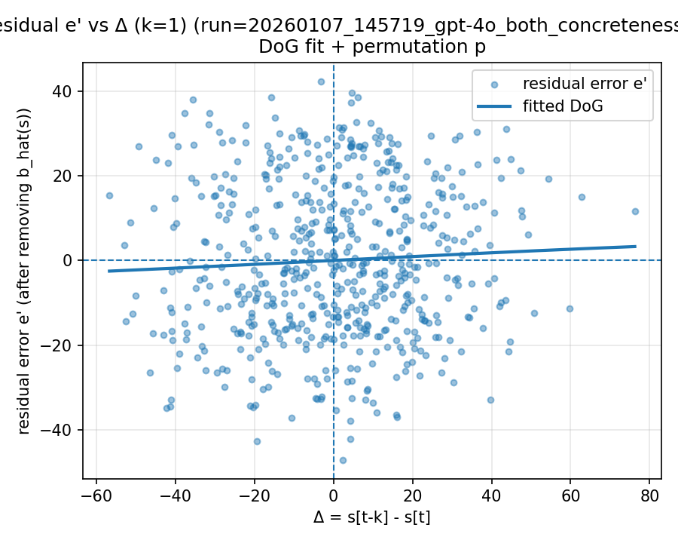 | 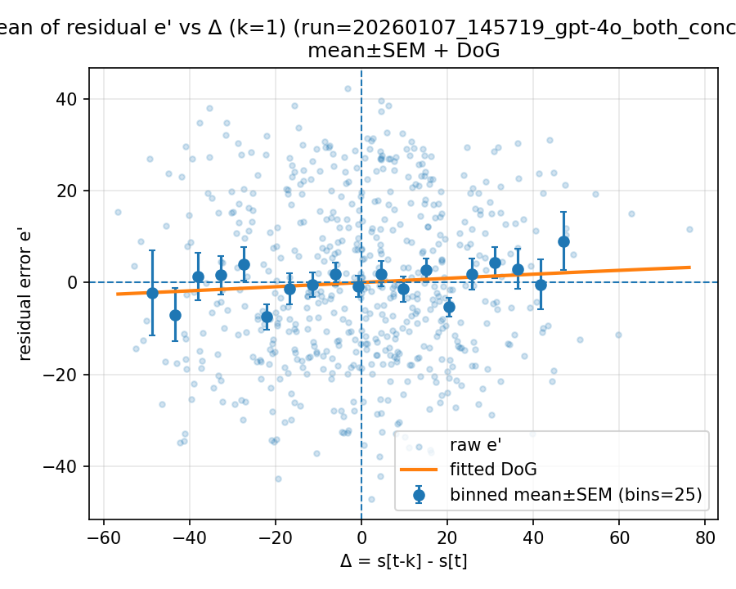

20260112_001408_gpt-4o_both_concreteness_n1000

Mode: exp1 (stimulus=exp1_mean)
model: gpt-4o
which: both
dimension: concreteness
uses_warriner_word_source: False
n_words: 1000
match_rate_vs_exp2: 1
k=1 half_amp: 1.4986
k=1 sigma: 93.4132
k=1 p (permutation): 0.0549451
best p over ks: 0.0549451 (k=1)
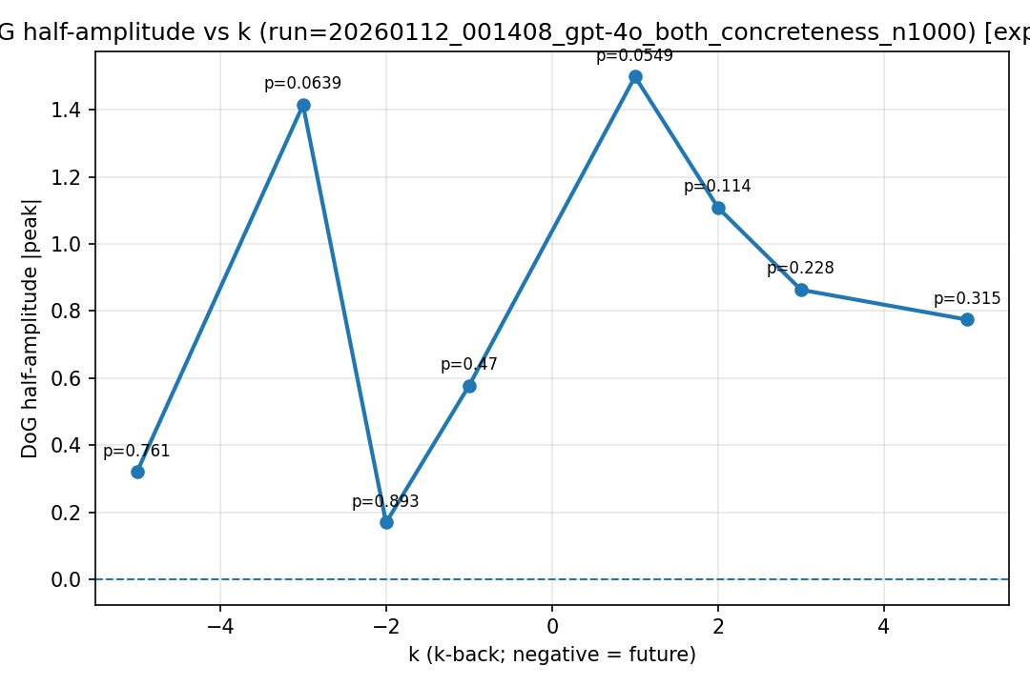
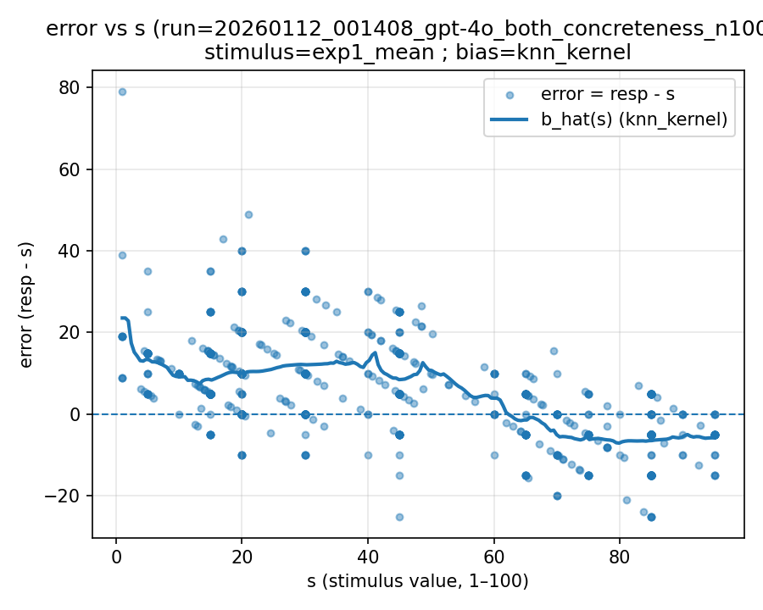 | 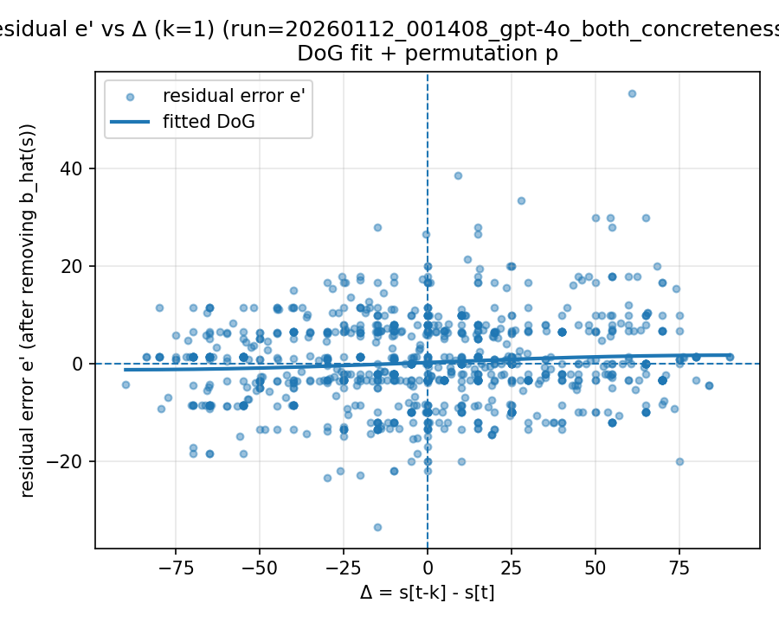 | 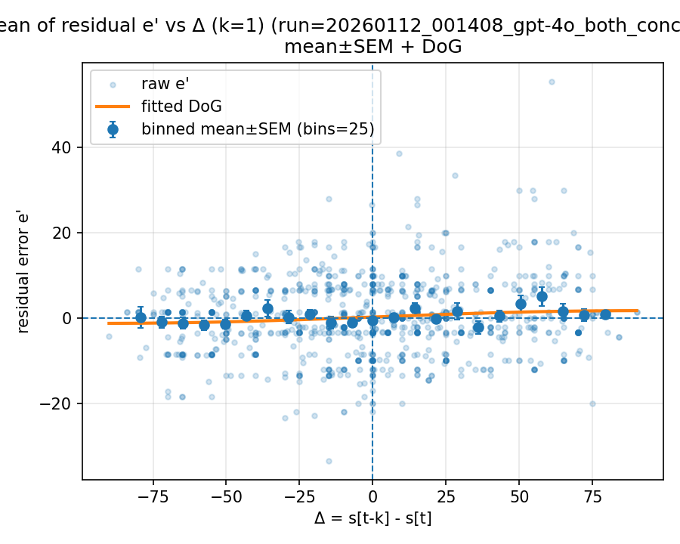

Mode: norms (stimulus=warriner_norms)
model: gpt-4o
which: both
dimension: concreteness
uses_warriner_word_source: False
n_words: 1000
match_rate_vs_exp2: 0.333
k=1 half_amp: 2.00226
k=1 sigma: 25.9533
k=1 p (permutation): 0.591409
best p over ks: 0.00999001 (k=-2)
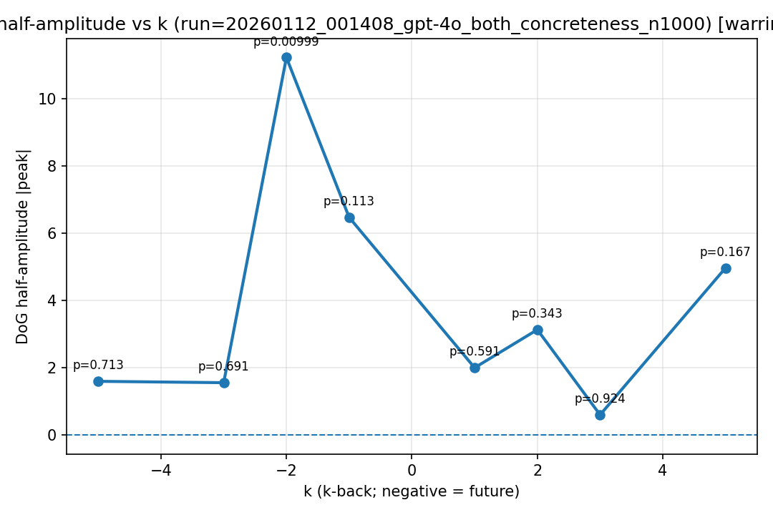
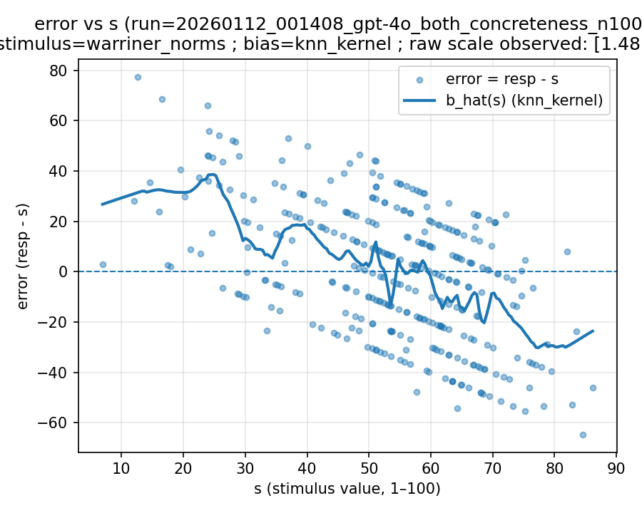 | 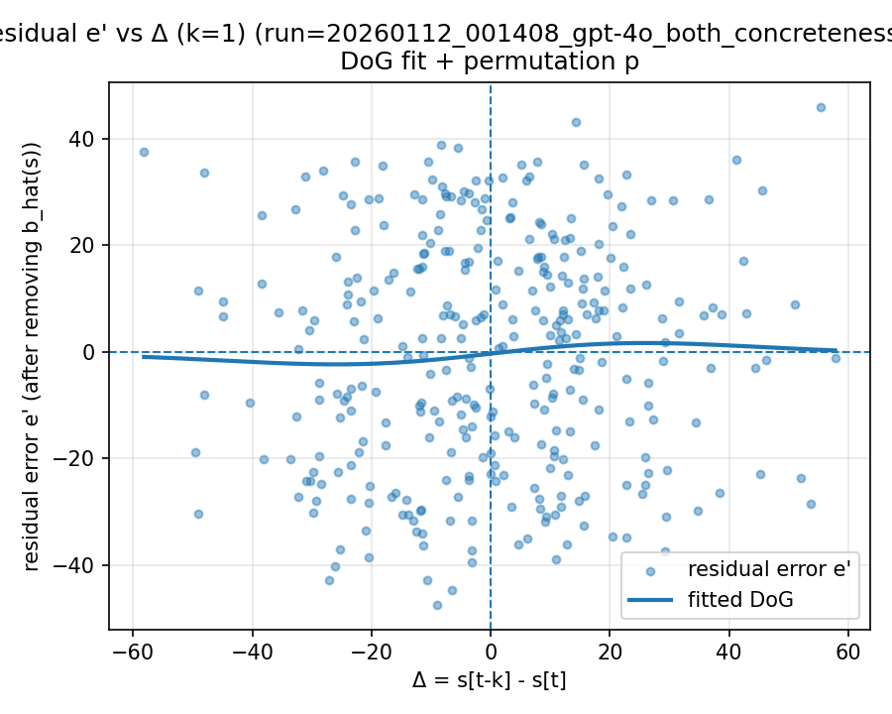 | 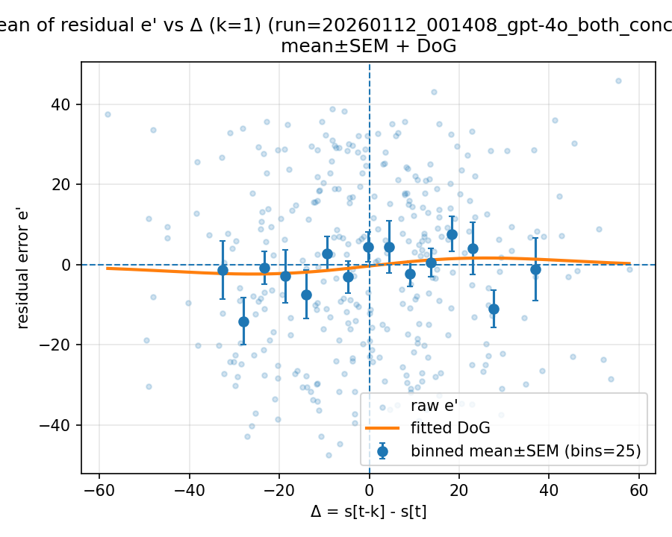

20260113_162650_gpt-4o_both_concreteness_n1000

Mode: exp1 (stimulus=exp1_mean)
model: gpt-4o
which: both
dimension: concreteness
uses_warriner_word_source: False
n_words: 1000
match_rate_vs_exp2: 1
k=1 half_amp: 1.82026
k=1 sigma: 200
k=1 p (permutation): 0.046953
best p over ks: 0.046953 (k=1)
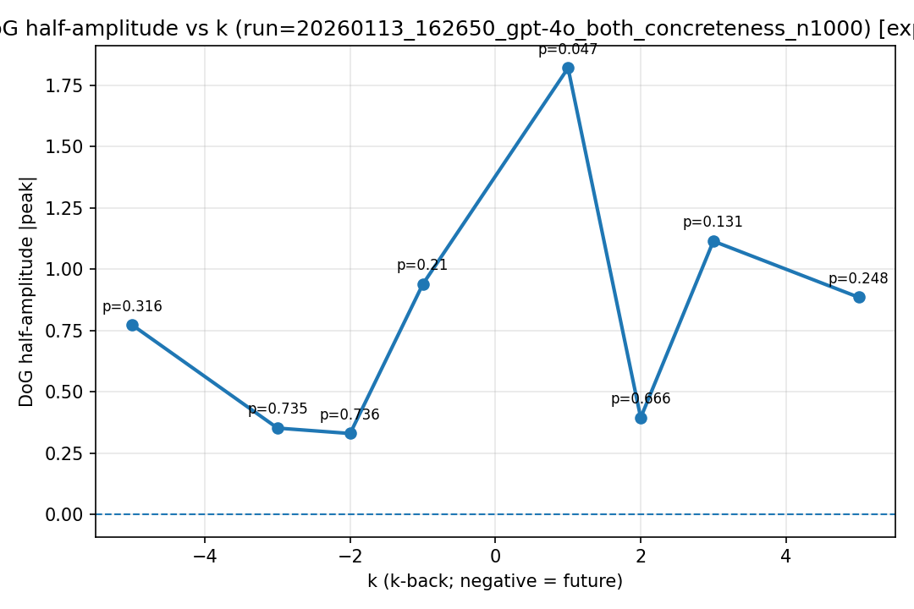
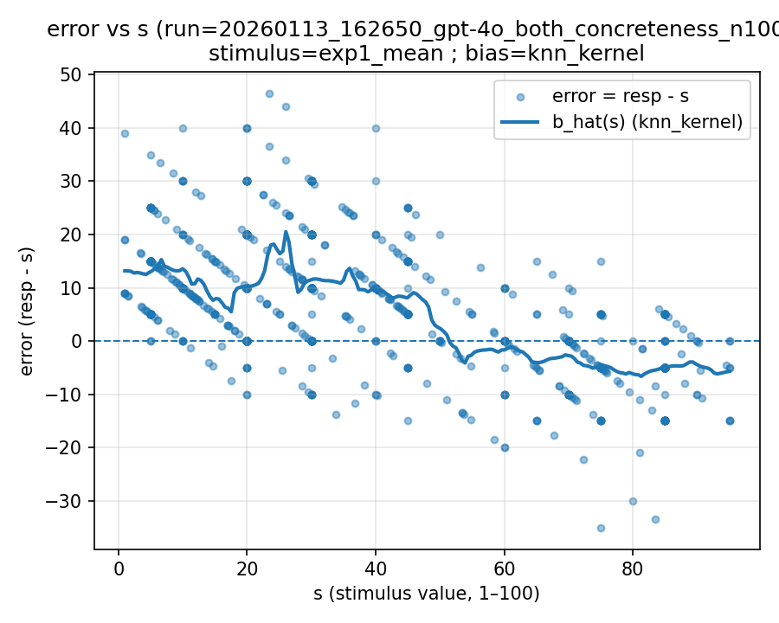 | 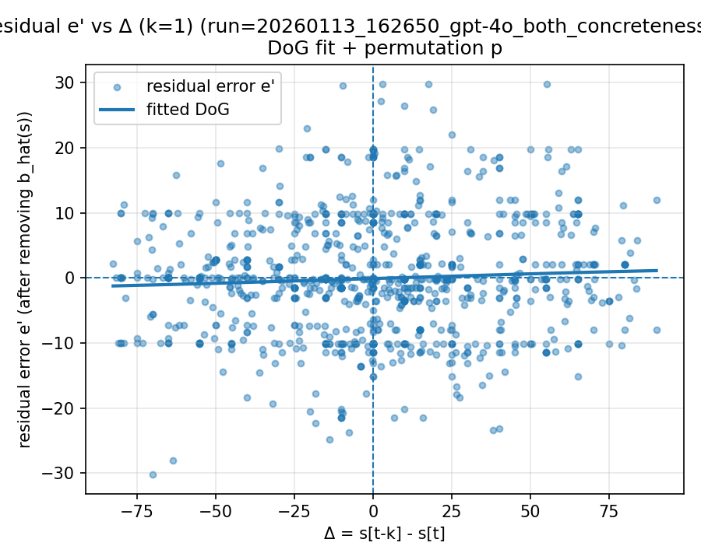 | 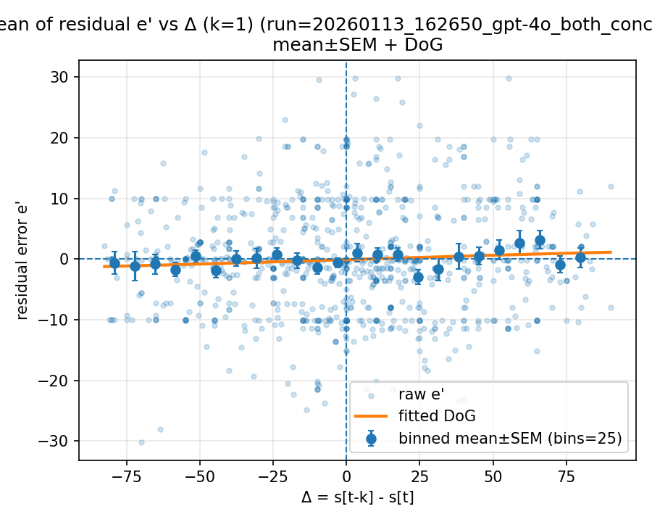

Mode: norms (stimulus=warriner_norms)
model: gpt-4o
which: both
dimension: concreteness
uses_warriner_word_source: False
n_words: 1000
match_rate_vs_exp2: 0.316
k=1 half_amp: 0.854998
k=1 sigma: 10.8805
k=1 p (permutation): 0.848152
best p over ks: 0.0809191 (k=5)
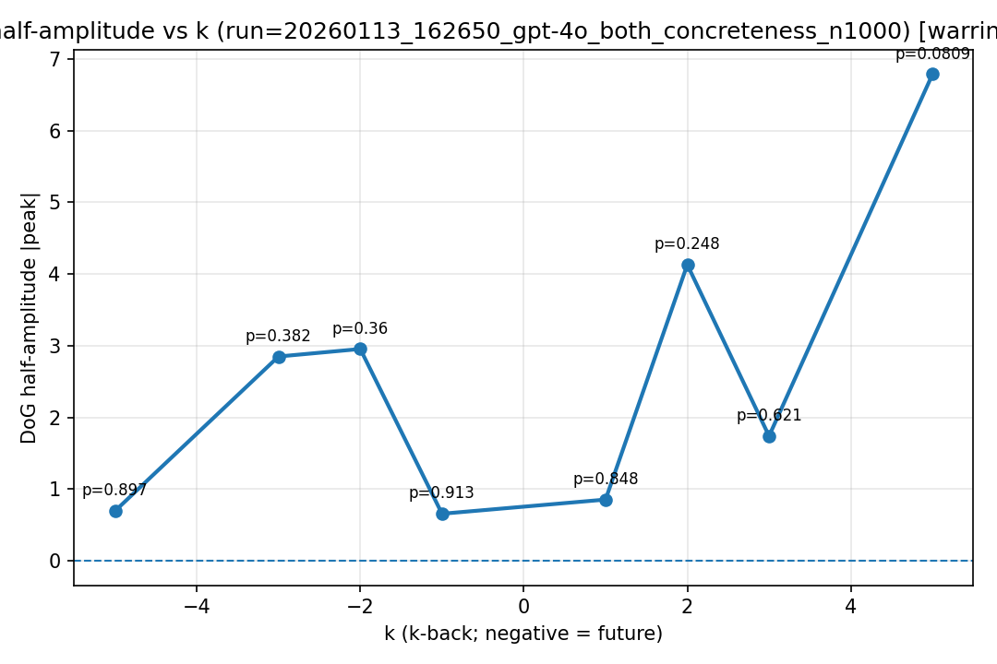
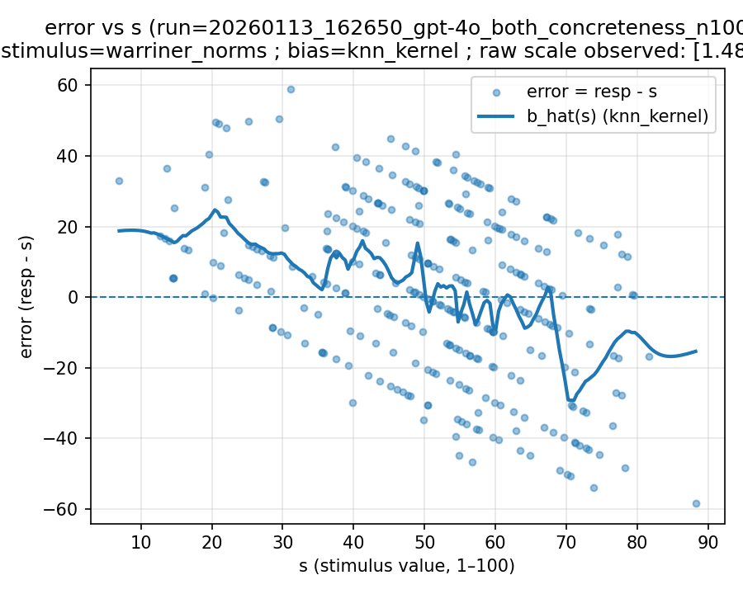 | 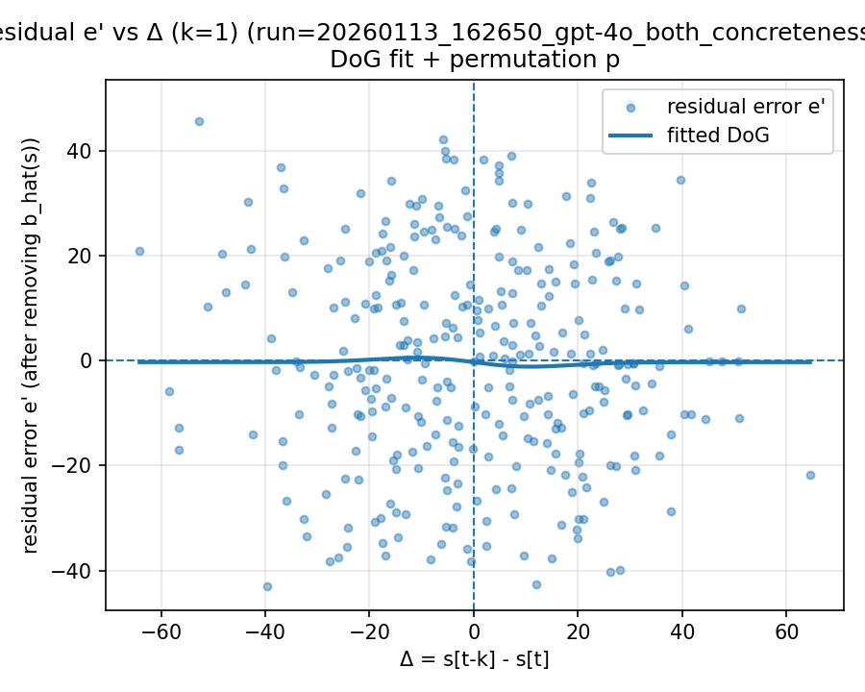 | 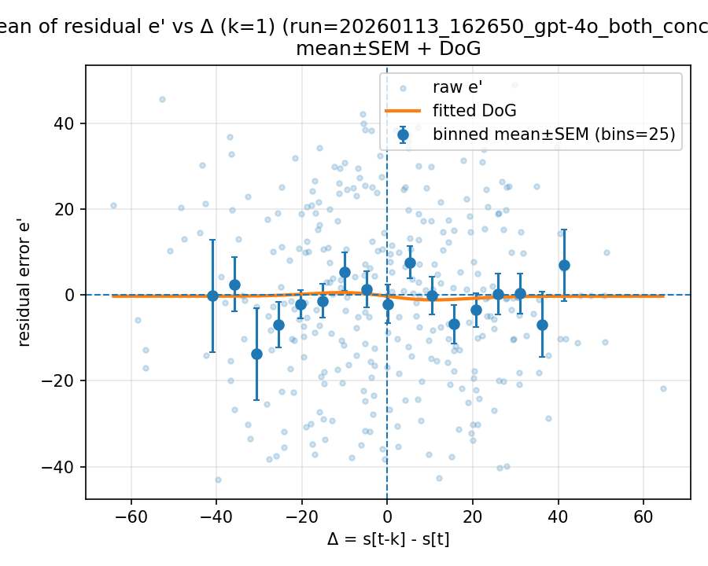

20260122_222005_gpt-4o_both_concreteness_n1000

Mode: exp1 (stimulus=exp1_mean)
model: gpt-4o
which: both
dimension: concreteness
uses_warriner_word_source: False
n_words: 1000
match_rate_vs_exp2: 1
k=1 half_amp: 0.812269
k=1 sigma: 44.5404
k=1 p (permutation): 0.342657
best p over ks: 0.28971 (k=5)
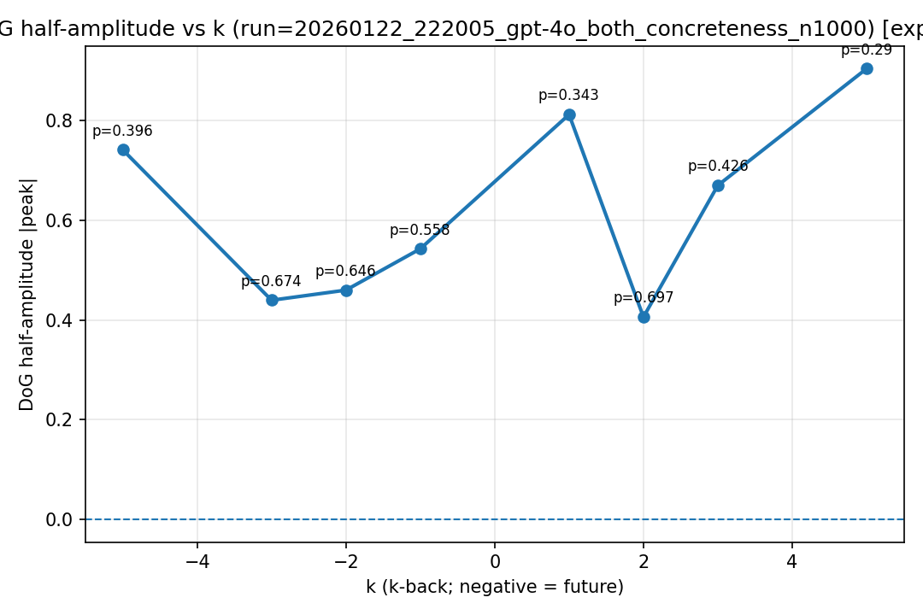
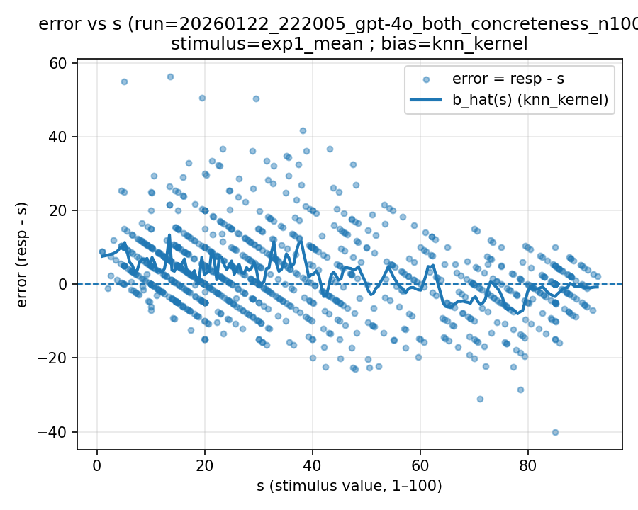 | 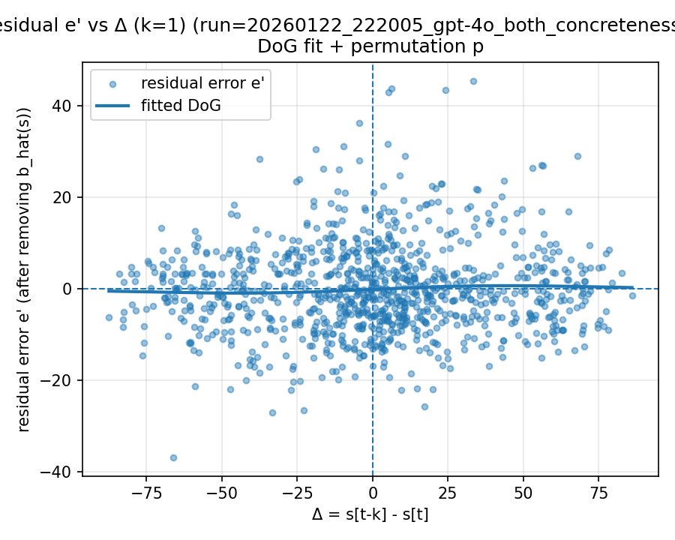 | 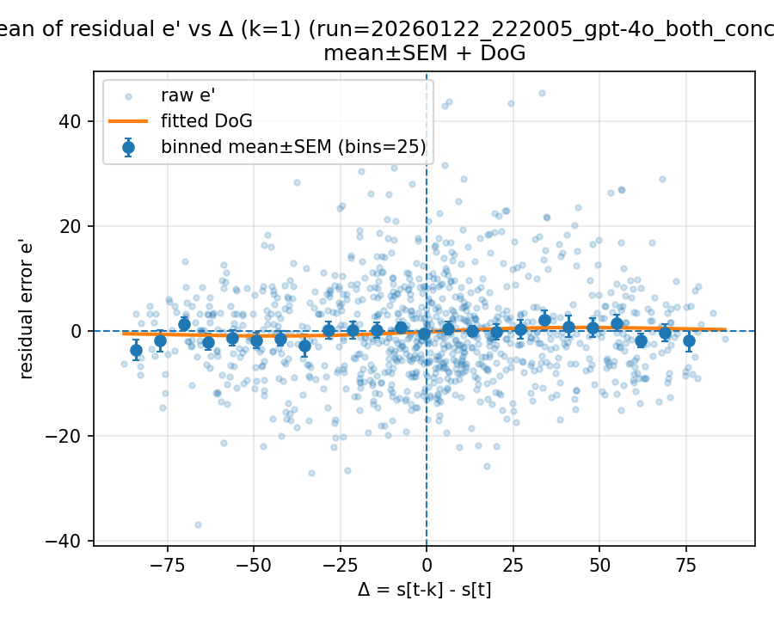

Mode: norms (stimulus=warriner_norms)
model: gpt-4o
which: both
dimension: concreteness
uses_warriner_word_source: False
n_words: 1000
match_rate_vs_exp2: 0.333
k=1 half_amp: 2.49197
k=1 sigma: 6.72899
k=1 p (permutation): 0.634366
best p over ks: 0.136863 (k=-3)
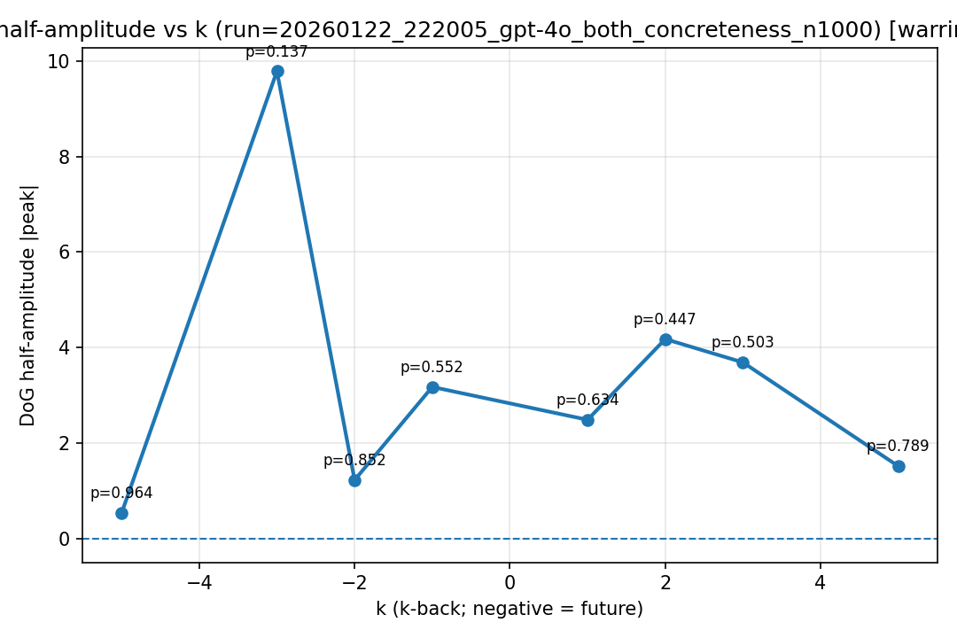
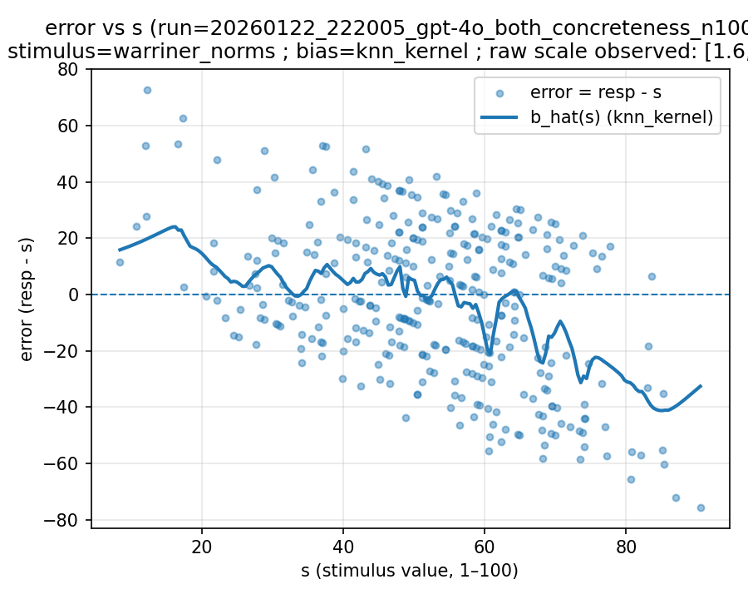 | 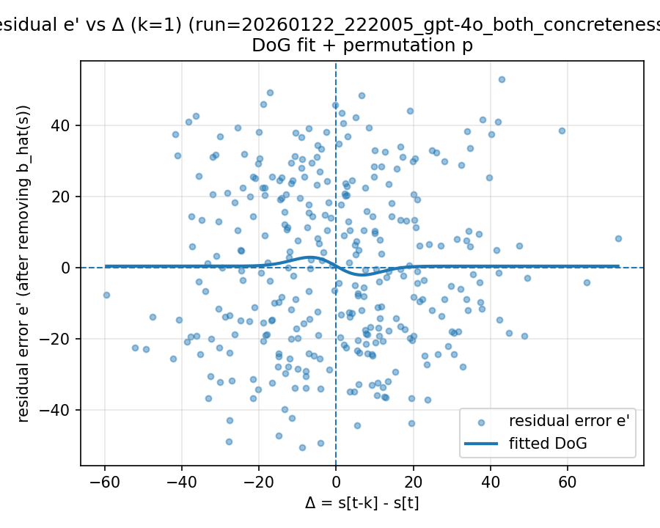 | 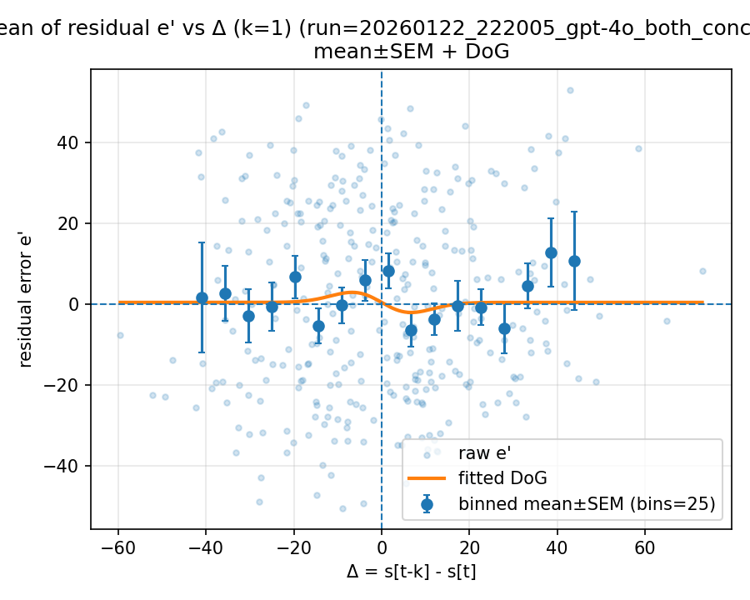

20260126_174821_gpt-4o_exp2_concreteness_n2000

kvMode: norms (stimulus=warriner_norms)
model: gpt-4o
which: exp2
dimension: concreteness
uses_warriner_word_source: False
n_words: 2000
match_rate_vs_exp2: 0.33
k=1 half_amp: 2.66041
k=1 sigma: 12.2246
k=1 p (permutation): 0.406593
best p over ks: 0.04995 (k=2)
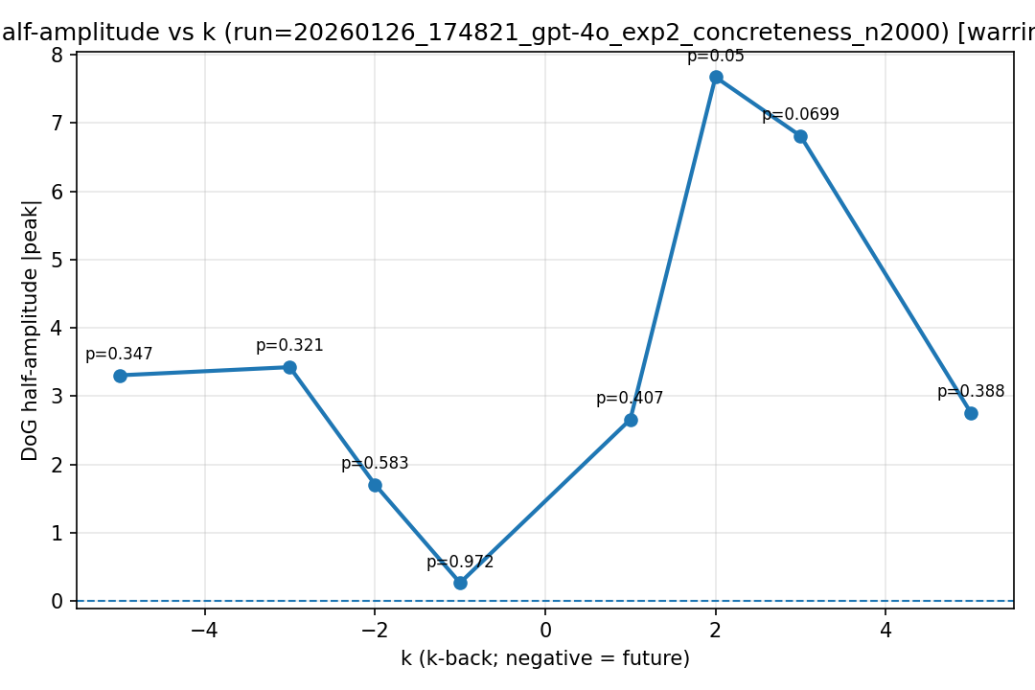
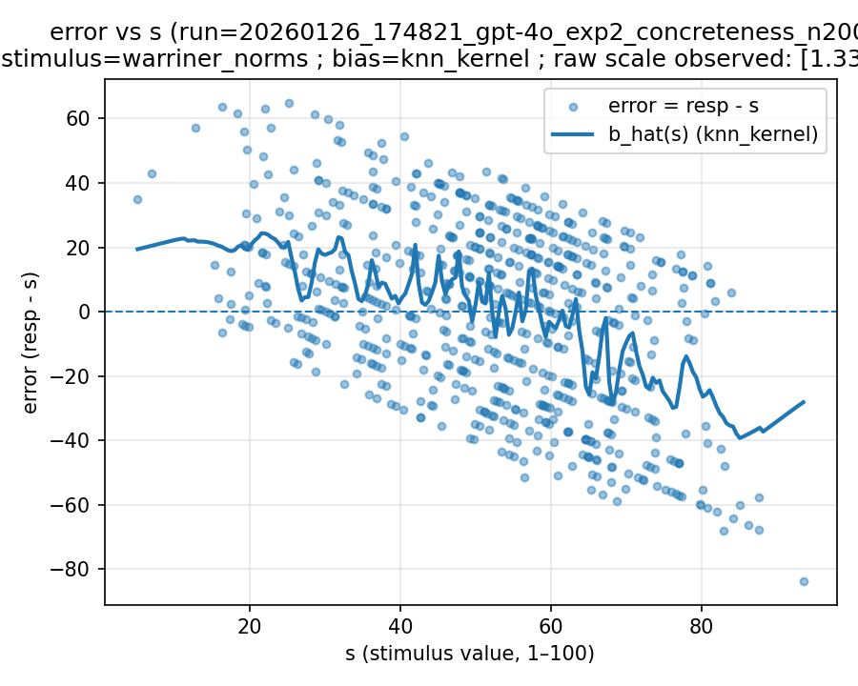 | 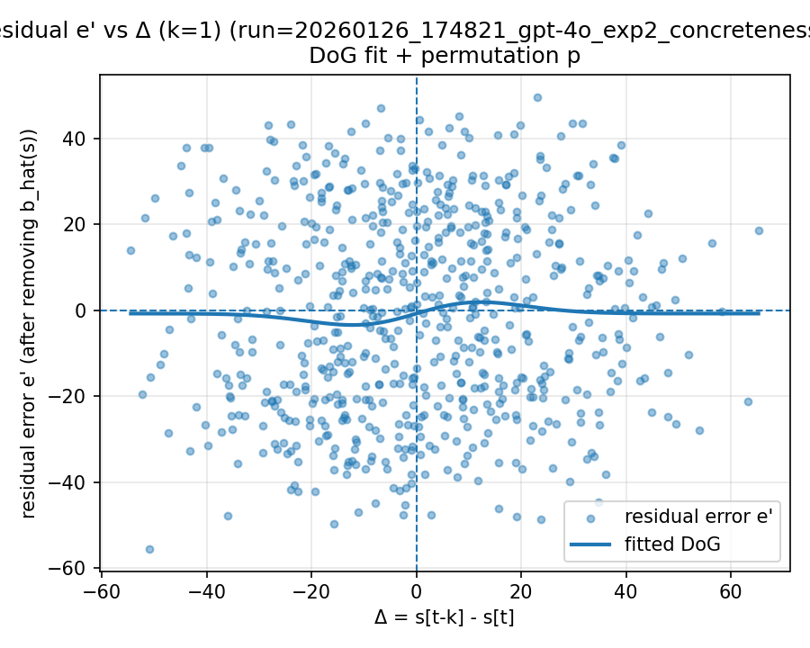 | 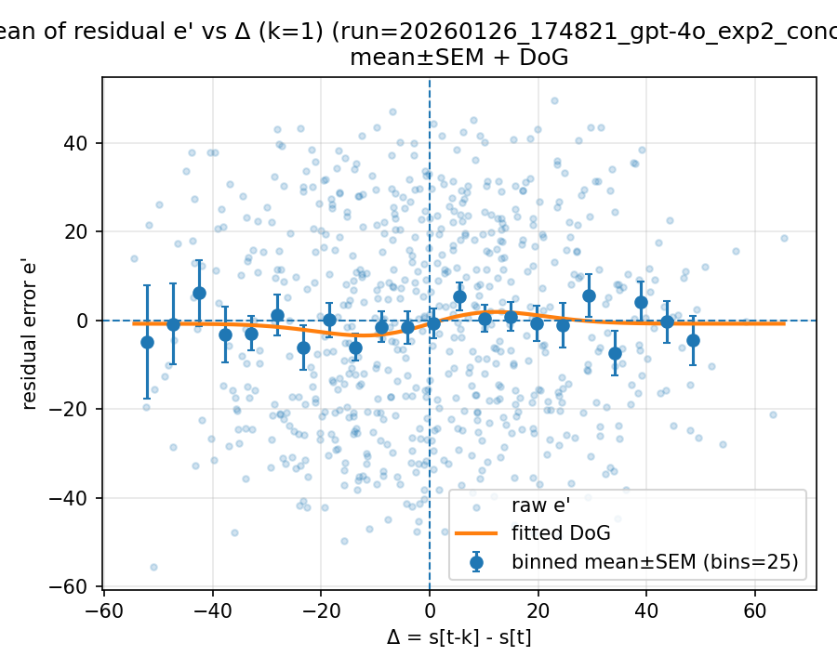

20260126_174922_gpt-4o_exp2_valence_n1000

kvMode: norms (stimulus=warriner_norms)
model: gpt-4o
which: exp2
dimension: valence
uses_warriner_word_source: False
n_words: 1000
match_rate_vs_exp2: 0.339
k=1 half_amp: 1.09993
k=1 sigma: 5.57045
k=1 p (permutation): 0.518482
best p over ks: 0.0919081 (k=-5)
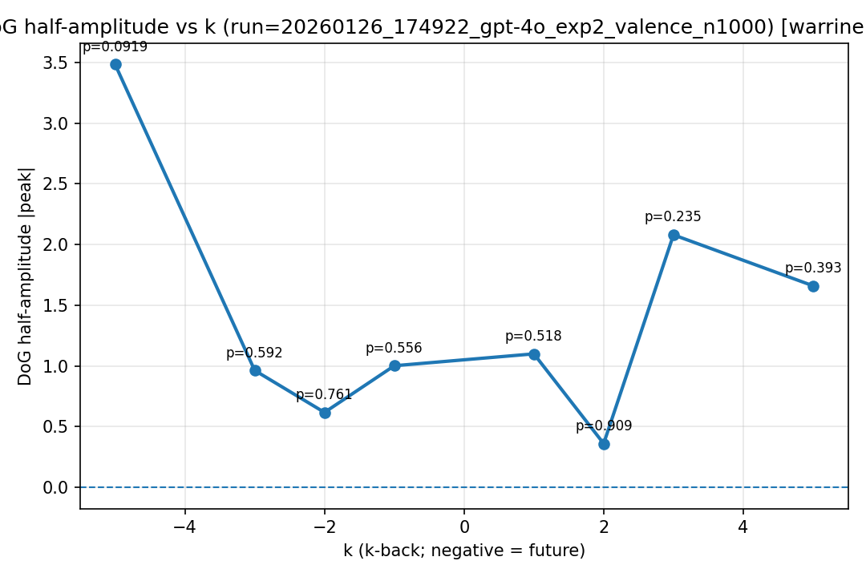
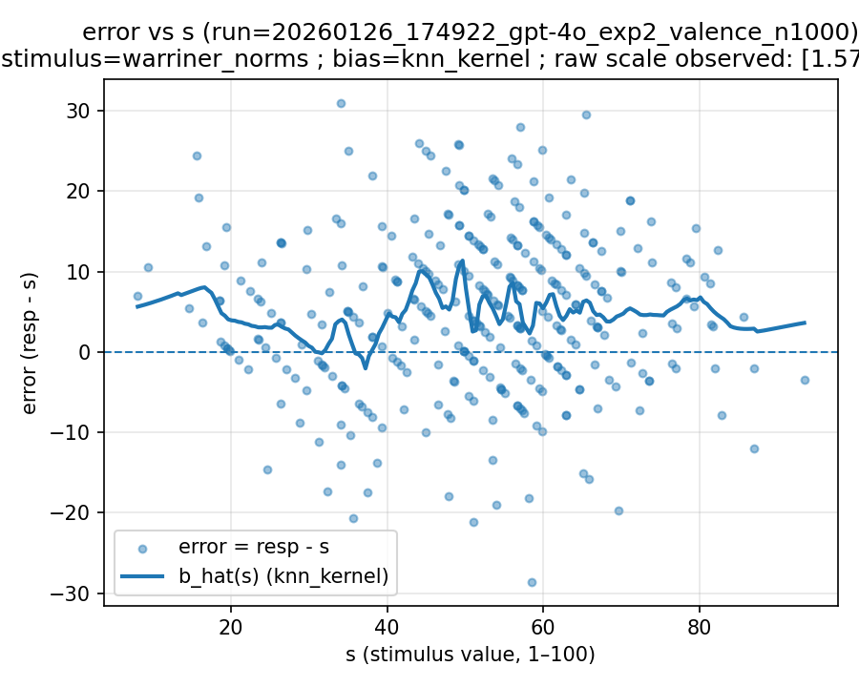 | 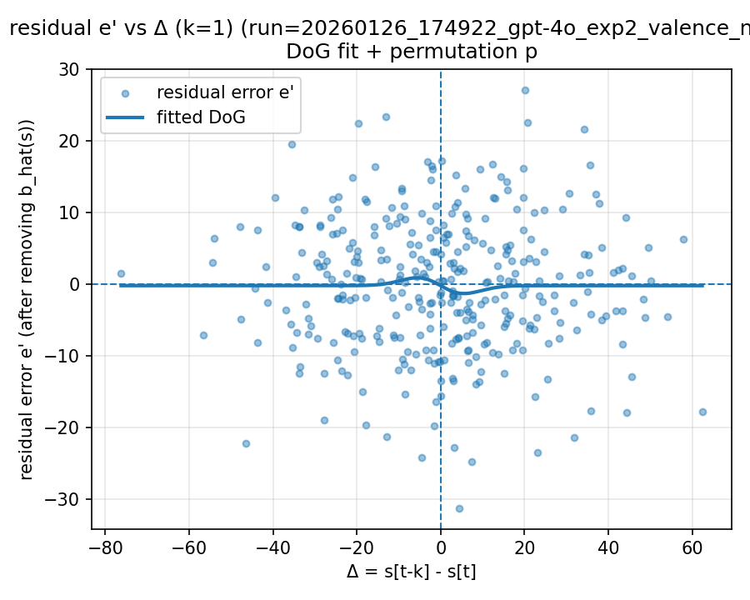 | 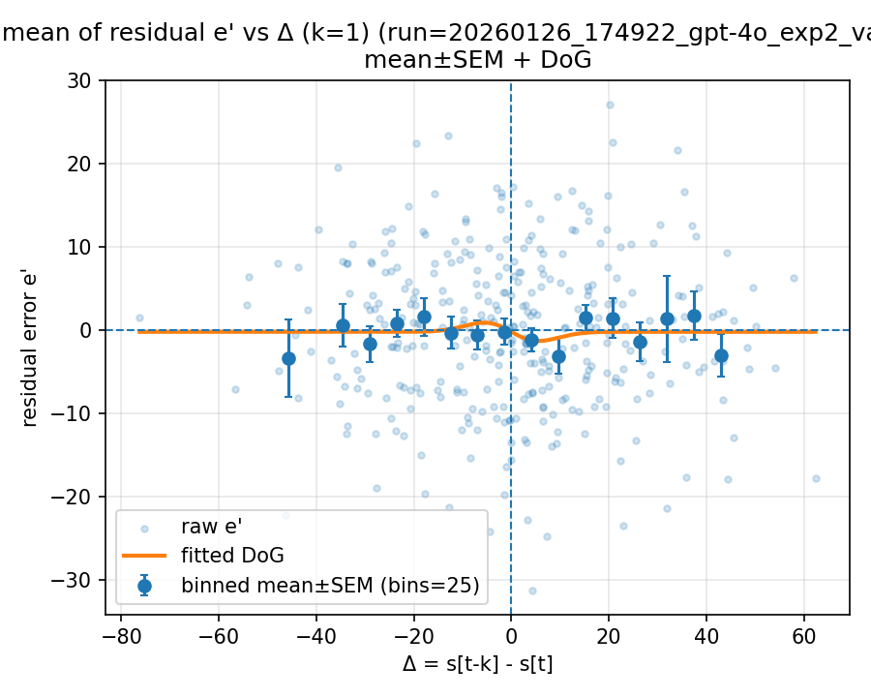

20260126_192052_gpt-4o_exp2_concreteness_n1000

kvMode: norms (stimulus=warriner_norms)
model: gpt-4o
which: exp2
dimension: concreteness
uses_warriner_word_source: False
n_words: 1000
match_rate_vs_exp2: 0.357
k=1 half_amp: 0.84742
k=1 sigma: 49.8835
k=1 p (permutation): 0.884116
best p over ks: 0.017982 (k=-3)
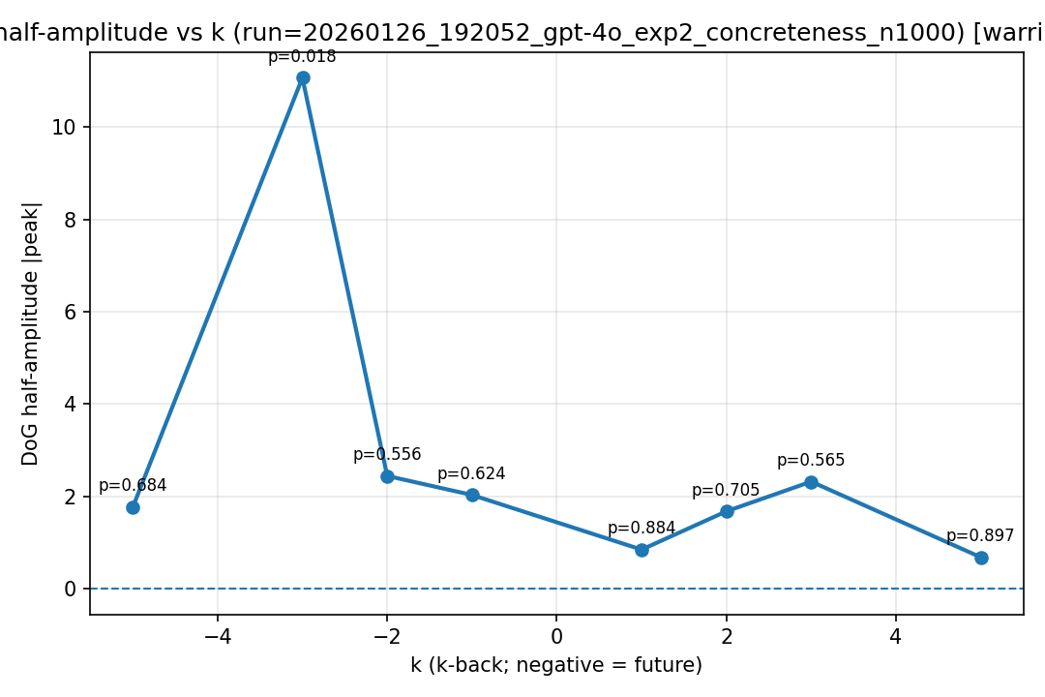
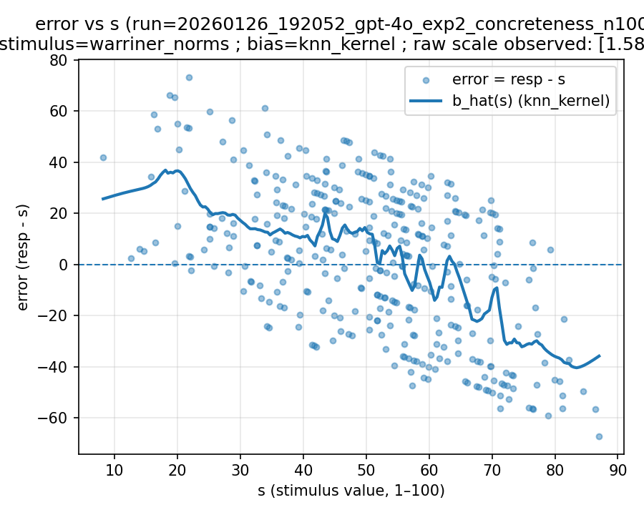 | 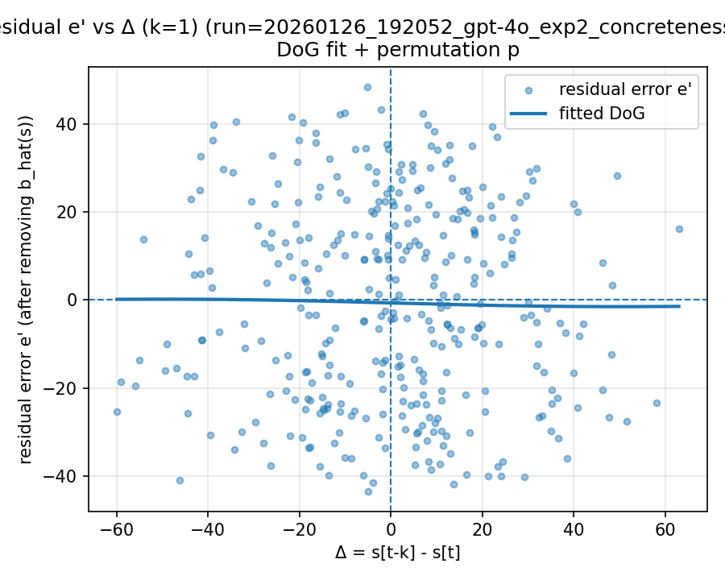 | 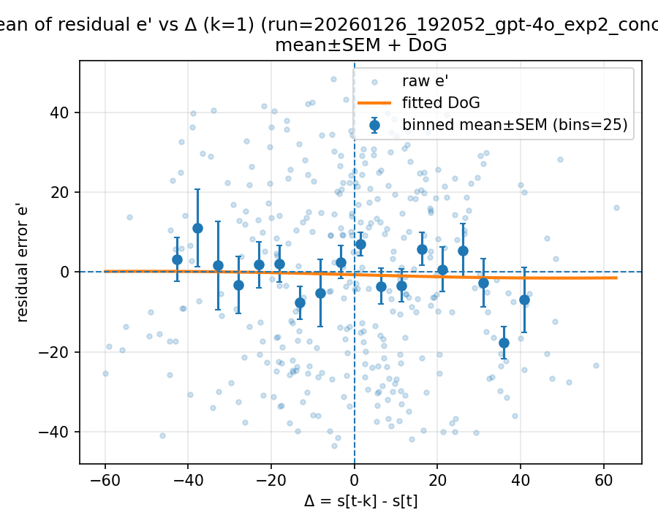

20260127_225919_gpt-4o_exp2_concreteness_n1000

非kv较好结果Mode: norms (stimulus=warriner_norms)
model: gpt-4o
which: exp2
dimension: concreteness
uses_warriner_word_source: False
n_words: 1000
match_rate_vs_exp2: 0.346
k=1 half_amp: 4.77728
k=1 sigma: 7.30229
k=1 p (permutation): 0.197802
best p over ks: 0.197802 (k=1)
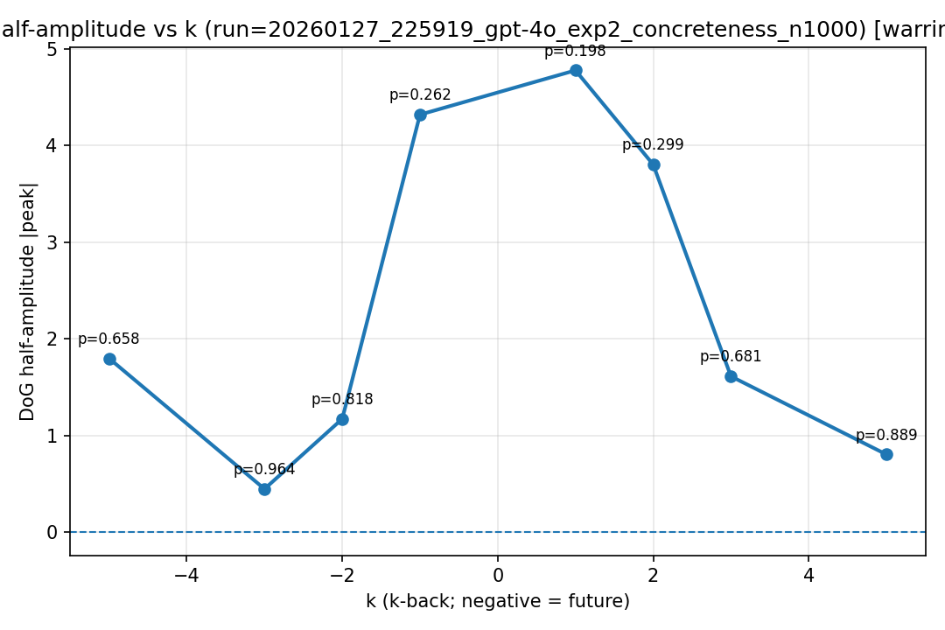
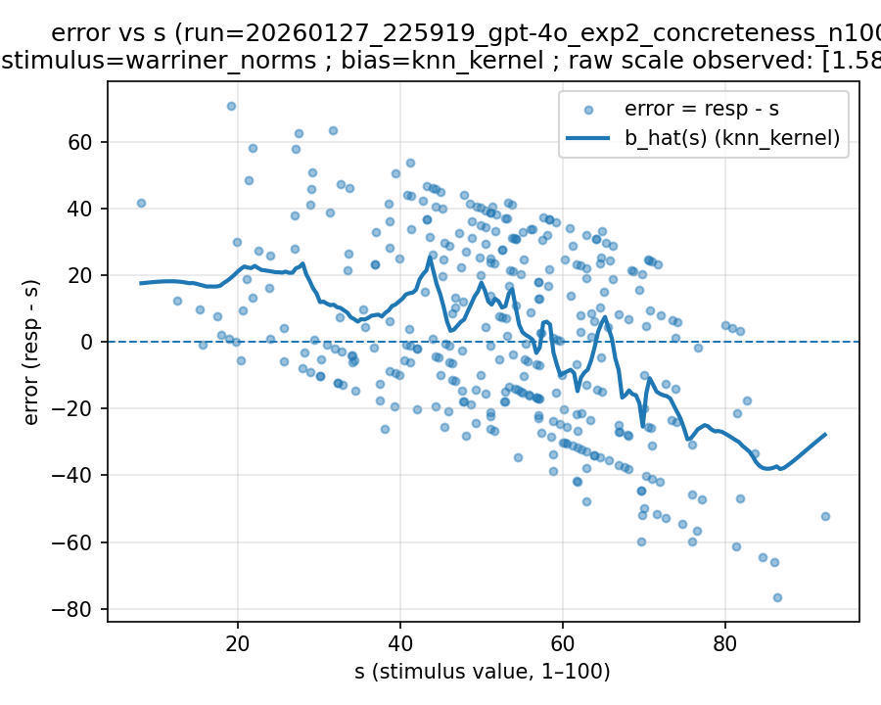 | 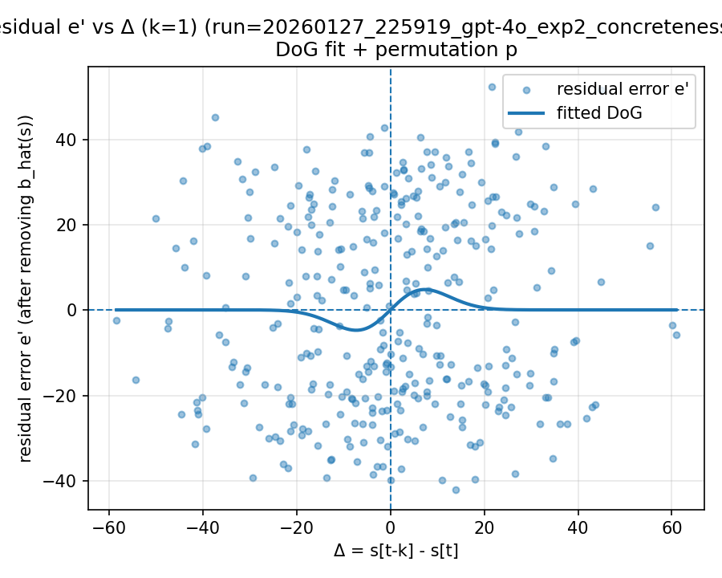 | 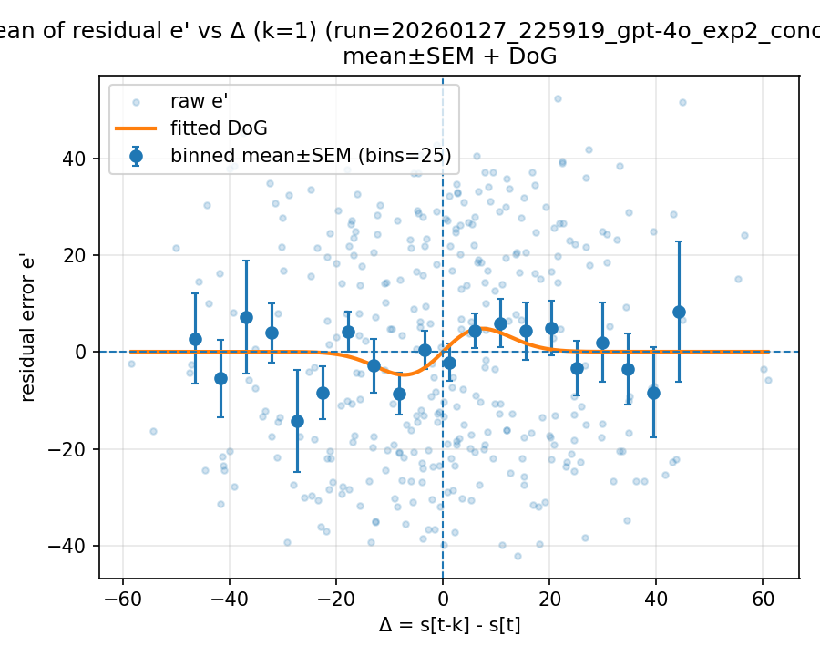

20260127_230016_gpt-4o_exp2_valence_n1000

Mode: norms (stimulus=warriner_norms)
model: gpt-4o
which: exp2
dimension: valence
uses_warriner_word_source: False
n_words: 1000
match_rate_vs_exp2: 0.327
k=1 half_amp: 0.0972654
k=1 sigma: 15.3237
k=1 p (permutation): 0.987013
best p over ks: 0.28971 (k=-5)
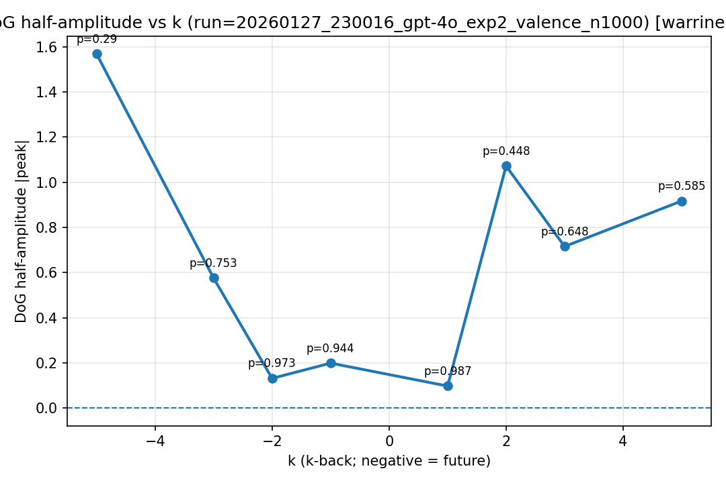
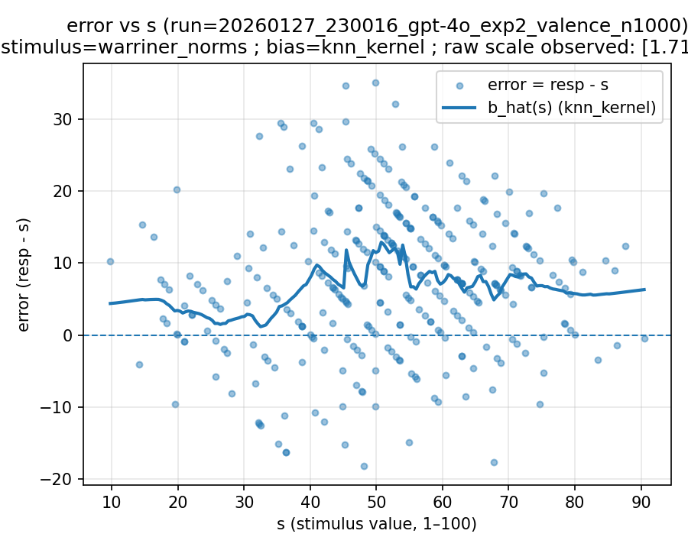 | 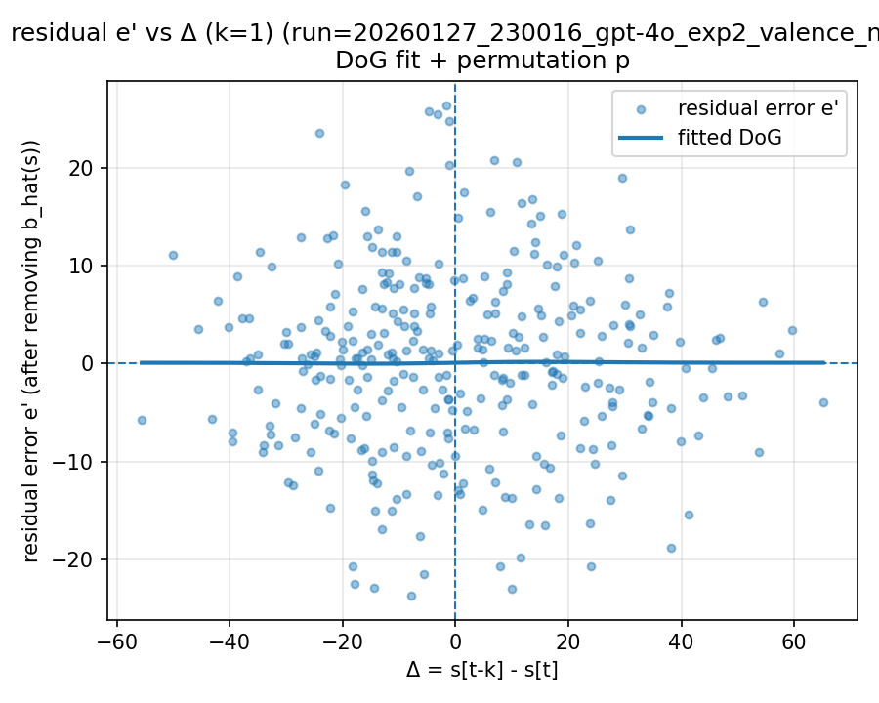 | 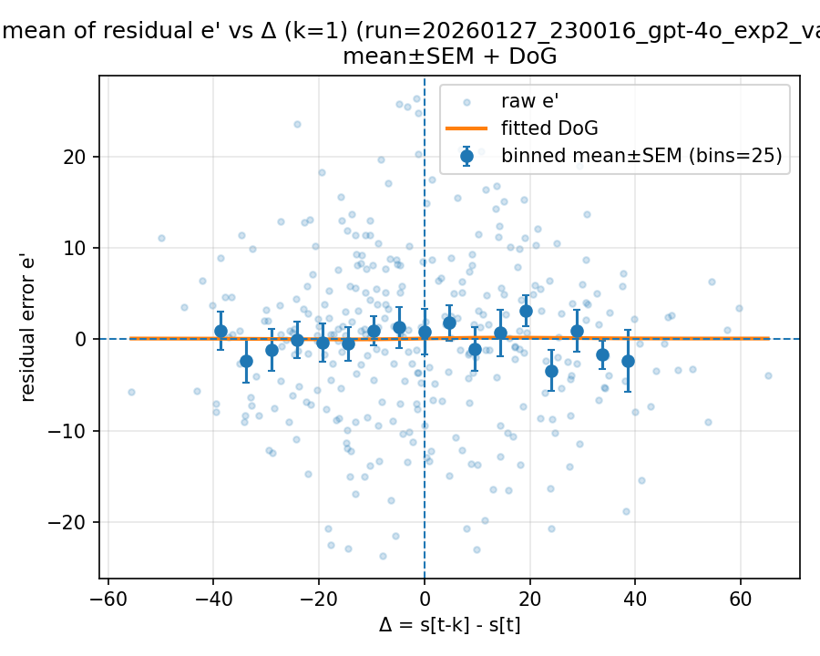

20260128_002209_gpt-4o_exp2_valence_n1000

Mode: norms (stimulus=warriner_norms)
model: gpt-4o
which: exp2
dimension: valence
uses_warriner_word_source: False
n_words: 1000
match_rate_vs_exp2: 0.3383
k=1 half_amp: 2.11447
k=1 sigma: 6.07042
k=1 p (permutation): 0.195804
best p over ks: 0.195804 (k=1)
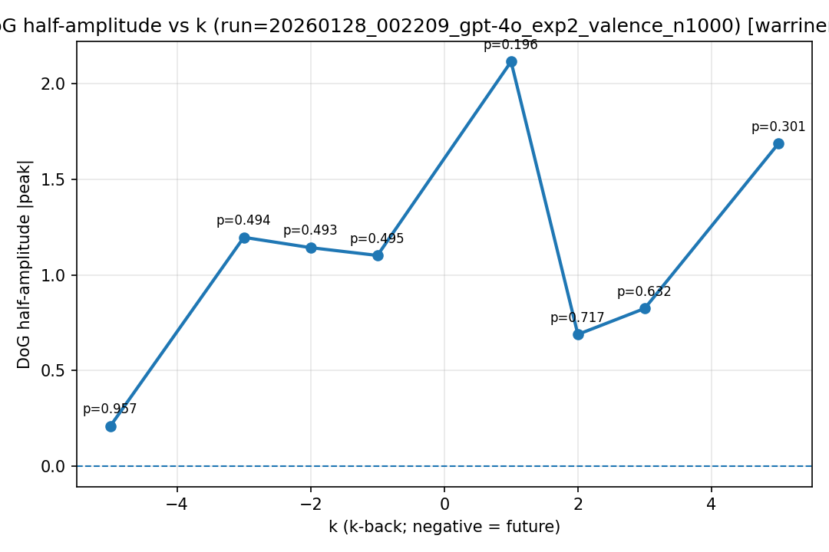
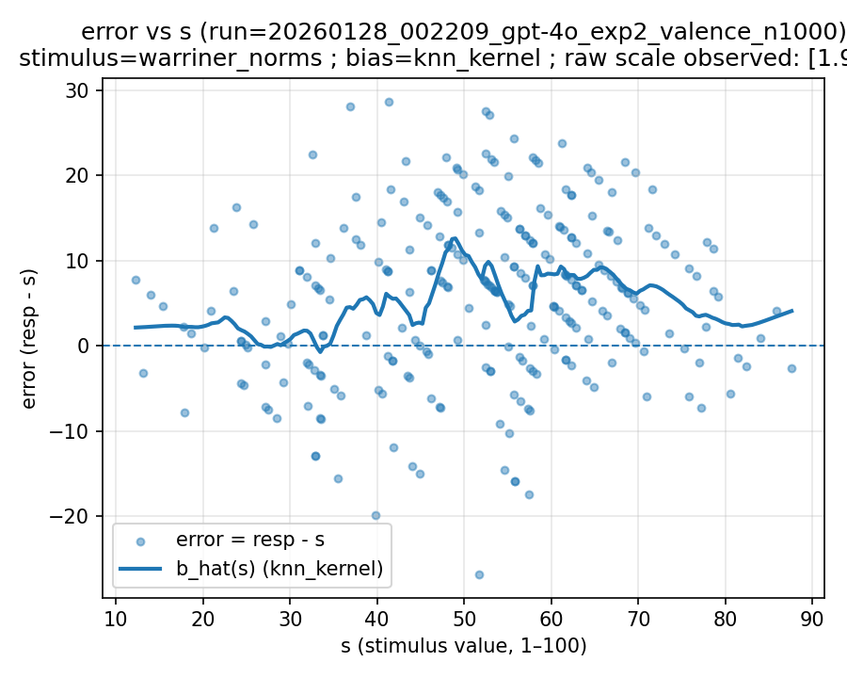 | 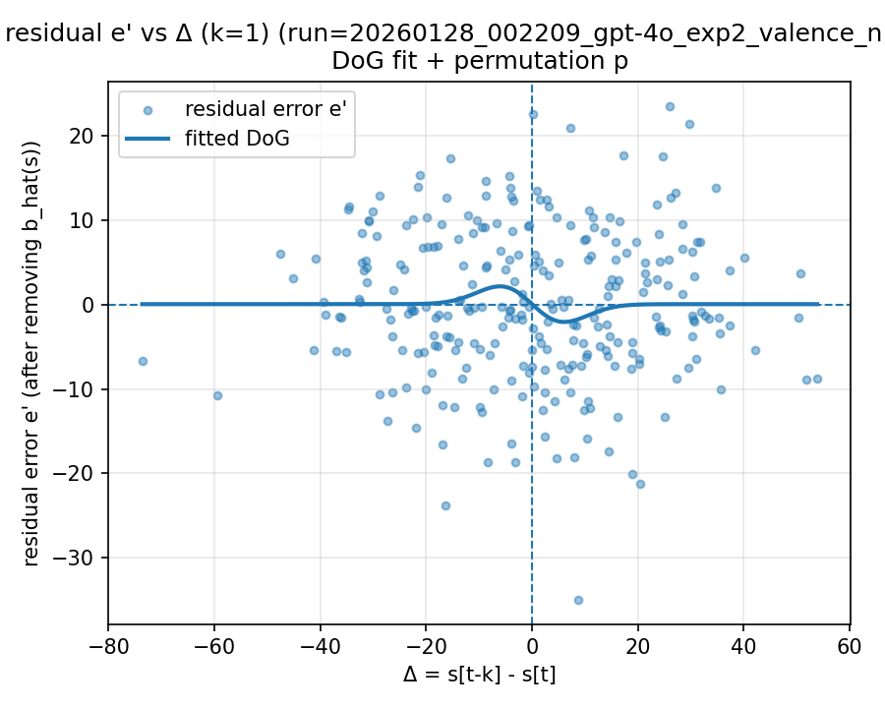 | 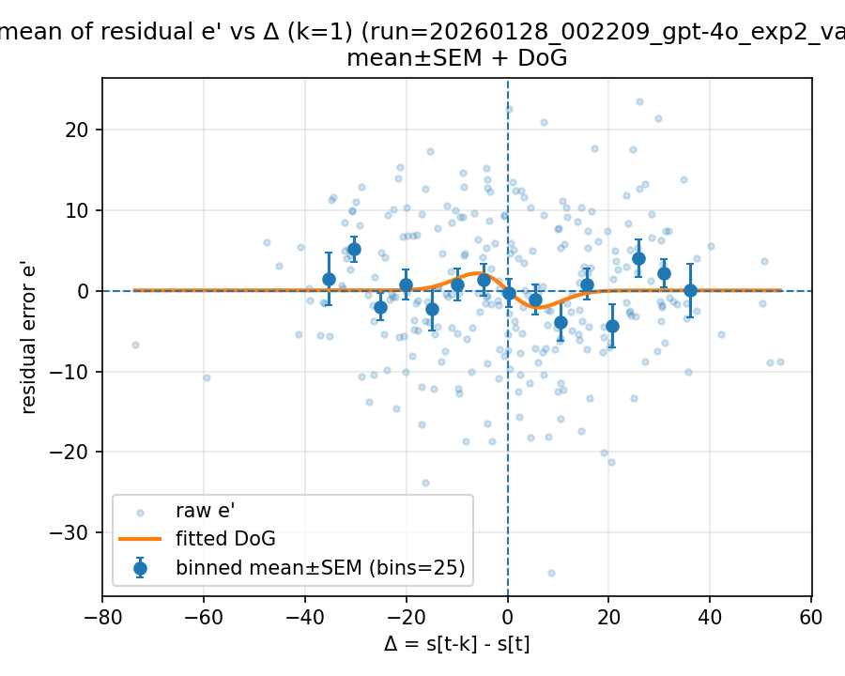

20260128_002256_gpt-4o_exp2_concreteness_n1000

Mode: norms (stimulus=warriner_norms)
model: gpt-4o
which: exp2
dimension: concreteness
uses_warriner_word_source: False
n_words: 1000
match_rate_vs_exp2: 0.311
k=1 half_amp: 0.402068
k=1 sigma: 26.7466
k=1 p (permutation): 0.966034
best p over ks: 0.002997 (k=-3)
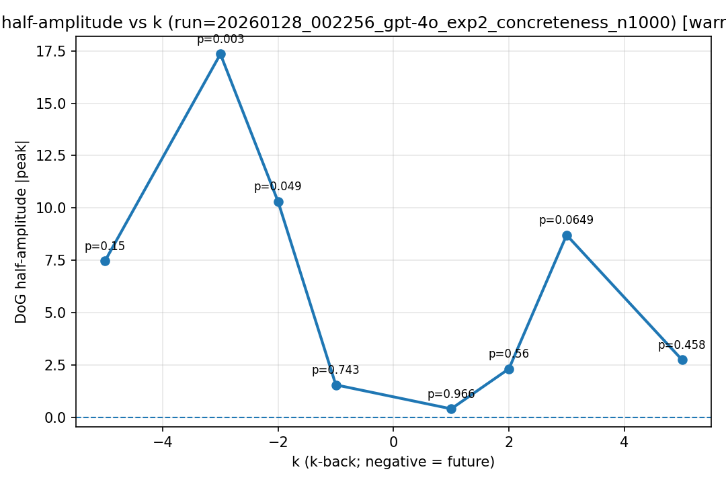
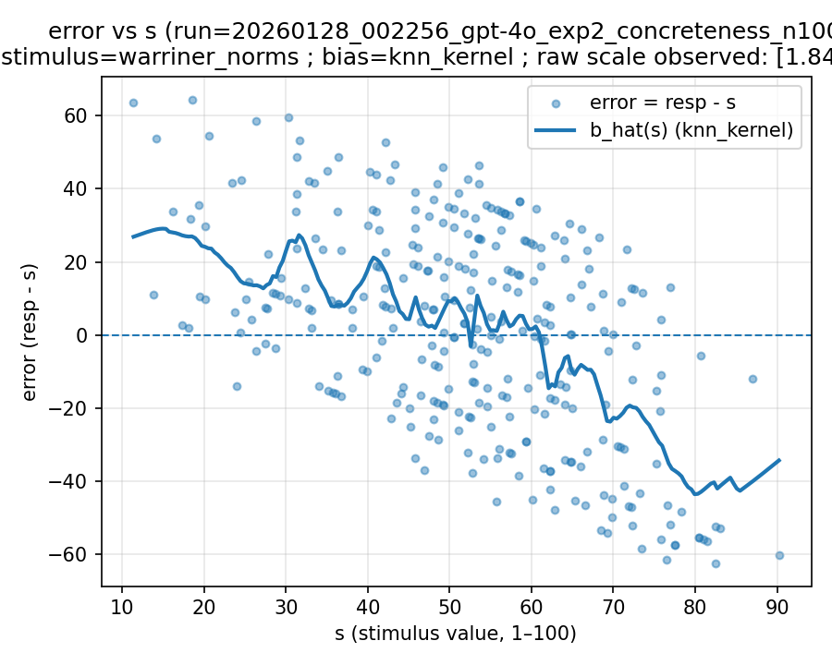 | 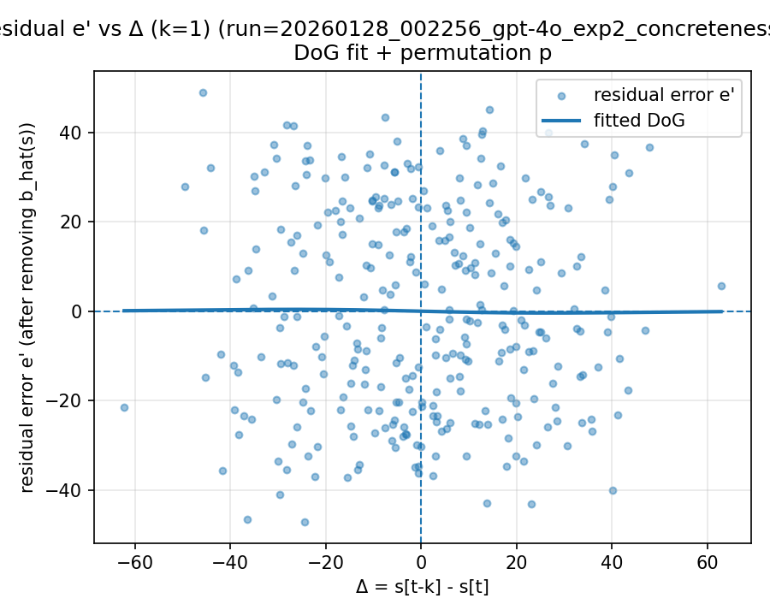 | 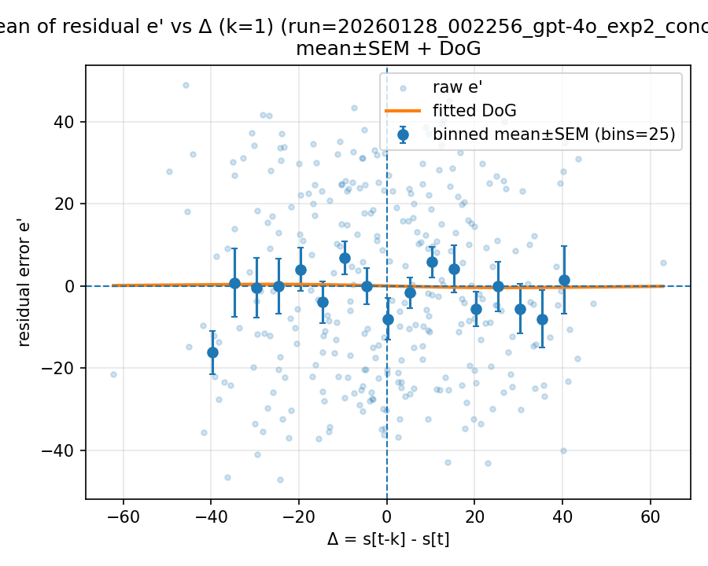

20260129_145137_gpt-4o_both_valence_n1000

Mode: exp1 (stimulus=exp1_mean)
model: gpt-4o
which: both
dimension: valence
uses_warriner_word_source: False
n_words: 1000
match_rate_vs_exp2: 1
k=1 half_amp: 2.84859
k=1 sigma: 200
k=1 p (permutation): 0.001998
best p over ks: 0.001998 (k=1)
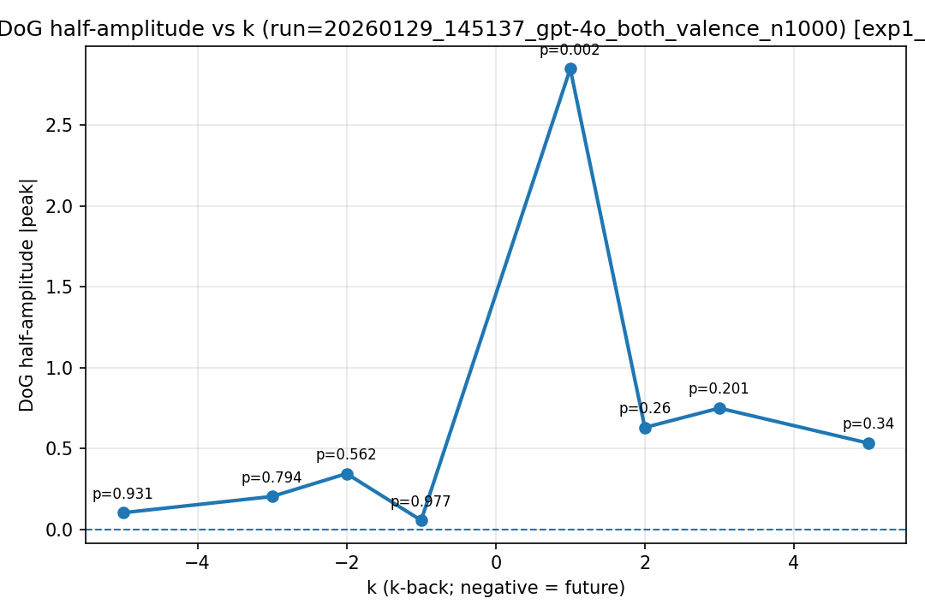
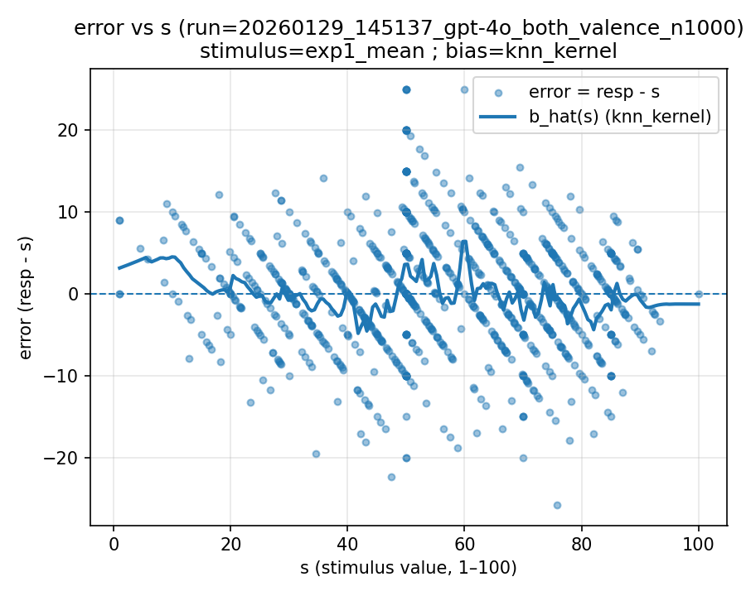 | 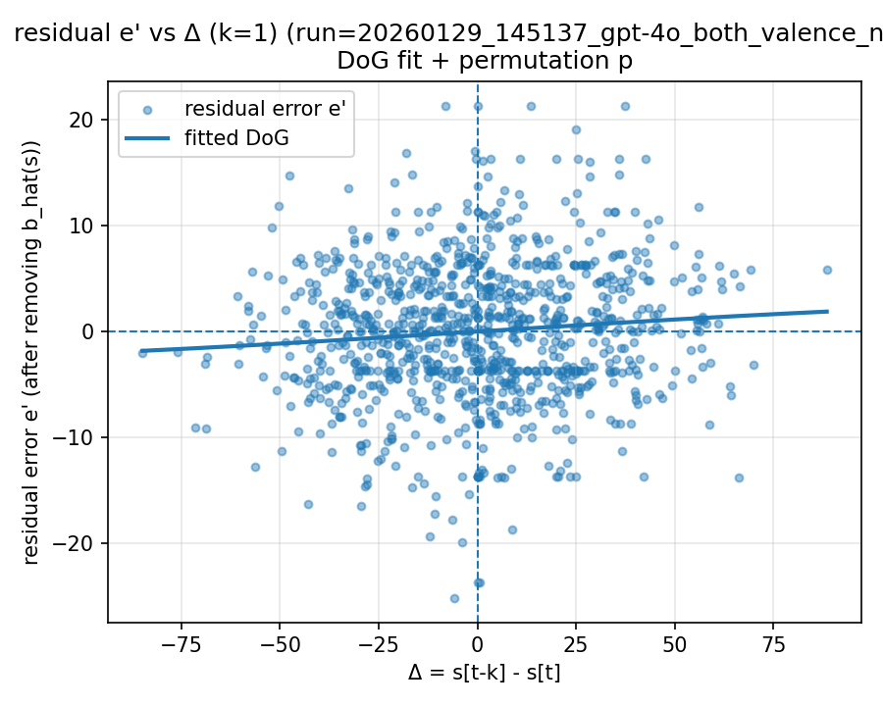 | 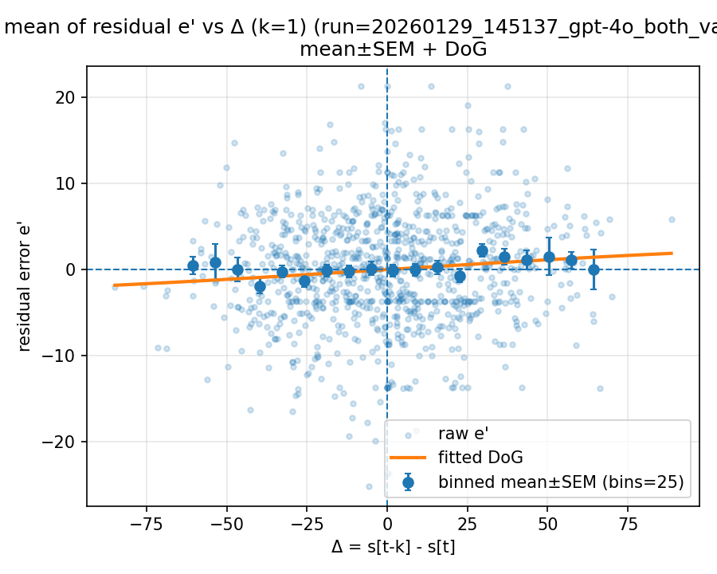

Mode: norms (stimulus=warriner_norms)
model: gpt-4o
which: both
dimension: valence
uses_warriner_word_source: False
n_words: 1000
match_rate_vs_exp2: 0.347
k=1 half_amp: 1.03297
k=1 sigma: 42.8146
k=1 p (permutation): 0.507493
best p over ks: 0.035964 (k=2)
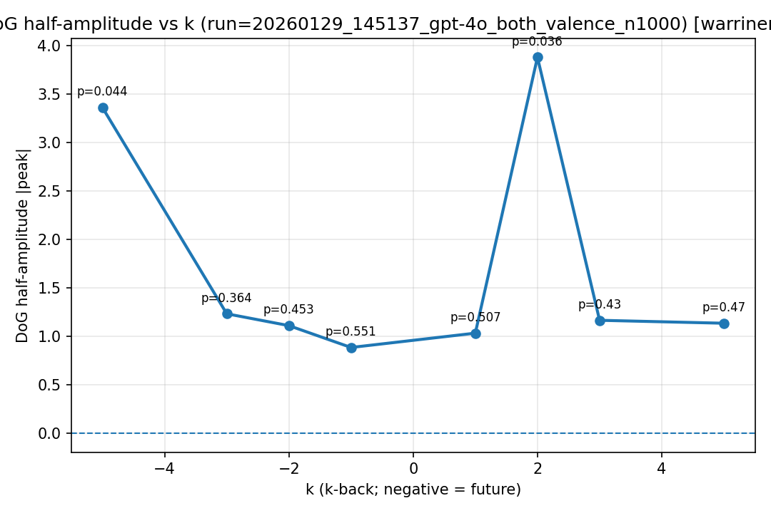
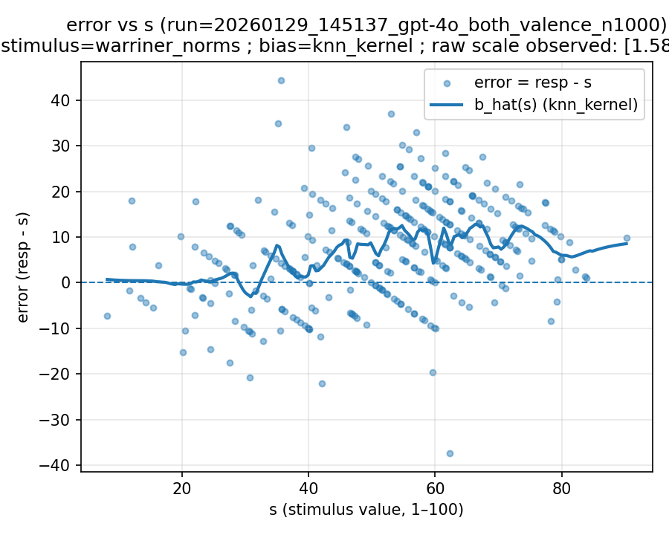 | 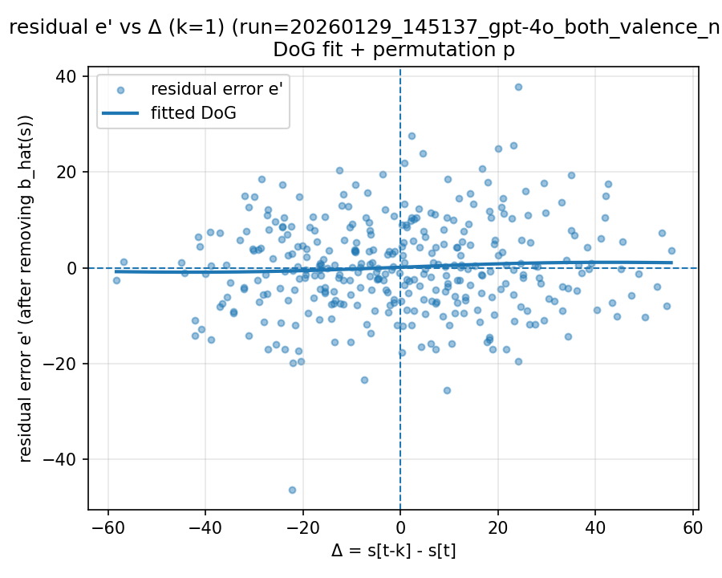 | 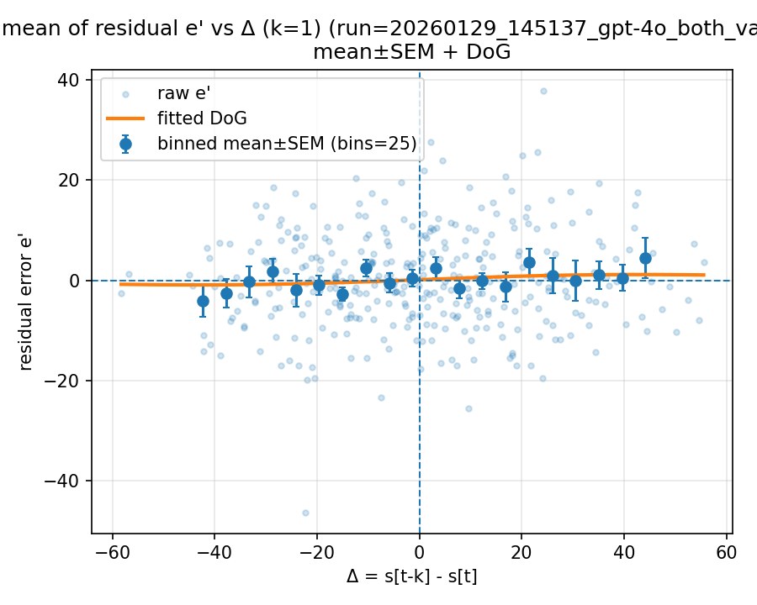

20260202_004249_gpt-4o_exp2_valence_n1000

Mode: norms (stimulus=warriner_norms)
model: gpt-4o
which: exp2
dimension: valence
uses_warriner_word_source: True
n_words: 1000
match_rate_vs_exp2: 1.002
k=1 half_amp: 2.03639
k=1 sigma: 6.41255
k=1 p (permutation): 0.016983
best p over ks: 0.016983 (k=1)
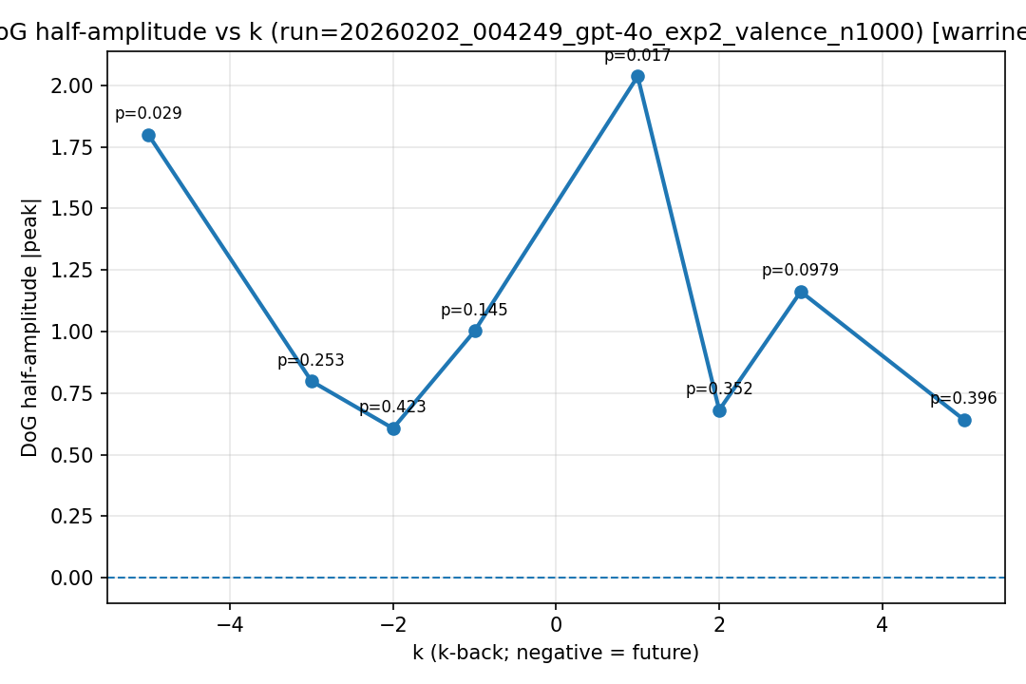
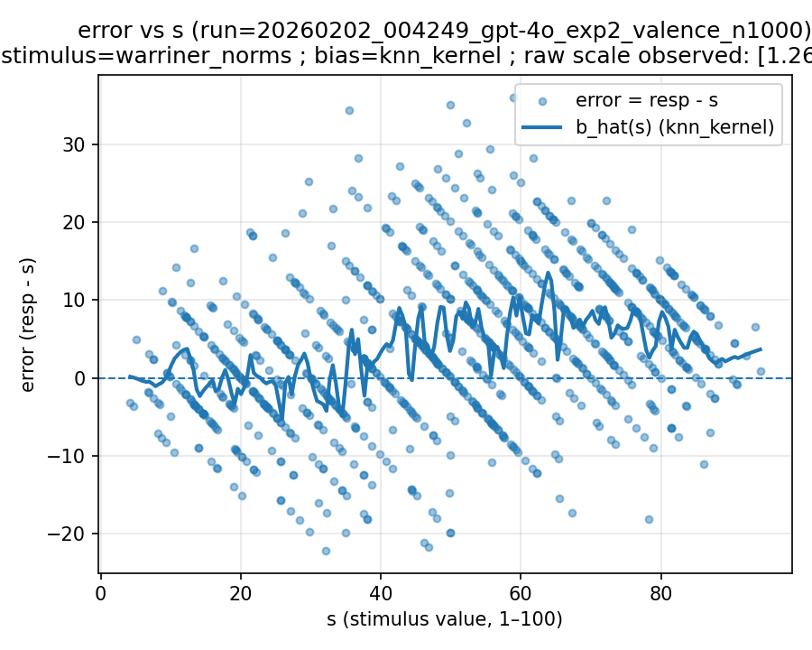 | 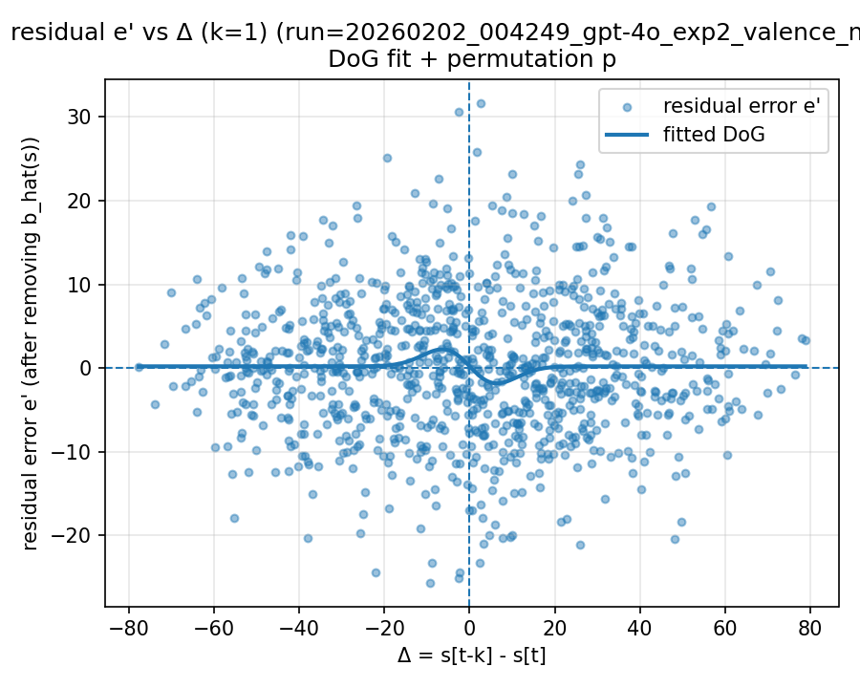 | 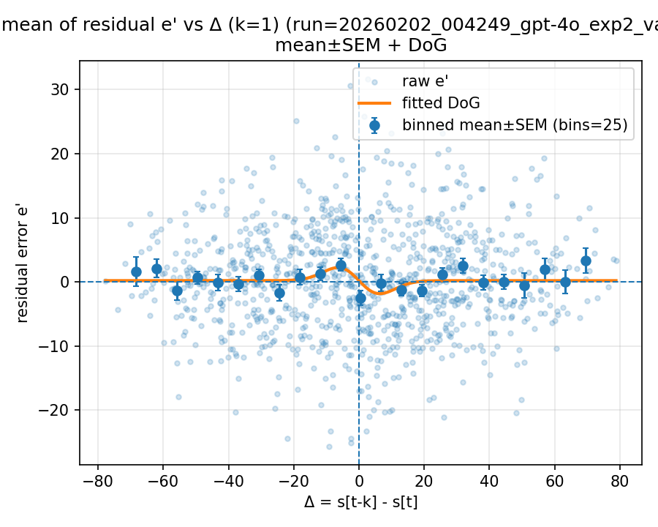

20260202_005410_gpt-4o_exp2_valence_n1000

Mode: norms (stimulus=warriner_norms)
model: gpt-4o
which: exp2
dimension: valence
uses_warriner_word_source: True
n_words: 1000
match_rate_vs_exp2: 1.001
k=1 half_amp: 0.242878
k=1 sigma: 47.6022
k=1 p (permutation): 0.833167
best p over ks: 0.033966 (k=-5)
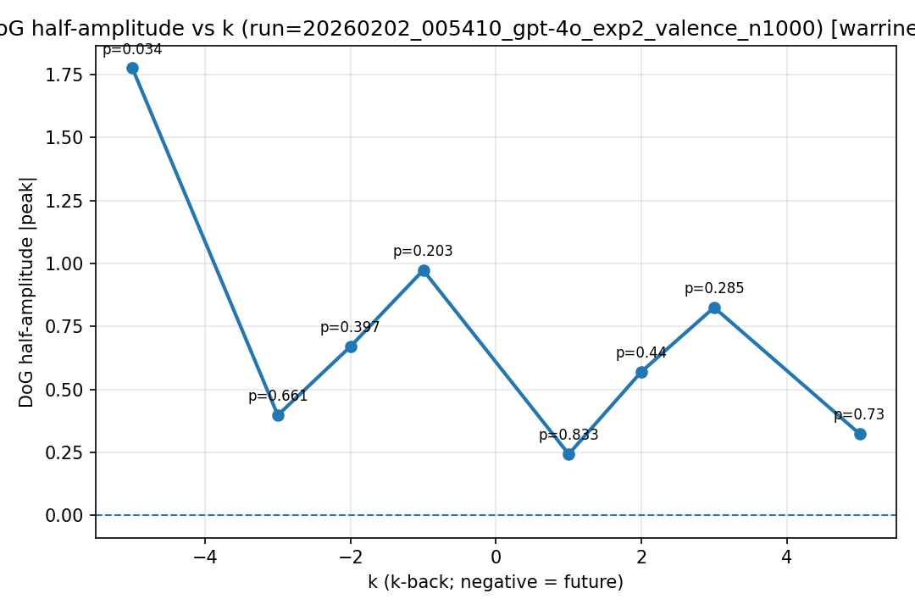
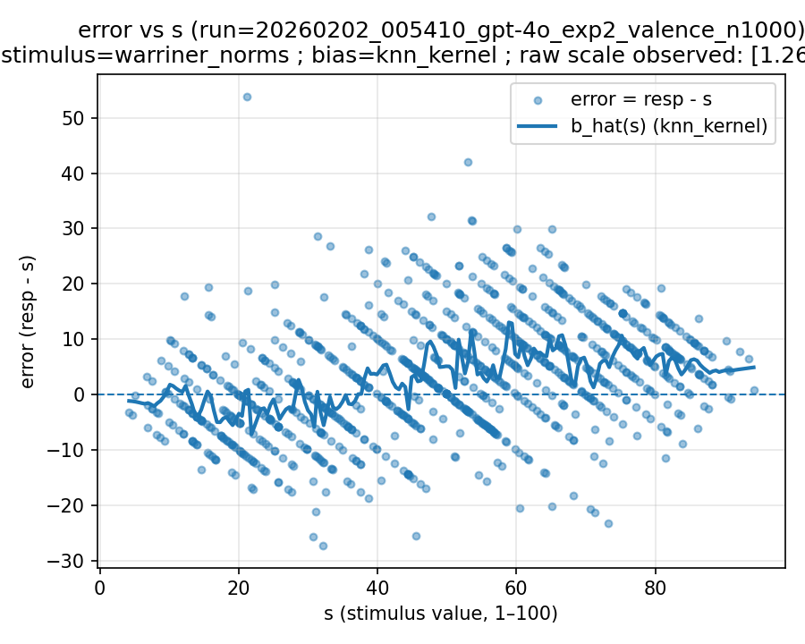 | 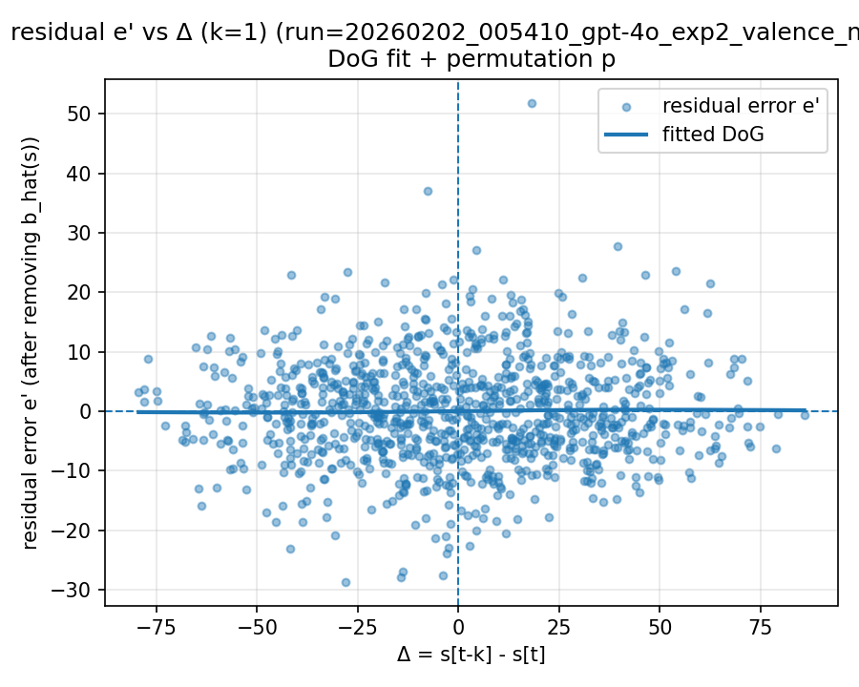 | 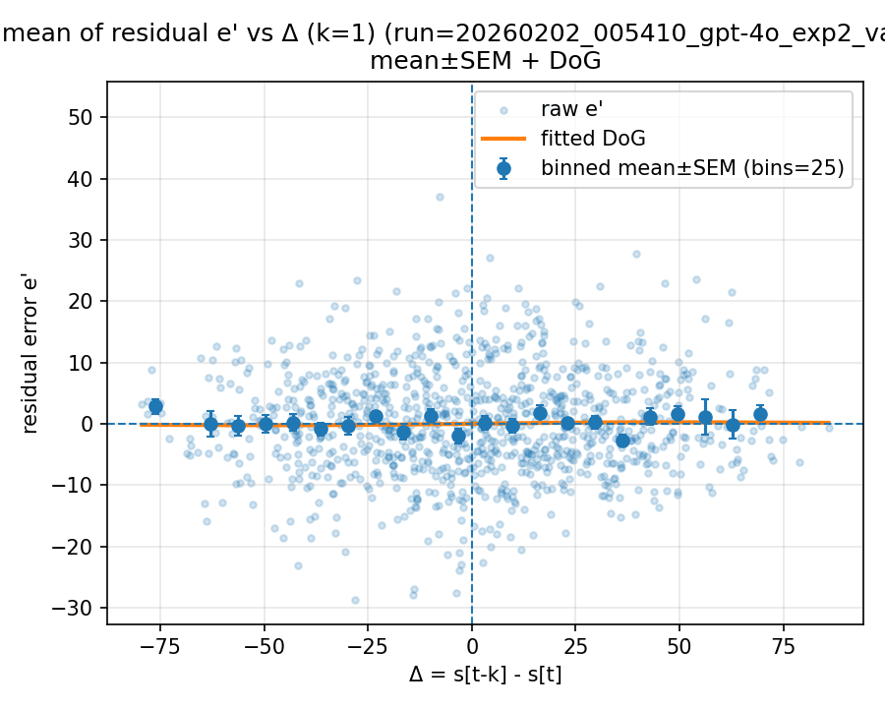

20260202_114143_gpt-4o_exp2_valence_n1000

Mode: norms (stimulus=warriner_norms)
model: gpt-4o
which: exp2
dimension: valence
uses_warriner_word_source: True
n_words: 1000
match_rate_vs_exp2: 1.001
k=1 half_amp: 2.092
k=1 sigma: 200
k=1 p (permutation): 0.012987
best p over ks: 0.012987 (k=1)
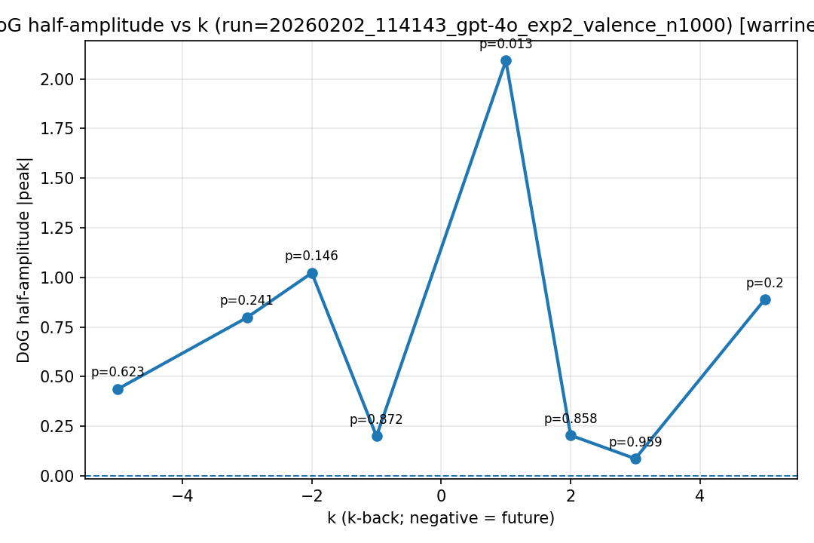
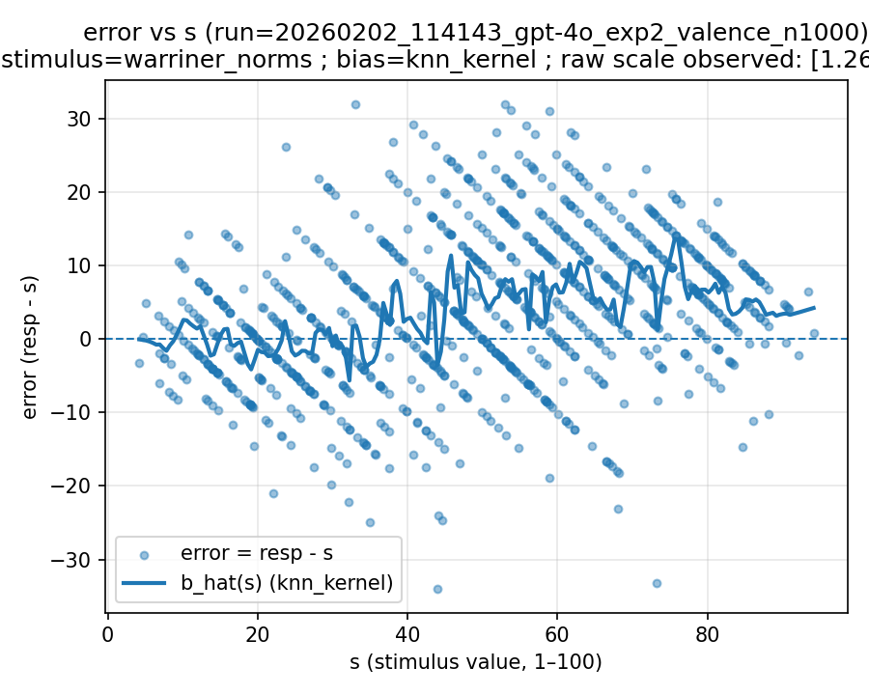 | 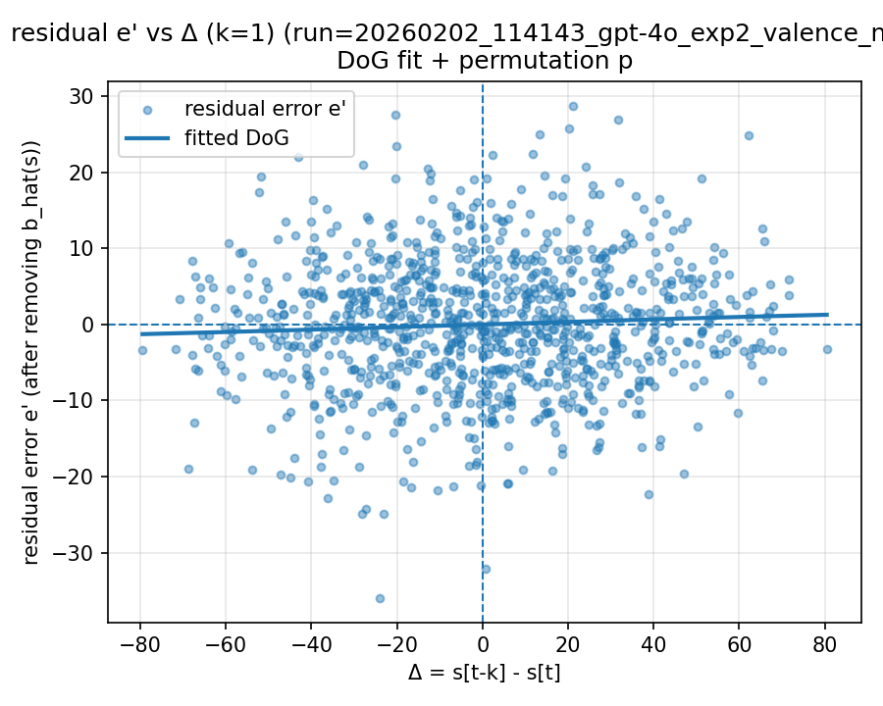 | 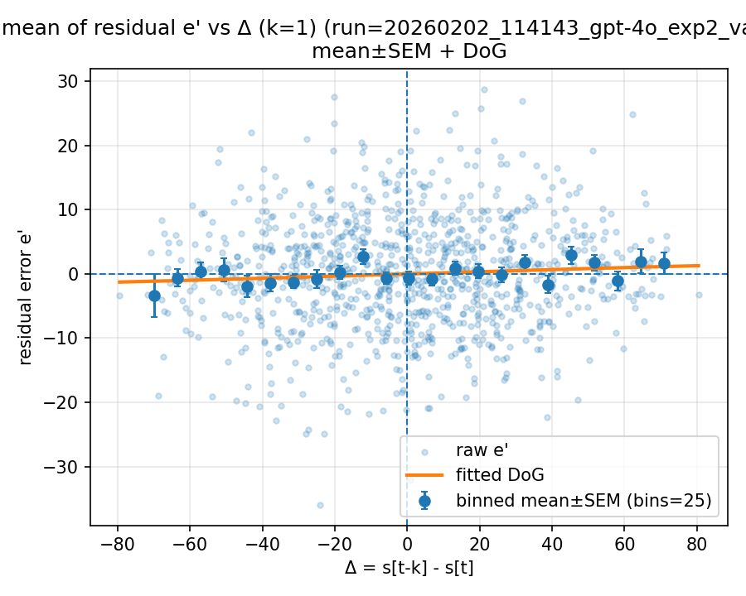

20260202_121450_gpt-4o_exp2_valence_n1000

Mode: norms (stimulus=warriner_norms)
model: gpt-4o
which: exp2
dimension: valence
uses_warriner_word_source: True
n_words: 1000
match_rate_vs_exp2: 1.002
k=1 half_amp: 0.918106
k=1 sigma: 50.6866
k=1 p (permutation): 0.196803
best p over ks: 0.121878 (k=2)
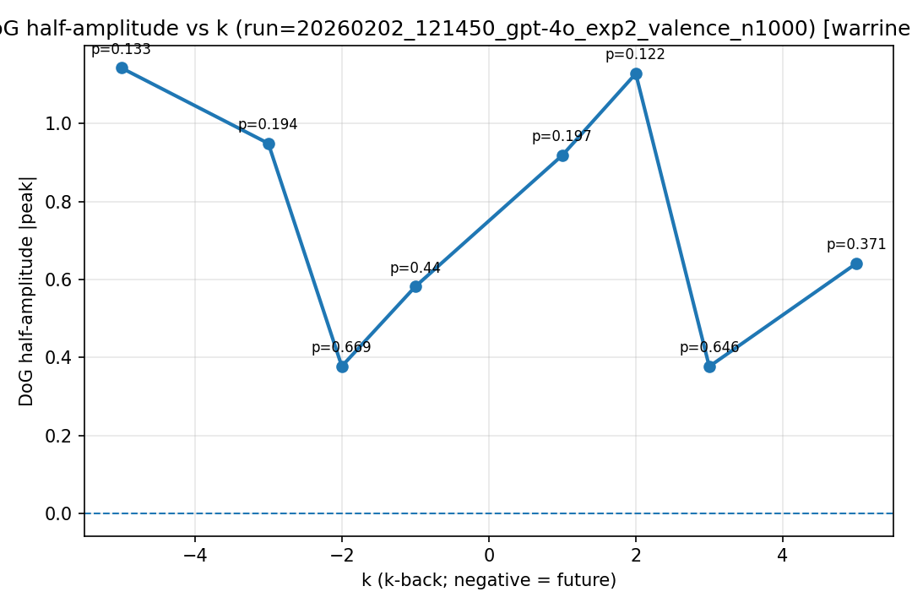
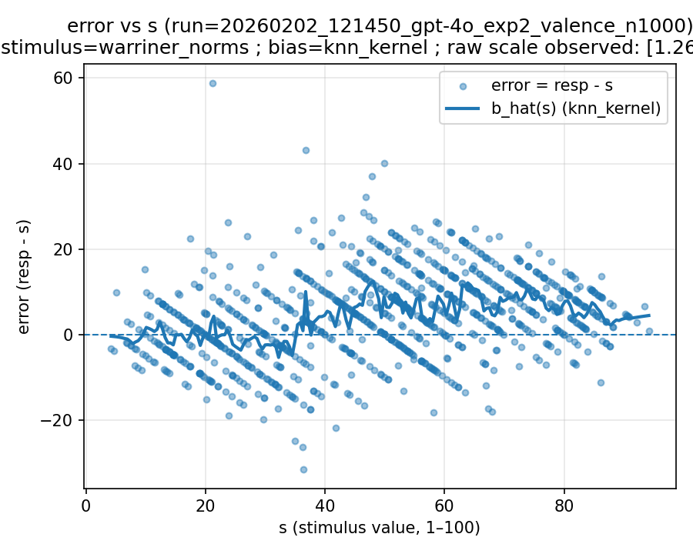 | 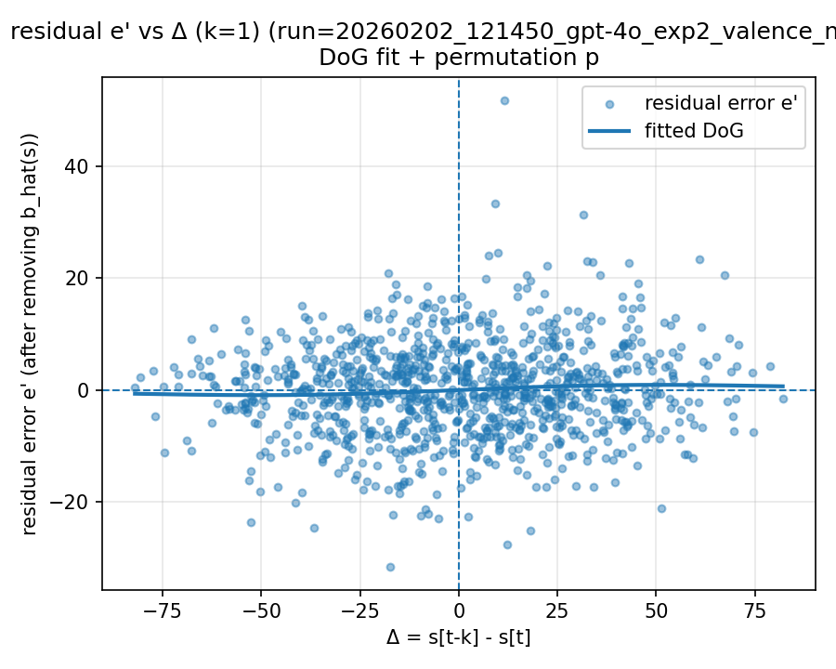 | 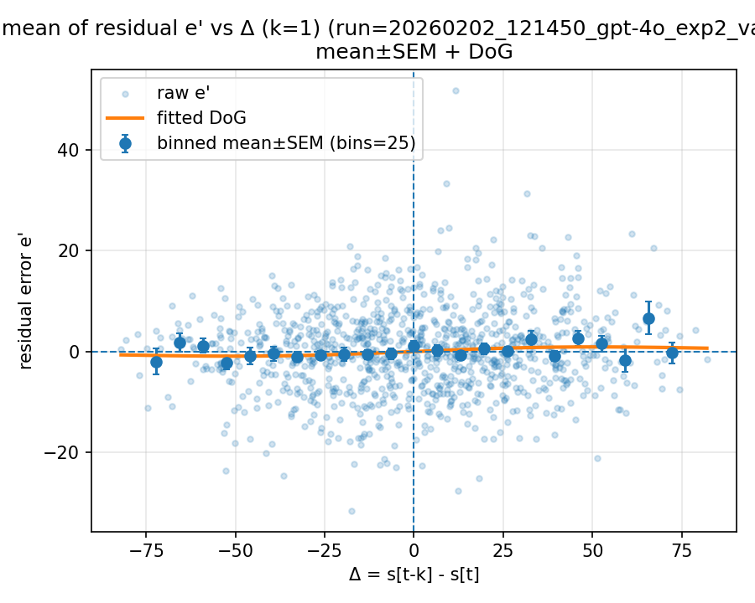

20260202_124834_gpt-4o_exp2_valence_n1000

Mode: norms (stimulus=warriner_norms)
model: gpt-4o
which: exp2
dimension: valence
uses_warriner_word_source: True
n_words: 1000
match_rate_vs_exp2: 1.001
k=1 half_amp: 1.08226
k=1 sigma: 54.6991
k=1 p (permutation): 0.136863
best p over ks: 0.0769231 (k=2)
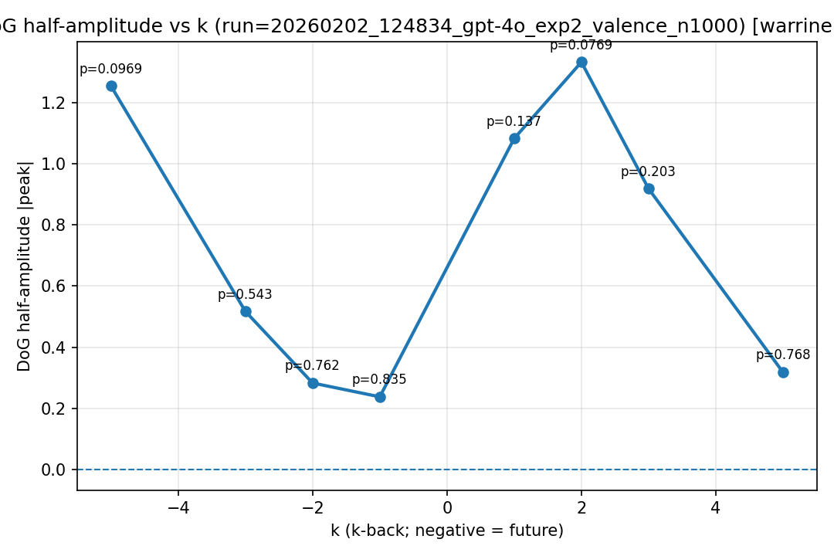
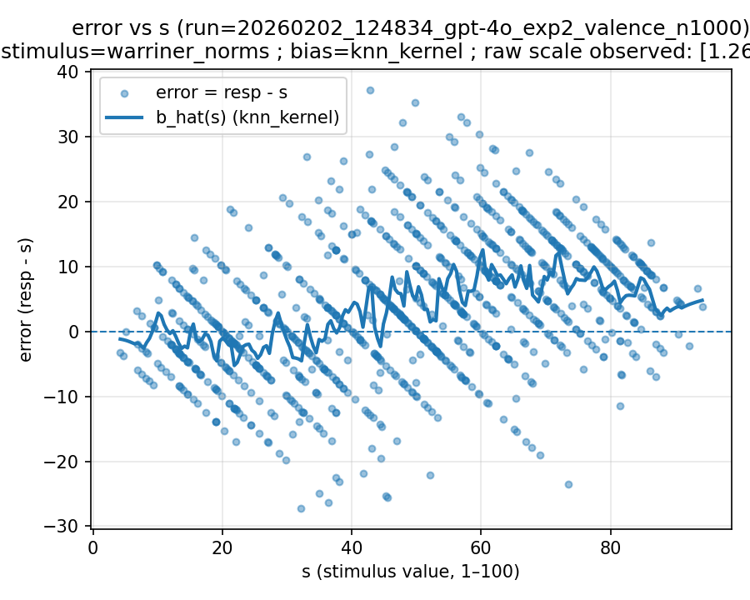 | 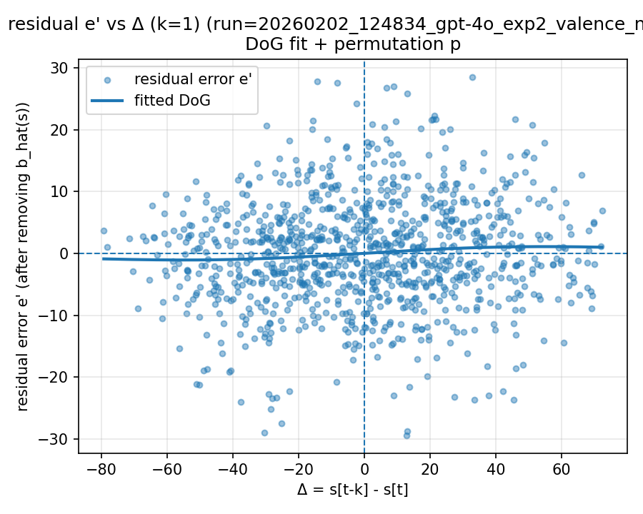 | 