Norms-based bias removal + serial dependence report
Generated at: 2026-02-04T17:46:26
Results root: /home/leve/serial-dependence-lyf-experiment/ana_norms_bias_sd/results

20260129_145137_gpt-4o_both_valence_n1000
Run configuration (outputs/<run_tag>/run_config.yaml):
base_url: https://www.dmxapi.cn/v1
model: gpt-4o
temperature: 1.0
which: both
dimension: valence
mixed_dimensions: None
two_d_dimensions: None
two_d_variants: None
n_words: 1000
n_words_exp2: None
n_trials_none: None
seed: 838969362
excel_path: testing_data/Estimates concreteness words Brysbaert et al.xlsx
word_sampling: uniform_random
word_sampling_score_col: None
ci95_enable: True
ci95_threshold: 1.0
max_trials_per_word: 20
merged_cfg: {'base_url': 'https://www.dmxapi.cn/v1', 'api_key': 'sk-DfBAcHghxb9iIvDB2MzHPAutxKtbwMMVGVKXzaABkJnHckQz', 'model': 'gpt-4o', 'temperature': 1.0, 'which': 'both', 'n_words': 1000, 'seed': None, 'excel_path': 'testing_data/Estimates concreteness words Brysbaert et al.xlsx', 'ci95_enable': True, 'ci95_threshold': 1.0, 'max_trials_per_word': 20, 'dimension': 'concreteness', 'exp2_context_window': 50, 'valence': True}
cli_args: {'config': None, 'base_url': None, 'api_key': None, 'model': 'gpt-4o', 'temperature': 1.0, 'which': 'both', 'n_words': 1000, 'seed': None, 'excel_path': None, 'ci95_enable': True, 'ci95_threshold': 1.0, 'max_trials_per_word': None, 'exp2_context_window': 50, 'n_words_exp2': None, 'n_trials_none': None, 'concreteness': False, 'valence': True, 'arousal': False, 'none': False, 'mixed': None, 'two_d': None}
bias_fit.json (key fields):
norms_csv: None
raw_scale_min_observed: nan
raw_scale_max_observed: nan
bias_method: bin
match_n: 1000
match_rate_vs_exp2: 1.0
Plots:
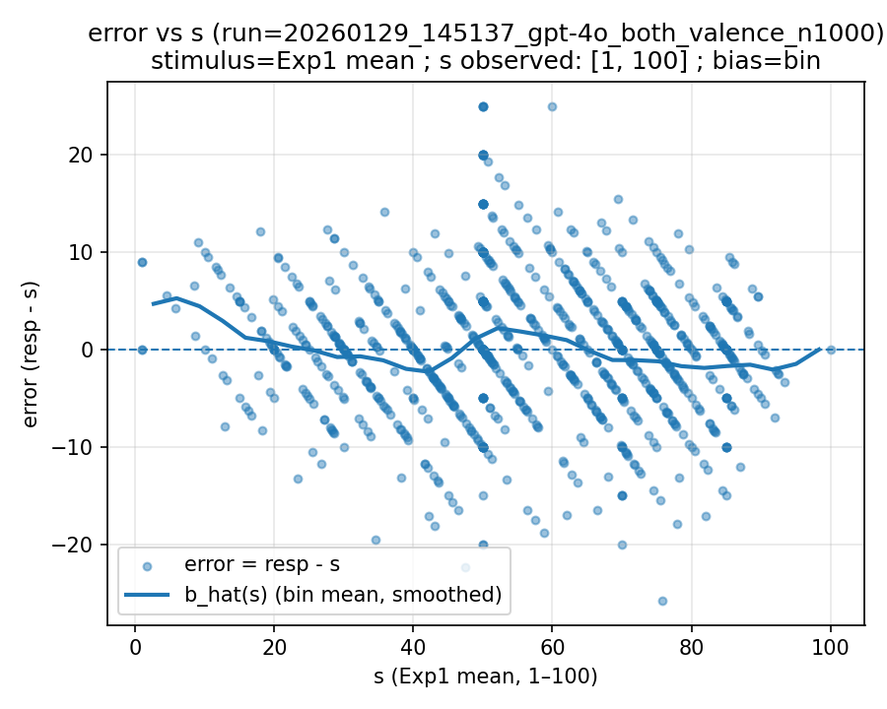 | 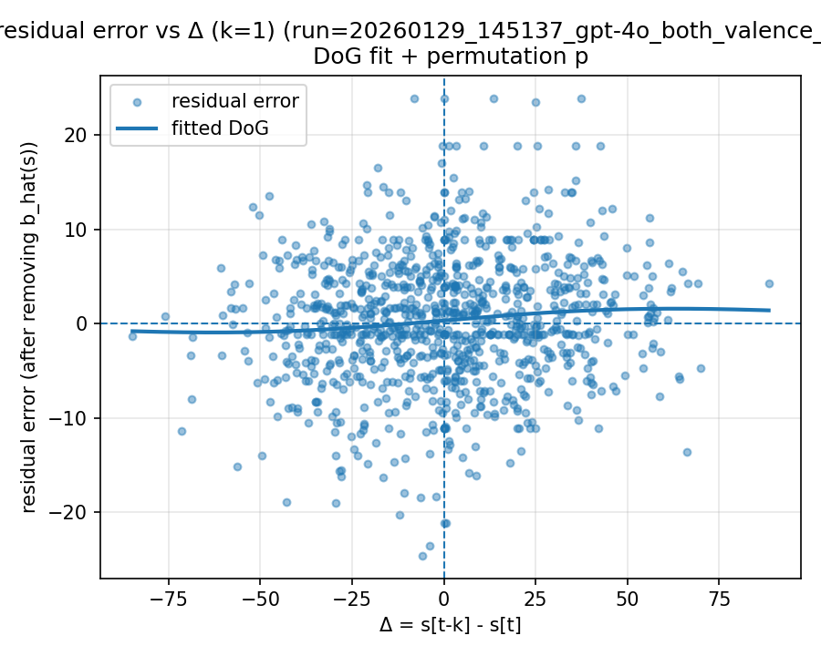
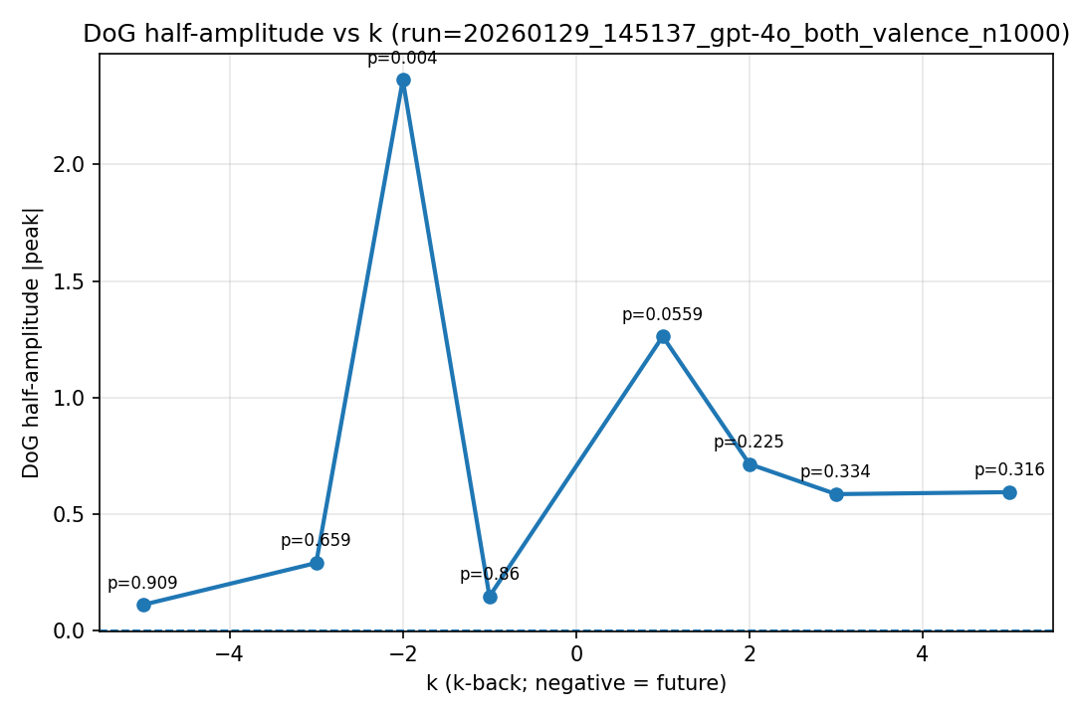
k-back summary (nback_summary.csv):
k | n | c0 | A | sigma | r2 | half_amp | p_half_amp
-5 | 995 | 0.317902 | 0.00863471 | 20.8473 | 0.000125758 | 0.109182 | 0.909091
-3 | 997 | 0.320202 | -0.029738 | 16.014 | 0.000723129 | 0.288845 | 0.659341
-2 | 998 | 0.320845 | -1.40672 | 2.76964 | 0.0103517 | 2.36311 | 0.003996
-1 | 999 | 0.319087 | 0.00927441 | 25.8681 | 0.000235704 | 0.145514 | 0.86014
1 | 999 | 0.343478 | 0.0332242 | 62.6138 | 0.0109429 | 1.26176 | 0.0559441
2 | 998 | 0.354671 | 0.033625 | 34.9977 | 0.00561731 | 0.713765 | 0.224775
3 | 997 | 0.352685 | 0.00481882 | 199.98 | 0.000359926 | 0.584493 | 0.333666
5 | 995 | 0.392419 | -0.110046 | 8.88524 | 0.00202975 | 0.593058 | 0.315684

20260202_004249_gpt-4o_exp2_valence_n1000
Run configuration (outputs/<run_tag>/run_config.yaml):
base_url: https://www.dmxapi.cn/v1
model: gpt-4o
temperature: 1.0
which: exp2
dimension: valence
mixed_dimensions: None
two_d_dimensions: None
two_d_variants: None
n_words: 1000
n_words_exp2: None
n_trials_none: None
seed: 3251792589
excel_path: testing_data/Warriner_et_alemotratings.csv
ci95_enable: True
ci95_threshold: 1.0
max_trials_per_word: 20
merged_cfg: {'base_url': 'https://www.dmxapi.cn/v1', 'api_key': 'sk-DfBAcHghxb9iIvDB2MzHPAutxKtbwMMVGVKXzaABkJnHckQz', 'model': 'gpt-4o', 'temperature': 1.0, 'which': 'exp2', 'n_words': 1000, 'seed': None, 'excel_path': 'testing_data/Warriner_et_alemotratings.csv', 'ci95_enable': True, 'ci95_threshold': 1.0, 'max_trials_per_word': 20, 'dimension': 'concreteness', 'exp2_context_window': 30, 'valence': True}
cli_args: {'config': None, 'base_url': None, 'api_key': None, 'model': 'gpt-4o', 'temperature': 1.0, 'which': 'exp2', 'n_words': 1000, 'seed': None, 'excel_path': 'testing_data/Warriner_et_alemotratings.csv', 'ci95_enable': True, 'ci95_threshold': 1.0, 'max_trials_per_word': None, 'exp2_context_window': 30, 'n_words_exp2': None, 'n_trials_none': None, 'warriner_max_sd_sum': None, 'warriner_max_mf_diff': None, 'warriner_n_bins': None, 'concreteness': False, 'valence': True, 'arousal': False, 'none': False, 'mixed': None, 'two_d': None}
word_source_meta: {'source_path': 'testing_data/Warriner_et_alemotratings.csv', 'source_type': 'warriner_vad', 'filters': {'max_sd_sum': 1.7, 'max_mf_diff': 0.5, 'dims_applied': ['valence']}, 'stimulus_col_by_dim': {'valence': 'valence_mean_1_100', 'arousal': 'arousal_mean_1_100', 'dominance': 'dominance_mean_1_100'}}
word_sampling_meta: {'method': 'stratified_equal_width', 'value_col': 'valence_mean_1_100', 'n_bins': 20}
bias_fit.json (key fields):
norms_csv: /home/leve/serial-dependence-lyf-experiment/testing_data/Warriner_et_alemotratings.csv
raw_scale_min_observed: 1.26
raw_scale_max_observed: 8.53
bias_method: bin
match_n: 1002
match_rate_vs_exp2: 1.002
Plots:
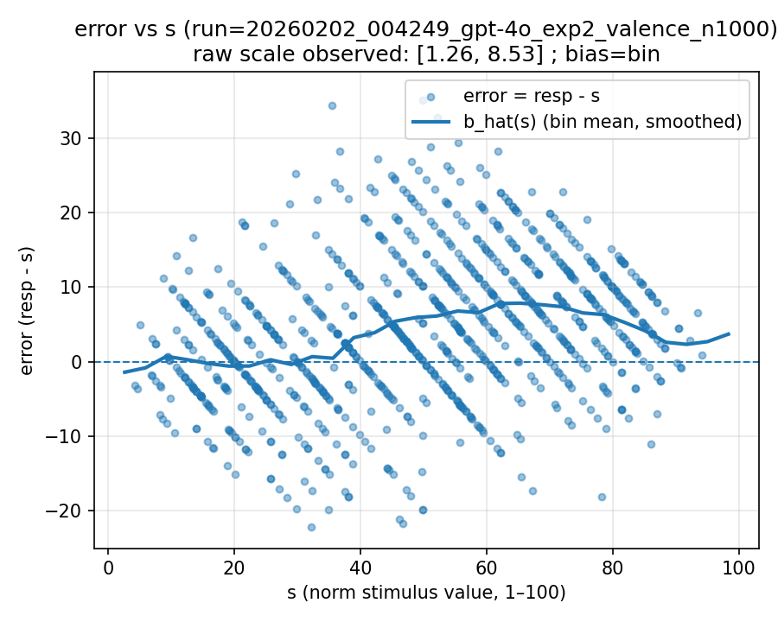 | 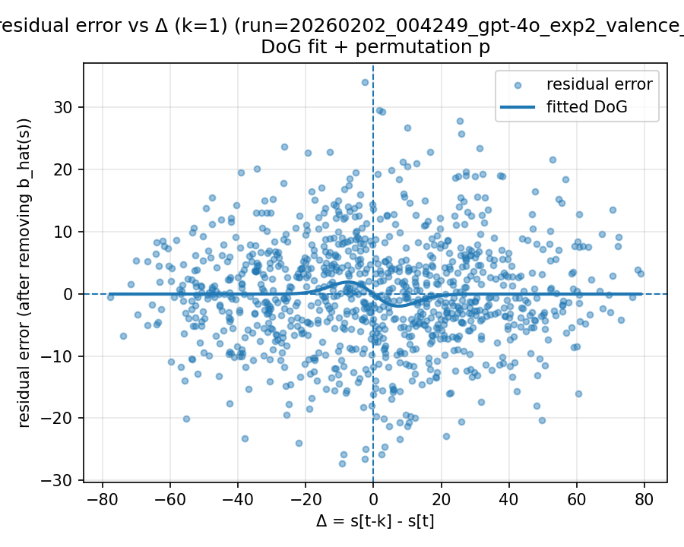
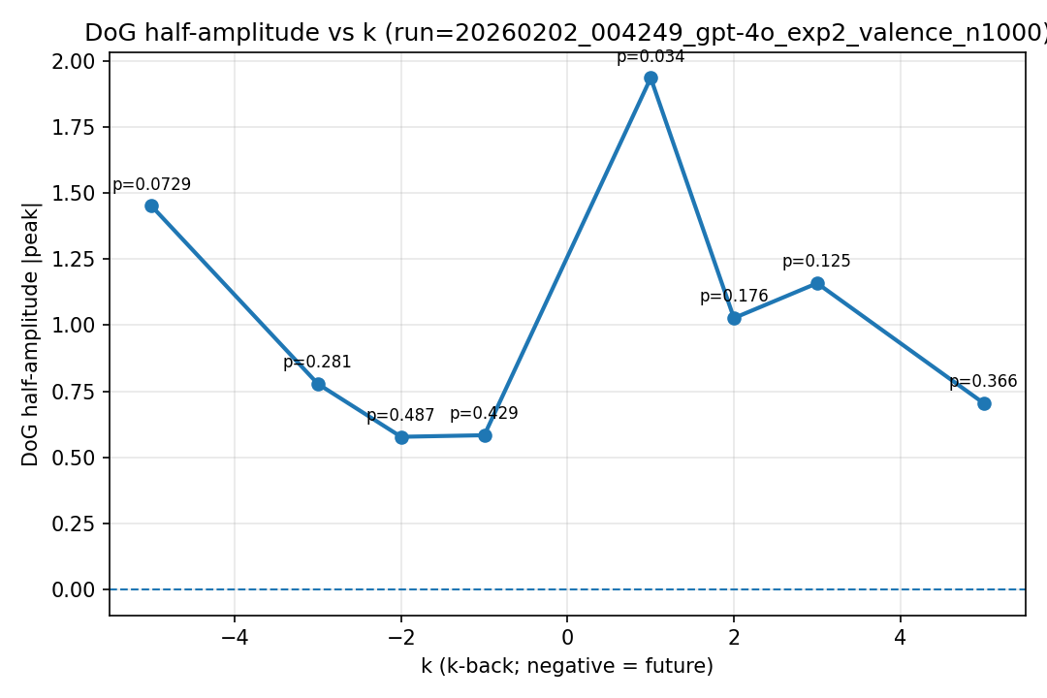
k-back summary (nback_summary.csv):
k | n | c0 | A | sigma | r2 | half_amp | p_half_amp
-5 | 997 | -0.017032 | 0.0119632 | 200 | 0.0015983 | 1.45122 | 0.0729271
-3 | 999 | -0.0422981 | -0.131552 | 9.75153 | 0.00212018 | 0.778077 | 0.280719
-2 | 1000 | -0.0274613 | -0.0692092 | 13.7681 | 0.00149849 | 0.57795 | 0.486513
-1 | 1001 | -0.033743 | -0.00481349 | 200 | 0.000272902 | 0.583906 | 0.428571
1 | 1001 | -0.0603901 | -0.429088 | 7.43573 | 0.00957146 | 1.93519 | 0.033966
2 | 1000 | -0.0351929 | -0.0979745 | 17.2814 | 0.00555584 | 1.02694 | 0.175824
3 | 999 | -0.0100874 | -0.245705 | 7.77583 | 0.00378755 | 1.15881 | 0.124875
5 | 997 | 0.0150321 | 0.104133 | 11.1676 | 0.00193925 | 0.705343 | 0.365634

20260202_005410_gpt-4o_exp2_valence_n1000
Run configuration (outputs/<run_tag>/run_config.yaml):
base_url: https://www.dmxapi.cn/v1
model: gpt-4o
temperature: 1.0
which: exp2
dimension: valence
mixed_dimensions: None
two_d_dimensions: None
two_d_variants: None
n_words: 1000
n_words_exp2: None
n_trials_none: None
seed: 1430842060
excel_path: testing_data/Warriner_et_alemotratings.csv
ci95_enable: True
ci95_threshold: 1.0
max_trials_per_word: 20
merged_cfg: {'base_url': 'https://www.dmxapi.cn/v1', 'api_key': 'sk-DfBAcHghxb9iIvDB2MzHPAutxKtbwMMVGVKXzaABkJnHckQz', 'model': 'gpt-4o', 'temperature': 1.0, 'which': 'exp2', 'n_words': 1000, 'seed': None, 'excel_path': 'testing_data/Warriner_et_alemotratings.csv', 'ci95_enable': True, 'ci95_threshold': 1.0, 'max_trials_per_word': 20, 'dimension': 'concreteness', 'exp2_context_window': 30, 'valence': True}
cli_args: {'config': None, 'base_url': None, 'api_key': None, 'model': 'gpt-4o', 'temperature': 1.0, 'which': 'exp2', 'n_words': 1000, 'seed': None, 'excel_path': 'testing_data/Warriner_et_alemotratings.csv', 'ci95_enable': True, 'ci95_threshold': 1.0, 'max_trials_per_word': None, 'exp2_context_window': 30, 'n_words_exp2': None, 'n_trials_none': None, 'warriner_max_sd_sum': None, 'warriner_max_mf_diff': None, 'warriner_n_bins': None, 'concreteness': False, 'valence': True, 'arousal': False, 'none': False, 'mixed': None, 'two_d': None}
word_source_meta: {'source_path': 'testing_data/Warriner_et_alemotratings.csv', 'source_type': 'warriner_vad', 'filters': {'max_sd_sum': 1.7, 'max_mf_diff': 0.5, 'dims_applied': ['valence']}, 'stimulus_col_by_dim': {'valence': 'valence_mean_1_100', 'arousal': 'arousal_mean_1_100', 'dominance': 'dominance_mean_1_100'}}
word_sampling_meta: {'method': 'stratified_equal_width', 'value_col': 'valence_mean_1_100', 'n_bins': 20}
bias_fit.json (key fields):
norms_csv: /home/leve/serial-dependence-lyf-experiment/testing_data/Warriner_et_alemotratings.csv
raw_scale_min_observed: 1.26
raw_scale_max_observed: 8.53
bias_method: bin
match_n: 1001
match_rate_vs_exp2: 1.001
Plots:
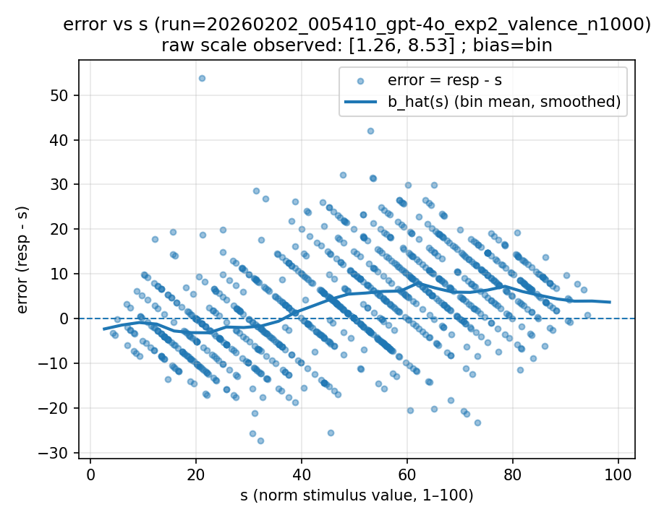 | 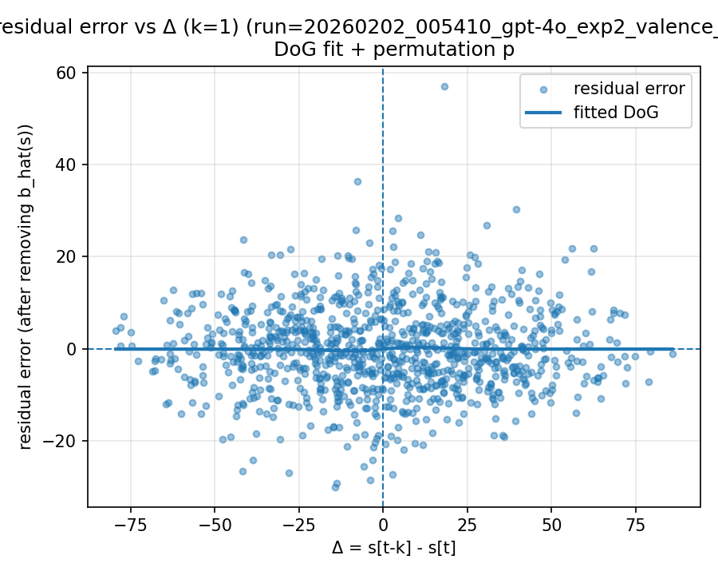
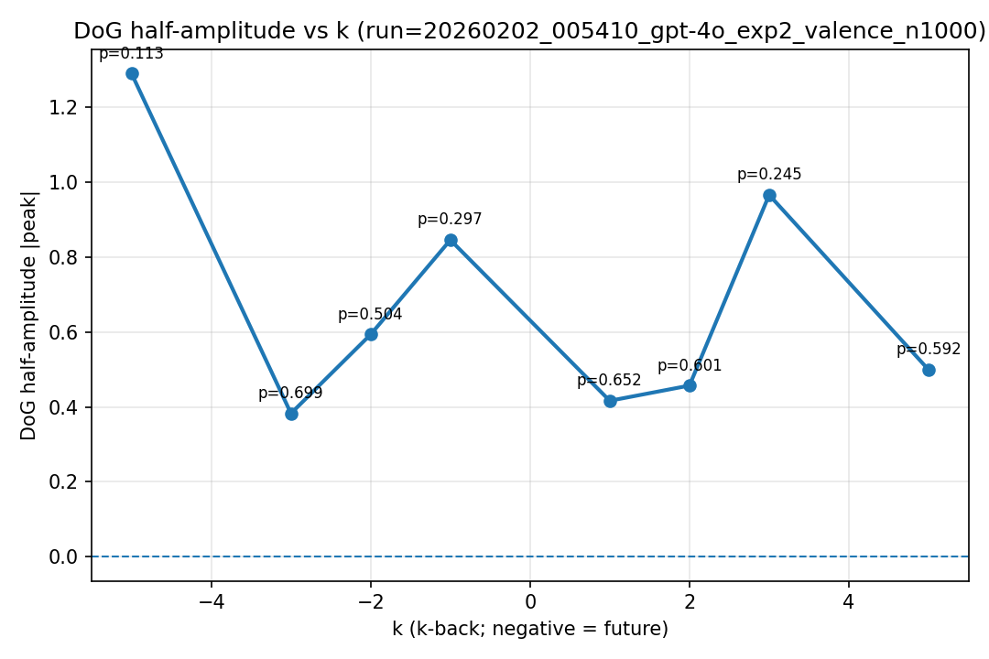
k-back summary (nback_summary.csv):
k | n | c0 | A | sigma | r2 | half_amp | p_half_amp
1 | 1000 | -0.0375292 | 0.0704522 | 9.7406 | 0.000512132 | 0.416229 | 0.652348
2 | 999 | -0.0628639 | 0.0453766 | 16.5976 | 0.000985475 | 0.456805 | 0.601399
3 | 998 | -0.00472138 | -0.0797226 | 19.9735 | 0.00495363 | 0.965804 | 0.244755
5 | 996 | -0.0220961 | -0.0339993 | 24.2024 | 0.0014537 | 0.499093 | 0.592408
-1 | 1000 | -0.0380921 | 0.117951 | 11.8198 | 0.00251033 | 0.845596 | 0.296703
-2 | 999 | -0.0114959 | 0.0492723 | 19.8512 | 0.00183088 | 0.593257 | 0.504496
-3 | 998 | -0.0168511 | 0.0256259 | 24.6093 | 0.000865656 | 0.3825 | 0.699301
-5 | 996 | -0.00550449 | 0.0106322 | 200 | 0.00115877 | 1.28975 | 0.112887

20260202_114143_gpt-4o_exp2_valence_n1000
Run configuration (outputs/<run_tag>/run_config.yaml):
base_url: https://www.dmxapi.cn/v1
model: gpt-4o
temperature: 1.0
which: exp2
dimension: valence
mixed_dimensions: None
two_d_dimensions: None
two_d_variants: None
n_words: 1000
n_words_exp2: None
n_trials_none: None
seed: 2710422806
excel_path: testing_data/Warriner_et_alemotratings.csv
ci95_enable: True
ci95_threshold: 1.0
max_trials_per_word: 20
merged_cfg: {'base_url': 'https://www.dmxapi.cn/v1', 'api_key': 'sk-DfBAcHghxb9iIvDB2MzHPAutxKtbwMMVGVKXzaABkJnHckQz', 'model': 'gpt-4o', 'temperature': 1.0, 'which': 'exp2', 'n_words': 1000, 'seed': None, 'excel_path': 'testing_data/Warriner_et_alemotratings.csv', 'ci95_enable': True, 'ci95_threshold': 1.0, 'max_trials_per_word': 20, 'dimension': 'concreteness', 'exp2_context_window': 30, 'valence': True}
cli_args: {'config': None, 'base_url': None, 'api_key': None, 'model': 'gpt-4o', 'temperature': 1.0, 'which': 'exp2', 'n_words': 1000, 'seed': None, 'excel_path': 'testing_data/Warriner_et_alemotratings.csv', 'ci95_enable': True, 'ci95_threshold': 1.0, 'max_trials_per_word': None, 'exp2_context_window': 30, 'n_words_exp2': None, 'n_trials_none': None, 'warriner_max_sd_sum': None, 'warriner_max_mf_diff': None, 'warriner_n_bins': None, 'concreteness': False, 'valence': True, 'arousal': False, 'none': False, 'mixed': None, 'two_d': None}
word_source_meta: {'source_path': 'testing_data/Warriner_et_alemotratings.csv', 'source_type': 'warriner_vad', 'filters': {'max_sd_sum': 1.7, 'max_mf_diff': 0.5, 'dims_applied': ['valence']}, 'stimulus_col_by_dim': {'valence': 'valence_mean_1_100', 'arousal': 'arousal_mean_1_100', 'dominance': 'dominance_mean_1_100'}}
word_sampling_meta: {'method': 'stratified_equal_width', 'value_col': 'valence_mean_1_100', 'n_bins': 20}
bias_fit.json (key fields):
norms_csv: /home/leve/serial-dependence-lyf-experiment/testing_data/Warriner_et_alemotratings.csv
raw_scale_min_observed: 1.26
raw_scale_max_observed: 8.53
bias_method: bin
match_n: 1001
match_rate_vs_exp2: 1.001
Plots:
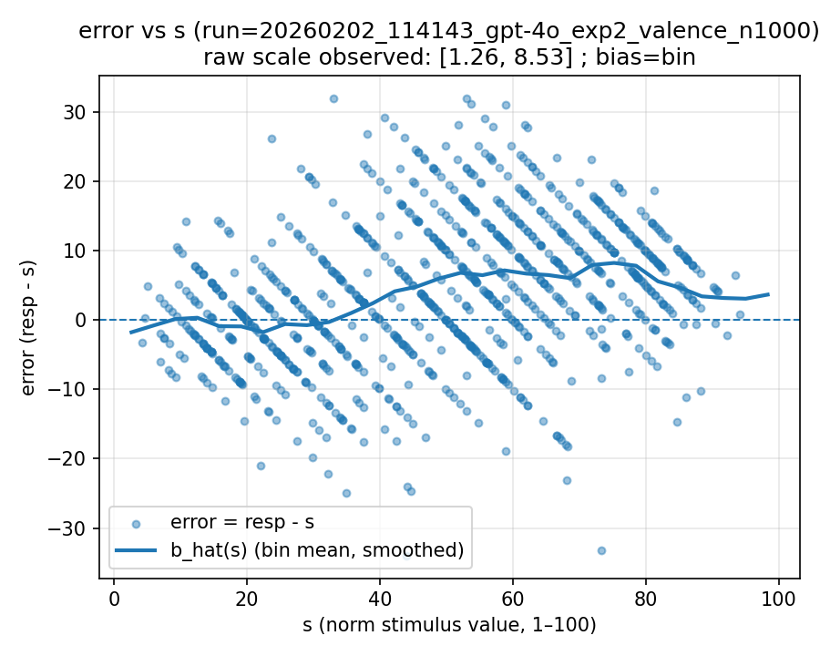 | 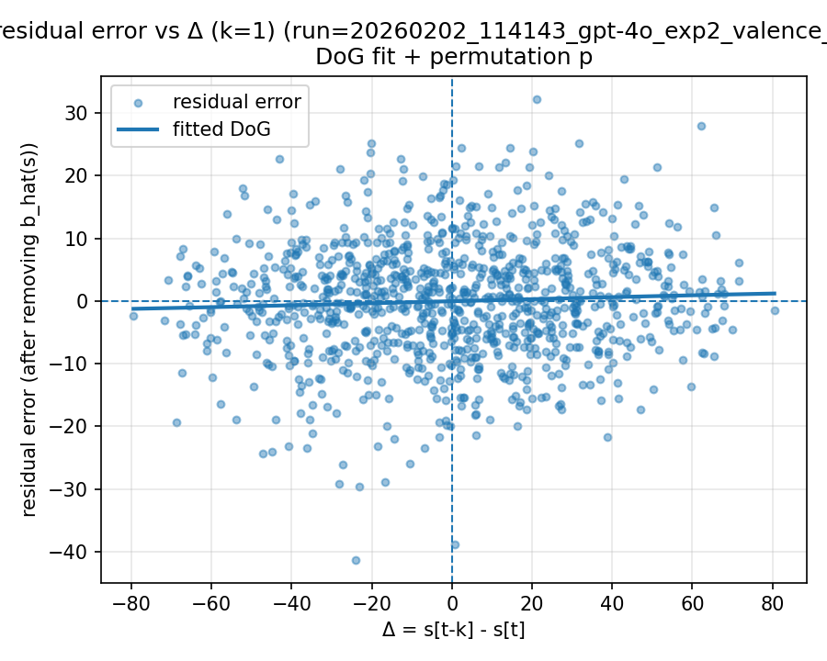
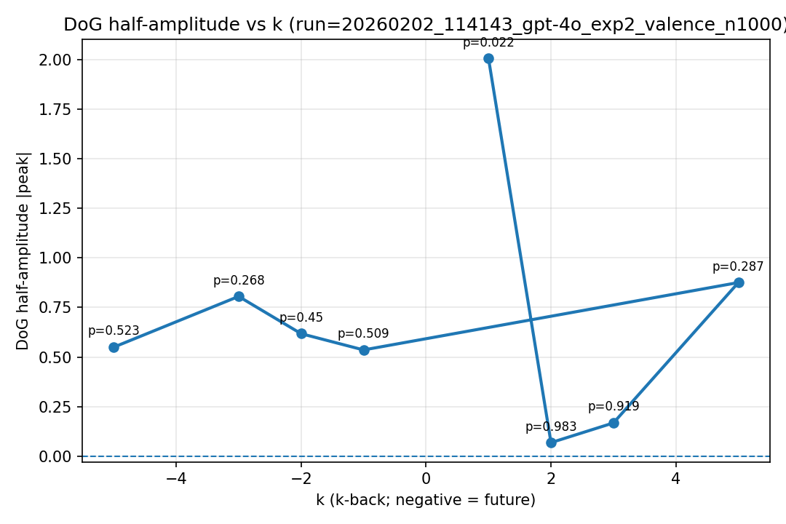
k-back summary (nback_summary.csv):
k | n | c0 | A | sigma | r2 | half_amp | p_half_amp
1 | 1000 | -0.0250573 | 0.0165454 | 200 | 0.00285871 | 2.00706 | 0.021978
2 | 999 | -0.0129837 | 0.00612399 | 18.1895 | 2.29233e-05 | 0.0675628 | 0.983017
3 | 998 | -0.00241079 | -0.00693882 | 39.7015 | 0.000169344 | 0.167088 | 0.919081
5 | 996 | -0.00817768 | 0.0157493 | 91.6861 | 0.00218729 | 0.875827 | 0.286713
-1 | 1000 | 0.00246296 | -0.0196476 | 44.943 | 0.00165676 | 0.53558 | 0.509491
-2 | 999 | 0.0128011 | 0.00509217 | 200 | 0.000272453 | 0.61771 | 0.44955
-3 | 998 | -0.00281857 | 0.169353 | 7.8452 | 0.00167389 | 0.805841 | 0.267732
-5 | 996 | 0.0315989 | -0.0402305 | 22.5181 | 0.00166831 | 0.549465 | 0.523477

20260202_121450_gpt-4o_exp2_valence_n1000
Run configuration (outputs/<run_tag>/run_config.yaml):
base_url: https://www.dmxapi.cn/v1
model: gpt-4o
temperature: 1.0
which: exp2
dimension: valence
mixed_dimensions: None
two_d_dimensions: None
two_d_variants: None
n_words: 1000
n_words_exp2: None
n_trials_none: None
seed: 336222452
excel_path: testing_data/Warriner_et_alemotratings.csv
ci95_enable: True
ci95_threshold: 1.0
max_trials_per_word: 20
merged_cfg: {'base_url': 'https://www.dmxapi.cn/v1', 'api_key': 'sk-DfBAcHghxb9iIvDB2MzHPAutxKtbwMMVGVKXzaABkJnHckQz', 'model': 'gpt-4o', 'temperature': 1.0, 'which': 'exp2', 'n_words': 1000, 'seed': None, 'excel_path': 'testing_data/Warriner_et_alemotratings.csv', 'ci95_enable': True, 'ci95_threshold': 1.0, 'max_trials_per_word': 20, 'dimension': 'concreteness', 'exp2_context_window': 30, 'valence': True}
cli_args: {'config': None, 'base_url': None, 'api_key': None, 'model': 'gpt-4o', 'temperature': 1.0, 'which': 'exp2', 'n_words': 1000, 'seed': None, 'excel_path': 'testing_data/Warriner_et_alemotratings.csv', 'ci95_enable': True, 'ci95_threshold': 1.0, 'max_trials_per_word': None, 'exp2_context_window': 30, 'n_words_exp2': None, 'n_trials_none': None, 'warriner_max_sd_sum': None, 'warriner_max_mf_diff': None, 'warriner_n_bins': None, 'concreteness': False, 'valence': True, 'arousal': False, 'none': False, 'mixed': None, 'two_d': None}
word_source_meta: {'source_path': 'testing_data/Warriner_et_alemotratings.csv', 'source_type': 'warriner_vad', 'filters': {'max_sd_sum': 1.7, 'max_mf_diff': 0.5, 'dims_applied': ['valence']}, 'stimulus_col_by_dim': {'valence': 'valence_mean_1_100', 'arousal': 'arousal_mean_1_100', 'dominance': 'dominance_mean_1_100'}}
word_sampling_meta: {'method': 'stratified_equal_width', 'value_col': 'valence_mean_1_100', 'n_bins': 20}
bias_fit.json (key fields):
norms_csv: /home/leve/serial-dependence-lyf-experiment/testing_data/Warriner_et_alemotratings.csv
raw_scale_min_observed: 1.26
raw_scale_max_observed: 8.53
bias_method: bin
match_n: 1002
match_rate_vs_exp2: 1.002
Plots:
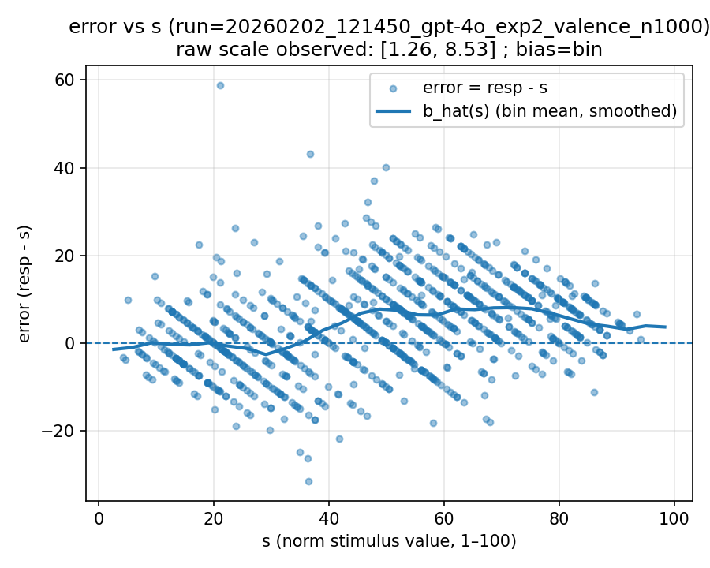 | 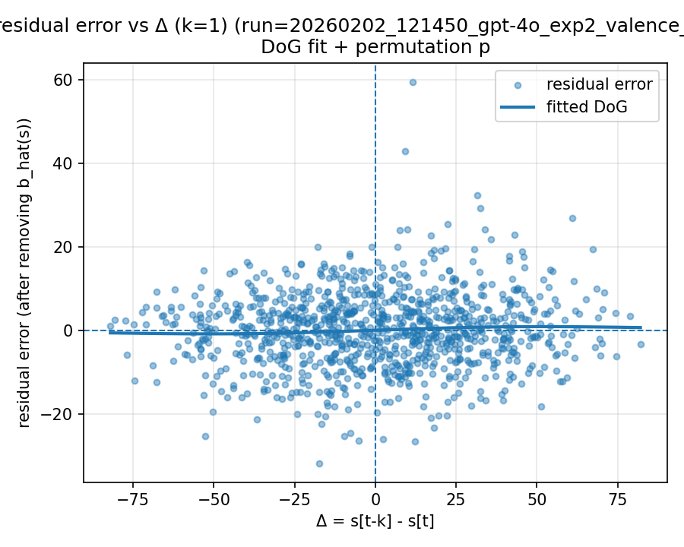
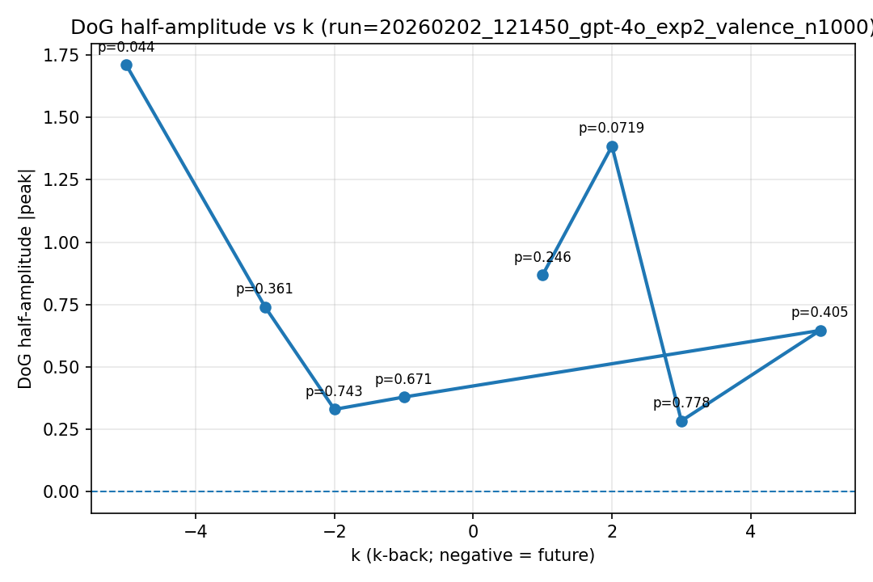
k-back summary (nback_summary.csv):
k | n | c0 | A | sigma | r2 | half_amp | p_half_amp
1 | 1001 | 0.047864 | 0.0278964 | 51.2958 | 0.00427103 | 0.867926 | 0.245754
2 | 1000 | 0.042301 | -0.011417 | 200 | 0.00135778 | 1.38496 | 0.0719281
3 | 999 | 0.0323457 | 0.0128519 | 36.352 | 0.000510113 | 0.283367 | 0.778222
5 | 997 | 0.028055 | 0.108058 | 9.85922 | 0.00136696 | 0.646178 | 0.404595
-1 | 1001 | 0.064895 | 0.04423 | 14.1299 | 0.000660962 | 0.379061 | 0.671329
-2 | 1000 | 0.0748088 | 0.0180547 | 30.1138 | 0.000716911 | 0.329769 | 0.743257
-3 | 999 | 0.087965 | 0.109778 | 11.1271 | 0.00205627 | 0.740883 | 0.360639
-5 | 997 | 0.0963284 | -0.0140982 | 200 | 0.00216242 | 1.71019 | 0.043956

20260202_124834_gpt-4o_exp2_valence_n1000
Run configuration (outputs/<run_tag>/run_config.yaml):
base_url: https://www.dmxapi.cn/v1
model: gpt-4o
temperature: 1.0
which: exp2
dimension: valence
mixed_dimensions: None
two_d_dimensions: None
two_d_variants: None
n_words: 1000
n_words_exp2: None
n_trials_none: None
seed: 2196659167
excel_path: testing_data/Warriner_et_alemotratings.csv
ci95_enable: True
ci95_threshold: 1.0
max_trials_per_word: 20
merged_cfg: {'base_url': 'https://www.dmxapi.cn/v1', 'api_key': 'sk-DfBAcHghxb9iIvDB2MzHPAutxKtbwMMVGVKXzaABkJnHckQz', 'model': 'gpt-4o', 'temperature': 1.0, 'which': 'exp2', 'n_words': 1000, 'seed': None, 'excel_path': 'testing_data/Warriner_et_alemotratings.csv', 'ci95_enable': True, 'ci95_threshold': 1.0, 'max_trials_per_word': 20, 'dimension': 'concreteness', 'exp2_context_window': 30, 'valence': True}
cli_args: {'config': None, 'base_url': None, 'api_key': None, 'model': 'gpt-4o', 'temperature': 1.0, 'which': 'exp2', 'n_words': 1000, 'seed': None, 'excel_path': 'testing_data/Warriner_et_alemotratings.csv', 'ci95_enable': True, 'ci95_threshold': 1.0, 'max_trials_per_word': None, 'exp2_context_window': 30, 'n_words_exp2': None, 'n_trials_none': None, 'warriner_max_sd_sum': None, 'warriner_max_mf_diff': None, 'warriner_n_bins': None, 'concreteness': False, 'valence': True, 'arousal': False, 'none': False, 'mixed': None, 'two_d': None}
word_source_meta: {'source_path': 'testing_data/Warriner_et_alemotratings.csv', 'source_type': 'warriner_vad', 'filters': {'max_sd_sum': 1.7, 'max_mf_diff': 0.5, 'dims_applied': ['valence']}, 'stimulus_col_by_dim': {'valence': 'valence_mean_1_100', 'arousal': 'arousal_mean_1_100', 'dominance': 'dominance_mean_1_100'}}
word_sampling_meta: {'method': 'stratified_equal_width', 'value_col': 'valence_mean_1_100', 'n_bins': 20}
bias_fit.json (key fields):
norms_csv: /home/leve/serial-dependence-lyf-experiment/testing_data/Warriner_et_alemotratings.csv
raw_scale_min_observed: 1.26
raw_scale_max_observed: 8.53
bias_method: bin
match_n: 1001
match_rate_vs_exp2: 1.001
Plots:
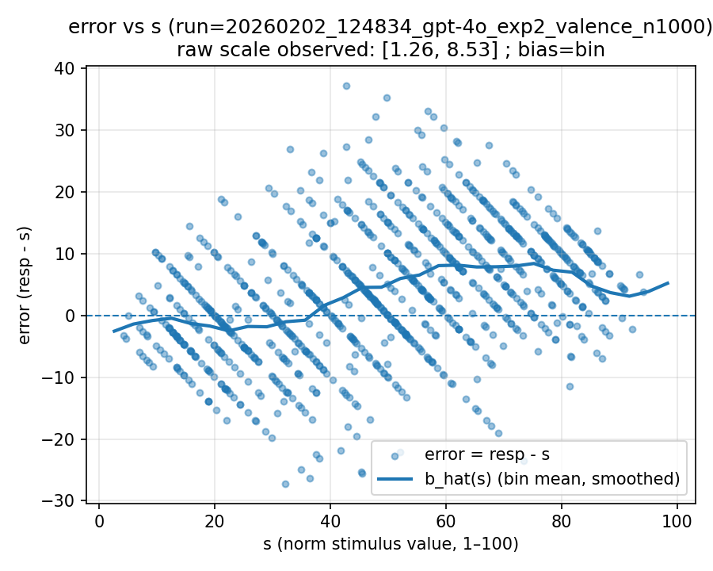 | 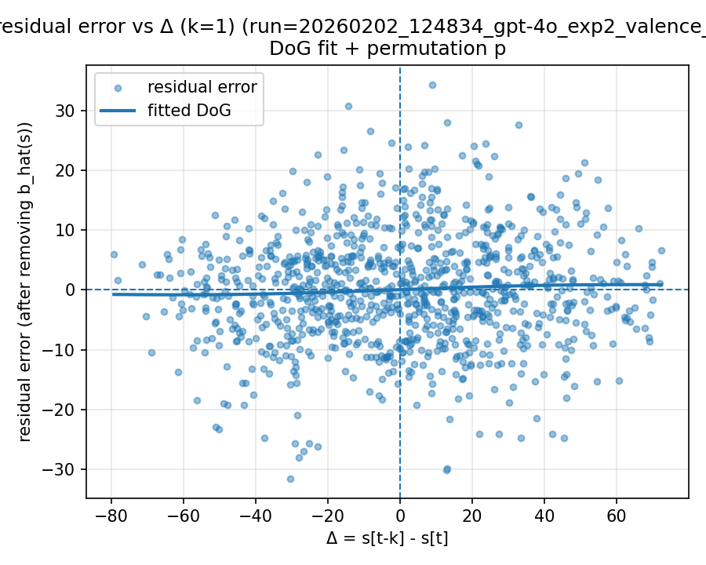
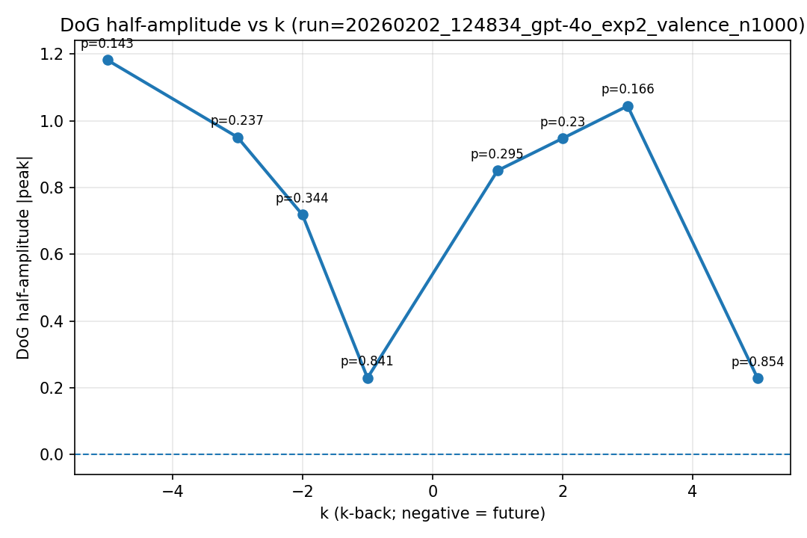
k-back summary (nback_summary.csv):
k | n | c0 | A | sigma | r2 | half_amp | p_half_amp
-5 | 996 | 0.0560702 | 0.120037 | 16.2357 | 0.00640553 | 1.18206 | 0.142857
-3 | 998 | 0.0258382 | -0.0145939 | 107.444 | 0.00193467 | 0.951054 | 0.236763
-2 | 999 | 0.0219141 | -0.0126049 | 93.9511 | 0.00134378 | 0.718278 | 0.343656
-1 | 1000 | 0.0165664 | -0.0143408 | 26.3798 | 0.000320181 | 0.229455 | 0.841159
1 | 1000 | 0.0393982 | 0.0227631 | 61.6285 | 0.00332838 | 0.850875 | 0.294705
2 | 999 | 0.0497081 | 0.00780914 | 200 | 0.000635151 | 0.947297 | 0.22977
3 | 998 | 0.0324208 | -0.120578 | 14.2816 | 0.00447864 | 1.04447 | 0.165834
5 | 996 | 0.0475237 | 0.0173777 | 21.6249 | 0.000285031 | 0.227929 | 0.854146

