Prev-n-class (low/high) n-back analysis report
Generated at: 2026-02-19 17:00:19
Params file: /home/leve/serial-dependence-lyf-experiment/ana_prev_n_class/params.yaml
n_values: [-10, -5, 1, 2, 3, 4, 5, 6, 7, 8, 9, 10]
low_max: 50
high_min: 51
test: welch

20251212_203849_both_valence_n400
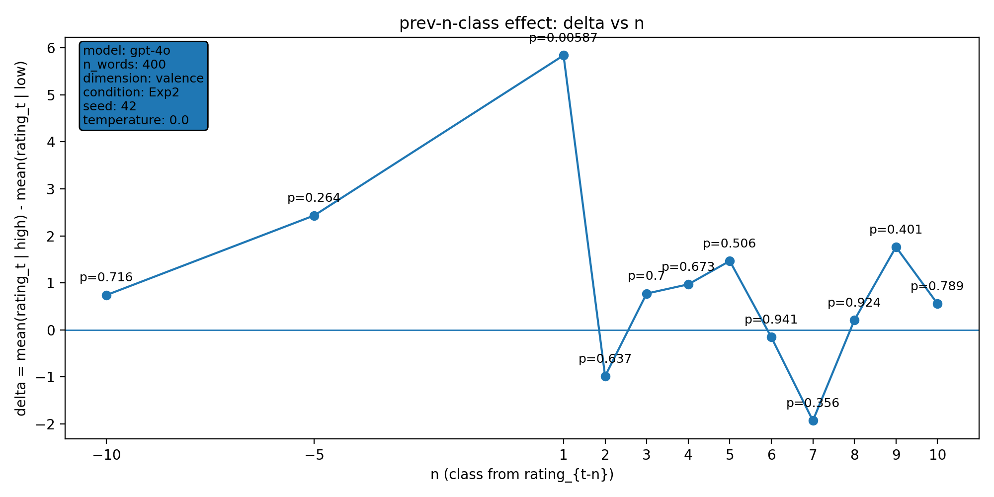 | model: gpt-4o  which: both  dimension: valence  n_words: 400  temperature: 0.0  seed: 42  stats_csv: ana_prev_n_class/results/20251212_203849_both_valence_n400/n_back_stats.csv
n-back deltas (per n):
n | p_value | n_low | n_high
-10 | 0.716 | 100 | 189
-5 | 0.264 | 101 | 191
1 | 0.00587 | 102 | 195
2 | 0.637 | 101 | 195
3 | 0.7 | 100 | 195
4 | 0.673 | 99 | 195
5 | 0.506 | 99 | 194
6 | 0.941 | 99 | 193
7 | 0.356 | 99 | 192
8 | 0.924 | 99 | 191
9 | 0.401 | 99 | 190
10 | 0.789 | 99 | 190

20251212_203916_both_arousal_n400
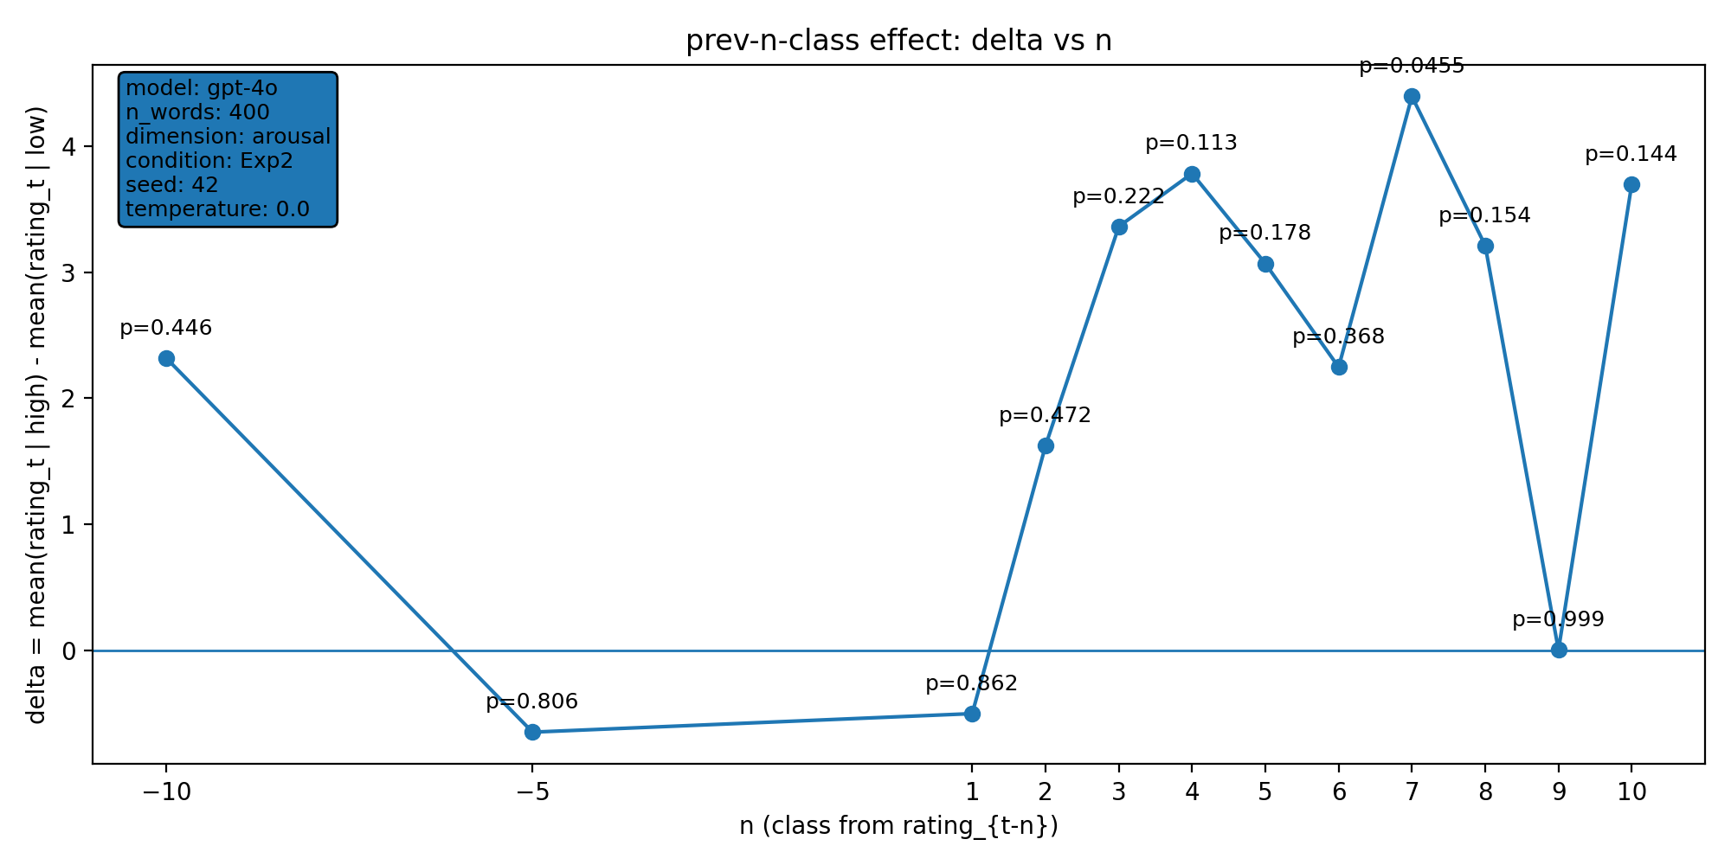 | model: gpt-4o  which: both  dimension: arousal  n_words: 400  temperature: 0.0  seed: 42  stats_csv: ana_prev_n_class/results/20251212_203916_both_arousal_n400/n_back_stats.csv
n-back deltas (per n):
n | p_value | n_low | n_high
-10 | 0.446 | 29 | 234
-5 | 0.806 | 30 | 237
1 | 0.862 | 31 | 239
2 | 0.472 | 31 | 238
3 | 0.222 | 31 | 237
4 | 0.113 | 31 | 237
5 | 0.178 | 31 | 237
6 | 0.368 | 31 | 237
7 | 0.0455 | 31 | 236
8 | 0.154 | 31 | 235
9 | 0.999 | 31 | 234
10 | 0.144 | 31 | 234

20251213_010833_both_arousal_n400
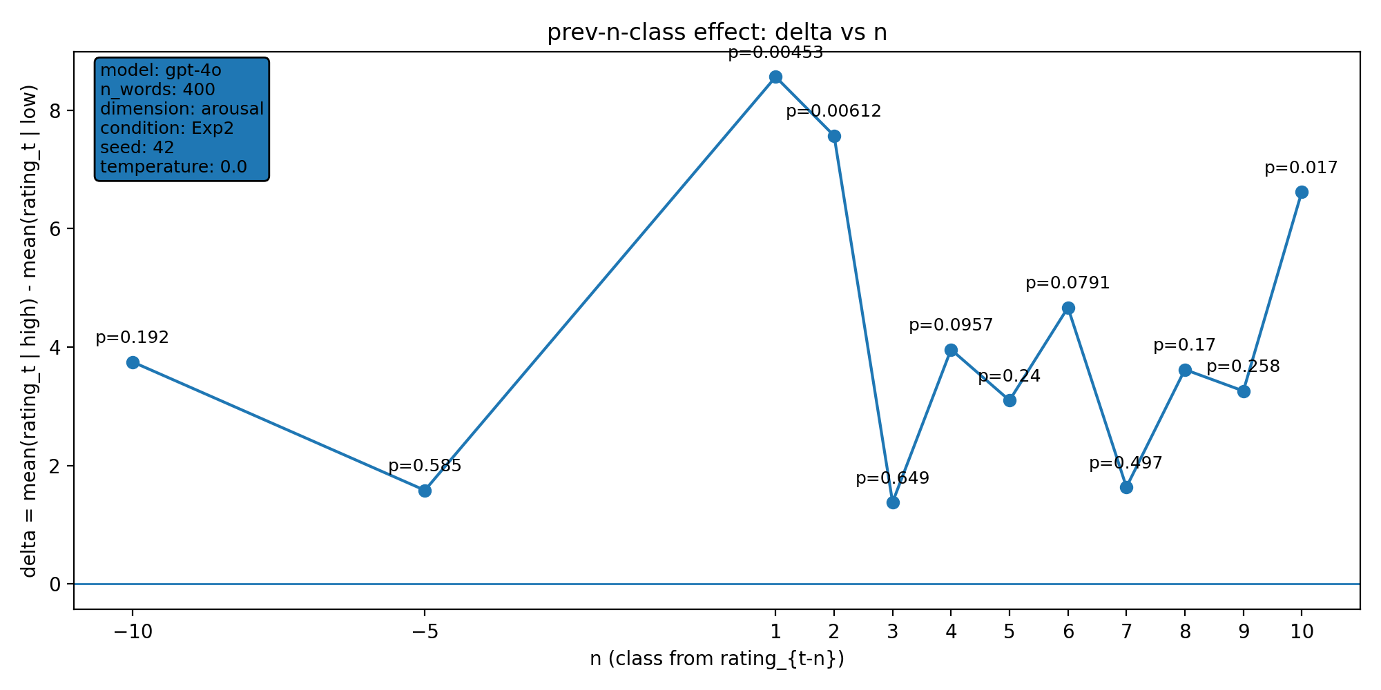 | model: gpt-4o  which: both  dimension: arousal  n_words: 400  temperature: 0.0  seed: 42  stats_csv: ana_prev_n_class/results/20251213_010833_both_arousal_n400/n_back_stats.csv
n-back deltas (per n):
n | p_value | n_low | n_high
-10 | 0.192 | 29 | 240
-5 | 0.585 | 30 | 241
1 | 0.00453 | 31 | 243
2 | 0.00612 | 31 | 242
3 | 0.649 | 31 | 241
4 | 0.0957 | 31 | 240
5 | 0.24 | 31 | 239
6 | 0.0791 | 31 | 238
7 | 0.497 | 31 | 237
8 | 0.17 | 31 | 236
9 | 0.258 | 31 | 235
10 | 0.017 | 31 | 235

20251213_133659_both_concreteness_n400
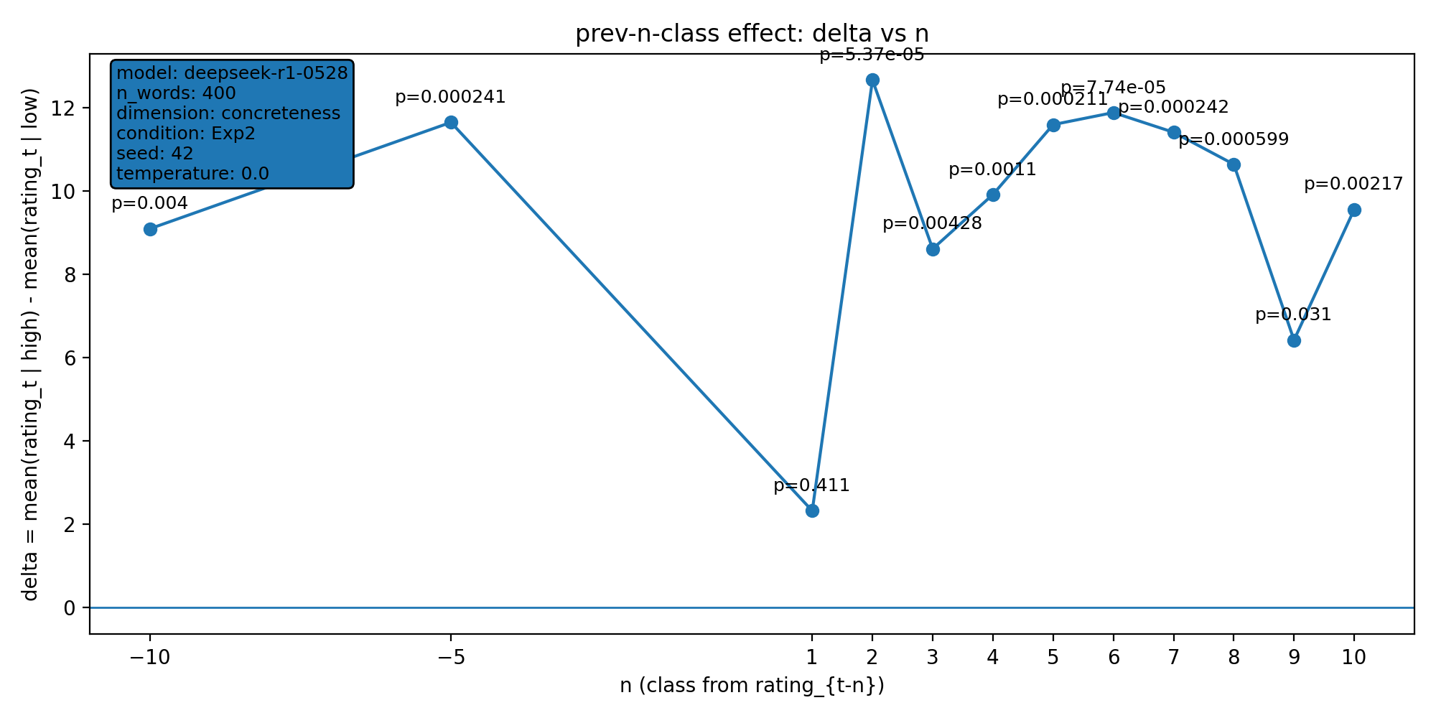 | model: deepseek-r1-0528  which: both  dimension: concreteness  n_words: 400  temperature: 0.0  seed: 42  stats_csv: ana_prev_n_class/results/20251213_133659_both_concreteness_n400/n_back_stats.csv
n-back deltas (per n):
n | p_value | n_low | n_high
-10 | 0.004 | 88 | 300
-5 | 0.000241 | 91 | 302
1 | 0.411 | 94 | 303
2 | 5.37e-05 | 94 | 302
3 | 0.00428 | 94 | 301
4 | 0.0011 | 94 | 300
5 | 0.000211 | 94 | 299
6 | 7.74e-05 | 93 | 299
7 | 0.000242 | 93 | 298
8 | 0.000599 | 93 | 297
9 | 0.031 | 93 | 296
10 | 0.00217 | 93 | 295

20251213_133742_both_concreteness_n400
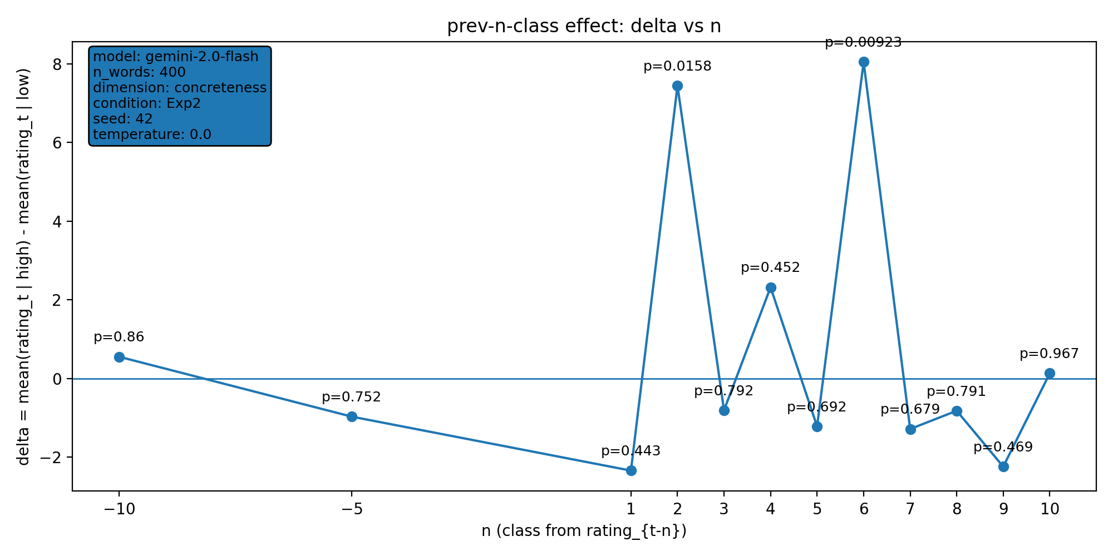 | model: gemini-2.0-flash  which: both  dimension: concreteness  n_words: 400  temperature: 0.0  seed: 42  stats_csv: ana_prev_n_class/results/20251213_133742_both_concreteness_n400/n_back_stats.csv
n-back deltas (per n):
n | p_value | n_low | n_high
-10 | 0.86 | 195 | 184
-5 | 0.752 | 198 | 186
1 | 0.443 | 202 | 186
2 | 0.0158 | 201 | 186
3 | 0.792 | 201 | 185
4 | 0.452 | 201 | 184
5 | 0.692 | 200 | 184
6 | 0.00923 | 199 | 184
7 | 0.679 | 199 | 183
8 | 0.791 | 198 | 183
9 | 0.469 | 197 | 183
10 | 0.967 | 196 | 183

20251217_213039_both_concreteness_n400
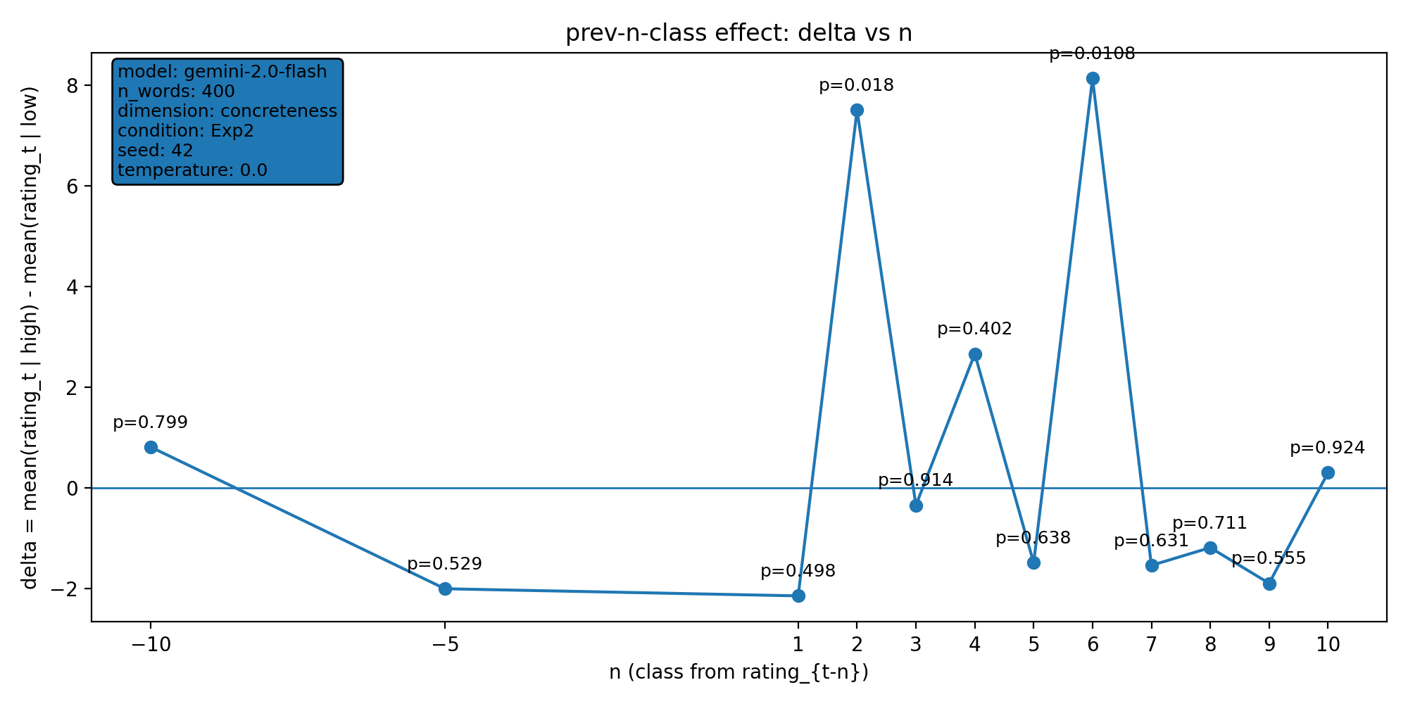 | model: gemini-2.0-flash  which: both  dimension: concreteness  n_words: 400  temperature: 0.0  seed: 42  stats_csv: ana_prev_n_class/results/20251217_213039_both_concreteness_n400/n_back_stats.csv
n-back deltas (per n):
n | p_value | n_low | n_high
-10 | 0.799 | 191 | 183
-5 | 0.529 | 194 | 185
1 | 0.498 | 198 | 185
2 | 0.018 | 197 | 185
3 | 0.914 | 197 | 184
4 | 0.402 | 197 | 183
5 | 0.638 | 196 | 183
6 | 0.0108 | 195 | 183
7 | 0.631 | 195 | 182
8 | 0.711 | 194 | 182
9 | 0.555 | 193 | 182
10 | 0.924 | 192 | 182

20251218_170111_both_concreteness_n400
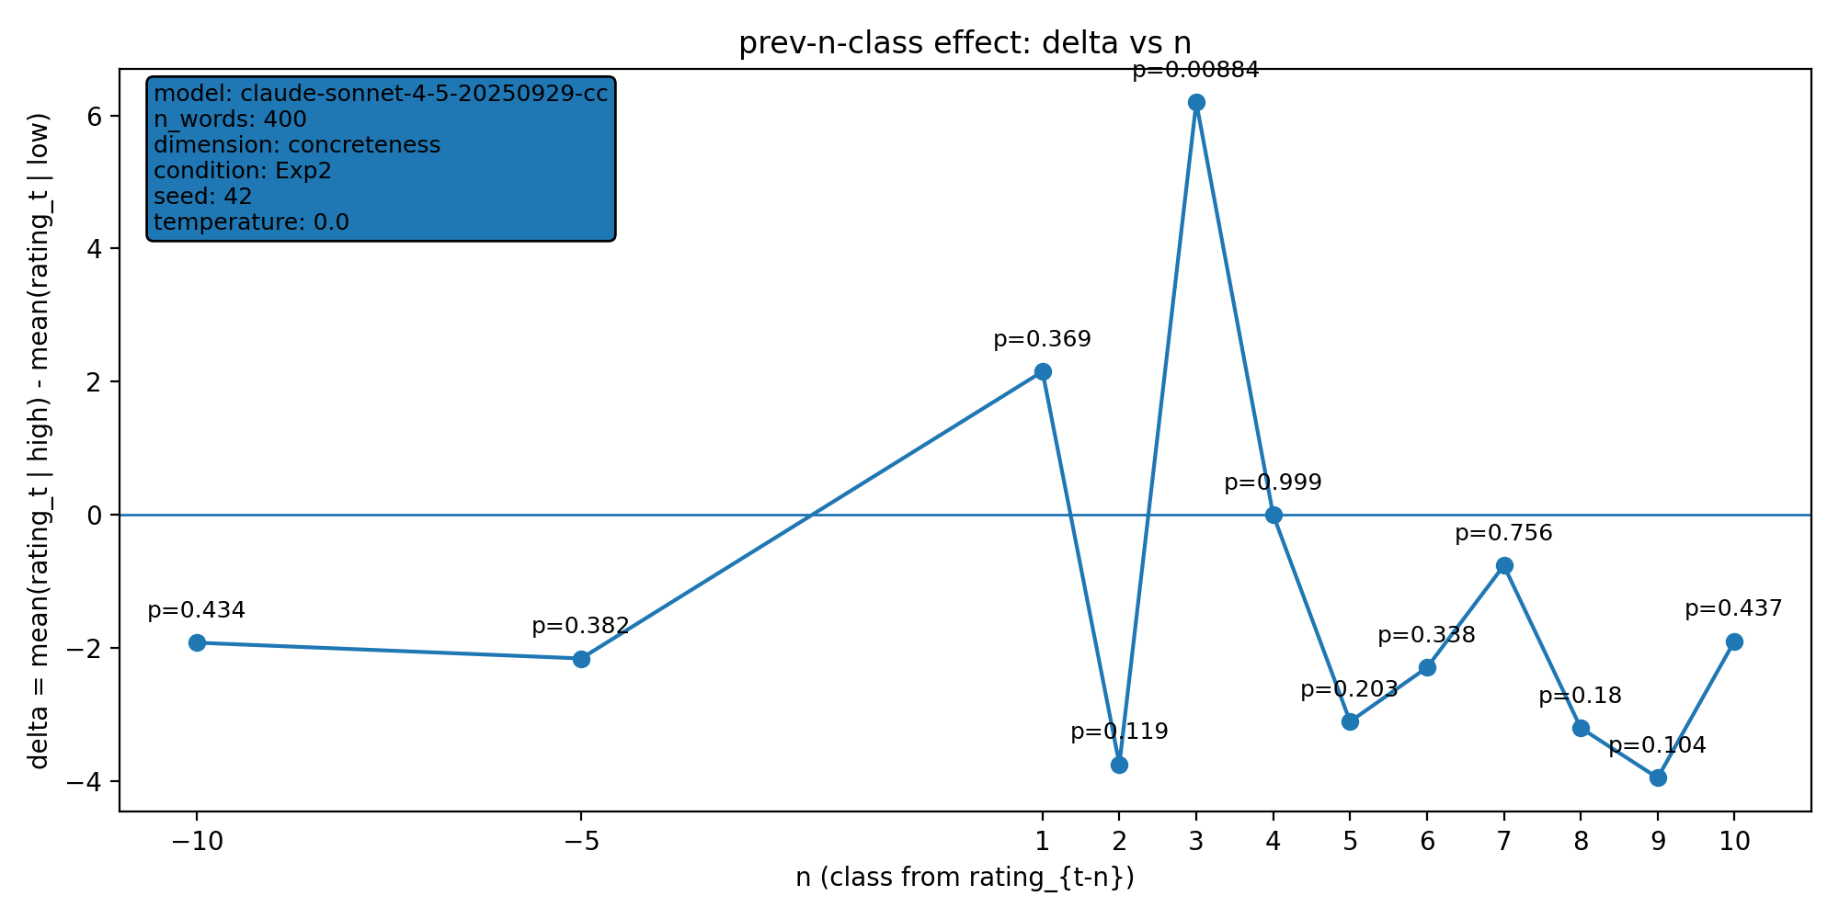 | model: claude-sonnet-4-5-20250929-cc  which: both  dimension: concreteness  n_words: 400  temperature: 0.0  seed: 42  stats_csv: ana_prev_n_class/results/20251218_170111_both_concreteness_n400/n_back_stats.csv
n-back deltas (per n):
n | p_value | n_low | n_high
-10 | 0.434 | 171 | 161
-5 | 0.382 | 173 | 162
1 | 0.369 | 175 | 165
2 | 0.119 | 174 | 165
3 | 0.00884 | 173 | 165
4 | 0.999 | 173 | 164
5 | 0.203 | 173 | 163
6 | 0.338 | 173 | 162
7 | 0.756 | 173 | 162
8 | 0.18 | 173 | 162
9 | 0.104 | 172 | 162
10 | 0.437 | 171 | 162

20251218_170152_both_concreteness_n400
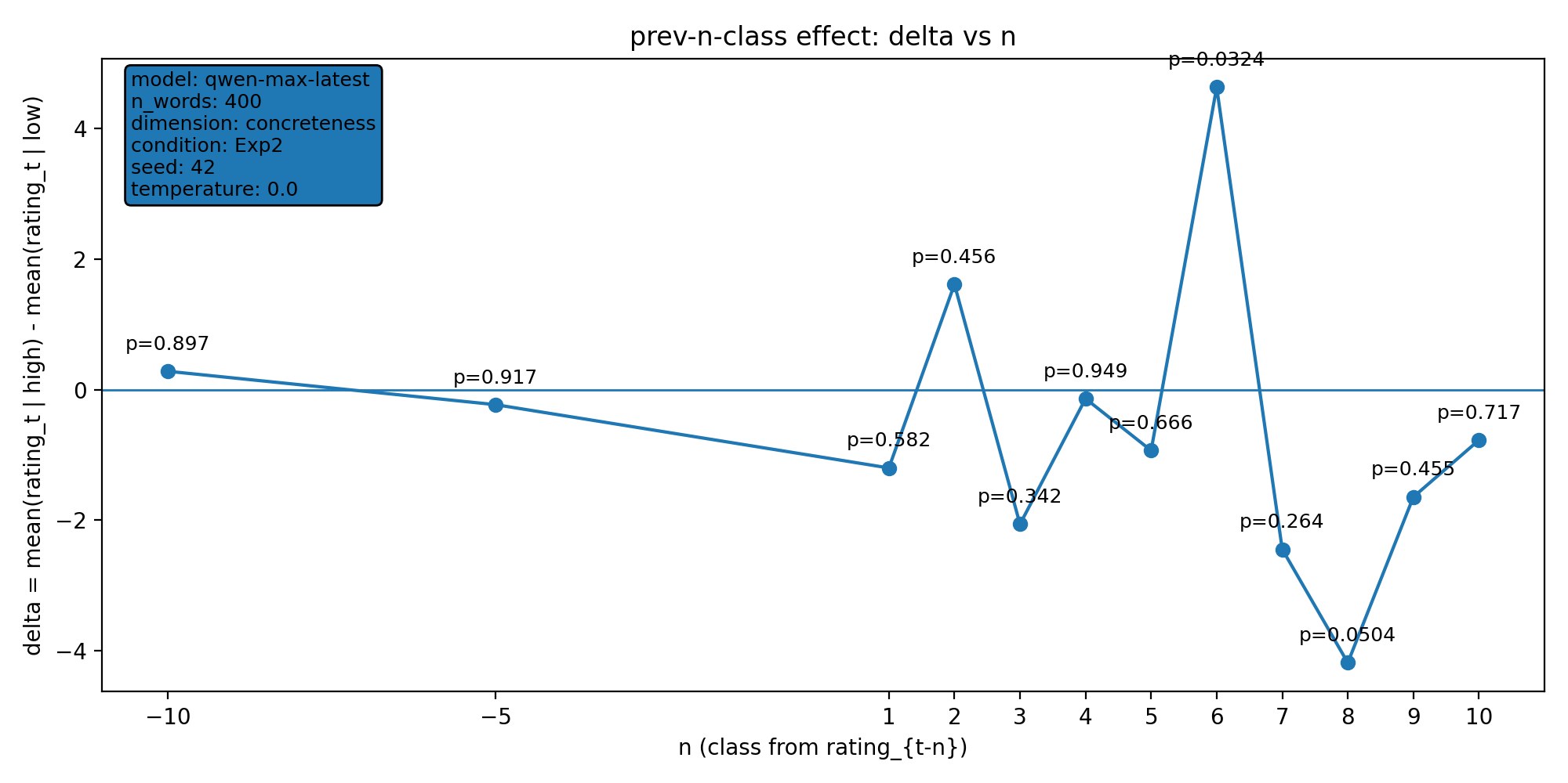 | model: qwen-max-latest  which: both  dimension: concreteness  n_words: 400  temperature: 0.0  seed: 42  stats_csv: ana_prev_n_class/results/20251218_170152_both_concreteness_n400/n_back_stats.csv
n-back deltas (per n):
n | p_value | n_low | n_high
-10 | 0.897 | 153 | 180
-5 | 0.917 | 154 | 183
1 | 0.582 | 158 | 183
2 | 0.456 | 157 | 183
3 | 0.342 | 157 | 182
4 | 0.949 | 157 | 181
5 | 0.666 | 156 | 181
6 | 0.0324 | 155 | 181
7 | 0.264 | 155 | 180
8 | 0.0504 | 155 | 180
9 | 0.455 | 154 | 180
10 | 0.717 | 154 | 180

20251218_193433_both_concreteness_n400
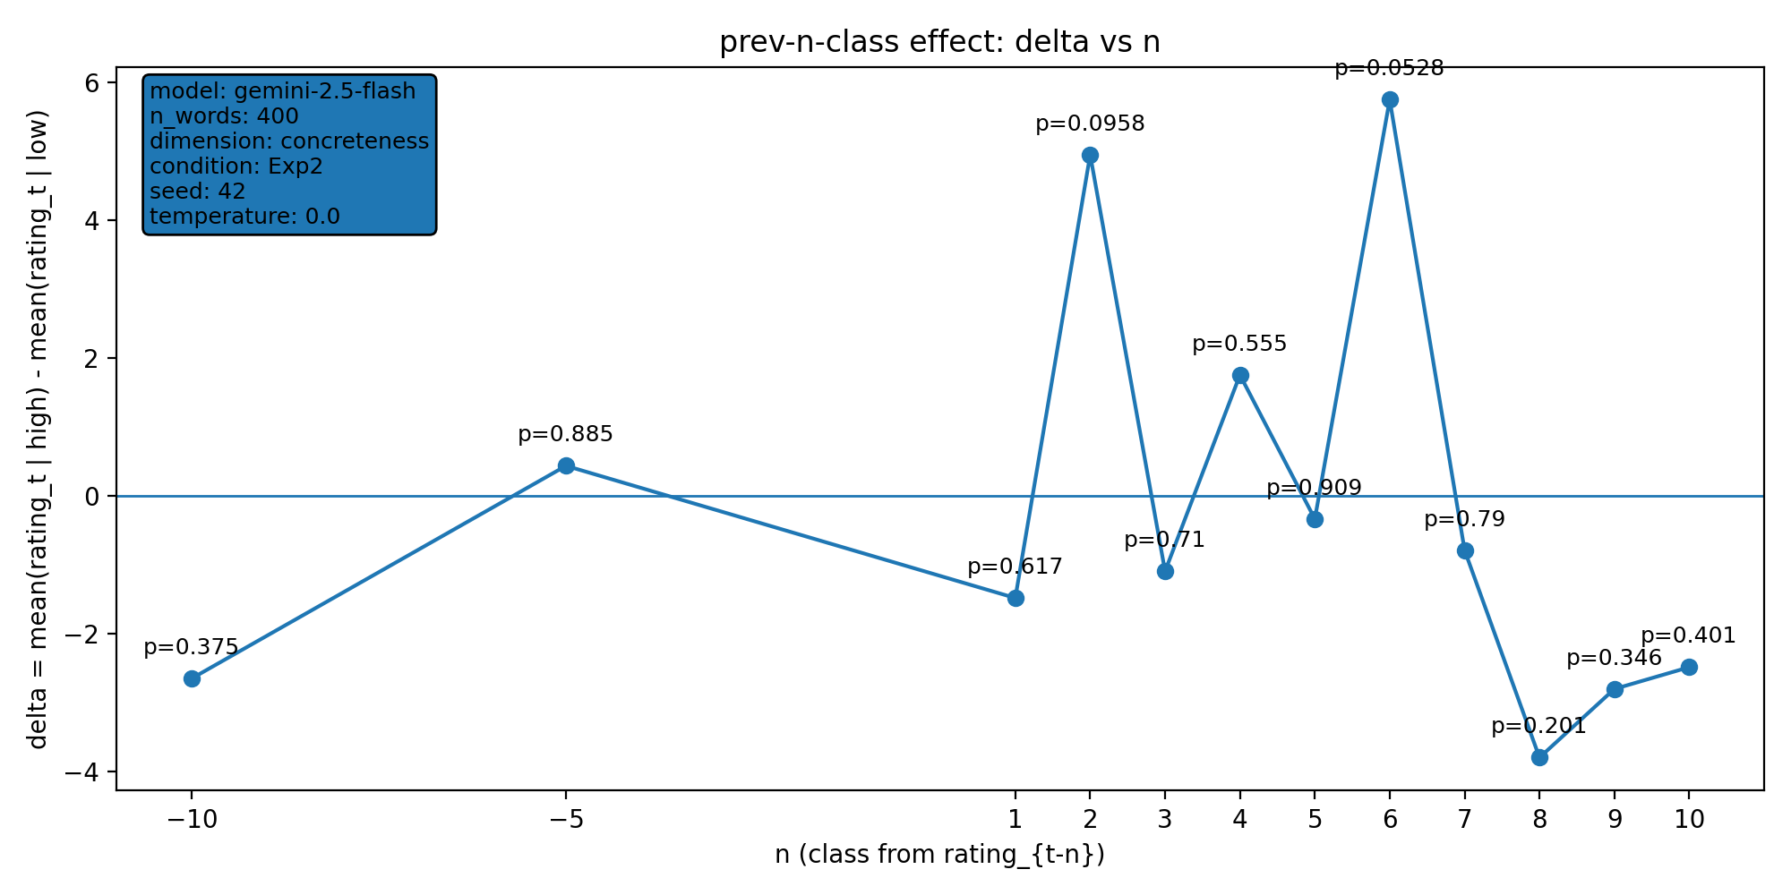 | model: gemini-2.5-flash  which: both  dimension: concreteness  n_words: 400  temperature: 0.0  seed: 42  stats_csv: ana_prev_n_class/results/20251218_193433_both_concreteness_n400/n_back_stats.csv
n-back deltas (per n):
n | p_value | n_low | n_high
-10 | 0.375 | 197 | 175
-5 | 0.885 | 199 | 177
1 | 0.617 | 202 | 178
2 | 0.0958 | 201 | 178
3 | 0.71 | 201 | 178
4 | 0.555 | 201 | 177
5 | 0.909 | 200 | 177
6 | 0.0528 | 199 | 177
7 | 0.79 | 199 | 176
8 | 0.201 | 198 | 176
9 | 0.346 | 197 | 176
10 | 0.401 | 196 | 176

20251221_131659_both_concreteness_n400
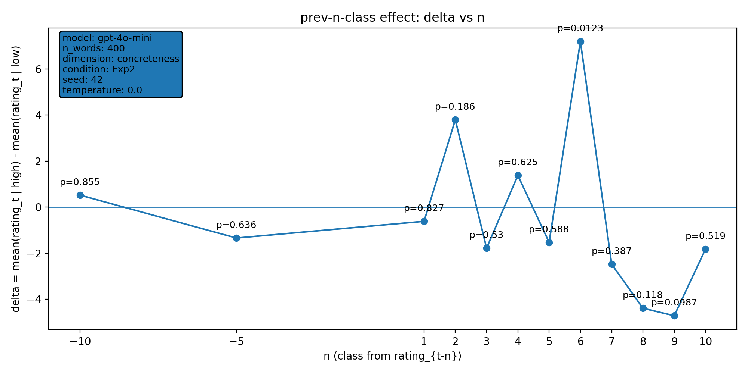 | model: gpt-4o-mini  which: both  dimension: concreteness  n_words: 400  temperature: 0.0  seed: 42  stats_csv: ana_prev_n_class/results/20251221_131659_both_concreteness_n400/n_back_stats.csv
n-back deltas (per n):
n | p_value | n_low | n_high
-10 | 0.855 | 190 | 168
-5 | 0.636 | 192 | 170
1 | 0.827 | 196 | 170
2 | 0.186 | 195 | 170
3 | 0.53 | 195 | 169
4 | 0.625 | 195 | 168
5 | 0.588 | 194 | 168
6 | 0.0123 | 193 | 168
7 | 0.387 | 193 | 167
8 | 0.118 | 192 | 167
9 | 0.0987 | 191 | 167
10 | 0.519 | 190 | 167

20251221_135907_both_concreteness_n400
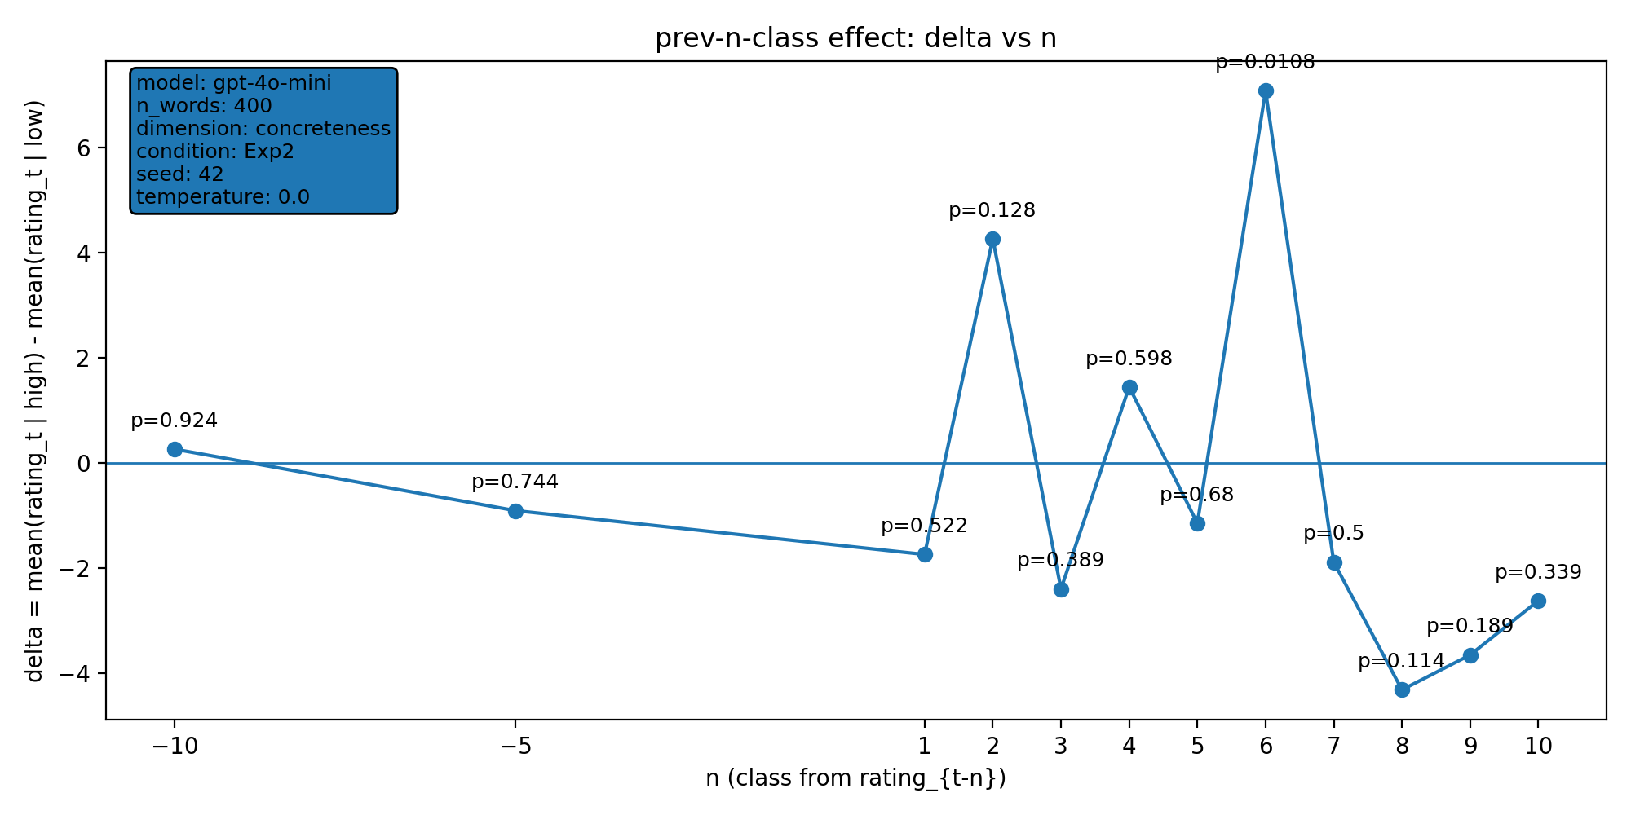 | model: gpt-4o-mini  which: both  dimension: concreteness  n_words: 400  temperature: 0.0  seed: 42  stats_csv: ana_prev_n_class/results/20251221_135907_both_concreteness_n400/n_back_stats.csv
n-back deltas (per n):
n | p_value | n_low | n_high
-10 | 0.924 | 188 | 169
-5 | 0.744 | 190 | 171
1 | 0.522 | 194 | 171
2 | 0.128 | 193 | 171
3 | 0.389 | 193 | 170
4 | 0.598 | 193 | 169
5 | 0.68 | 192 | 169
6 | 0.0108 | 191 | 169
7 | 0.5 | 191 | 168
8 | 0.114 | 190 | 168
9 | 0.189 | 189 | 168
10 | 0.339 | 188 | 168

20251221_135911_both_arousal_n400
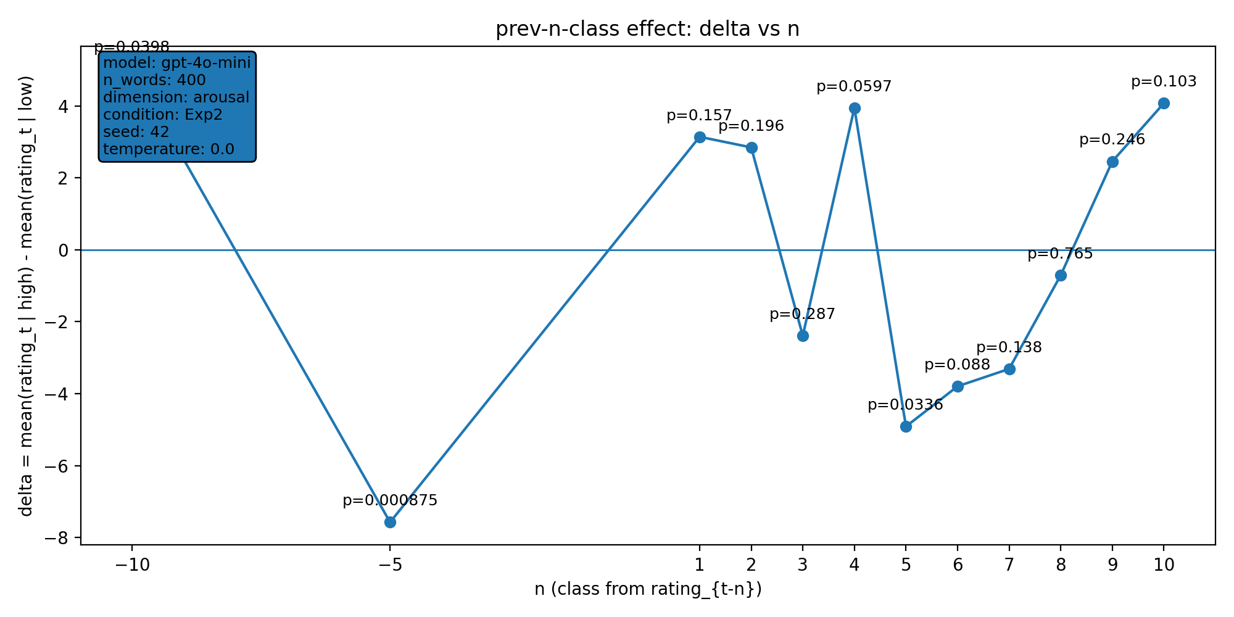 | model: gpt-4o-mini  which: both  dimension: arousal  n_words: 400  temperature: 0.0  seed: 42  stats_csv: ana_prev_n_class/results/20251221_135911_both_arousal_n400/n_back_stats.csv
n-back deltas (per n):
n | p_value | n_low | n_high
-10 | 0.0398 | 57 | 197
-5 | 0.000875 | 58 | 198
1 | 0.157 | 59 | 202
2 | 0.196 | 59 | 201
3 | 0.287 | 59 | 200
4 | 0.0597 | 59 | 199
5 | 0.0336 | 59 | 198
6 | 0.088 | 59 | 198
7 | 0.138 | 59 | 197
8 | 0.765 | 59 | 196
9 | 0.246 | 59 | 195
10 | 0.103 | 58 | 195

20251221_144236_both_concreteness_n400
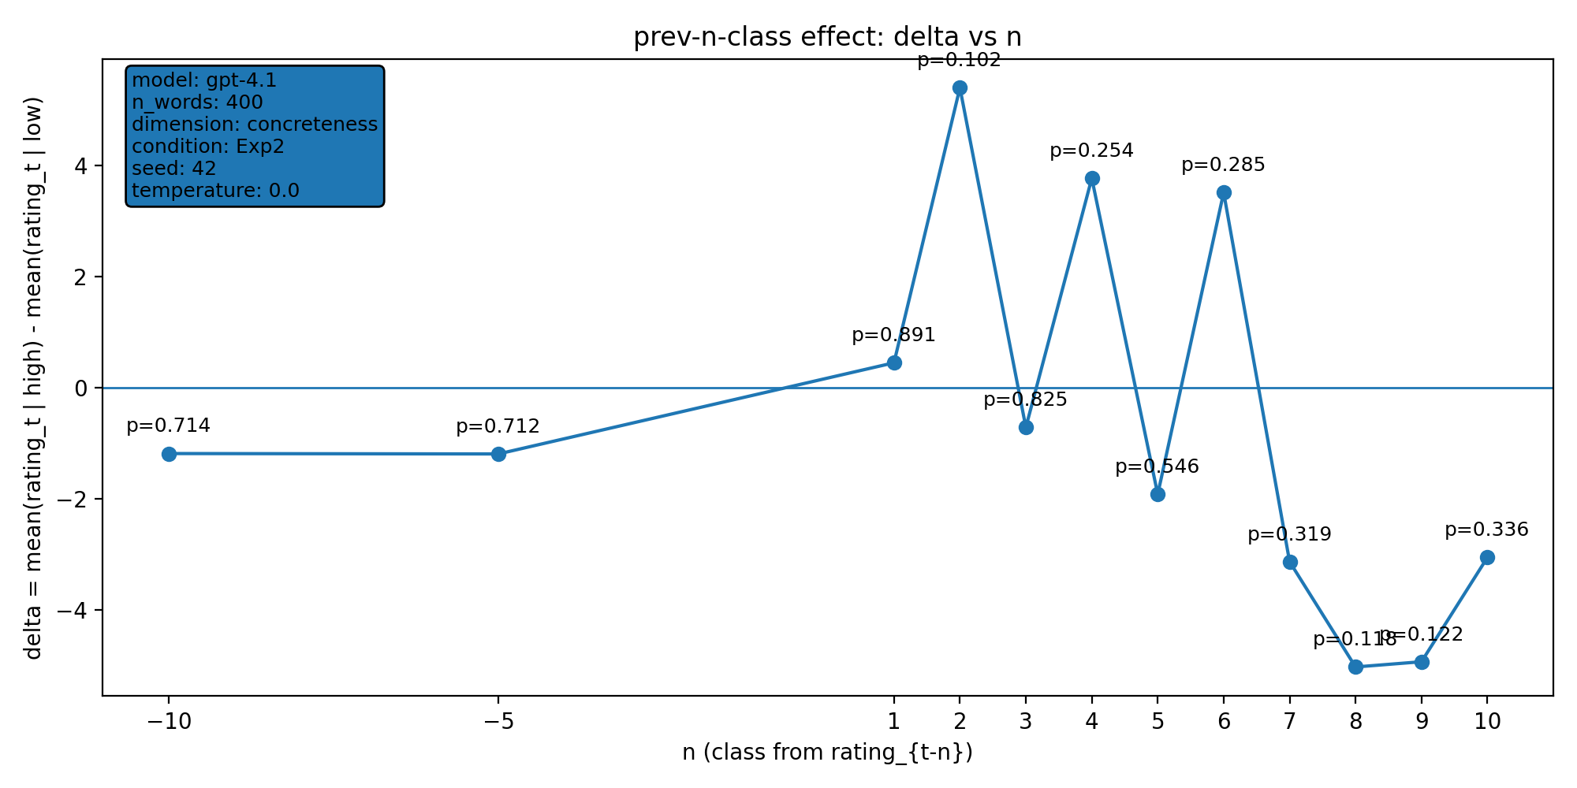 | model: gpt-4.1  which: both  dimension: concreteness  n_words: 400  temperature: 0.0  seed: 42  stats_csv: ana_prev_n_class/results/20251221_144236_both_concreteness_n400/n_back_stats.csv
n-back deltas (per n):
n | p_value | n_low | n_high
-10 | 0.714 | 224 | 132
-5 | 0.712 | 227 | 134
1 | 0.891 | 231 | 134
2 | 0.102 | 230 | 134
3 | 0.825 | 230 | 134
4 | 0.254 | 230 | 133
5 | 0.546 | 229 | 133
6 | 0.285 | 228 | 133
7 | 0.319 | 228 | 132
8 | 0.118 | 227 | 132
9 | 0.122 | 226 | 132
10 | 0.336 | 225 | 132

20251221_144304_both_arousal_n400
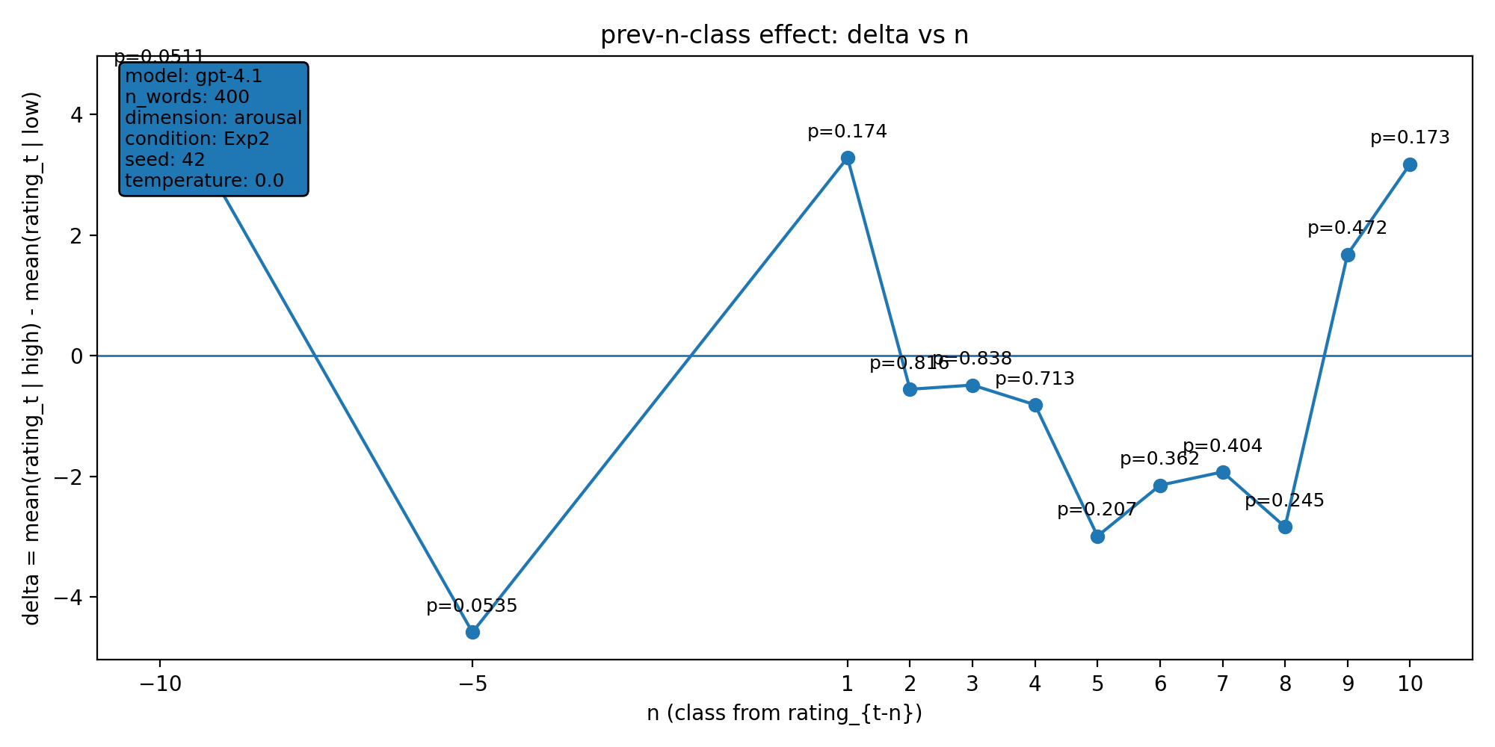 | model: gpt-4.1  which: both  dimension: arousal  n_words: 400  temperature: 0.0  seed: 42  stats_csv: ana_prev_n_class/results/20251221_144304_both_arousal_n400/n_back_stats.csv
n-back deltas (per n):
n | p_value | n_low | n_high
-10 | 0.0511 | 108 | 145
-5 | 0.0535 | 110 | 146
1 | 0.174 | 111 | 149
2 | 0.816 | 111 | 148
3 | 0.838 | 111 | 147
4 | 0.713 | 111 | 146
5 | 0.207 | 111 | 145
6 | 0.362 | 111 | 145
7 | 0.404 | 111 | 145
8 | 0.245 | 111 | 144
9 | 0.472 | 111 | 144
10 | 0.173 | 110 | 144

20251221_172610_both_concreteness_n400
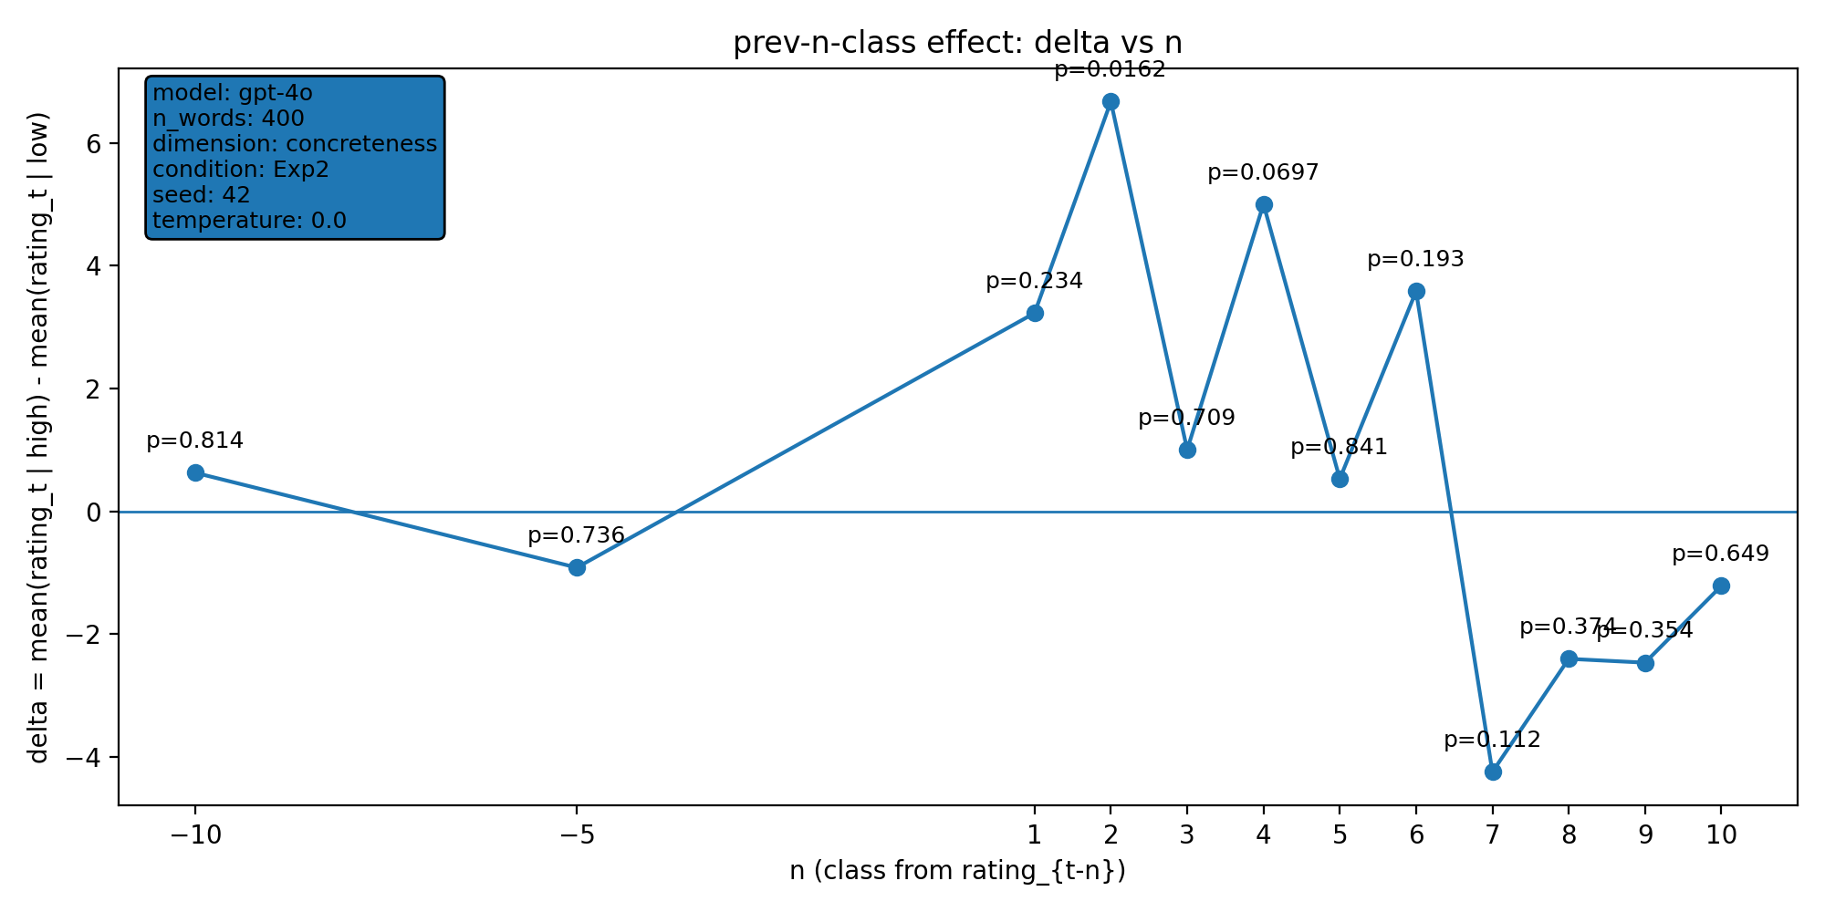 | model: gpt-4o  which: both  dimension: concreteness  n_words: 400  temperature: 0.0  seed: 42  stats_csv: ana_prev_n_class/results/20251221_172610_both_concreteness_n400/n_back_stats.csv
n-back deltas (per n):
n | p_value | n_low | n_high
-10 | 0.814 | 203 | 125
-5 | 0.736 | 206 | 127
1 | 0.234 | 210 | 127
2 | 0.0162 | 209 | 127
3 | 0.709 | 209 | 127
4 | 0.0697 | 209 | 126
5 | 0.841 | 208 | 126
6 | 0.193 | 207 | 126
7 | 0.112 | 207 | 126
8 | 0.374 | 206 | 126
9 | 0.354 | 205 | 126
10 | 0.649 | 204 | 126

20251224_103903_gpt-4o_exp2_concreteness_n1000
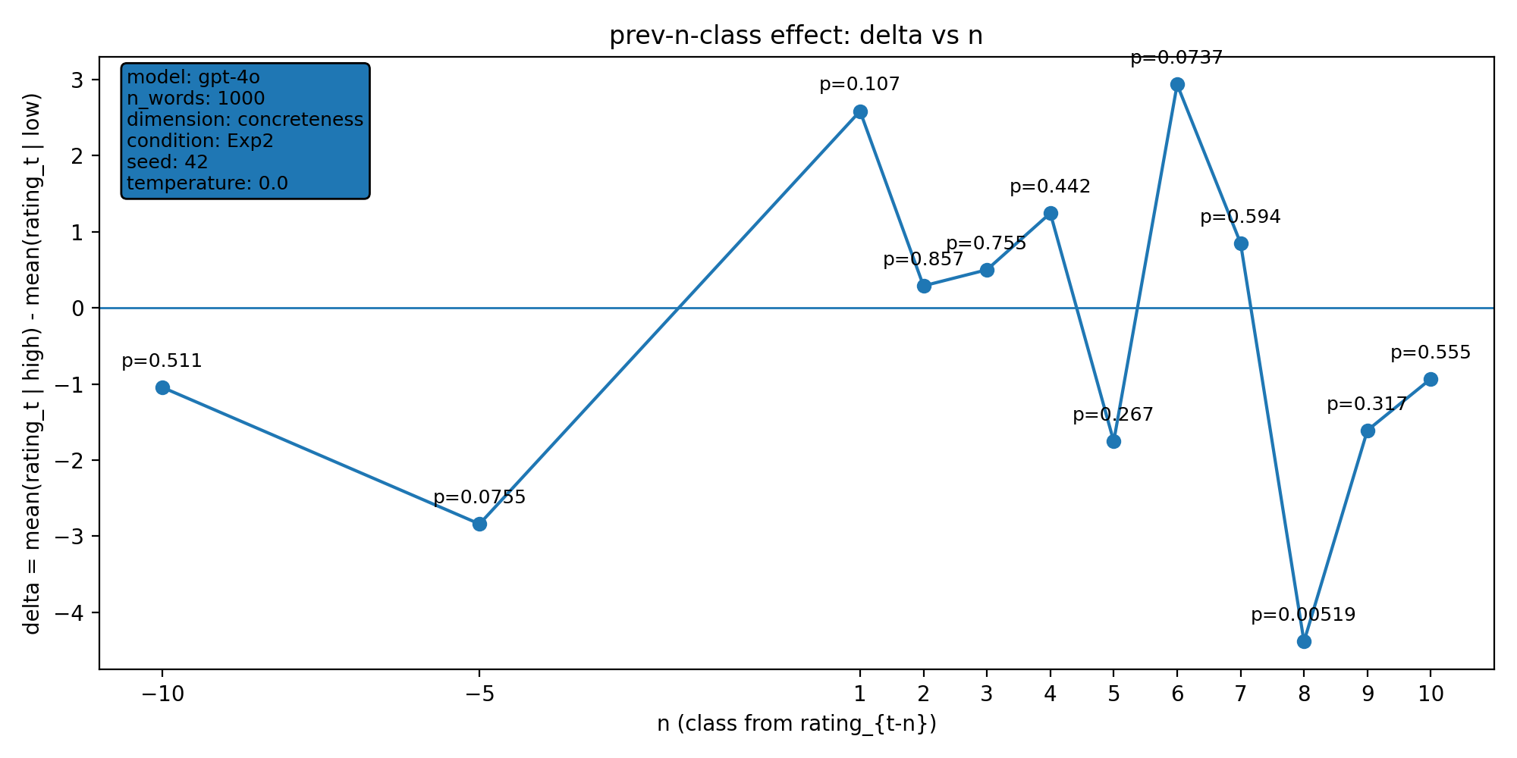 | model: gpt-4o  which: exp2  dimension: concreteness  n_words: 1000  temperature: 0.0  seed: 42  stats_csv: ana_prev_n_class/results/20251224_103903_gpt-4o_exp2_concreteness_n1000/n_back_stats.csv
n-back deltas (per n):
n | p_value | n_low | n_high
-10 | 0.511 | 489 | 327
-5 | 0.0755 | 492 | 328
1 | 0.107 | 495 | 329
2 | 0.857 | 494 | 329
3 | 0.755 | 494 | 329
4 | 0.442 | 494 | 328
5 | 0.267 | 494 | 328
6 | 0.0737 | 494 | 327
7 | 0.594 | 494 | 326
8 | 0.00519 | 494 | 325
9 | 0.317 | 494 | 325
10 | 0.555 | 493 | 325

20260107_145719_gpt-4o_both_concreteness_n2000
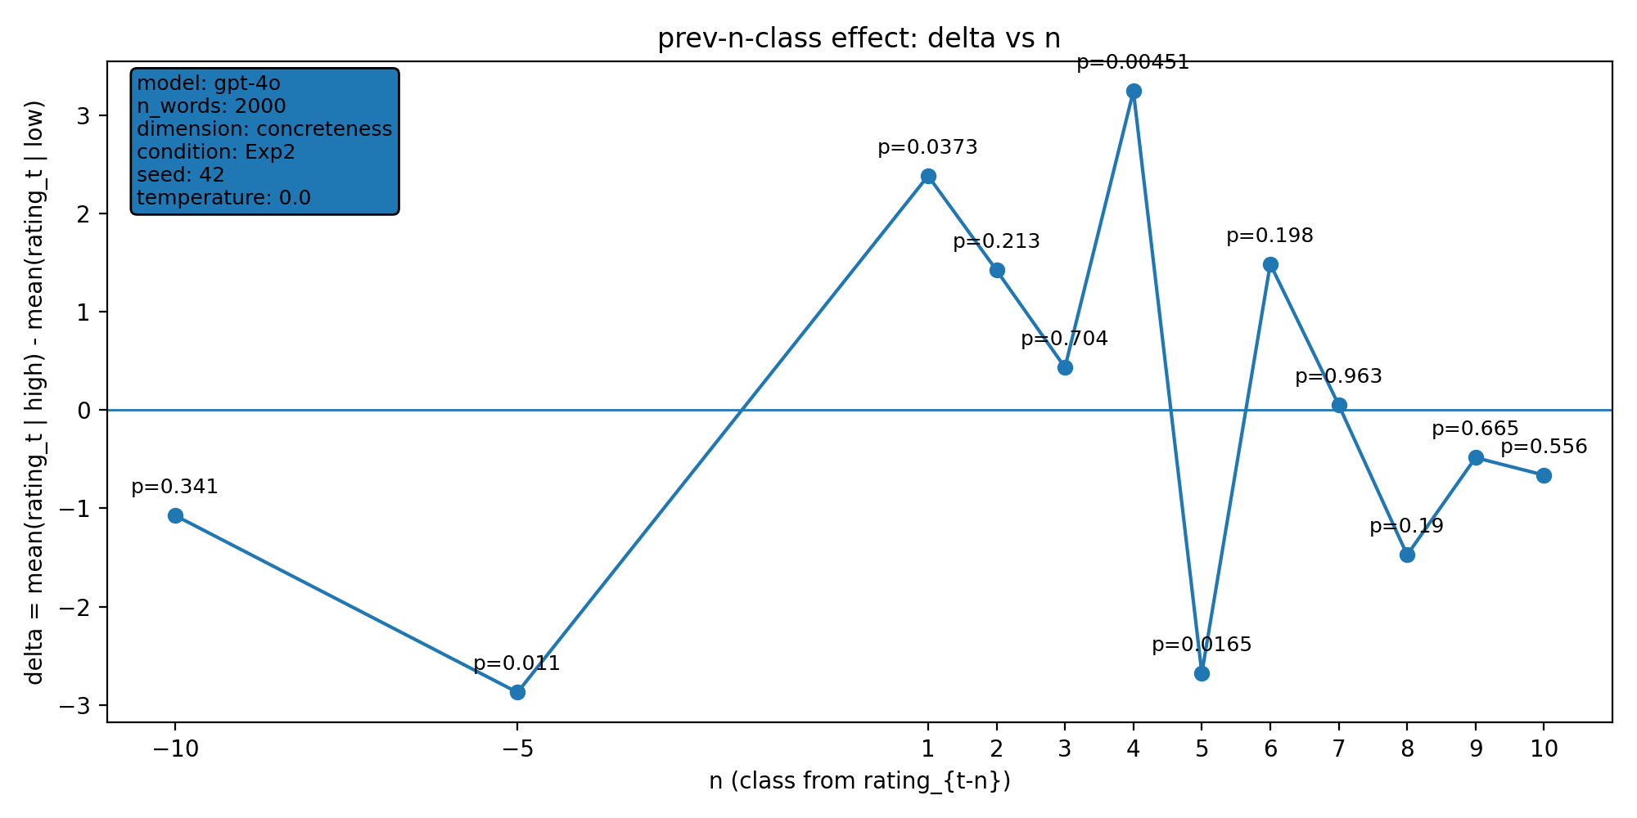 | model: gpt-4o  which: both  dimension: concreteness  n_words: 2000  temperature: 0.0  seed: 42  stats_csv: ana_prev_n_class/results/20260107_145719_gpt-4o_both_concreteness_n2000/n_back_stats.csv
n-back deltas (per n):
n | p_value | n_low | n_high
-10 | 0.341 | 875 | 506
-5 | 0.011 | 878 | 508
1 | 0.0373 | 882 | 508
2 | 0.213 | 882 | 508
3 | 0.704 | 881 | 508
4 | 0.00451 | 881 | 508
5 | 0.0165 | 880 | 508
6 | 0.198 | 879 | 508
7 | 0.963 | 878 | 508
8 | 0.19 | 878 | 507
9 | 0.665 | 878 | 506
10 | 0.556 | 878 | 505

20260112_001408_gpt-4o_both_concreteness_n1000
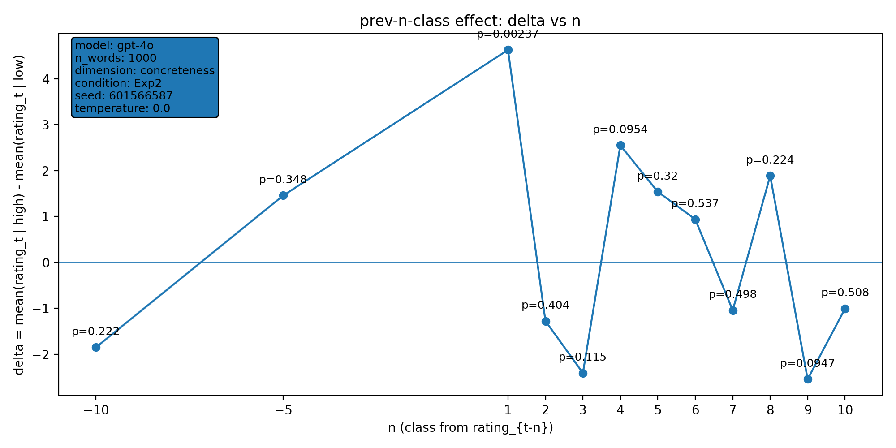 | model: gpt-4o  which: both  dimension: concreteness  n_words: 1000  temperature: 0.0  seed: 601566587  stats_csv: ana_prev_n_class/results/20260112_001408_gpt-4o_both_concreteness_n1000/n_back_stats.csv
n-back deltas (per n):
n | p_value | n_low | n_high
-10 | 0.222 | 493 | 385
-5 | 0.348 | 495 | 388
1 | 0.00237 | 499 | 389
2 | 0.404 | 498 | 389
3 | 0.115 | 498 | 389
4 | 0.0954 | 498 | 388
5 | 0.32 | 498 | 387
6 | 0.537 | 497 | 387
7 | 0.498 | 497 | 386
8 | 0.224 | 496 | 386
9 | 0.0947 | 495 | 386
10 | 0.508 | 494 | 386

20260113_162650_gpt-4o_both_concreteness_n1000
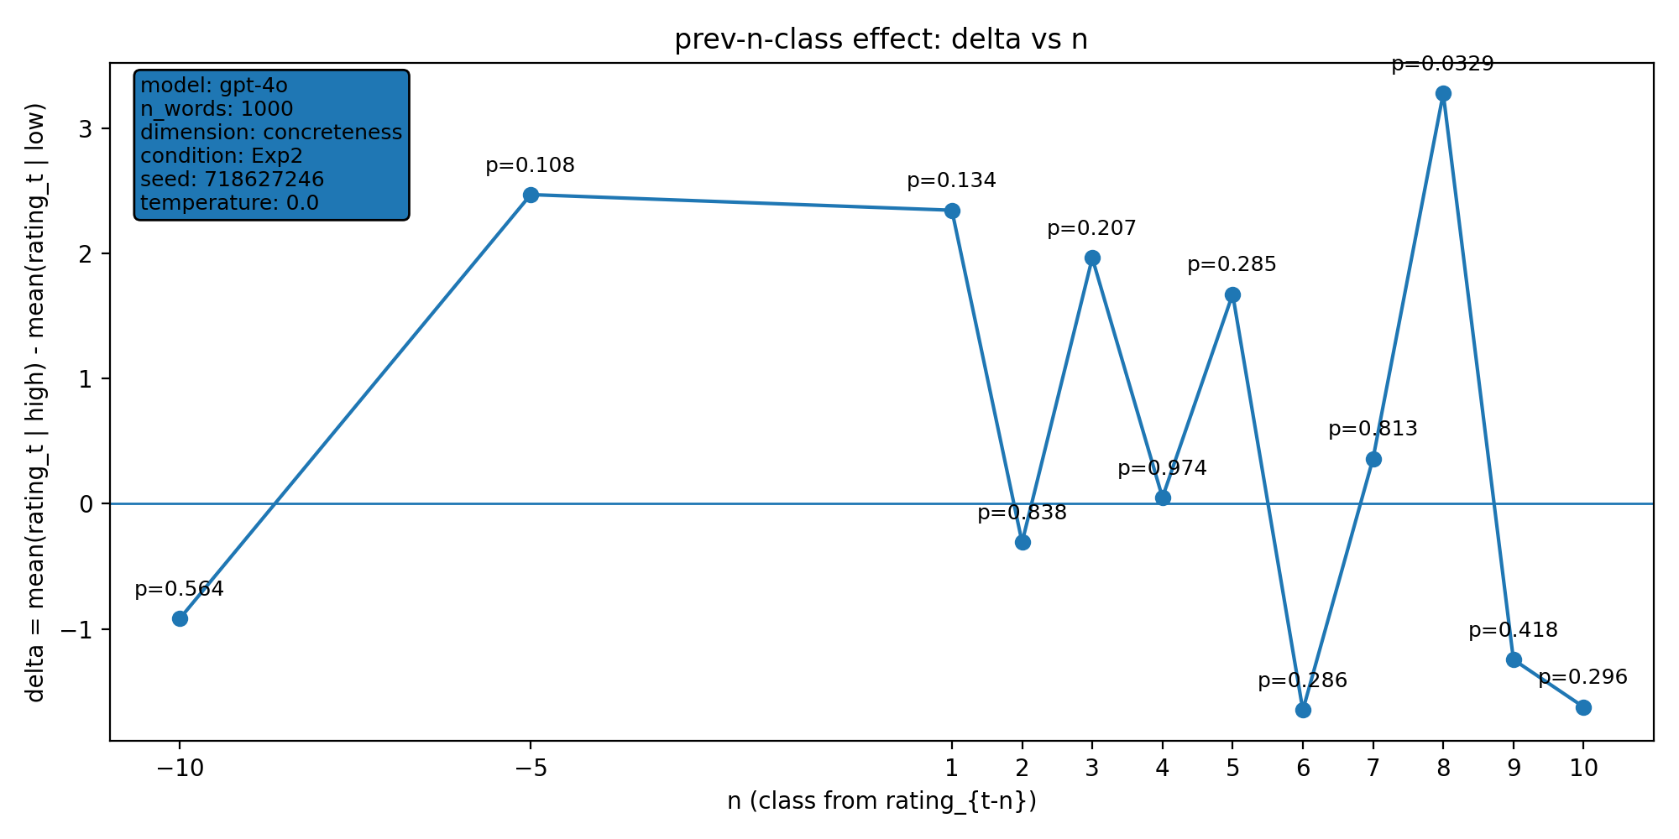 | model: gpt-4o  which: both  dimension: concreteness  n_words: 1000  temperature: 0.0  seed: 718627246  stats_csv: ana_prev_n_class/results/20260113_162650_gpt-4o_both_concreteness_n1000/n_back_stats.csv
n-back deltas (per n):
n | p_value | n_low | n_high
-10 | 0.564 | 545 | 318
-5 | 0.108 | 548 | 318
1 | 0.134 | 551 | 319
2 | 0.838 | 550 | 319
3 | 0.207 | 550 | 318
4 | 0.974 | 550 | 318
5 | 0.285 | 550 | 317
6 | 0.286 | 549 | 317
7 | 0.813 | 549 | 316
8 | 0.0329 | 549 | 316
9 | 0.418 | 548 | 316
10 | 0.296 | 547 | 316

20260122_222005_gpt-4o_both_concreteness_n1000
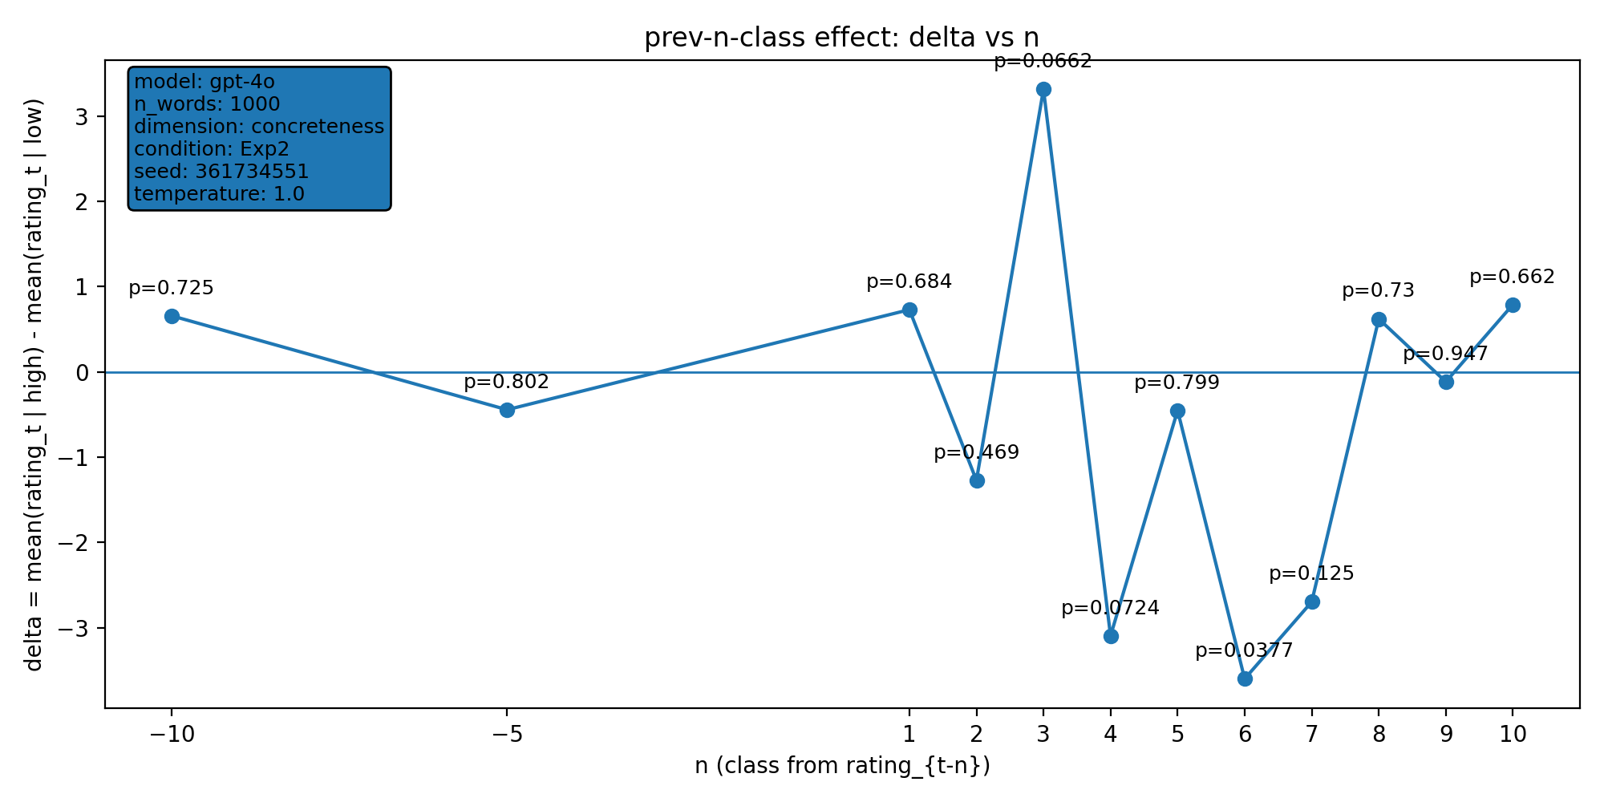 | model: gpt-4o  which: both  dimension: concreteness  n_words: 1000  temperature: 1.0  seed: 361734551  stats_csv: ana_prev_n_class/results/20260122_222005_gpt-4o_both_concreteness_n1000/n_back_stats.csv
n-back deltas (per n):
n | p_value | n_low | n_high
-10 | 0.725 | 593 | 291
-5 | 0.802 | 598 | 291
1 | 0.684 | 601 | 291
2 | 0.469 | 600 | 291
3 | 0.0662 | 599 | 291
4 | 0.0724 | 598 | 291
5 | 0.799 | 598 | 291
6 | 0.0377 | 597 | 291
7 | 0.125 | 596 | 291
8 | 0.73 | 595 | 291
9 | 0.947 | 594 | 291
10 | 0.662 | 593 | 291

20260126_174821_gpt-4o_exp2_concreteness_n2000
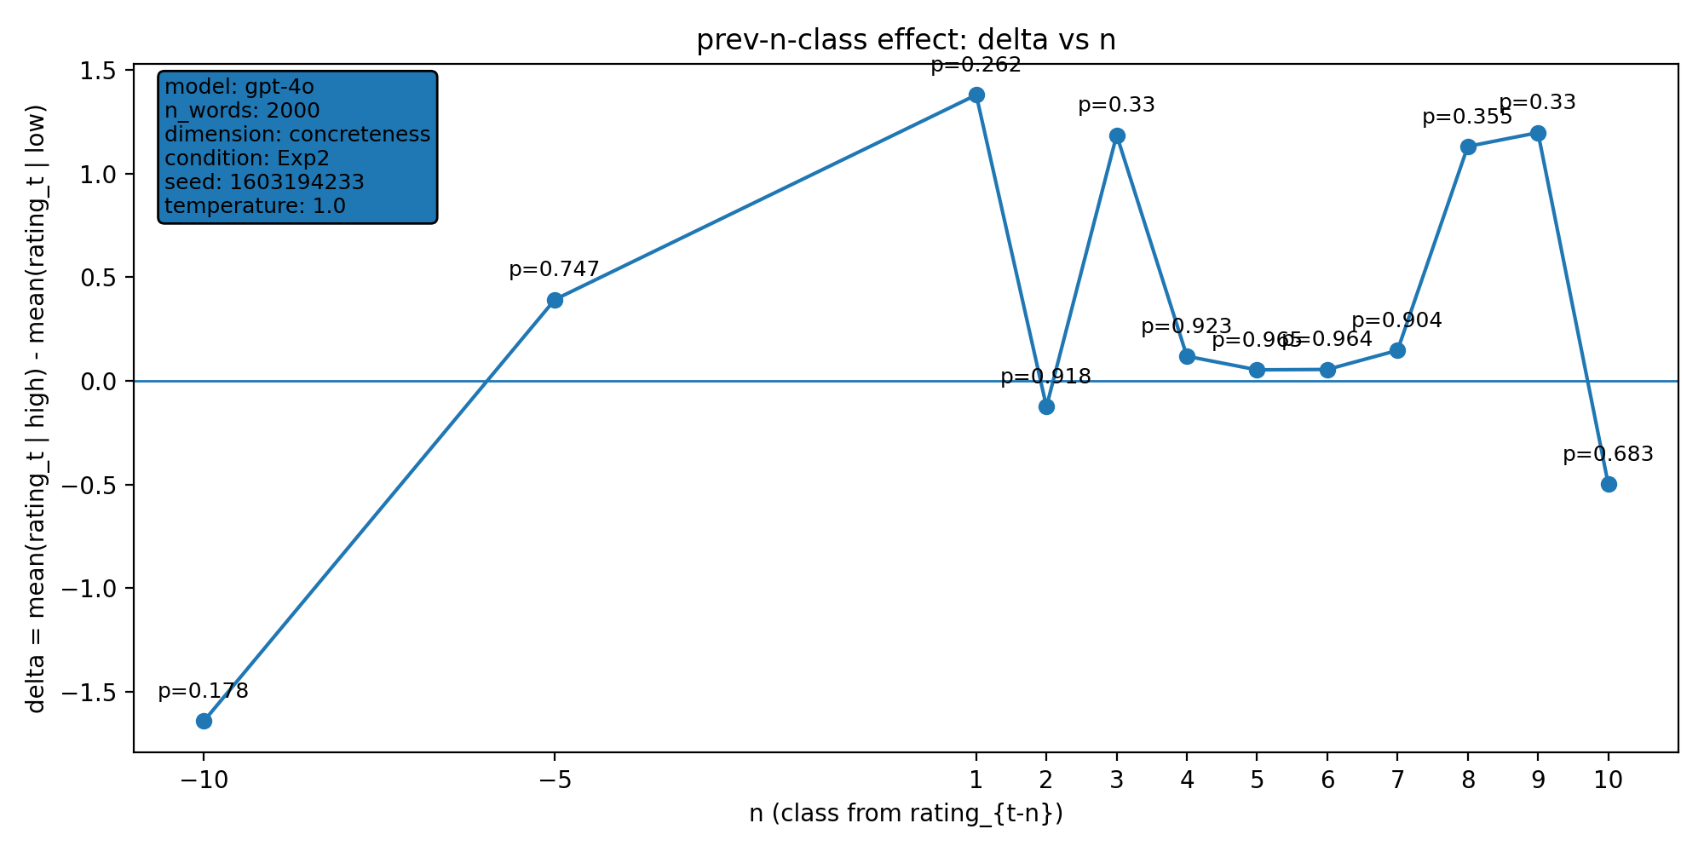 | model: gpt-4o  which: exp2  dimension: concreteness  n_words: 2000  temperature: 1.0  seed: 1603194233  stats_csv: ana_prev_n_class/results/20260126_174821_gpt-4o_exp2_concreteness_n2000/n_back_stats.csv
n-back deltas (per n):
n | p_value | n_low | n_high
-10 | 0.178 | 1101 | 648
-5 | 0.747 | 1105 | 648
1 | 0.262 | 1109 | 648
2 | 0.918 | 1108 | 648
3 | 0.33 | 1107 | 648
4 | 0.923 | 1107 | 647
5 | 0.965 | 1106 | 647
6 | 0.964 | 1106 | 646
7 | 0.904 | 1106 | 645
8 | 0.355 | 1105 | 645
9 | 0.33 | 1105 | 644
10 | 0.683 | 1105 | 644

20260126_174922_gpt-4o_exp2_valence_n1000
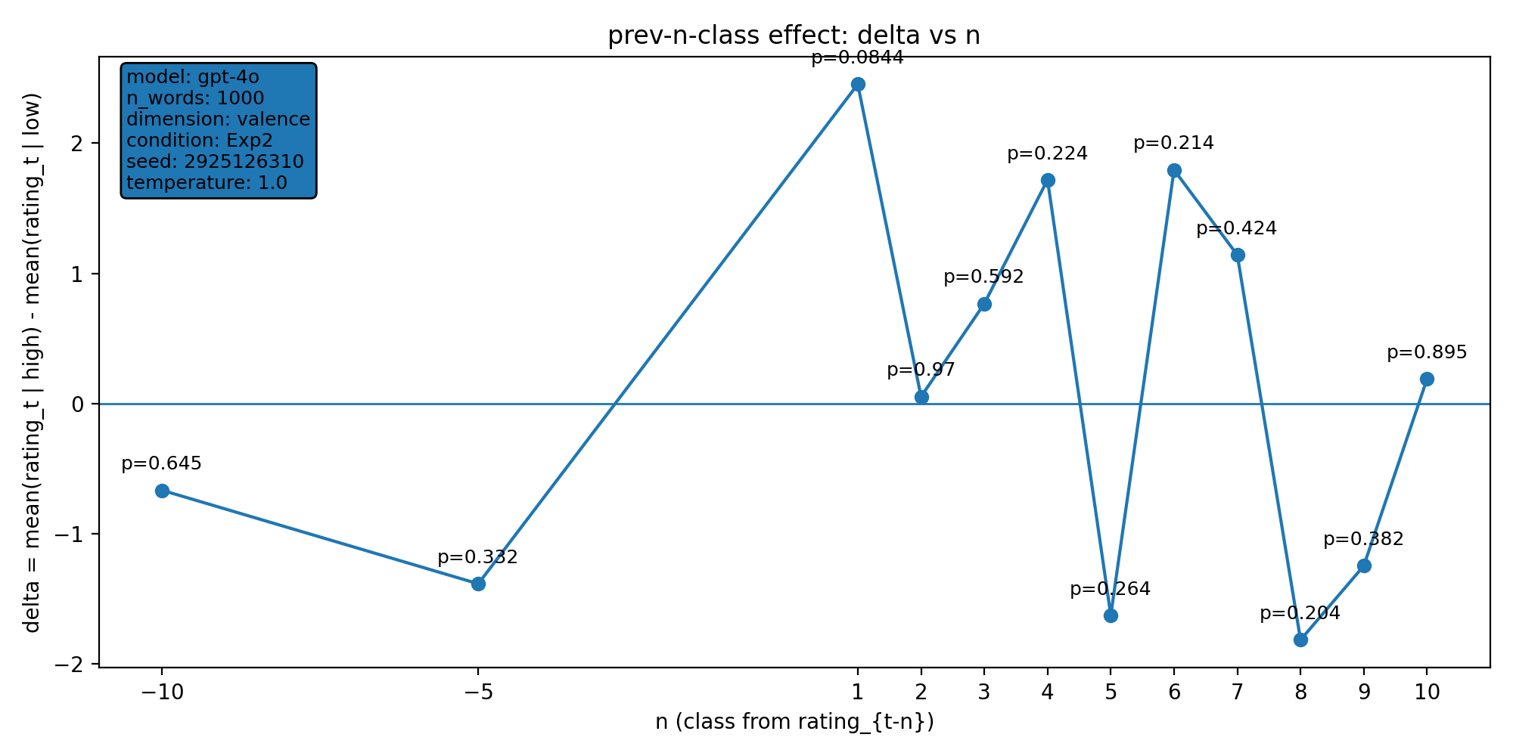 | model: gpt-4o  which: exp2  dimension: valence  n_words: 1000  temperature: 1.0  seed: 2925126310  stats_csv: ana_prev_n_class/results/20260126_174922_gpt-4o_exp2_valence_n1000/n_back_stats.csv
n-back deltas (per n):
n | p_value | n_low | n_high
-10 | 0.645 | 286 | 461
-5 | 0.332 | 287 | 463
1 | 0.0844 | 286 | 467
2 | 0.97 | 286 | 466
3 | 0.592 | 286 | 465
4 | 0.224 | 285 | 465
5 | 0.264 | 285 | 464
6 | 0.214 | 284 | 464
7 | 0.424 | 284 | 463
8 | 0.204 | 284 | 463
9 | 0.382 | 284 | 462
10 | 0.895 | 284 | 461

20260126_192052_gpt-4o_exp2_concreteness_n1000
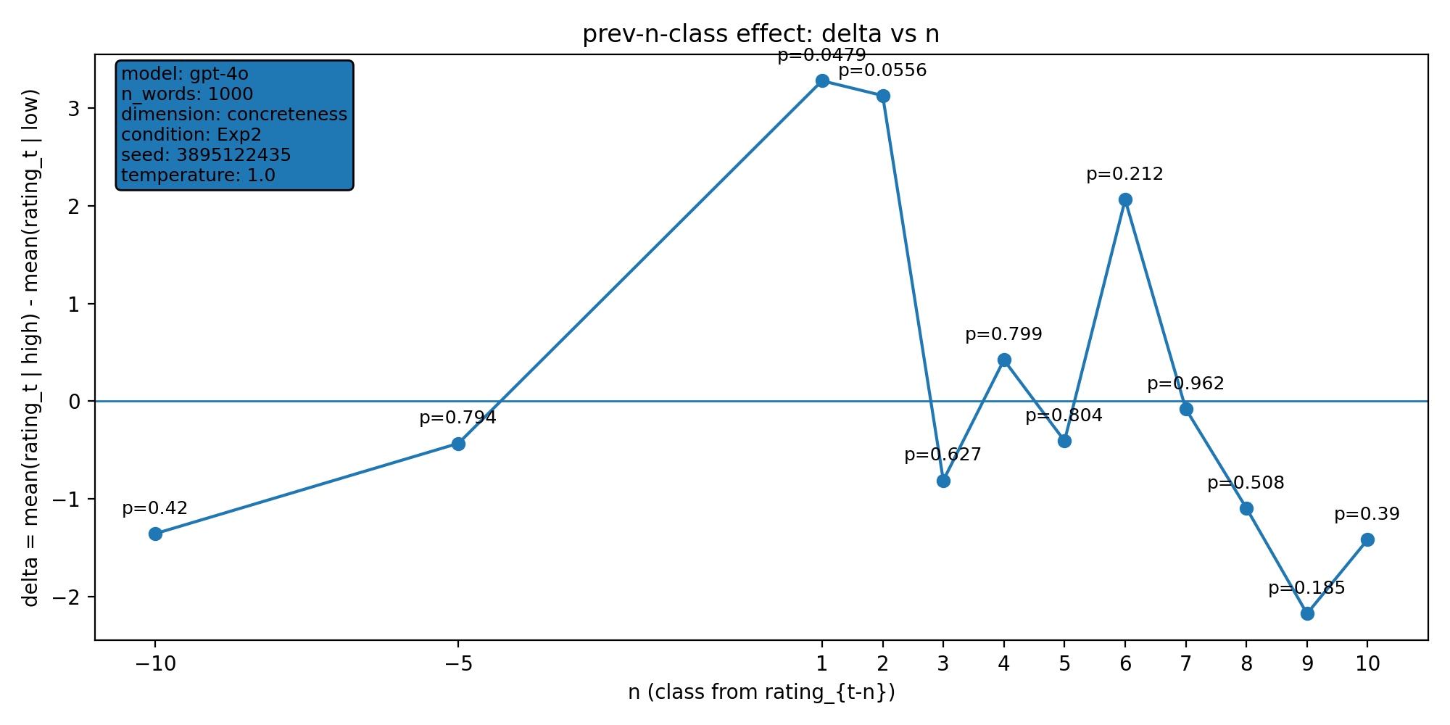 | model: gpt-4o  which: exp2  dimension: concreteness  n_words: 1000  temperature: 1.0  seed: 3895122435  stats_csv: ana_prev_n_class/results/20260126_192052_gpt-4o_exp2_concreteness_n1000/n_back_stats.csv
n-back deltas (per n):
n | p_value | n_low | n_high
-10 | 0.42 | 506 | 340
-5 | 0.794 | 509 | 341
1 | 0.0479 | 510 | 343
2 | 0.0556 | 510 | 342
3 | 0.627 | 510 | 341
4 | 0.799 | 509 | 341
5 | 0.804 | 509 | 341
6 | 0.212 | 509 | 340
7 | 0.962 | 509 | 339
8 | 0.508 | 508 | 339
9 | 0.185 | 508 | 338
10 | 0.39 | 507 | 338

20260127_225919_gpt-4o_exp2_concreteness_n1000
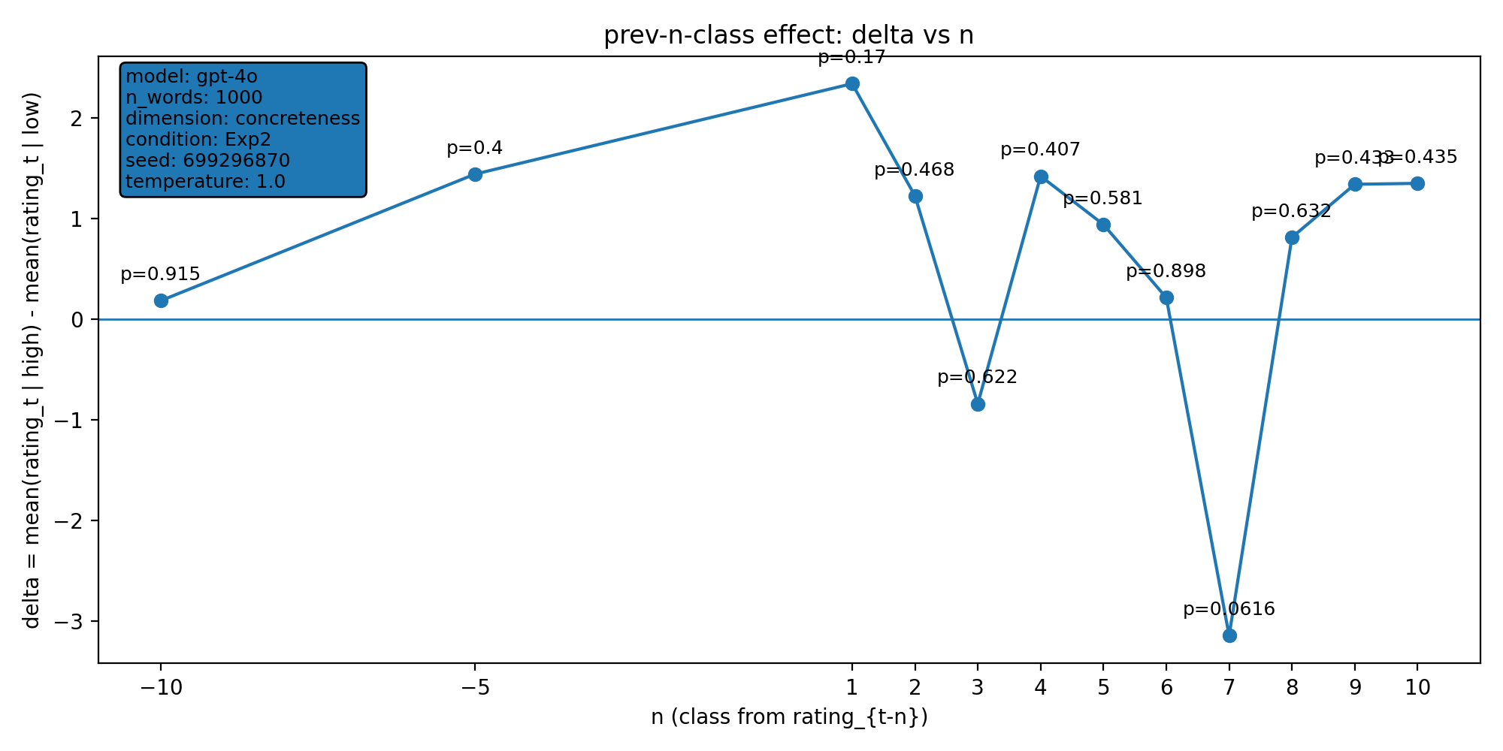 | model: gpt-4o  which: exp2  dimension: concreteness  n_words: 1000  temperature: 1.0  seed: 699296870  stats_csv: ana_prev_n_class/results/20260127_225919_gpt-4o_exp2_concreteness_n1000/n_back_stats.csv
n-back deltas (per n):
n | p_value | n_low | n_high
-10 | 0.915 | 506 | 358
-5 | 0.4 | 511 | 358
1 | 0.17 | 512 | 359
2 | 0.468 | 512 | 359
3 | 0.622 | 511 | 359
4 | 0.407 | 511 | 358
5 | 0.581 | 510 | 358
6 | 0.898 | 509 | 358
7 | 0.0616 | 508 | 358
8 | 0.632 | 508 | 357
9 | 0.433 | 508 | 356
10 | 0.435 | 508 | 356

20260127_230016_gpt-4o_exp2_valence_n1000
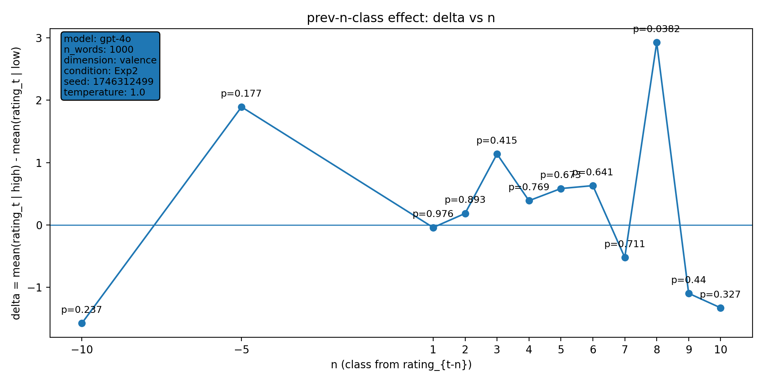 | model: gpt-4o  which: exp2  dimension: valence  n_words: 1000  temperature: 1.0  seed: 1746312499  stats_csv: ana_prev_n_class/results/20260127_230016_gpt-4o_exp2_valence_n1000/n_back_stats.csv
n-back deltas (per n):
n | p_value | n_low | n_high
-10 | 0.237 | 252 | 529
-5 | 0.177 | 254 | 531
1 | 0.976 | 256 | 532
2 | 0.893 | 256 | 531
3 | 0.415 | 255 | 531
4 | 0.769 | 255 | 530
5 | 0.673 | 255 | 530
6 | 0.641 | 254 | 530
7 | 0.711 | 254 | 529
8 | 0.0382 | 254 | 529
9 | 0.44 | 254 | 528
10 | 0.327 | 253 | 528

20260128_002209_gpt-4o_exp2_valence_n1000
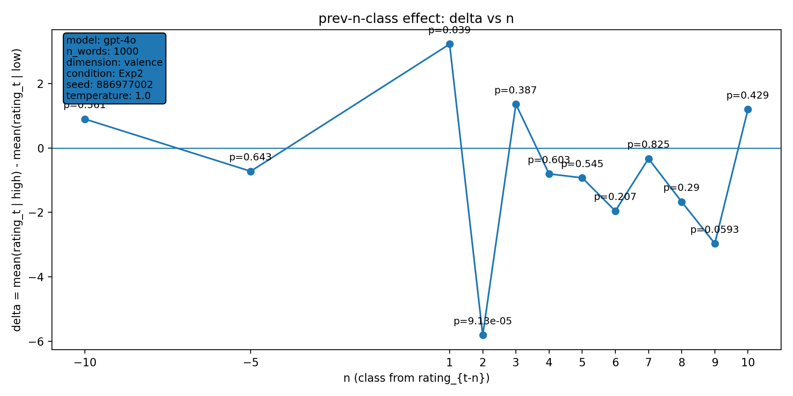 | model: gpt-4o  which: exp2  dimension: valence  n_words: 1000  temperature: 1.0  seed: 886977002  stats_csv: ana_prev_n_class/results/20260128_002209_gpt-4o_exp2_valence_n1000/n_back_stats.csv
n-back deltas (per n):
n | p_value | n_low | n_high
-10 | 0.561 | 212 | 411
-5 | 0.643 | 212 | 414
1 | 0.039 | 214 | 415
2 | 9.13e-05 | 214 | 414
3 | 0.387 | 213 | 414
4 | 0.603 | 212 | 414
5 | 0.545 | 211 | 414
6 | 0.207 | 211 | 413
7 | 0.825 | 211 | 412
8 | 0.29 | 211 | 412
9 | 0.0593 | 211 | 411
10 | 0.429 | 210 | 411

20260128_002228_gpt-4o_exp2_valence_n1000
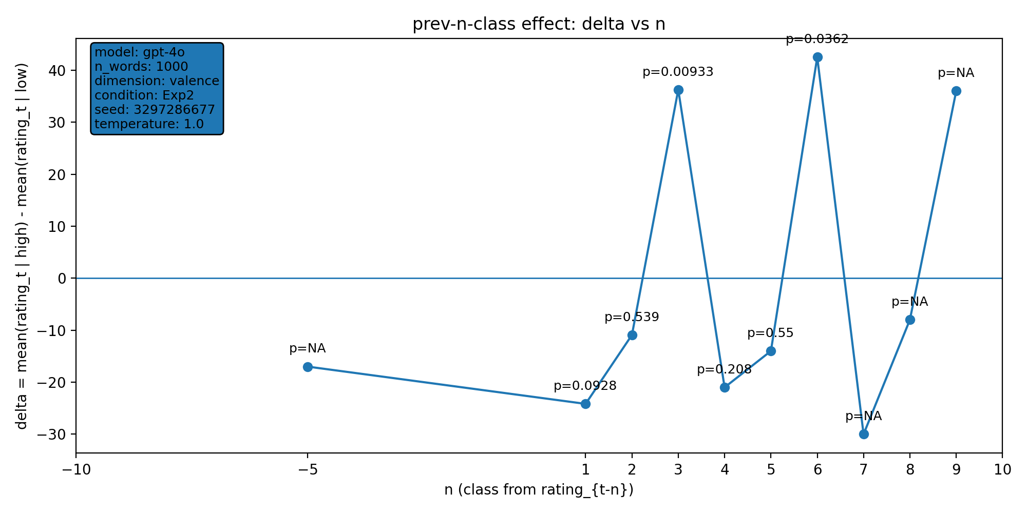 | model: gpt-4o  which: exp2  dimension: valence  n_words: 1000  temperature: 1.0  seed: 3297286677  stats_csv: ana_prev_n_class/results/20260128_002228_gpt-4o_exp2_valence_n1000/n_back_stats.csv
n-back deltas (per n):
n | p_value | n_low | n_high
-10 | nan | 1 | 0
-5 | nan | 3 | 1
1 | 0.0928 | 4 | 3
2 | 0.539 | 4 | 3
3 | 0.00933 | 4 | 3
4 | 0.208 | 3 | 3
5 | 0.55 | 3 | 2
6 | 0.0362 | 2 | 2
7 | nan | 1 | 2
8 | nan | 1 | 1
9 | nan | 1 | 1
10 | nan | 0 | 1

20260128_002256_gpt-4o_exp2_concreteness_n1000
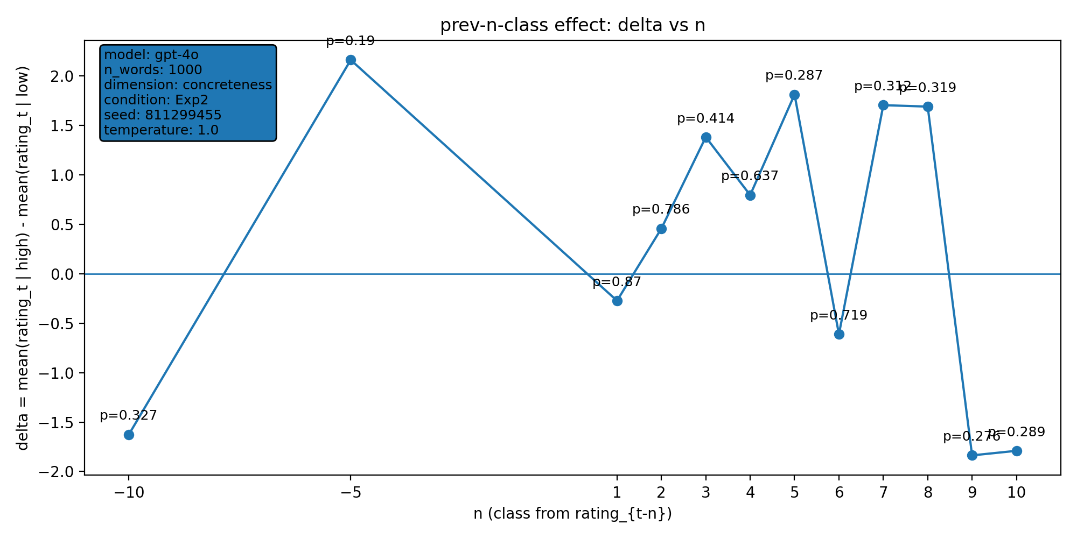 | model: gpt-4o  which: exp2  dimension: concreteness  n_words: 1000  temperature: 1.0  seed: 811299455  stats_csv: ana_prev_n_class/results/20260128_002256_gpt-4o_exp2_concreteness_n1000/n_back_stats.csv
n-back deltas (per n):
n | p_value | n_low | n_high
-10 | 0.327 | 509 | 326
-5 | 0.19 | 512 | 326
1 | 0.87 | 513 | 326
2 | 0.786 | 512 | 326
3 | 0.414 | 512 | 325
4 | 0.637 | 512 | 324
5 | 0.287 | 512 | 323
6 | 0.719 | 512 | 322
7 | 0.312 | 512 | 321
8 | 0.319 | 512 | 320
9 | 0.276 | 511 | 320
10 | 0.289 | 511 | 319

20260129_145137_gpt-4o_both_valence_n1000
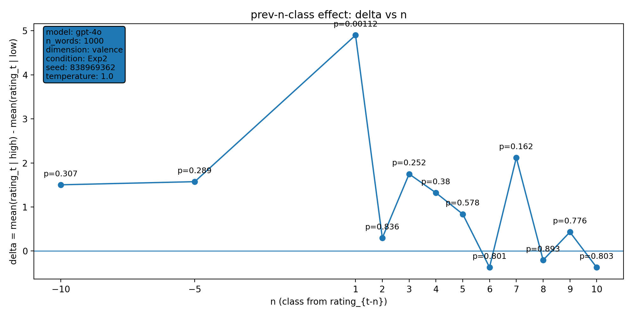 | model: gpt-4o  which: both  dimension: valence  n_words: 1000  temperature: 1.0  seed: 838969362  stats_csv: ana_prev_n_class/results/20260129_145137_gpt-4o_both_valence_n1000/n_back_stats.csv
n-back deltas (per n):
n | p_value | n_low | n_high
-10 | 0.307 | 291 | 506
-5 | 0.289 | 292 | 509
1 | 0.00112 | 293 | 511
2 | 0.836 | 293 | 510
3 | 0.252 | 293 | 509
4 | 0.38 | 293 | 509
5 | 0.578 | 293 | 508
6 | 0.801 | 293 | 508
7 | 0.162 | 292 | 508
8 | 0.893 | 291 | 508
9 | 0.776 | 291 | 507
10 | 0.803 | 291 | 507

20260202_004249_gpt-4o_exp2_valence_n1000
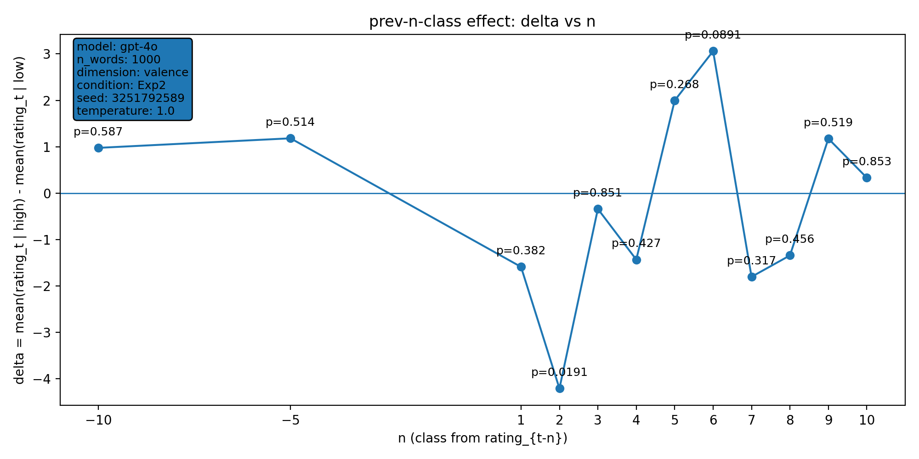 | model: gpt-4o  which: exp2  dimension: valence  n_words: 1000  temperature: 1.0  seed: 3251792589  stats_csv: ana_prev_n_class/results/20260202_004249_gpt-4o_exp2_valence_n1000/n_back_stats.csv
n-back deltas (per n):
n | p_value | n_low | n_high
-10 | 0.587 | 360 | 488
-5 | 0.514 | 361 | 492
1 | 0.382 | 362 | 494
2 | 0.0191 | 362 | 494
3 | 0.851 | 362 | 493
4 | 0.427 | 361 | 493
5 | 0.268 | 360 | 493
6 | 0.0891 | 360 | 492
7 | 0.317 | 359 | 492
8 | 0.456 | 358 | 492
9 | 0.519 | 358 | 491
10 | 0.853 | 357 | 491

20260202_005410_gpt-4o_exp2_valence_n1000
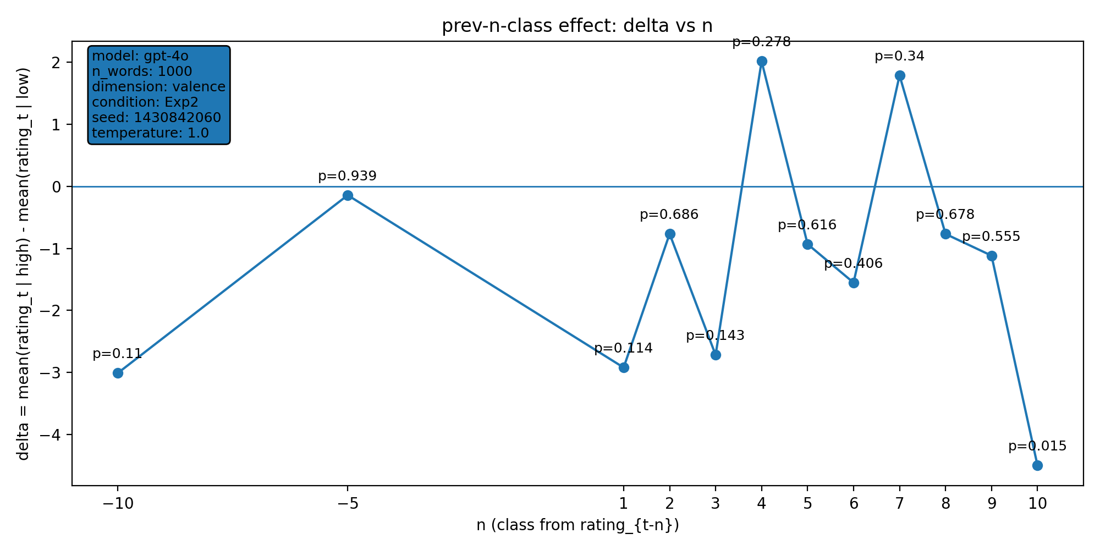 | model: gpt-4o  which: exp2  dimension: valence  n_words: 1000  temperature: 1.0  seed: 1430842060  stats_csv: ana_prev_n_class/results/20260202_005410_gpt-4o_exp2_valence_n1000/n_back_stats.csv
n-back deltas (per n):
n | p_value | n_low | n_high
-10 | 0.11 | 376 | 459
-5 | 0.939 | 378 | 461
1 | 0.114 | 378 | 464
2 | 0.686 | 378 | 463
3 | 0.143 | 377 | 463
4 | 0.278 | 376 | 463
5 | 0.616 | 376 | 463
6 | 0.406 | 376 | 462
7 | 0.34 | 375 | 462
8 | 0.678 | 375 | 461
9 | 0.555 | 374 | 461
10 | 0.015 | 373 | 461

20260202_114143_gpt-4o_exp2_valence_n1000
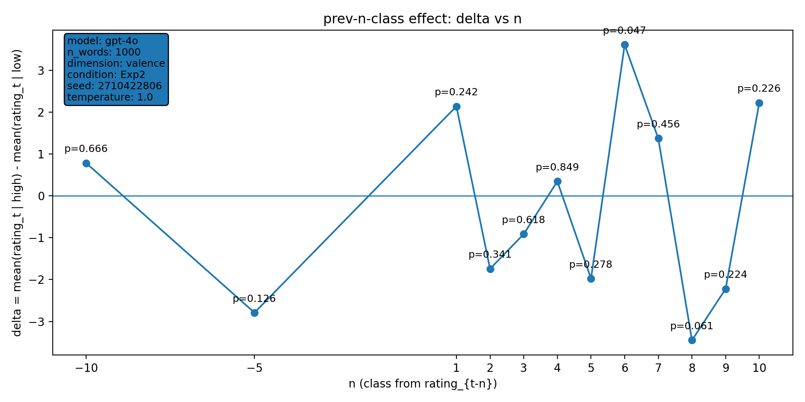 | model: gpt-4o  which: exp2  dimension: valence  n_words: 1000  temperature: 1.0  seed: 2710422806  stats_csv: ana_prev_n_class/results/20260202_114143_gpt-4o_exp2_valence_n1000/n_back_stats.csv
n-back deltas (per n):
n | p_value | n_low | n_high
-10 | 0.666 | 376 | 478
-5 | 0.126 | 376 | 483
1 | 0.242 | 377 | 484
2 | 0.341 | 377 | 484
3 | 0.618 | 377 | 483
4 | 0.849 | 376 | 483
5 | 0.278 | 375 | 483
6 | 0.047 | 375 | 483
7 | 0.456 | 374 | 483
8 | 0.061 | 373 | 483
9 | 0.224 | 372 | 483
10 | 0.226 | 371 | 483

20260202_121450_gpt-4o_exp2_valence_n1000
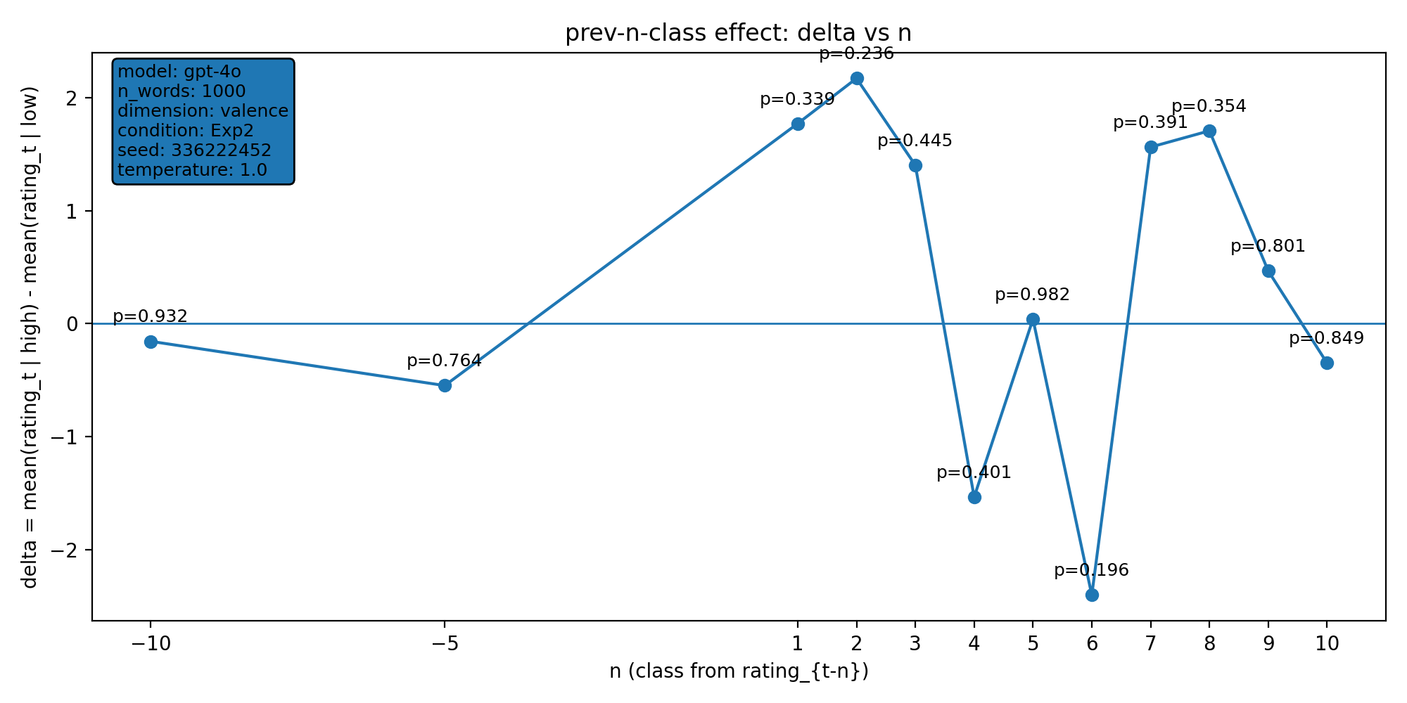 | model: gpt-4o  which: exp2  dimension: valence  n_words: 1000  temperature: 1.0  seed: 336222452  stats_csv: ana_prev_n_class/results/20260202_121450_gpt-4o_exp2_valence_n1000/n_back_stats.csv
n-back deltas (per n):
n | p_value | n_low | n_high
-10 | 0.932 | 358 | 484
-5 | 0.764 | 358 | 488
1 | 0.339 | 358 | 492
2 | 0.236 | 358 | 491
3 | 0.445 | 358 | 490
4 | 0.401 | 358 | 490
5 | 0.982 | 357 | 490
6 | 0.196 | 356 | 490
7 | 0.391 | 355 | 490
8 | 0.354 | 354 | 490
9 | 0.801 | 353 | 490
10 | 0.849 | 352 | 490

20260202_124834_gpt-4o_exp2_valence_n1000
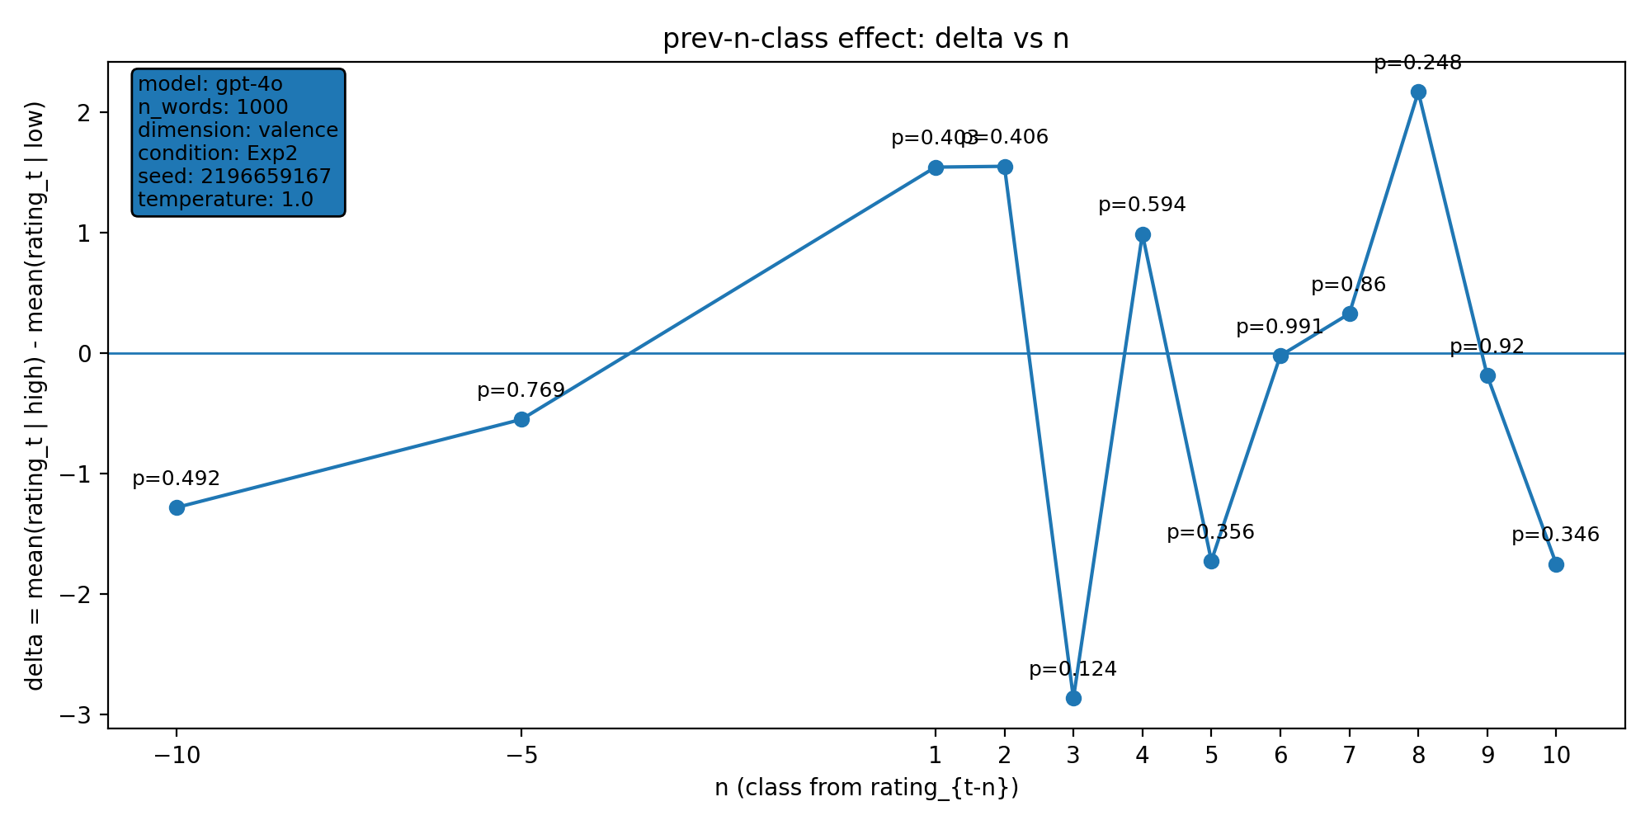 | model: gpt-4o  which: exp2  dimension: valence  n_words: 1000  temperature: 1.0  seed: 2196659167  stats_csv: ana_prev_n_class/results/20260202_124834_gpt-4o_exp2_valence_n1000/n_back_stats.csv
n-back deltas (per n):
n | p_value | n_low | n_high
-10 | 0.492 | 378 | 474
-5 | 0.769 | 379 | 476
1 | 0.403 | 381 | 476
2 | 0.406 | 380 | 476
3 | 0.124 | 379 | 476
4 | 0.594 | 379 | 476
5 | 0.356 | 378 | 476
6 | 0.991 | 378 | 475
7 | 0.86 | 378 | 474
8 | 0.248 | 378 | 473
9 | 0.92 | 378 | 473
10 | 0.346 | 377 | 473

