Prev-n-class (low/high) n-back analysis report
Generated at: 2026-02-18 23:02:16
Params file: /home/leve/serial-dependence-lyf-experiment/ana_prev_n_class/params.yaml
n_values: [-10, -5, 1, 2, 3, 4, 5, 6, 7, 8, 9, 10]
low_max: 50
high_min: 51
test: welch

20251212_203849_both_valence_n400
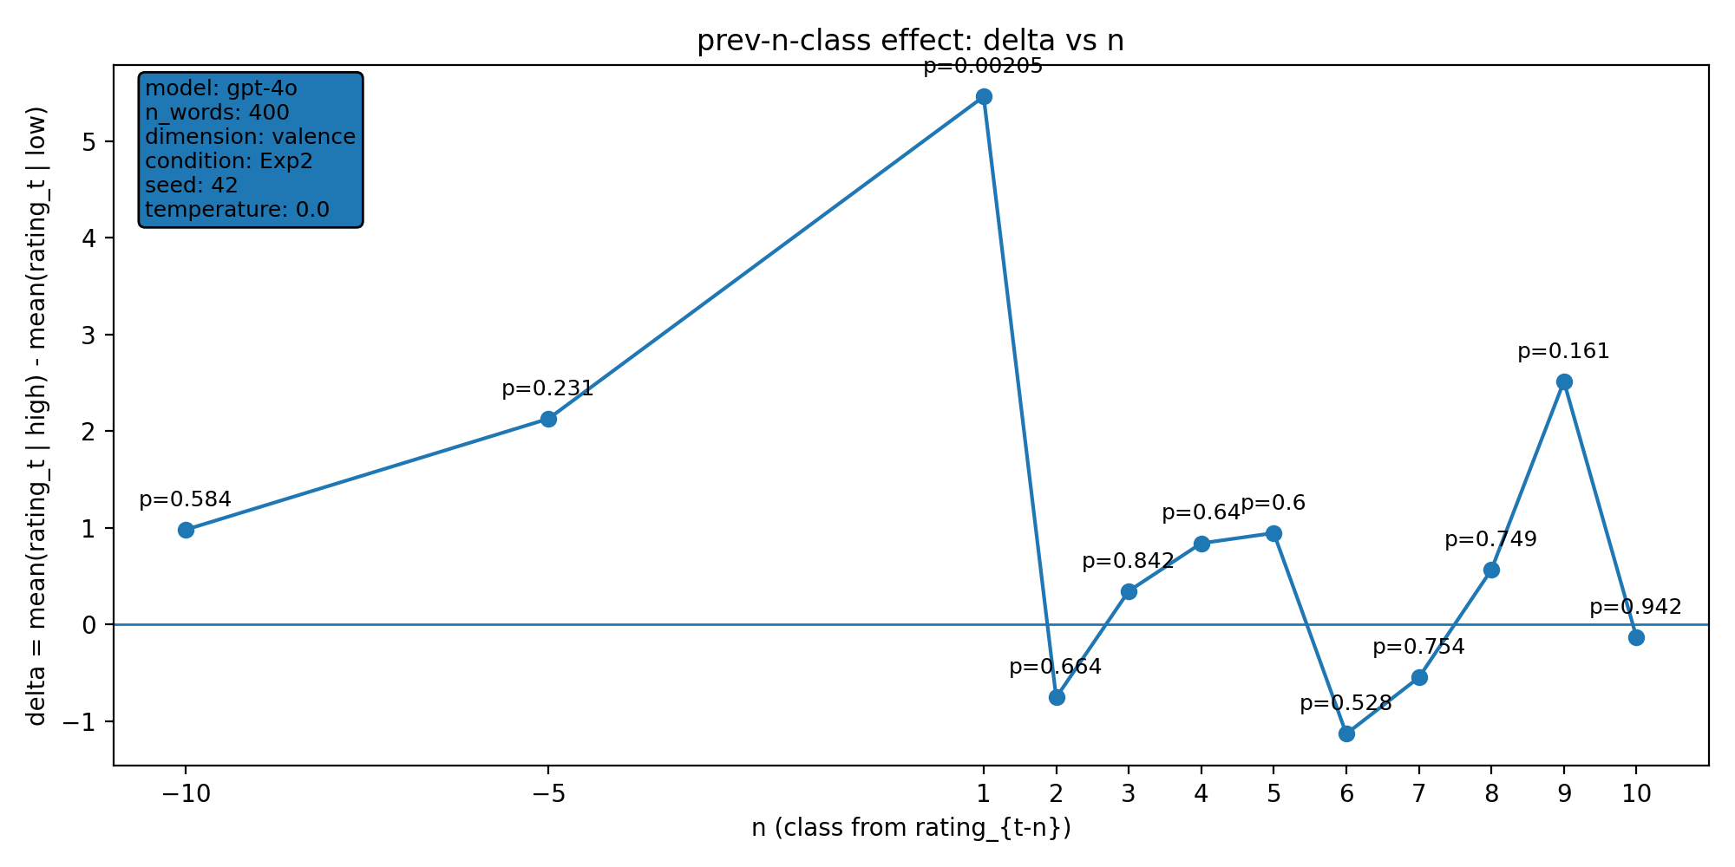 | model: gpt-4o  which: both  dimension: valence  n_words: 400  temperature: 0.0  seed: 42  stats_csv: ana_prev_n_class/results/20251212_203849_both_valence_n400/n_back_stats.csv
n-back deltas (per n):
n | p_value | n_low | n_high
-10 | 0.584 | 163 | 227
-5 | 0.231 | 165 | 230
1 | 0.00205 | 165 | 234
2 | 0.664 | 164 | 234
3 | 0.842 | 163 | 234
4 | 0.64 | 162 | 234
5 | 0.6 | 162 | 233
6 | 0.528 | 162 | 232
7 | 0.754 | 162 | 231
8 | 0.749 | 162 | 230
9 | 0.161 | 162 | 229
10 | 0.942 | 161 | 229

20251212_203916_both_arousal_n400
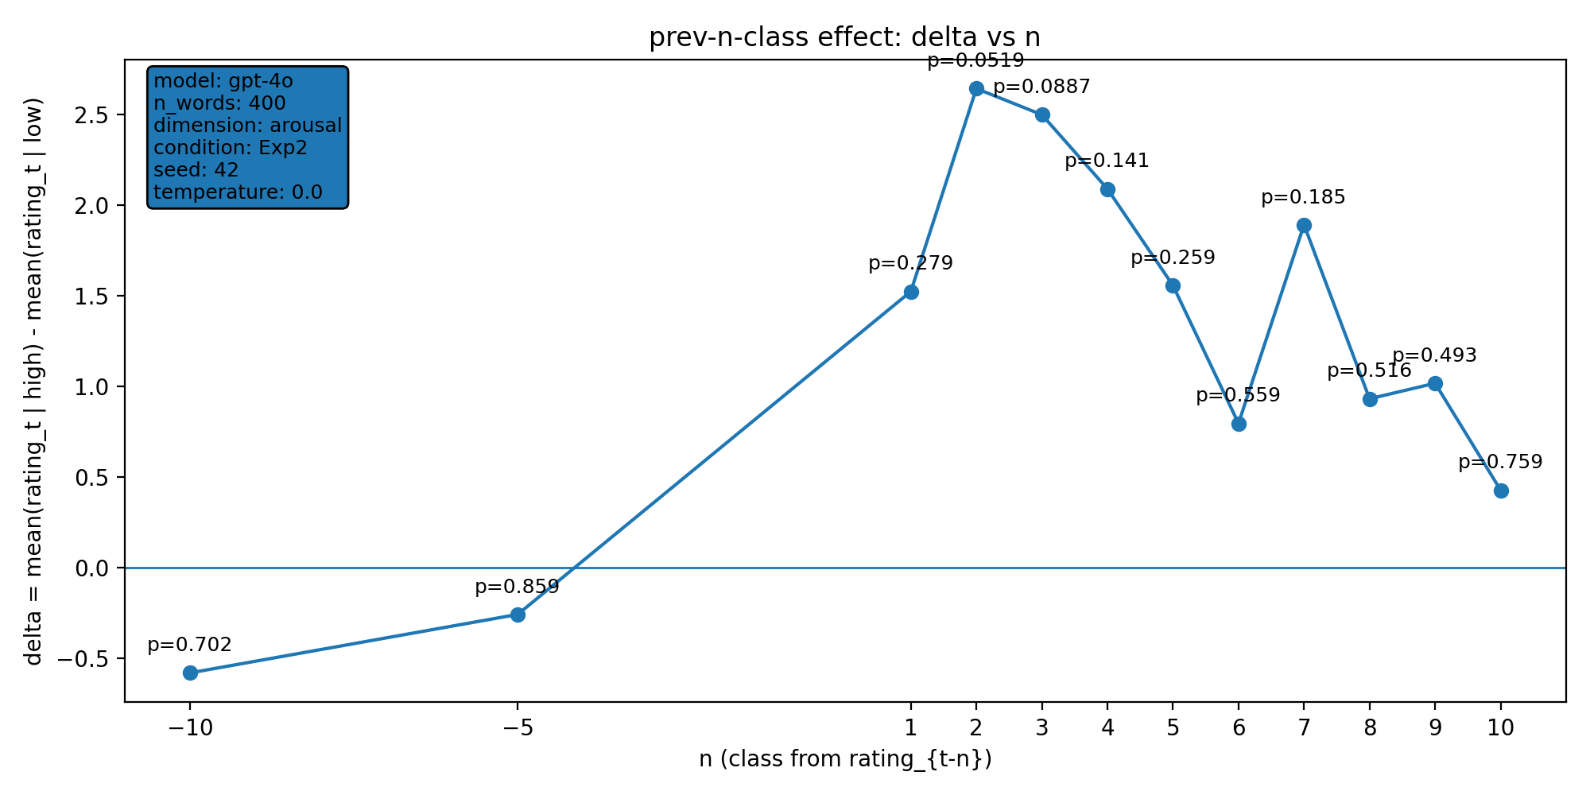 | model: gpt-4o  which: both  dimension: arousal  n_words: 400  temperature: 0.0  seed: 42  stats_csv: ana_prev_n_class/results/20251212_203916_both_arousal_n400/n_back_stats.csv
n-back deltas (per n):
n | p_value | n_low | n_high
-10 | 0.702 | 106 | 284
-5 | 0.859 | 107 | 288
1 | 0.279 | 109 | 290
2 | 0.0519 | 109 | 289
3 | 0.0887 | 109 | 288
4 | 0.141 | 109 | 287
5 | 0.259 | 108 | 287
6 | 0.559 | 108 | 286
7 | 0.185 | 108 | 285
8 | 0.516 | 108 | 284
9 | 0.493 | 108 | 283
10 | 0.759 | 108 | 282

20251213_010833_both_arousal_n400
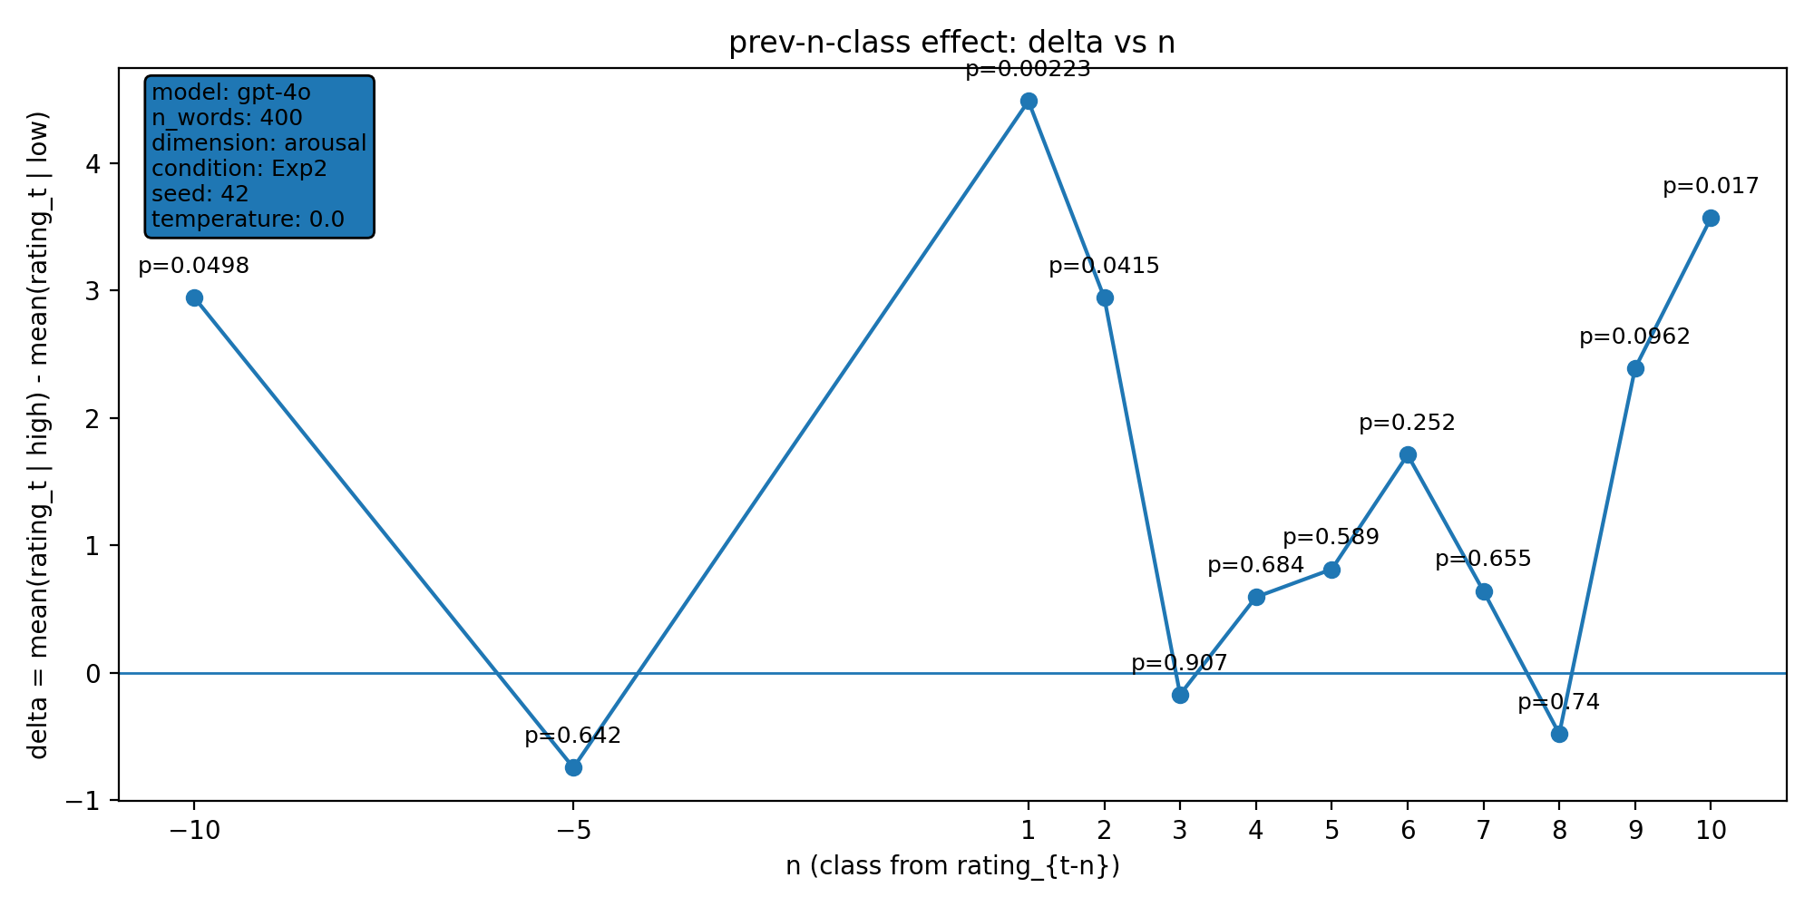 | model: gpt-4o  which: both  dimension: arousal  n_words: 400  temperature: 0.0  seed: 42  stats_csv: ana_prev_n_class/results/20251213_010833_both_arousal_n400/n_back_stats.csv
n-back deltas (per n):
n | p_value | n_low | n_high
-10 | 0.0498 | 97 | 293
-5 | 0.642 | 101 | 294
1 | 0.00223 | 102 | 297
2 | 0.0415 | 102 | 296
3 | 0.907 | 102 | 295
4 | 0.684 | 102 | 294
5 | 0.589 | 102 | 293
6 | 0.252 | 102 | 292
7 | 0.655 | 102 | 291
8 | 0.74 | 102 | 290
9 | 0.0962 | 102 | 289
10 | 0.017 | 101 | 289

20251213_133659_both_concreteness_n400
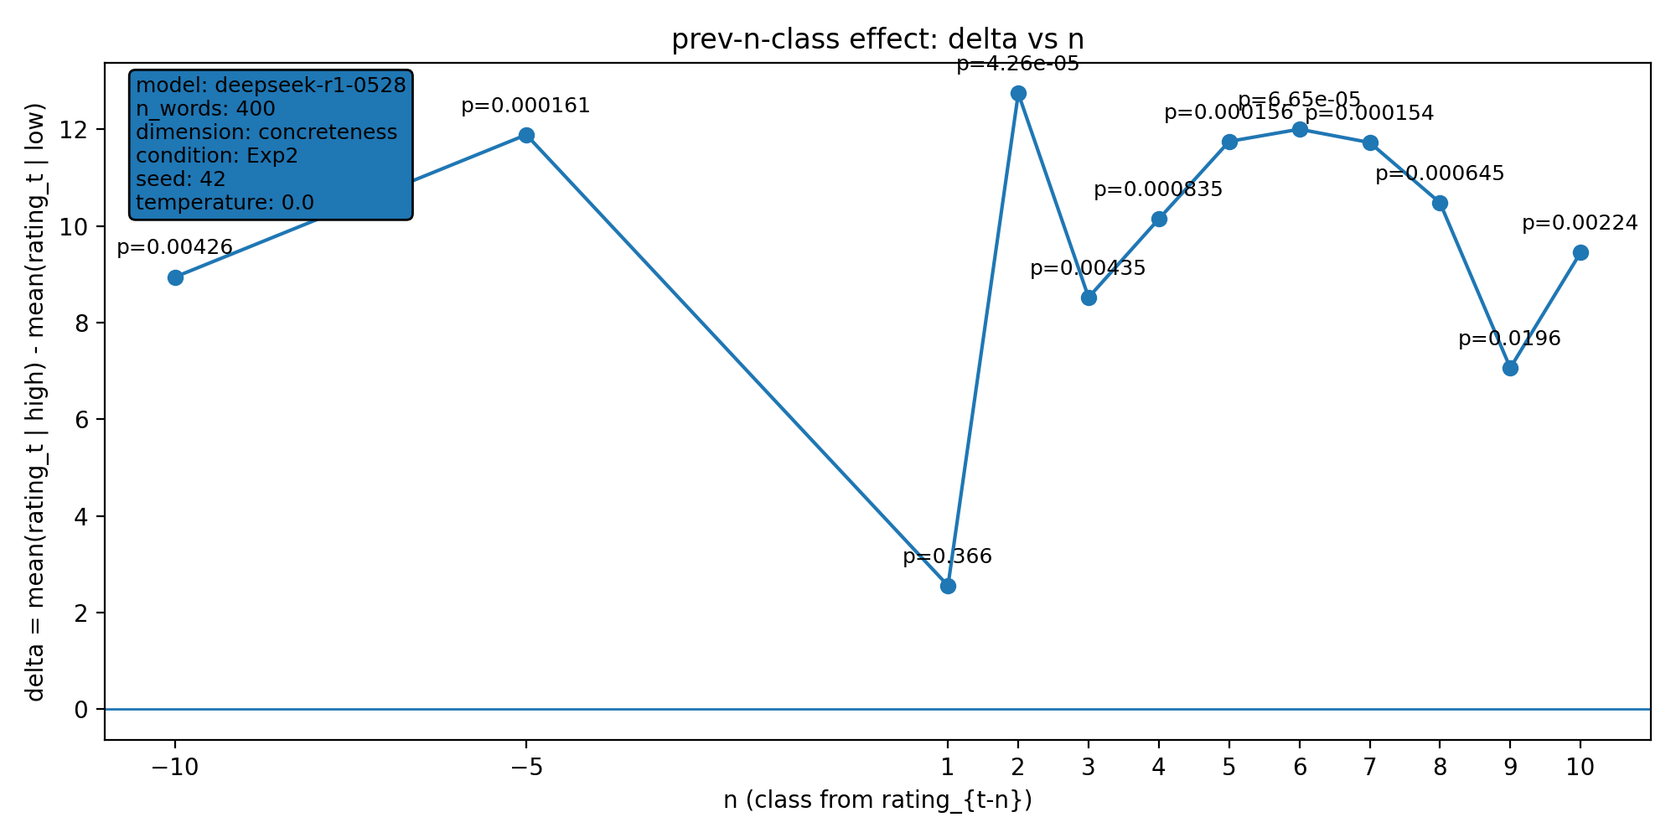 | model: deepseek-r1-0528  which: both  dimension: concreteness  n_words: 400  temperature: 0.0  seed: 42  stats_csv: ana_prev_n_class/results/20251213_133659_both_concreteness_n400/n_back_stats.csv
n-back deltas (per n):
n | p_value | n_low | n_high
-10 | 0.00426 | 89 | 301
-5 | 0.000161 | 92 | 303
1 | 0.366 | 95 | 304
2 | 4.26e-05 | 95 | 303
3 | 0.00435 | 95 | 302
4 | 0.000835 | 95 | 301
5 | 0.000156 | 95 | 300
6 | 6.65e-05 | 94 | 300
7 | 0.000154 | 94 | 299
8 | 0.000645 | 94 | 298
9 | 0.0196 | 94 | 297
10 | 0.00224 | 94 | 296

20251213_133742_both_concreteness_n400
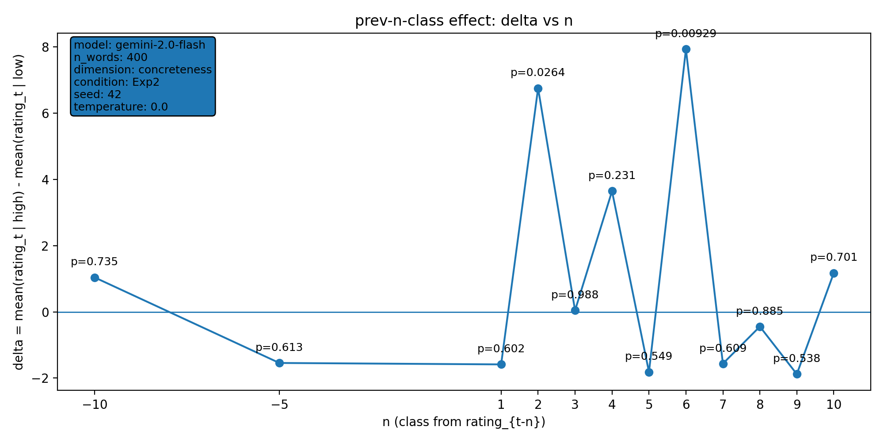 | model: gemini-2.0-flash  which: both  dimension: concreteness  n_words: 400  temperature: 0.0  seed: 42  stats_csv: ana_prev_n_class/results/20251213_133742_both_concreteness_n400/n_back_stats.csv
n-back deltas (per n):
n | p_value | n_low | n_high
-10 | 0.735 | 206 | 184
-5 | 0.613 | 209 | 186
1 | 0.602 | 213 | 186
2 | 0.0264 | 212 | 186
3 | 0.988 | 212 | 185
4 | 0.231 | 212 | 184
5 | 0.549 | 211 | 184
6 | 0.00929 | 210 | 184
7 | 0.609 | 210 | 183
8 | 0.885 | 209 | 183
9 | 0.538 | 208 | 183
10 | 0.701 | 207 | 183

20251217_213039_both_concreteness_n400
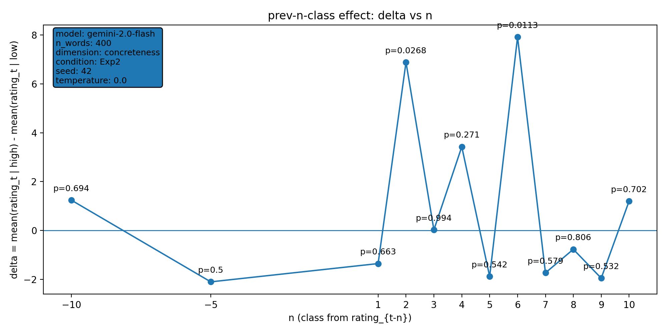 | model: gemini-2.0-flash  which: both  dimension: concreteness  n_words: 400  temperature: 0.0  seed: 42  stats_csv: ana_prev_n_class/results/20251217_213039_both_concreteness_n400/n_back_stats.csv
n-back deltas (per n):
n | p_value | n_low | n_high
-10 | 0.694 | 207 | 183
-5 | 0.5 | 210 | 185
1 | 0.663 | 214 | 185
2 | 0.0268 | 213 | 185
3 | 0.994 | 213 | 184
4 | 0.271 | 213 | 183
5 | 0.542 | 212 | 183
6 | 0.0113 | 211 | 183
7 | 0.579 | 211 | 182
8 | 0.806 | 210 | 182
9 | 0.532 | 209 | 182
10 | 0.702 | 208 | 182

20251218_170111_both_concreteness_n400
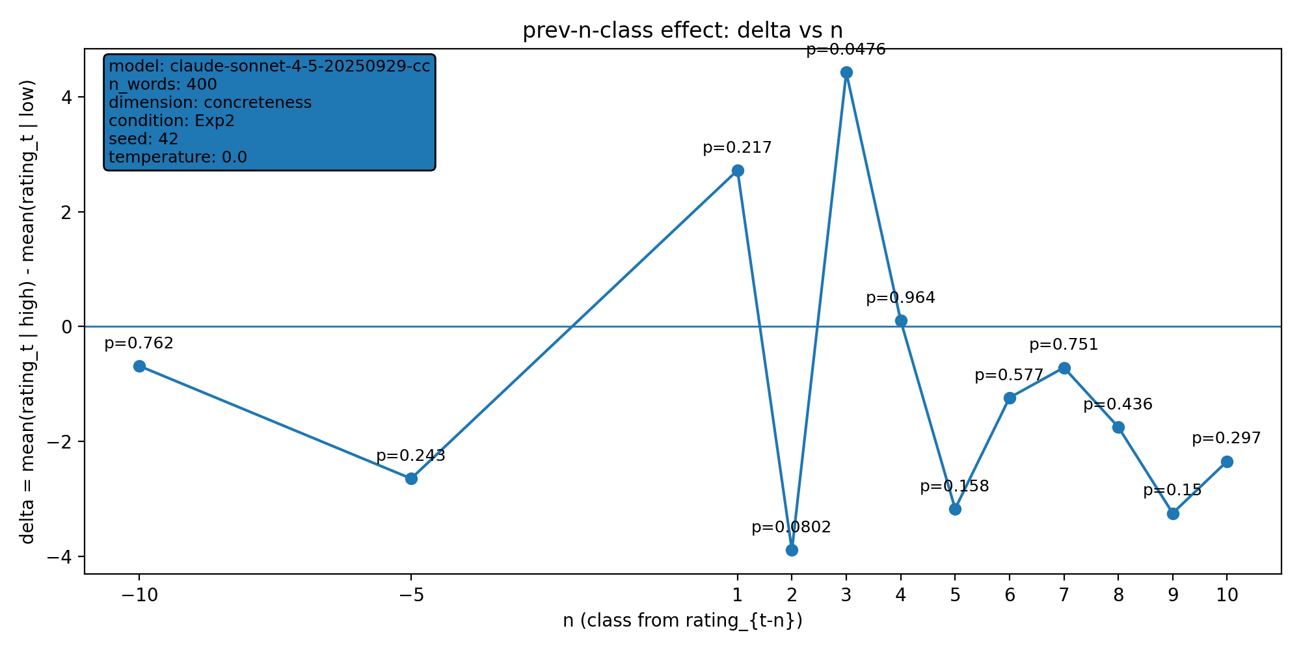 | model: claude-sonnet-4-5-20250929-cc  which: both  dimension: concreteness  n_words: 400  temperature: 0.0  seed: 42  stats_csv: ana_prev_n_class/results/20251218_170111_both_concreteness_n400/n_back_stats.csv
n-back deltas (per n):
n | p_value | n_low | n_high
-10 | 0.762 | 217 | 173
-5 | 0.243 | 221 | 174
1 | 0.217 | 222 | 177
2 | 0.0802 | 221 | 177
3 | 0.0476 | 220 | 177
4 | 0.964 | 220 | 176
5 | 0.158 | 220 | 175
6 | 0.577 | 220 | 174
7 | 0.751 | 219 | 174
8 | 0.436 | 218 | 174
9 | 0.15 | 217 | 174
10 | 0.297 | 216 | 174

20251218_170152_both_concreteness_n400
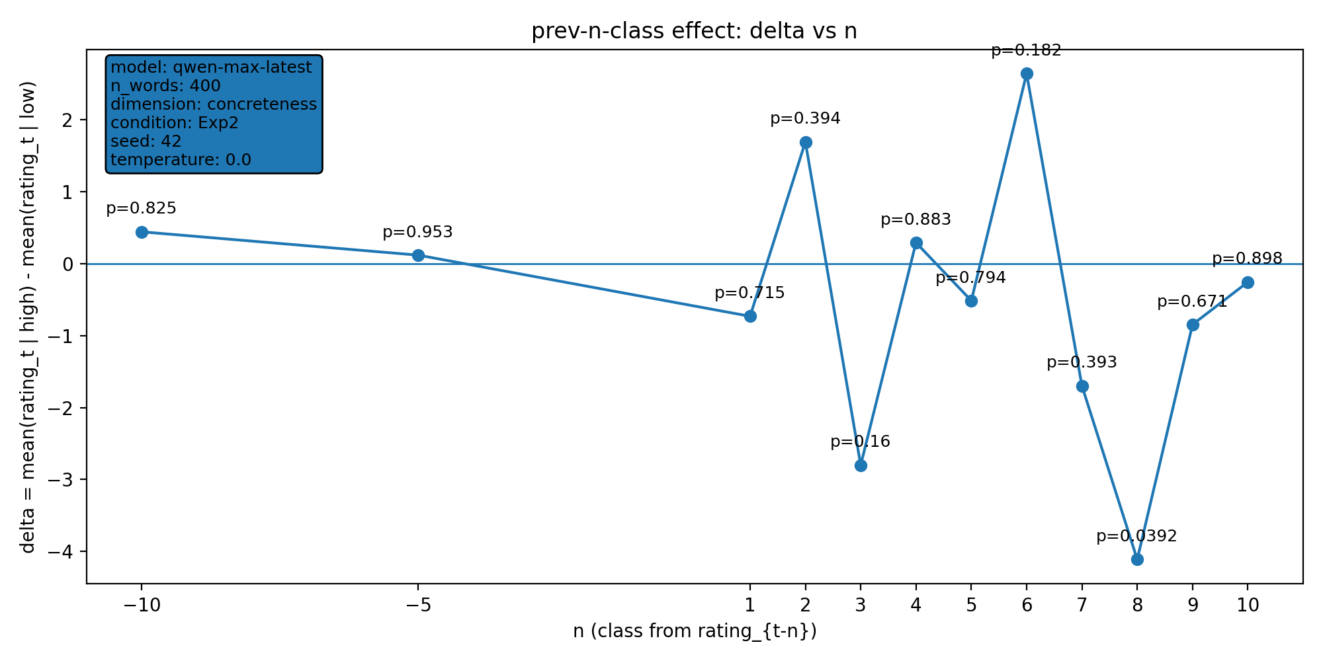 | model: qwen-max-latest  which: both  dimension: concreteness  n_words: 400  temperature: 0.0  seed: 42  stats_csv: ana_prev_n_class/results/20251218_170152_both_concreteness_n400/n_back_stats.csv
n-back deltas (per n):
n | p_value | n_low | n_high
-10 | 0.825 | 210 | 180
-5 | 0.953 | 212 | 183
1 | 0.715 | 216 | 183
2 | 0.394 | 215 | 183
3 | 0.16 | 215 | 182
4 | 0.883 | 215 | 181
5 | 0.794 | 214 | 181
6 | 0.182 | 213 | 181
7 | 0.393 | 213 | 180
8 | 0.0392 | 212 | 180
9 | 0.671 | 211 | 180
10 | 0.898 | 210 | 180

20251218_193433_both_concreteness_n400
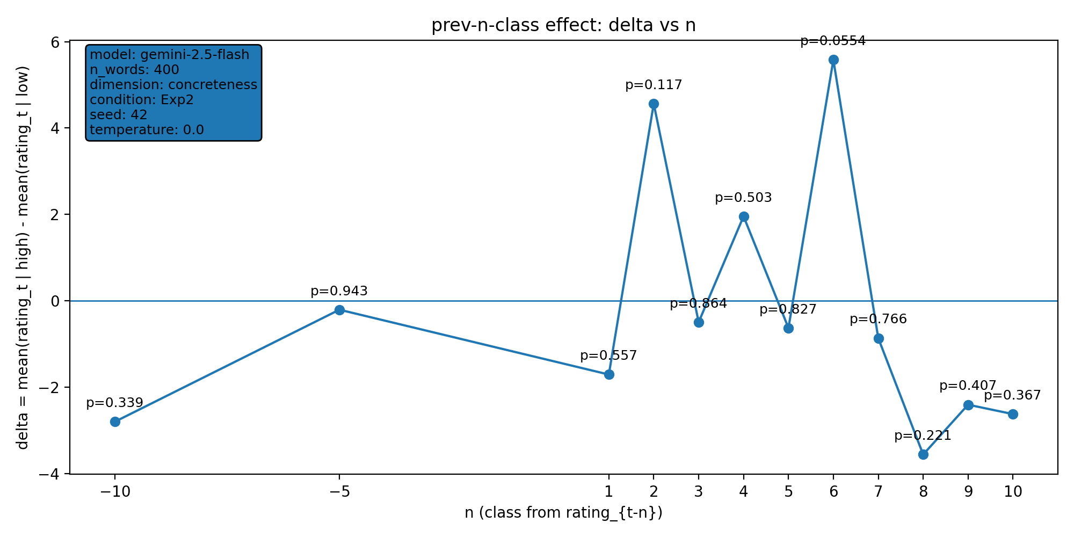 | model: gemini-2.5-flash  which: both  dimension: concreteness  n_words: 400  temperature: 0.0  seed: 42  stats_csv: ana_prev_n_class/results/20251218_193433_both_concreteness_n400/n_back_stats.csv
n-back deltas (per n):
n | p_value | n_low | n_high
-10 | 0.339 | 214 | 176
-5 | 0.943 | 216 | 179
1 | 0.557 | 219 | 180
2 | 0.117 | 218 | 180
3 | 0.864 | 217 | 180
4 | 0.503 | 217 | 179
5 | 0.827 | 216 | 179
6 | 0.0554 | 215 | 179
7 | 0.766 | 215 | 178
8 | 0.221 | 214 | 178
9 | 0.407 | 213 | 178
10 | 0.367 | 212 | 178

20251221_131659_both_concreteness_n400
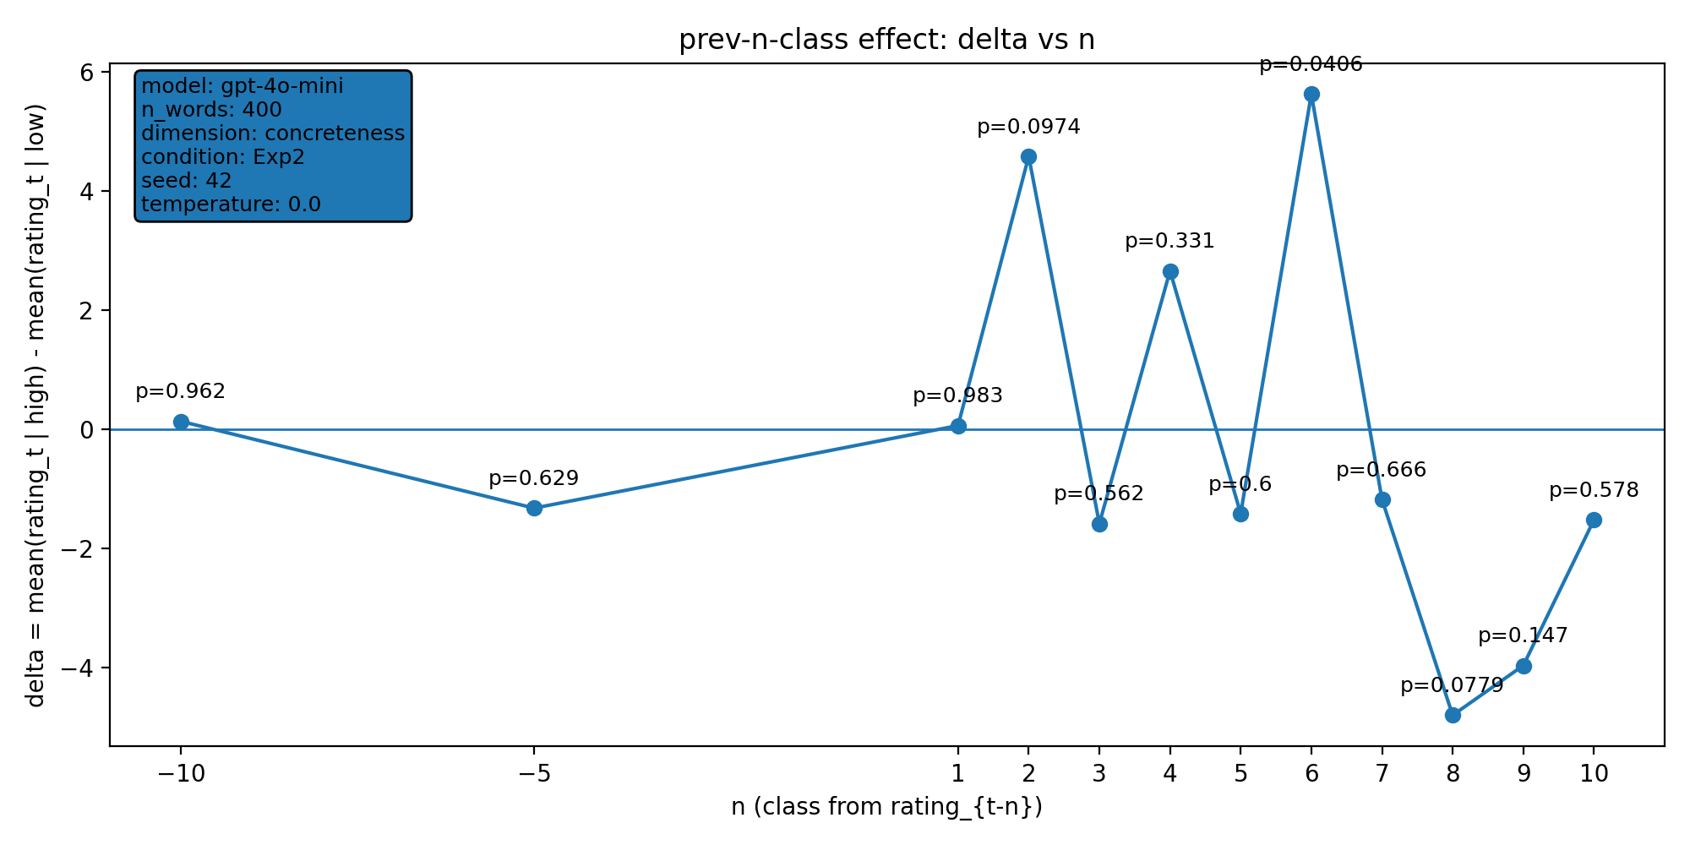 | model: gpt-4o-mini  which: both  dimension: concreteness  n_words: 400  temperature: 0.0  seed: 42  stats_csv: ana_prev_n_class/results/20251221_131659_both_concreteness_n400/n_back_stats.csv
n-back deltas (per n):
n | p_value | n_low | n_high
-10 | 0.962 | 221 | 169
-5 | 0.629 | 224 | 171
1 | 0.983 | 228 | 171
2 | 0.0974 | 227 | 171
3 | 0.562 | 227 | 170
4 | 0.331 | 227 | 169
5 | 0.6 | 226 | 169
6 | 0.0406 | 225 | 169
7 | 0.666 | 225 | 168
8 | 0.0779 | 224 | 168
9 | 0.147 | 223 | 168
10 | 0.578 | 222 | 168

20251221_135907_both_concreteness_n400
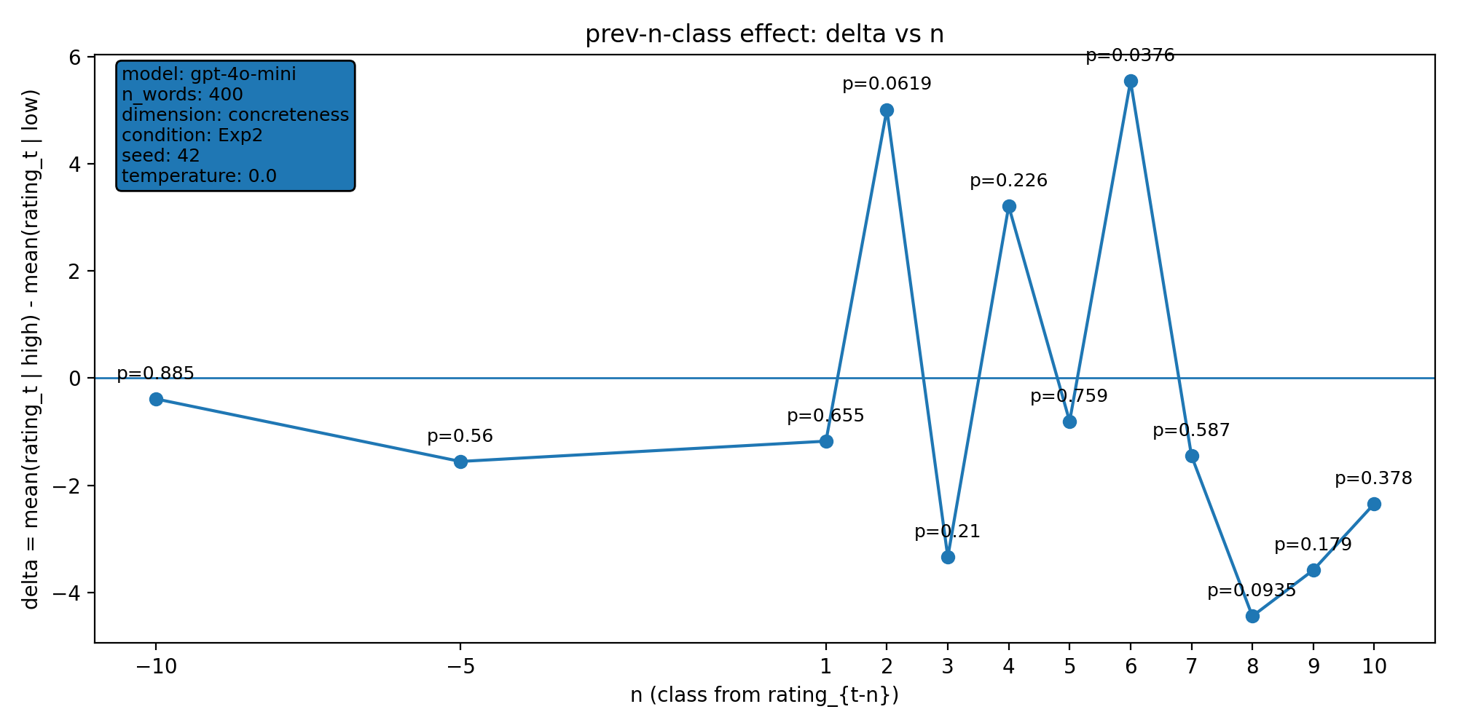 | model: gpt-4o-mini  which: both  dimension: concreteness  n_words: 400  temperature: 0.0  seed: 42  stats_csv: ana_prev_n_class/results/20251221_135907_both_concreteness_n400/n_back_stats.csv
n-back deltas (per n):
n | p_value | n_low | n_high
-10 | 0.885 | 219 | 171
-5 | 0.56 | 222 | 173
1 | 0.655 | 226 | 173
2 | 0.0619 | 225 | 173
3 | 0.21 | 225 | 172
4 | 0.226 | 225 | 171
5 | 0.759 | 224 | 171
6 | 0.0376 | 223 | 171
7 | 0.587 | 223 | 170
8 | 0.0935 | 222 | 170
9 | 0.179 | 221 | 170
10 | 0.378 | 220 | 170

20251221_135911_both_arousal_n400
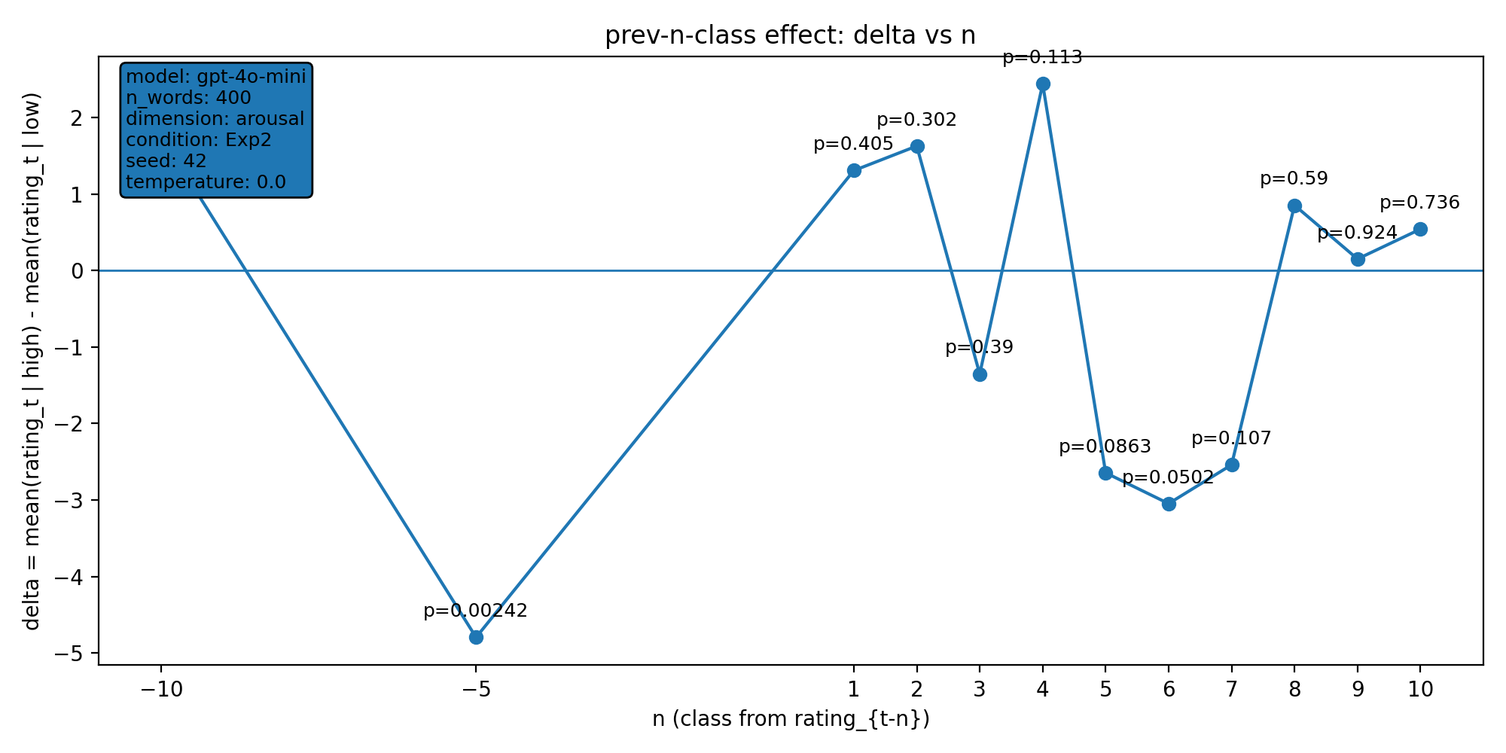 | model: gpt-4o-mini  which: both  dimension: arousal  n_words: 400  temperature: 0.0  seed: 42  stats_csv: ana_prev_n_class/results/20251221_135911_both_arousal_n400/n_back_stats.csv
n-back deltas (per n):
n | p_value | n_low | n_high
-10 | 0.261 | 158 | 232
-5 | 0.00242 | 161 | 234
1 | 0.405 | 161 | 238
2 | 0.302 | 161 | 237
3 | 0.39 | 161 | 236
4 | 0.113 | 161 | 235
5 | 0.0863 | 161 | 234
6 | 0.0502 | 160 | 234
7 | 0.107 | 160 | 233
8 | 0.59 | 160 | 232
9 | 0.924 | 160 | 231
10 | 0.736 | 159 | 231

20251221_144236_both_concreteness_n400
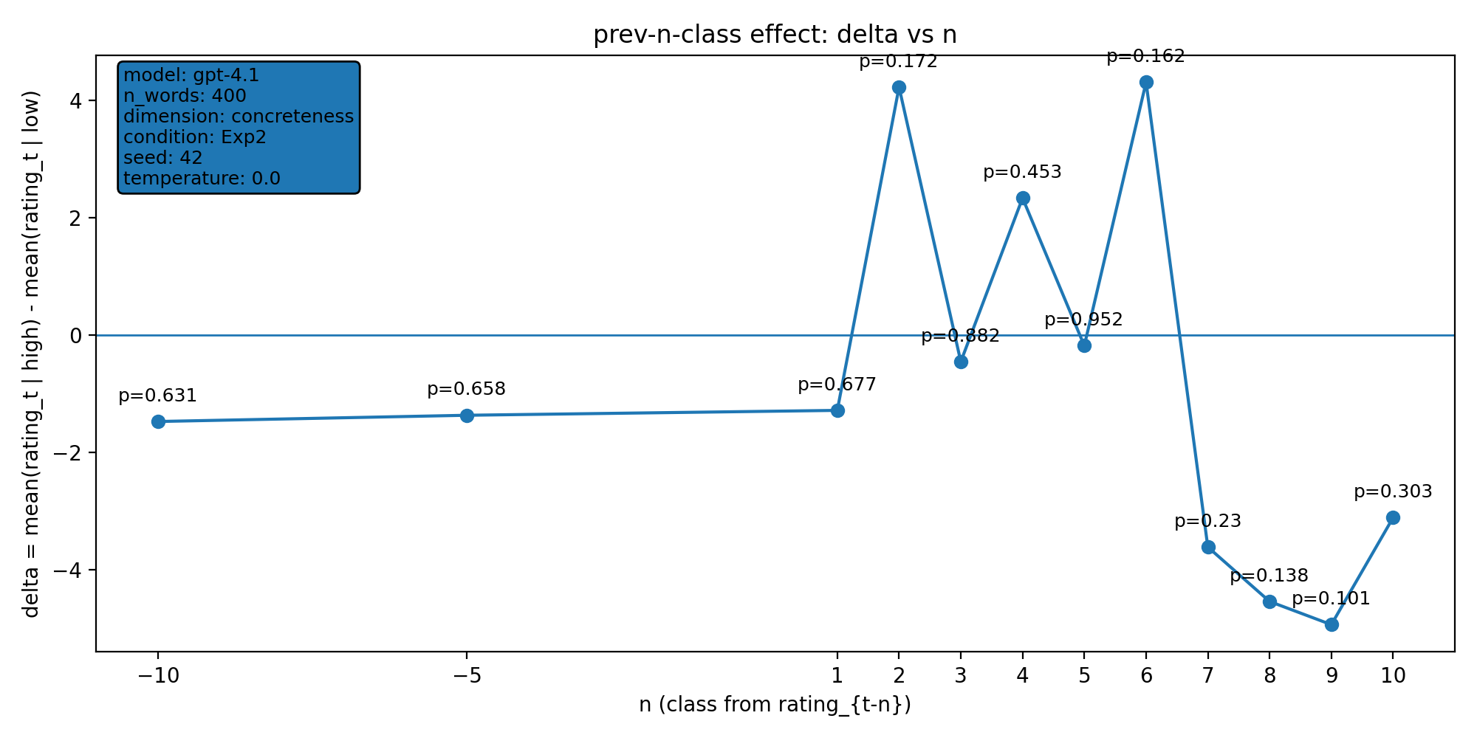 | model: gpt-4.1  which: both  dimension: concreteness  n_words: 400  temperature: 0.0  seed: 42  stats_csv: ana_prev_n_class/results/20251221_144236_both_concreteness_n400/n_back_stats.csv
n-back deltas (per n):
n | p_value | n_low | n_high
-10 | 0.631 | 240 | 150
-5 | 0.658 | 243 | 152
1 | 0.677 | 247 | 152
2 | 0.172 | 246 | 152
3 | 0.882 | 246 | 151
4 | 0.453 | 246 | 150
5 | 0.952 | 245 | 150
6 | 0.162 | 244 | 150
7 | 0.23 | 244 | 149
8 | 0.138 | 243 | 149
9 | 0.101 | 242 | 149
10 | 0.303 | 241 | 149

20251221_144304_both_arousal_n400
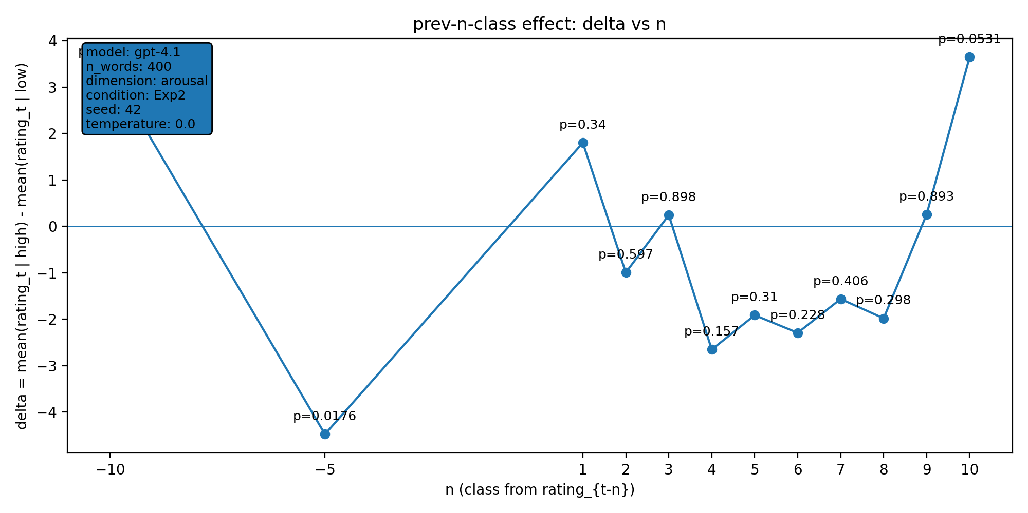 | model: gpt-4.1  which: both  dimension: arousal  n_words: 400  temperature: 0.0  seed: 42  stats_csv: ana_prev_n_class/results/20251221_144304_both_arousal_n400/n_back_stats.csv
n-back deltas (per n):
n | p_value | n_low | n_high
-10 | 0.0737 | 181 | 209
-5 | 0.0176 | 184 | 211
1 | 0.34 | 184 | 215
2 | 0.597 | 184 | 214
3 | 0.898 | 184 | 213
4 | 0.157 | 184 | 212
5 | 0.31 | 184 | 211
6 | 0.228 | 184 | 210
7 | 0.406 | 184 | 209
8 | 0.298 | 184 | 208
9 | 0.893 | 183 | 208
10 | 0.0531 | 182 | 208

20251221_172610_both_concreteness_n400
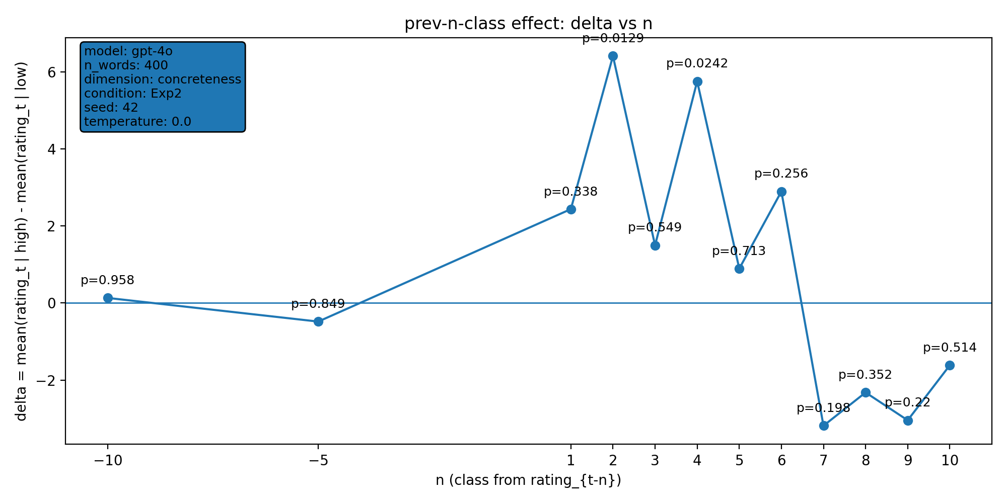 | model: gpt-4o  which: both  dimension: concreteness  n_words: 400  temperature: 0.0  seed: 42  stats_csv: ana_prev_n_class/results/20251221_172610_both_concreteness_n400/n_back_stats.csv
n-back deltas (per n):
n | p_value | n_low | n_high
-10 | 0.958 | 251 | 139
-5 | 0.849 | 254 | 141
1 | 0.338 | 258 | 141
2 | 0.0129 | 257 | 141
3 | 0.549 | 257 | 140
4 | 0.0242 | 257 | 139
5 | 0.713 | 256 | 139
6 | 0.256 | 255 | 139
7 | 0.198 | 254 | 139
8 | 0.352 | 253 | 139
9 | 0.22 | 252 | 139
10 | 0.514 | 251 | 139

20251224_103903_gpt-4o_exp2_concreteness_n1000
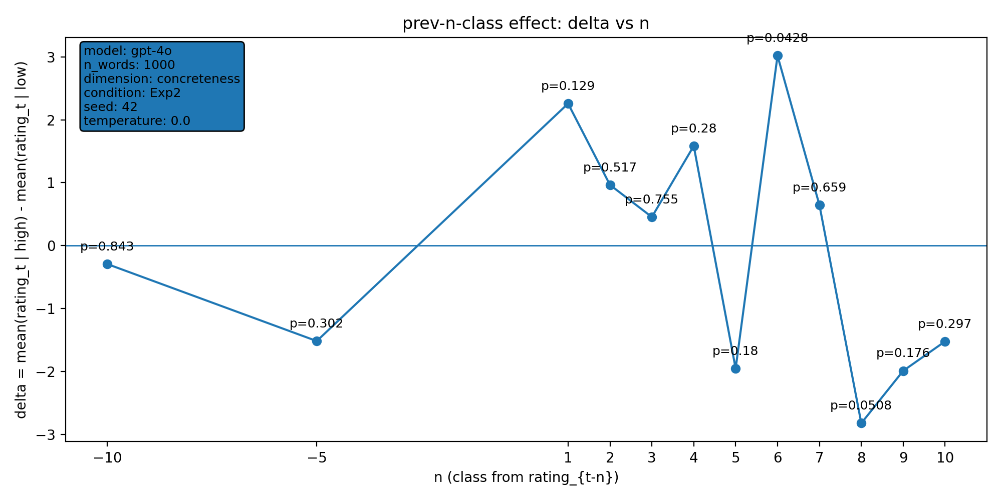 | model: gpt-4o  which: exp2  dimension: concreteness  n_words: 1000  temperature: 0.0  seed: 42  stats_csv: ana_prev_n_class/results/20251224_103903_gpt-4o_exp2_concreteness_n1000/n_back_stats.csv
n-back deltas (per n):
n | p_value | n_low | n_high
-10 | 0.843 | 618 | 372
-5 | 0.302 | 621 | 374
1 | 0.129 | 624 | 375
2 | 0.517 | 623 | 375
3 | 0.755 | 622 | 375
4 | 0.28 | 622 | 374
5 | 0.18 | 621 | 374
6 | 0.0428 | 621 | 373
7 | 0.659 | 621 | 372
8 | 0.0508 | 621 | 371
9 | 0.176 | 621 | 370
10 | 0.297 | 620 | 370

20260107_145719_gpt-4o_both_concreteness_n2000
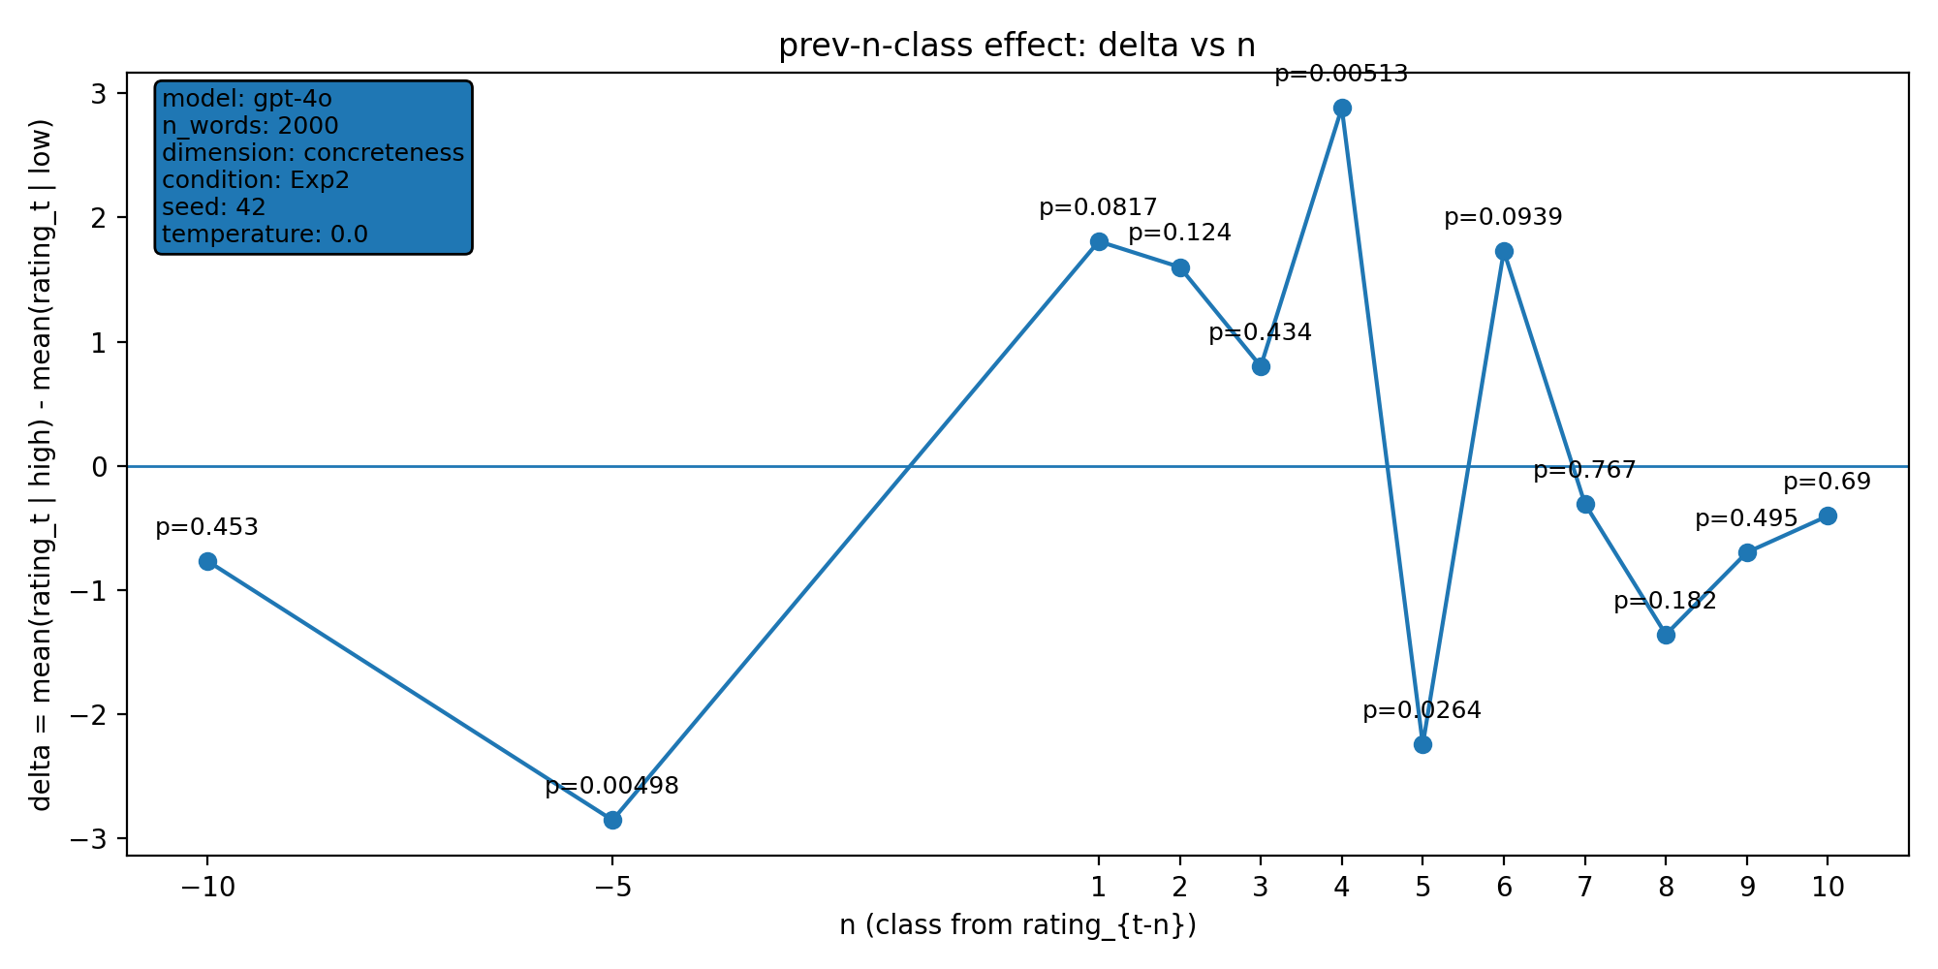 | model: gpt-4o  which: both  dimension: concreteness  n_words: 2000  temperature: 0.0  seed: 42  stats_csv: ana_prev_n_class/results/20260107_145719_gpt-4o_both_concreteness_n2000/n_back_stats.csv
n-back deltas (per n):
n | p_value | n_low | n_high
-10 | 0.453 | 1132 | 601
-5 | 0.00498 | 1135 | 603
1 | 0.0817 | 1139 | 603
2 | 0.124 | 1138 | 603
3 | 0.434 | 1137 | 603
4 | 0.00513 | 1137 | 602
5 | 0.0264 | 1136 | 602
6 | 0.0939 | 1135 | 602
7 | 0.767 | 1134 | 602
8 | 0.182 | 1134 | 601
9 | 0.495 | 1134 | 600
10 | 0.69 | 1134 | 599

20260112_001408_gpt-4o_both_concreteness_n1000
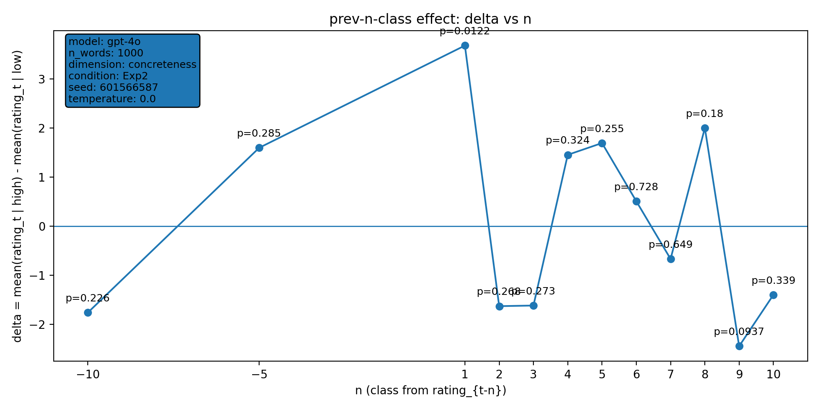 | model: gpt-4o  which: both  dimension: concreteness  n_words: 1000  temperature: 0.0  seed: 601566587  stats_csv: ana_prev_n_class/results/20260112_001408_gpt-4o_both_concreteness_n1000/n_back_stats.csv
n-back deltas (per n):
n | p_value | n_low | n_high
-10 | 0.226 | 604 | 386
-5 | 0.285 | 606 | 389
1 | 0.0122 | 609 | 390
2 | 0.268 | 608 | 390
3 | 0.273 | 607 | 390
4 | 0.324 | 607 | 389
5 | 0.255 | 607 | 388
6 | 0.728 | 606 | 388
7 | 0.649 | 606 | 387
8 | 0.18 | 605 | 387
9 | 0.0937 | 604 | 387
10 | 0.339 | 603 | 387

20260113_162650_gpt-4o_both_concreteness_n1000
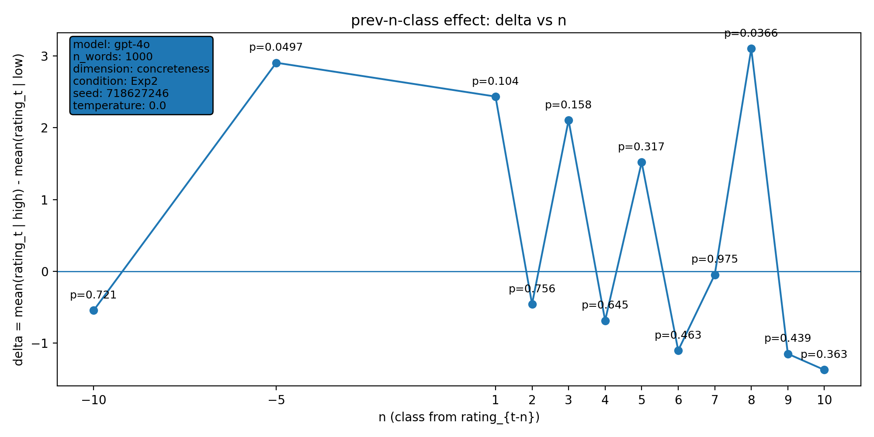 | model: gpt-4o  which: both  dimension: concreteness  n_words: 1000  temperature: 0.0  seed: 718627246  stats_csv: ana_prev_n_class/results/20260113_162650_gpt-4o_both_concreteness_n1000/n_back_stats.csv
n-back deltas (per n):
n | p_value | n_low | n_high
-10 | 0.721 | 670 | 320
-5 | 0.0497 | 675 | 320
1 | 0.104 | 678 | 321
2 | 0.756 | 677 | 321
3 | 0.158 | 677 | 320
4 | 0.645 | 676 | 320
5 | 0.317 | 676 | 319
6 | 0.463 | 675 | 319
7 | 0.975 | 675 | 318
8 | 0.0366 | 674 | 318
9 | 0.439 | 673 | 318
10 | 0.363 | 672 | 318

20260122_222005_gpt-4o_both_concreteness_n1000
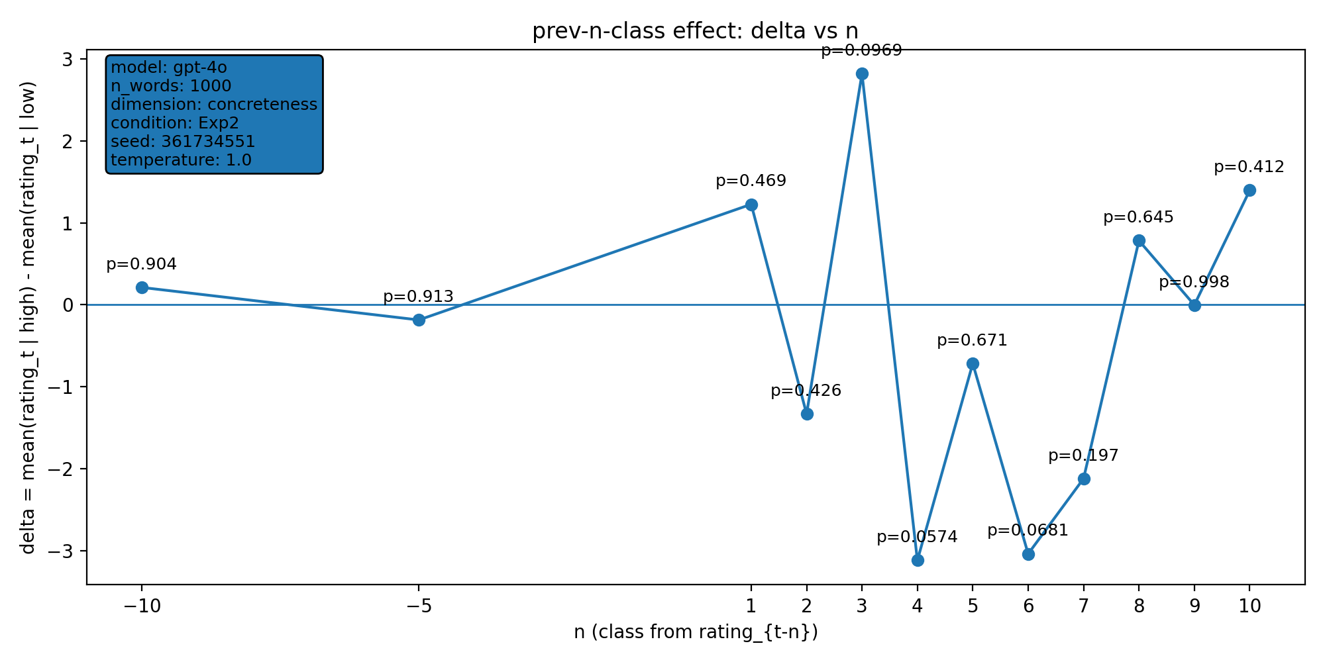 | model: gpt-4o  which: both  dimension: concreteness  n_words: 1000  temperature: 1.0  seed: 361734551  stats_csv: ana_prev_n_class/results/20260122_222005_gpt-4o_both_concreteness_n1000/n_back_stats.csv
n-back deltas (per n):
n | p_value | n_low | n_high
-10 | 0.904 | 672 | 318
-5 | 0.913 | 677 | 318
1 | 0.469 | 681 | 318
2 | 0.426 | 680 | 318
3 | 0.0969 | 679 | 318
4 | 0.0574 | 678 | 318
5 | 0.671 | 677 | 318
6 | 0.0681 | 676 | 318
7 | 0.197 | 675 | 318
8 | 0.645 | 674 | 318
9 | 0.998 | 673 | 318
10 | 0.412 | 672 | 318

20260126_174821_gpt-4o_exp2_concreteness_n2000
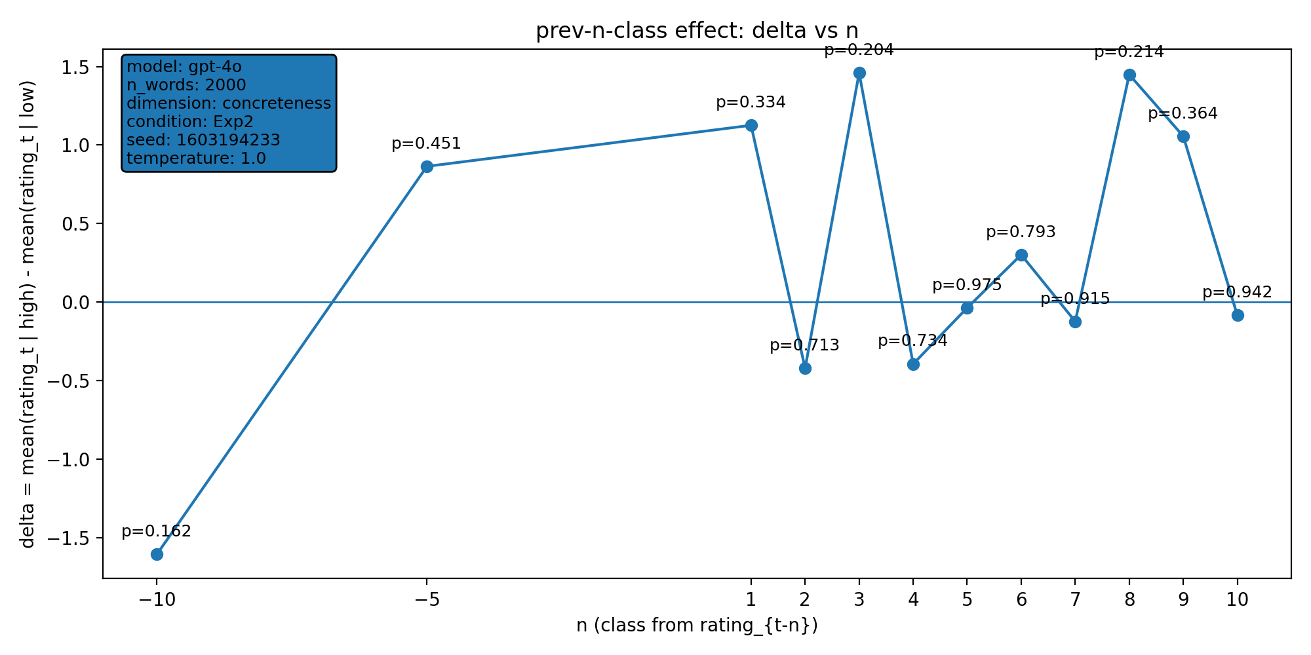 | model: gpt-4o  which: exp2  dimension: concreteness  n_words: 2000  temperature: 1.0  seed: 1603194233  stats_csv: ana_prev_n_class/results/20260126_174821_gpt-4o_exp2_concreteness_n2000/n_back_stats.csv
n-back deltas (per n):
n | p_value | n_low | n_high
-10 | 0.162 | 1286 | 704
-5 | 0.451 | 1291 | 704
1 | 0.334 | 1295 | 704
2 | 0.713 | 1294 | 704
3 | 0.204 | 1293 | 704
4 | 0.734 | 1293 | 703
5 | 0.975 | 1292 | 703
6 | 0.793 | 1292 | 702
7 | 0.915 | 1292 | 701
8 | 0.214 | 1291 | 701
9 | 0.364 | 1291 | 700
10 | 0.942 | 1290 | 700

20260126_174922_gpt-4o_exp2_valence_n1000
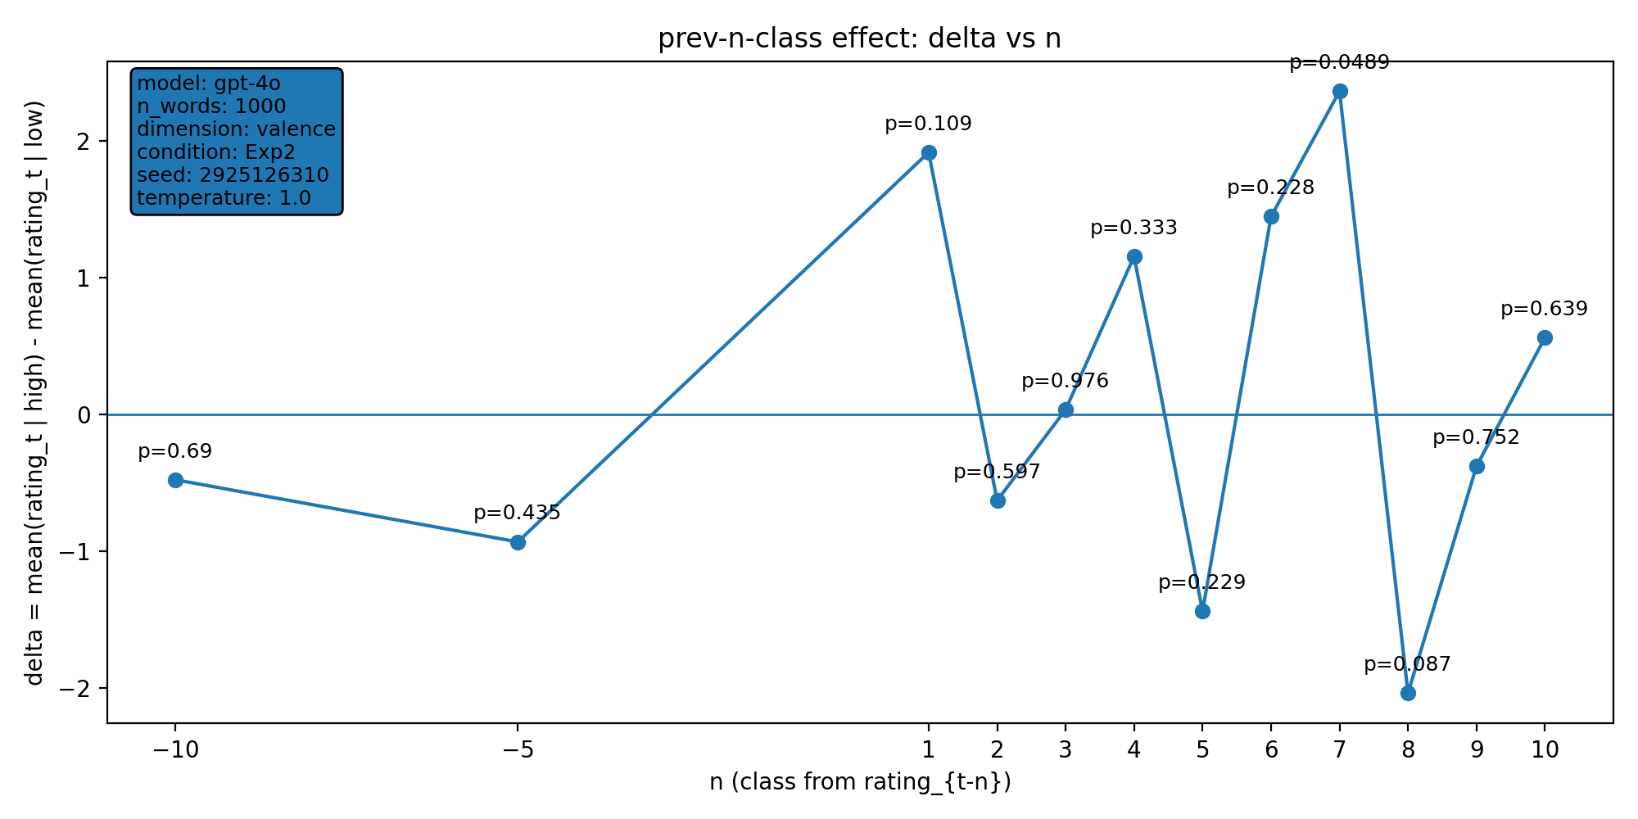 | model: gpt-4o  which: exp2  dimension: valence  n_words: 1000  temperature: 1.0  seed: 2925126310  stats_csv: ana_prev_n_class/results/20260126_174922_gpt-4o_exp2_valence_n1000/n_back_stats.csv
n-back deltas (per n):
n | p_value | n_low | n_high
-10 | 0.69 | 460 | 530
-5 | 0.435 | 462 | 533
1 | 0.109 | 462 | 537
2 | 0.597 | 462 | 536
3 | 0.976 | 462 | 535
4 | 0.333 | 461 | 535
5 | 0.229 | 461 | 534
6 | 0.228 | 460 | 534
7 | 0.0489 | 460 | 533
8 | 0.087 | 459 | 533
9 | 0.752 | 459 | 532
10 | 0.639 | 459 | 531

20260126_192052_gpt-4o_exp2_concreteness_n1000
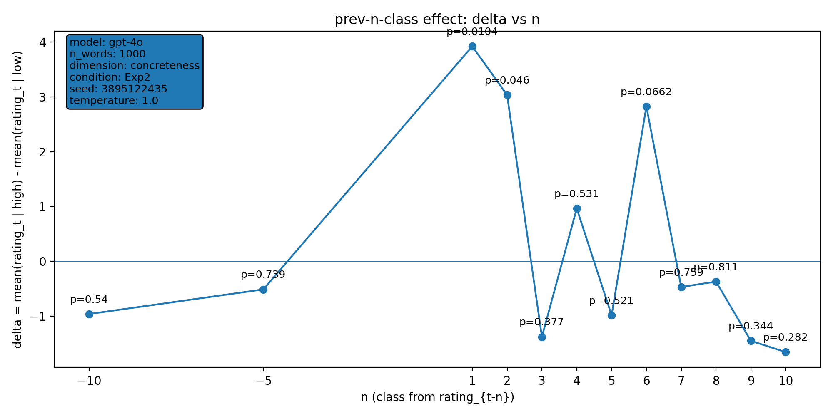 | model: gpt-4o  which: exp2  dimension: concreteness  n_words: 1000  temperature: 1.0  seed: 3895122435  stats_csv: ana_prev_n_class/results/20260126_192052_gpt-4o_exp2_concreteness_n1000/n_back_stats.csv
n-back deltas (per n):
n | p_value | n_low | n_high
-10 | 0.54 | 614 | 376
-5 | 0.739 | 617 | 378
1 | 0.0104 | 619 | 380
2 | 0.046 | 619 | 379
3 | 0.377 | 619 | 378
4 | 0.531 | 618 | 378
5 | 0.521 | 617 | 378
6 | 0.0662 | 617 | 377
7 | 0.759 | 617 | 376
8 | 0.811 | 616 | 376
9 | 0.344 | 616 | 375
10 | 0.282 | 615 | 375

20260127_225919_gpt-4o_exp2_concreteness_n1000
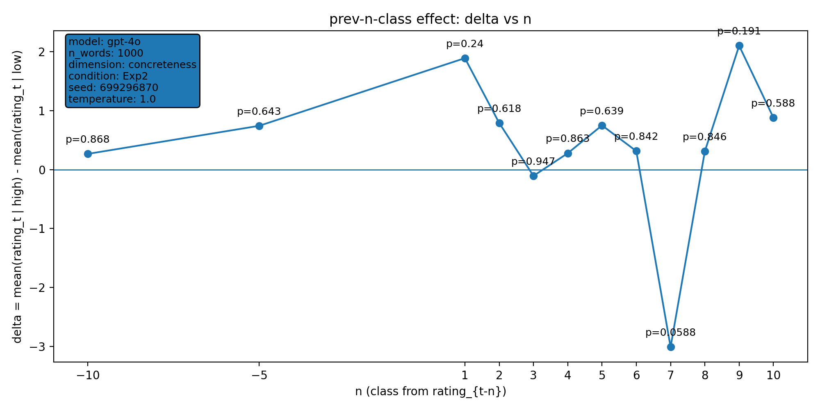 | model: gpt-4o  which: exp2  dimension: concreteness  n_words: 1000  temperature: 1.0  seed: 699296870  stats_csv: ana_prev_n_class/results/20260127_225919_gpt-4o_exp2_concreteness_n1000/n_back_stats.csv
n-back deltas (per n):
n | p_value | n_low | n_high
-10 | 0.868 | 600 | 390
-5 | 0.643 | 605 | 390
1 | 0.24 | 607 | 392
2 | 0.618 | 606 | 392
3 | 0.947 | 605 | 392
4 | 0.863 | 605 | 391
5 | 0.639 | 604 | 391
6 | 0.842 | 603 | 391
7 | 0.0588 | 602 | 391
8 | 0.846 | 602 | 390
9 | 0.191 | 602 | 389
10 | 0.588 | 601 | 389

20260127_230016_gpt-4o_exp2_valence_n1000
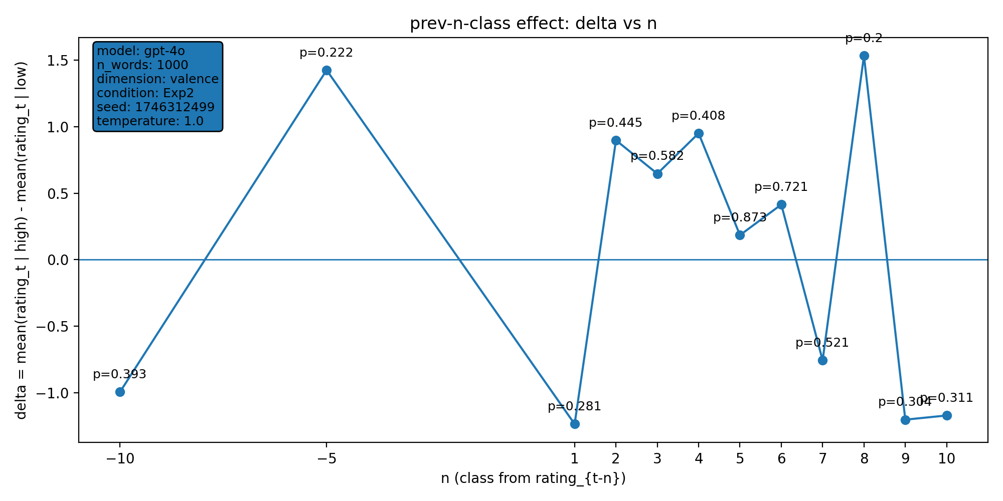 | model: gpt-4o  which: exp2  dimension: valence  n_words: 1000  temperature: 1.0  seed: 1746312499  stats_csv: ana_prev_n_class/results/20260127_230016_gpt-4o_exp2_valence_n1000/n_back_stats.csv
n-back deltas (per n):
n | p_value | n_low | n_high
-10 | 0.393 | 401 | 589
-5 | 0.222 | 404 | 591
1 | 0.281 | 407 | 592
2 | 0.445 | 407 | 591
3 | 0.582 | 406 | 591
4 | 0.408 | 406 | 590
5 | 0.873 | 405 | 590
6 | 0.721 | 404 | 590
7 | 0.521 | 404 | 589
8 | 0.2 | 403 | 589
9 | 0.304 | 403 | 588
10 | 0.311 | 402 | 588

20260128_002209_gpt-4o_exp2_valence_n1000
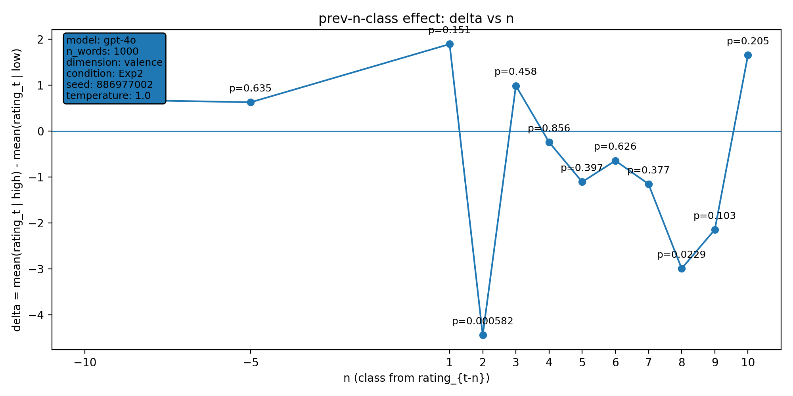 | model: gpt-4o  which: exp2  dimension: valence  n_words: 1000  temperature: 1.0  seed: 886977002  stats_csv: ana_prev_n_class/results/20260128_002209_gpt-4o_exp2_valence_n1000/n_back_stats.csv
n-back deltas (per n):
n | p_value | n_low | n_high
-10 | 0.6 | 330 | 467
-5 | 0.635 | 331 | 471
1 | 0.151 | 334 | 472
2 | 0.000582 | 334 | 471
3 | 0.458 | 333 | 471
4 | 0.856 | 332 | 471
5 | 0.397 | 331 | 471
6 | 0.626 | 331 | 470
7 | 0.377 | 331 | 469
8 | 0.0229 | 330 | 469
9 | 0.103 | 330 | 468
10 | 0.205 | 329 | 468

20260128_002228_gpt-4o_exp2_valence_n1000
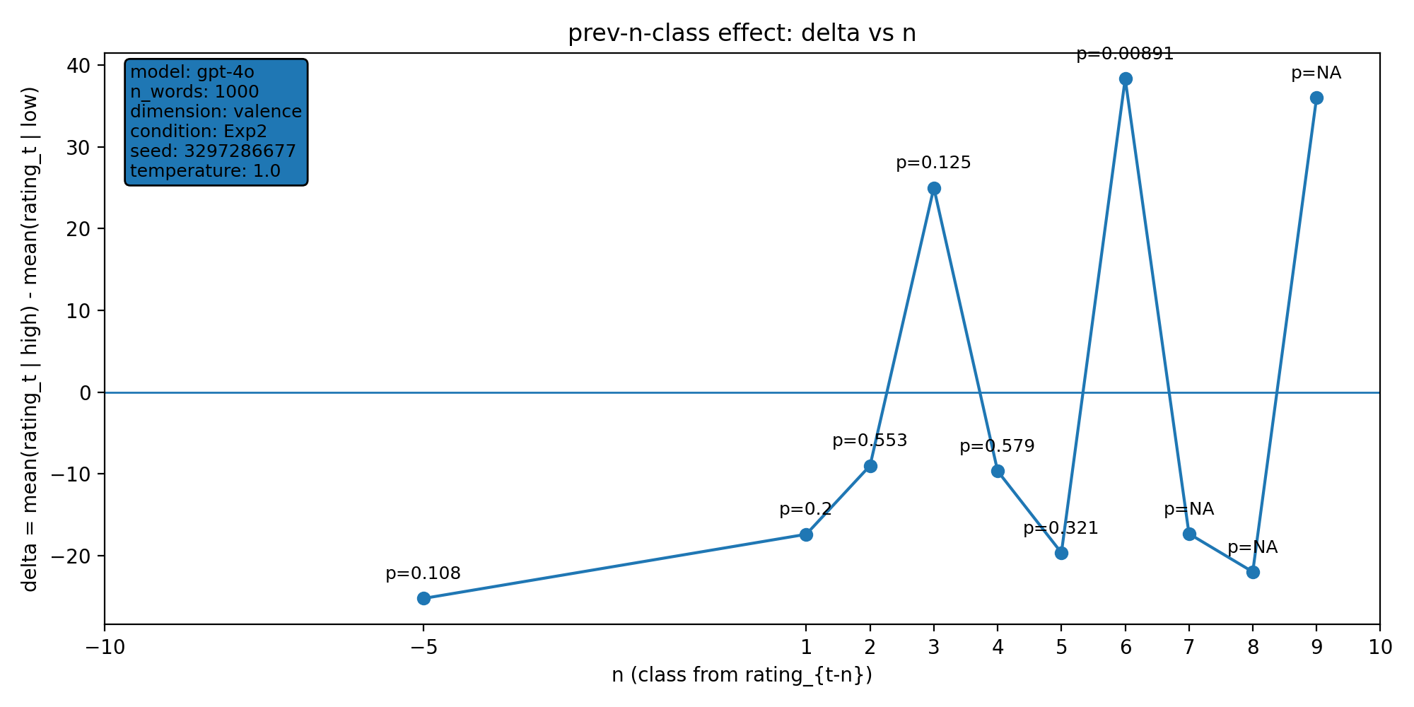 | model: gpt-4o  which: exp2  dimension: valence  n_words: 1000  temperature: 1.0  seed: 3297286677  stats_csv: ana_prev_n_class/results/20260128_002228_gpt-4o_exp2_valence_n1000/n_back_stats.csv
n-back deltas (per n):
n | p_value | n_low | n_high
-10 | nan | 1 | 0
-5 | 0.108 | 4 | 2
1 | 0.2 | 5 | 5
2 | 0.553 | 5 | 4
3 | 0.125 | 4 | 4
4 | 0.579 | 3 | 4
5 | 0.321 | 3 | 3
6 | 0.00891 | 2 | 3
7 | nan | 1 | 3
8 | nan | 1 | 2
9 | nan | 1 | 1
10 | nan | 0 | 1

20260128_002256_gpt-4o_exp2_concreteness_n1000
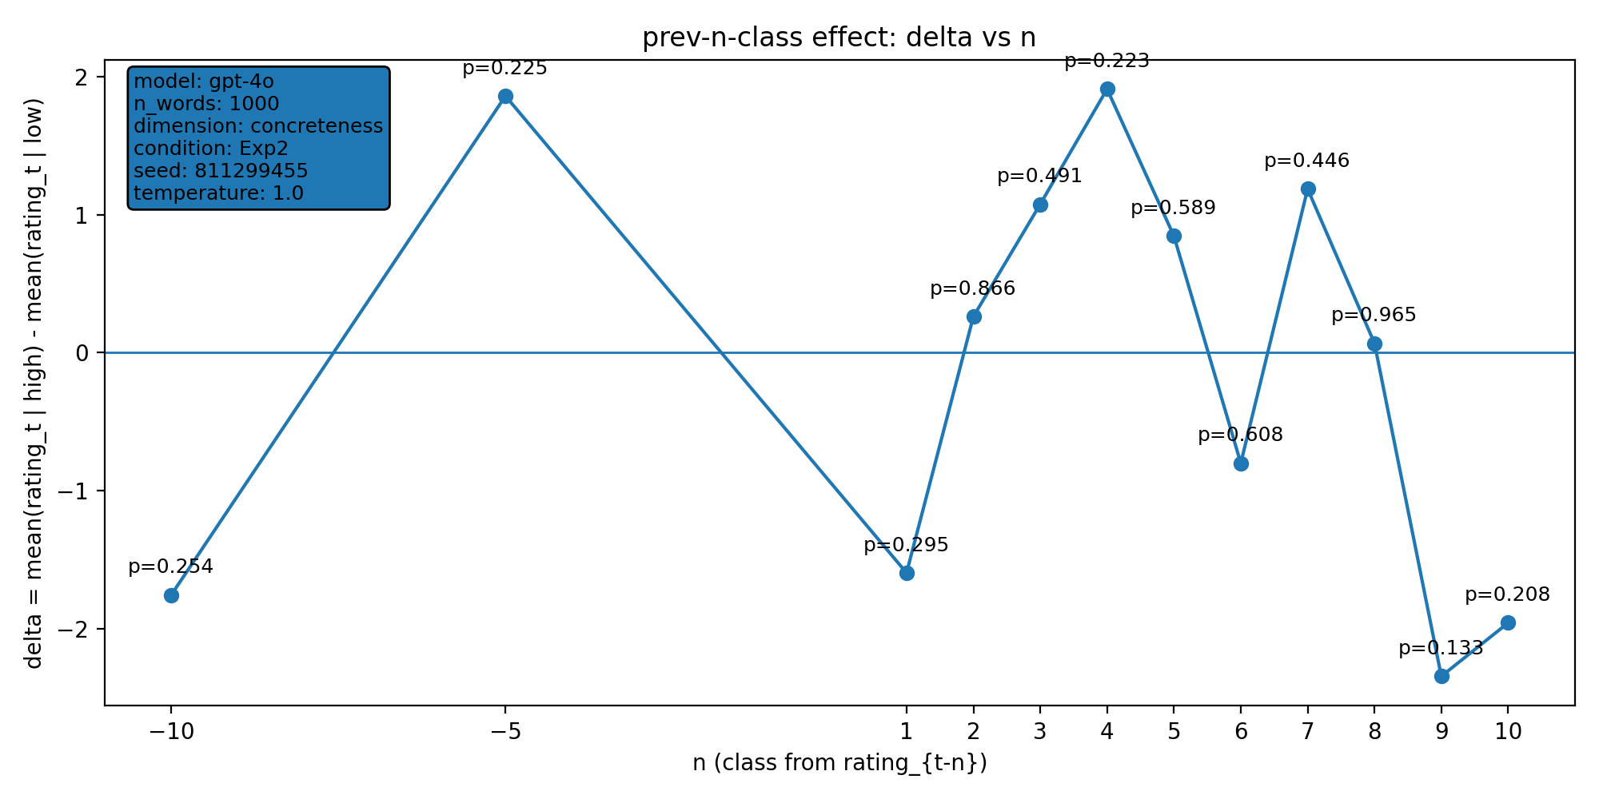 | model: gpt-4o  which: exp2  dimension: concreteness  n_words: 1000  temperature: 1.0  seed: 811299455  stats_csv: ana_prev_n_class/results/20260128_002256_gpt-4o_exp2_concreteness_n1000/n_back_stats.csv
n-back deltas (per n):
n | p_value | n_low | n_high
-10 | 0.254 | 618 | 372
-5 | 0.225 | 623 | 372
1 | 0.295 | 625 | 374
2 | 0.866 | 624 | 374
3 | 0.491 | 624 | 373
4 | 0.223 | 624 | 372
5 | 0.589 | 624 | 371
6 | 0.608 | 624 | 370
7 | 0.446 | 624 | 369
8 | 0.965 | 624 | 368
9 | 0.133 | 623 | 368
10 | 0.208 | 623 | 367

20260129_145137_gpt-4o_both_valence_n1000
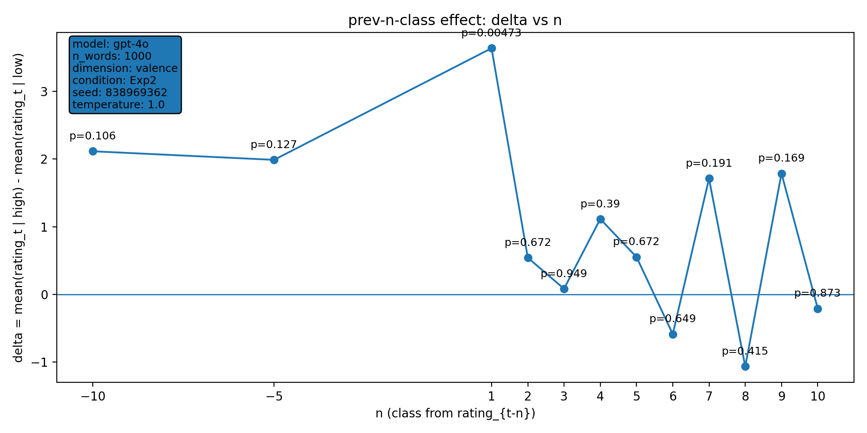 | model: gpt-4o  which: both  dimension: valence  n_words: 1000  temperature: 1.0  seed: 838969362  stats_csv: ana_prev_n_class/results/20260129_145137_gpt-4o_both_valence_n1000/n_back_stats.csv
n-back deltas (per n):
n | p_value | n_low | n_high
-10 | 0.106 | 442 | 548
-5 | 0.127 | 444 | 551
1 | 0.00473 | 446 | 553
2 | 0.672 | 446 | 552
3 | 0.949 | 446 | 551
4 | 0.39 | 445 | 551
5 | 0.672 | 445 | 550
6 | 0.649 | 444 | 550
7 | 0.191 | 443 | 550
8 | 0.415 | 442 | 550
9 | 0.169 | 442 | 549
10 | 0.873 | 441 | 549

20260202_004249_gpt-4o_exp2_valence_n1000
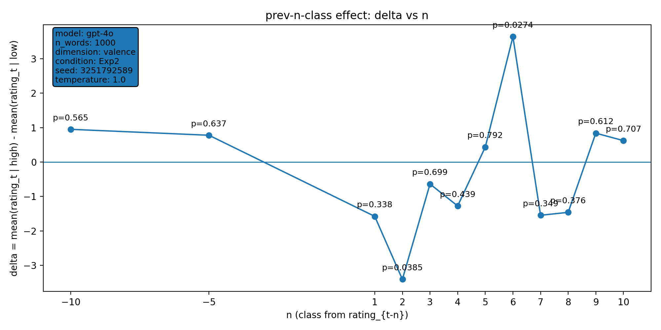 | model: gpt-4o  which: exp2  dimension: valence  n_words: 1000  temperature: 1.0  seed: 3251792589  stats_csv: ana_prev_n_class/results/20260202_004249_gpt-4o_exp2_valence_n1000/n_back_stats.csv
n-back deltas (per n):
n | p_value | n_low | n_high
-10 | 0.565 | 478 | 512
-5 | 0.637 | 479 | 516
1 | 0.338 | 481 | 518
2 | 0.0385 | 480 | 518
3 | 0.699 | 480 | 517
4 | 0.439 | 479 | 517
5 | 0.792 | 478 | 517
6 | 0.0274 | 478 | 516
7 | 0.349 | 477 | 516
8 | 0.376 | 476 | 516
9 | 0.612 | 476 | 515
10 | 0.707 | 475 | 515

20260202_005410_gpt-4o_exp2_valence_n1000
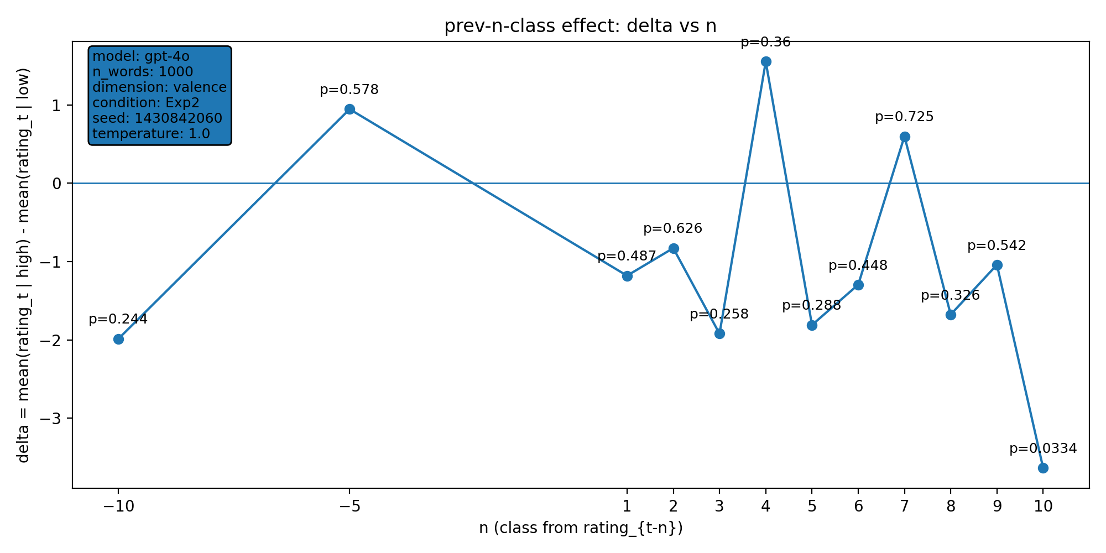 | model: gpt-4o  which: exp2  dimension: valence  n_words: 1000  temperature: 1.0  seed: 1430842060  stats_csv: ana_prev_n_class/results/20260202_005410_gpt-4o_exp2_valence_n1000/n_back_stats.csv
n-back deltas (per n):
n | p_value | n_low | n_high
-10 | 0.244 | 512 | 478
-5 | 0.578 | 515 | 480
1 | 0.487 | 516 | 483
2 | 0.626 | 516 | 482
3 | 0.258 | 515 | 482
4 | 0.36 | 514 | 482
5 | 0.288 | 513 | 482
6 | 0.448 | 513 | 481
7 | 0.725 | 512 | 481
8 | 0.326 | 512 | 480
9 | 0.542 | 511 | 480
10 | 0.0334 | 510 | 480

20260202_114143_gpt-4o_exp2_valence_n1000
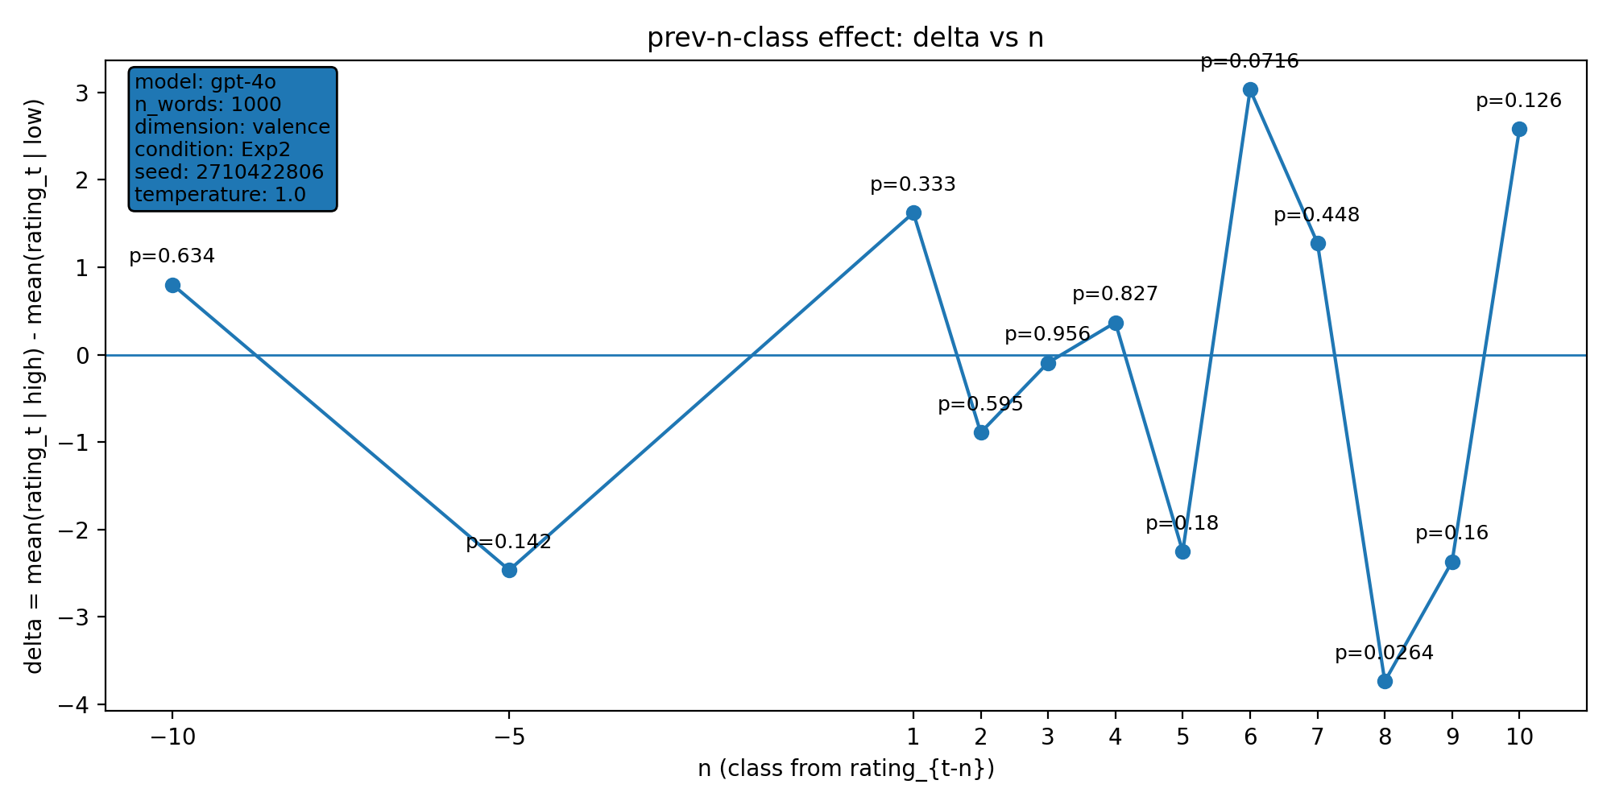 | model: gpt-4o  which: exp2  dimension: valence  n_words: 1000  temperature: 1.0  seed: 2710422806  stats_csv: ana_prev_n_class/results/20260202_114143_gpt-4o_exp2_valence_n1000/n_back_stats.csv
n-back deltas (per n):
n | p_value | n_low | n_high
-10 | 0.634 | 497 | 493
-5 | 0.142 | 497 | 498
1 | 0.333 | 499 | 500
2 | 0.595 | 498 | 500
3 | 0.956 | 498 | 499
4 | 0.827 | 497 | 499
5 | 0.18 | 496 | 499
6 | 0.0716 | 495 | 499
7 | 0.448 | 494 | 499
8 | 0.0264 | 493 | 499
9 | 0.16 | 492 | 499
10 | 0.126 | 491 | 499

20260202_121450_gpt-4o_exp2_valence_n1000
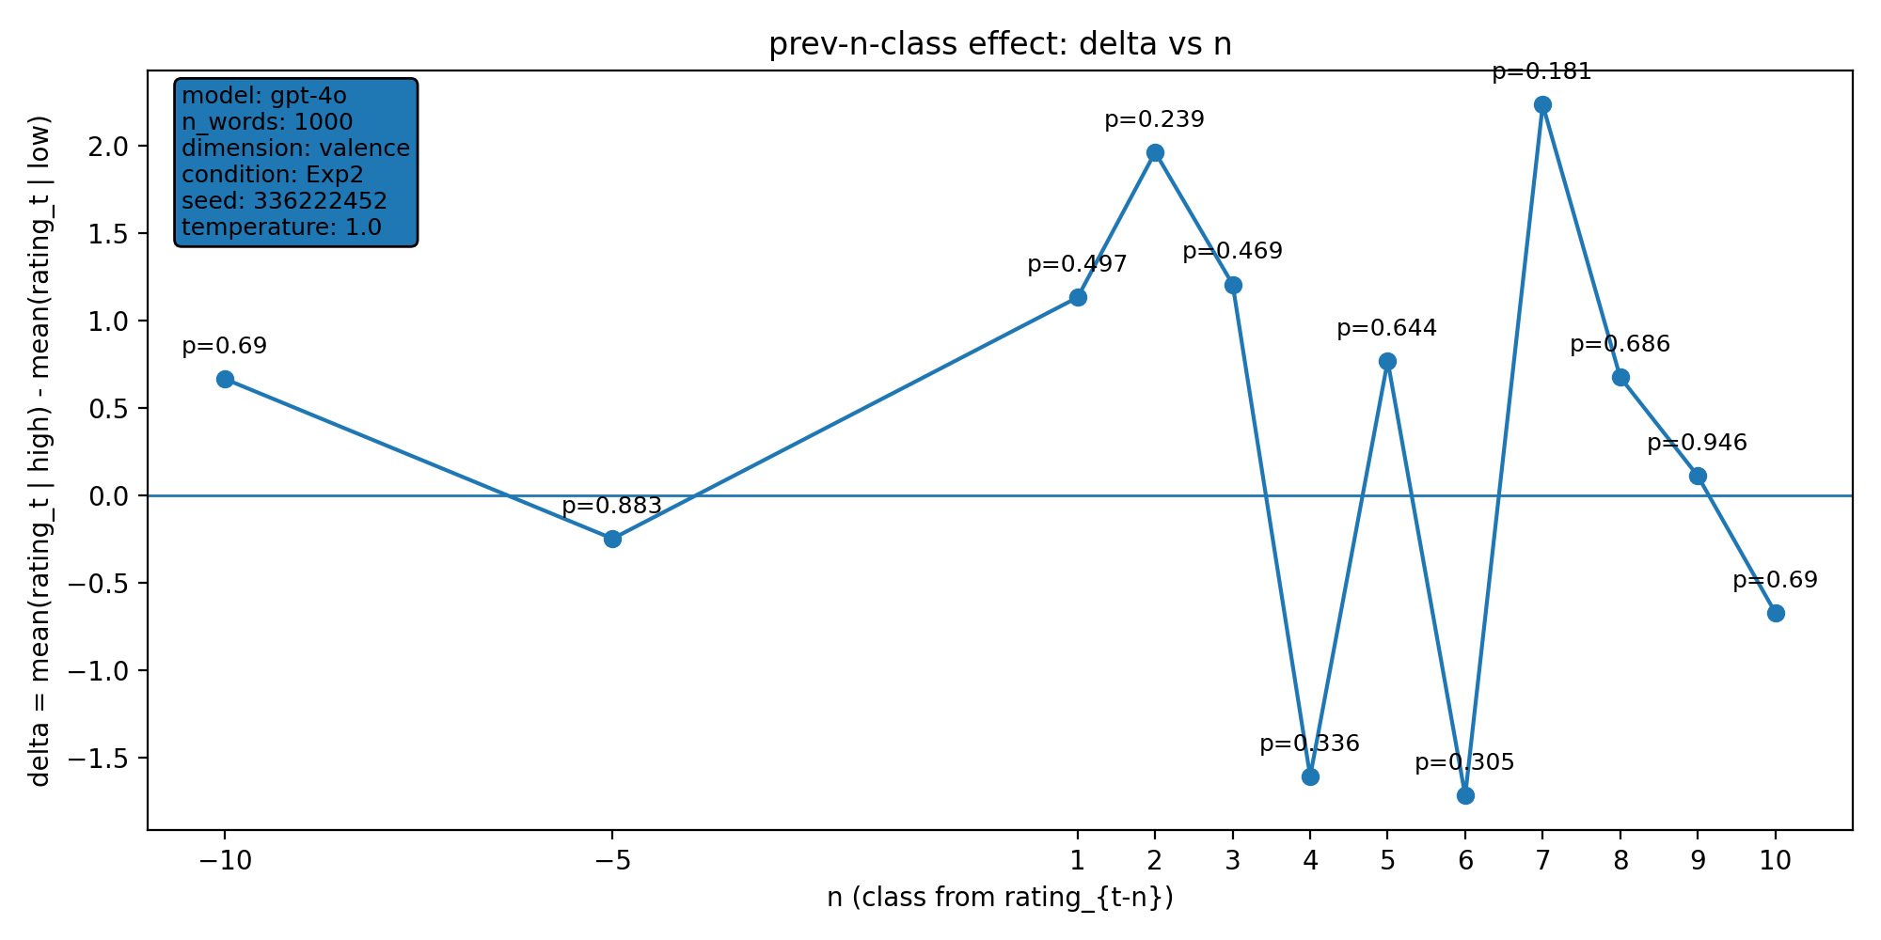 | model: gpt-4o  which: exp2  dimension: valence  n_words: 1000  temperature: 1.0  seed: 336222452  stats_csv: ana_prev_n_class/results/20260202_121450_gpt-4o_exp2_valence_n1000/n_back_stats.csv
n-back deltas (per n):
n | p_value | n_low | n_high
-10 | 0.69 | 482 | 508
-5 | 0.883 | 483 | 512
1 | 0.497 | 483 | 516
2 | 0.239 | 483 | 515
3 | 0.469 | 483 | 514
4 | 0.336 | 482 | 514
5 | 0.644 | 481 | 514
6 | 0.305 | 480 | 514
7 | 0.181 | 479 | 514
8 | 0.686 | 478 | 514
9 | 0.946 | 477 | 514
10 | 0.69 | 476 | 514

20260202_124834_gpt-4o_exp2_valence_n1000
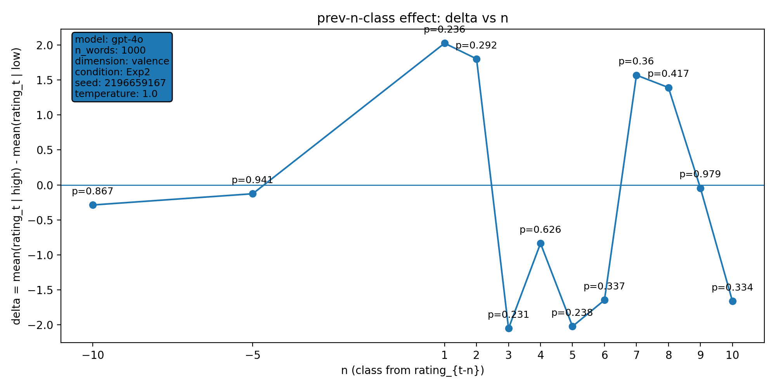 | model: gpt-4o  which: exp2  dimension: valence  n_words: 1000  temperature: 1.0  seed: 2196659167  stats_csv: ana_prev_n_class/results/20260202_124834_gpt-4o_exp2_valence_n1000/n_back_stats.csv
n-back deltas (per n):
n | p_value | n_low | n_high
-10 | 0.867 | 497 | 493
-5 | 0.941 | 500 | 495
1 | 0.236 | 503 | 496
2 | 0.292 | 502 | 496
3 | 0.231 | 501 | 496
4 | 0.626 | 500 | 496
5 | 0.238 | 499 | 496
6 | 0.337 | 499 | 495
7 | 0.36 | 499 | 494
8 | 0.417 | 499 | 493
9 | 0.979 | 498 | 493
10 | 0.334 | 497 | 493

