Prev-class (low/high) analysis report
Generated at: 2026-02-19 16:59:42

Single-dimension runs

20251212_203849_both_valence_n400
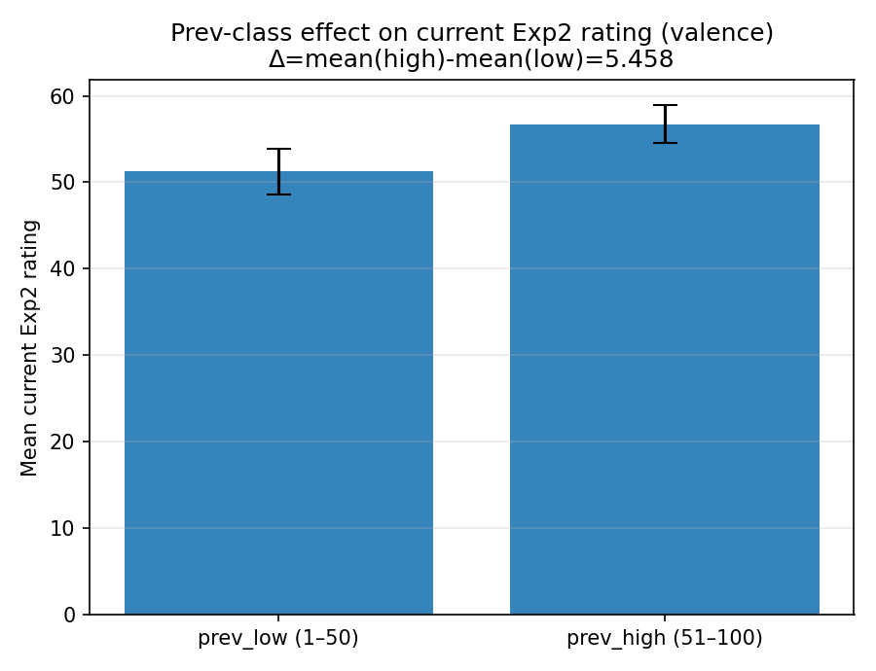 | model: gpt-4o  which: both  dimension: valence  temperature: 0.0  n_words: 400  delta (high-low): 5.458042  p_value (permutation): 0.00179982  p_value (Welch t-test): 0.00204511

20251212_203916_both_arousal_n400
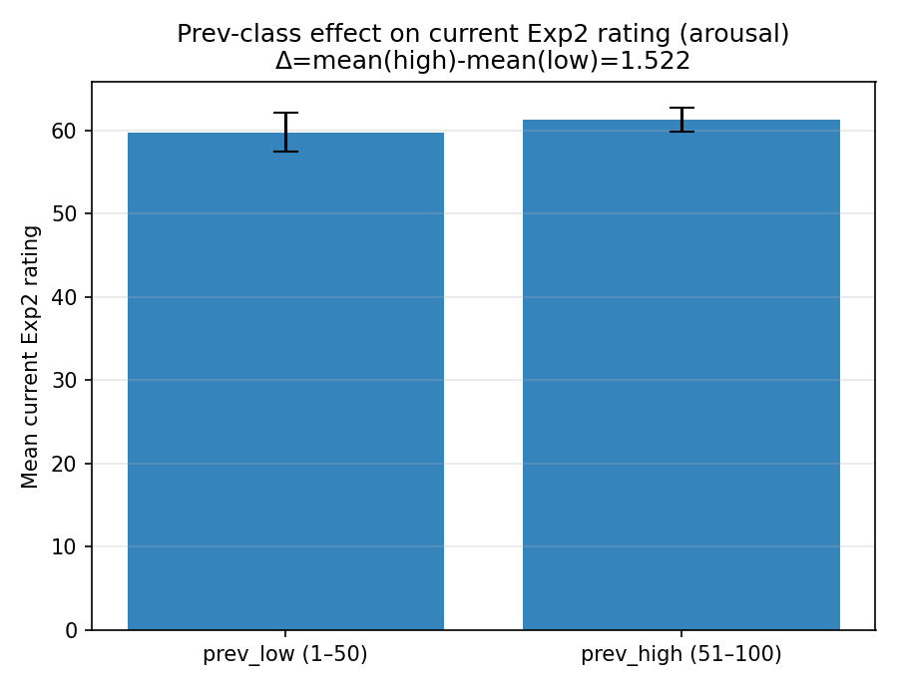 | model: gpt-4o  which: both  dimension: arousal  temperature: 0.0  n_words: 400  delta (high-low): 1.522461  p_value (permutation): 0.282072  p_value (Welch t-test): 0.279242

20251213_010833_both_arousal_n400
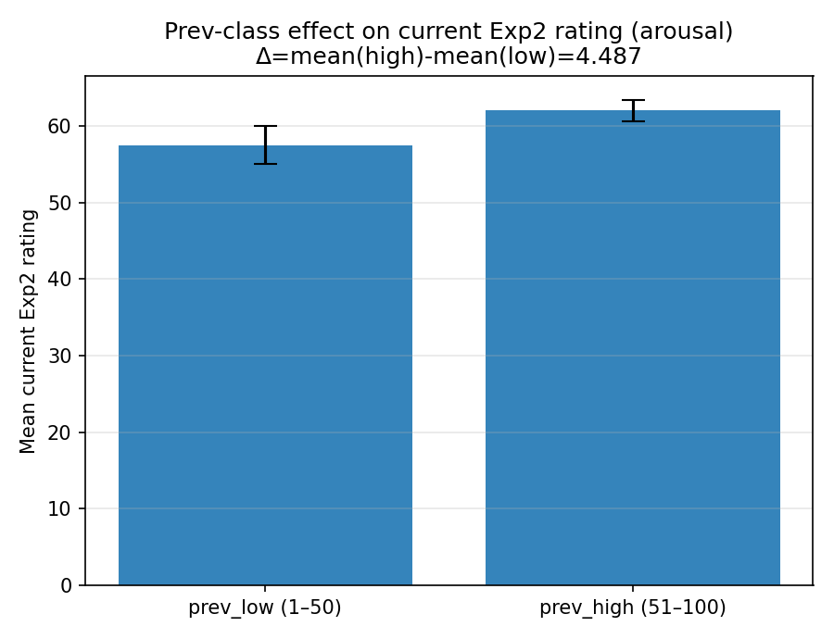 | model: gpt-4o  which: both  dimension: arousal  temperature: 0.0  n_words: 400  delta (high-low): 4.486532  p_value (permutation): 0.00129987  p_value (Welch t-test): 0.00223146

20251213_133659_both_concreteness_n400
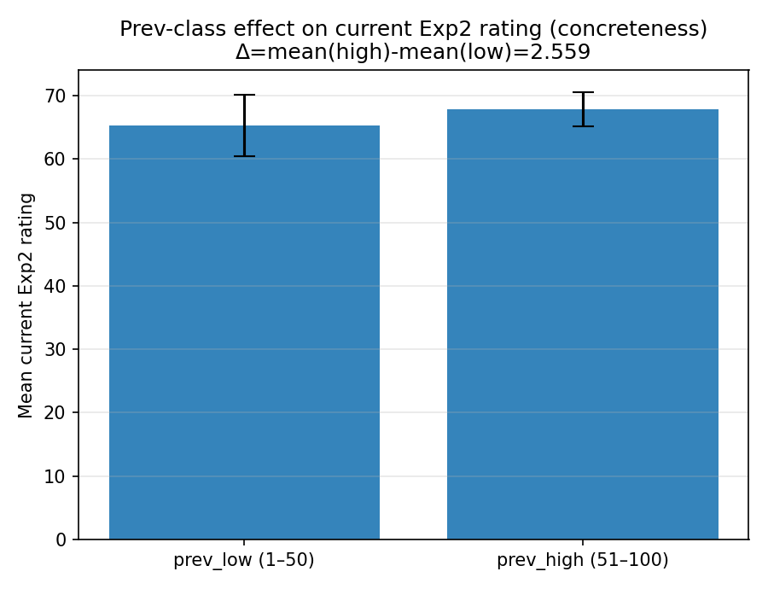 | model: deepseek-r1-0528  which: both  dimension: concreteness  temperature: 0.0  n_words: 400  delta (high-low): 2.558553  p_value (permutation): 0.362564  p_value (Welch t-test): 0.366045

20251213_133742_both_concreteness_n400
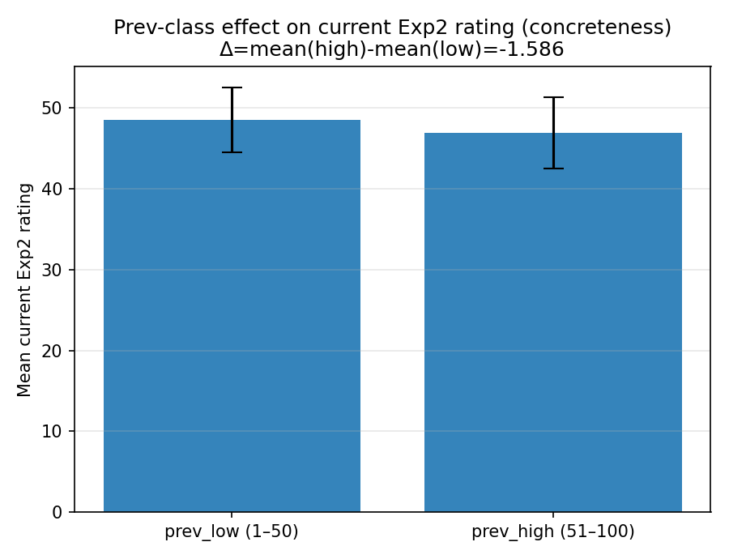 | model: gemini-2.0-flash  which: both  dimension: concreteness  temperature: 0.0  n_words: 400  delta (high-low): -1.585643  p_value (permutation): 0.611139  p_value (Welch t-test): 0.602044

20251217_213039_both_concreteness_n400
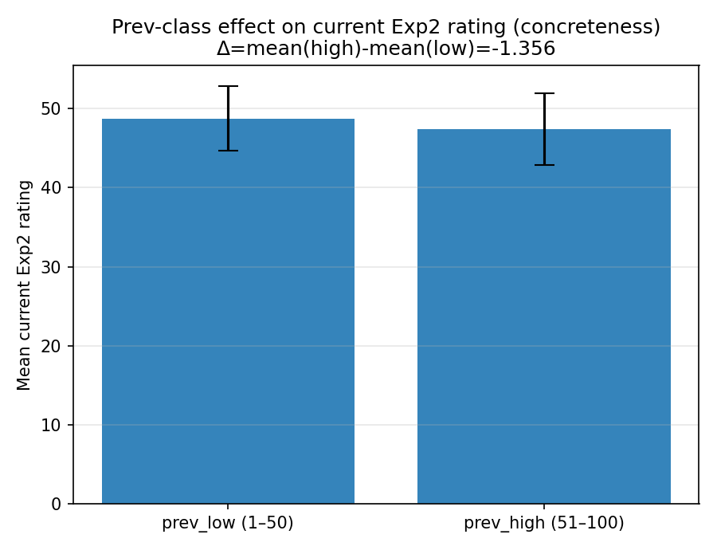 | model: gemini-2.0-flash  which: both  dimension: concreteness  temperature: 0.0  n_words: 400  delta (high-low): -1.356277  p_value (permutation): 0.672933  p_value (Welch t-test): 0.663074

20251218_170111_both_concreteness_n400
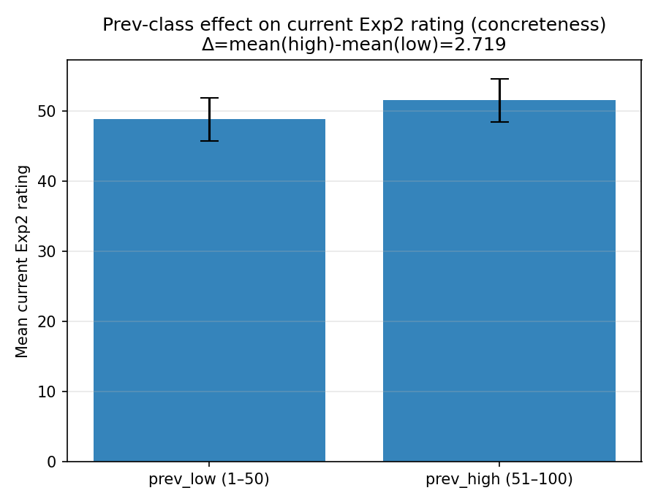 | model: claude-sonnet-4-5-20250929-cc  which: both  dimension: concreteness  temperature: 0.0  n_words: 400  delta (high-low): 2.719117  p_value (permutation): 0.226677  p_value (Welch t-test): 0.217427

20251218_170152_both_concreteness_n400
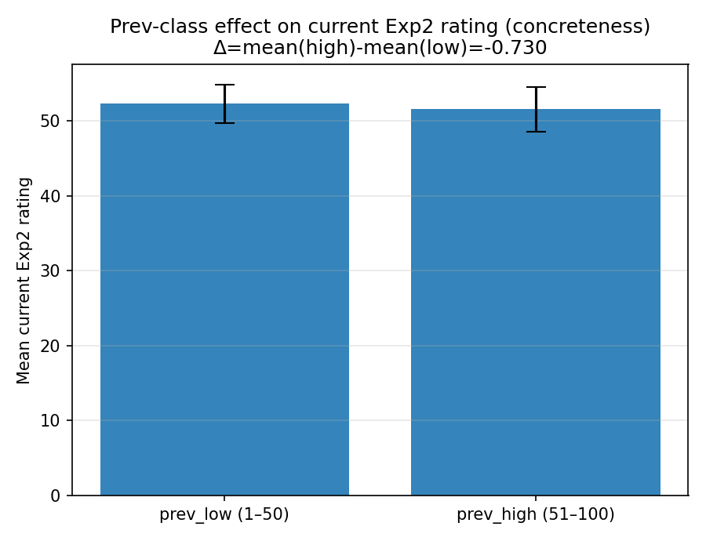 | model: qwen-max-latest  which: both  dimension: concreteness  temperature: 0.0  n_words: 400  delta (high-low): -0.730115  p_value (permutation): 0.724328  p_value (Welch t-test): 0.714851

20251218_193433_both_concreteness_n400
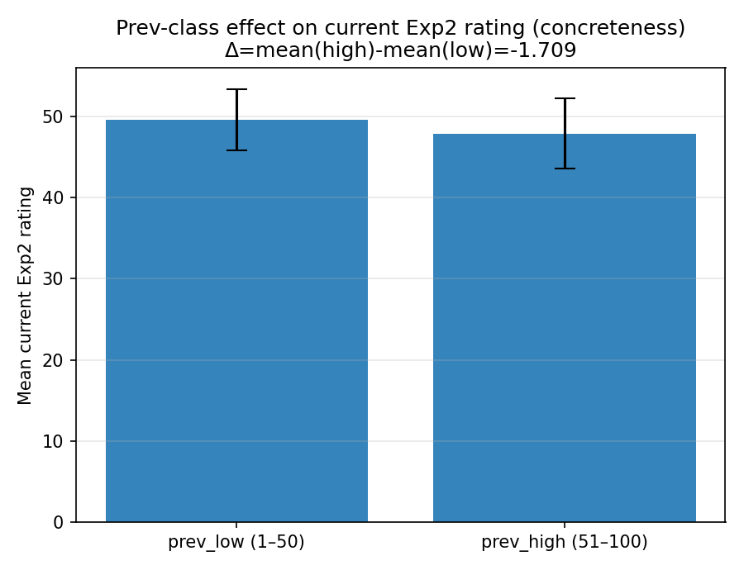 | model: gemini-2.5-flash  which: both  dimension: concreteness  temperature: 0.0  n_words: 400  delta (high-low): -1.708904  p_value (permutation): 0.556344  p_value (Welch t-test): 0.557143

20251221_131659_both_concreteness_n400
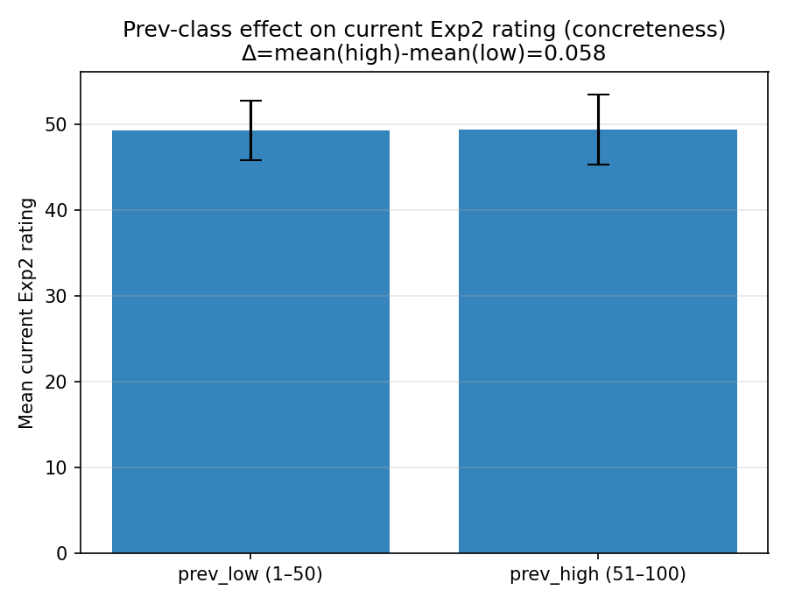 | model: gpt-4o-mini  which: both  dimension: concreteness  temperature: 0.0  n_words: 400  delta (high-low): 0.058480  p_value (permutation): 0.985501  p_value (Welch t-test): 0.982915

20251221_135907_both_concreteness_n400
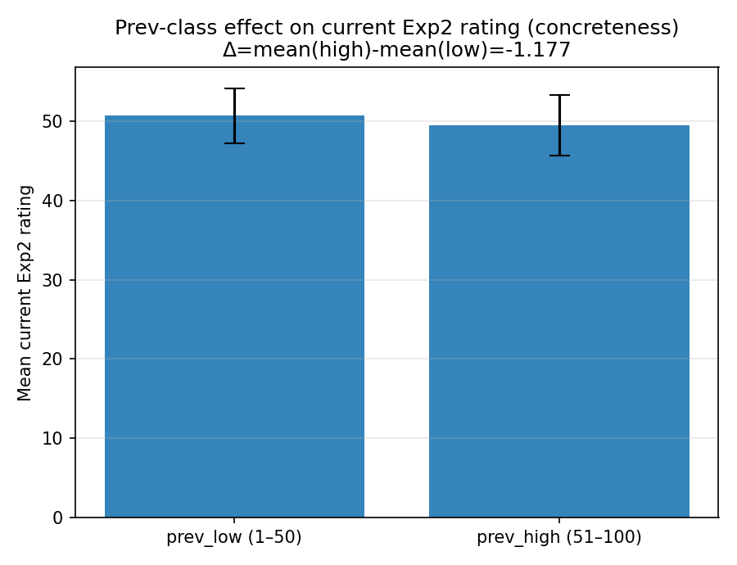 | model: gpt-4o-mini  which: both  dimension: concreteness  temperature: 0.0  n_words: 400  delta (high-low): -1.177170  p_value (permutation): 0.654835  p_value (Welch t-test): 0.65545

20251221_135911_both_arousal_n400
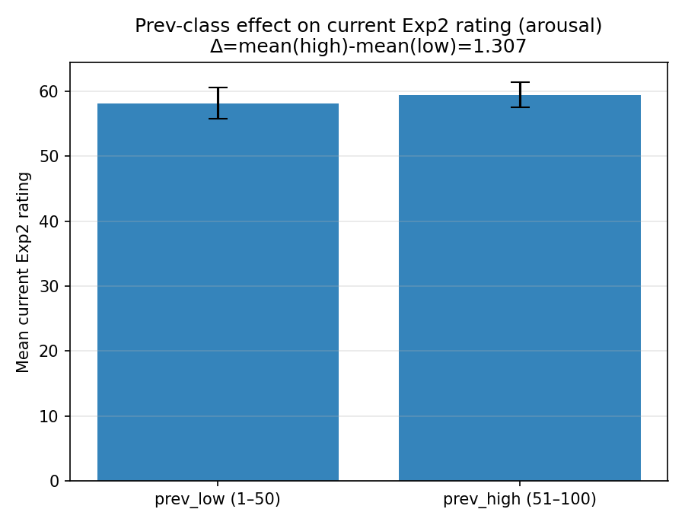 | model: gpt-4o-mini  which: both  dimension: arousal  temperature: 0.0  n_words: 400  delta (high-low): 1.307088  p_value (permutation): 0.40346  p_value (Welch t-test): 0.404837

20251221_144236_both_concreteness_n400
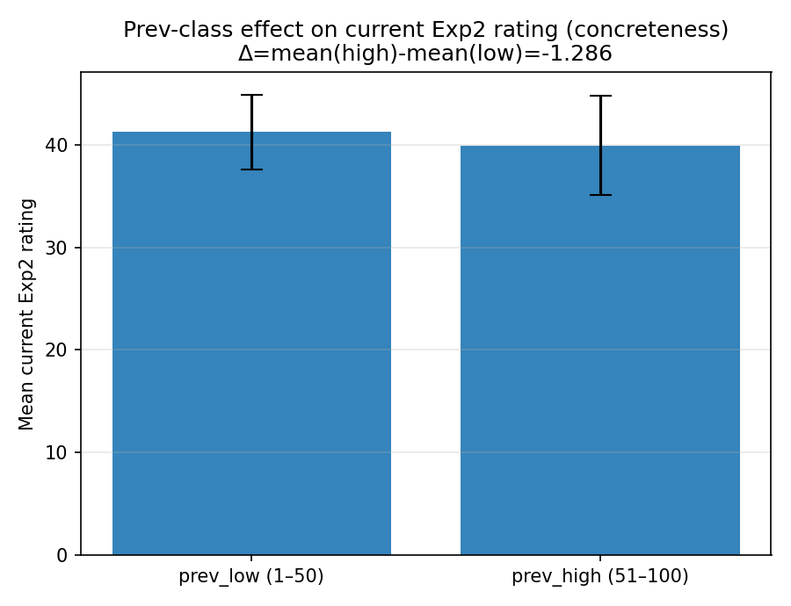 | model: gpt-4.1  which: both  dimension: concreteness  temperature: 0.0  n_words: 400  delta (high-low): -1.285931  p_value (permutation): 0.666133  p_value (Welch t-test): 0.677419

20251221_144304_both_arousal_n400
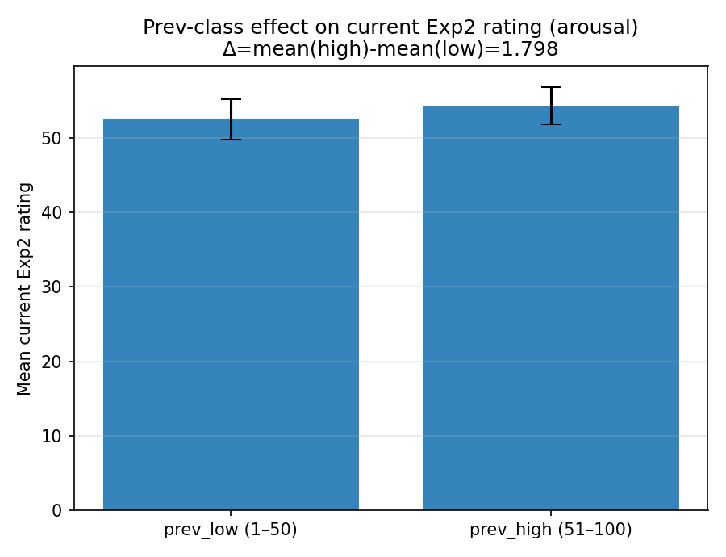 | model: gpt-4.1  which: both  dimension: arousal  temperature: 0.0  n_words: 400  delta (high-low): 1.798407  p_value (permutation): 0.335266  p_value (Welch t-test): 0.340421

20251221_172610_both_concreteness_n400
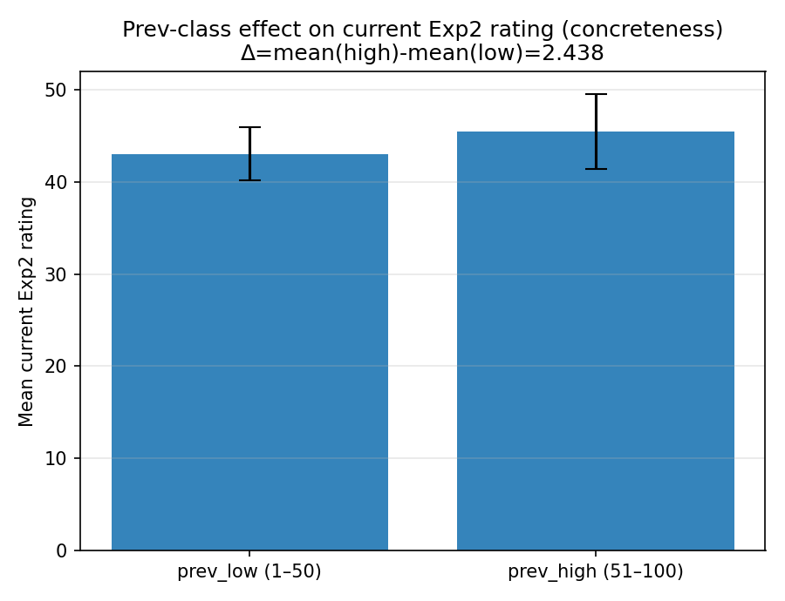 | model: gpt-4o  which: both  dimension: concreteness  temperature: 0.0  n_words: 400  delta (high-low): 2.437737  p_value (permutation): 0.328767  p_value (Welch t-test): 0.337804

20251224_103903_gpt-4o_exp2_concreteness_n1000
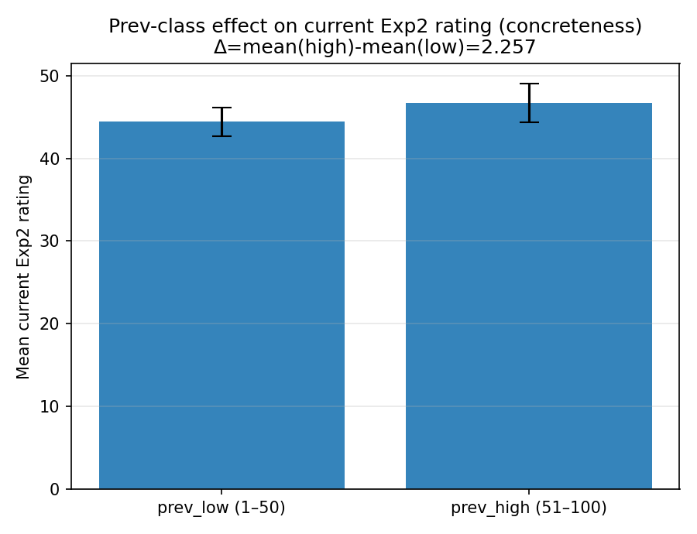 | model: gpt-4o  which: exp2  dimension: concreteness  temperature: 0.0  n_words: 1000  delta (high-low): 2.256910  p_value (permutation): 0.122888  p_value (Welch t-test): 0.12925

20260107_145719_gpt-4o_both_concreteness_n2000
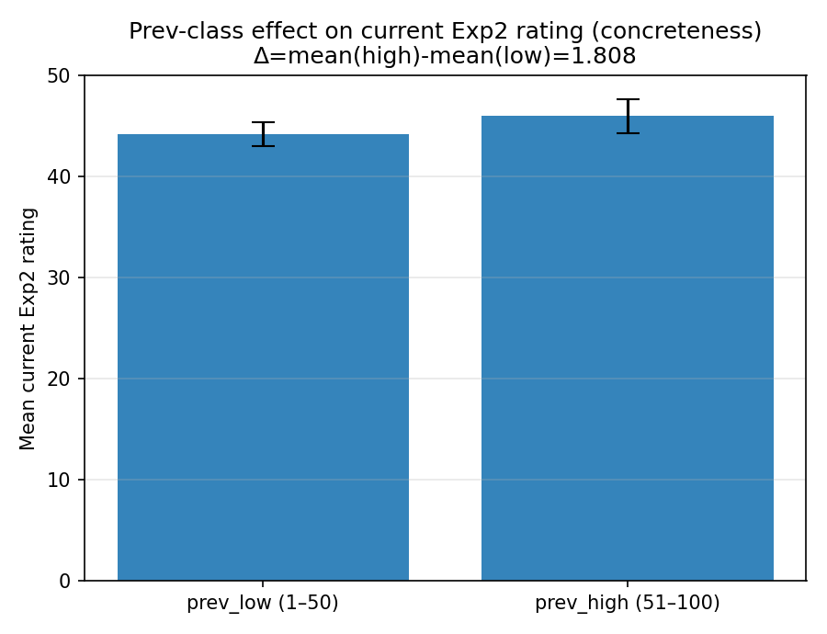 | model: gpt-4o  which: both  dimension: concreteness  temperature: 0.0  n_words: 2000  delta (high-low): 1.807629  p_value (permutation): 0.0769923  p_value (Welch t-test): 0.0816688

20260112_001408_gpt-4o_both_concreteness_n1000
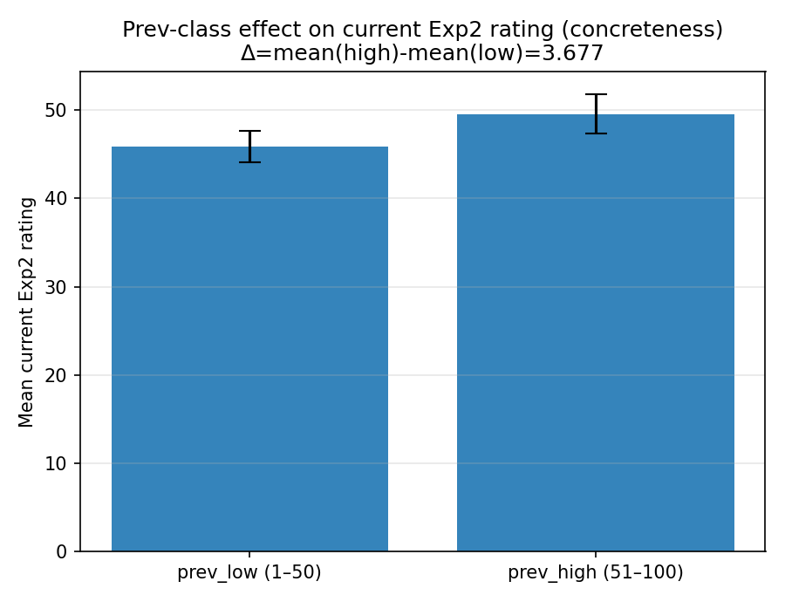 | model: gpt-4o  which: both  dimension: concreteness  temperature: 0.0  n_words: 1000  delta (high-low): 3.677403  p_value (permutation): 0.0120988  p_value (Welch t-test): 0.0121763

20260113_162650_gpt-4o_both_concreteness_n1000
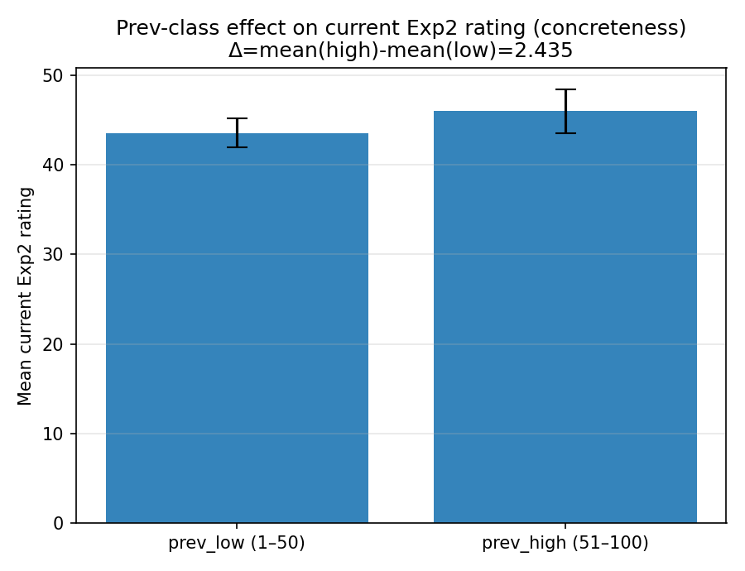 | model: gpt-4o  which: both  dimension: concreteness  temperature: 0.0  n_words: 1000  delta (high-low): 2.434938  p_value (permutation): 0.10299  p_value (Welch t-test): 0.103908

20260122_222005_gpt-4o_both_concreteness_n1000
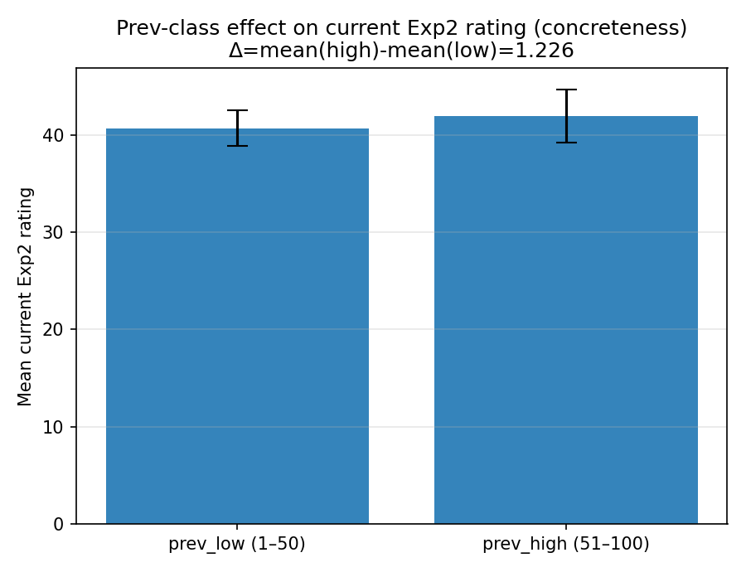 | model: gpt-4o  which: both  dimension: concreteness  temperature: 1.0  n_words: 1000  delta (high-low): 1.225556  p_value (permutation): 0.470153  p_value (Welch t-test): 0.469489

20260126_174821_gpt-4o_exp2_concreteness_n2000
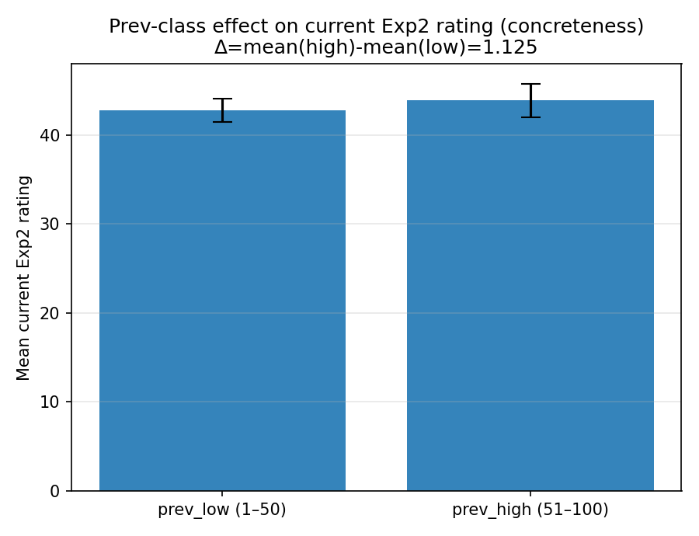 | model: gpt-4o  which: exp2  dimension: concreteness  temperature: 1.0  n_words: 2000  delta (high-low): 1.125498  p_value (permutation): 0.320068  p_value (Welch t-test): 0.333651

20260126_174922_gpt-4o_exp2_valence_n1000
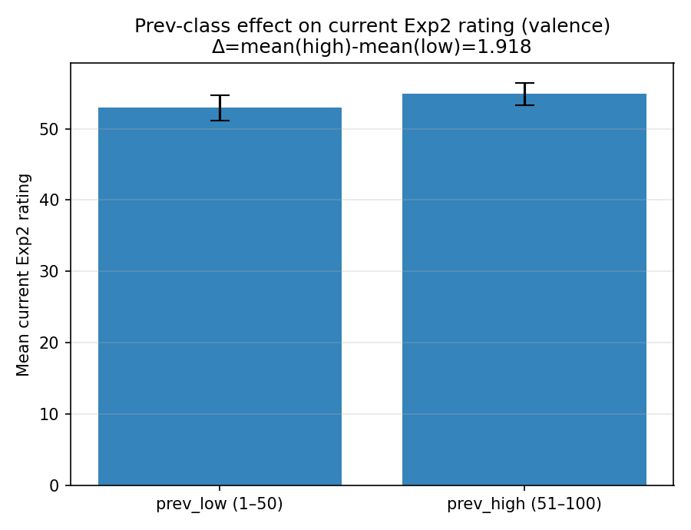 | model: gpt-4o  which: exp2  dimension: valence  temperature: 1.0  n_words: 1000  delta (high-low): 1.918124  p_value (permutation): 0.110089  p_value (Welch t-test): 0.109126

20260126_192052_gpt-4o_exp2_concreteness_n1000
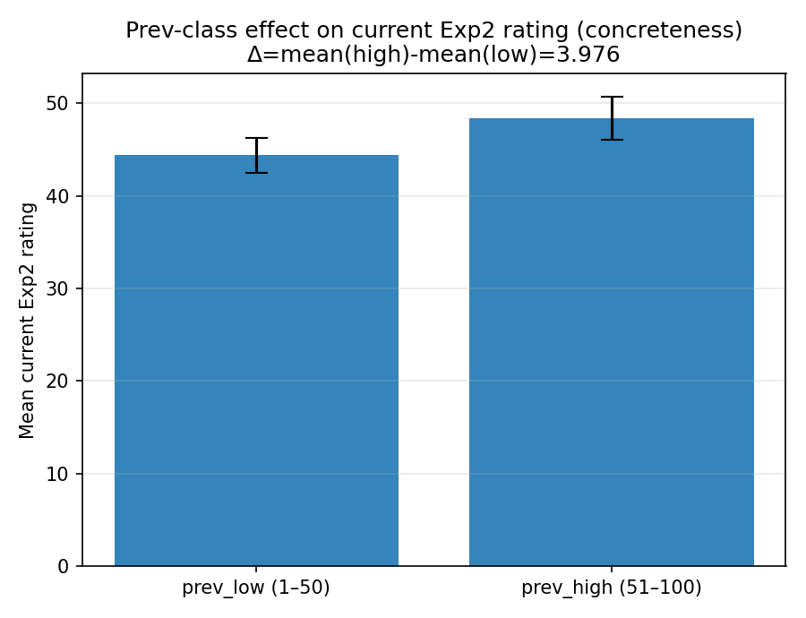 | model: gpt-4o  which: exp2  dimension: concreteness  temperature: 1.0  n_words: 1000  delta (high-low): 3.976442  p_value (permutation): 0.010499  p_value (Welch t-test): 0.00943539

20260127_225919_gpt-4o_exp2_concreteness_n1000
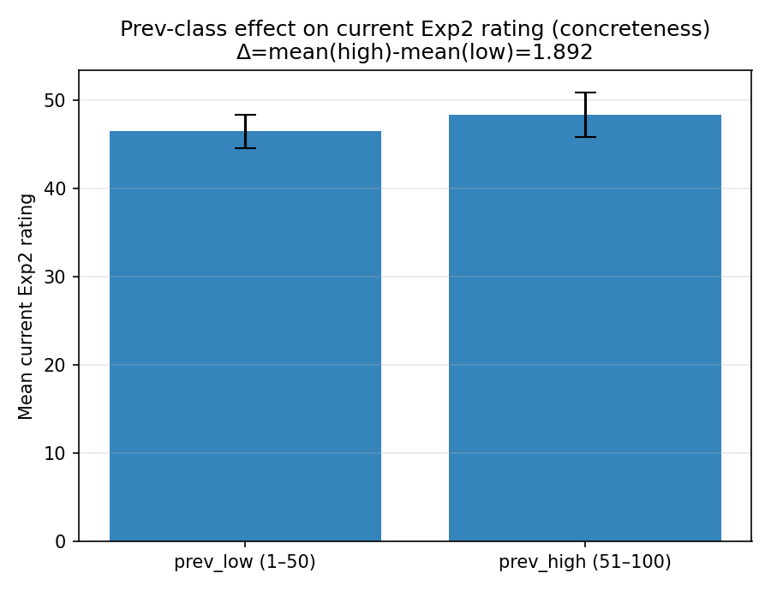 | model: gpt-4o  which: exp2  dimension: concreteness  temperature: 1.0  n_words: 1000  delta (high-low): 1.891554  p_value (permutation): 0.238676  p_value (Welch t-test): 0.239862

20260127_230016_gpt-4o_exp2_valence_n1000
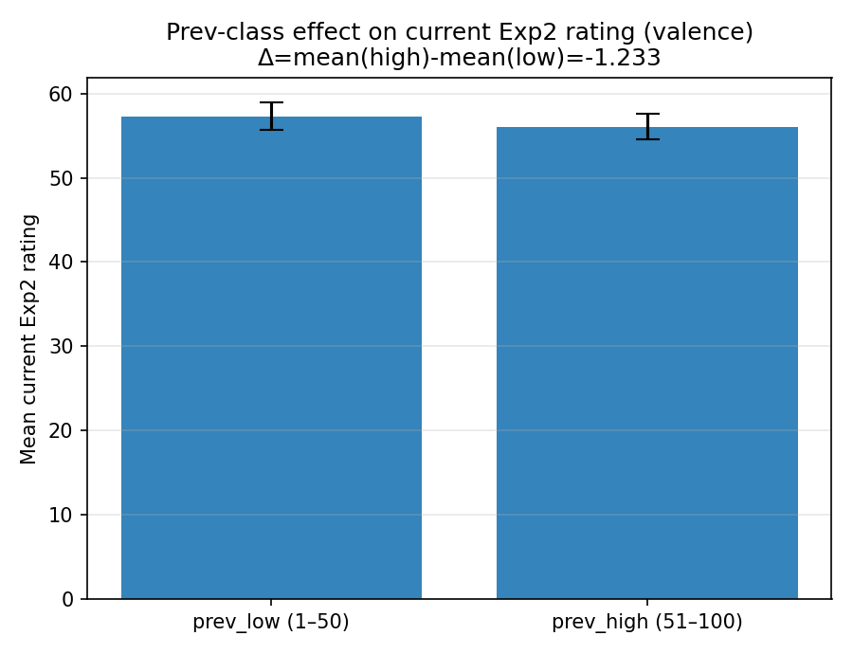 | model: gpt-4o  which: exp2  dimension: valence  temperature: 1.0  n_words: 1000  delta (high-low): -1.233108  p_value (permutation): 0.289871  p_value (Welch t-test): 0.281303

20260128_002209_gpt-4o_exp2_valence_n1000
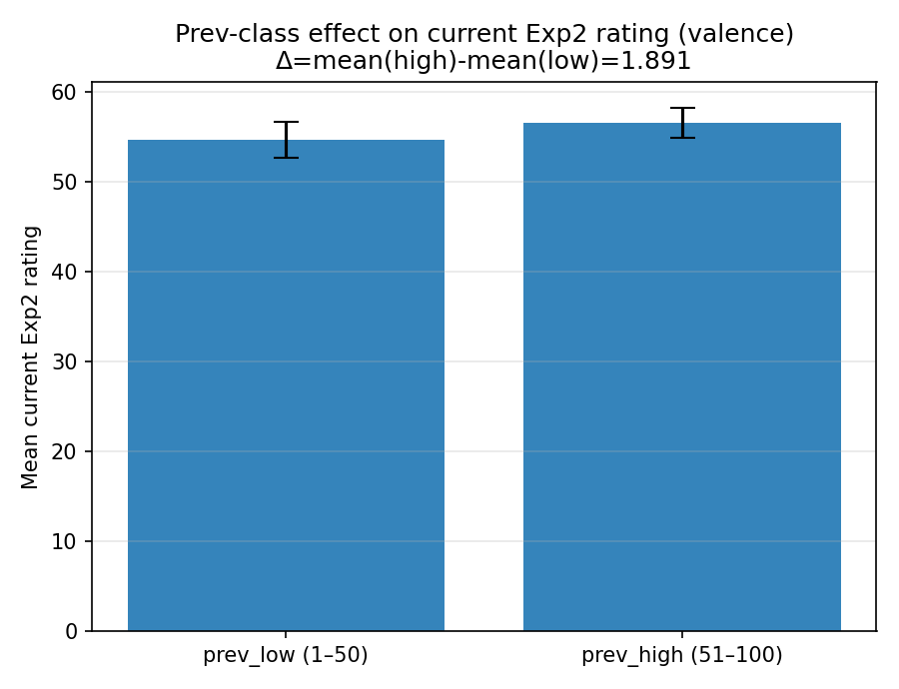 | model: gpt-4o  which: exp2  dimension: valence  temperature: 1.0  n_words: 1000  delta (high-low): 1.891061  p_value (permutation): 0.154185  p_value (Welch t-test): 0.150707

20260128_002228_gpt-4o_exp2_valence_n1000
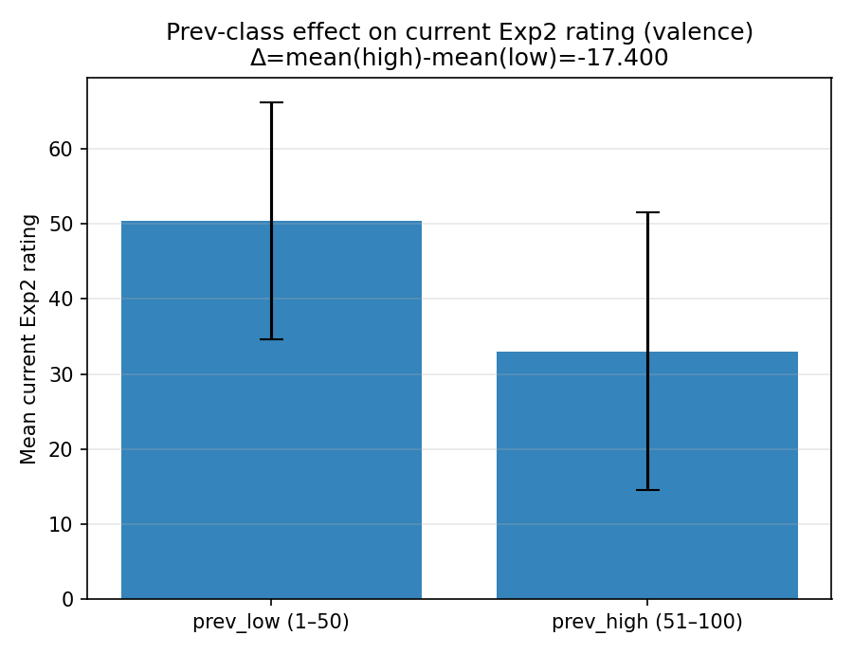 | model: gpt-4o  which: exp2  dimension: valence  temperature: 1.0  n_words: 1000  delta (high-low): -17.400000  p_value (permutation): 0.193781  p_value (Welch t-test): 0.199968

20260128_002256_gpt-4o_exp2_concreteness_n1000
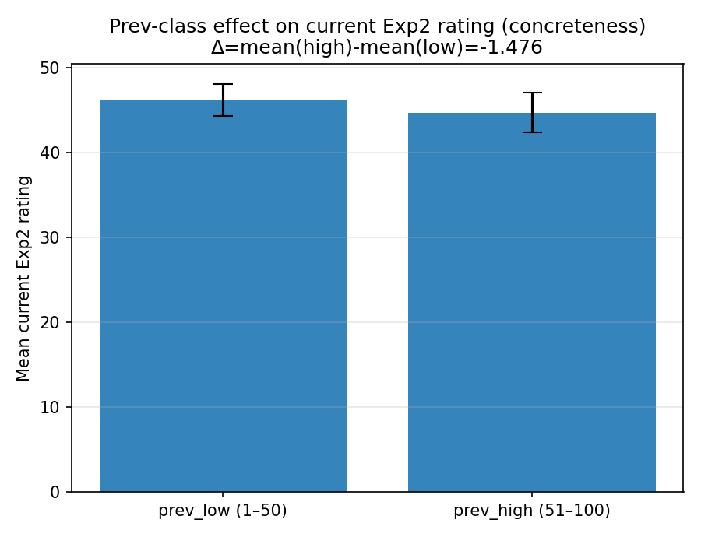 | model: gpt-4o  which: exp2  dimension: concreteness  temperature: 1.0  n_words: 1000  delta (high-low): -1.476453  p_value (permutation): 0.334267  p_value (Welch t-test): 0.332353

20260129_145137_gpt-4o_both_valence_n1000
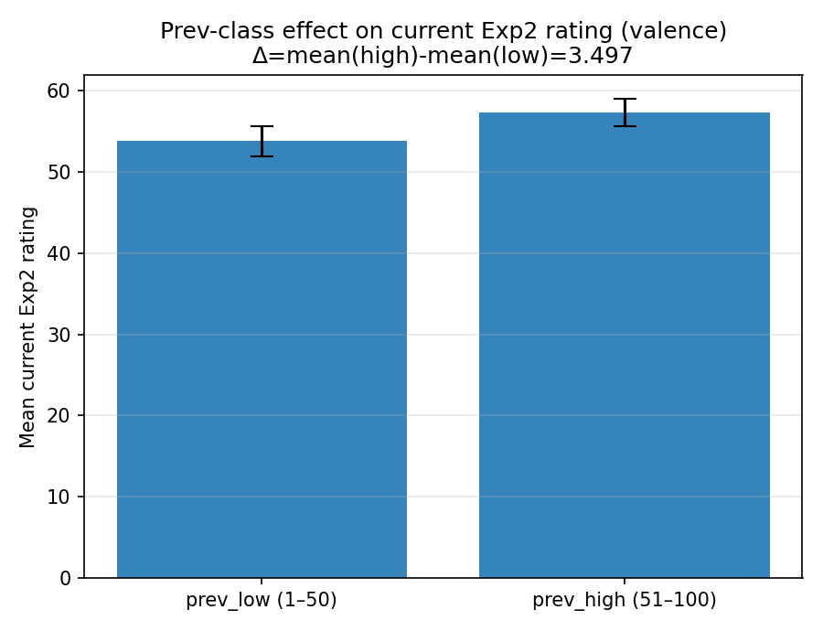 | model: gpt-4o  which: both  dimension: valence  temperature: 1.0  n_words: 1000  delta (high-low): 3.496617  p_value (permutation): 0.00639936  p_value (Welch t-test): 0.00645537

20260202_004249_gpt-4o_exp2_valence_n1000
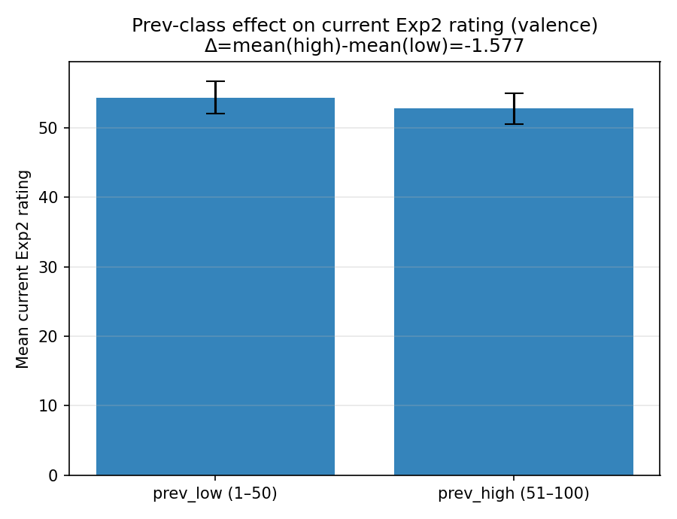 | model: gpt-4o  which: exp2  dimension: valence  temperature: 1.0  n_words: 1000  delta (high-low): -1.576923  p_value (permutation): 0.341966  p_value (Welch t-test): 0.338153

20260202_005410_gpt-4o_exp2_valence_n1000
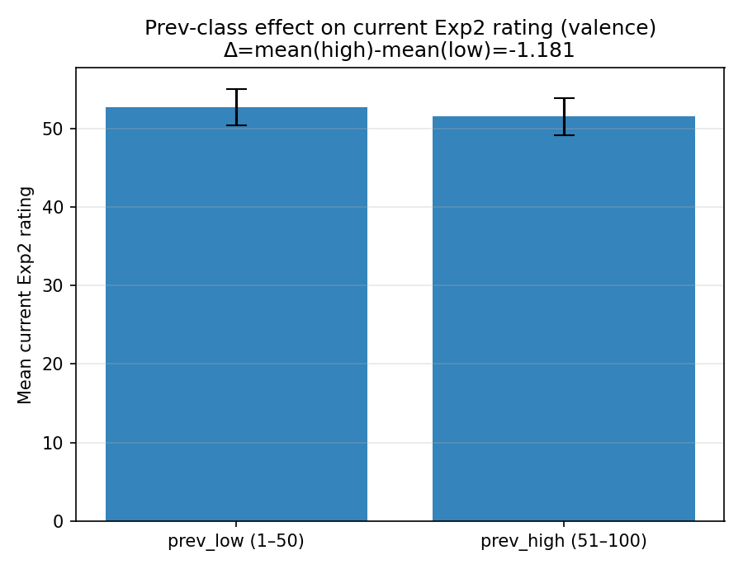 | model: gpt-4o  which: exp2  dimension: valence  temperature: 1.0  n_words: 1000  delta (high-low): -1.180606  p_value (permutation): 0.484552  p_value (Welch t-test): 0.486888

20260202_114143_gpt-4o_exp2_valence_n1000
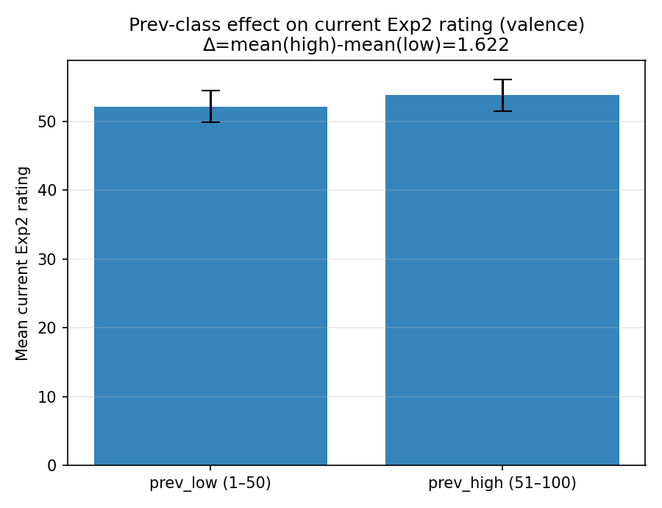 | model: gpt-4o  which: exp2  dimension: valence  temperature: 1.0  n_words: 1000  delta (high-low): 1.621607  p_value (permutation): 0.336766  p_value (Welch t-test): 0.333136

20260202_121450_gpt-4o_exp2_valence_n1000
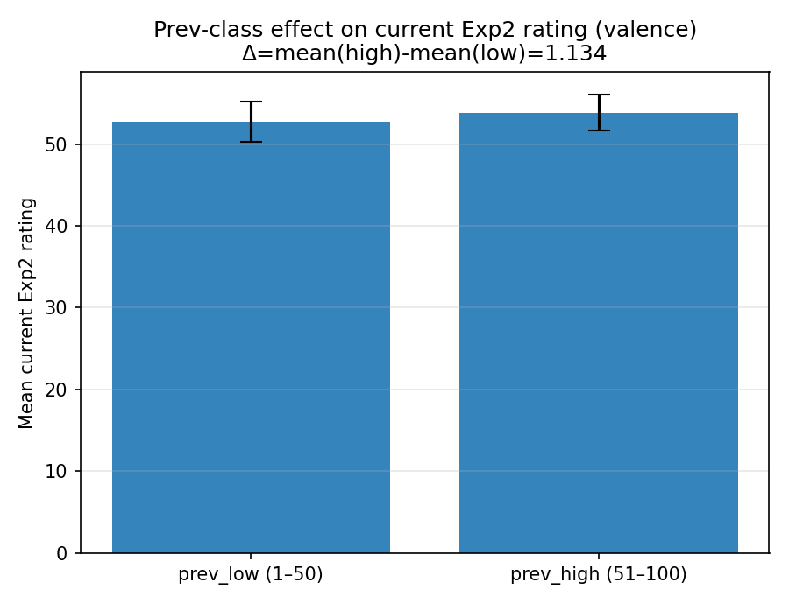 | model: gpt-4o  which: exp2  dimension: valence  temperature: 1.0  n_words: 1000  delta (high-low): 1.134287  p_value (permutation): 0.505349  p_value (Welch t-test): 0.497401

20260202_124834_gpt-4o_exp2_valence_n1000
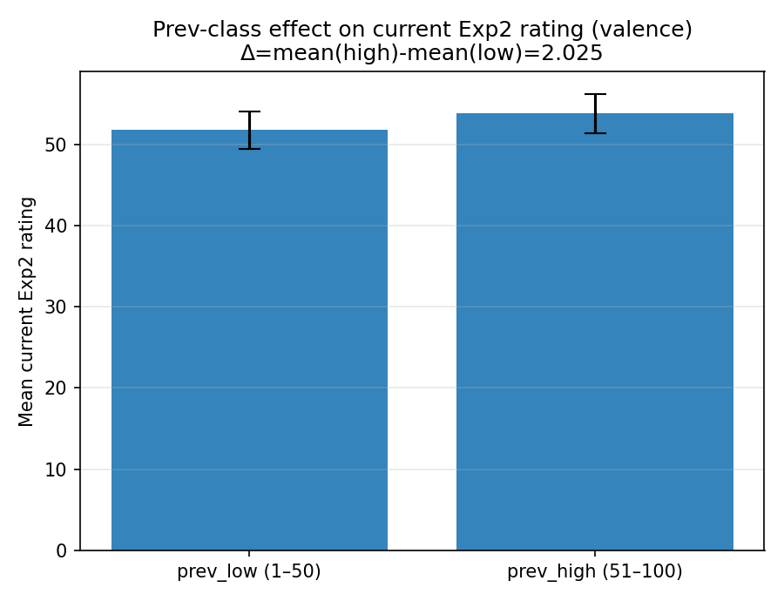 | model: gpt-4o  which: exp2  dimension: valence  temperature: 1.0  n_words: 1000  delta (high-low): 2.024550  p_value (permutation): 0.232677  p_value (Welch t-test): 0.236362

Mixed-dimension runs

20251220_221630_both_mixed_concreteness_arousal_n400
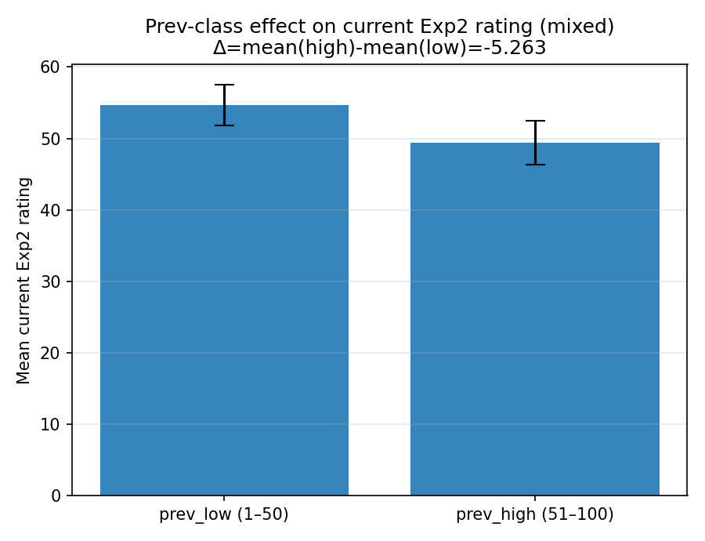 | model: gpt-4o-mini  which: both  dimension: mixed  temperature: 0.0  mixed dims: concreteness / arousal  n_words: 400  delta (high-low): -5.262759  p_value (permutation): 0.0130987  p_value (Welch t-test): 0.0146813

20251221_131633_both_mixed_concreteness_valence_n400
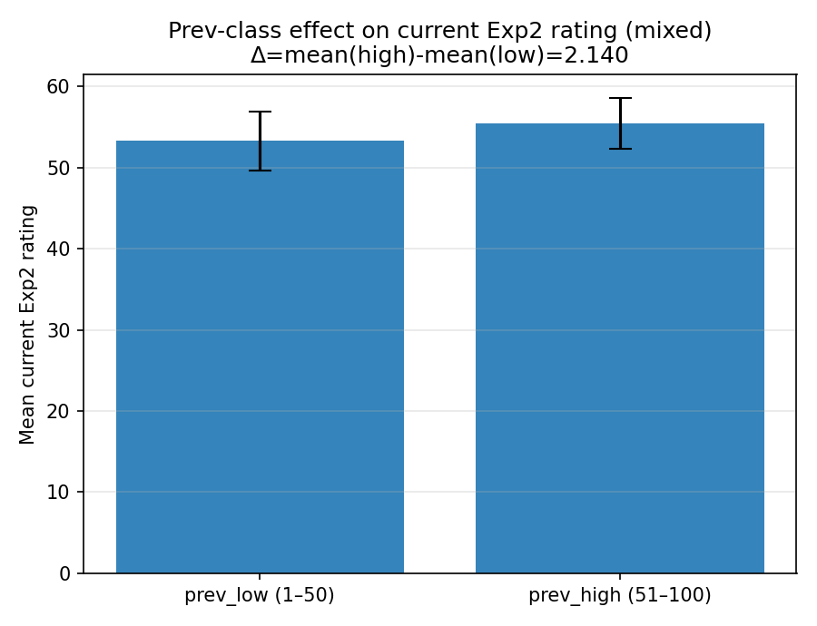 | model: gpt-4o-mini  which: both  dimension: mixed  temperature: 0.0  mixed dims: concreteness / valence  n_words: 400  delta (high-low): 2.140021  p_value (permutation): 0.387961  p_value (Welch t-test): 0.381284

20251221_143308_both_mixed_concreteness_arousal_n400
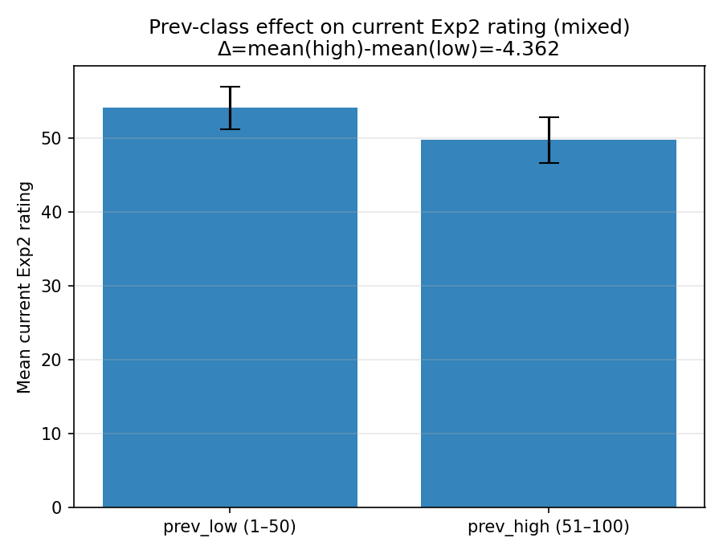 | model: gpt-4o-mini  which: both  dimension: mixed  temperature: 0.0  mixed dims: concreteness / arousal  n_words: 400  delta (high-low): -4.362098  p_value (permutation): 0.0391961  p_value (Welch t-test): 0.0422425

20251221_171515_both_mixed_concreteness_arousal_n400
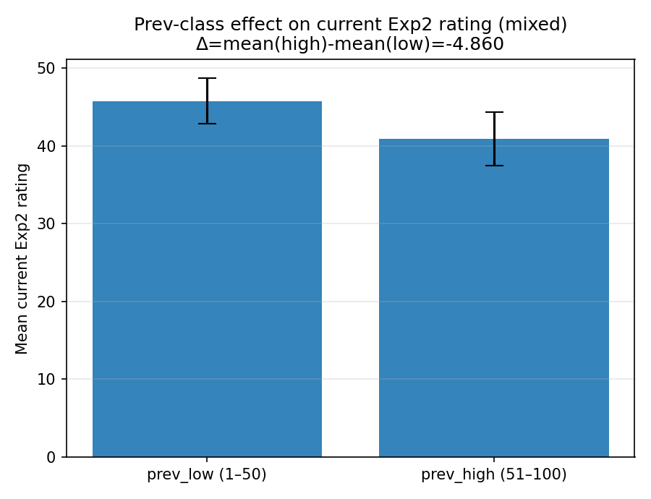 | model: gpt-4.1  which: both  dimension: mixed  temperature: 0.0  mixed dims: concreteness / arousal  n_words: 400  delta (high-low): -4.859993  p_value (permutation): 0.0375962  p_value (Welch t-test): 0.036422

20251221_172638_both_mixed_concreteness_arousal_n400
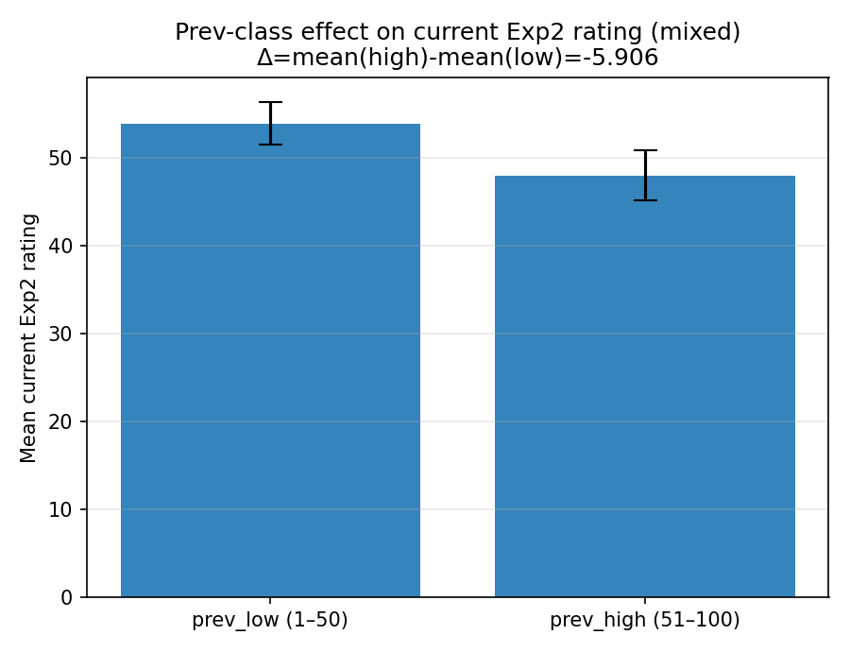 | model: gpt-4o  which: both  dimension: mixed  temperature: 0.0  mixed dims: concreteness / arousal  n_words: 400  delta (high-low): -5.905532  p_value (permutation): 0.00209979  p_value (Welch t-test): 0.0023292

