Structured DB retrieval Evaluation

Structured DB retrieval Evaluation 1
QA Dataset generation Methodology 3
Answer Quality Evaluation Methodology 4
Experimental Data 5
Response Evaluation 7
Benchmarking 11
Statistical Analysis 19
Summary 20
TURSIO PERFORMANCE ANALYSIS 20
PERPLEXITY PERFORMANCE ANALYSIS 21
CHAT-GPT PERFORMANCE ANALYSIS 22
COMPARATIVE INSIGHTS & STRATEGIC IMPLICATIONS 22
Future Direction 22
Evaluation Methodology Improvements 23
Advanced Question Generation 23
Coverage & Robustness 23
Appendix 23

Tursio’s Answer Relevancy Score: (100% is better): Tursio’s responses to simple questions are 97% relevant, responses to medium-difficulty questions are 90% relevant, and responses to hard questions are 89.5% relevant. Across all difficulty levels, these responses consistently maintain safety standards. When benchmarking Tursio’s performance against Perplexity and GPT-4o, no significant differences were observed.

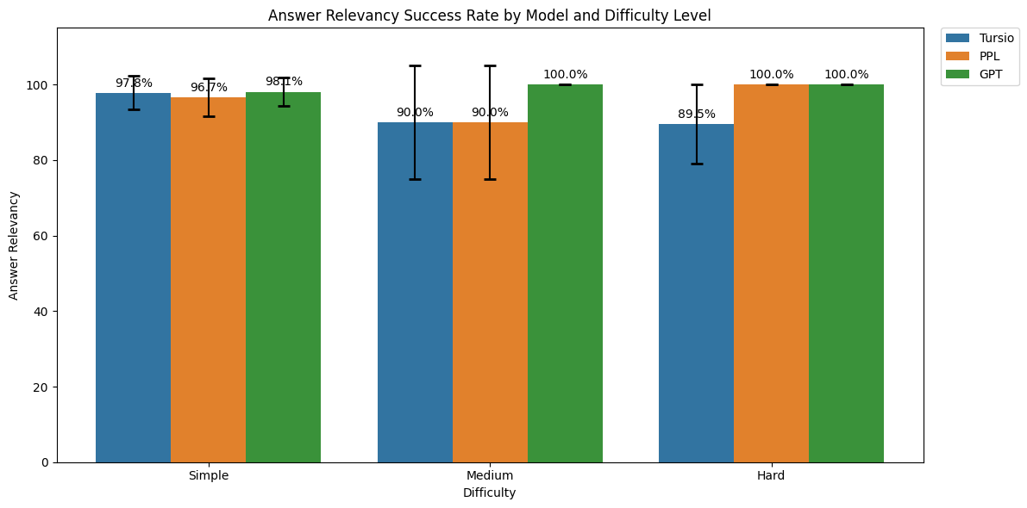

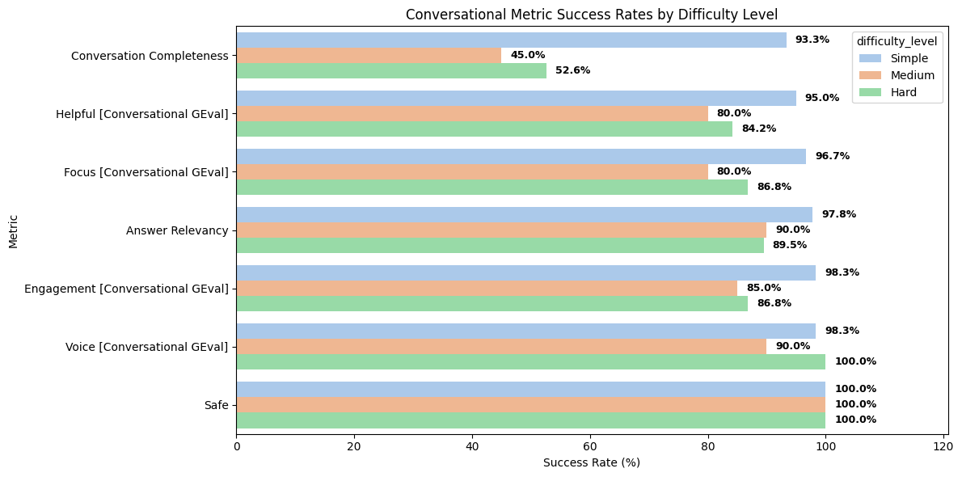
Figure 1(a) Top: Answer relevancy across all search apps with confidence bounds, (b)Bottom: Tursio’s evaluation for all difficulty levels across all KPIs.

Background: Most current benchmarks for evaluating search accuracy, such as those used by exa.ai and travilo, rely on web search datasets like SimpleQA and BIRD. These benchmarks typically require creating a separate table for each data row, which is not scalable or practical for structured database evaluation. As a result, they are poorly suited for assessing real-world structured database search tasks.

Proposal: To address the limitations of current benchmarks, it is essential to develop evaluation methods specifically tailored for structured databases. This involves using realistic datasets and scalable approaches that reflect actual database operations, such as joins, aggregations, and multi-table queries. Rather than creating a separate table for each row, comprehensive datasets should be employed to mirror real-world database structures, ensuring that the benchmarks are both practical and generalizable for structured DB evaluation.

QA Dataset generation Methodology
In the banking domain, a single-turn QA dataset was created by extrapolating 15 “golden” questions to ~ 150 synthetic examples. The process involved:

1. Persona Establishment & KPI Mapping
- Key banking personas and their analytical domains were identified.
- Each persona combines two or more roles to introduce variability in analysis patterns (e.g., ‘Risk & Credit Analytics Manager; CRO; Compliance Officer’).
- For each persona, relevant KPIs were defined based on typical role focus (e.g., the above persona is mapped to KPIs such as ‘90+ DPD Rate’, ‘Delinquency Ratio’, and ‘Non-Performing Loan %’).

2. Question Difficulty Definitions: Questions were classified as Simple, Medium, or Hard:
- Simple: Single-table operations.
- Medium: Involving joins or basic segmentation.
- Hard: Advanced, multi-hop analysis across multiple tables.

3. Golden Question Set Segmentation
- The 15 golden questions were segmented by difficulty as defined above
- Each question was mapped to a relevant banking role (e.g., Banking Analyst, Financial Analyst) and associated KPIs as defined above

4. Synthetic Question Generation
- Natural language questions were systematically generated using large language models (LLMs) to ensure coverage across diverse personas (analyst, manager, etc.) and difficulty levels.
- Experimentation schema relations were provided as context.
- Golden questions were used as few-shot examples, mapped to personas and KPIs.

5. Questions for Benchmarking – Since the experimental scheme and data are not open source, generic open-source questions were used for benchmarking purposes. To ensure relevance and coverage, the previously defined questions were mapped to open web search datasets using Claude Chat with the Sonnet 4.5 base model and a robust prompt instruction. This approach allows for robust benchmarking by leveraging publicly available data and advanced language model capabilities, ensuring that the evaluation remains practical and generalizable even without proprietary datasets.

6. Question Quality Assurance
- An LLM with strong instruction-following and conversational abilities (e.g., GPT-4) was utilized.
- In addition, a suite of deterministic NLP quality assurance checks was applied, including: detection of duplicate questions, identification of semantically similar queries, enforcement of length thresholds, assessment of lexical diversity, and monitoring of stop word usage. These measures collectively support the creation of a robust, high-quality question set and reliable evaluation outcomes.

This systematic approach (Figure 0a) enabled the curation of synthetic, high-quality questions with varied personas and KPIs, supporting robust evaluation across different difficulty levels.

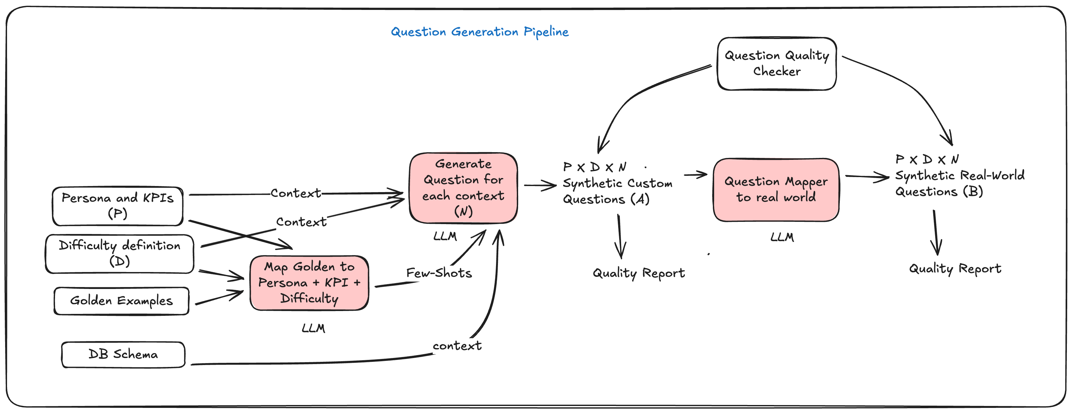
Figure 0a: Question Generation Pipeline

Answer Quality Evaluation Methodology

Answer Generation
For the questions generated in the previous section, answers were produced using the Tursio App. To benchmark performance with web search data, responses were also generated using the Perplexity App and Chat-GPT App (as of 12/25). This multi-model approach enables a comprehensive comparison of answer quality across different platforms, ensuring that the evaluation is robust and reflects a variety of language model capabilities. Standardized prompt template which lays the context for response generation and length (3-5 sentences) was utilized.

Open Source Evaluation with DeepEval
DeepEval is an industry-standard open-source framework for unit testing large language models (LLMs). It provides automated metrics for measuring response quality, leveraging the G-Eval framework. It also provides flexibility to add custom metrics and their evaluation criteria. Under the hood there is LLMJ running on Open-AI foundational model (i.e. GPT 4.1). It also provides metrics logging and traceability with its front-end UI. Key metrics include:

- Answer Relevancy: Automatically assesses how relevant the answer is to the question and its context (i.e. Persona and KPI). Recommended to be Primary metric for evaluation.
- Bias: Evaluates potential bias in responses. [Note: reported as “Safe” in this report for better interpretability i.e. Safe Score = 1- Bias Score]
- Conversation-Level Metrics: Evaluates all turns Question + Answer with context to access overall quality. Following metrics are used:
  - Conversation Completeness: Considers the entire user-agent interaction. This is out of the box metric in the DeepEval framework.
  - This research added following custom criteria for holistic evaluation:
    - Focus: Does the response directly address the specific question or task?
    - Engagement: Is the language appropriate and engaging?
    - Helpfulness: Does the response meaningfully assist the user?
    - Voice: Is the response clear and uses active voice?

For each metric, the evaluation framework returns a score between 0 and 1, where 1 represents the best performance. A default threshold is applied to these scores to define success criteria. For example, an answer is considered relevant if its “Answer Relevancy” score is ≥ 0.5. These thresholds are tunable parameters. Many practical guides and sample repositories suggest starting with thresholds in the 0.5–0.7 range (e.g., threshold=0.5 in documentation) before calibration. DeepEval’s documentation recommends deriving thresholds from score distributions on a labeled dataset such as using the 75th percentile so that only the top-performing answers pass (https://deepeval.com/guides/guides-answer-correctness-metric). For this iteration, we have retained the default setting to benchmark other models and establish a baseline for Tursio’s performance. In future iterations, we plan to fine-tune this threshold to narrower bounds for a more conservative evaluation.

Success is calculated as follows:

Answer Relevancy = N (Score >=0.5)/ Sample size

Custom LLMJ Prompts: While custom prompts can be used for tailored evaluation, DeepEval offers a robust alternative for assessing LLM responses.

Alignment with Human Scoring: To ensure high-quality evaluation, models fine-tuned for human preference alignment (e.g., reward models from RewardBench) will be integrated into large-scale response quality assessments for the LLMJ model. These models will serve as a proxy for human annotation, enabling automated evaluation and the calculation of correlation scores with human judgments. [Details TBD]

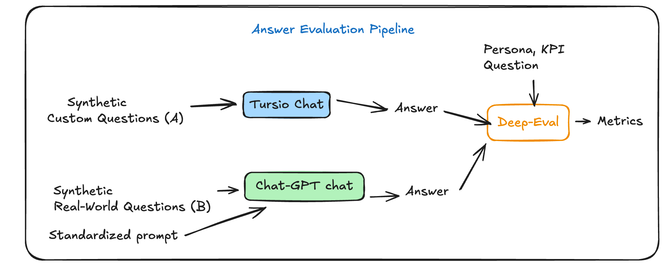
Figure 0b: Answer Evaluation Pipeline with DeepEval

Experimental Data

Following are the data settings used for the question generation experiments:

Persona = ['Risk & Credit Analytics Manager; CRO; Compliance Officer',
'Finance / Treasury Manager; Branch / Regional Manager',
'Product Manager; Member Analytics Lead',
'Finance Manager; CRO; Product Manager',
'Member Analytics Lead; Compliance Officer',
'Member Analytics Lead; Executive Leadership',
'Member Analytics Lead; Product Manager',
'Product Manager; Risk Manager',
'Member Analytics Lead; CRO',
'Executive Leadership; CRO, CEO; COO; Board; CRO',
'Risk Manager; Finance Manager',
'Fraud Analyst; Risk Manager',
'Fraud Analyst; Card Product Manager']

KPI definition = ['90+ DPD Rate; Delinquency Ratio; Non-Performing Loan %',
'Total Deposit Balance by Geography; Concentration Risk',
'Early Closure Rate; Account Churn (≤90 days)',
'Portfolio Mix %; Credit Card Exposure by Balance',
'Dormant Account Rate; Inactivity Ratio',
'Average Account Tenure; Member Lifetime Value (proxy)',
'Active Account Tenure; Retention Duration',
'Monthly Closure Rate; Product Attrition Rate',
'Long-Tenure Account %; Dormant vs Active Ratio',
'Product Mix %; Portfolio Allocation',
'Composite Health Score (Capital, Asset Quality, Earnings, Liquidity, Growth)',
'High-Balance Exposure; Concentration Risk',
'Transfer Limit Exposure; Operational Risk Indicator',
'ATM Utilization Rate; Limit Utilization Anomaly']

Difficulty definition = {
"simple":
"- Single metric or straightforward count, percentage, or ranking\n"
"- Minimal filtering and no segmentation\n"
"- No time-series analysis or trend comparison\n"
"- Answerable with one aggregation or query",

"medium":
"- Involves filtering, grouping, or basic segmentation\n"
"- May include a single time window or comparison\n"
"- Requires joins across a small number of datasets\n"
"- Produces ratios, breakdowns, or ranked results but not deep causal analysis",

"hard":
"- Require multi-step analysis, segmentation, or time-based trends\n"
"- Focus on early-warning signals, concentration risk, behavioral risk, or product-level risk\n"
"- Go beyond simple counts or percentages\n"
"- Be suitable for executive risk reviews or regulatory discussions"
}

DB Schema Details:

TABLE_JOINS = """
Fact Table, Foreign Key, Join Type, Join Table, Primary Key,Status
PUBLIC.COMMENT, ACCOUNT_NUMBER, LEFT, PUBLIC.ACCOUNT, ACCOUNT_NUMBER, Accept
PUBLIC.TRACKING, ACCOUNT_NUMBER, LEFT, PUBLIC.ACCOUNT, ACCOUNT_NUMBER, Accept
PUBLIC.NOTE, ACCOUNT_NUMBER, LEFT, PUBLIC.ACCOUNT, ACCOUNT_NUMBER, Accept
PUBLIC.SHARE, ACCOUNT_NUMBER, LEFT, PUBLIC.ACCOUNT, ACCOUNT_NUMBER, Accept
PUBLIC.LOOKUP, ACCOUNT_NUMBER, LEFT, PUBLIC.ACCOUNT, ACCOUNT_NUMBER, Accept
PUBLIC.LOAN, ACCOUNT_NUMBER, LEFT, PUBLIC.ACCOUNT, ACCOUNT_NUMBER, Accept
PUBLIC.CARD, ACCOUNT_NUMBER, LEFT, PUBLIC.ACCOUNT, ACCOUNT_NUMBER, Accept
PUBLIC.MEMBER, ACCOUNT_NUMBER, LEFT, PUBLIC.ACCOUNT, ACCOUNT_NUMBER, Accept
"""

Few-shots = Randomly sampled from the golden 15 set for corresponding Persona and difficulty level.

For initial experiments, the Gpt-40-mini model was used with default hyperparameters to enable faster inference. However, for more robust and reliable results, it is recommended to use models with stronger instruction-following capabilities, such as o4 or Claude Sonnet 4.5. Using these approaches, approximately 150 synthetic questions were generated for evaluation.

Response Evaluation

Tursio’s Insights

- Analysis for Simple (60 Samples): Answer Relevancy score is 0 for QA pair as response is not relevant to accounts which have made any comments. This aligns with the expected outcome of QA pair evaluation:
---
Q: What percentage of accounts have made a comment in the last year?
A: Key Insight:
All active accounts included in the sample have an associated loan record—i.e., 100% of the active accounts in the dataset have a loan.
Metric Score: 0.0
Feedback: The score is 0.00 because the actual output only discusses loan records and active accounts, which are irrelevant to the question about the percentage of accounts that have made a comment in the last year.
-----
- Answer relevancy for Medium (20 samples) – Two responses failed the evaluation test because they did not address the question context. According to the evaluation criteria, these responses were deemed irrelevant, which aligns with the expected outcome for this assessment.
```
Q: Which geographical region has the highest concentration of accounts with balances over $10,000?
A: Great question but unfortunately no data points were found to generate an answer for you. Consider adjusting your query to change one or more parameters, such as time or other filters.

Metric Score: 0.0
Feedback: The score is 0.00 because none of the statements in the output addressed the question about which geographical region has the highest concentration of accounts with balances over $10,000; instead, the output only discussed data availability and suggestions unrelated to the actual question.
-----
Q: What is the distribution of credit card balances across different age groups of members?
A: Key Insights:

The dataset shows significant variability in credit card limits across the member groups (interpreted as age groups). On a per-group basis, the average credit card limit ranges from as low as $2,109.39 (Group 40) to as high as approximately $7,294.05 (Group 66), reflecting a broad distribution in available credit.
The number of cards per group also varies, with counts ranging from 2 cards (e.g., Group 66) up to 19 cards (e.g., Groups 7 and 34), and the total credit limits per group correspondingly range from under $10,000 to over $104,000.
Metric Score: 0.0
Feedback: The score is 0.00 because the output only discussed credit card limits and the number of cards, not the distribution of credit card balances as requested. None of the statements addressed the actual question, which is why the score cannot be higher.
----------```
- Analysis for Hard (40 samples): following QA pairs have low response relevance. This is partly impacted by lack of data in the DB.
Q: What behavioral traits or transaction patterns can predict early warning signals for accounts that transition from 30 DPD to 90 DPD, based on historical data?
A: Great question but unfortunately no data points were found to generate an answer for you. Consider adjusting your query to change one or more parameters, such as time or other filters.
Metric Score: 0.0
Feedback: The score is 0.00 because the output did not address the question about behavioral traits or transaction patterns predicting DPD transitions, and instead focused on data availability and query modifications, which are irrelevant to the input.
-----
Q: How do the recent credit utilization ratios of non-performing loan accounts compare to those that have remained performing, particularly in the last six months?
A: Great question but unfortunately no data points were found to generate an answer for you. Consider adjusting your query to change one or more parameters, such as time or other filters.
Metric Score: 0.3333333333333333
Feedback: The score is 0.33 because the answer mostly gave general suggestions about modifying queries rather than directly comparing the credit utilization ratios of non-performing and performing loan accounts as asked. The response did not provide the specific comparison requested, which limits its relevance.
-----
Q: Evaluate the effect of promotional loan offers on the delinquency rates of those specific products; what is the post-promotion delinquency trend for those who took advantage?
A: Great question but unfortunately no data points were found to generate an answer for you. Consider adjusting your query to change one or more parameters, such as time or other filters.
Metric Score: 0.3333333333333333
Feedback: The score is 0.33 because most of the output consisted of general suggestions and commentary rather than directly addressing the question about post-promotion delinquency trends. The answer did not provide relevant analysis or data on the effect of promotional loan offers on delinquency rates, which is why the score is not higher.
-----
Q: What are the trends in member feedback score changes relative to tenure length, specifically noting any significant negative shifts prior to account closures?
A: Key Insights

No Significant Negative Feedback Shifts: All records show a feedback score of 0 before account closure. Among the 1,000 members analyzed, not a single negative feedback instance was recorded, resulting in a 0% negative feedback rate.

Uniform Feedback Scores: The minimum, average, and maximum feedback scores are consistently 0, indicating no observable variation in feedback scores relative to account closures.
Metric Score: 0.3333333333333333
Feedback: The score is 0.33 because the output mostly provided static statistics (minimum, maximum, average, and negative feedback rate) rather than addressing the requested trends or significant negative shifts in feedback scores relative to tenure or prior to account closures. The answer did not directly respond to the core of the input question, which is why the score is not higher.
-----

Score Distribution for Simple, Medium and Hard Questions:

Insights:
- For simple question (Figure 2) except for “Engagement” (93.3%) all other are meeting high quality bar. Responses are omitting the user questions in some cases.

turn: [TurnApi(role='user', content='What percentage of accounts have made a comment in the last year?', order=0, user_id=None, retrieval_context=['user persona: Member Analytics Lead; CRO', 'KPI : Long-Tenure Account %; Dormant vs Active Ratio'], tools_called=None, additional_metadata=None, comments=None), TurnApi(role='assistant', content='Key Insight:\nAll active accounts included in the sample have an associated loan record—i.e., 100% of the active accounts in the dataset have a loan.', order=1, user_id=None, retrieval_context=None, tools_called=None, additional_metadata=None, comments=None)]
Metric Score: 0.1562176500885798
Feedback: The chatbot's response does not address the user's question about the percentage of accounts that have made a comment in the last year. Instead, it provides information about loan records, which is unrelated. This is a major omission, as the user's query is not answered at all.
-----
turn: [TurnApi(role='user', content='What percentage of total liabilities do the top 10 accounts represent?', order=0, user_id=None, retrieval_context=['user persona: Risk Manager; Finance Manager', 'KPI : High-Balance Exposure; Concentration Risk'], tools_called=None, additional_metadata=None, comments=None), TurnApi(role='assistant', content='Key Insight:\nThe top 10 accounts represent 0% of the total liabilities.', order=1, user_id=None, retrieval_context=None, tools_called=None, additional_metadata=None, comments=None)]
Metric Score: 0.2456409737734822
Feedback: The assistant identifies the role correctly and attempts to answer the user's question, but the response is implausible and lacks explanation or supporting data. It does not address how the 0% figure was determined, nor does it clarify if this is an error or provide context. The answer is incomplete and potentially misleading, failing to fully address the user's query as required by the evaluation steps.
-----
turn: [TurnApi(role='user', content='How many accounts have multiple credit products linked to them?', order=0, user_id=None, retrieval_context=['user persona: Risk Manager; Finance Manager', 'KPI : High-Balance Exposure; Concentration Risk'], tools_called=None, additional_metadata=None, comments=None), TurnApi(role='assistant', content='Key Insight:\nThe query returned a count of 1,000 unique accounts, which represents the total number of accounts processed, rather than explicitly identifying those with multiple credit products.', order=1, user_id=None, retrieval_context=None, tools_called=None, additional_metadata=None, comments=None)]
Metric Score: 0.3222700143984234
Feedback: The assistant's response does not directly answer the user's question about the number of accounts with multiple credit products. Instead, it provides information about the total number of accounts processed, explicitly noting that this does not identify those with multiple credit products. This leaves the user's query unaddressed, resulting in a largely incomplete response.
----------
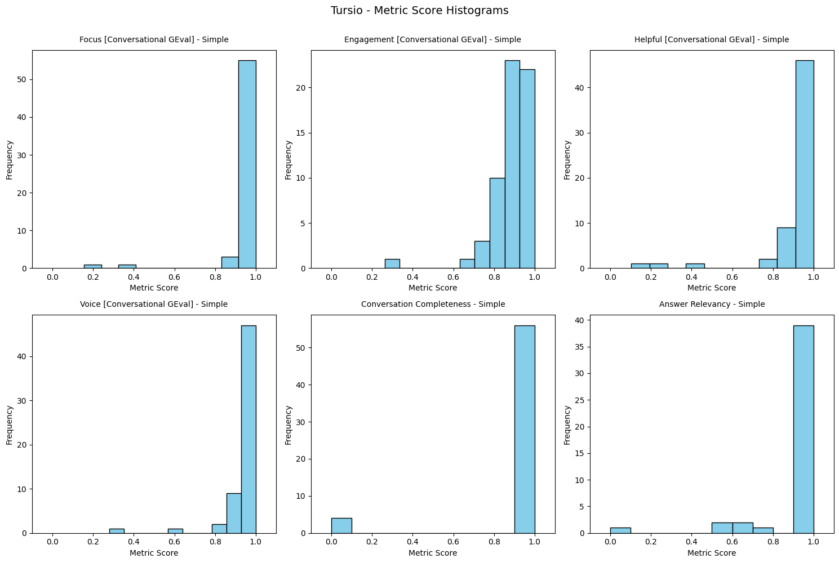
Figure 2: Tursio Simple Score Distribution

- For medium difficulty questions (see Figure 3), only 45% of Tursio’s responses were fully complete, while other evaluation metrics averaged around 80%. This lower completeness rate was primarily due to data scarcity in the database, so responses often addressed just one out of five requested account details, resulting in partial answers rather than comprehensive coverage.

turn: [TurnApi(role='user', content='What is the total deposit balance for the top 5 customer segments by account number in each region?', order=0, user_id=None, retrieval_context=['user persona: Finance / Treasury Manager; Branch / Regional Manager', 'KPI : Total Deposit Balance by Geography; Concentration Risk'], tools_called=None, additional_metadata=None, comments=None), TurnApi(role='assistant', content='High-Impact Findings\n\nThe total deposit balance for the top 5 records by account number is 1,381.', order=1, user_id=None, retrieval_context=None, tools_called=None, additional_metadata=None, comments=None)]
Metric Score: 0.3047425873514159
Feedback: The assistant's response does not fully address the user's request for total deposit balances by customer segment and region; it only provides a single total for the top 5 records by account number, omitting segmentation and regional breakdowns. The user's question is clear and appropriate, but the assistant's content is incomplete and lacks necessary details.
-----
turn: [TurnApi(role='user', content='Which 5 zip codes show the highest growth in total deposit balance over the past year?', order=0, user_id=None, retrieval_context=['user persona: Finance / Treasury Manager; Branch / Regional Manager', 'KPI : Total Deposit Balance by Geography; Concentration Risk'], tools_called=None, additional_metadata=None, comments=None), TurnApi(role='assistant', content='High-Impact Findings:\nThe data shows one zip code (with an empty value) achieving a total deposit balance growth of 475,382, while another (also with an empty zip code) experienced a decline of 506,519 in deposit balances.', order=1, user_id=None, retrieval_context=None, tools_called=None, additional_metadata=None, comments=None)]
Metric Score: 0.2014063624835024
Feedback: The assistant's response does not fully address the user's request for the top 5 zip codes with the highest growth in total deposit balance. Instead, it mentions only two entries, both with empty zip codes, and does not provide a ranked list or specific zip codes as requested. The user's question is clear and appropriate, but the assistant's content is incomplete and omits key information.
-----
turn: [TurnApi(role='user', content='What is the average credit card balance per account in the top 5 states by total account balance?', order=0, user_id=None, retrieval_context=['user persona: Finance Manager; CRO; Product Manager', 'KPI : Portfolio Mix %; Credit Card Exposure by Balance'], tools_called=None, additional_metadata=None, comments=None), TurnApi(role='assistant', content='Key Insight:\nThe dataset shows that for the top 5 states by total account balance, the only returned state (labeled "0") has an average credit card balance of $12,426.40 per account.', order=1, user_id=None, retrieval_context=None, tools_called=None, additional_metadata=None, comments=None)]
Metric Score: 0.3562176500885798
Feedback: The assistant's response is appropriate in role and attempts to answer the user's question, but it only provides data for one state (labeled '0') instead of the requested top 5 states. The user's question is clear and provides sufficient information. The assistant omits important information by not addressing all five states, resulting in an incomplete answer.
-----
turn: [TurnApi(role='user', content='Which 10 zip codes have the highest average credit card balances among active accounts?', order=0, user_id=None, retrieval_context=['user persona: Finance Manager; CRO; Product Manager', 'KPI : Portfolio Mix %; Credit Card Exposure by Balance'], tools_called=None, additional_metadata=None, comments=None), TurnApi(role='assistant', content='Key Insight:\nAmong the active accounts in the sample, the highest average credit card balance is found for the zip code represented as an empty value, with an average limit amount of $4,979.76 across 955 distinct cards.', order=1, user_id=None, retrieval_context=None, tools_called=None, additional_metadata=None, comments=None)]
Metric Score: 0.2562176500885798
Feedback: The assistant's response only provides information about a single zip code (an empty value) and does not list the 10 zip codes with the highest average credit card balances as requested. This is a major omission, as the user's question was clear and specific. The roles are appropriate, but the assistant fails to fully address the user's query.
-----
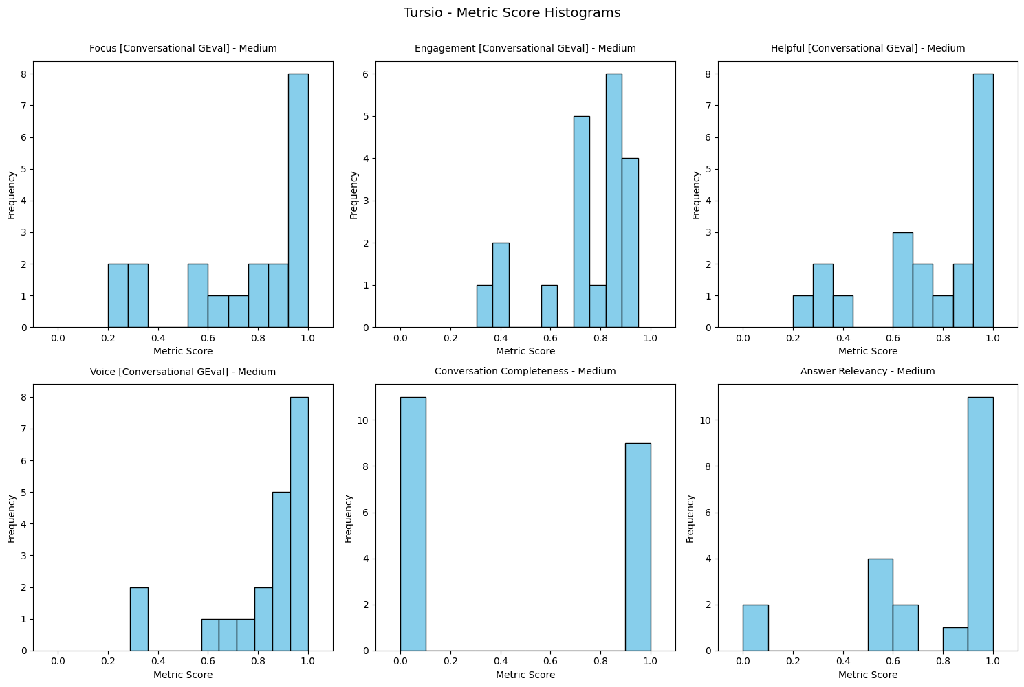
Figure 3: Tursio’s Medium score distribution

- For hard questions (see Figure 4), 52.6% of Tursio’s responses were complete. This limited completeness is primarily due to data unavailability in the database or partial responses. Additionally, for this evaluation cycle, only the key insights or top paragraph of each response were assessed, mainly because of manual copy-paste constraints. In future iterations, the plan is to evaluate the full response content for a more comprehensive assessment.

turn: [TurnApi(role='user', content='What behavioral traits or transaction patterns can predict early warning signals for accounts that transition from 30 DPD to 90 DPD, based on historical data?', order=0, user_id=None, retrieval_context=['user persona: Risk & Credit Analytics Manager; CRO; Compliance Officer', 'KPI : 90+ DPD Rate; Delinquency Ratio; Non-Performing Loan %'], tools_called=None, additional_metadata=None, comments=None), TurnApi(role='assistant', content='Great question but unfortunately no data points were found to generate an answer for you. Consider adjusting your query to change one or more parameters, such as time or other filters.', order=1, user_id=None, retrieval_context=None, tools_called=None, additional_metadata=None, comments=None)]
Metric Score: 0.2095349462328422
Feedback: The assistant's response is appropriate in tone and role but fails to address the user's question, which is clear and specific. Instead of providing behavioral traits or transaction patterns, the assistant claims no data is available without attempting to generalize from typical historical data or offering possible predictors. This results in a major omission, as the user's request is not answered and important information is missing.
-----
turn: [TurnApi(role='user', content='How do the recent credit utilization ratios of non-performing loan accounts compare to those that have remained performing, particularly in the last six months?', order=0, user_id=None, retrieval_context=['user persona: Risk & Credit Analytics Manager; CRO; Compliance Officer', 'KPI : 90+ DPD Rate; Delinquency Ratio; Non-Performing Loan %'], tools_called=None, additional_metadata=None, comments=None), TurnApi(role='assistant', content='Great question but unfortunately no data points were found to generate an answer for you. Consider adjusting your query to change one or more parameters, such as time or other filters.', order=1, user_id=None, retrieval_context=None, tools_called=None, additional_metadata=None, comments=None)]
Metric Score: 0.3437823499114202
Feedback: The user provided a clear and specific question appropriate for their role. The assistant's response is appropriate in tone but fails to address the user's question, offering no analysis, explanation, or alternative insights—only stating that no data is available. The assistant could have elaborated on typical trends, explained why data might be unavailable, or suggested more actionable next steps. This results in a significant omission in fully addressing the user's request.

- For hard questions (see Figure 4), Tursio’s responses were rated 80% for helpfulness and focus. This performance is primarily attributed to incomplete account information in the database or the use of abbreviated responses during evaluation.

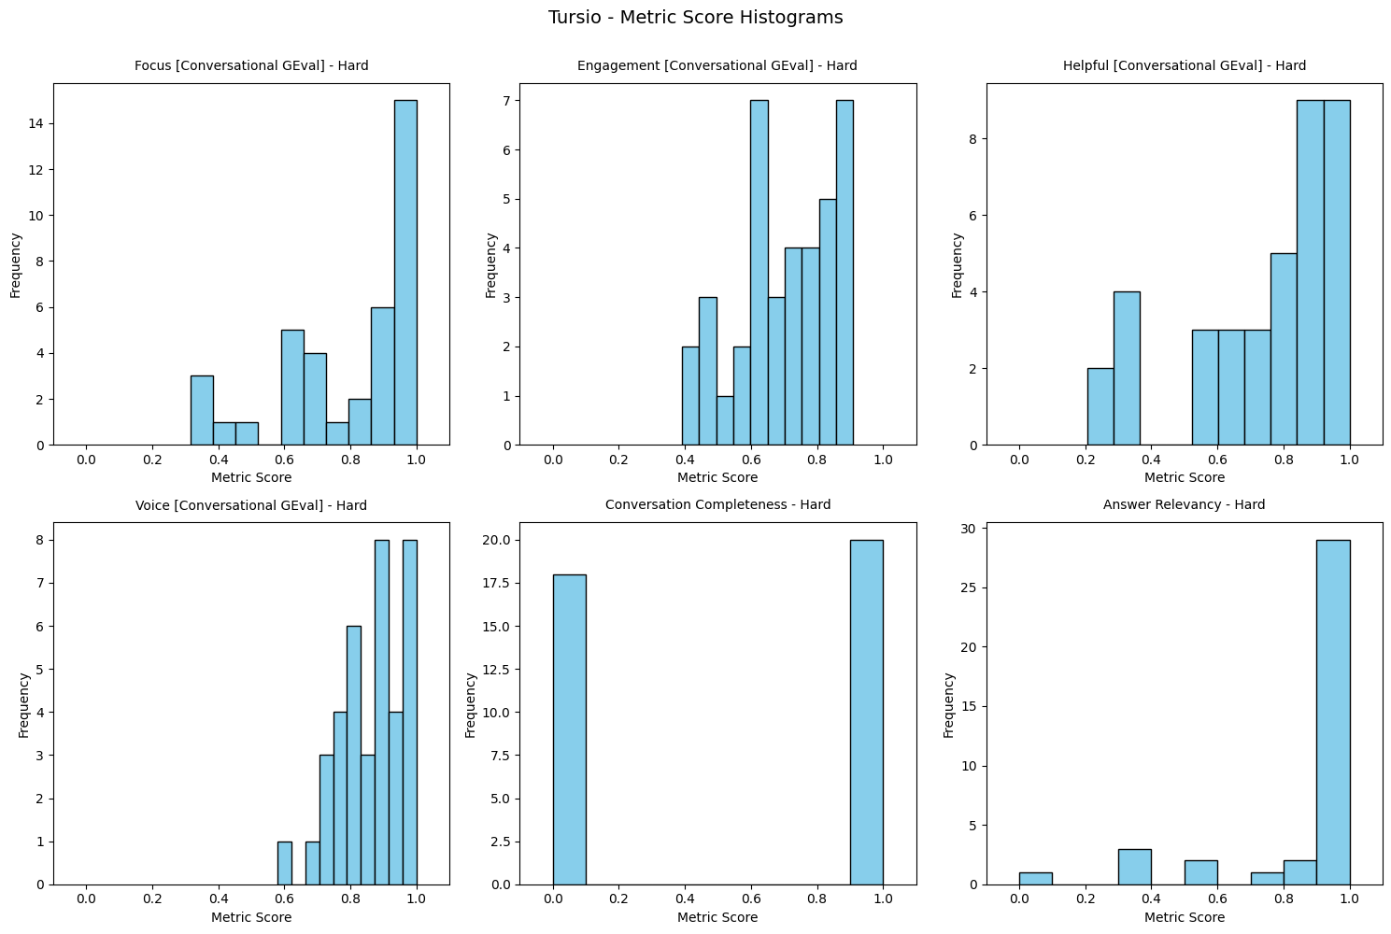
Figure 4: Tursio’s Hard score distribution

Benchmarking

Perplexity: batch uploaded to the chat interface and got inference as .csv

- All responses received from PPL (see Figure 5) demonstrated high quality in both Voice and Answer Relevancy. However, since responses were intentionally limited to 3–5 sentences, some issues with completeness were observed

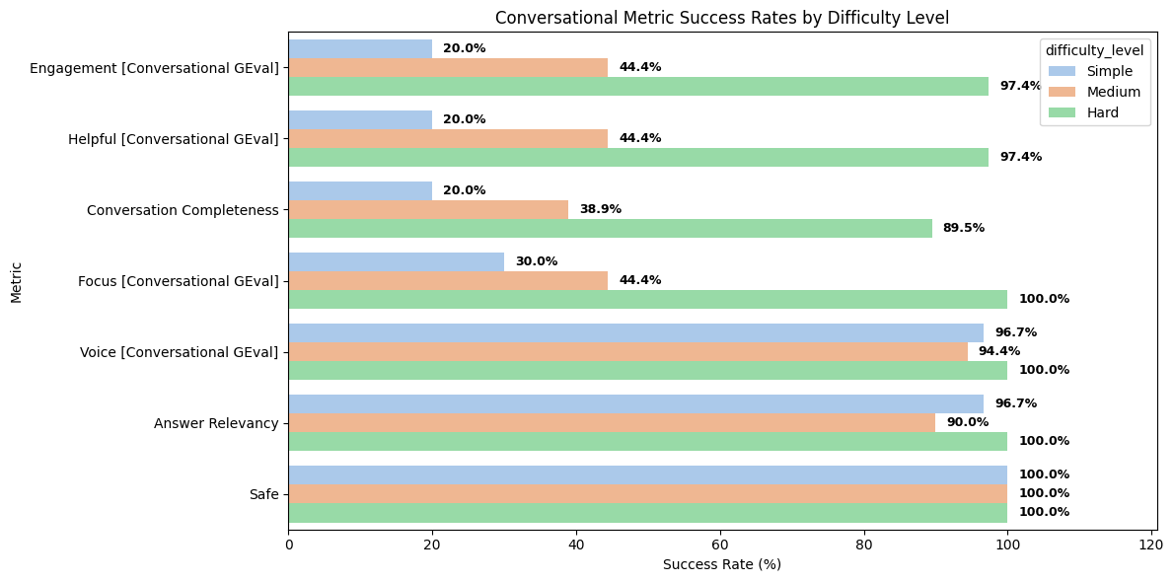
Figure 5: Perplexity Evaluation for all difficulty levels

Score Distribution charts for Perplexity

- For simple questions (see Figure 6), Perplexity achieved an answer relevancy rate of 96.7%. However, there were instances where questions could not be answered using open search data. To address these gaps, future iterations will focus on refining the question mapping process to improve coverage and completeness

Q: What is the average net worth of the top 1% of US households?
A: Insufficient information to answer the question.
Metric Score: 0.0
Feedback: The score is 0.00 because the response did not provide any relevant information about the average net worth of the top 1% of US households and instead stated there was not enough information, which does not address the question at all.
-----
Q: What is the average daily ACH transfer limit for US banks?
A: Insufficient information to answer the question.
Metric Score: 0.0
Feedback: The score is 0.00 because the response did not provide any information about the average daily ACH transfer limit for US banks and instead stated there was not enough information, which does not address the input question at all.
-----
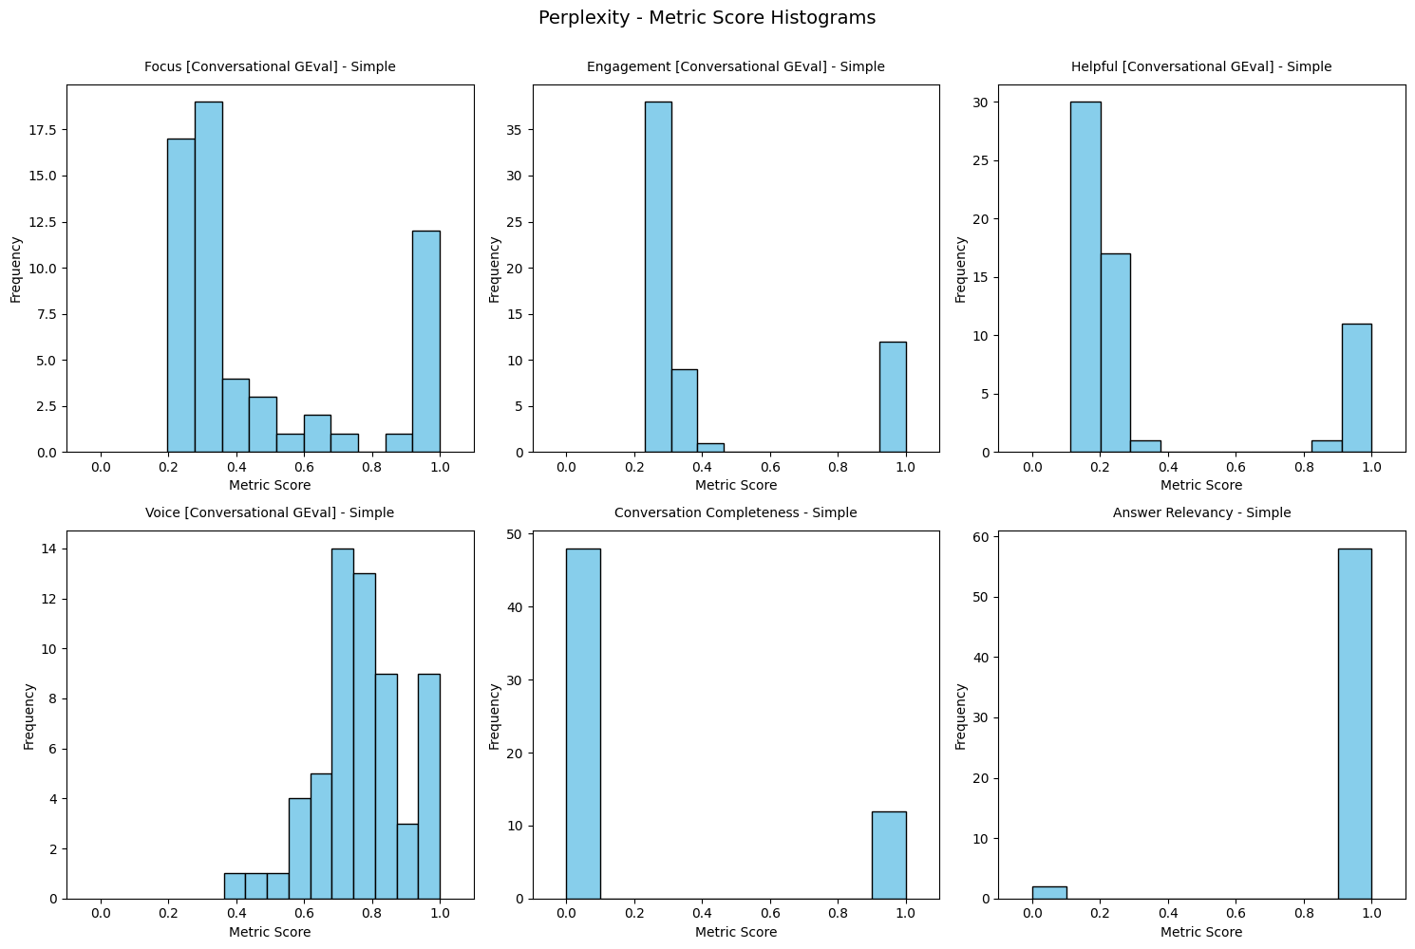
Figure 6: Perplexity Simple Score Distribution

- Similarly, for other metrics under the Simple questions category (see Figure 6), Perplexity’s responses reveal limitations in addressing queries using open search data, resulting in lower evaluation scores for Engagement (20%), Helpfulness (20%), Completeness (20%), and Focus (30%).
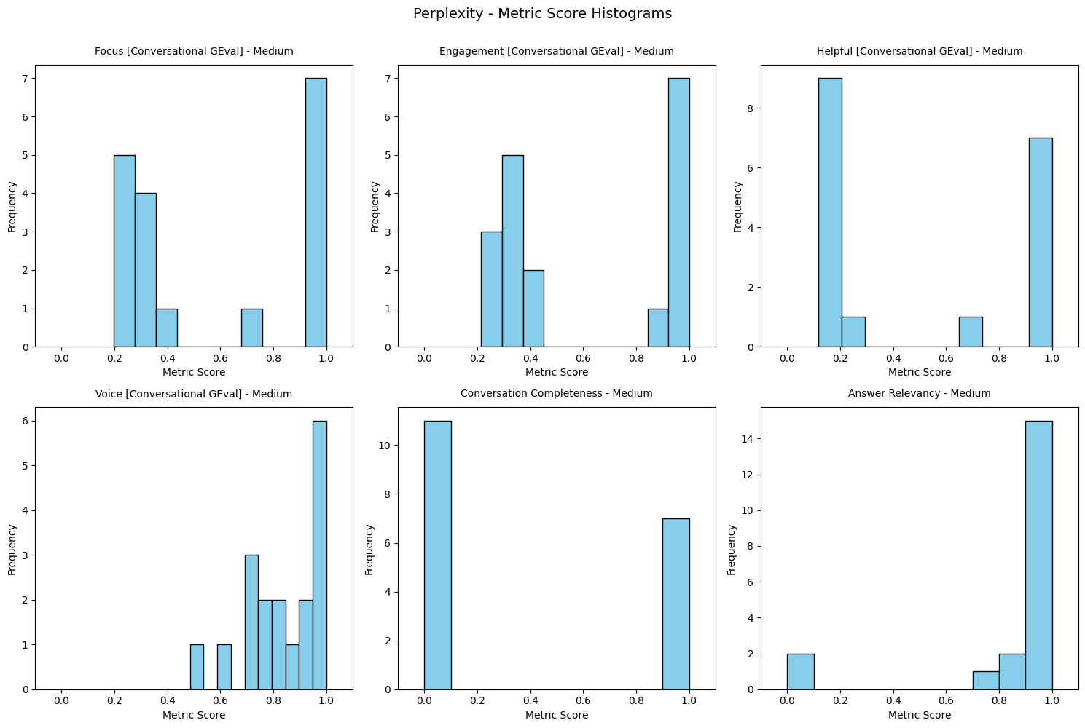
Figure 7: Perplexity Medium difficulty Score distribution

- For medium difficulty questions (see Figure 7), Perplexity responses exhibit similar limitations in addressing queries using open search data. While answer relevancy remains high at 90%, scores for Engagement, Helpfulness, and Focus are each at 44%, reflecting challenges in providing comprehensive and engaging answers.
- For hard questions (see Figure 8), Perplexity performs notably better, as responses are more frequently supported by open web data. With the exception of Conversation Completeness (89.5%), all evaluation metrics demonstrate strong performance. However, there are instances where conversations remain incomplete, typically due to the brevity or scope of the responses

turn: [TurnApi(role='user', content='What are industry trends for dormant bank account rates?', order=0, user_id=None, retrieval_context=['user persona: Member Analytics Lead; Compliance Officer', 'KPI: Dormant Account Rate; Inactivity Ratio'], tools_called=None, additional_metadata=None, comments=None), TurnApi(role='assistant', content='Industry commentary indicates that dormant accounts represent a meaningful minority of total accounts at many banks. Over time, digital banking has reduced some dormancy by making access easier, but a long tail of low-balance, rarely used accounts persists. Dormant accounts can accumulate across legacy product sets, closed branches, or customers who have shifted primary relationships elsewhere. Institutions increasingly view dormancy as an operational and risk issue, prompting targeted cleanup and reactivation efforts.', order=1, user_id=None, retrieval_context=None, tools_called=None, additional_metadata=None, comments=None)]
Metric Score: 0.0
Feedback: The score is 0.0 because the LLM response did not address the user's intention to learn about industry trends for dormant bank account rates, specifically lacking the quantitative data or statistics that the user requested.
-
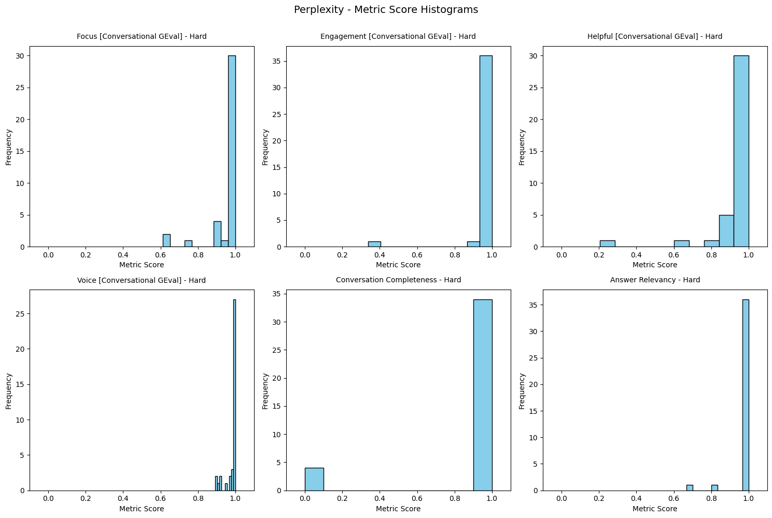
Figure 8: Perplexity Hard difficulty score distribution

Chat-GPT- batch uploaded to the chat interface and got inference as .csv

- For all difficulty levels (see Figure 9), Chat-GPT consistently achieved high performance across all evaluation metrics, with scores exceeding 95%
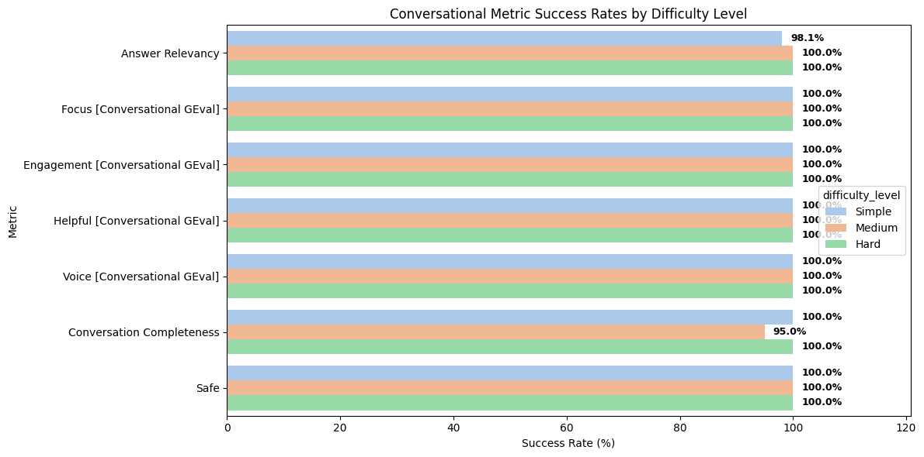
Figure 9: Chat-GPT Evaluation for all difficulty level

Chat-GPT Score distribution chart

14. For simple questions (see Figure 10), Chat-GPT’s score distribution is sharply right-skewed, with all metrics except Helpfulness consistently meeting the highest standard (100%).
15. For medium difficulty questions (see Figure 11), Chat-GPT’s Focus and Helpfulness metrics show some variability, but overall scores still reach 100%.
16. For hard questions (see Figure 12), Chat-GPT’s Engagement displays some spread, indicating variability in conversational quality.
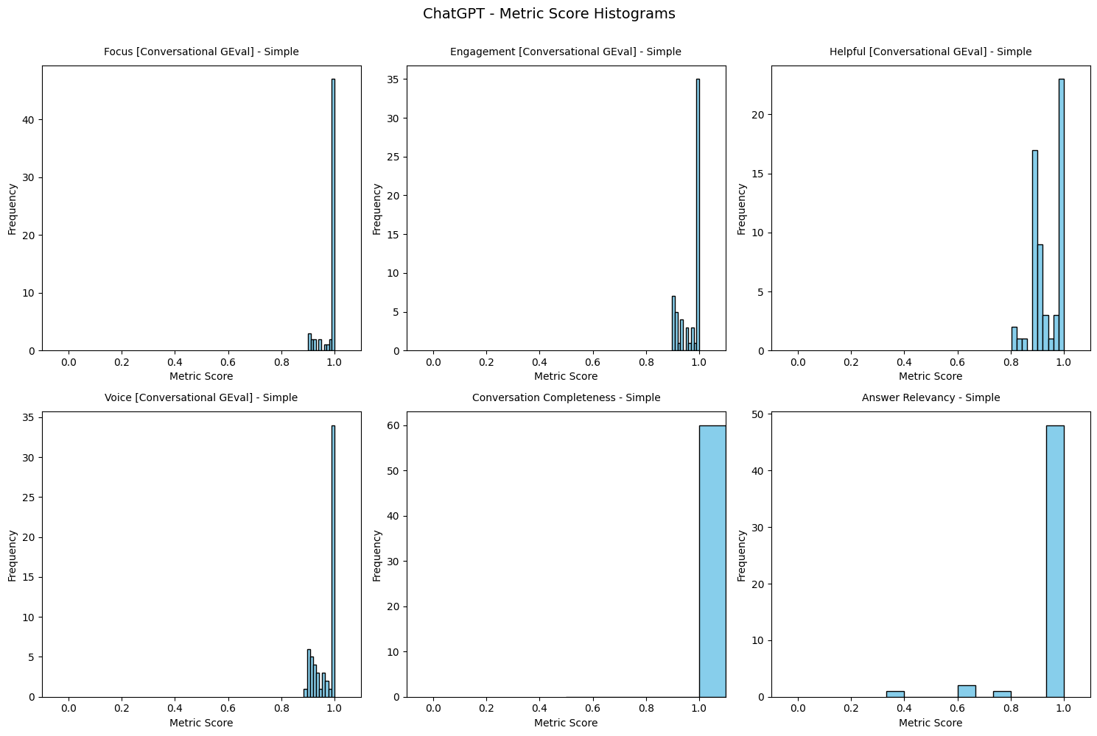
Figure 10: Chat-GPT – Simple Score distribution

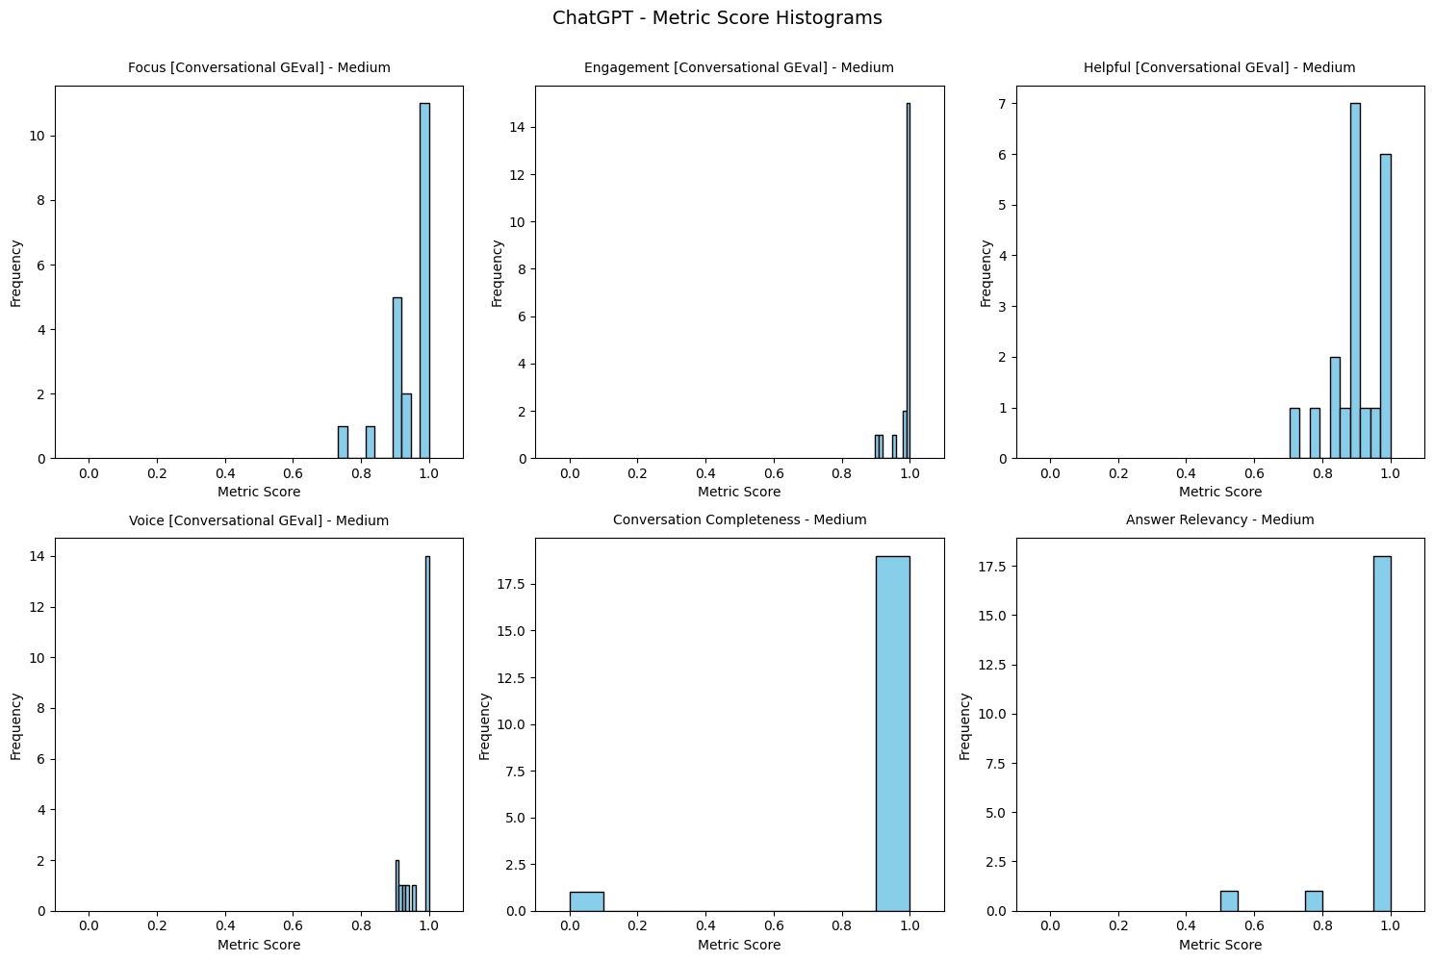
Figure 11: Chat-GPT - Medium Score distribution

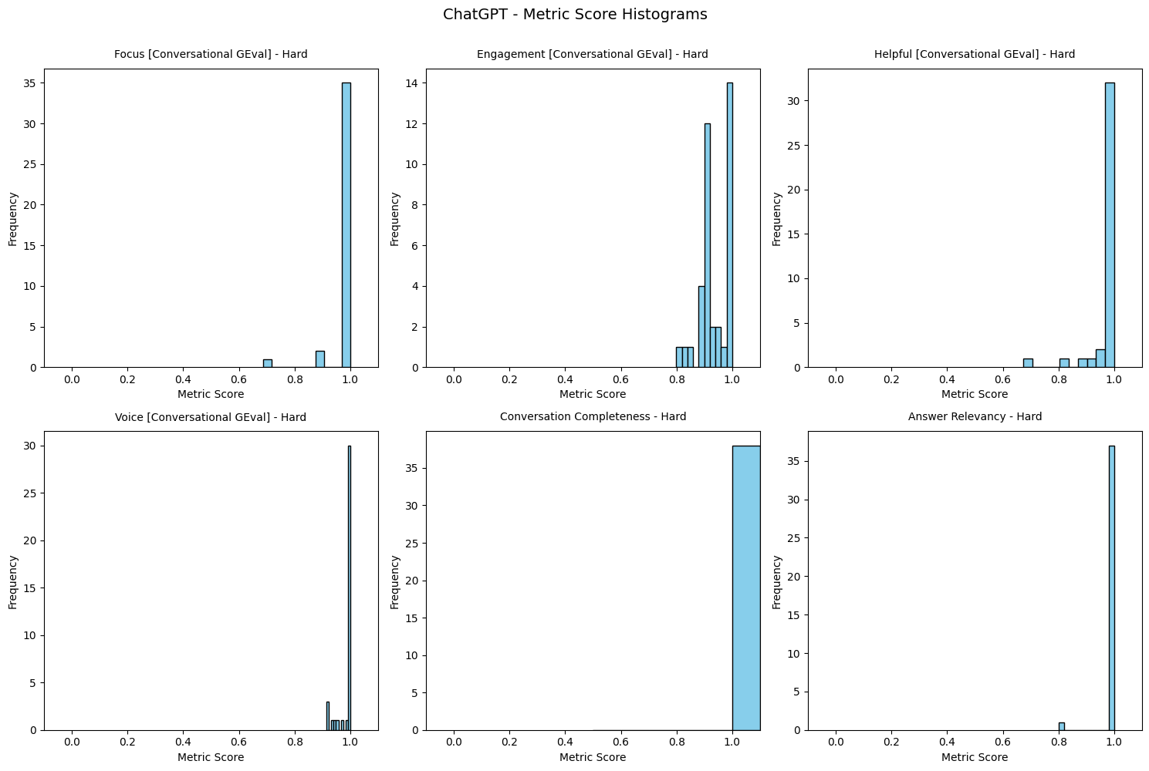
Figure 12: Chat-GPT – Hard Score distribution

Statistical Analysis

No statistically significant differences were found in the success rates among Tursio, Perplexity, and Chat-GPT across all difficulty levels (Table 1). Statistical analyses, including chi-square tests for simple, medium, and hard question categories, consistently indicated that the performance of these models is comparable, with p-values well above conventional significance thresholds

[Note: A discrepancy in the total number of questions across models has been observed (Tursio simple: 45 vs. PPL simple: 58). This is mainly due to inferencing limitation while using deep-eval when some requests get time-outs etc.]

Table 1: Statistical success count distribution for threshold = 0.5
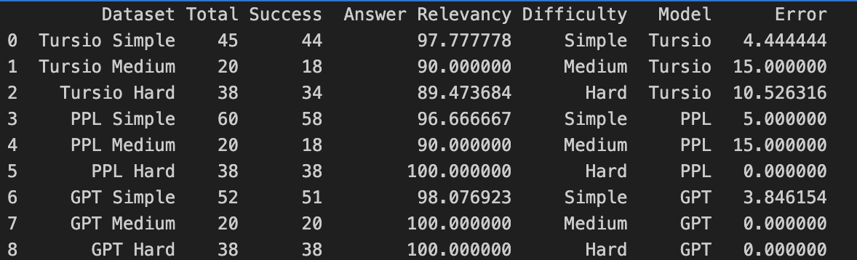

---- Simple ----
The difference between Tursio and GPT for Simple difficulty is not statistically significant (p = 1.0000).
The difference between Tursio and PPL for Simple difficulty is not statistically significant (p = 1.0000).
---- Medium ----
The difference between Tursio and GPT for Medium difficulty is not statistically significant (p = 0.4682).
The difference between Tursio and PPL for Medium difficulty is not statistically significant (p = 1.0000).
---- Hard ----
The difference between Tursio and GPT for Hard difficulty is not statistically significant (p = 0.1233).
The difference between Tursio and PPL for Hard difficulty is not statistically significant (p = 0.1233).

Summary

TURSIO PERFORMANCE ANALYSIS

Answer Relevancy & Contextual Understanding
Tursio demonstrates variable performance in answer relevancy across difficulty levels. For simple questions (Figure 2), one QA pair scored 0 due to misinterpreting the question context—responding about accounts that made comments rather than addressing the actual query. This contextual misalignment persisted in medium questions (Figure 3), where two responses failed evaluation by not addressing the specific question context. The pattern reveals a systematic issue with contextual understanding that compounds as question complexity increases. For hard questions (Figure 4), response relevance degraded significantly when the underlying database lacked sufficient data, highlighting a critical dependency on data availability rather than purely comprehension issues.

Completeness Challenges Across Difficulty Levels
Tursio's completeness metrics reveal a progressive degradation correlated with question complexity and data availability. Simple questions (Figure 2) generally met high-quality standards across most metrics, though responses occasionally omitted direct acknowledgment of user questions. For medium questions (Figure 3), only 45% of responses were fully complete—a stark contrast to other metrics that averaged ~80%. This disparity stemmed primarily from database data scarcity, where responses often covered only 1 of 5 requested account details, yielding partial rather than comprehensive answers. Hard questions (Figure 4) showed marginal improvement at 52.6% completeness, driven by similar database data gaps and partial responses. Notably, this evaluation cycle assessed only key insights or opening paragraphs due to manual copy-paste constraints, meaning actual completeness may be even lower when full response content is considered in future iterations.

Engagement, Helpfulness & Focus Performance
For simple questions (Figure 2), Engagement scored 93.3%—the only metric below the high-quality threshold—while all other metrics met standards. For hard questions (Figure 4), both Helpfulness and Focus achieved 80%, with performance limited by incomplete database information and the evaluation of abbreviated response excerpts rather than full content. This suggests that when data is available and properly contextualized, Tursio can deliver focused, helpful responses, but struggles when foundational data is missing.

Statistical Insights on Consistency
Tursio's Relevancy Metric (Figure 1a) reveals that while upper bounds match competitor performance, the system exhibits higher variance, suggesting less consistent performance across queries. This inconsistency manifests most clearly at a 0.7 success threshold (Figure 13), where statistically significant differences emerged between Tursio and GPT for medium and hard difficulty questions, indicating that Tursio's performance becomes less reliable as complexity increases.

PERPLEXITY PERFORMANCE ANALYSIS

Open Search Data Dependency: A Tale of Two Performance Levels
Perplexity's performance exhibits a clear bifurcation based on whether queries can be effectively answered using open web data. For simple and medium questions (Figures 6 and 7), this dependency creates severe limitations. Simple questions (Figure 6) achieved 96.7% answer relevancy, yet Engagement (20%), Helpfulness (20%), Completeness (20%), and Focus (30%) all scored critically low, revealing fundamental limitations in addressing query types that require proprietary or non-public information. Medium questions (Figure 7) showed similar constraints—while Answer Relevancy remained strong at 90%, Engagement, Helpfulness, and Focus each scored only 44%, reflecting persistent challenges in delivering comprehensive, engaging responses when open search data proves insufficient.
However, hard questions (Figure 8) demonstrate markedly improved performance, as these queries are more frequently supported by available open web data. All metrics showed strong performance except Conversation Completeness (89.5%), where brevity or limited response scope occasionally left conversations incomplete. This suggests Perplexity excels at complex, research-oriented queries answerable through public information but struggles with application-specific or proprietary data queries.

Response Format Constraints
Perplexity responses (Figure 5) demonstrated excellent Voice and Answer Relevancy across all difficulty levels. However, the intentional 3–5 sentence limit introduced systematic completeness issues. This format constraint, while potentially beneficial for conciseness, appears to conflict with the comprehensive coverage required for certain query types, particularly those requiring detailed account information or multi-faceted explanations.

CHAT-GPT PERFORMANCE ANALYSIS

Consistent Excellence Across All Dimensions
Chat-GPT achieved uniformly high performance across all difficulty levels (Figure 9), with all evaluation metrics exceeding 95% for simple, medium, and hard questions. This consistency represents a fundamental difference from both Tursio and Perplexity, neither of which maintained such stable performance across varying complexity levels.

Difficulty-Specific Performance Patterns
For simple questions (Figure 10), score distribution was sharply right-skewed, with all metrics except Helpfulness consistently achieving 100%, suggesting near-perfect performance on straightforward queries. Medium questions (Figure 11) showed slight variability in Focus and Helpfulness metrics, though overall scores still reached 100%. Hard questions (Figure 12) revealed the most variance, with Engagement displaying the widest spread, indicating some variability in conversational quality for complex questions. However, even this "variability" occurred within a high-performance range, suggesting Chat-GPT maintains quality even when showing relative inconsistency.

Statistical Positioning
While no statistically significant differences were found in overall success rates among all three apps across difficulty levels (Table 1), threshold-based analysis reveals Chat-GPT's advantage. At a 0.7 success threshold (Figure 13), statistically significant differences emerged between Chat-GPT and Tursio for medium and hard difficulty questions, with Chat-GPT demonstrating superior reliability at this threshold.

COMPARATIVE INSIGHTS & STRATEGIC IMPLICATIONS
- Data Dependency Patterns: Tursio's performance correlates strongly with internal database completeness, Perplexity depends on open web data availability, while Chat-GPT demonstrates more robust performance regardless of data source constraints.
- Consistency vs. Peak Performance: While Tursio's upper bounds match competitors (Figure 1a), its higher variance indicates reliability issues. Chat-GPT shows both high performance and high consistency, making it the most predictable solution.
- Complexity Scaling: Chat-GPT maintains quality across difficulty levels, Perplexity improves with complexity (when data supports it), and Tursio degrades as complexity increases, particularly for medium questions where completeness drops to 45%.
- Threshold Sensitivity: At relaxed thresholds (Table 1), no significant differences exist, but at 0.7 threshold (Figure 13), Chat-GPT's advantages become statistically significant for medium and hard questions, suggesting performance gaps emerge under more stringent quality requirements.

Future Direction

Evaluation Methodology Improvements
- Complete Response Analysis: Evaluate full responses from Tursio rather than excerpts (currently only key insights/opening paragraphs), as current approach likely underestimates completeness gaps. Extend response length limits for Perplexity beyond 3-5 sentences to enable realistic assessment of comprehensive answer delivery.
- Multi-Turn Conversational Evaluation: Add multi-turn assessments (3-5+ exchanges) to evaluate conversational flow, context retention, clarification handling, and coherence—critical gaps in current single-turn evaluations that miss real-world usage patterns.
- Human-Aligned Reward Models: Select top-performing models from HuggingFace Reward Benchmark to reduce subjective variability and enable scalable evaluation. Note: Current compute/storage limitations prevent immediate implementation; requires infrastructure scaling.

Advanced Question Generation
- Perplexity-Specific Enhancements: Address the 20-30% performance gaps in simple/medium questions by implementing intelligent query generation and mapping framework suitable for open search.
- Tursio Database Enhancement: Database scarcity drives completeness gaps (45% medium, 52.6% hard). Prioritize: coverage audits across query patterns, data enrichment for identified gaps (especially account details), freshness monitoring, and fallback strategies for insufficient data returns.
- Use high-capability models (GPT-4, Claude Sonnet 4.5) with systematic quality controls:
- Quarterly reviewer feedback cycles for iterative refinement [TBD]
- Constitutional AI or rejection sampling for quality filtering

Coverage & Robustness
- Golden Sample Expansion: Generate 3-5 golden samples for each persona × difficulty combination to ensure balanced representation, reduce evaluator uncertainty, and enable reliable cross-category comparisons. Current gaps in some combinations limit evaluation robustness.
- Bloom Evaluation Integration: Investigate Anthropic's Bloom Evaluation (launched 12/23/24) for advanced assessment capabilities. Priorities: understand evaluation dimensions, assess infrastructure compatibility, pilot on subset of data [Q1 2026 investigation sprint recommended].
- Evaluation Automation : Address manual copy-paste constraints through automated response extraction, cloud compute allocation for reward models, version-controlled datasets, and real-time monitoring dashboards.

Appendix

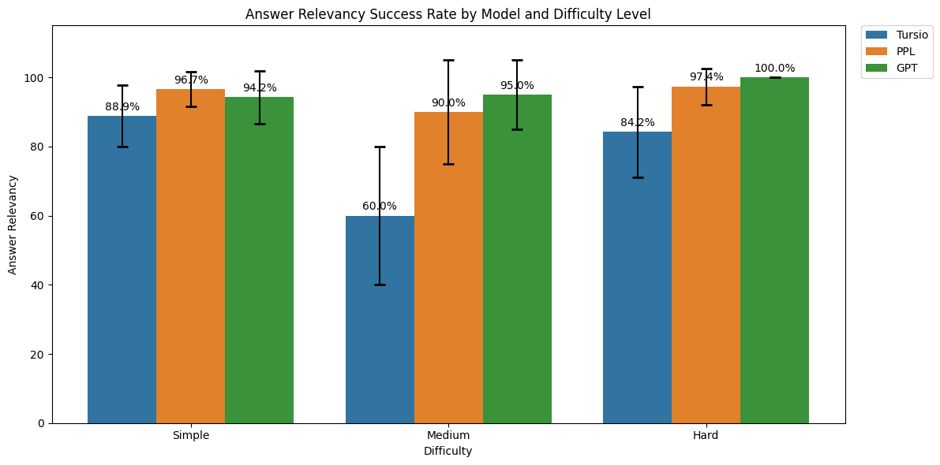
Figure 13: For threshold = 0.7 – Answer Relevancy success rate for all difficulty and Search Apps

References:

- DeepEval - https://deepeval.com/docs/evaluation-end-to-end-llm-evals
- DeepEval Github - https://github.com/confident-ai/deepeval
- RewardBench - https://huggingface.co/spaces/allenai/reward-bench
- LMUnit: Fine-grained evaluation with Natural Language - https://github.com/ContextualAI/LMUnit
- G-Eval - https://arxiv.org/abs/2303.16634

GitHub Experiments - https://github.com/sulbhajain/research

End-of-Document

Scratch

- Value based evaluation: Explore methods to calculate value addition with Tursio’s auto-query formation and NLU based solutions e.g. Query-GPT from Uber or Anthropic
  - Length of query does not directly correlate to the length of the NLP questions. So sometimes questions are too abstract and manual query writing may take much longer. Estimating the manual time to write a query and then evaluating how many can be processed under 4 minutes might help measure overall value. Ref: https://metr.org/blog/2025-03-19-measuring-ai-ability-to-complete-long-tasks]
  - Anthropic Estimation for productivity gain - https://www.anthropic.com/research/estimating-productivity-gains

