# *1- WAP AREA OF RECTANGLE*

## *CODE OUTPUT*

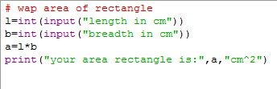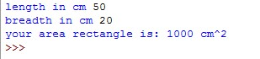

# *2-WAP AREA OF CIRCLE*

## *CODE OUTPUT*

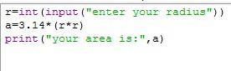

## *3- WAP AREA OF CUBOID*

### *CODE OUTPUT*

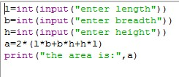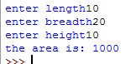

## *4- WAP AREA OF CUBE*

*CODE OUTPUT*

**



## *5- WAP AREA OF CSA OF CYLINDER*

### *CODE OUTPUT*

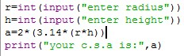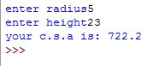

## *6-WAP AREA OF TSA OF CYLINDER*

### *CODE OUTPUT*

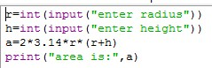

## *7-WAP AREA OF CSA OF CONE*

### *CODE OUTPUT*

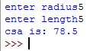

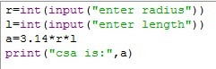

## *8- WAP AREA OF TSA OF RIGHT CIRCULAR CONE*

*CODE OUTPUT*

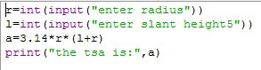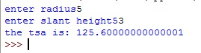

## *9- WAP TSA OF SPHERE*

### *CODE OUTPUT*

***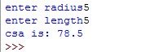*

## *10-WAP VOLUME OF CUBOID*

### *CODE OUTPUT*

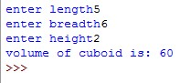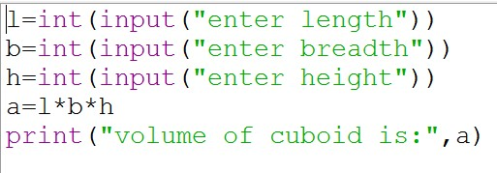

## *11-WAP VOLUME OF CUBE*

### *CODE OUTPUT*

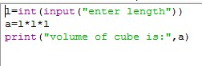

## *12-WAP VOLUME OF CYLINDER*

*CODE OUTPUT*

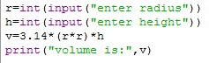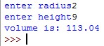

## *13- WAP VOLUME OF CONE*

### *CODE OUTPUT*

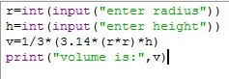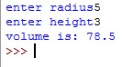

## *14-WAP VOLUME OF SPHERE*

### *CODE OUTPUT*



## *15-WAP PERIMETER OF RECTANGLE*

### *CODE OUTPUT*

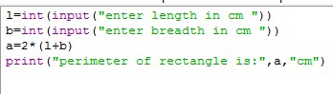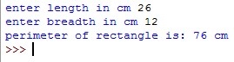

## *16- WAP AREA OF SQUARE*

*CODE OUTPUT*

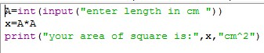

## *17- WAP AREA OF TRIANGLE*

### *CODE OUTPUT*

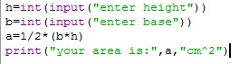

***18- WAP GREATEST NO. IN THREE NO.***

### *CODE OUTPUT*

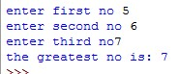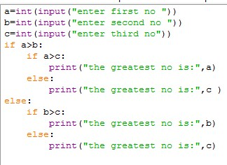

## *19- WAP PERIMETER OF TRIANGLE*

### *CODE OUTPUT*

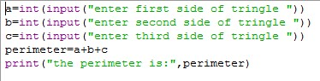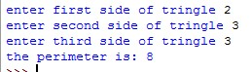

***20- WAP GREATEST NO. IN FOUR NO****.*

### *CODE OUTPUT*

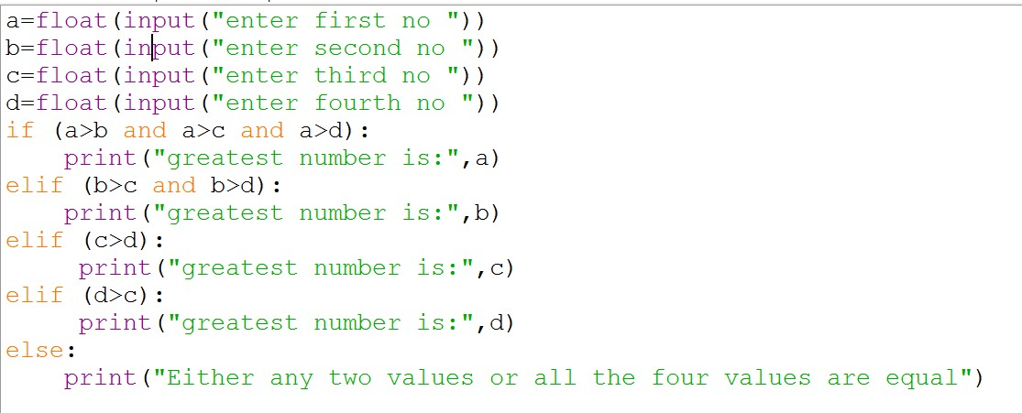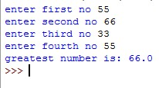

## *21-WAP TO CHECK DIVISION IN RESULT*

### *CODE OUTPUT*

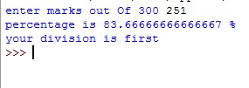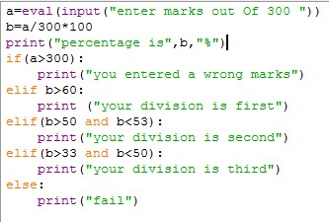

## *22-WAP TO CHEAK AGE CRITERIA*

### *CODE OUTPUT*

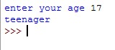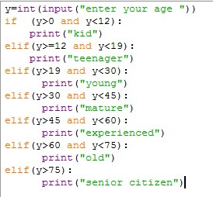

***23- WAP SUM OF NTH NO.***

*CODE OUTPUT*

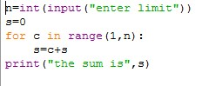

## *24- WAP TO CHEAK THE VALUE OF FACTORIAL*

### *OUTPUT CODE*

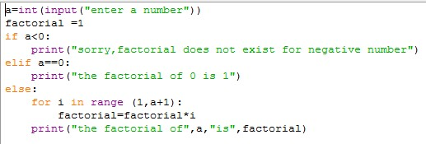

## *25- WAP TO PRINT MULTIPLICATION TABLE CODE OUTPUT*

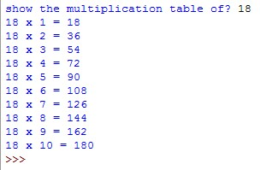

***26- WAP TO PRINT OPPOSITE RIGHT ANGLE TRIANGLE***

## *CODE OUTPUT*

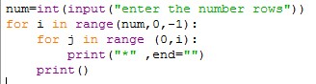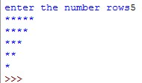

# *27- WAP TO PRINT 1,22,333,444*

## *CODE OUTPUT*

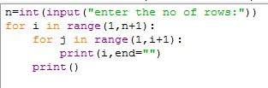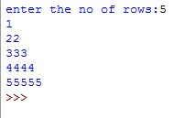

## *28- WAP TO PRINT STAR PATTERN OF OPPOSITE TRIANGLE*

*CODE*

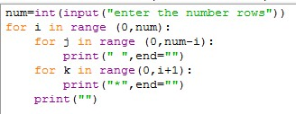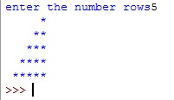

*OUTPUT*

## *29- WAP TO PRINT PATTERN 1,12,123*

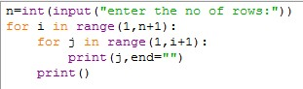

*CODE*

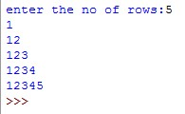

*OUTPUT*

## *30- WAP TO PRINT FIBONACCI SERIES USE WHILE LOOP*

### *CODE OUTPUT*

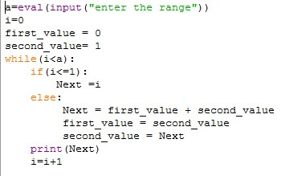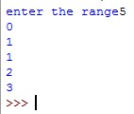

## *31- WAP TO PRINT FIBONACCI SERIES USE FOR LOOP*

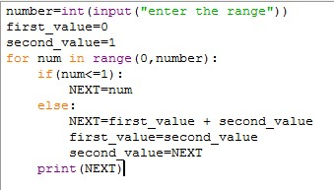

### *CODE*



*OUTPUT*

## *32- WAP TO PRINT PATTERN A,AB,ABC*

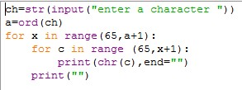

### *CODE*

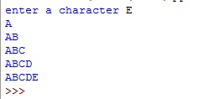

*OUTPUT*

## *33- WAP TO CALCULATION OF Xn BY FOR LOOP*

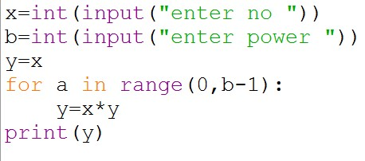

*CODE*

*OUTPUT*

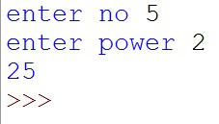

# *33- WAP TO CALCULATION OF Xn*

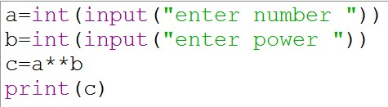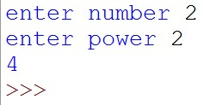

*CODE*

*OUTPUT*

# *33- WAP TO PRINT THE INTEGER IS PALINDROME OR NOT PALINDROME*

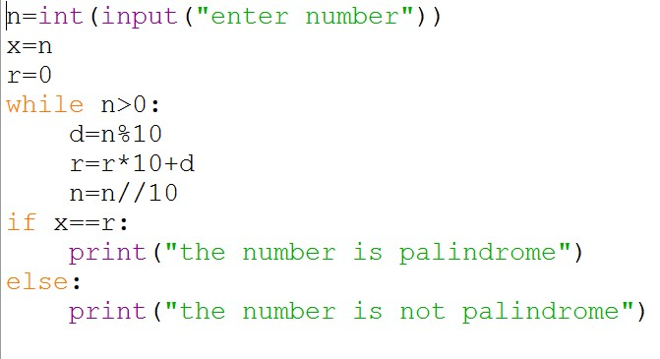

## *CODE*

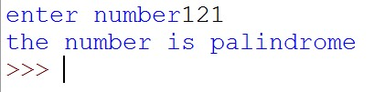

*OUTPUT*

# *35-WAP TO PRINT FACTORIAL OF LIST*

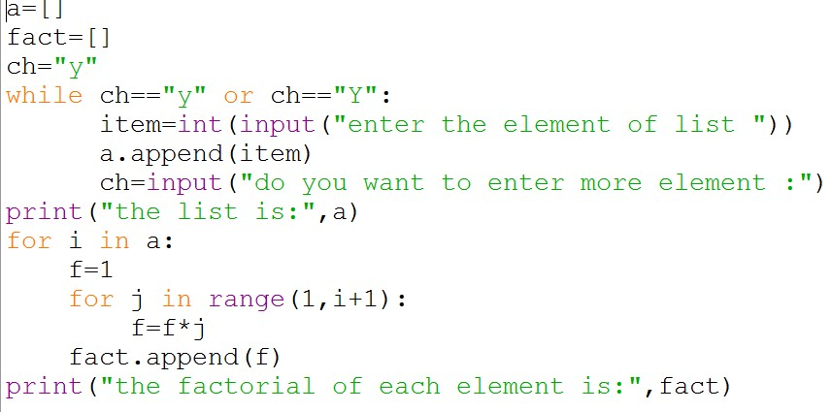

*CODE*

*OUTPUT*

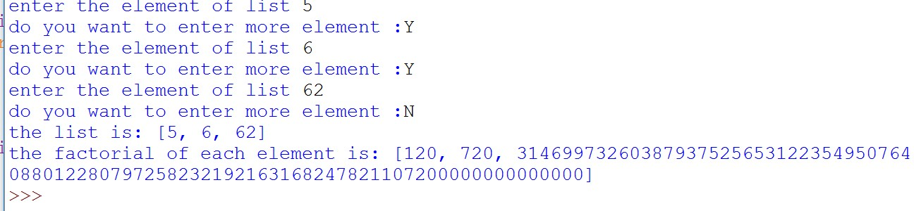

# *36-WAP TO PRINT PASCAL TRIANGLE*

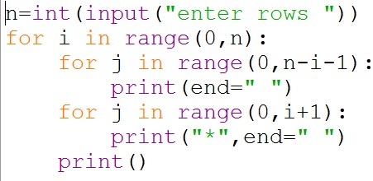

## *CODE*

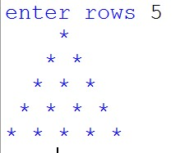

*OUTPUT*

# *37-WAP TO CREATE A LIST OF VALUES INPUTTED BY USER*

## *CODE OUTPUT*

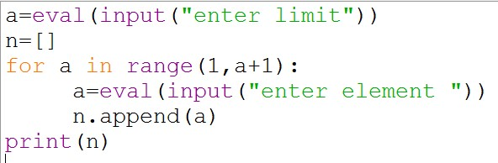 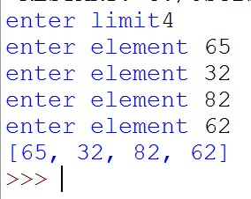

# *38-WAP TO CREATE A LIST OF VALUES INPUTTED BY USER AND SORT IN INCREASING ORDER*

## *CODE OUTPUT*

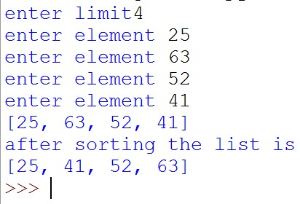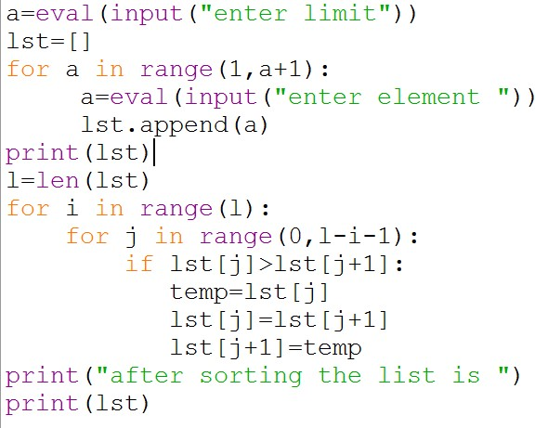

# *SORTING IN ACCENDING ORDER USE BUBBLE SORT*

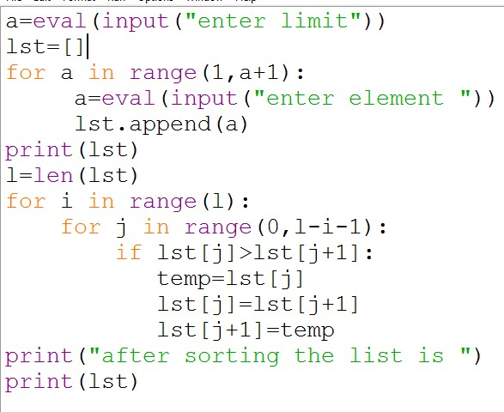

## *CODE*

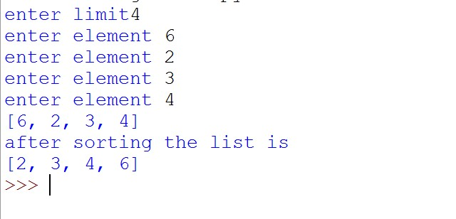

*OUTPUT*

# *WAP in Python to create a phone dictionary*

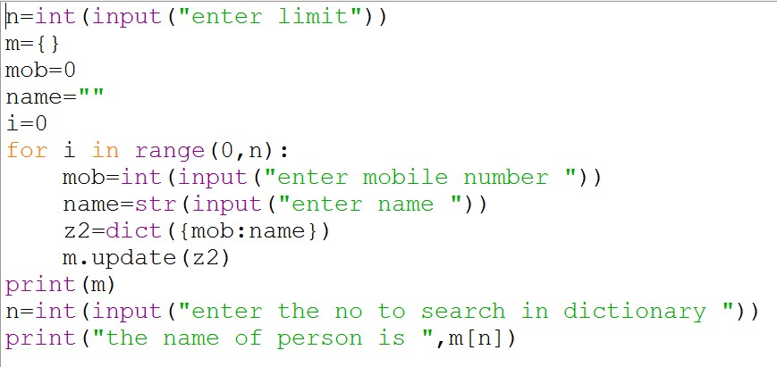

*CODE OUTPUT*

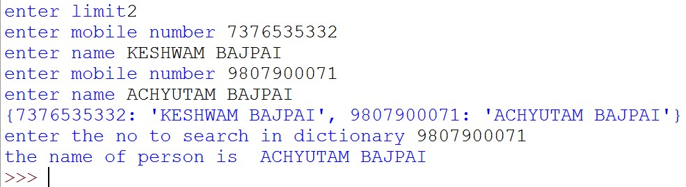

# *WAP TO FIND GIVEN NUMBER IS PRIME OR NOT*

## *CODE*

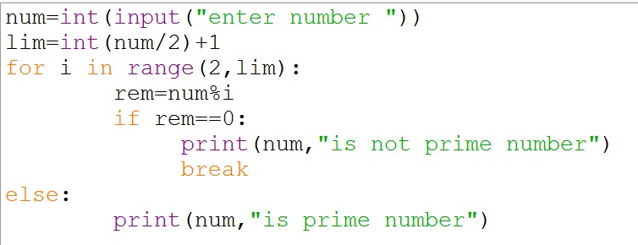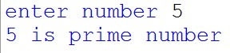

*OUTPUT*

# *42-WAP TO FIND GIVEN NUMBER IS EVEN OR ODD*

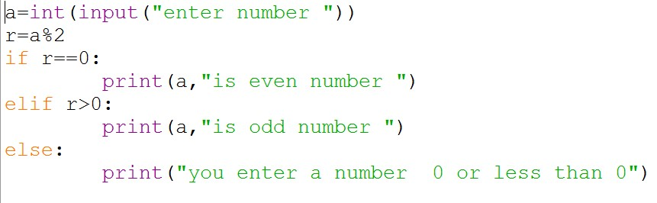

## *CODE*

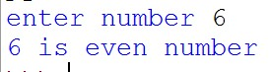

*OUTPUT*

# *43- WAP TO CREATE A TUPLE OF VALUES INPUTED BY USER*

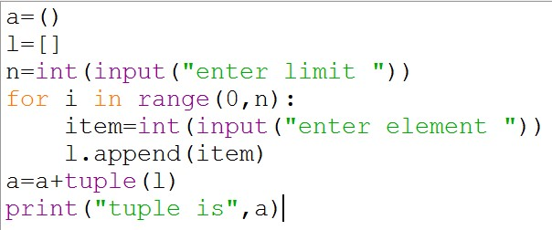

## *CODE*

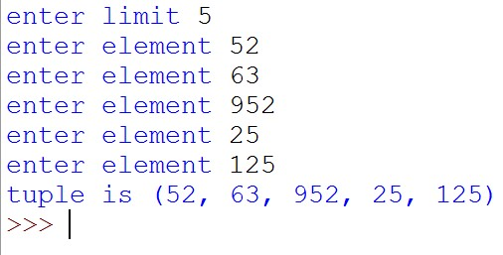

*OUTPUT*

# *44-WAP TO REVERSE AN INTEGER*

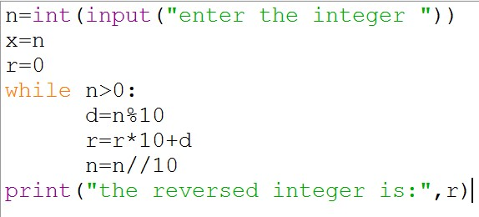

## *CODE*



## *OUTPUT*