4 Pics 1 Word

Thank you for your purchase. For support you can email me at support@vincityapps.com

Pics and words
You have to place all of your images into the folder “pics” and add them to the Xcode project (There is a pics folder in the project, too). The application has a file called “Images.plist”. Here is the information about the images and words you want to use. It has two arrays, one for standard images that are displayed to the user while playing (“PicsAndWords”) and the other one (“Bonus”) used as bonus challenges.
The first array (“PicsAndWords”) contains arrays, which represent level packs. Each level pack is an array of dictionaries, which have the key “Word”, which is a string that describes the word in the pictures. The length of the words must be 7 or less, otherwise the user won’t see all of the letters. The second array in the dictionary, “Pics”, is an array of the picture names, for example “pic1.jpg”. The size of the images should be almost square, otherwise the images get skewed.
The “Bonus” array doesn’t have level packs. It has the same structure like one single level pack from the “PicsAndWords” array.
Please use the Images.plist file that is already in the project as reference.

Ads

AdColony
The user can watch a video to earn more coins. In the applications plist file (“FourPicsOneWord-Info.plist”) change the keys “AdColonyAppID” and “AdColonyZoneID” to your app id and signature from AdColony respectively.

RevMob
RevMob fullscreen ads are shown after every fifth time the user answers a picture correctly. In the applications plist file (“FourPicsOneWord-Info.plist”) change the key “RevMobID” to your RevMob app ID.

Chartboost
The “More Games” button on the home screen uses Chartboost to display other apps of you. In the applications plist file (“FourPicsOneWord-Info.plist”) change the keys “ChartboostAppID” and “ChartboostAppSignature” to your app id and signature from Chartboost respectively.

Rate this app
The app displays a “Rate this app” screen after four minutes. If the user wants to be reminded, it will be displayed after four minutes again. To guide the user to your app in the App Store, change the key “iTunesAppID” of the applications plist file (“FourPicsOneWord-Info.plist”) to you app id from iTunesConnect.

In App Purchases
There are 6 different In Apps. You should set the up in iTunesConnect with the following identifiers:
- coins350
- coins750
- coins2000
- coins4500
- coins10000
- premium

Example: coins350 gives the user 350 coins.

Style
When replacing the images to re-skin the app, please use the image sizes in the table below. You have to include standard sizes and double sized images with the @2x suffix. You must not change the file names.
Image | Name | Size  Width x Height  Width x Height @2x | Description
 | availableLetterBG.png  availableLetterBG@2x.png | 38x38  76x76 | Background of letters that are available for using in guessed word
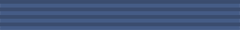 | background.png  background@2x.png | 320x40  640x80 | Used as background in all screens. Width must be 320, height can be different than 40
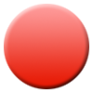 | badge.png  badge@2x.png | 50x50  100x100 | Used as background of label which displays the progress of the user, for example 5 out of 100 answered
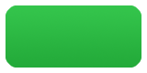 | button1.png  button1@2x.png | 80x40  160x80 | Background of “Play” button
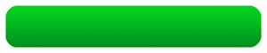 | button2.png  button2@2x.png | 300x60  600x120 | Used as “Continue” button when the user guessed a word correctly, and in the “Get Premium” page to purchase the premium version
 | button3.png  button3@2x.png | 300x60  600x120 | Used as “Continue” button in the “Get Premium” page
 | coins.png  coins@2x.png | 20x20  40x40 | Coin displayed in the win page
 | deleteLetterBtn.png  deleteLetterBtn@2x.png | 38x38  76x76 | Button for deleting incorrect letters for the user
 | fbBtn.png  fbBtn@2x.png | 38x38  76x76 | The user may ask on facebook for help, this is the button
 | hideAdsBtn.png  hideAdsBtn@2x.png | 80x30  160x60 | This button shows the “Get Premium” page on the home screen
 | morecoins.png  morecoins@2x.png | 15x15  30x30 | Used at the top of the playing screen to display the user’s number of coins. Also displayed when the user wants to purchase coins.
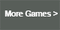 | moreGamesBtn.png  moreGamesBtn@2x.png | 80x40  160x80 | This button displays more games from Chartboost on the home screen
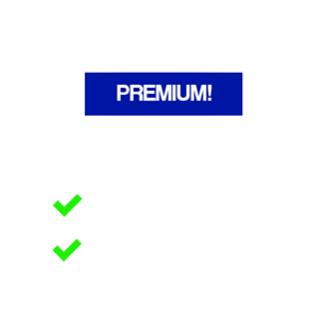 | premium.png  premium@2x.png | 320x320  640x640 | This images is displayed to the user in the “Get Premium” page. It’s supposed to show the benefits of the premium version
 | premiumSmall.png  premiumSmall@2x.png | 50x50  100x100 | This image is displayed when the user wants to purchase coins or the premium version.
 | selectedLetterBG.png  selectedLetterBG@2x.png | 30x30  60x60 | Background image of letter selected by the user
 | settingsBtn.png  settingsBtn@2x.png | 30x20  60x40 | Settings button at the top right of home screen
 | showLetterBtn.png  showLetterBtn@2x.png | 38x38  76x76 | Power up button, lets the user display a correct letter
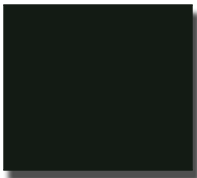 | startBGImage.png  startBGImage@2x.png | 200x180  400x360 | Background of images at the home screen
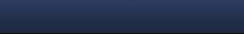 | topbar.png  topbar@2x.png | 320x45  640x90 | Top navigation bar

Strings
You can change some of the strings used in the project. Open the file “Localizable.strings”. All changeable strings are here in the format “Key” = “Value”. You must not change the “Key” string.

