**应用示例**

**电路连接**

|  |  |
| --- | --- |
| 超声波模块 | Arduino UNO |
| VCC | +5V |
| Trig | A2 |
| Echo | A3 |
| GND | GND |

**示例代码**

//HC_SR04 Test

const int TrigPin = A2;

const int EchoPin = A3;

float cm;

void setup()

{

Serial.begin(9600);

pinMode(TrigPin, OUTPUT);

pinMode(EchoPin, INPUT);

}

void loop()

{

digitalWrite(TrigPin, LOW);

delayMicroseconds(2);

digitalWrite(TrigPin, HIGH);

delayMicroseconds(10);

digitalWrite(TrigPin, LOW);

cm = pulseIn(EchoPin, HIGH) / 58.0; //echo time conversion into a distance

cm = (int(cm * 100.0)) / 100.0; //keep two decimal places

Serial.print(cm);

Serial.print("cm");

Serial.println();

delay(1000);

}

程序运行结果：超声波对着墙，测出实时距离，结果如图：

[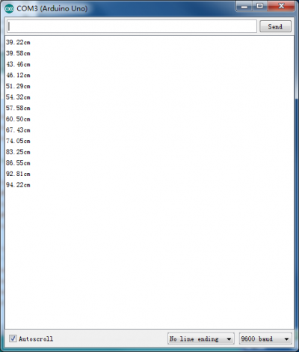](http://www.yfrobot.com/wiki/index.php?title=File:%E8%B6%85%E5%A3%B0%E6%B3%A2%E6%B5%8B%E8%AF%95%E7%BB%93%E6%9E%9C%E5%9B%BE.png)

**注意：TRIP引脚是内部上拉10K的电阻，用单片机的IO口拉低TRIP引脚，然后给一个10us以上的脉冲信号。**===接线方法===  
*uno-SR04  
*2-TRIG   
*3-ECHO  
*5V- VCC  
*GND- GND

[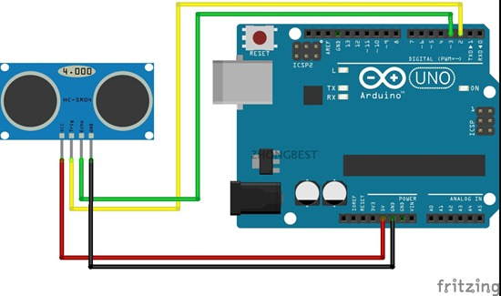](http://zhongbest.com/wp-content/uploads/2016/09/Open-Live-Writer94b6138718bb_8651TB2CpEetpXXXXcxXXXXXXXXXXXX_14857792_2.jpg)

const int TrigPin = 2;  
const int EchoPin = 3;  
float distance;  
void setup()  
{  
Serial.begin(9600);  
pinMode(TrigPin, OUTPUT);  
pinMode(EchoPin, INPUT);  
Serial.println("Ultrasonic sensor:");  
}  
void loop()  
{  
//发一个10μs的高脉冲去触发TrigPin  
digitalWrite(TrigPin, LOW);  
delayMicroseconds(2);  
digitalWrite(TrigPin, HIGH);  
delayMicroseconds(10);  
digitalWrite(TrigPin, LOW);  
  
distance = pulseIn(EchoPin, HIGH) / 58.0; //算成厘米  
Serial.print(distance);  
Serial.print("cm");  
Serial.println();  
delay(1000);  
}

==程序效果==

打开串口监视器可以观察到输出的距离值为当前超声波距前方障碍物的实际距离。

[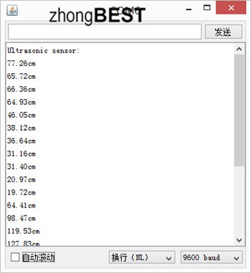](http://zhongbest.com/wp-content/uploads/2016/09/Open-Live-Writer94b6138718bb_8651152123zz738fq6jl7t7m73_2.jpg)