INTERNSHIP REPORT

IN

IBM - SMART BRIDGE

Duration period: 03 June 2019 to 22 June 2019

Submitted by

Aishwaraya Baskar
Talasu Aasritha Narayani

B.Tech. COMPUTER SCIENCE AND ENGINEERING

PROJECT NAME :

SMART- STREET LIGHT MANAGEMENT

USING IBM WATSON

INTRODUCTION

Nowadays, we have remote controls for our television sets and other electronic systems, which have made our lives real easy. We have come up with a system called NODE MCU based Street-Light automation using Basic shield. This system can give the user, the ability to control any electronic device without even spending for a remote control. This project helps the user to control all the lights using any device .
Time is a very valuable thing. Everybody wants to save time as much as they can. New technologies are being introduced to save our time. To save people’s time we are introducing Smart-Street-Light system using NODE MCU . With the help of this system you can control appliances from your mobile phone or laptop. You can turn on/off lights from anywhere.

Project Aim :
The aim of the project is to design and construct a Smart lighting system that will remotely switch on or off the LED or automatically by detection of Light dependent resistance in a specific range.

Project Objective :
The objective of this project is to implement a low cost , reliable and scalable smart lighting system that can be used to remotely switch on or off the LED or if set to automatic mode , uses LDR sensor to detect resistance and turn on if there is light resistance else turn off the LED .

Description of the Project

Street lights are among a city’s strategic assets providing safe roads,inviting pubic area, and enhanced security in home, businesses, and city centers .they’re usually very costly to operate and they use in average 40% of a city’s electricity spending. Its becoming crucial that municipalities, highway companies and other streetlight owners deploy control systems to the lights at right time, to automatically identify lamp and electrical failures and enable real time control.

Based on the intensity levels we can change the intensity of the street lights from the user interface which is created in Node-red platform of IBM Watson services.we can even control all the street light from the user interface

This project is one of the important NODE MCU Projects. NODE- MCU based smart lighting using Basic Shield project helps the user to control lights in your house from any device . The web page sends commands to the controller – NODE- MCU, through the IBM cloud connection. The NODE- MCU is connected to the LED and LDR sensor. When the user presses on the ‘On’ button displayed on the app the LED is switched on. This can be switched off, by pressing the off button. When the user presses the ‘Automatic’ button displayed on the app , it wroks automatically using the data from LDR sensor . It turns on when the LDR sensor senses some light intensities .The mode can be changed simply by clicking the on / off buttons , when in automatic mode.

Hardware Requirement
- Node MCU ➢
- Basic shield
- LDR sensor➢
- Connecting wires
- LED➢➢

Software Requirement ➢
- Arduino IDE
- IBM Watson cloud Service
- MIT app inventor

NODE - MCU with Esp8266
The NODE - MCU is a development board featuring the popular Esp8266 wifi chip . As it turns out, you can program the Esp8266 just like any other micro controller it obvious advantage over the Arduino or PIC is that it can readily connect to the the internet via wifi. However , the Esp8266 breakout board has limited pin although the chip itself has alot of output port. The NODE-MCU solves this problem by featuring 10 GPIO pins each capable of using PWM, I2C and 1-wire interface.

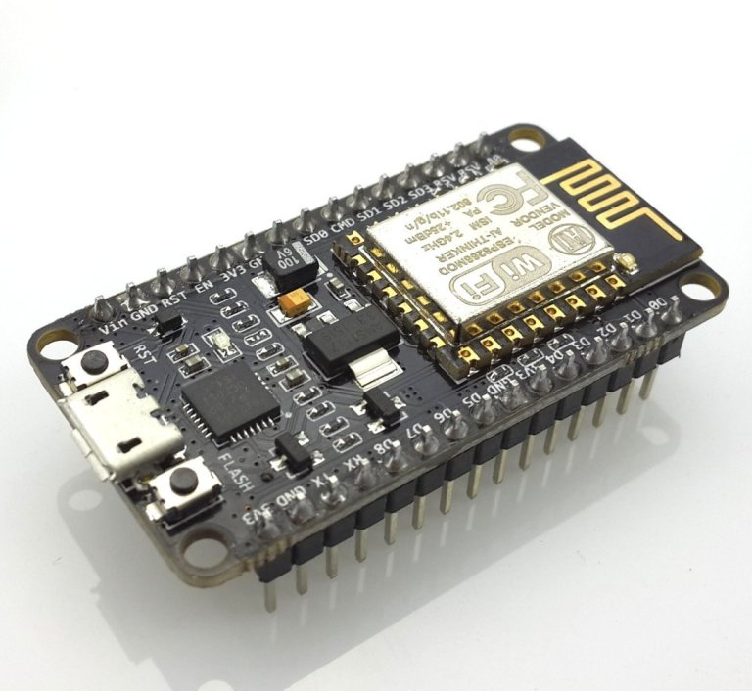

LDR - SENSOR
An LDR is a component that has a Resistance that changes with the light intensity that falls upon it. This allows them to be used in light sensing circuits.
LIGHT SWITCHING:
The most obvious application for an LDR is to automatically turn on a light at a certain light level.
An example of this could be street light or garden light.

WORKING PRINCIPLE:
These devices depends on the light , when light falls on the LDR then the Resistance decreases, and increases in the dark .when a LDR is kept in the dark place , its Resistance is high and , when the LDR is kept in the light its resistance will decreases.
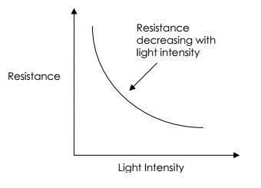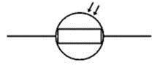
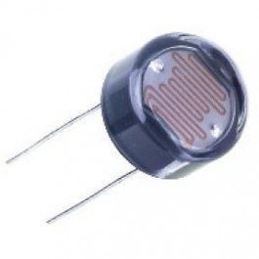

LED LIGHT

LED stands for "light emitting diode." A diode is an electrical component with two terminals which conduct the electricity only in one direction. With an electrical current, the diode emits a bright light around the small bulb

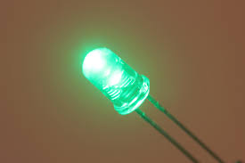

ARDUINO IDE

The open - source Arduino Software (IDE) makes it easy to write the code and upload it to the board . It runs on the windows, Mac OS X, and Linux. The environment is written in java and based on processing and other open - source Software . This Software can be used with any Arduino Board.

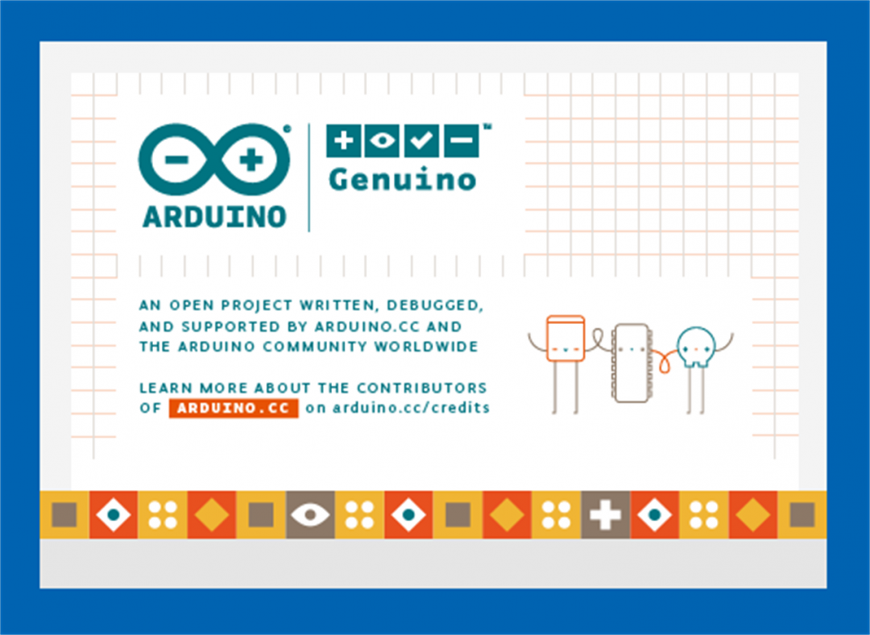

It includes a code editor with processing and wiring. It includes a code editor with features such as text cutting and pasting, searching and replacing text, automatic indenting,brace matching, and syntax highlighting , and provides simple one - click mechanisms to compile and upload programs to an NODE- MCU. It also contains a message area, a text console, a toolbar with buttons for common functions and a hierarchy of operations menus.

The Arduino IDE supplies a software library from the wiring project, which provides many input and output procedures. User - written code only requires two basic functions, for starting the sketch and the main program loop, that are complied and linked with program stub main() into an executable cyclic executive program with the GNU tool-chain.

SKETCH:

* setup() : This function is called once when a sketch starts after power-up or reset. It is used to intialize variables, input and output pin Modes ,and other libraries needed in the sketch.

* loop() : After setup() function exits , the loop() function is executed repeatedly in the main program. It controls the board until the board is powered off or reset

MIT APP INVENTOR
MIT app inventor is an intuitive , visual programming environment that allows everyone to build fully functional apps for Smart Phones and Tablets. By using this app inventor we created an app for this project to make this project as user interface .

It is easy and simple procedure for creating an app . In this two phases are there one is designing phase and second phase is to create blocks for the designed screen.



IBM WATSON CLOUD SERVICES
IBM Watson cloud is an integrated platform that accelerate the shift to becoming a data-driven organization.
In this services we used an IOT platform service for this project . The internet of Things is now a reality due to the convergence of several technologies, including wireless communications, micro-electrical systems and of course, the internet.
IBM Watson IOT platform is a managed, cloud-hosted service designed to make it simple to derive value from your Internet of Things devices.
In this we have the Rules & Actions for Watson IOT. We used this service in the project to store the sensor values and by connecting the data base with the program by using the credentials , it can access the data and performs the program . The results we get only when the device we created in IBM IOT platform is connected to the program.

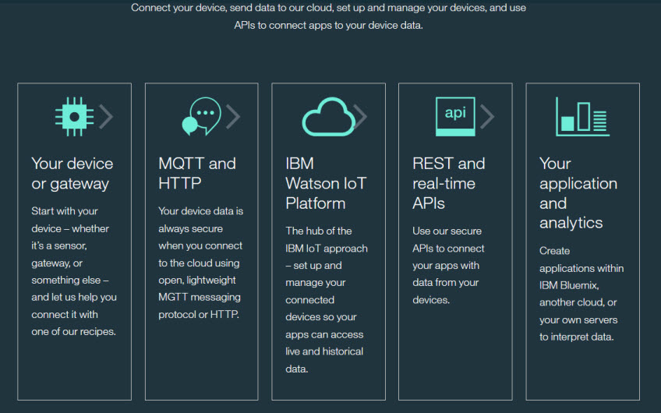

PROJECT CODE :
#include <ESP8266WiFi.h>
#include <PubSubClient.h>
#include <SoftwareSerial.h>
const char* ssid = "Nokia 6";
const char* password = "gopileela";

#define ORG "r0fe4x"
#define DEVICE_TYPE "light"
#define DEVICE_ID "1234"
#define TOKEN "12345678"
String command;
int sensorPin = A0;
int sensorValue = 0;

char server[] = ORG ".messaging.internetofthings.ibmcloud.com";
char topic[] = "iot-2/cmd/home/fmt/String";
char authMethod[] = "use-token-auth";
char token[] = TOKEN;
char clientId[] = "d:" ORG ":" DEVICE_TYPE ":" DEVICE_ID;
//Serial.println(clientID);
void callback(char* topic, byte* payload, unsigned int payloadLength);
WiFiClient wifiClient;
PubSubClient client(server, 1883, callback, wifiClient);
void setup() {
Serial.begin(115200);
Serial.println();
pinMode(D1,OUTPUT);
pinMode(D2,OUTPUT);
pinMode(D3,OUTPUT);
wifiConnect();
mqttConnect();
}

void loop() {
sensorValue = analogRead(sensorPin);

Serial.println(sensorValue);
if (!client.loop()) {
mqttConnect();
}
delay(100);
}

void wifiConnect() {
Serial.print("Connecting to "); Serial.print(ssid);
WiFi.begin(ssid, password);
while (WiFi.status() != WL_CONNECTED) {
delay(500);
Serial.print(".");
}
Serial.print("nWiFi connected, IP address: "); Serial.println(WiFi.localIP());
}

void mqttConnect() {
if (!client.connected()) {
Serial.print("Reconnecting MQTT client to "); Serial.println(server);
while (!client.connect(clientId, authMethod, token)) {
Serial.print(".");
delay(500);
}
initManagedDevice();
Serial.println();
}
}
void initManagedDevice() {
if (client.subscribe(topic)) {
Serial.println("subscribe to cmd OK");
} else {
Serial.println("subscribe to cmd FAILED");
}
}

void callback(char* topic, byte* payload, unsigned int payloadLength) {
Serial.print("callback invoked for topic: "); Serial.println(topic);

for (int i = 0; i < payloadLength; i++) {
//Serial.println((char)payload[i]);
command += (char)payload[i];
}
Serial.println(command);
if(command == "LIGHT1ON"){
digitalWrite(D1,HIGH);
Serial.println("Light is Switched ON");
}
else if(command == "LIGHT1OFF"){
digitalWrite(D1,LOW);
Serial.println("Light is Switched OFF");
}
if(command == "LIGHT2ON"){
digitalWrite(D2,HIGH);
Serial.println("Light is Switched ON");
}
else if(command == "LIGHT2OFF"){
digitalWrite(D2,LOW);
Serial.println("Light is Switched OFF");
}
if(command == "LIGHT3ON"){
digitalWrite(D3,HIGH);
Serial.println("Light is Switched ON");
}
else if(command == "LIGHT3OFF"){
digitalWrite(D3,LOW);
Serial.println("Light is Switched OFF");
}
else if(command == "AUTOMATIC"){
if(sensorValue>800){

digitalWrite(D1,HIGH);
digitalWrite(D2,HIGH);
digitalWrite(D3,HIGH);

Serial.println("Light is Swithed ON");
delay(1000);
}
else if(sensorValue<=800)
{
digitalWrite(D1,LOW);
digitalWrite(D2,LOW);
digitalWrite(D3,LOW);
Serial.println("Light is Swithed OFF");
delay(sensorValue);

}
}

command ="";

}

WORKING
comprises of buttons :
- LIGHT1ON :
When you click the button the LED is switched on .
- LIGHT1 OFF :
- When you click the button the LED is switched off .
- LIGHT2 ON :
When you click the button the LED is switched on .
- LIGHT2 OFF :
- When you click the button the LED is switched off
- .LIGHT3 ON :
When you click the button the LED is switched on .
- LIGHT3 OFF :
When you click the button the LED is switched off

- Automatic :
When you click this button .The controls is taken by the arduino board based on the output of the LDR sensor . Whenever lighting is not there in specific region , the LDR sensor detects the value of light resistance if it is decreases and it turns on the LED.If there is increase in resistance detected the LED is turned off.
The change of mode is displayed in the app
This can be overridden by simply using the light on and light off buttons.
- The status of the LED is printed in IBM

CONCLUSION
- Thus a wireless control over the lights has be established using NODE- MCU and the BASIC shield.
- The automatic functionality needs no human interaction and also works well saving more energy .
- The smart light system has been experimentally proven to work satisfactorily .
- This provides comfort for elderly or disables people.
- This system could be used in street light where the light turn on when it detects LIGHT resistance
- Thus a low-cost home smart light system was successfully designed, implemented and tested.

