1. **EMPLOYEE ATTRITION PREDICTION**

**1.1 Introduction**

**Python** is an [interpreted](https://en.wikipedia.org/wiki/Interpreted_language), [high-level](https://en.wikipedia.org/wiki/High-level_programming_language), [general-purpose](https://en.wikipedia.org/wiki/General-purpose_programming_language) [programming language](https://en.wikipedia.org/wiki/Programming_language). It was created by Guido van Rossum, and released in 1991.

It is used for:

* web development (server-side),
* software development,
* mathematics,
* system scripting.

Python has syntax that allows developers to write programs with fewer lines than some other programming languages.

Python runs on an interpreter system, meaning that code can be executed as soon as it is written. It is designed for readability

What can I do with Python?

* System Programming
* Graphical User Interface
* Internet Scripting
* Component Integration
* Database Programming
* Gaming, Images, XML, Robot

**Artificial intelligence (AI)** is an area of research that goes back to the very beginnings of computer science. The possibility of building a machine that can perform tasks that require human

             The term Artificial Intelligence has been applied to computer systems and programs capable of performing tasks more complex than basic programming.The most important fields of research in this area include information processing, pattern recognition, and practical fields such as medical diagnosis. Systems are being created that can understand speech and game playing computers are being created that can beat even the best human chess player.

Applications of artificial intelligence

* Knowledge reasoning
* Planning
* Machine Learning
* Natural language processing
* Computer vision
* Robotics

There are various programming languages like Lisp, Prolog, C++, Java and Python, which can be used for developing applications of AI. Among them, Python programming language gains a huge popularity and the reasons are as follows −

### Simple syntax & less coding

Python involves very less coding and simple syntax among other programming languages which can be used for developing AI applications. Due to this feature, the testing can be easier and we can focus more on programming.

### Inbuilt libraries for AI projects

A major advantage for using Python for AI is that it comes with inbuilt libraries. Python has libraries for almost all kinds of AI projects. For example, NumPy, SciPy, matplotlib, nltk, Simple AI are some the important inbuilt libraries of Python.

* Open source − Python is an open source programming language. This makes it widely popular in the community.
* Can be used for broad range of programming − Python can be used for a broad range of programming tasks like small shell script to enterprise web applications. This is another reason Python is suitable for AI projects.
* **Robotics**
* **Machine vision**
* **Natural language processing (NLP)**
* **Self-driving cars**

**1.2 OBJECTIVES OF RESEARCH**

The main role of this research is to identify to predict whether an employee of a company will leave or not, using the k-Nearest Neighbors algorithm. We use evaluation of employee performance, average monthly hours at work and number of years spent in the company, among others, as our features. The approaches to this problem include the use of ANN (Artificial Neural Networks), decision trees and logistic regression.

Attrition may be defined as gradual reduction in membership or personnel as through retirement, resignation or death. In other words, attrition can be defined as the number of employees leaving the organization which includes both voluntary and involuntary separation.

Some organizations have a long hiring lead time because of the time required for security background checks (> 6 months). This study developed a methodology to forecast employee attrition at organizational and departmental levels to shorten this time.

It also investigated attrition seasonal patterns and such factors as employee demographics, job categories, and organization structures; identified influential financial indices; and measured the magnitude of retention.

This research was done in two stages. The first stage was advancement of ANN algorithm. The second stage we used the UI (User Interface) with node red.

The purpose of this paper is to study patterns and use predictive analytics to correlate with the real-world situation of leaving the business school.

**1.3 Problem Statement**

Employee attrition can have a severe impact on your business, both financially and emotionally. If you suspect that attrition is an issue for the company business, you should take steps to recognize possible causes of turnover, measure your attrition rate, determine attrition costs, and then address your attrition problems.

With this application the we can determine the scope of the employees leaving or still working with the company in the future by considering all the possibilities (independent variables).

1. **REVIEW OF LITERATURE**

Denvir and McMahon (1992) define labour turnover as “the movement of people into and out of employment within an organization”.

While Mobley (1982) defines turnover as “voluntary cessation of membership in an organization by an individual who receives monetary compensation for participating in that organization”.

Meaghan et al (2002) draws attention on controlling attrition, he states that the value of employees to an organization is a very crucial element in the success of the organization. He further states that this value is intangible and cannot easily be replicated, therefore, the managers should control attrition.

Mobley (1977) suggests a measure to predict attrition, he says that tenure of an employee is one of the best measures that can be used to predict turnover.

Firth et al (2007) tries to find out the causes of attrition, he says that there are a range of factors that lead to job related stress, lack of commitment towards the organization and job dissatisfaction which cause employees to quit. Griffeth et al.

(2000) concludes that pay and pay-related variables have a significant effect on employee turnover.

Hom & Griffeth (1995) state that several investigations in the past have revealed that organizational commitment and job satisfaction are crucial factors that influence turnover intention.

Wanous (1992) focuses on new employee attrition and says that new employees often leave the organization because their expectations are not met which results into a violation of their psychological contract resulting into turnover.

Abassi et al (2000) conclude that there are other factors like inefficient and poor recruitment practices, style of management, lack of recognition, work place conditions, and a lack of competitive compensation system that cause employees to quit the organization.

Louis (1980) states that attrition takes place because new employees compare their actual experience with their past work experiences. Past work experience plays significant role in taking decision to quit in case the new worker’s expectations are not met.

Ongori (2007) focuses on stress as a cause of attrition; he says that the good workers in organization may tend to leave when they start experiencing signs of occupational stress.

This turnover affects the organization adversely in increasing the recruitment and selection costs of the organization.

1. **DATA COLLECTION**

The data contains:

Employee id, employee record date ( year of data), birth date ,hire date ,termination date, age, length of service ,city department ,job ,title ,store number, gender, termination reason, termination type, status, year, status ,business unit

**Acknowledgements**

None- its fake data

**Inspiration**

A lot of turnover analyses occur at an aggregate level-such as turnover rates. But few analyses concentrate on trying to identify exactly which individuals might leave based on patterns that might be present in existing data.

Machine learning algorithms often showcase customer churn examples for Telco’s or product marketing. Those algorithms equally apply to employee churn.

**Columns**

* EmployeeID
* recorddate_key
* birthdate_key
* orighiredate_key
* terminationdate_key
* age
* length_of_service
* city_name
* department_name
* job_title
* store_name
* gender_short
* gender_full
* termreason_desc
* termtype_desc
* STATUS_YEAR
* STATUS
* BUSINESS_UNIT

**4.METHODOLOGY**

**4.1 Exploratory Data Analysis**

**4.1.1 Figures and Tables**

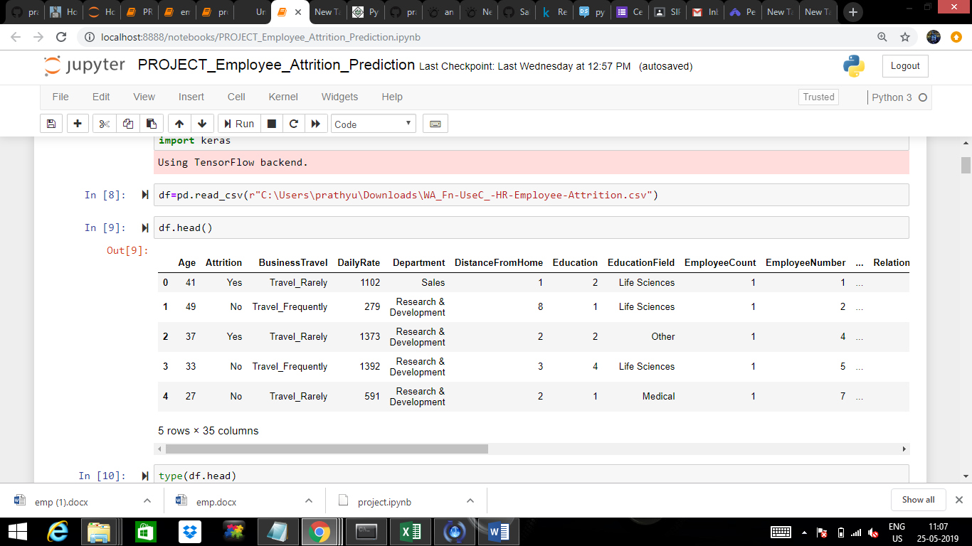

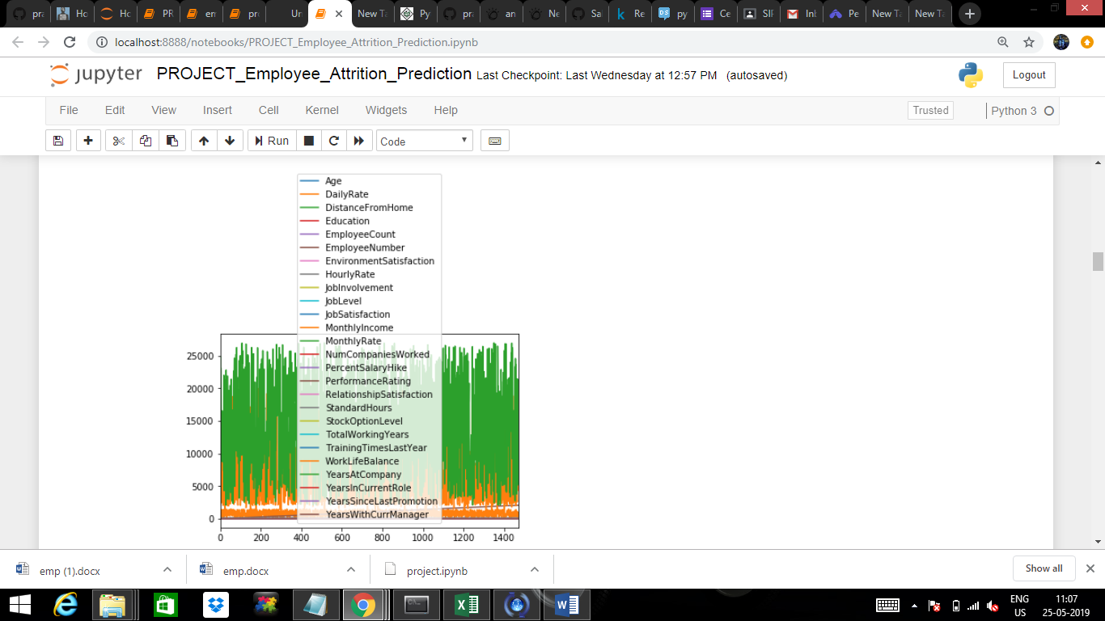

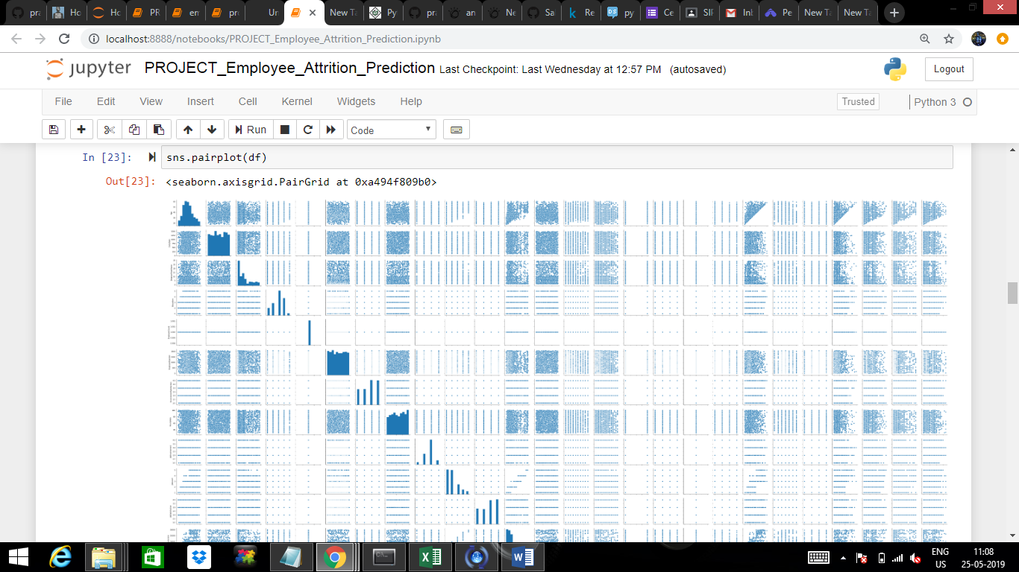

**4.2 Data Modelling**

The algorithm applied is ANN (Artificial Neural Networks) in Employee Attrition Prediction model.

**Artificial Neural Networks**

Artificial neural networks (ANN) or connectionist systems are computing systems vaguely inspired by the [biological neural networks](https://en.wikipedia.org/wiki/Biological_neural_network) and [astrocytes](https://en.wikipedia.org/wiki/Astrocytes) that constitute animal [brains](https://en.wikipedia.org/wiki/Brain). Such systems "learn" to perform tasks by considering examples, generally without being programmed with any task-specific rules. Instead, they automatically generate identifying characteristics from the learning material that they process.

An ANN is based on a collection of connected units or nodes called [artificial neurons](https://en.wikipedia.org/wiki/Artificial_neuron), which loosely model the [neurons](https://en.wikipedia.org/wiki/Neuron) in a biological brain. Each connection, like the [synapses](https://en.wikipedia.org/wiki/Synapse) in a biological brain, can transmit a signal from one artificial neuron to another.

An artificial neuron that receives a signal can process it and then signal additional artificial neurons connected to it.

There are two Artificial Neural Network topologies –

* Feed Forward
* Feedback

### Feed Forward ANN

In this ANN, the information flow is unidirectional. A unit sends information to other unit from which it does not receive any information. There are no feedback loops. They are used in pattern generation/recognition/classification. They have fixed inputs and outputs.

**Feed Back ANN**

Here, feedback loops are allowed. They are used in content addressable memories.

### Components of an Artificial Neural Network

#### **Neurons**

A neuron with label {\displaystyle j} receiving an input {\displaystyle p_{j}(t)} from predecessor neurons consists of the following components:

* an activation {\displaystyle a_{j}(t)}, the neuron's state, depending on a discrete time parameter,
* possibly a threshold {\displaystyle \theta _{j}}, which stays fixed unless changed by a learning function,
* an activation function {\displaystyle f} that computes the new activation at a given time {\displaystyle t+1} from {\displaystyle a_{j}(t)}, {\displaystyle \theta _{j}} and the net input {\displaystyle p_{j}(t)} giving rise to the relation
* And an output function {\displaystyle f_{out}} computing the output from the activation . . . Often the output function is simply the [Identity function](https://en.wikipedia.org/wiki/Identity_function).

An input neuron has no predecessor but serves as input interface for the whole network. Similarly, an output neuron has no successor and thus serves as output interface of the whole network.

#### Connections, weights and biases

The network consists of connections, each connection transferring the output of a neuron {\displaystyle i} to the input of a neuron {\displaystyle j}. In this sense {\displaystyle i} is the predecessor of {\displaystyle j} and {\displaystyle j} is the successor of {\displaystyle i}. Each connection is assigned a weight {\displaystyle w_{ij}}. Sometimes a bias term is added to the total weighted sum of inputs to serve as a threshold to shift the activation function.[[51]](https://en.wikipedia.org/wiki/Artificial_neural_network#cite_note-Abbod2007-51)

#### Propagation function

The propagation function computes the input {\displaystyle p_{j}(t)} to the neuron {\displaystyle j} from the outputs {\displaystyle o_{i}(t)} of predecessor neurons and typically has the form.

1. **Findings and Suggestions**{\displaystyle p_{j}(t)=\sum _{i}o_{i}(t)w_{ij}}

For creating the employee attrition prediction model using ANN algorithm

Sources:

Data Science

Kaggle

Suggestions:

a. Global recession and attrition can be taken as an issue for discussion and research.

b. Attrition and women labour force can be studied and undertaken as a topic for research

c. Attrition in sales force can be taken as a vibrant topic for future researches.

**6.CONCLUSION**

* Attrition is inevitable; it will always prevail; it can only be minimised

• Intrinsic factors are equally and sometimes more important than extrinsic factors

while controlling attrition.

• Effective leadership; to a great extent, may be helpful to control attrition

• Attrition does not always have a negative impact on the organization

**7 ways to Reduce Employee Attrition**

**Communicate the vision**

While you may be able to articulate the purpose or vision of your business, your employees might not have a clear idea on what your business stands for and in which direction it is going. When your staff is in the loop of what’s driving the business, they will share in the same vision that you have. It earns their dedication and commitment.

**Optimize Recruitment**

You can optimize your [recruitment process](http://recruitloop.com/blog/who-really-needs-to-get-involved-in-the-recruitment-process/) by starting with clear and specific requirements. Set goals for hiring for a position and clearly list the tasks and responsibilities, and what value the position will bring to your business. An objective and focused [candidate profile](http://recruitloop.com/blog/recruiter-tips-how-to-write-a-powerful-candidate-profile/) should also outline what knowledge and previous work experience a candidate is expected to have. Make it relevant to the job requirement.

**Make the interview matter**

The [interview questions](http://recruitloop.com/blog/behavioural-interview-questions/) should be based on past and present work performance and behaviours. Allow the candidate to demonstrate their skill levels, motivations and competencies in their fields of experience. Ask for more information regarding their previous work experiences. When you need to interview more than one candidate, it is best to [prepare a list of core questions](http://recruitloop.com/blog/5-interview-questions-for-managers-to-ask-every-candidate/) in order to be able to evaluate them fairly.

**Improve work conditions**

What you offer as work benefits is a big deal for your employees. Top companies that are known for their perks for their employees have strong development programs, outstanding benefits not only for employees but also to their families, and fun [work cultures](http://recruitloop.com/blog/zappos-hiring-for-culture-and-the-bizarre-things-they-do/). When a business knows to meet the needs of their employees beyond the office, they benefit more from their employees. While you may not be able to compete with what Google, Facebook and all the other big guys have to offer, you can improve work conditions by offering [flexible work schedules](http://recruitloop.com/blog/why-workplace-flexibility-is-good-for-business/) that help promote a work-life balance.

**Create a pleasant workspace**

Other way would be to [invest in a workspace](https://www.findmyworkspace.com/) that employees would want to go to. Employees spend almost half a day inside their workplaces. Any person would want that place to be where they are most [productive, happy, healthy, and engaged](http://recruitloop.com/blog/5-employee-self-care-practices-support/). A person’s well-being affects his productivity and work performance, so it is common sense to provide for such. According to studies like Gensler’s Workplace Index, there should be spaces for collaboration, for learning, for socialization, and for more focused work or activities. When your workspace is a place that allows your staff to be able to [work productively](http://recruitloop.com/blog/5-workplace-management-tips-for-increasing-productivity/), they would love coming to work and love the work that they do.

**Benefits and Perks**

The most common reason employees leave is because of the their salary. No matter how loyal and how driven they are with the company’s vision, if it cannot meet with their financial needs, they often look for new jobs. Your salary packages and increases should be prevalent with the current range of your competitors.

**Employee enagement**

When you have talented employees, you need to find ways that you can help them expand their skill set. Give your feedback, let them know what you think. Pay attention, and let them know that you are there for them. If you don’t engage with them, they will get bored and complacent, and think that they are not growing within the organization.