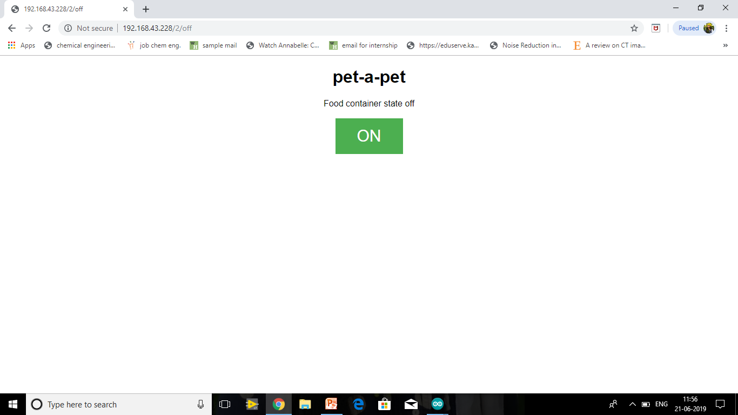

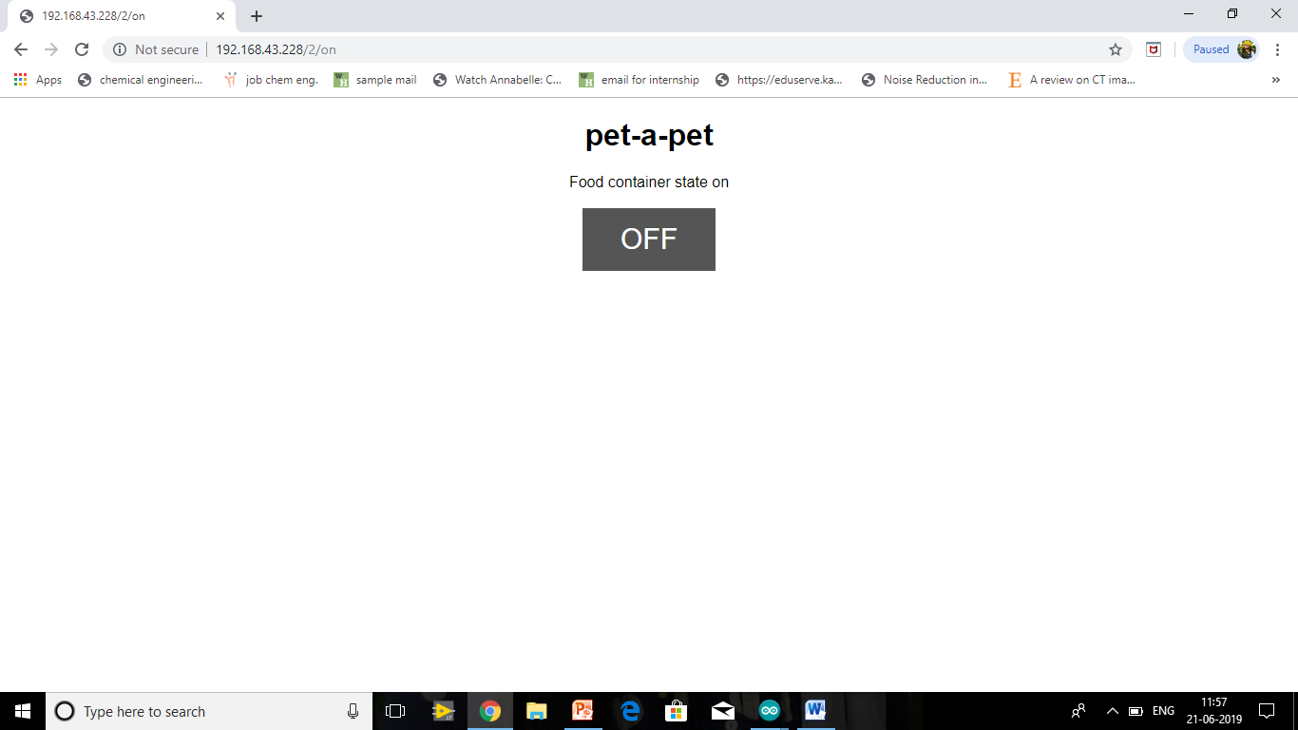

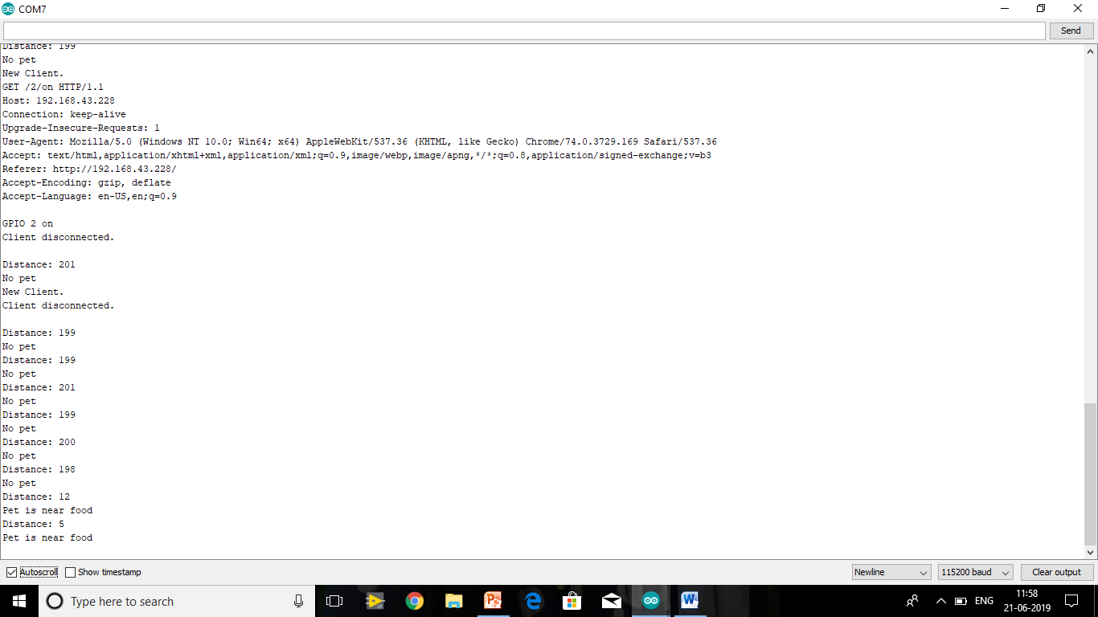

PET – A - PET

**Esther Emmanuel**

**Daffinia F**

**Swathi P**

**A J Hernisha Antony**

**J Jaziz Jerusha Paulin**