Project plan: the Riverside Community Kitchen
November 10, 2026

Project plan: the Riverside Community Kitchen

Executive Summary and Authorisation
This plan authorises the Riverside Community Kitchen. Its objective: Open a community kitchen that serves 200 meals a week. The sponsor is Riverside Trust. The declared budget is USD 48,000.00. The critical path runs 40 periods, with 3 critical activities. The plan carries the charter, scope, work breakdown, schedule, cost, assignments and risks; a record that is missing is named rather than guessed.

Project Charter
Figure 1. Project charter
Field | Value
• Title | • the Riverside Community Kitchen
• Objective | • Open a community kitchen that serves 200 meals a week.
• Sponsor | • Riverside Trust
• Project manager | • Alex Rivera
• Budget | • USD 48,000.00
• Start | • 2026-01-05
• End | • 2026-06-30
The charter authorises the Riverside Community Kitchen under Riverside Trust. The project manager is Alex Rivera. The declared budget is USD 48,000.00. Work starts on 2026-01-05. It is due on 2026-06-30.

Scope and Exclusions
Figure 2. Scope and deliverables
Direction | Item
• In scope | • Kitchen fit-out
• In scope | • Permit applications
• Out of scope | • Delivery service
• Deliverable | • Kitchen open
• Deliverable | • Permit issued
The scope declares 2 included items, 1 exclusion and 2 deliverables. The WBS decomposes the deliverables; the exclusions bound the work the project will not do.

Work Breakdown Structure
Figure 3. Work breakdown structure
ID | Work package | Owner | Cost | Acceptance
• A1 | • Design the kitchen | • Architect | • USD 6,000.00 | • Drawings signed
• A2 | • Apply for the permit | • Project manager | • USD 2,000.00 | • Permit issued
• A3 | • Fit out the kitchen | • Builder | • USD 30,000.00 | • Handover signed
• A4 | • Install equipment | • Supplier | • USD 10,000.00 | • Equipment commissioned
The WBS carries 4 nodes and 4 work packages. Each work package states an owner, a cost and the test that shows it is complete; the parent nodes carry the roll-up.

Schedule
Figure 4. Critical path schedule
ID | Activity | Duration | ES | EF | LS | LF | Float | Critical
• A1 | • Design | • 10.0 | • 0 | • 10.0 | • 5.0 | • 15.0 | • 5.0 | • no
• A2 | • Permit | • 15.0 | • 0 | • 15.0 | • 0.0 | • 15.0 | • 0.0 | • yes
• A3 | • Fit out | • 20.0 | • 15.0 | • 35.0 | • 15.0 | • 35.0 | • 0.0 | • yes
• A4 | • Install | • 5.0 | • 35.0 | • 40.0 | • 35.0 | • 40.0 | • 0.0 | • yes
The schedule carries 4 activities. The critical path runs 40 periods and carries 3 critical activities. Early and late dates and float are the frozen method's own values; an activity with float is not on the critical path.

Schedule chart
Figure 5. Project schedule
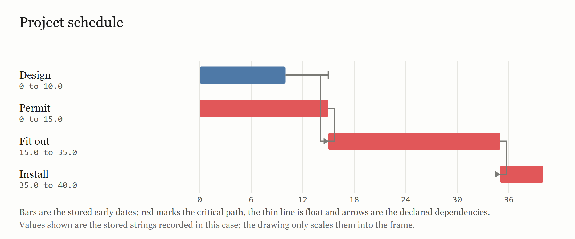

Activity network
Figure 6. Activity network
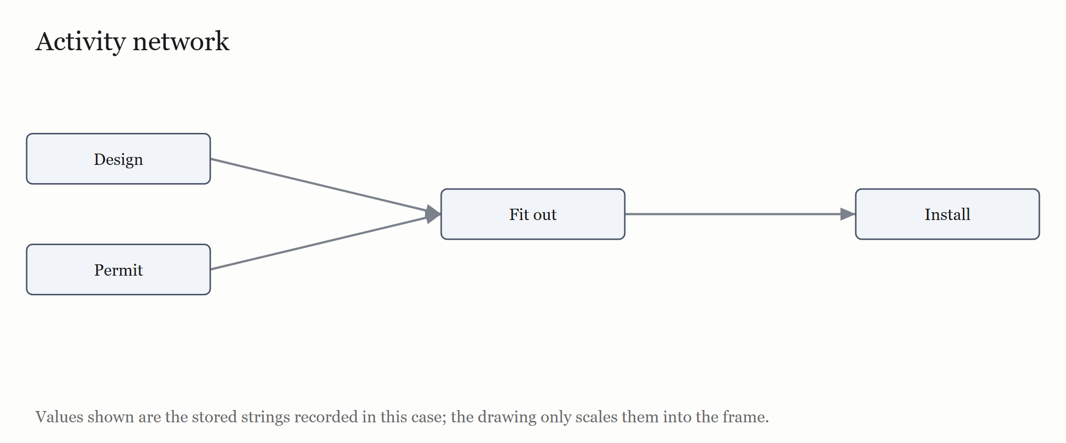

Planned completion
Figure 7. Planned completion curve
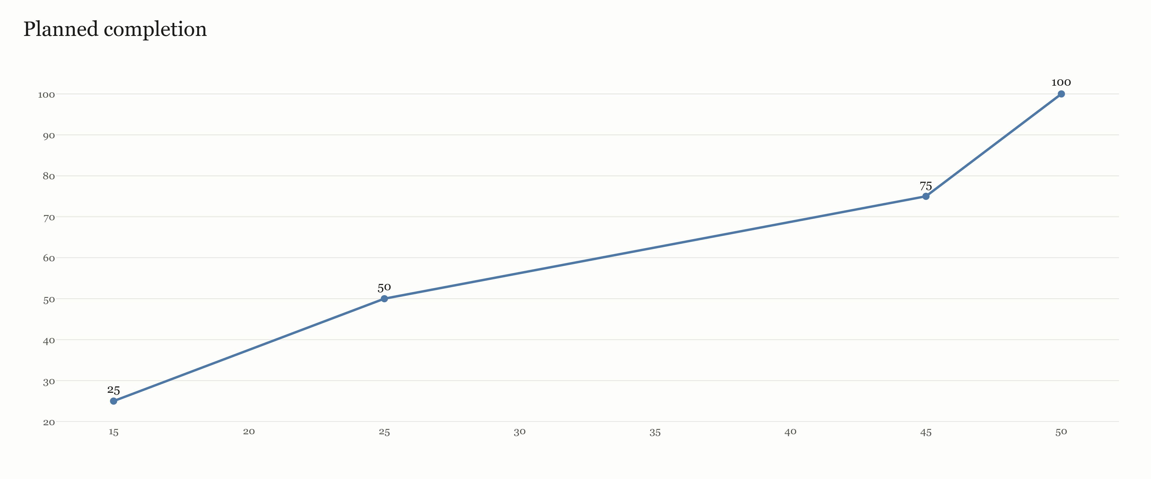

Dated Schedule
Figure 8. Dated schedule
ID | Activity | Start | Finish | Working days
• A1 | • Design | • 2026-01-05 | • 2026-01-16 | • 12
• A2 | • Permit | • 2026-01-05 | • 2026-01-23 | • 19
• A3 | • Fit out | • 2026-01-26 | • 2026-02-20 | • 26
• A4 | • Install | • 2026-02-23 | • 2026-02-27 | • 5
Dates count one declared period as one working day, Monday to Friday, from the declared start date of 2026-01-05. A finish is the last working day of the activity; weekends are a gap and no holiday is inferred.

Resource-Levelled Schedule
Figure 9. Resource-levelled schedule
ID | Activity | Levelled start | Levelled finish | Delay
• A1 | • Design | • 15 | • 25 | • 15
• A2 | • Permit | • 0 | • 15 | • 0
• A3 | • Fit out | • 25 | • 45 | • 10
• A4 | • Install | • 45 | • 50 | • 10
The frozen resource-levelling method orders activities by early start, then longest duration, then id, and delays an activity until its declared resource has capacity. It adds 10 periods, so the plan finishes in 50 periods against 40 without resource limits. 10 periods were over capacity before levelling and 0 after; the peak demand was 2 before and 1 after.

Resource load
Figure 10. Resource load by period
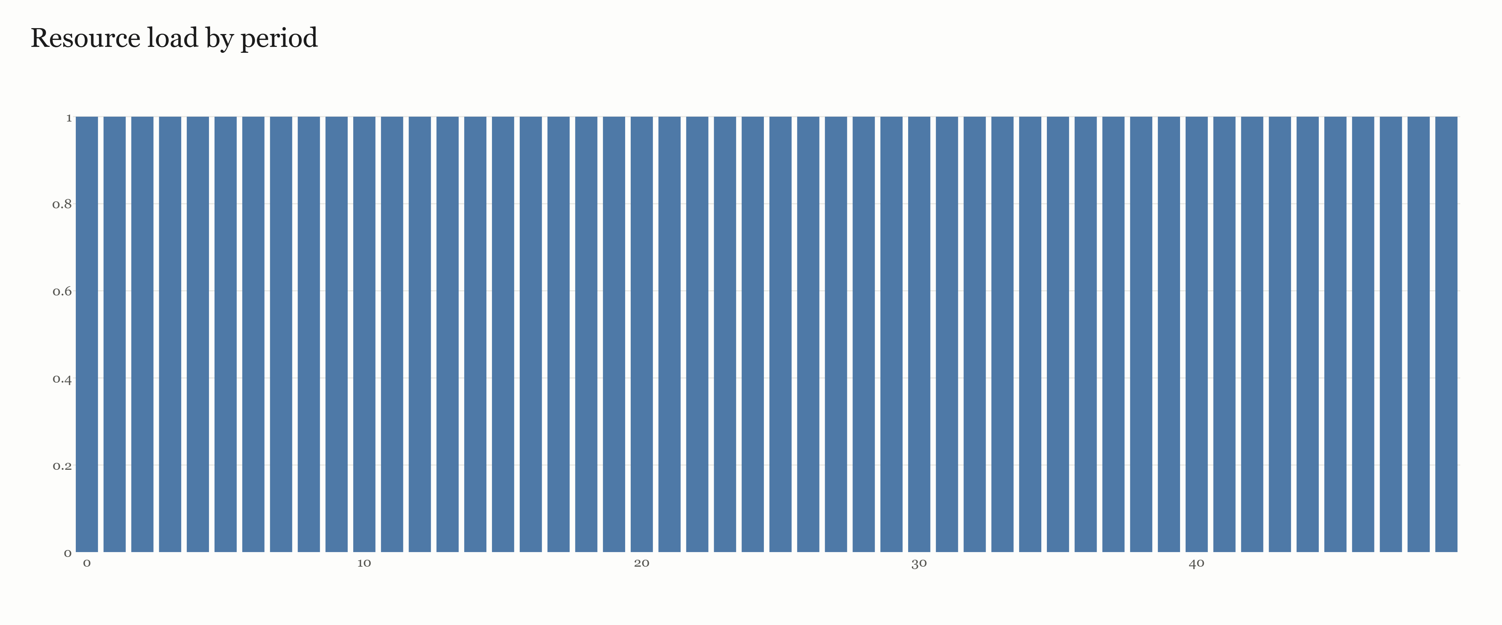

Cost Plan
Figure 11. Cost roll-up by work package
ID | Item | Cost
• A1 | • Design the kitchen | • USD 6,000.00
• A2 | • Apply for the permit | • USD 2,000.00
• A3 | • Fit out the kitchen | • USD 30,000.00
• A4 | • Install equipment | • USD 10,000.00
• | • Total | • USD 48,000.00
The WBS rolls 4 nodes up to a total of USD 48,000.00. The declared budget is USD 48,000.00; the variance is USD 0.00. Cost is carried by the work package, not by the activity; no estimate is added where the record declares none.

Organisation and Assignments
Figure 12. Resources
Name | Role | Capacity
• Architect | • Design | • 1.0
• Project manager | • Management | • 1.0
• Builder | • Build | • 1.0
• Supplier | • Equipment | • 1.0
The plan names 4 resources. Every activity carries exactly one accountable role and at least one responsible role in the RACI matrix; a blank cell or a missing role is a named gap, not an inferred assignment.

RACI Matrix
Figure 13. RACI responsibility matrix
Activity | Name | Design | Management | Build | Equipment
• A1 | • Design | • R | • A | • | •
• A2 | • Permit | • | • A | • | •
• A3 | • Fit out | • | • A | • R | •
• A4 | • Install | • | • A | • | • R
The matrix names, for every activity, the roles the record declares as responsible and accountable, and the consulted or informed roles it states.

Risk Register
Figure 14. Risk register
ID | Risk | Likelihood | Impact | Response | Owner
• R1 | • Permit delay | • Medium | • High | • Apply early | • Project manager
The register carries 1 risk. Likelihood and impact are labels, not probabilities, and each risk states a response and an owner. No risk score or expected loss is computed.

Governance and Change Control
The sponsor chairs a monthly review with the project manager Any scope change is approved in writing by the sponsor Decisions above the stated change threshold go to the sponsor; decisions below it stay with the project manager. The plan records the arrangement the student declared and adds no approval route of its own.

Monitoring and Success Measures
Figure 15. Success measures, assumptions and constraints
Item | Type
• 200 meals a week by month six | • success measure
• The lease is signed before work starts | • assumption
• The kitchen must open before June | • constraint
Progress is judged against 1 success measure, 1 assumption and 1 constraint. A success measure without a baseline is reported as stated, not converted into a target.

Limitations
The plan is limited to the record the student supplied. The CPM uses the declared single-point durations; PERT was not run unless the record asks for it. Costs are work-package estimates, not commitments. The plan does not assess procurement, financing or benefits beyond the declared success measures, and it does not rank the risks. The schedule and cost are tied to the WBS as recorded, so a changed scope changes both and must follow the change-control route above. A reader should treat the named gaps as open questions, not as conditions already met.

Conclusion
The plan states what the project delivers, how it is broken down, what it costs, who does the work and what could go wrong. The WBS rolls up to USD 48,000.00 against a declared budget of USD 48,000.00. The critical path is 40 periods over 4 activities.

References
No sources were used.

