SMART CARE

Anjana Soman
Athira N Kaimal
Devipriya U
Lavanya J

Under The Guidance of ICFOSS (International Centre for Free and Open Source Software)

ABSTRACT

The Smart Care system is aimed to prevent delays in the arrival of patients’ medical information to the healthcare providers, particularly in emergency situations The architecture for this system is based on medical sensors which measure patients physical parameters by using wireless sensor networks (WSNs).These sensors transfer data from patients’ body over the wireless network to the cloud environment using open hardware like Arduino or Raspberry Pi. Data mining techniques are used to extract an appropriate decision based on patient’s condition and historical medical data.This system notifies nearby healthcare providers, ambulance services and inform relatives of patient’s info in case of emergency without time delay.The proposed system is an economy intelligent automated health monitor and control system to help the bed-ridden patient by monitoring the patient’s heart rate, pressure, body temperature, bed position and flow rate of oxygen , comparing those values with the prescribed values, taking care of the patient accordingly and interacting with medical staff, by stander, ambulance services through GSM in case of any abnormalities (or) critical position.

CONTENTS

Introduction
System Analysis
- Existing System
- Proposed System
- System Architecture
Conclusion

INTRODUCTION

Managing bedridden patients is an important issue as many people are involved in it and patients need round the clock assistance. Any reduction in the number of people involved and the amount of efforts required is going to benefit a large section of the society. Bedridden patients need to be managed in hospitals or at homes and this involves number of people. Apart from the patient, the others involved are family members of the patient, doctors, nursing staff and other caretakers. In bedridden patients, the management of the normal physiological functions is a difficult and sensitive issue.Therefore, an attempt is being made, to reduce the amount of assistance required in managing these patients by designing a new bed for such patients.

The population of India was estimated to be 1.3 billion by December 2015 and a significant number of them are bedridden due to age related problems. Apart from this, many people are forced to be bedridden because of various reasons like – paralysis, orthopedic problems, vehicle & otheraccidents, etc. These bedridden people need almost round the clock assistance and care from their relatives, care takers, doctors, etc. This problem is compounded as the system of joint family is almost nonexistent now and round the clock assistance is not available in the family, to take care of bedridden patients. Any reduction in the number of people involved and the amount of efforts required in managing such patients is going to benefit a large section of the society. Therefore, it is necessary to develop some kind of healthcare system by which such patients can be managed easily.

In the area of equipment or system design for bedridden healthcare, few published works are available. As bed is the most important unit in this healthcare system, major focus is on the design of beds or related systems so that the patients can be managed without much assistance. Various researchers have tried different approaches for designs of such healthcare systems.

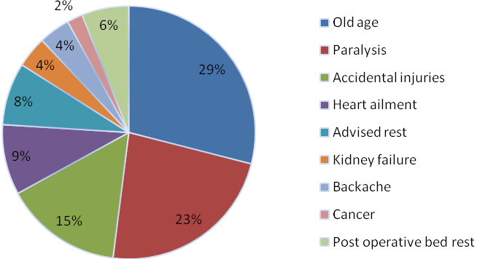

Figure: Patients covered in the survey (Courtesy: Design of Bed for Bedridden Patients: Determination of Design Criteria)

SYSTEM ANALYSIS

EXISTING SYSTEM

Senior hospital Namyangju,Korea provide suitable environment for senior patients real time monitoring and alarm to staff for any emergency condition for elders by tracing location and amount of movment to guarantee health and safety.

In European and US countries,many adults will be living alone.For their safety U.S. Department of Health and Human Services: Administration for Community Living (ACL) has introduced a device
where Wireless sensors throughout his house help measure healthy activity levels, sleeping patterns and medication schedules.In emergency condition the nearby health service and family members are alerted.

Aerocrine’s NIOX MINO creates exhaled nitric oxide (NO) monitoring devices that provide data about asthma for research and clinical applications. The NIOX MINO is a small, hand-held device that takes routine measurements of NO in a patient’s breath, which can improve the management of asthma and other inflammatory airway conditions. When a patient breathes into the mouthpiece of the device, the levels of NO in their breath are calculated to determine if there is airway inflammation and the best medication to treat it. The data that is collected can be synced with electronic medical record systems.

The disadvantages of the existing system is
- Expensive
- They cannot cover all the health related issue

So we propose a system that is cost effective for this issue.

PROPOSED SYSTEM
The architecture of the proposed system is based on the integration between WSNs and using cloud environment to provide an automated smart health system.Sensors are used to measure the physical parameters of the patient such as heart rate,movment,Movement etcsThese sensors transfer data from patients’ body over the wireless network to the cloud environment using open hardware like Arduino or Raspberry Pi.This system notifies nearby healthcare providers, ambulance services and inform relatives of patient’s info in case of emergency without time delay.
The value of the sensors are passed through cloud.The database in the cloud has the details of the patient. Before saving the data in the cloud,the values are checked if it is not normal rate but little high a notification is given to the Doctor.The doctor check the result and suggest the appropriate measure to be taken. If the patient is in critical stage we inform the nearby ambulance service through GSM and by standers are alerted by an alarm.
The parameters measured will be
- The movement of the patient (using accelerometer)
- Temperature
- Pulse and Oxygen rate in blood(SPO2)
- Glucose in the blood(glcometer)
- Sweating
- Breathing
- ECG(ecg sensors)

Advantages
- Real time monitoring of bedridden patients at home to overcome delay in access to health care services.
- Since the whole system is automated it provides assistance of medical staff only when required
- Reducing manual data entry of patients data by medical staff.

SYSTEM ARCHITECTURE
Informing nearby ambulance service and
by stander



Checking
System

Sensors + GSM Module
Patient
critical

normal

mildly abnormal

Device




Ambulance service
Sending present condition

Consulting Doctor



Decision

By stander

CONCLUSION

The integration between wireless sensor networks and cloud computing will create a new generation of technology in many aspects such as patient monitoring with minimal cost, reducing
the number of occupied beds in hospitals, and improving medical staff performance. In addition, applying various data mining techniques help to extract and analyze patients’ data. The system introduced provides decisions based on patients’ historical data, real-time data gathering, and thus eliminating manual data collection.

REFERENCES

Reference Papers
- A Smart System Connecting e-Health Sensors and the Cloud ,Mohammad S. Jassas, Abdullah A. Qasem, Qusay H. MahmoudDepartment of Electrical, Computer and Software Engineering University of Ontario Institute of TechnologyOshawa, ON, L1H 7K4 Canada
- Design of bed for Bedridden Patients:Determination of Design Criteria,Atul B Andhare,
Anil M Onkar

Reference Sites

- www.instructables.com-smart-patient-monitoring-system-using-Arduino
- E-Health Sensor Platform Complete Kit V2.0 for Arduino, Raspberry Pi.http://www.cooking-hcks.com/ehealthsensors-
- http://postscapes.com/what-exactly-is-the-internet-of-things-infographic
- http://www.link-labs.com/iot-healthcare/

