N | NECRYOER | Contribute


Republic of the Philippines
AGUSAN DEL SUR STATE UNIVERSITY
Bunawan, Agusan del Sur, Philippines

FIND DIGITAL BOOKS
Search and discover approved digital books, textbooks, and references shared by the community.

PROJECT TITLE
Necry Open Knowledge System
(NECRYOER)

Subject Code | ITCC 104
Subject Description | Database Management System
Date of Submission | June 05, 2026
Name of Instructor | BERNIE S. BALIGHOT
Academic Rank | Associate Professor I

SUBMITTED BY
Moreno, Jun Dave
BSIT 2B

AGUSAN DEL SUR STATE UNIVERSITY
College of Computing and Information Sciences • Academic Year 2025–2026

TABLE OF CONTENTS

────────────────────────────────────
Chapter 1 – System Overview 2
A. System Overview
B. Target Users of the System
C. Scope of the System
D. Technology Stack
Chapter 2 – System Architecture 7 A. System Architecture Diagram
B. Discussion
Chapter 3 – Unified Modeling Language (UML) 11
A. Introduction to UML
B. Use Case Diagram
C. Use Case Descriptions
Chapter 4 – Sequence Diagrams 17
A. Sequence Diagrams and Discussion
Chapter 5 – Database Design 27
A. Entity Relationship Diagram (ERD)
B. Overview of Entities
C. Database Schema (Data Dictionary)
D. Relationship Description
Chapter 6 – SQL Implementation of CRUD Operations 35
A. Data Entry (CREATE)
B. Data Views (READ)
C. Data Manipulation (UPDATE)
D. Search and Delete Records (DELETE)

CHAPTER 1
SYSTEM OVERVIEW
═════════════════════════════════
A. System Overview
System Name: Necry OER Portal (NECRYOER)
NECRYOER is a decoupled digital marketplace designed to revolutionize the accessibility of Open Educational Resources (OER) within the academic community. Built on a modern three-tier architecture, it provides a secure environment where educators can contribute, share, and monetize their academic work, while learners can access high-quality curated content efficiently. The system implements role-based access control with four distinct user roles: Administrator, Uploader, Student, and Guest.
Purpose of the System: The system addresses the critical need for a localized, relational database-driven platform that supports both open access and academic monetization. It ensures intellectual property protection through secure streaming and access logging while fostering a community of knowledge exchange. Key objectives include: (1) providing a centralized repository for digital educational materials, (2) enabling uploaders to monetize their content through a revenue-sharing model, (3) implementing subscription and promo discount systems to make content affordable, and (4) ensuring secure authentication with email verification and device tracking.
B. Target Users of the System
1. Administrator
The system administrator has full access to user management, content moderation, withdrawal processing, and system configuration. Administrators can approve or reject uploaded resources, manage user accounts (verify, suspend, reset passwords), process withdrawal requests, and oversee the entire platform ecosystem.
2. Uploader / Author
Uploaders are educators or content creators who contribute learning materials to the platform. They can upload books and resources with metadata (title, author, ISBN, edition, publisher, etc.), set prices, track real-time sales and earnings, manage their own content library, set up payout accounts (GCash, Maya, Bank), and request withdrawals of their accumulated earnings.
3. Student / Regular User
Students and regular users can browse the digital library by subject/department, search for specific titles, preview materials (free preview up to configured percentage), purchase resources with applicable discounts (promo or subscription-based), access purchased materials through secure streaming, upgrade subscription tiers (Pro or Pro+), and track their purchase history and transactions.
4. Guest User
Guest users can browse the public catalog, view resource details and metadata, and search available materials. However, they must register and verify their email to access full content, make purchases, or upload materials.
C. Scope of the System
Administrator Privileges
- Full user management: view, verify, suspend, and manage all users
- Content moderation: approve or reject uploaded resources and books
- User verification: process student verification with proof documents
- Password management: reset user passwords when needed
- Department and course management: add, update, and delete academic departments and courses
- Section management: organize course content into sections
- Withdrawal processing: review and process uploader payout requests
Uploader / Author Privileges
- Upload and manage digital books and resources with full metadata
- Set pricing and configure preview percentages for their materials
- View real-time earnings dashboard with transaction history
- Set up and manage multiple payout accounts (up to 3 per type: GCash, Maya, Bank)
- Set a 6-digit payout PIN for withdrawal security
- Request withdrawals of accumulated earnings
- Edit and delete their own uploaded materials
- Access their own materials for free without purchase or open limits
Student / Regular User Privileges
- Browse the full digital library catalog by department, course, or search query
- View detailed resource information including preview samples
- Register and verify email through OTP-based verification
- Purchase resources with automatic best-discount computation
- Access purchased resources through secure in-app reading
- Upgrade subscription tier (Pro: 10% discount, Pro+: 25% discount)
- View purchase history and transaction records
- Track account activity and manage trusted devices
Guest User Privileges
- Browse public catalog and search for resources
- View resource metadata, descriptions, and preview information

D. Technology Stack
Front-End Technologies
React 18 – A modern JavaScript library for building user interfaces. Used to create a dynamic single-page application (SPA) with component-based architecture, state management via React hooks (useState, useEffect, useContext), and client-side routing.
Tailwind CSS – A utility-first CSS framework that enables rapid UI development through pre-built utility classes. Provides responsive design, consistent styling, and rapid prototyping without leaving the HTML.
JavaScript (ES6+) – Modern JavaScript with async/await patterns for asynchronous API calls, Promises for request handling, and template literals for dynamic content generation.
Axios – HTTP client for making API requests from the frontend to the backend with automatic JSON parsing, request/response interceptors, and token-based authentication headers.
Back-End Technologies
PHP 8.2 – The server-side scripting language powering the application logic. Provides robust type safety, JIT compilation for improved performance, and comprehensive error handling.
CodeIgniter 4 – A lightweight PHP MVC framework that provides structured application architecture, built-in database abstraction layer (Query Builder), request routing, middleware support (Filters), and RESTful API development capabilities.
JWT (JSON Web Tokens) via firebase/php-jwt – Implements token-based authentication where users receive a signed JWT upon login, which is then verified on every subsequent API request to maintain session state.
Database Technologies
MariaDB / MySQL – Relational database management system using InnoDB engine with utf8mb4 charset. Provides ACID-compliant transactions, foreign key constraints for referential integrity, and optimized query performance through proper indexing strategies.
Additional Technologies
- PHPMailer – SMTP-based email delivery for verification codes, password reset links, purchase receipts, and device alerts via Gmail TLS 587
- ip-api.com – IP geolocation service for tracking user login locations and detecting unrecognized devices
- Git – Version control for source code management
- Node.js – Used for development tooling and documentation generation

CHAPTER 2
SYSTEM ARCHITECTURE
═════════════════════════════════
A. System Architecture Diagram
The Necry OER Portal follows a Decoupled Three-Tier Client-Server Architecture, where each tier operates independently and communicates through well-defined interfaces. This separation of concerns ensures maintainability, scalability, and independent deployment of each layer.
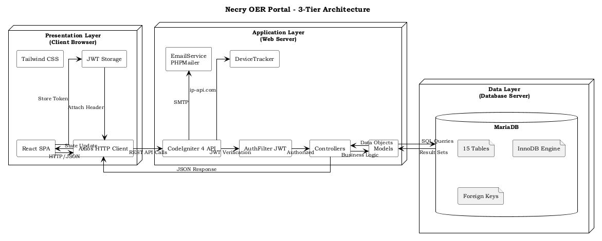
Figure 2.1: System Architecture – Three-Tier Diagram
Architecture Overview
The architecture consists of three primary layers: (1) the Presentation Layer (React SPA) running in the user's browser, (2) the Application Layer (CodeIgniter 4 REST API) running on the web server, and (3) the Data Layer (MariaDB) running on the database server. Communication between layers is strictly through HTTP/HTTPS protocols with JSON as the data interchange format.
Component Diagram
Presentation Layer (Frontend)
[React SPA] ↔ [Axios HTTP Client] → JSON Requests
- React 18 with component-based architecture
- Tailwind CSS for responsive UI styling
- JWT stored in localStorage for authenticated sessions
- 15-second polling for notifications and profile sync
Application Layer (Backend API)
[CodeIgniter 4] → [Controllers] → [Models] → [Query Builder]
- RESTful API endpoints grouped by resource (auth, courses, users, admin)
- JWT authentication filter (AuthFilter) guards protected routes
- Role-based access control (admin, uploader, student)
- Email service via PHPMailer for transactional emails
- Device tracking and OTP verification services
Data Layer (Database)
[MariaDB] → [InnoDB Engine] → [15 Tables]
- 15 relational tables with foreign key constraints
- ACID-compliant transactions for purchase and withdrawal operations
- Indexed columns for query performance optimization
- utf8mb4 charset for full Unicode support
Data Flow
1. A user interacts with the React SPA in their browser.
2. The SPA makes an HTTP request (GET/POST/PUT/DELETE) via Axios to the CodeIgniter 4 API.
3. The request passes through CORS and authentication filters (if protected).
4. The appropriate Controller processes the request, validates input, and calls the relevant Model.
5. The Model executes SQL queries via CodeIgniter's Query Builder against MariaDB.
6. Results flow back: Database → Model → Controller → JSON Response → React SPA → User Interface.

Deployment Setup
The system is deployed on a local or hosted web server (Apache/Nginx) with PHP 8.2 and MariaDB. The React frontend is served as a single-page application, while the CodeIgniter 4 API runs as a separate application under the same or a subdomain. The database server can be hosted on the same machine or a separate dedicated server.
System Workflow
The following describes the high-level system workflow:
1. User accesses the Necry OER Portal via web browser
2. React SPA loads and renders the appropriate page based on URL routing
3. Unauthenticated users can browse public catalog and view resource details
4. Registration requires OTP verification via email before account creation
5. Login generates a JWT token stored in localStorage for subsequent requests
6. Email verification check occurs at login (unverified emails are blocked with 403)
7. Device tracking records each login session and alerts on unrecognized devices
8. Uploaders can submit materials which require admin approval before public visibility
9. Purchases compute the best applicable discount (promo vs subscription, not stackable)
10. Revenue is split 80% to uploader / 20% to platform upon each purchase
11. Uploaders can request withdrawal of earnings after setting up payout accounts and PIN
12. The system logs all transactions, access events, and user activities for auditing

CHAPTER 3
UNIFIED MODELING LANGUAGE (UML)
═════════════════════════════════
A. Introduction to UML
The Unified Modeling Language (UML) is a standardized modeling language used in software engineering to visualize, specify, construct, and document the artifacts of a software system. UML provides a set of graphical notation techniques to create visual models of object-oriented software systems.
Importance of UML in System Development: UML helps developers and stakeholders understand the system architecture, behavior, and interactions through standardized diagrams. It bridges the gap between technical and non-technical team members, facilitates communication, and serves as documentation for future maintenance and enhancement.
UML Diagrams Used in This Project: This project employs Use Case Diagrams to represent system functionality from the user's perspective, and Sequence Diagrams to illustrate the flow of interactions between system components over time.

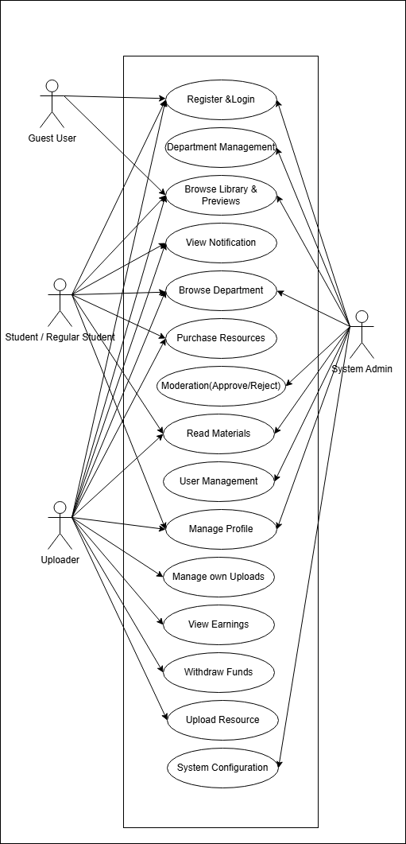
B. Use Case Diagram
Figure 3.1: Complete Use Case Diagram

The Use Case Diagram above illustrates the major functionalities of the Necry OER Portal and the actors that interact with them. The system has four primary actors: Administrator, Uploader, Student, and Guest User. Each actor has a specific set of use cases representing the actions they can perform within the system.
Actors and Their Responsibilities
Administrator – Responsible for overall system management and moderation
- Manage Users: View, verify, suspend, and reset passwords for all users
- Moderate Resources: Approve or reject uploaded materials
- Manage Departments/Courses: Add, update, and organize academic structures
- Process Withdrawals: Review and process payout requests from uploaders
Uploader – Responsible for content creation and monetization
- Upload Resources: Submit books and materials with metadata
- Manage Content: Edit, delete, and organize own uploaded materials
- Track Earnings: View sales, earnings, and transaction history
- Manage Payout Accounts: Set up GCash, Maya, or Bank accounts
- Request Withdrawals: Withdraw accumulated earnings
Student – Consumes educational content
- Register and Verify Email: Create account with OTP verification
- Browse and Search: Explore the digital library catalog
- Purchase Resources: Buy materials with discount computation
- Access Materials: Open and read purchased resources
- Upgrade Subscription: Subscribe to Pro or Pro+ tiers
Guest User – Explores public content
- Browse Catalog: View available resources and metadata
- Search: Look for specific titles or subjects

C. Use Case Descriptions

Use Case Name | Actor | Description | Preconditions | Main Flow | Alternative Flow | Postconditions
User Registration | Guest User | New user creates an account with OTP email verification | User is not logged in. Email is not already registered. | 1. User fills registration form with name, email, password, role, and education level 2. System sends OTP code to email 3. User enters OTP code 4. System validates OTP and creates account 5. User is redirected to login | OTP expires (15 min): User requests new code. Email already exists: System returns error. | User account created with email_verified=1. JWT not issued (user must login).
User Login | Student, Uploader, Administrator | Registered user authenticates with email and password | User has a registered account with verified email. | 1. User enters email and password 2. System validates credentials 3. System checks email_verified status 4. System checks login_attempts for IP lock 5. System records device session and checks for unrecognized devices 6. System issues JWT token 7. User is redirected to dashboard | Email not verified: Return 403 error. Too many attempts: Lock IP. Unrecognized device: Send email alert. | User is authenticated with JWT. Device session recorded. Login attempt counter reset.
Forgot Password | Student, Uploader | User resets password via email OTP verification | User is not logged in. Email exists in system. | 1. User enters registered email 2. System sends OTP code to email 3. User enters OTP code 4. System validates OTP 5. User enters new password 6. System updates password hash 7. User is redirected to login | OTP expires: User requests resend. Invalid OTP: Increment attempts counter. | Password hash updated in database. Verification code marked as used.
Resource Upload | Uploader | Uploader submits a new educational resource with metadata | User is logged in with uploader role. | 1. Uploader fills resource metadata (title, author, ISBN, edition, publisher, description) 2. Uploader selects department, course, and section 3. Uploader uploads file (PDF) and cover image 4. Uploader sets price, material type, and preview percentage 5. System saves resource with is_approved=0 6. System records upload transaction | Validation fails: Return specific error. File too large: Return file size error. | Resource created in database with pending approval status. Admin notified.
Resource Approval | Administrator | Admin reviews and approves uploaded resources for public visibility | User is logged in as administrator. Resources exist with is_approved=0. | 1. Admin views list of pending resources 2. Admin reviews resource metadata and file 3. Admin approves or rejects the resource 4. System updates is_approved status 5. Resource becomes visible in public catalog if approved | Reject: Resource is deleted from the system. | Resource is approved (is_approved=1) and publicly visible, or removed from system.
Purchase Resource | Student | Student purchases a resource with best discount applied | User is logged in. Resource is approved. User has not already purchased this resource. | 1. User views resource detail with price and discount information 2. System computes best discount (promo discount vs subscription discount) 3. User clicks Purchase and selects payment method (GCash, Maya, or Card) 4. System processes payment (simulated) 5. System records purchase with discounted price 6. System computes revenue split: 80% uploader, 20% platform 7. System records transactions for both parties 8. System sends purchase receipt email 9. User gains access to the resource | Uploader owns the resource: Free access with no incentive recorded. Payment fails: Transaction marked as failed. | Resource_purchases row created. User_transactions recorded. Email receipt sent.
Open Resource | Student, Uploader | User opens and accesses a digital resource through secure streaming | User is logged in and has access rights (purchased or uploader-owned). | 1. User clicks Open on a resource 2. System checks access rights (purchased, uploader-owned, or free preview) 3. System verifies open limits (if applicable) 4. System records access in resource_access_logs 5. System generates temporary access token 6. Resource is displayed in the reader/viewer | Uploader accessing own material: No limit check, no incentive. No access rights: Return 403. Limit reached: Show purchase prompt. | Access log entry created. Resource displayed to user.
Subscription Upgrade | Student | User upgrades subscription tier for enhanced benefits | User is logged in. User is on a lower tier (free or pro). | 1. User selects subscription tier (Pro or Pro+) 2. System displays tier benefits and price 3. User selects payment method 4. System processes payment (simulated) 5. System updates subscription_tier and subscription_expires_at 6. System sends upgrade confirmation email 7. User gains tier benefits immediately | Payment fails: Tier not updated. Already on tier: Return current status. | User subscription tier updated. Benefits applied to future purchases.
Request Withdrawal | Uploader | Uploader requests withdrawal of accumulated earnings | User is logged in as uploader. User has payout_pin set. User has at least one payout account configured.

CHAPTER 4
SEQUENCE DIAGRAMS
═════════════════════════════════
A. Sequence Diagrams and Discussion
Sequence diagrams illustrate the interactions between actors and system components over time. Each diagram below describes a specific use case, showing the message flow between the Actor, System Interface (React SPA), Application Logic (CodeIgniter 4 API), and Database (MariaDB).
1. User Authentication (Login)
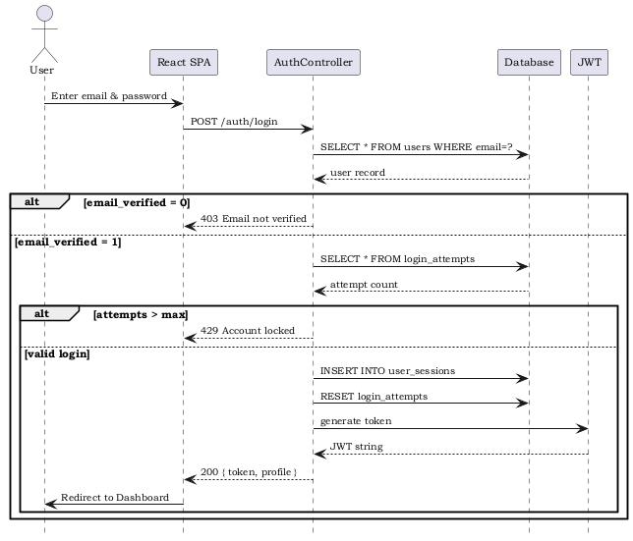
Figure 4.1: User Authentication – Login Sequence

Flow:
1. User enters email and password in the Login form (React SPA)
2. SPA sends POST /auth/login with credentials to the API
3. Auth controller validates credentials against users table (password_verify)
4. System checks email_verified field — if 0, returns 403 error
5. System checks login_attempts table for IP lockout
6. On success, system records device session (IP, user agent, device name, location)
7. System checks if device is trusted — if not, sends device alert email
8. System generates JWT token and returns it to the frontend
9. SPA stores token in localStorage and redirects to dashboard
Database tables involved: users, login_attempts, user_sessions, verification_codes

2. OTP Registration
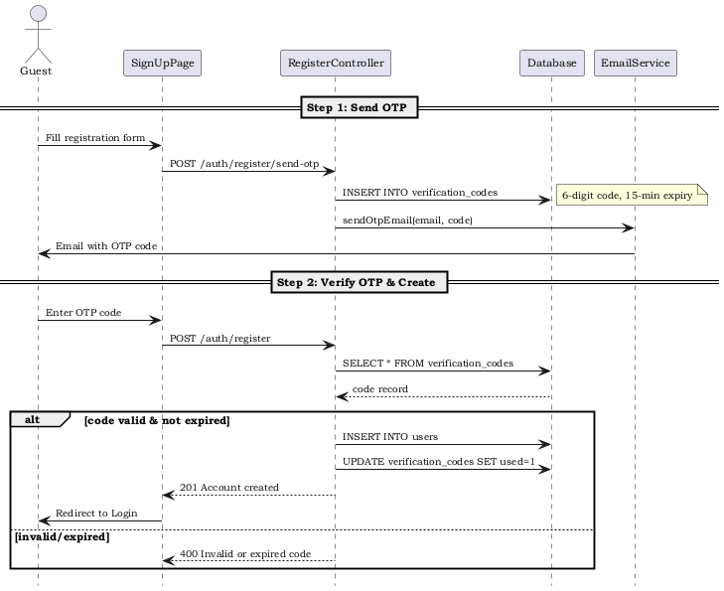
Figure 4.2: OTP Registration Sequence
Flow:
1. Guest fills registration form in the SignUp page
2. SPA sends POST /auth/register/send-otp with email
3. System generates 6-digit OTP via array_rand on ['0'..'9']
4. System stores OTP in verification_codes table with type='email_verify', 15-min expiry
5. System sends OTP via email through PHPMailer
6. User enters OTP code in step 2 of registration
7. System validates OTP (checks expiry, max 1 attempt before new code, 3/hr limit)
8. On valid OTP, system creates user account with email_verified=1
3. Resource Purchase with Discount
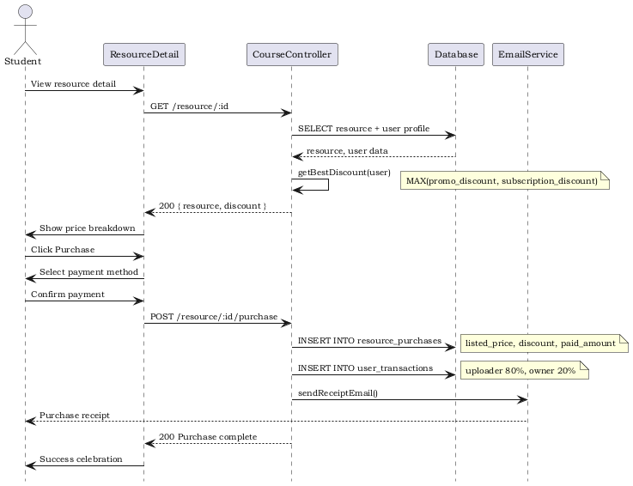
Figure 4.3: Resource Purchase Sequence
Flow:
1. User views resource detail page (GET /resource/:id)
2. System calls getBestDiscount() helper to compute applicable discount
3. System checks user.promo_discount (e.g., 15% for Secondary, 20% for Tertiary)
4. System checks user.subscription_tier (Pro=10%, Pro+=25%)
5. System picks the higher of the two (not stackable) and displays breakdown
6. User clicks Purchase and selects payment method
7. System records purchase: listed_price, discount_percent, paid_amount
8. System computes uploader_amount = paid_amount * 0.80, owner_amount = paid_amount * 0.20
9. System records user_transactions for both uploader and platform
10. System sends purchase receipt email to buyer
Database tables involved: resources, resource_purchases, user_transactions, users
4. Uploader Opening Own Material
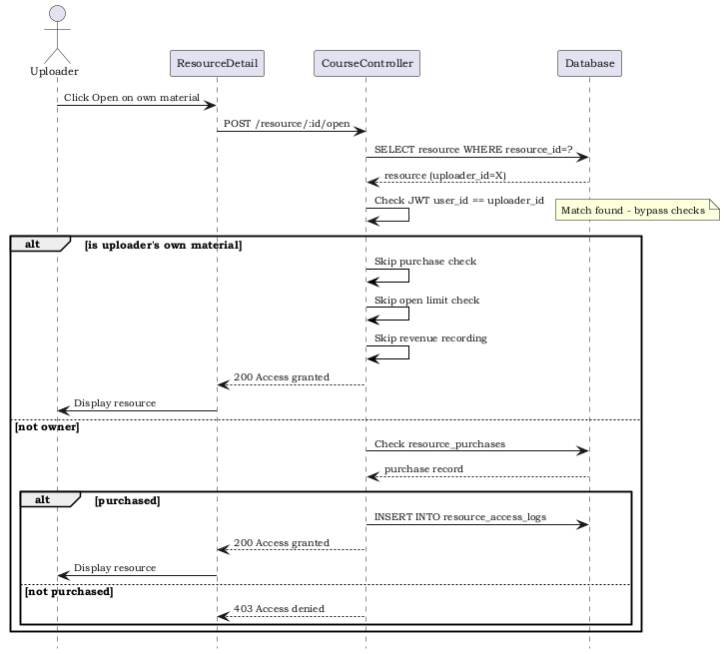
Figure 4.4: Uploader Self-Open Sequence
Flow:
1. Uploader navigates to one of their own uploaded materials
2. Uploader clicks Open
3. System checks if uploader_id matches the authenticated user
4. If match: system grants free access WITHOUT checking resource_access_logs limits
5. System does NOT record uploader_amount or owner_amount (no incentive)
6. Resource is displayed in the viewer
This is a distinct flow from regular user access — uploaders bypass purchase requirements, open limits, and revenue recording.
5. Subscription Upgrade
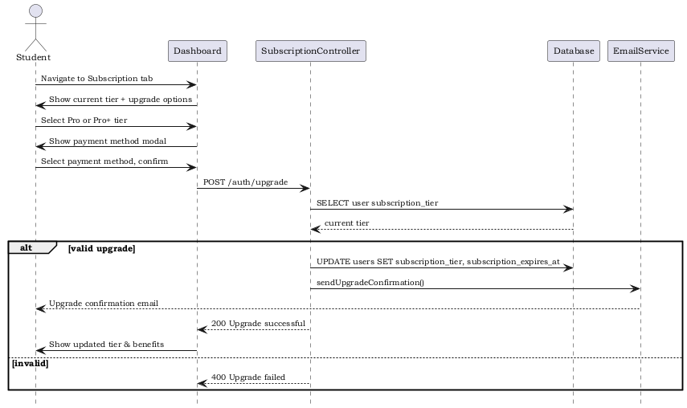
Figure 4.5: Subscription Upgrade Sequence
Flow:
1. User navigates to Dashboard > Subscription section
2. User selects Pro or Pro+ tier and clicks Upgrade
3. SPA shows PaymentModal for method selection
4. On payment confirmation, SPA sends POST /auth/upgrade
5. System validates current tier and processes upgrade
6. System updates subscription_tier and subscription_expires_at
7. System sends upgrade confirmation email
8. Dashboard refreshes to show updated tier and new benefits
Discounts: Pro = 10% off all purchases, Pro+ = 25% off all purchases.
6. Resource Upload and Approval
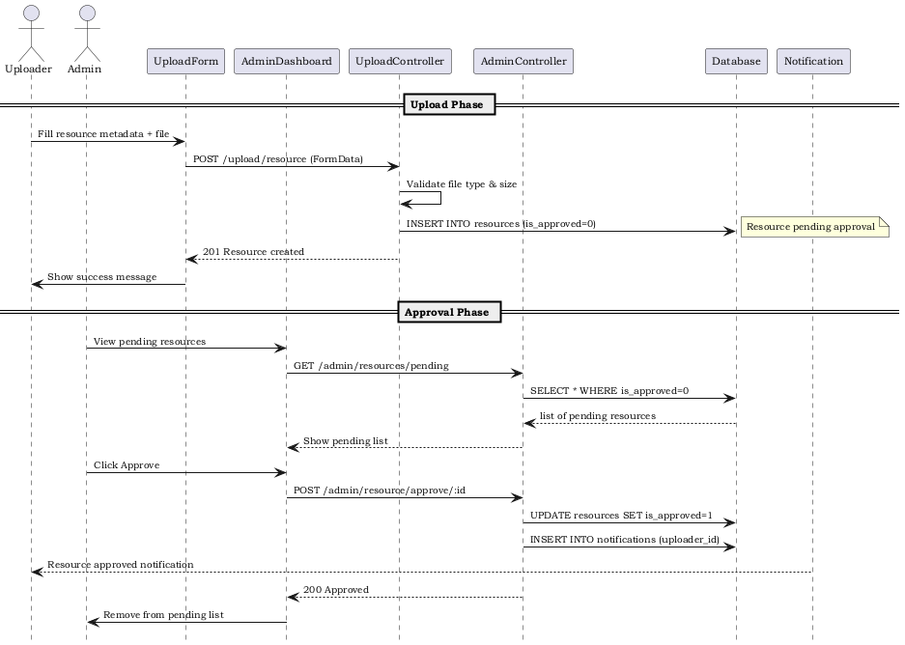
Figure 4.6: Resource Upload and Approval Sequence
Flow:
1. Uploader fills upload form with metadata and file
2. SPA sends POST /upload/resource as FormData
3. System validates file type and size, saves file to server
4. System creates resource record with is_approved=0
5. Admin accesses AdminDashboard, views pending resources
6. Admin reviews resource and clicks Approve
7. System sets is_approved=1, resource becomes publicly visible
8. If rejected, resource is deleted from database and file system
Database tables involved: resources, courses, departments, course_sections, tags, resource_tags
7. Withdrawal Request
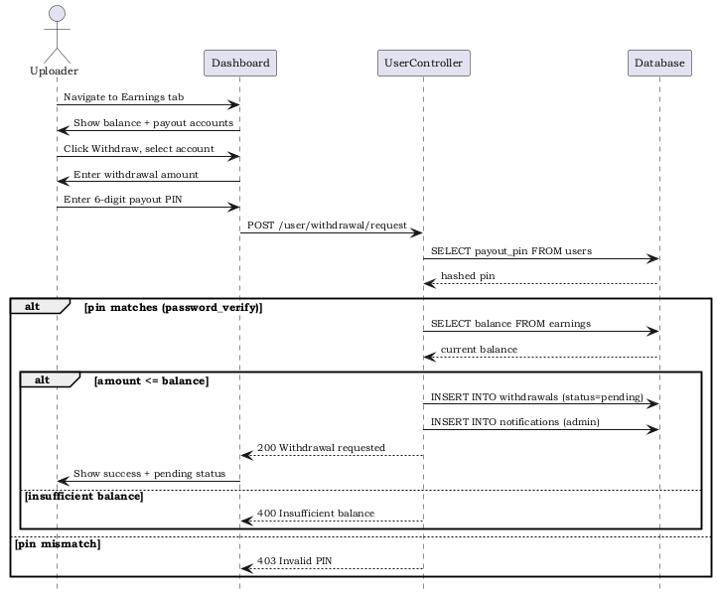
Figure 4.7: Withdrawal Request Sequence
Flow:
1. Uploader views earnings dashboard showing current balance
2. Uploader navigates to Withdraw section, selects payout account
3. Uploader enters amount and clicks Withdraw
4. System prompts for 6-digit payout PIN via modal
5. Uploader enters PIN (direct keyboard input, no numpad)
6. System verifies PIN using password_verify against stored payout_pin hash
7. System validates amount <= available balance
8. System creates withdrawal record with status=pending
9. Admin reviews and processes withdrawal (marks as withdrawn or failed)
Database tables involved: users (payout_pin), payout_accounts, withdrawals, user_transactions
8. Resource Search and Delete
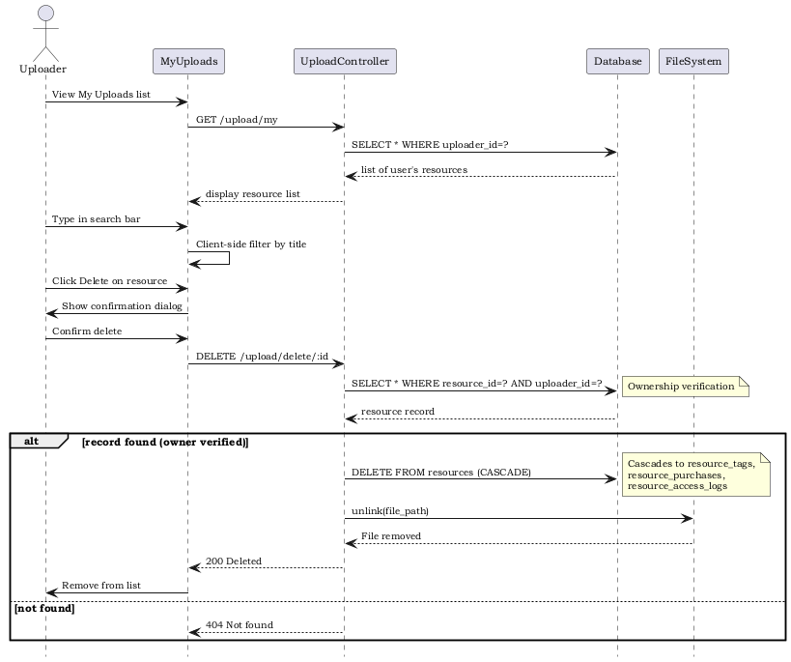
Figure 4.8: Resource Delete Sequence
Flow:
1. Uploader views their own uploaded resources via GET /upload/my
2. System filters resources by uploader_id (JWT ownership verification)
3. Uploader can search within their own resources by title
4. Uploader clicks Delete on a resource
5. System shows confirmation dialog
6. On confirm, SPA sends DELETE /upload/delete/:id
7. System verifies ownership (uploader_id matches JWT user_id)
8. System deletes resource from database (cascades to resource_tags, resource_purchases, etc.)
9. System deletes file from server file system
Database tables involved: resources (ON DELETE CASCADE to resource_tags, resource_purchases, resource_access_logs, user_transactions)

CHAPTER 5
DATABASE DESIGN
═════════════════════════════════
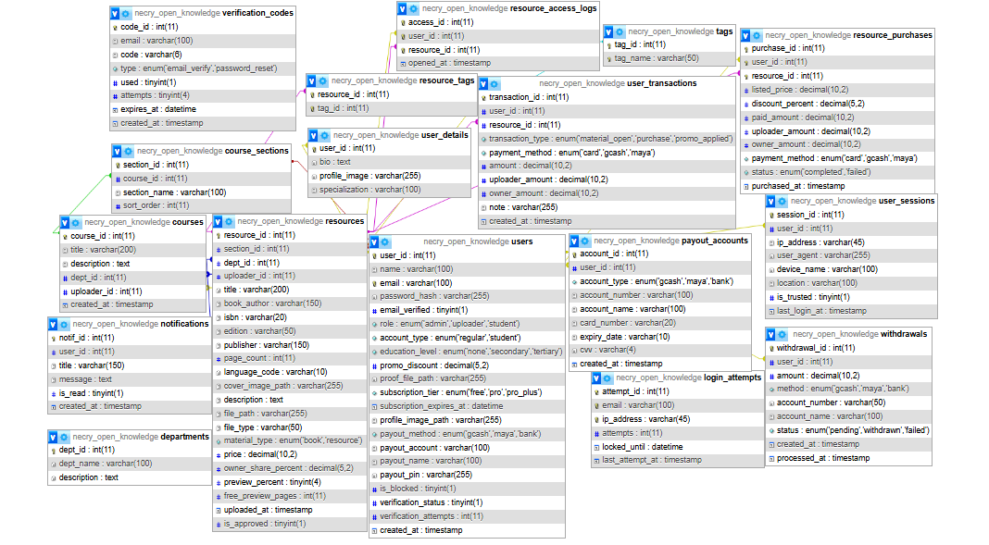
- Entity Relationship Diagram (ERD)
Figure 5.1: Complete Entity Relationship Diagram
The Necry OER Portal database consists of 15 tables designed to support user management, content storage, purchase transactions, access control, notifications, and financial operations. The ERD follows a normalized relational schema with InnoDB engine for ACID compliance and foreign key constraints for referential integrity.
B. Overview of Entities
Core Entities (5)
- users – Stores all user accounts with authentication, role, subscription, and verification data
- resources – Stores all uploaded educational materials with metadata and pricing
- departments – Academic departments/colleges for organizing courses
- courses – Academic courses belonging to departments
- course_sections – Sections within courses for organizing resources
Feature Entities (9)
- resource_purchases – Records of completed resource purchases with pricing and revenue split
- resource_access_logs – Tracks user access to resources for usage monitoring and limit enforcement
- user_transactions – Financial audit trail for all monetary operations
- withdrawals – Uploader withdrawal requests and their processing status
- notifications – In-app notification system for user alerts
- verification_codes – OTP codes for email verification and password reset
- user_sessions – Device login tracking for security and unrecognized device detection
- payout_accounts – Uploader payout method configuration (GCash, Maya, Bank)
- login_attempts – Brute force protection through IP-based login attempt tracking
Mapping Entities (1)
- resource_tags – Many-to-many relationship between resources and tags
Supporting Entities (2)
- user_details – Extended user profile information
- tags – Resource categorization tags

C. Database Schema (Data Dictionary)
Table: users
Field Name | Data Type | Length | Constraints | Description
user_id | INT | 11 | PRIMARY KEY, AUTO_INCREMENT | Unique user identifier
name | VARCHAR | 255 | NOT NULL | Full name of the user
email | VARCHAR | 100 | NOT NULL, UNIQUE | Email address for login and notifications
password_hash | VARCHAR | 255 | NOT NULL | Bcrypt hashed password
email_verified | TINYINT | 1 | NOT NULL, DEFAULT 1 | Email verification status (0=pending, 1=verified)
role | ENUM | - | NOT NULL | User role: admin, student, uploader
account_type | ENUM | - | NOT NULL, DEFAULT student | Account classification: regular, student
education_level | ENUM | - | NOT NULL, DEFAULT none | Education level: none, secondary, tertiary
promo_discount | DECIMAL | 5,2 | NOT NULL, DEFAULT 0.00 | Lifetime promo discount percentage
subscription_tier | ENUM | - | NOT NULL, DEFAULT free | Subscription tier: free, pro, pro_plus
subscription_expires_at | DATETIME | - | NULL | Subscription expiry timestamp
payout_pin | VARCHAR | 255 | NULL | Bcrypt hashed 6-digit payout PIN
is_blocked | TINYINT | 1 | NOT NULL, DEFAULT 0 | Account blocked status
created_at | TIMESTAMP | - | NOT NULL, DEFAULT CURRENT_TIMESTAMP | Account creation timestamp

Table: resources
Field Name | Data Type | Length | Constraints | Description
resource_id | INT | 11 | PRIMARY KEY, AUTO_INCREMENT | Unique resource identifier
section_id | INT | 11 | FK → course_sections.section_id | Course section for organization
dept_id | INT | 11 | FK → departments.dept_id, ON DELETE SET NULL | Department classification
uploader_id | INT | 11 | FK → users.user_id | Uploader who submitted the resource
title | VARCHAR | 255 | NOT NULL | Resource title
book_author | VARCHAR | 150 | NULL | Original author of the material
isbn | VARCHAR | 20 | NULL | ISBN number if applicable
price | DECIMAL | 10,2 | NOT NULL, DEFAULT 0.00 | Purchase price
file_path | VARCHAR | 255 | NOT NULL | Path to uploaded file
file_type | VARCHAR | 50 | NOT NULL | File type: pdf, link, epub
material_type | ENUM | - | NOT NULL, DEFAULT book | Type: book, resource
owner_share_percent | DECIMAL | 5,2 | NOT NULL, DEFAULT 20.00 | Platform revenue share percentage
preview_percent | TINYINT | 4 | NOT NULL, DEFAULT 20 | Percentage available for free preview
is_approved | TINYINT | 1 | NOT NULL, DEFAULT 0 | Admin approval status (0=pending, 1=approved)
created_at | TIMESTAMP | - | NOT NULL, DEFAULT CURRENT_TIMESTAMP | Upload timestamp

Table: resource_purchases
Field Name | Data Type | Length | Constraints | Description
purchase_id | INT | 11 | PRIMARY KEY, AUTO_INCREMENT | Unique purchase identifier
user_id | INT | 11 | FK → users.user_id, ON DELETE CASCADE | Buyer user ID
resource_id | INT | 11 | FK → resources.resource_id, ON DELETE CASCADE | Purchased resource ID
listed_price | DECIMAL | 10,2 | NOT NULL | Original listed price before discount
discount_percent | DECIMAL | 5,2 | NOT NULL, DEFAULT 0.00 | Applied discount percentage
paid_amount | DECIMAL | 10,2 | NOT NULL | Actual amount paid after discount
uploader_amount | DECIMAL | 10,2 | NOT NULL, DEFAULT 0.00 | Uploader earnings (80% of paid amount)
owner_amount | DECIMAL | 10,2 | NOT NULL, DEFAULT 0.00 | Platform earnings (20% of paid amount)
payment_method | ENUM | - | NULL | Payment method: card, gcash, maya
status | ENUM | - | NOT NULL, DEFAULT completed | Purchase status: completed, failed
purchased_at | TIMESTAMP | - | NOT NULL, DEFAULT CURRENT_TIMESTAMP | Purchase timestamp

Table: verification_codes
Field Name | Data Type | Length | Constraints | Description
code_id | INT | 11 | PRIMARY KEY, AUTO_INCREMENT | Unique code identifier
email | VARCHAR | 100 | NOT NULL | Email address for verification
code | VARCHAR | 6 | NOT NULL | 6-digit OTP code
type | ENUM | - | NOT NULL | Code type: email_verify, password_reset
used | TINYINT | 1 | NOT NULL, DEFAULT 0 | Whether code has been used
attempts | TINYINT | 4 | NOT NULL, DEFAULT 0 | Verification attempt count
expires_at | DATETIME | - | NOT NULL | Code expiration timestamp (15 min)
created_at | TIMESTAMP | - | NOT NULL, DEFAULT CURRENT_TIMESTAMP | Code creation timestamp

Table: user_sessions
Field Name | Data Type | Length | Constraints | Description
session_id | INT | 11 | PRIMARY KEY, AUTO_INCREMENT | Unique session identifier
user_id | INT | 11 | FK → users.user_id, ON DELETE CASCADE | User who owns this session
ip_address | VARCHAR | 45 | NOT NULL | IP address of login
user_agent | VARCHAR | 255 | NOT NULL | Browser user agent string
device_name | VARCHAR | 100 | NOT NULL | Parsed device/browser name
location | VARCHAR | 100 | NOT NULL, DEFAULT Unknown | Geolocation from IP (via ip-api.com)
is_trusted | TINYINT | 1 | NOT NULL, DEFAULT 0 | Whether user has trusted this device
last_login_at | TIMESTAMP | - | NOT NULL, DEFAULT CURRENT_TIMESTAMP | Last login timestamp

Table: payout_accounts
Field Name | Data Type | Length | Constraints | Description
account_id | INT | 11 | PRIMARY KEY, AUTO_INCREMENT | Unique account identifier
user_id | INT | 11 | FK → users.user_id, ON DELETE CASCADE | Uploader who owns this account
account_type | ENUM | - | NOT NULL | Account type: gcash, maya, bank
account_number | VARCHAR | 100 | NOT NULL | Account number or GCash/Maya number
account_name | VARCHAR | 100 | NOT NULL | Account holder name
card_number | VARCHAR | 20 | NULL (bank only) | Bank card number
expiry_date | VARCHAR | 10 | NULL (bank only) | Card expiry date (MM/YY)
cvv | VARCHAR | 4 | NULL (bank only) | Card CVV code

Additional Tables
departments
Field Name | Data Type | Length | Constraints | Description
dept_id | INT | 11 | PRIMARY KEY, AUTO_INCREMENT | Department ID
dept_name | VARCHAR | 100 | NOT NULL | Department name
description | TEXT | - | NULL | Department description

courses
Field Name | Data Type | Length | Constraints | Description
course_id | INT | 11 | PRIMARY KEY, AUTO_INCREMENT | Course ID
title | VARCHAR | 200 | NOT NULL | Course title
dept_id | INT | 11 | FK → departments.dept_id, ON DELETE CASCADE | Parent department

course_sections
Field Name | Data Type | Length | Constraints | Description
section_id | INT | 11 | PRIMARY KEY, AUTO_INCREMENT | Section ID
course_id | INT | 11 | FK → courses.course_id | Parent course
section_name | VARCHAR | 100 | NOT NULL | Section name
sort_order | INT | 11 | NOT NULL, DEFAULT 0 | Display sort order

login_attempts
Field Name | Data Type | Length | Constraints | Description
attempt_id | INT | 11 | PRIMARY KEY, AUTO_INCREMENT | Attempt record ID
email | VARCHAR | 100 | NOT NULL | Email being attempted
ip_address | VARCHAR | 45 | NOT NULL | IP address of the attempt
attempts | INT | 11 | NOT NULL, DEFAULT 0 | Consecutive failed attempts
locked_until | DATETIME | - | NULL | Lockout expiration timestamp

notifications
Field Name | Data Type | Length | Constraints | Description
notif_id | INT | 11 | PRIMARY KEY, AUTO_INCREMENT | Notification ID
user_id | INT | 11 | FK → users.user_id, ON DELETE CASCADE | Recipient user
title | VARCHAR | 150 | NOT NULL | Notification title
message | TEXT | - | NOT NULL | Notification message body
is_read | TINYINT | 1 | NOT NULL, DEFAULT 0 | Read status (0=unread, 1=read)

resource_access_logs, user_transactions, withdrawals
The remaining tables round out the schema: resource_access_logs (access_id, user_id, resource_id, opened_at) tracks user open events; user_transactions (transaction_id, user_id, resource_id, type, amount, uploader_amount, owner_amount) provides the financial audit trail; withdrawals (withdrawal_id, user_id, amount, method, account_number, account_name, status) stores payout requests.
D. Relationship Description
One-to-Many Relationships
- users → resources: One uploader can submit many resources
- users → resource_purchases: One user can make many purchases
- users → user_sessions: One user can have many device sessions
- users → payout_accounts: One uploader can have multiple payout accounts
- users → notifications: One user can receive many notifications
- departments → courses: One department contains many courses
- courses → course_sections: One course contains many sections
- resources → resource_purchases: One resource can be purchased by many users
- resources → resource_access_logs: One resource can be accessed many times
Many-to-Many Relationships
- resources → tags (via resource_tags): Resources can have multiple tags; tags can apply to multiple resources
One-to-One Relationships
- users → user_details: Each user has exactly one extended profile record
All foreign key relationships use ON DELETE CASCADE for dependent entities, ensuring data integrity when parent records are

CHAPTER 6
SQL IMPLEMENTATION OF CRUD OPERATIONS
═════════════════════════════════
A. Data Entry (CREATE)
Data entry in the Necry OER Portal is primarily handled through resource uploads. Uploaders submit educational materials with complete metadata through a multi-field form. The data flows from the frontend React form through the backend API into the MariaDB database.
Step 1: Upload Form (Frontend)
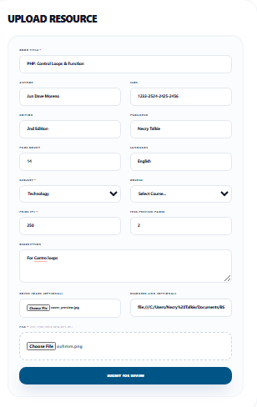

The upload form captures the following fields: title, book_author, ISBN, edition, publisher, page_count, language_code, description, file upload (PDF/EPUB), cover image (JPG/PNG), department, course, section, price, material_type (book or resource), and preview_percentage.
Step 2: Form Submission Handler
Frontend (React) – Upload form submission via Axios:
const handleSubmit = async (e) => {
e.preventDefault();
const formData = new FormData();
formData.append('title', form.title);
formData.append('book_author', form.author);
formData.append('isbn', form.isbn);
formData.append('edition', form.edition);
formData.append('publisher', form.publisher);
formData.append('page_count', form.pageCount);
formData.append('description', form.description);
formData.append('price', form.price);
formData.append('material_type', form.materialType);
formData.append('preview_percent', form.previewPercent);
formData.append('file', form.file);
formData.append('cover', form.coverImage);
formData.append('dept_id', form.deptId);
formData.append('course_id', form.courseId);
formData.append('section_id', form.sectionId);
await axios.post('/upload/resource', formData, {
headers: { Authorization: 'Bearer ' + token }
});
toast.success('Resource uploaded successfully!');
}

Step 3: Backend Validation and Database Insertion
Backend (CodeIgniter 4 PHP) – UploadController.create():
public function create() {
// Server-side validation
$rules = [
'title' => 'required|min_length[3]|max_length[255]',
'price' => 'required|numeric',
'file' => 'uploaded[file]|max_size[file,102400]'
+ '|ext_in[file,pdf,epub]',
'cover' => 'max_size[cover,5120]'
+ '|ext_in[cover,jpg,jpeg,png]',
];
if (!$this->validate($rules))
return $this->fail($this->validator->getErrors());
// File processing
$file = $this->request->getFile('file');
$fileName = $file->getRandomName();
$file->move(FCPATH . 'uploads/resources', $fileName);
// Database insertion
$data = [
'uploader_id' => $userId,
'title' => $this->request->getPost('title'),
'book_author' => $this->request->getPost('book_author'),
'isbn' => $this->request->getPost('isbn'),
'price' => $this->request->getPost('price'),
'file_path' => 'uploads/resources/' . $fileName,
'file_type' => $file->getClientExtension(),
'material_type' => $this->request->getPost('material_type'),
'is_approved' => 0, // Pending admin approval
];
$resourceModel = new ResourceModel();
$resourceModel->insert($data);
return $this->respondCreated([
'resource_id' => $resourceModel->getInsertID()
]);
}

Data Flow Summary
The data flows through three layers:
1. Frontend (React): User fills form → client-side validation → FormData assembled → Axios POST with JWT
2. Backend (CI4): Route matched → AuthFilter verifies JWT → UploadController.create() validates rules → File saved to filesystem → Query Builder INSERT into resources table
3. Database (MariaDB): INSERT executed → AUTO_INCREMENT generates resource_id → New row with is_approved=0 → INSERT ID returned to controller → JSON response to frontend

B. Data Views (READ)
Data retrieval is implemented across multiple views: the public catalog, resource details, user purchase history, and admin management pages. All read operations follow a similar pattern of API request, controller processing, and data formatting.
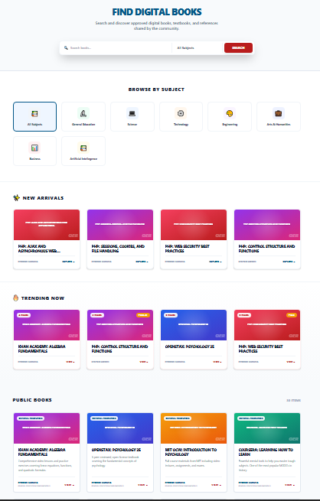
Screenshot: Catalog Listing

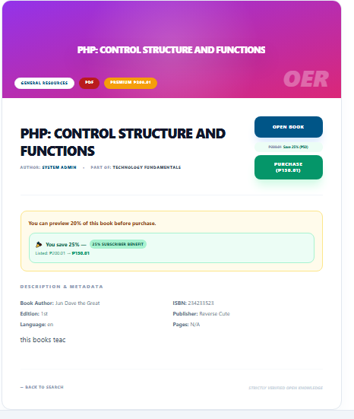
Source Code: Retrieving the Resource Catalog
Frontend – Fetching courses and recent resources:
// React component (Home.js)
const [courses, setCourses] = useState([]);
const [recent, setRecent] = useState([]);
useEffect(() => {
const fetchData = async () => {
const [coursesRes, recentRes] = await Promise.all([
axios.get('/courses'),
axios.get('/courses/recent')
]);
setCourses(coursesRes.data);
setRecent(recentRes.data);
};
fetchData();
}, []);

Backend – Listing approved resources with discount info:
public function index() {
$resourceModel = new ResourceModel();
$resources = $resourceModel
->select('resources.*, departments.dept_name')
->join('departments',
'departments.dept_id = resources.dept_id', 'left')
->where('resources.is_approved', 1)
->orderBy('resources.created_at', 'DESC')
->findAll();
// Compute discounts for authenticated users
if ($tokenData = $this->getJWTData()) {
$userModel = new UserModel();
$user = $userModel->find($tokenData->user_id);
foreach ($resources as &$res) {
$res->best_discount =
$this->getBestDiscount($user);
$res->discounted_price =
$res->price * (1 - $res->best_discount / 100);
}
}
return $this->respond($resources);
}

Retrieval Process
The React frontend sends GET requests to API endpoints. The backend controller queries the resources table using CodeIgniter's Query Builder, applying filters (is_approved=1 for public catalog), joins (departments for display), and optional discount computation for authenticated users via getBestDiscount(). Results are returned as JSON and rendered by React components into card layouts.

C. Data Manipulation (UPDATE)
Update operations include resource approval by administrators, user profile updates, subscription tier upgrades, and payout PIN configuration. The most critical update flow is the resource approval process.
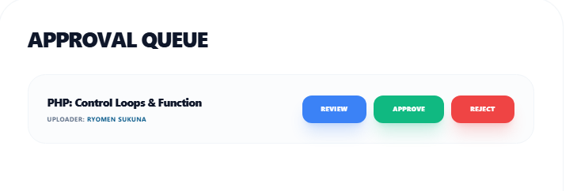
Screenshot: Admin Approval
Source Code: Approving a Resource
Frontend – Admin approval action:
// AdminDashboard.js
const handleApprove = async (resourceId) => {
try {
const res = await axios.post(
`/admin/resource/approve/${resourceId}`,
{},
{ headers: { Authorization: 'Bearer ' + token } }
);
// Remove from pending list
setPendingBooks(prev =>
prev.filter(b => b.resource_id !== resourceId)
);
toast.success('Resource approved successfully');
} catch (err) {
toast.error('Approval failed: ' +
(err.response?.data?.message || err.message));
}
};

Backend – Setting is_approved=1 and notifying uploader:
public function approveResource($resourceId) {
$resourceModel = new ResourceModel();
$resource = $resourceModel->find($resourceId);
if (!$resource)
return $this->failNotFound('Resource not found');
// UPDATE query
$resourceModel->update($resourceId, [
'is_approved' => 1
]);
// Notify the uploader
$notifModel = new NotificationModel();
$notifModel->insert([
'user_id' => $resource['uploader_id'],
'title' => 'Resource Approved',
'message' => 'Your resource "'
. $resource['title'] . '" has been approved.',
]);
return $this->respondUpdated([
'message' => 'Resource approved successfully'
]);
}

Update Workflow
The administrator reviews pending resources and clicks Approve. The frontend sends a POST request with the resource ID. The backend validates the resource exists, sets is_approved=1 in the resources table via an UPDATE query, sends a notification to the uploader, and returns success. The frontend removes the item from the pending list and shows a success message. This follows the MVC pattern: View (React) → Controller (approveResource) → Model (update) → Database.

D. Search and Delete Records (DELETE)
Uploaders can manage their own content library by searching within their uploaded resources and deleting materials they own. The system enforces ownership verification before any deletion operation.
Screenshot: My Uploads with Search and Delete
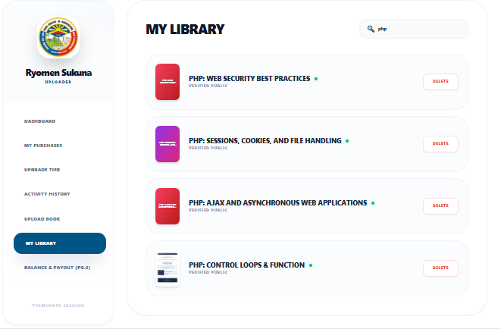
Source Code: Searching and Deleting Resources
Frontend – Search filter and delete handler:
// Dashboard.js - My Uploads tab
const [myResources, setMyResources] = useState([]);
const [searchTerm, setSearchTerm] = useState('');
// Fetch resources
useEffect(() => {
axios.get('/upload/my', {
headers: { Authorization: 'Bearer ' + token }
}).then(res => setMyResources(res.data));
}, []);
// Client-side search filter
const filtered = myResources.filter(r =>
r.title.toLowerCase()
.includes(searchTerm.toLowerCase())
);
// Delete with confirmation
const handleDelete = async (resourceId) => {
if (!window.confirm(
'Are you sure you want to delete this resource?'))
return;
try {
await axios.delete(
`/upload/delete/${resourceId}`,
{ headers: { Authorization: 'Bearer ' + token } }
);
setMyResources(prev =>
prev.filter(r => r.resource_id !== resourceId)
);
toast.success('Resource deleted');
} catch (err) {
toast.error('Delete failed');
}
};

Backend – Ownership verification and DELETE with cascade:
public function deleteMyResource($resourceId) {
$resourceModel = new ResourceModel();
$userId = $this->getJWTData()->user_id;
// Ownership verification
$resource = $resourceModel
->where('resource_id', $resourceId)
->where('uploader_id', $userId)
->first();
if (!$resource)
return $this->failNotFound(
'Resource not found or access denied');
// DELETE from database (CASCADE handles related)
$resourceModel->delete($resourceId);
// Delete physical file
$filePath = FCPATH . $resource['file_path'];
if (file_exists($filePath))
unlink($filePath);
return $this->respondDeleted([
'message' => 'Resource deleted successfully'
]);
}

Search and Delete Process
Uploaders view their own resources fetched via GET /upload/my (filtered by JWT user_id in the WHERE clause). Client-side search filtering allows real-time title matching without additional API calls. When deleting, the frontend shows a confirmation dialog, then sends a DELETE request. The backend performs ownership verification (matching resource_id AND uploader_id), then executes a DELETE query — ON DELETE CASCADE in the database schema automatically removes related records in resource_tags, resource_purchases, resource_access_logs, and user_transactions. Finally, the physical file is removed from the server filesystem.
E. Complete CRUD Matrix
The following table summarizes the CRUD operations and their corresponding API endpoints across all major entities:

Entity | Create | Read | Update | Delete
users | POST /auth/register | GET /user/profile | POST /user/profile-image | Admin via admin panel
resources | POST /upload/resource | GET /courses, GET /resource/:id | POST /admin/resource/approve/:id | DELETE /upload/delete/:id
resource_purchases | POST /resource/:id/purchase | GET /user/purchases | N/A (immutable) | N/A (audit trail)
withdrawals | POST /user/withdrawal/request | GET /user/withdrawal/history | Admin processing | N/A (audit trail)
payout_accounts | POST /user/payout/account/add | GET /user/payout/info | N/A (delete+re-add) | DELETE /user/payout/account/delete/:id
notifications | System-generated | GET /user/notifications | POST /user/notification/read/:id | DELETE /user/notification/delete/:id

