

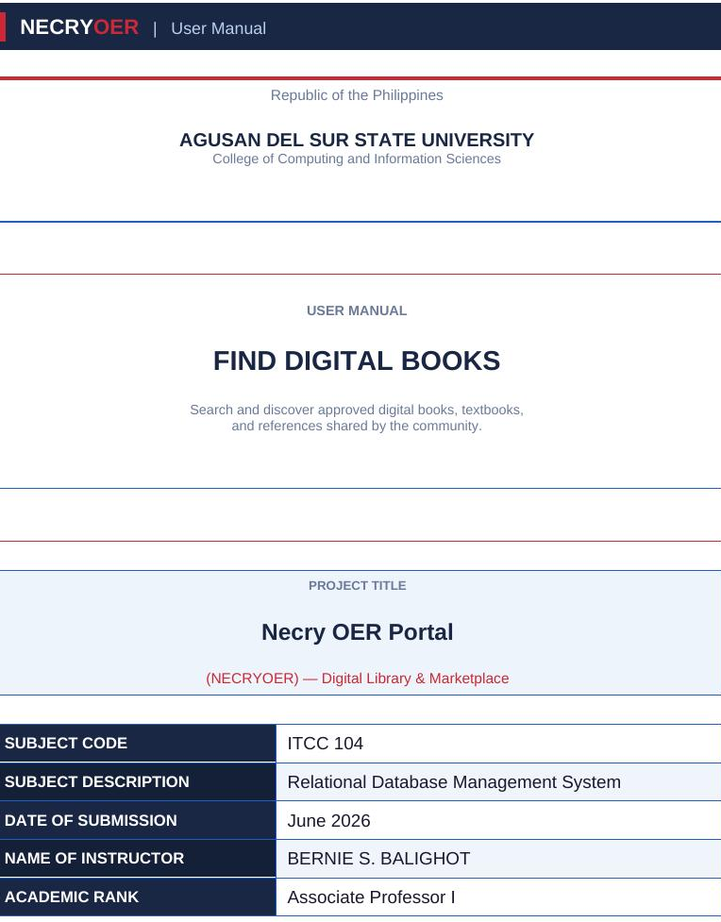
TABLE OF CONTENTS
──────────────────────────────

III. System Introduction
IV. System Requirements
V. System Installation Guide
VI. Login and User Access
VII. System Features & Operations
VIII. CRUD Operations Guide
IX. Searching & Filtering
X. Report Generation
XI. Error Handling & Troubleshooting
XII. Frequently Asked Questions
XIII. System Maintenance & Backup
XIV. Appendices (A–F)

LIST OF FIGURES
──────────────────────────────

Figure 1: Three-Tier System Architecture
Figure 2: Use Case Diagram – Actors and Functionalities
Figure 3: Complete Entity Relationship Diagram (ERD)
Figure 4: Login Authentication Sequence
Figure 5: OTP Registration Sequence
Figure 6: Resource Purchase Sequence
Figure 7: Uploader Self-Open Sequence
Figure 8: Subscription Upgrade Sequence
Figure 9: Resource Upload and Approval Sequence
Figure 10: Withdrawal Request Sequence
Figure 11: Resource Delete Sequence
III. SYSTEM INTRODUCTION
- System Name
The official name of the system is “Necry OER Portal” (also referred to as NECRYOER). It is an Open Educational Resources digital marketplace designed for the academic community of Agusan del Sur State University.
B. System Description
The Necry OER Portal is a decoupled web application that provides a centralized platform for the discovery, sharing, and monetization of educational materials. Built with a modern technology stack (React 18 frontend, CodeIgniter 4 backend, MariaDB database), the system enables educators to upload and sell their learning resources while allowing students to access high-quality, affordable educational content.
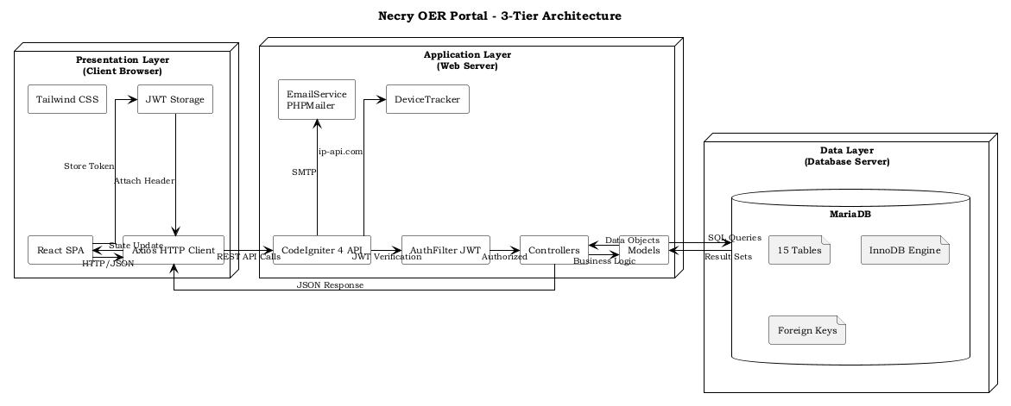
Figure 1: Necry OER Portal – Three-Tier System Architecture
Key capabilities include: user registration with email OTP verification, role-based access control (Administrator, Uploader, Student, Guest), resource browsing and search, secure purchase with automatic discount computation, digital content delivery via in-app reader, subscription tier upgrades, uploader earnings tracking, and payout management.

C. Intended Users
1. Administrator
- Manages all user accounts and system configuration
- Approves or rejects uploaded educational resources
- Processes uploader withdrawal requests
- Oversees departments, courses, and sections
2. Uploader / Author
- Uploads educational materials (PDF books, resources)
- Sets prices and preview configurations
- Tracks sales, earnings, and transaction history
- Manages payout accounts (Gcash, Maya, Bank)
- Requests withdrawal of accumulated earnings
3. Student / Regular User
- Registers with email OTP verification
- Browses and searches the digital library catalog
- Purchases resources with best-available discounts
- Upgrades subscription tier (Pro/Pro+)
- Opens and reads purchased materials
4. Guest User
- Browses public catalog and resource details
- Searches available materials
- Must register to access full content

IV. SYSTEM REQUIREMENTS
- Hardware Requirements
The following are the minimum hardware requirements to access the Necry OER Portal:
Component | Minimum Requirement | Recommended
Processor | Intel Celeron / AMD A4 | Intel i5 / AMD Ryzen 5
RAM | 4 GB | 8 GB or higher
Storage | 500 MB free space | 1 GB SSD
Display | 1366 x 768 resolution | 1920 x 1080
Internet | DSL / Fiber (1 Mbps) | Fiber (5 Mbps+)
Printer | Not required | Any printer (for reports)

B. Software Requirements
Software | Version | Purpose
Web Browser | Chrome 90+ / Firefox 88+ / Edge 90+ | Access the web application
Operating System | Windows 10+, macOS 11+, Linux | Platform compatibility
Node.js (Dev only) | 18.x or higher | React development server
PHP (Server) | 8.2 or higher | Backend API runtime
MariaDB / MySQL | 10.4+ / 8.0+ | Database server
Apache / Nginx | 2.4+ / 1.18+ | Web server
Composer | 2.x | PHP dependency manager

V. SYSTEM INSTALLATION GUIDE
This guide provides step-by-step instructions for installing and deploying the Necry OER Portal on a local development environment or a live web host.
Step 1: Download the Project Files
Download the project source code from the repository or copy the project folder to your web server directory. The project consists of two main directories:
- asscat-client/ – React 18 frontend application
- asscat-api/ – CodeIgniter 4 PHP backend API
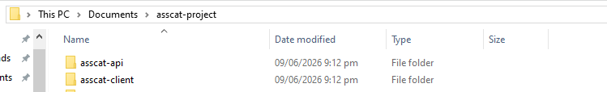

Step 2: Install Required Software
Ensure the following software is installed on your system:
- Node.js (v18 or higher) for running the React frontend
- PHP 8.2 or higher for the CodeIgniter 4 backend
- Composer for PHP dependency management
- MariaDB or MySQL for the database
- A web server (Apache or Nginx)
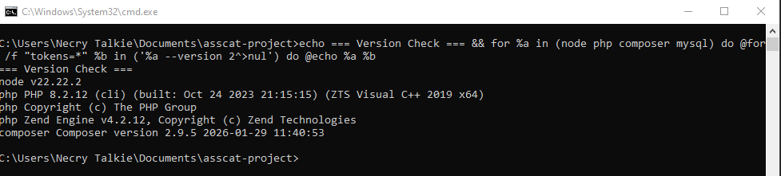

Step 3: Configure the Database
Create a new database for the system:
CREATE DATABASE asscat_db CHARACTER SET utf8mb4 COLLATE utf8mb4_general_ci;
CREATE USER ‘asscat_user’@’localhost’ IDENTIFIED BY ‘your_password’;
GRANT ALL PRIVILEGES ON asscat_db.* TO ‘asscat_user’@’localhost’;
FLUSH PRIVILEGES;

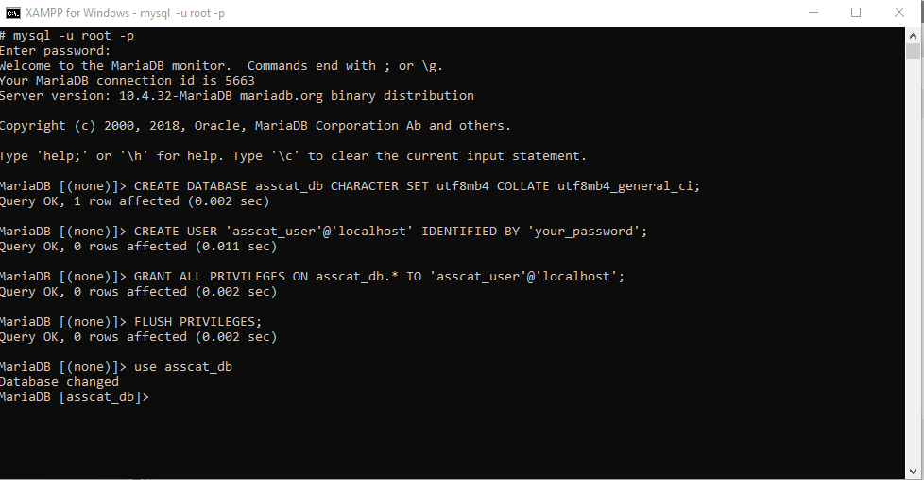
The database tables will be automatically created by the application’s FeatureSchema migration system on first run. Alternatively, import the provided SQL file if available.

Step 4: Configure Backend (asscat-api)
Navigate to the asscat-api directory and install PHP dependencies:
cd asscat-api
composer install

Copy the .env file and configure database connection:
cp env .env
# Edit .env with your database credentials:
# database.default.hostname = localhost
# database.default.database = asscat_db
# database.default.username = asscat_user
# database.default.password = your_password
# database.default.DBDriver = MySQLi

Configure email settings in app/Config/Email.php for SMTP:
// app/Config/Email.php
public $protocol = ‘smtp’;
public $SMTPHost = ‘smtp.gmail.com’;
public $SMTPUser = ‘your_email@gmail.com’;
public $SMTPPass = ‘your_app_password’;
public $SMTPPort = 587;
public $SMTPCrypto = ‘tls’;

Start the backend server:
php spark serve



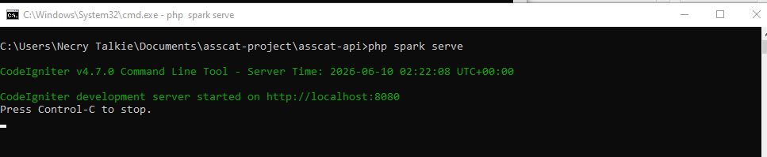

Step 5: Configure Frontend (asscat-client)
Navigate to the asscat-client directory and install dependencies:
cd asscat-client
npm install

Start the React development server:
npm start

The frontend will open at http://localhost:3000. Update the API base URL in the code if your backend runs on a different port.
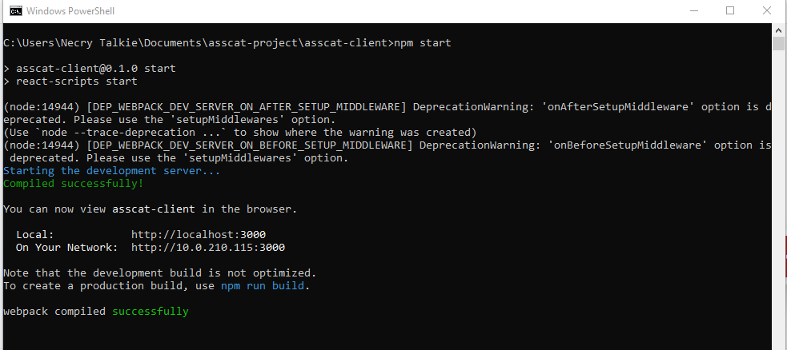

Step 6: Access the System
Open a web browser and navigate to:
Frontend: http://localhost:3000
Backend API: http://localhost:8080

You should see the Necry OER Portal home page with the catalog, search bar, and navigation links.
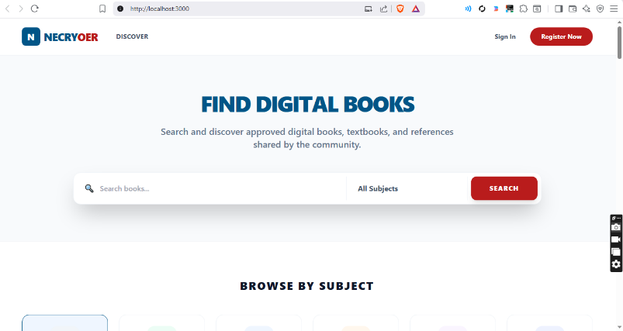

For production deployment on a live web host:
- Build the React frontend: npm run build
- Upload the asscat-api and the built frontend to your web host
- Configure the web server (Apache/Nginx) to serve the frontend and route API requests
- Set up the database on the host's MySQL/MariaDB server
- Update .env with production database credentials and the live site URL

VI. LOGIN AND USER ACCESS
A. Login Page
The Login page allows registered users to access their accounts. To access the Login page, click the "Login" button on the top-right corner of the navigation bar.
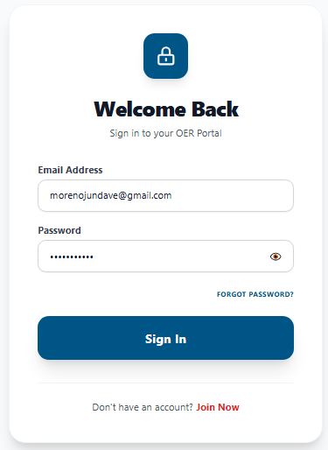

Login Procedure
Follow these steps to log in to the system:
1. Navigate to the Necry OER Portal home page.
2. Click the "Login" button on the top navigation bar.
3. Enter your registered email address in the Email field.
4. Enter your password in the Password field.
5. Click the "Login" button.
6. Upon successful authentication, you will be redirected to your Dashboard.
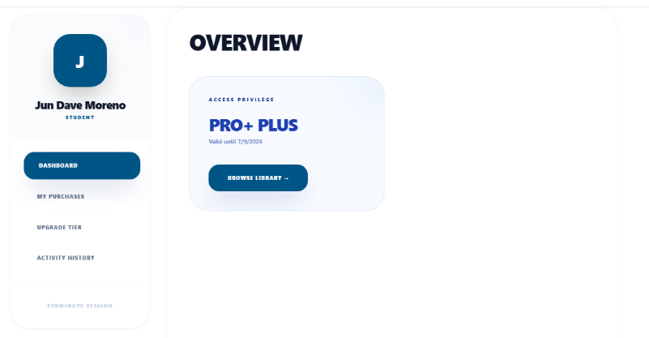

Troubleshooting Login Issues
- If your email is not yet verified, you will receive a 403 error with instructions to verify.
- If you forgot your password, click the "Forgot Password?" link to reset it via email OTP.
- After multiple failed attempts, your IP will be temporarily locked for security.

B. User Roles
The system has four user roles, each with specific permissions and capabilities:

Figure 2: Use Case Diagram – System Actors and Functionalities
Role | Permissions | Accessible Pages
Administrator | Full system management: users, resources, withdrawals, system config | Home, Dashboard (admin tabs), All admin pages
Uploader | Upload resources, manage content, track earnings, request payouts | Home, Dashboard (My Uploads, Earnings, Payouts)
Student | Browse, purchase, read resources, upgrade subscription | Home, Dashboard (My Purchases, Subscription)
Guest | Browse catalog, view resource details, search | Home, Resource Detail (read-only)

VII. SYSTEM FEATURES & OPERATIONS
Feature 1: User Registration
Registration with OTP Verification
Purpose:
Allows new users to create an account with email verification for security.
Procedure:
1. Click "Sign Up" on the navigation bar.
2. Fill in the registration form: Name, Email, Password, Confirm Password, Role (Student or Uploader), and Education Level (if Student).
3. Upload a proof document if registering as a Student (e.g., school ID, enrollment form).
4. Click "Send OTP" — a 6-digit code will be sent to your email.
5. Enter the OTP code in the verification field.
6. If OTP expires, click "Resend Code" to receive a new one.
7. Click "Verify & Register" to complete registration.
Expected Output:
You will be redirected to the Login page. Your account is now active with email_verified=1. You can now log in with your registered email and password.
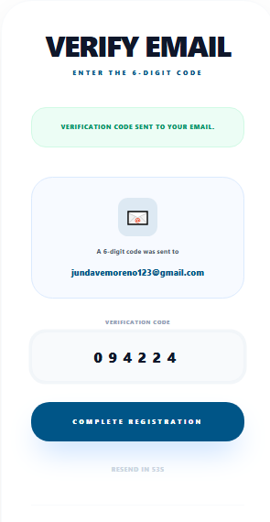
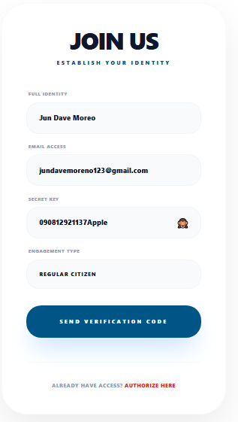

Feature 2: Browsing the Catalog
Resource Catalog Browsing
Purpose:
Enables users to discover available educational materials organized by department and course.
Procedure:
1. On the Home page, browse the "New Arrivals" section for recently added resources.
2. Use the department/subject filter dropdown to narrow results by academic department.
3. Scroll through the catalog grid showing resource cards with cover images, titles, and prices.
4. Click on any resource card to view its detailed information page.

Expected Output:
The catalog displays all approved resources sorted by newest first. Each card shows the cover thumbnail, title, price (with discount if applicable), and author.
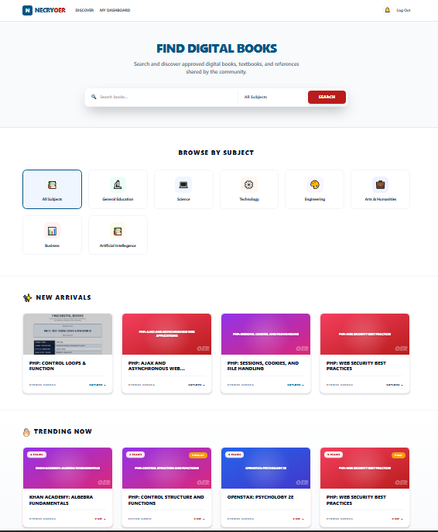

Feature 3: Searching for Resources
Search Functionality
Purpose:
Allows users to find specific resources by title keyword.
Procedure:
1. Locate the search bar at the top of the Home page.
2. Type a keyword related to the resource title (e.g., “Database”, “Programming”).
3. The catalog will automatically filter to show matching resources as you type.
4. Clear the search field to reset the full catalog view.
Expected Output:
The catalog dynamically filters to display only resources whose titles match the search keyword. Non-matching resources are hidden.
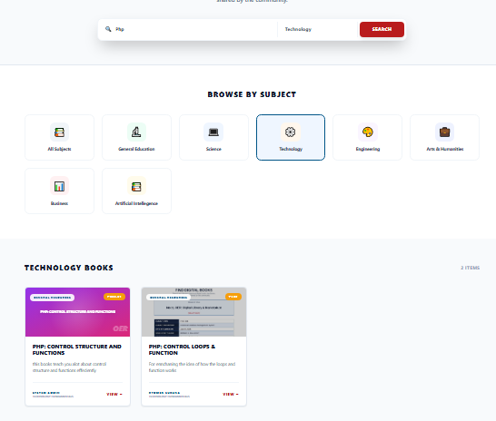

Feature 4: Resource Detail View
Resource Detail Page
Purpose:
Provides comprehensive information about a specific educational resource.
Procedure:
1. Click on a resource card from the catalog.
2. The Resource Detail page displays: cover image, title, author, ISBN, edition, publisher, page count, language, and description.
3. If logged in, the discount breakdown is shown: original listed price, discount percentage (from promo or subscription), discounted price, and savings amount.
4. Click "Open" to access the resource if you have already purchased it.
5. Click "Purchase" to buy the resource.
Expected Output:
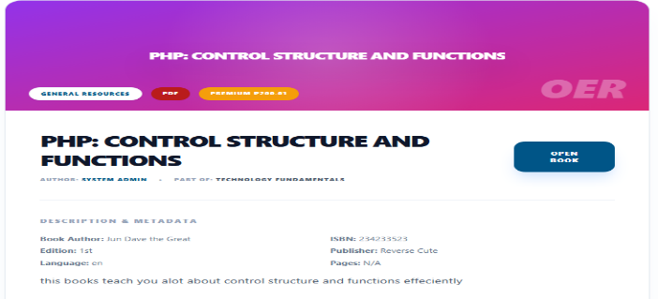
You see the complete resource information with pricing details. If a discount applies, a green badge shows the source ("Promo Discount" or "Subscription Discount") and the calculated savings.

Feature 5: Purchasing a Resource
Resource Purchase with Discount
Purpose:
Enables students to purchase resources at the best available price.
Procedure:
1. On the Resource Detail page, review the price and discount information.
2. Click the "Purchase" button.
3. A Payment Method modal appears — select your preferred method (Card, GCash, or Maya).
4. Click "Confirm Payment" to proceed.
5. A progress animation plays as the system processes the payment.
6. Upon success, a celebration overlay appears with a success message.
7. A purchase receipt is sent to your registered email.
Expected Output:
The resource is now in your library. You can access it anytime by clicking "Open" on the Resource Detail page or from the "My Purchases" tab in your Dashboard.
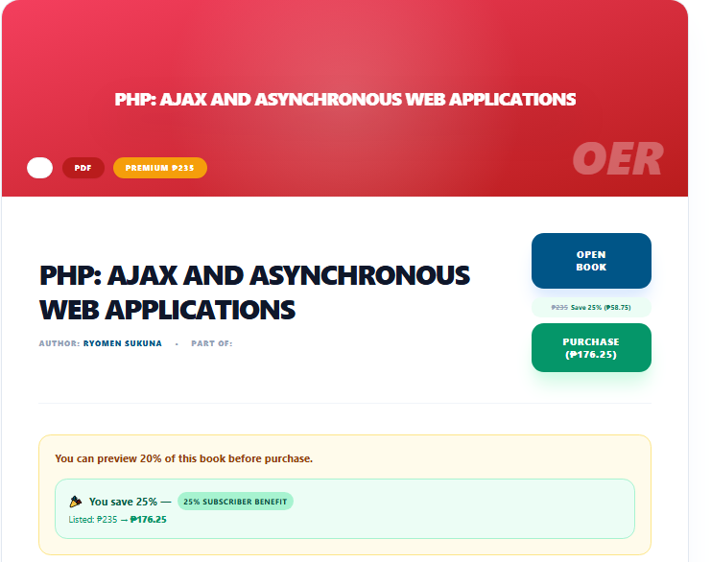

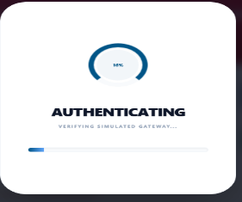
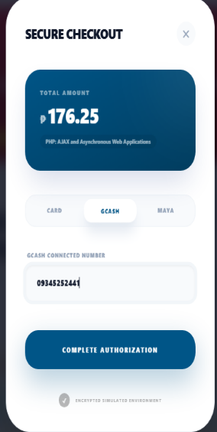

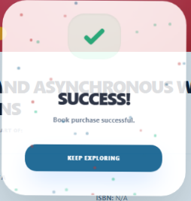

Feature 6: Opening and Reading Resources
In-App Resource Reader
Purpose:
Allows users to read purchased resources directly within the browser.
Procedure:
1. Navigate to a resource you have purchased.
2. Click the "Open" button on the Resource Detail page.
3. The resource opens in an in-app viewer/reader.
4. Use the viewer controls to navigate through pages.
5. Access is logged in the system for tracking purposes.

Expected Output:
The resource content is displayed securely within the browser. Uploaders can open their own materials for free without any purchase requirement.
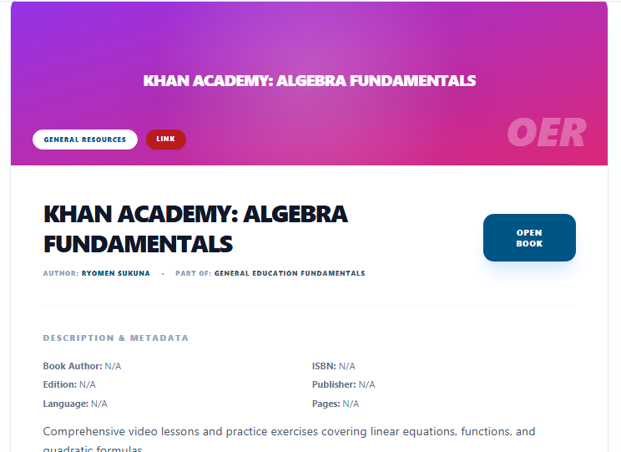

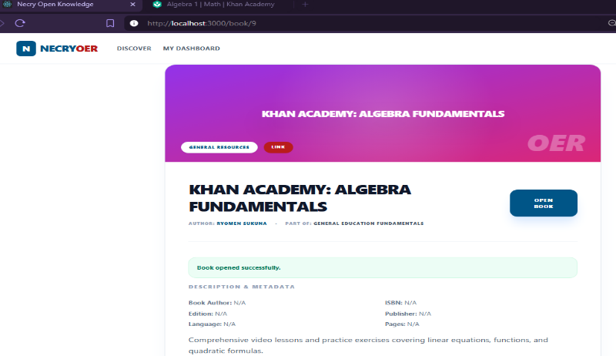

Feature 7: Dashboard Overview
User Dashboard
Purpose:
Provides a centralized hub for managing account activities based on user role.
Procedure:
1. Click "Dashboard" in the navigation bar after logging in.
2. The Dashboard displays different tabs based on your role:
3. For all users: Profile, Notifications, Activity History.
4. For Students: My Purchases, Subscription upgrade.
5. For Uploaders: My Uploads, Earnings & Payouts.

Expected Output:
The Dashboard adapts to your role, showing only relevant sections and features.
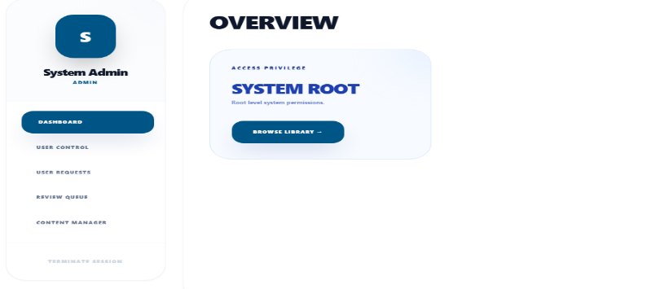
- Admin Sys

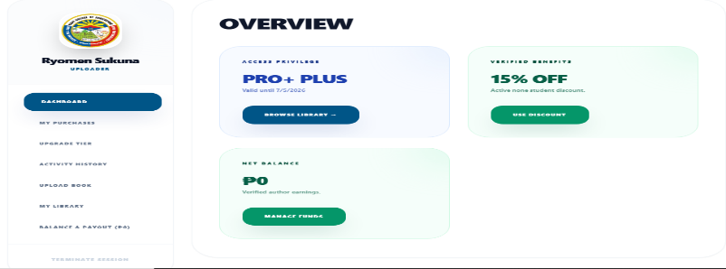
- Uploader

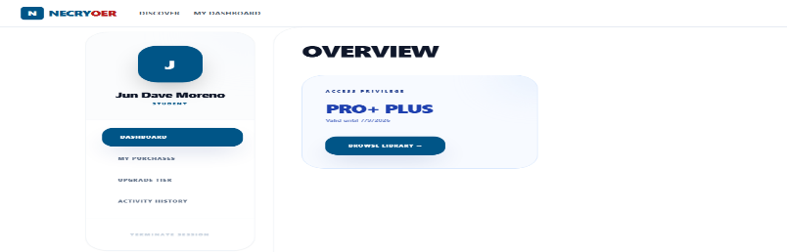
- Student/Regular user

Feature 8: My Purchases (Students)
My Purchases Tab
Purpose:
Lists all resources purchased by the student.
Procedure:
1. Go to Dashboard > My Purchases tab.
2. View a table listing all purchased resources with: title, listed price, discount, paid amount, and purchase date.
3. Click "Open" on any resource to access it directly.

Expected Output:
A complete list of all your purchases is displayed, allowing quick access to any purchased resource.
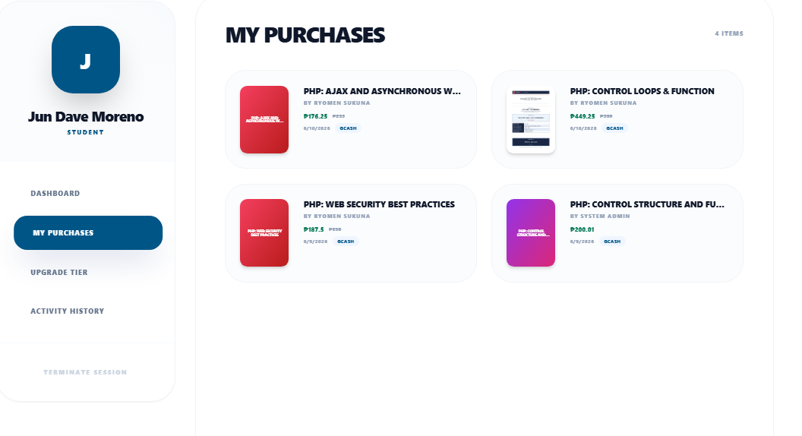

Feature 9: Subscription Upgrade
Subscription Tier Upgrade
Purpose:
Allows students to upgrade their account for additional discounts.
Procedure:
1. Go to Dashboard > Subscription tab.
2. View the current subscription tier and available upgrade options.
3. Compare the benefits: Pro (10% discount) vs Pro+ (25% discount).
4. Click "Upgrade" on your chosen tier.
5. Select a payment method in the Payment Modal.
6. Confirm payment to complete the upgrade.

Expected Output:
Your subscription tier is updated immediately. All future purchases will automatically receive the tier discount. An upgrade confirmation email is sent.
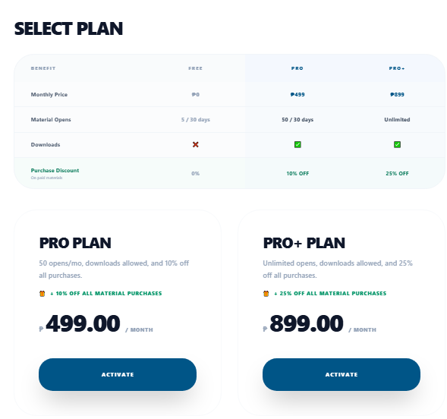

Feature 10: My Uploads (Uploaders)
Upload Management
Purpose:
Enables uploaders to manage their submitted educational materials.
Procedure:
1. Go to Dashboard > My Uploads tab.
2. View all your uploaded resources in a list with title, status (approved/pending), price, and upload date.
3. Use the search bar within My Uploads to filter by title.
4. Click "Delete" on a resource to remove it (confirmation required).

Expected Output:
You can see the status of each upload. Approved resources are publicly visible; pending resources await admin review.
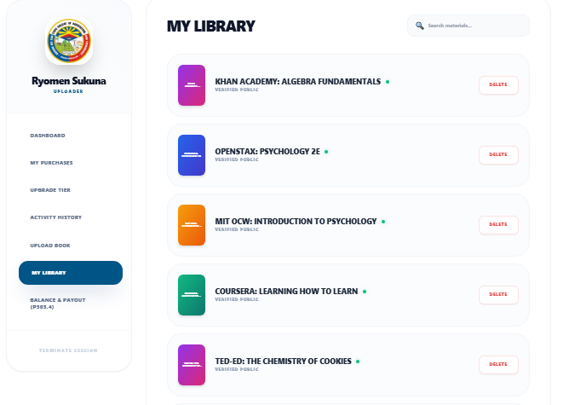

Feature 11: Uploading New Resources
Resource Upload Form
Purpose:
Allows uploaders to submit new educational materials to the platform.
Procedure:
1. Go to Dashboard > My Uploads tab.
2. Click the "Upload New Resource" button.
3. Fill in the upload form with: Title, Author, ISBN (optional), Edition, Publisher, Page Count, Language, and Description.
4. Select the Department, Course, and Section for the resource.
5. Upload the resource file (PDF format, max 100MB).
6. Upload a cover image (JPG/PNG, max 5MB).
7. Set the Price and select Material Type (Book or Resource).
8. Set the Preview Percentage (default 20%).
9. Click "Submit" to upload.
10. The resource will be pending admin approval before becoming public.
Expected Output:
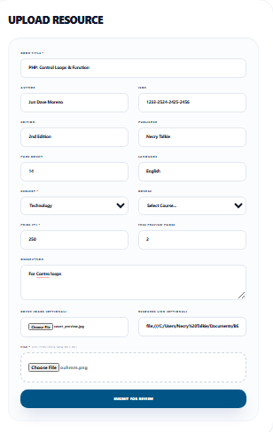
The resource is saved to the database with is_approved=0. An administrator will review and approve it. You will receive a notification once approved.

Feature 12: Earnings and Payouts (Uploaders)
Earnings Dashboard and Payout System
Purpose:
Allows uploaders to track their revenue and withdraw earnings.
Procedure:
1. Go to Dashboard > Earnings tab.
2. View your current balance, total earnings, pending withdrawals, and total withdrawn amounts.
3. Set up payout accounts: Click "Manage Payout Accounts" to add GCash, Maya, or Bank accounts (up to 3 per type).
4. For Bank accounts, provide: account number, account name, card number, expiry date, and CVV.
5. Set your 6-digit payout PIN for withdrawal security.
6. To withdraw: scroll to the Withdraw section, select a payout account, enter the amount, and click "Withdraw".
7. Enter your 6-digit payout PIN in the modal to confirm.
Expected Output:
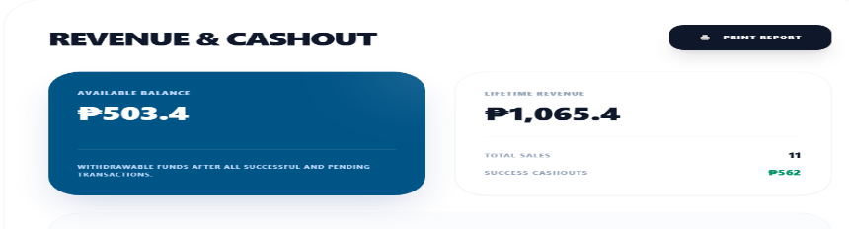
The withdrawal request is created with "pending" status. An administrator will review and process the payout. Your balance remains unchanged until the withdrawal is processed.

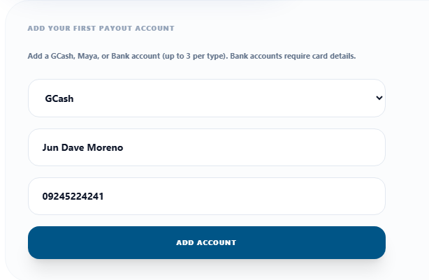

Feature 13: Admin – Resource Approval
Resource Moderation
Purpose:
Allows administrators to review and approve/reject uploaded resources.
Procedure:
1. Log in with an Administrator account.
2. Go to Dashboard > the admin-specific section.
3. View a list of pending resources with title, uploader, and upload date.
4. Review the resource details and file.
5. Click "Approve" to make the resource publicly visible.
6. Click "Reject" to remove the resource from the system.

Expected Output:
Approved resources become visible in the public catalog. The uploader receives a notification of the approval decision.
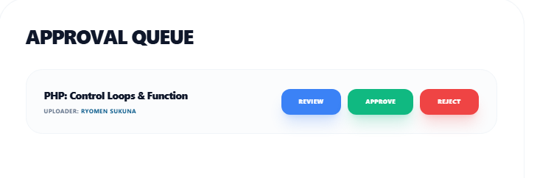

VIII. CRUD OPERATIONS GUIDE
A. Creating Records (CREATE)
Example 1: Upload a New Resource
As an Uploader, you can create new resource records in the system:
Procedure:
1. Navigate to Dashboard > My Uploads and click "Upload New Resource".
2. Fill in all required fields (Title, Price, File, etc.).
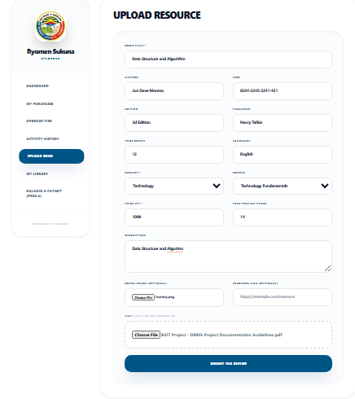
3. Click "Submit" to save.

Expected Output:
The resource is inserted into the database with is_approved=0. It appears in My Uploads with "Pending" status.
Example 2: Register a New User
Any guest can create a user account:
Procedure:
1. Click "Sign Up" on the navigation bar.
2. Fill in the registration form.
3. Verify email via OTP code.
4. Complete registration.
Expected Output:
A new user record is created in the users table with email_verified=1.

B. Viewing Records (READ)
Example 1: Browse Resource Catalog
All users can view the list of approved resources:
Procedure:
1. On the Home page, view the catalog grid showing all approved resources.
2. Use the department filter or search bar to narrow results.
3. Click a resource card to view detailed information.
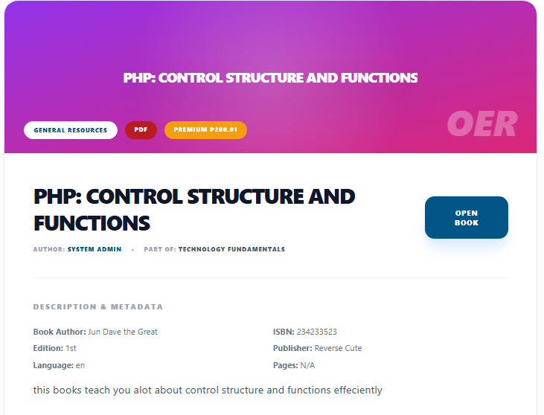

Expected Output:
A paginated grid of resource cards, each showing the cover image, title, author, and price. Details include full metadata and discount information.
Example 2: View Purchase History
Students can view their purchase history:
Procedure:
1. Go to Dashboard > My Purchases.
2. View the table listing all purchases with prices and dates.
Expected Output:
A sortable table showing all completed purchases with resource titles, prices, discounts, and purchase dates.

C. Updating Records (UPDATE)
Example 1: Approve a Resource (Admin)
Administrators can update a resource's approval status:
Procedure:
1. Log in as Administrator.
2. Navigate to the admin approval section.
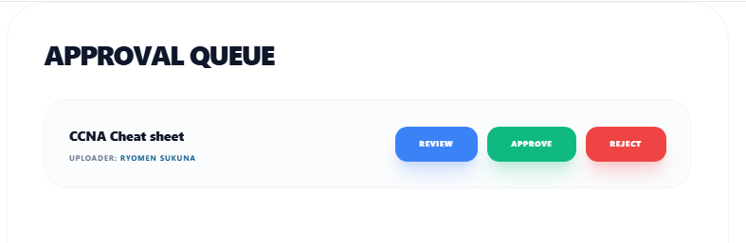
3. Click "Approve" on a pending resource.

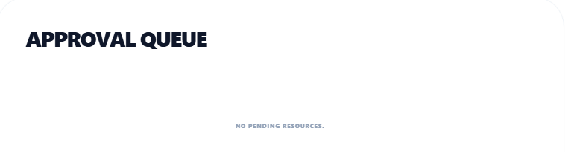

Expected Output:
The resource's is_approved field is updated from 0 to 1. The uploader receives a notification. The resource becomes publicly visible in the catalog.
Example 2: Upgrade Subscription
Students can update their subscription tier:
Procedure:
1. Go to Dashboard > Subscription.
2. Click "Upgrade" on the desired tier.
3. Confirm payment.
Expected Output:
The user's subscription_tier and subscription_expires_at fields are updated. All future purchases receive the tier discount.

D. Deleting Records (DELETE)
Example 1: Delete an Uploaded Resource
Uploaders can delete their own resources:
Procedure:
1. Go to Dashboard > My Uploads.
2. Locate the resource you want to delete.
3. Click the "Delete" button.
4. Confirm the deletion in the confirmation dialog.
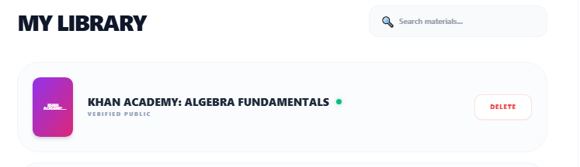

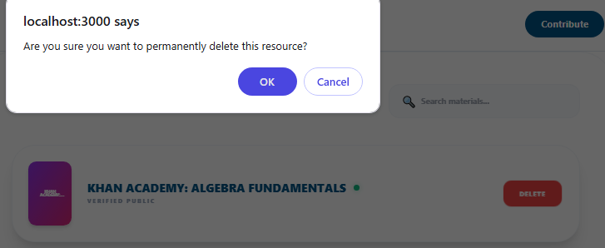

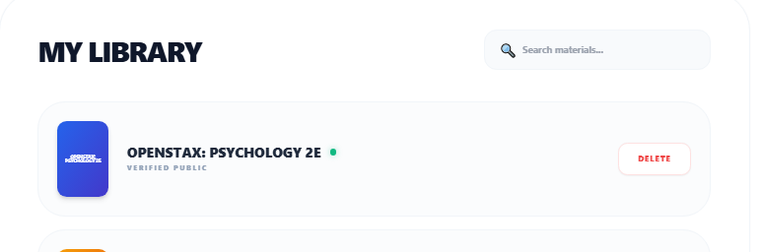

Example 2: Delete a Notification
Users can delete individual notifications:
Procedure:
1. Open the notifications panel.
2. Click the delete icon on a notification.
Expected Output:
The notification record is deleted from the database and removed from the user's notification list.

IX. SEARCHING AND FILTERING RECORDS
A. Searching Resources
The system provides a dynamic search feature on the Home page:
1. Type a keyword in the search bar at the top of the Home page.
2. Results filter in real-time as you type.
3. Matching resources are displayed based on title keyword match.
B. Filtering by Department
Users can narrow the catalog by academic department:
1. Locate the department/subject dropdown above the catalog.
2. Select a department from the dropdown list.
3. The catalog updates to show only resources from the selected department.
4. Select "All Departments" to reset the filter.
C. Sorting Information
The catalog automatically sorts resources:
- New Arrivals section: sorted by creation date (newest first)
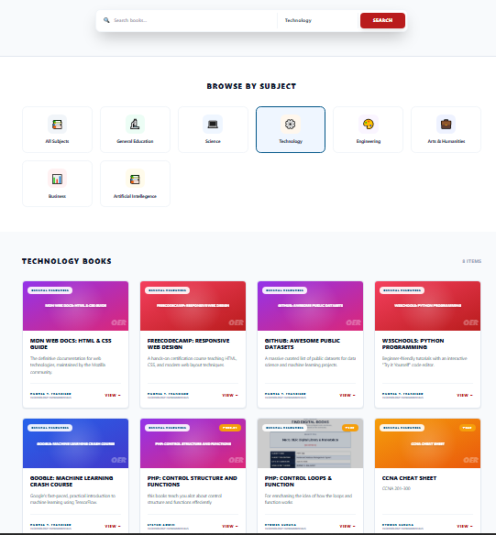
- Full catalog: sorted by creation date (descending) by default

X. REPORT GENERATION
The Necry OER Portal includes a Print Report feature for users to generate and print a summary of their account information.
Viewing and Printing Reports
Follow these steps to view and print reports:
1. Go to Dashboard > Profile tab.
2. Scroll down to the "Print Report" section.
3. Click the "Print Report" button.
4. A print dialog opens with a formatted report containing your profile summary, account statistics, and recent activity.
5. Select your printer or choose "Save as PDF" to export digitally.

6. Click "Print" to generate the output.
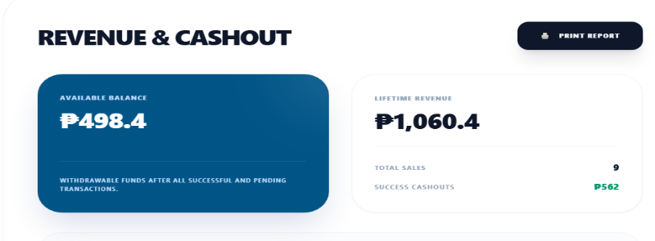

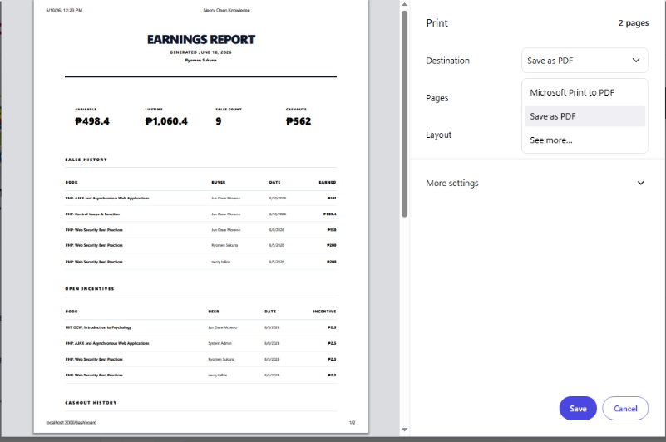

Report Contents
The generated report includes:
- User profile information (name, email, role)
- Account statistics (total purchases, total uploads, earnings)
- Recent transaction history
- Current subscription tier and benefits
- System-generated date and timestamp

XI. ERROR HANDLING AND TROUBLESHOOTING
The following table documents common system errors and their solutions:
Issue | Possible Cause | Solution
Unable to Login | Incorrect email or password | Use "Forgot Password" to reset. Check email for typos. Ensure email is verified.
"Email Not Verified" Error | Account not yet verified via OTP | Check your email for the verification code. Click "Resend Code" if needed.
Account Locked | Multiple failed login attempts | Wait 15 minutes for the IP lock to expire, then try again with correct credentials.
Cannot Upload File | File too large or wrong format | Ensure file is PDF format and under 100MB. Check your internet connection.
Resource Not Visible | Resource pending admin approval | Wait for an administrator to review and approve your upload. Check notifications.
Payment Failed | Insufficient balance or network error | Check your payment method and try again. Ensure stable internet connection.
Page Not Loading | Network or server issue | Check your internet connection. Verify the server is running. Try refreshing the page.
OTP Not Received | Email delivery delay or wrong email | Wait 1-2 minutes. Check Spam/Junk folder. Click "Resend Code" for a new OTP.
Database Connection Error | Database service not running | Contact the system administrator to start the database service.
Forbidden (403) Access | Insufficient user role permissions | Ensure you are logged in with the correct account role for the feature you are trying to access.
Cannot Open Resource | Resource not purchased | Purchase the resource first. If you are the uploader, ensure you are logged in with the correct account.

XII. FREQUENTLY ASKED QUESTIONS (FAQ)
1. How do I reset my password?
Click the "Forgot Password?" link on the Login page. Enter your registered email address. A 6-digit OTP code will be sent to your email. Enter the code, then set a new password. You can then log in with your new password.
2. How do I edit my profile information?
Go to Dashboard > Profile tab. Your account information (name, email, role) is displayed. You can upload a profile picture by clicking on the profile image area. For changes to core account details, contact the system administrator.

3. How do I purchase a resource?
Browse the catalog and click on a resource you want to purchase. On the Resource Detail page, review the price and any applicable discounts. Click the "Purchase" button, select your payment method (Card, GCash, or Maya), and confirm payment. The resource will be added to your library immediately.
4. How do I withdraw my earnings as an uploader?
First, ensure you have set up at least one payout account (Dashboard > Earnings > Manage Payout Accounts) and set your 6-digit payout PIN. Then, go to the Earnings tab, enter the withdrawal amount, select a payout account, and click "Withdraw". Enter your PIN to confirm. The request will be processed by an administrator.

5. How long does it take for my uploaded resource to be approved?
Resource approval depends on administrator availability. Typically, resources are reviewed within 24-48 hours. You will receive an in-app notification and email once your resource has been approved or rejected. You can check the status in Dashboard > My Uploads.
6. What is the difference between Pro and Pro+ subscription?
Pro subscription gives you a 10% discount on all resource purchases. Pro+ subscription gives you a 25% discount. The discount is automatically applied at checkout. Note that subscription discounts are not stackable with promo discounts — the system applies whichever gives you the better price.

7. Can I access my purchased resources offline?
The Necry OER Portal is a web-based application designed for online access. Resources are streamed securely within your browser and require an active internet connection. For offline access, consider downloading materials if permitted by the uploader.

XIII. SYSTEM MAINTENANCE AND BACKUP
A. Database Backup Procedures
Regular database backups are essential for data safety. To back up the MariaDB database:
1. Open a terminal or command prompt.
2. Run the mysqldump command:
mysqldump -u asscat_user -p asscat_db > backup_asscat_YYYYMMDD.sql
3. Enter the database password when prompted.
4. The SQL file is now saved as a complete database backup.
5. Store the backup file in a secure location (external drive, cloud storage).

B. Database Restoration Procedures
To restore the database from a backup:

1. Create a new database if needed:
CREATE DATABASE asscat_db CHARACTER SET utf8mb4;
2. Import the backup file:
mysql -u asscat_user -p asscat_db < backup_asscat_YYYYMMDD.sql
3. Enter the database password when prompted.
4. Verify the restoration by checking table counts and data.

C. User Account Maintenance
Administrators can perform the following user account maintenance tasks:
- View all registered users and their account status
- Verify or reject student verification documents
- Suspend or restore user accounts
- Reset user passwords when necessary
- Review and process withdrawal requests

D. System Updates
To update the system to a newer version:
1. Back up the current database and project files.
2. Replace the asscat-api and asscat-client files with the updated versions.
3. Run composer install in asscat-api for any new PHP dependencies.
4. Run npm install in asscat-client for any new frontend dependencies.
5. Check the changelog for any database migration scripts that need to be run.
6. Test all major features after the update.

XIV. APPENDICES
Appendix A: Sample User Accounts
The following are sample accounts for testing and demonstration purposes:
Role | Email | Password
Administrator | admin@asscat.edu.ph | admin123
Uploader | uploader@asscat.edu.ph | uploader123
Student | student@asscat.edu.ph | student123

Appendix B: Entity Relationship Diagram

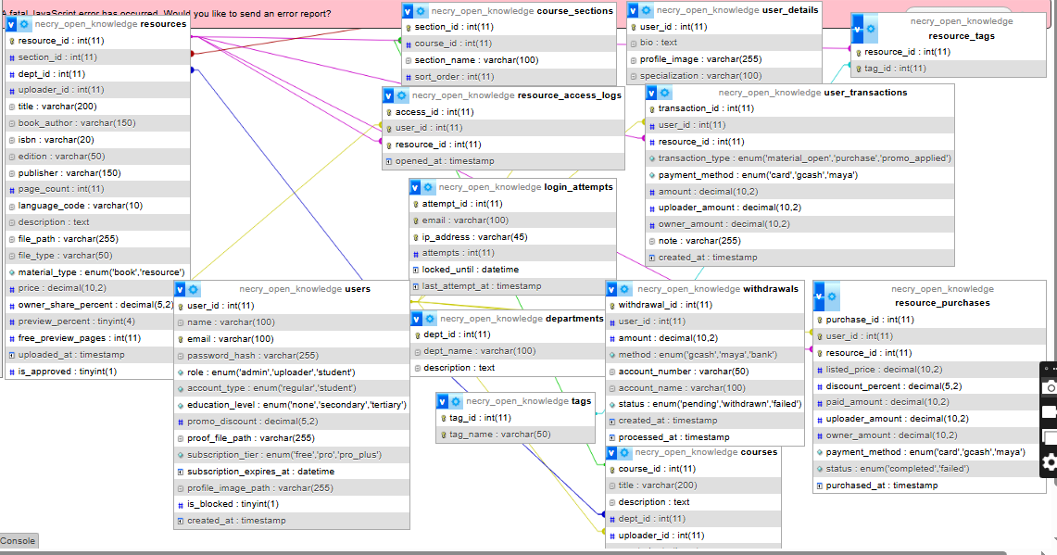

Figure 3: Complete Entity Relationship Diagram (All 15 Tables)
Appendix C: Sequence Diagrams
1. User Authentication (Login)

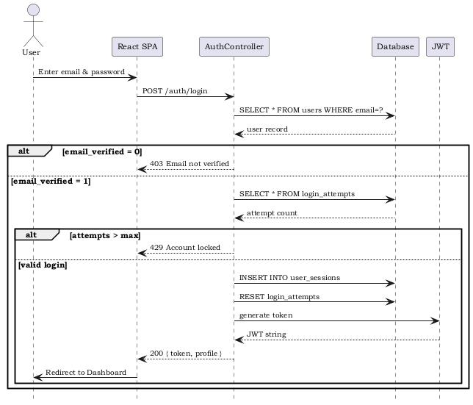

Figure 4: Login Authentication Sequence
2. OTP Registration

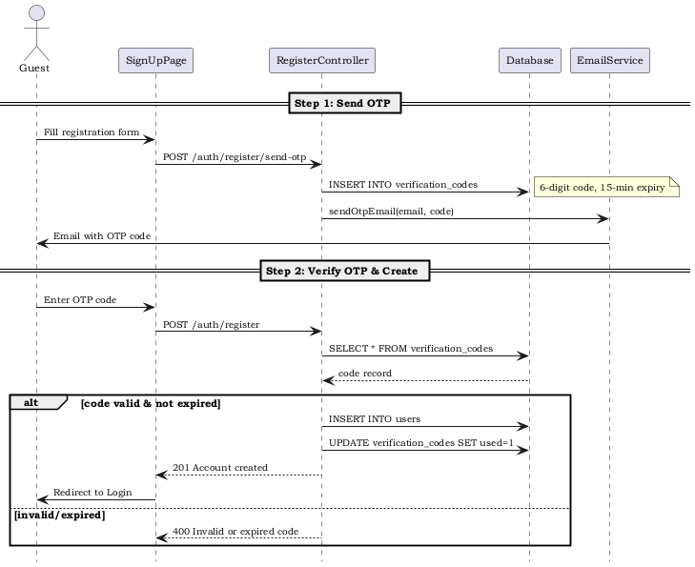

Figure 5: OTP Registration Sequence
3. Resource Purchase with Discount

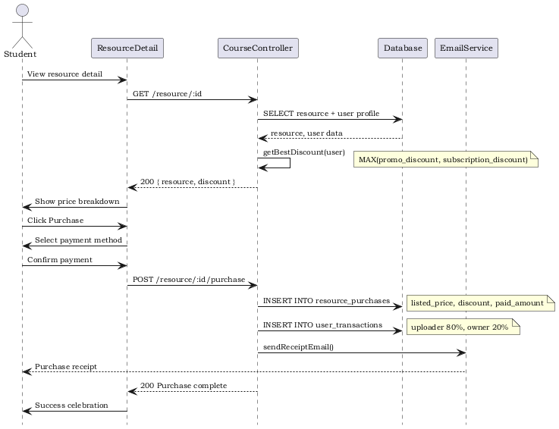

Figure 6: Resource Purchase Sequence
4. Uploader Opening Own Material

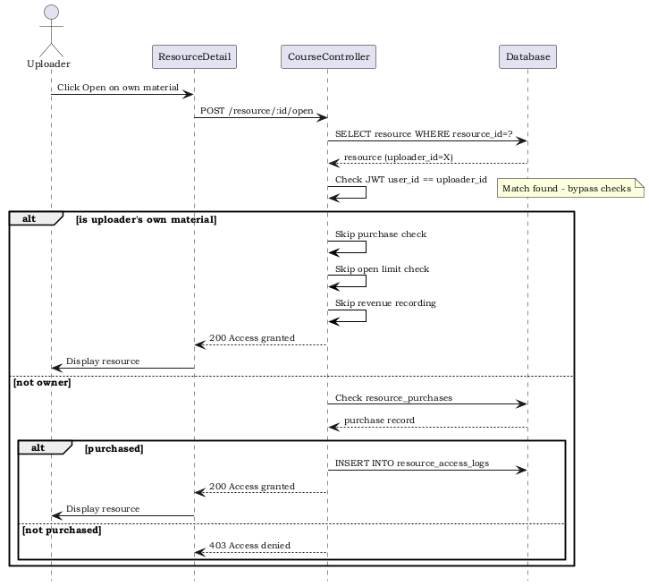

Figure 7: Uploader Self-Open Sequence
5. Subscription Upgrade

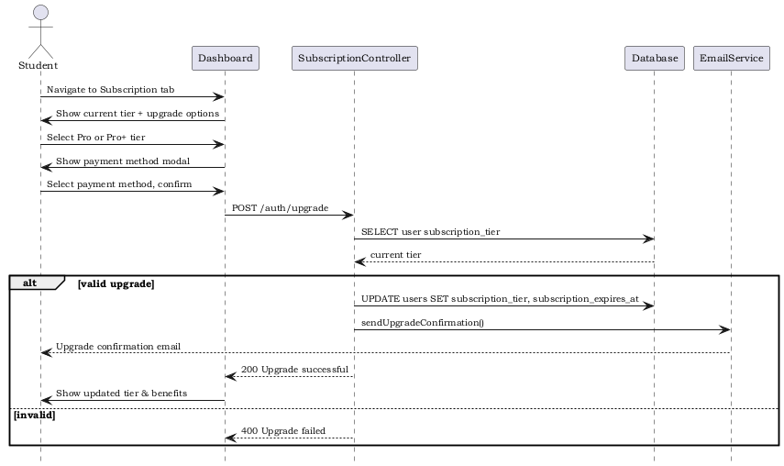

Figure 8: Subscription Upgrade Sequence
6. Resource Upload and Approval

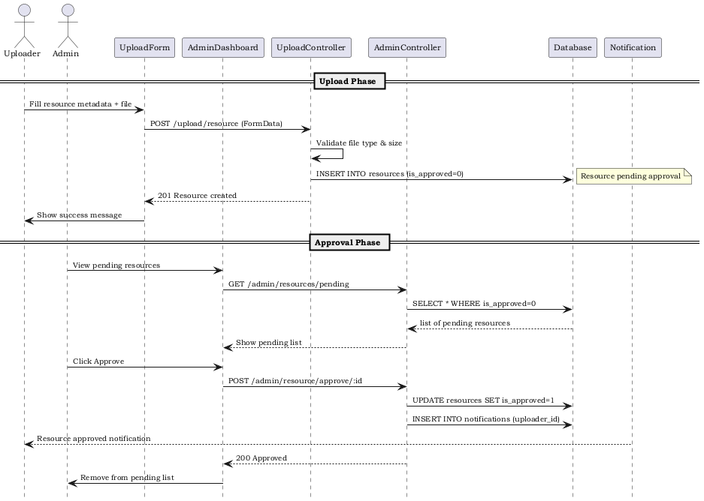

Figure 9: Resource Upload and Approval Sequence
7. Withdrawal Request

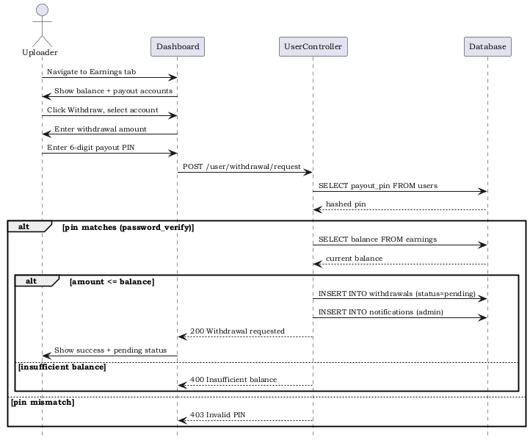

Figure 10: Withdrawal Request Sequence
8. Resource Search and Delete

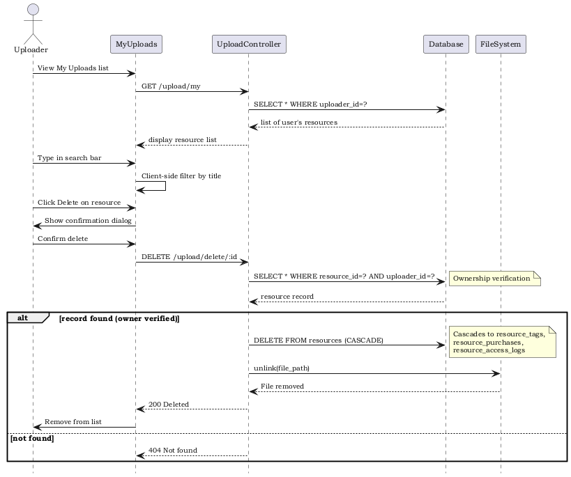

Figure 11: Resource Delete Sequence
Appendix D: Additional Screenshots
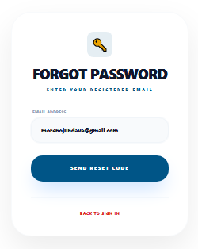

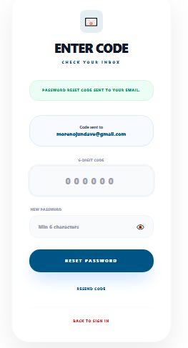

Appendix E: Forms Used by the System
The system uses the following forms for data input:
- Registration Form – Name, Email, Password, Role, Education Level, Proof Document
- Login Form – Email, Password
- Forgot Password Form – Email, OTP Code, New Password
- Upload Resource Form – Title, Author, ISBN, Edition, Publisher, Page Count, Language, Description, File, Cover Image, Department, Course, Section, Price, Material Type, Preview Percentage
- Payout Account Form – Account Type, Account Number, Account Name, Card Details (for Bank)
- Withdrawal Form – Amount, Payout Account, PIN
Appendix F: References
The following references were used in the development of this system:
- CodeIgniter 4 Documentation – https://codeigniter.com/user_guide/
- React 18 Documentation – https://react.dev/
- MariaDB Documentation – https://mariadb.com/kb/en/
- PHPMailer Documentation – https://github.com/PHPMailer/PHPMailer
- Firebase PHP-JWT – https://github.com/firebase/php-jwt
- Tailwind CSS Documentation – https://tailwindcss.com/docs
- https://drive.google.com/drive/u/1/folders/1kFE5OX35LxwmoEFW4T-ZS2gCx8yVkA6d

