论文：Kaiwen Cai, Cong Peng, Zhiquan Deng, et al. Suppression of Harmonic Vibration in Magnetically Suspended Centrifugal Compressor Using Zero-Phase Odd-Harmonic Repetitive Controller[J]. IEEE Transactions on Industrial Electronics, 2019

论文录用邮件：

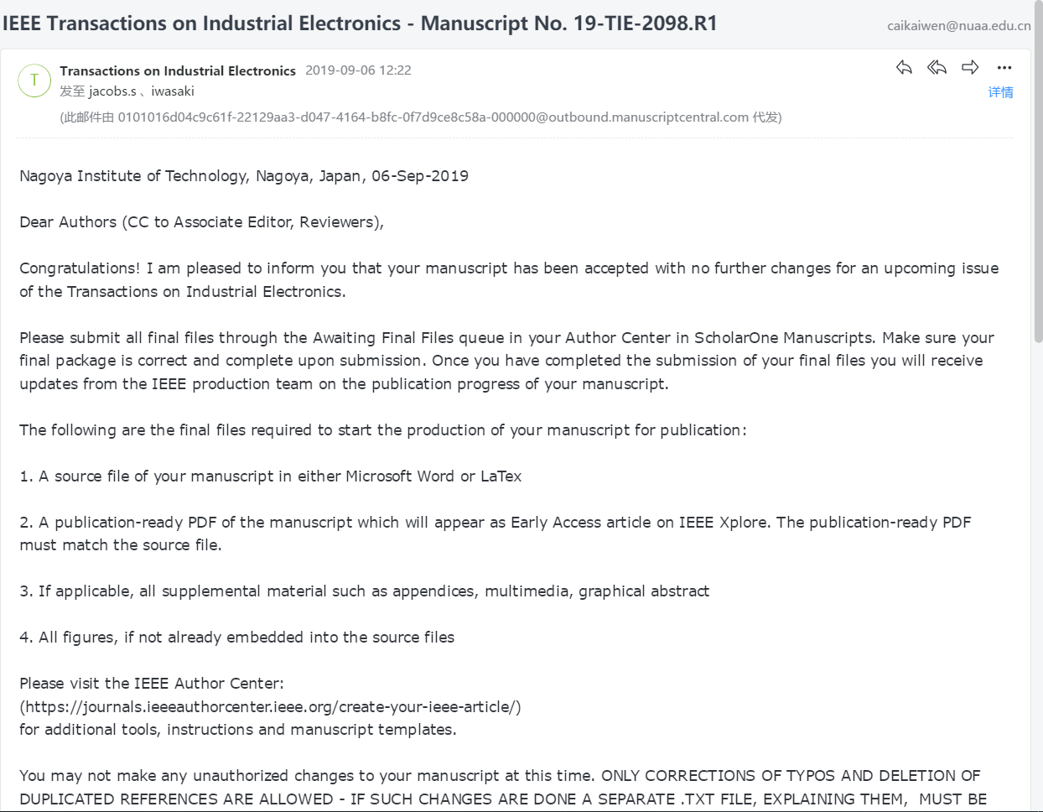

发表期刊截图：

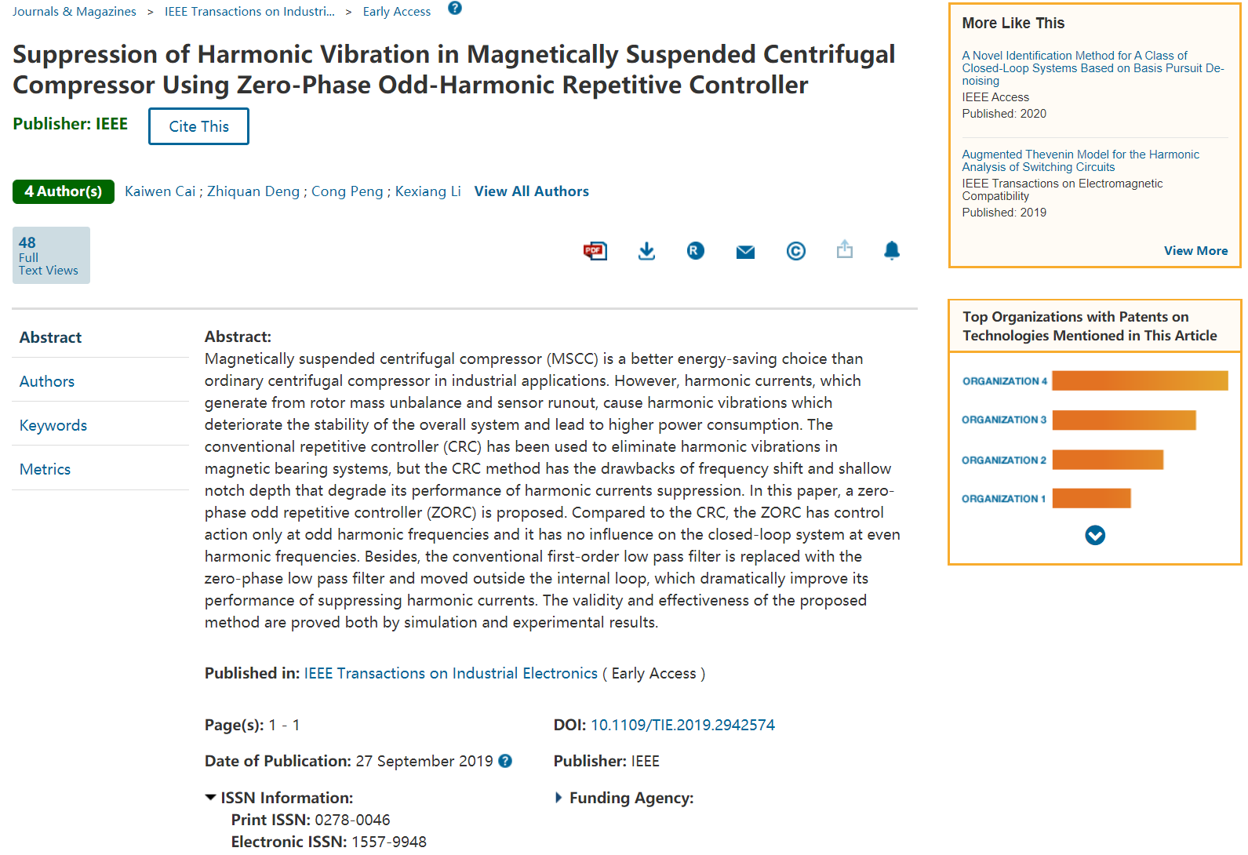

|  |  |  |  |  |
| --- | --- | --- | --- | --- |
| 学生： | 蔡凯文 |  | 导师： |  |