Setup and Implementation: -

Hardware Used: RaspberryPi Pi3 B+ with Groove Pi set and Plugwise Set.

Raspberry Pi is used as the central Gateway of the System which interacts with the endge sensors and actuators and also with the Server for data storage. A GUI is implemented in the Server side for displaying the current system Status and also to plot the recorded data.

Top Level

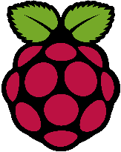

Sensor Driver

RaspberryPi

Interaction with MQTT

Server

Database Manager

GUI with Plotter

Actuator Driver

Control Logic

Sensor Driver