

# History of the ISS

## A Pictorial History of the International Space Station

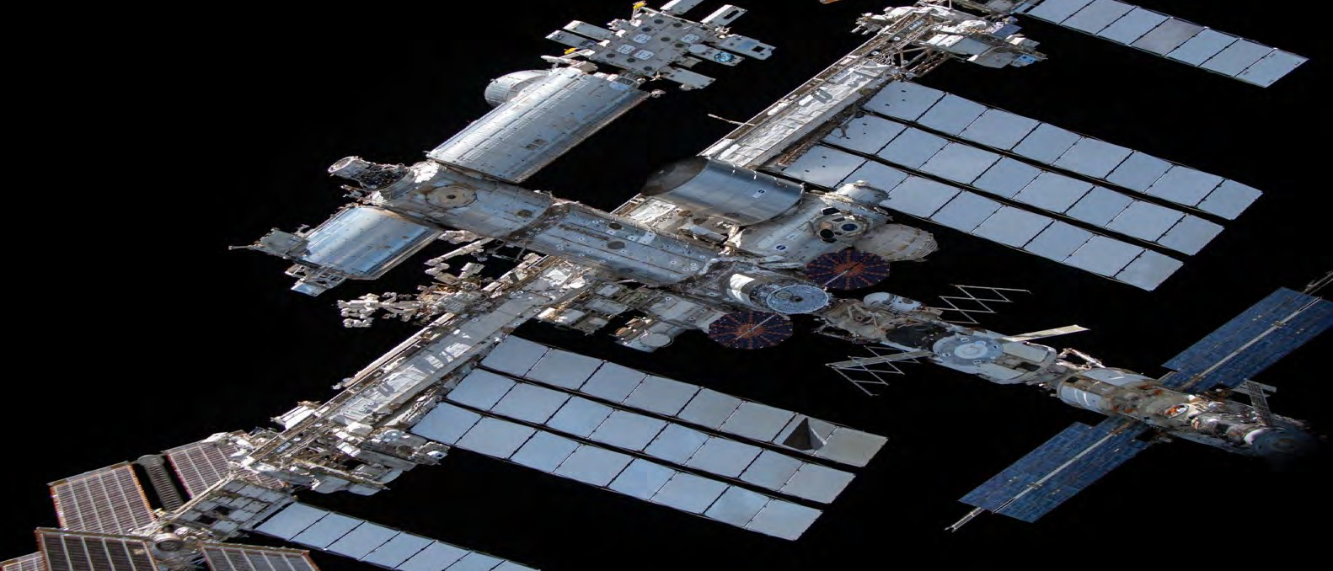

All images courtesy of NASA or CASIS 2024

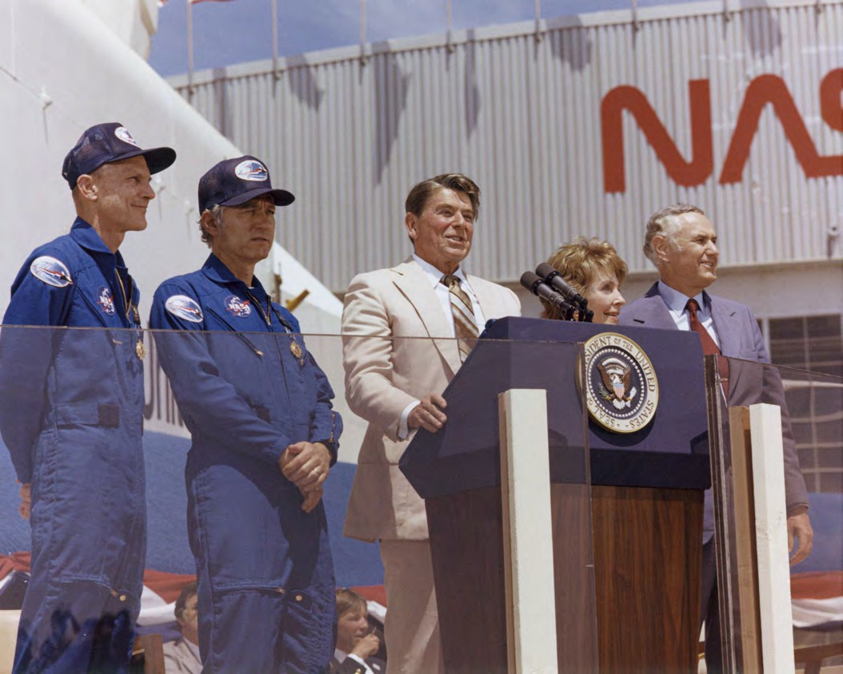

# January 25, 1984

## Reagan directs NASA to build the ISS

"Just as the oceans opened up a new world for clipper ships and Yankee traders, space holds enormous potential for commerce today." President Ronald Reagan's State of the Union Address directs NASA to build an international space station withn the next 10 years.

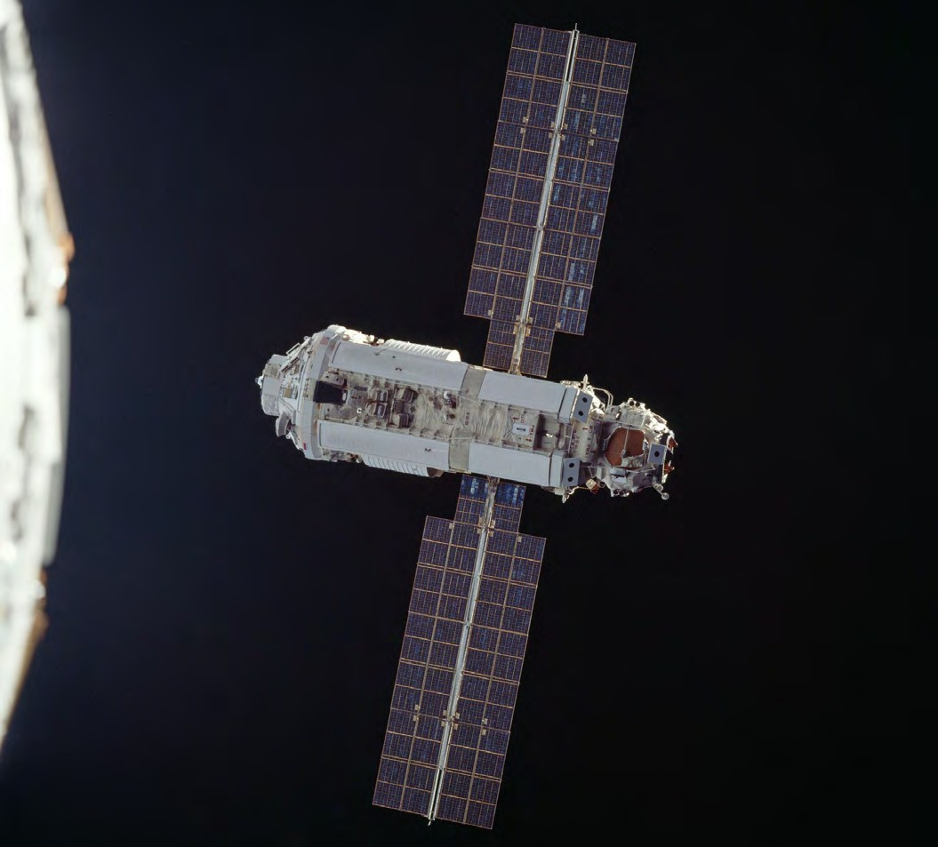

# November 20, 1998

## First ISS Segment Launches

The first segment of the ISS launches: The Zarya Control Module launched aboard a Russian Proton rocket from Baikonur Cosmodrome, Kazakhstan. Zarya (translates to "sunrise") supplied fuel storage, battery power and rendezvous and docking capability for Soyuz and Progress space vehicles.

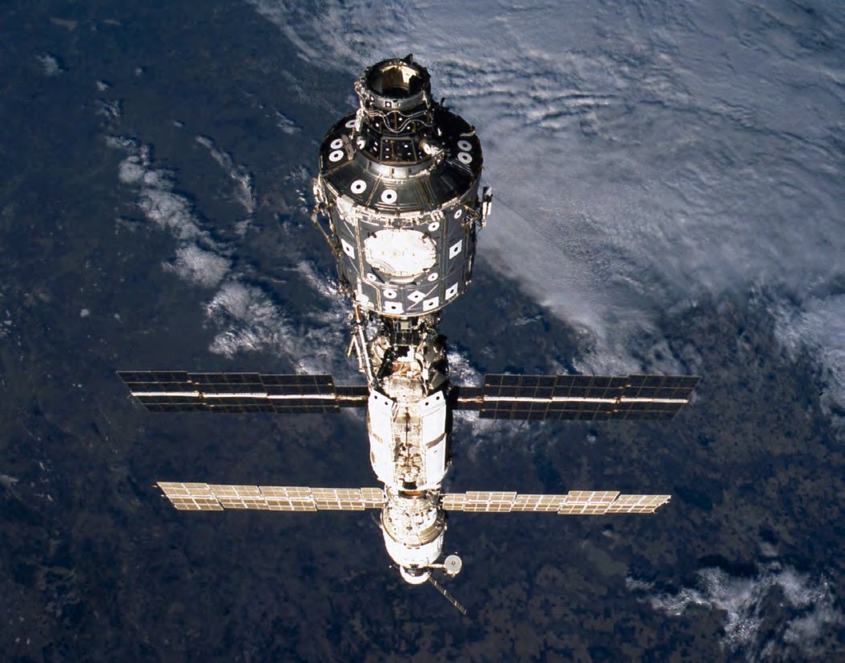

# December 4, 1998

## First U.S.-built component launches

Unity Node 1 module—the first U.S.-built component of the International Space Station— launches into orbit two weeks later during the STS-88 mission. Joining Unity with the Zarya module was the first step in the assembly of the orbiting laboratory.

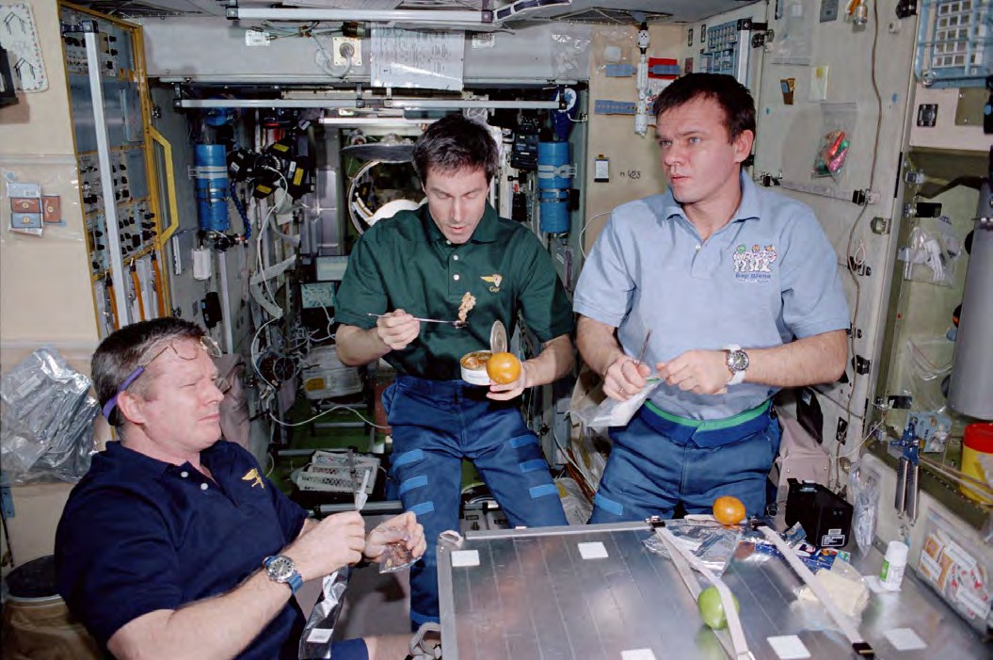

# November 2, 2000

## First Crew to Reside on Station

NASA Astronaut Bill Shepherd and cosmonauts Yuri Gidzenko and Sergei Krikalev become the first crew to reside onboard the station. Expedition 1 spent four months onboard completing tasks necessary to bring the ISS "to life" and began what is now more than 20 years of continuous human presence in space.

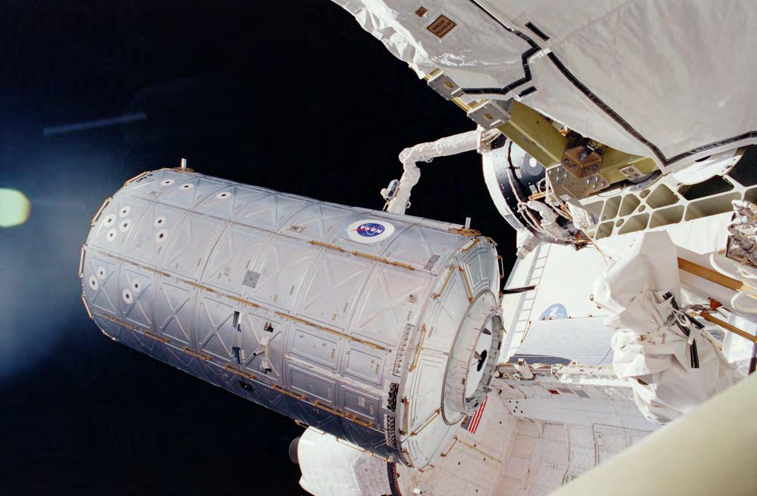

# February 7, 2001

## U.S. Lab Module Added

Destiny, the U.S. Laboratory module, becomes part of the station. The lab—that increased onboard living space by 41%—continues to be the primary research laboratory for U.S. payloads.

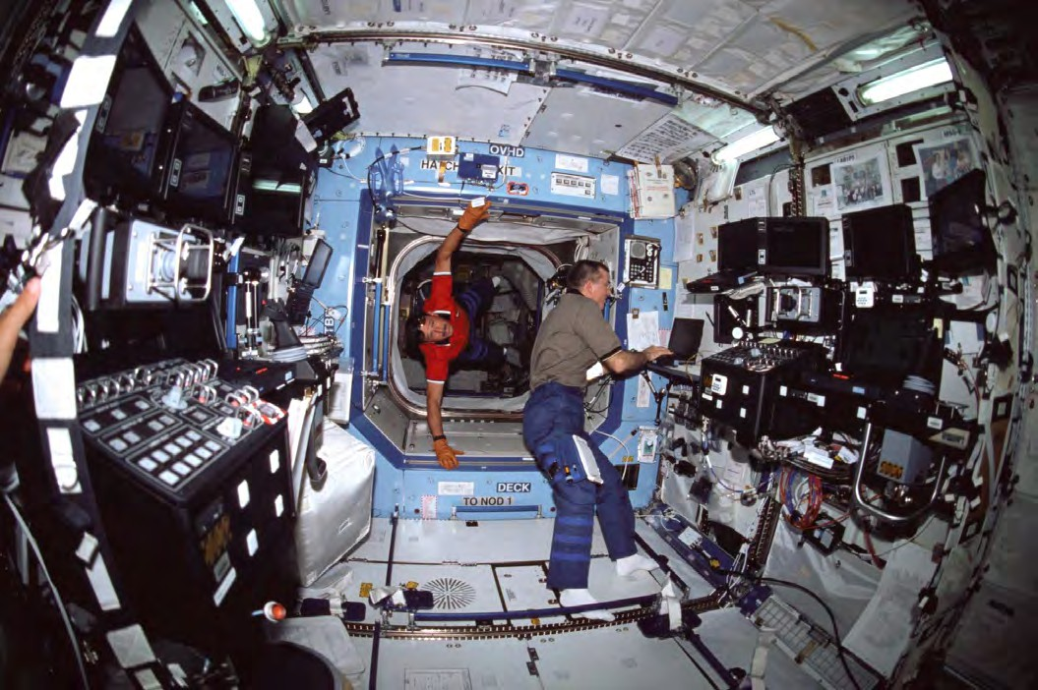

# December 30, 2005

## U.S. Lab Module Recognized as Newest U.S. National Laboratory

Congress designates the U.S. portion of the ISS as the nation's newest national laboratory to maximize its use for other U.S. government agencies and for academic and private institutions.

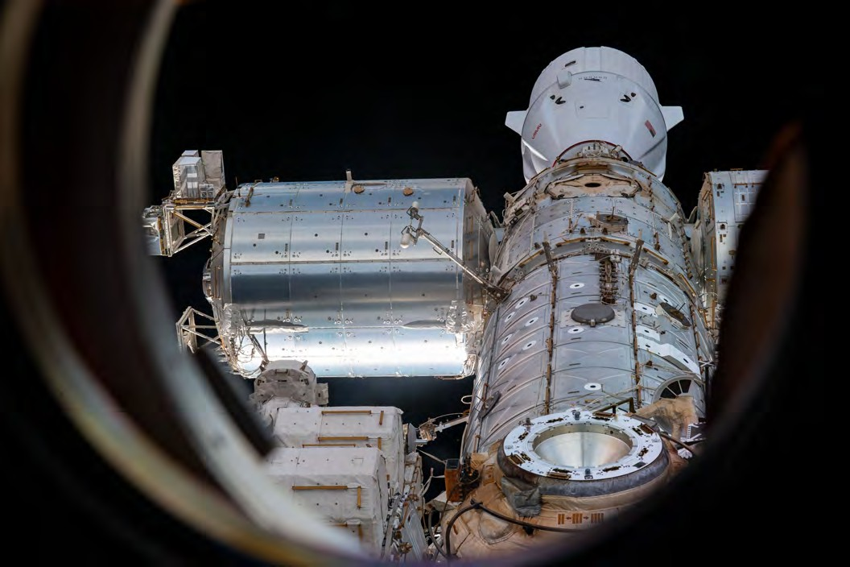

# February 7, 2008

## European Lab Joins the ISS

The European Space Agency's Columbus Laboratory becomes part of the station.

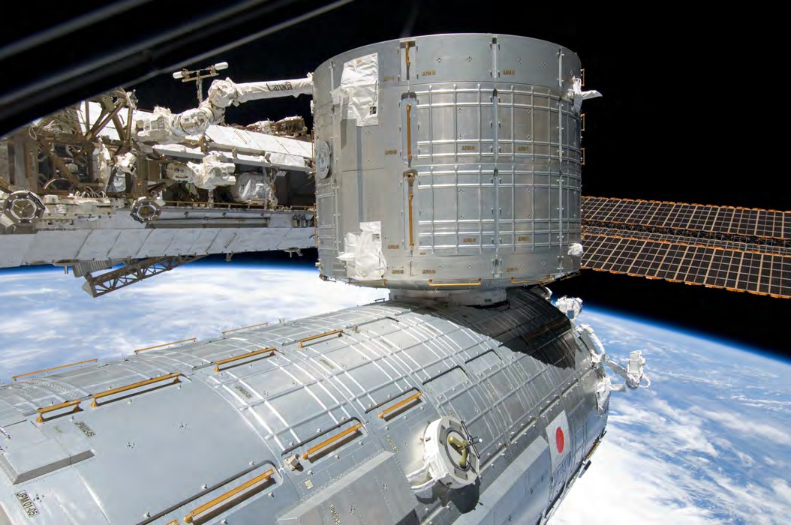

# March 11, 2008

## Japanese Lab Joins the ISS

The first Japanese Kibo laboratory module becomes part of the station.

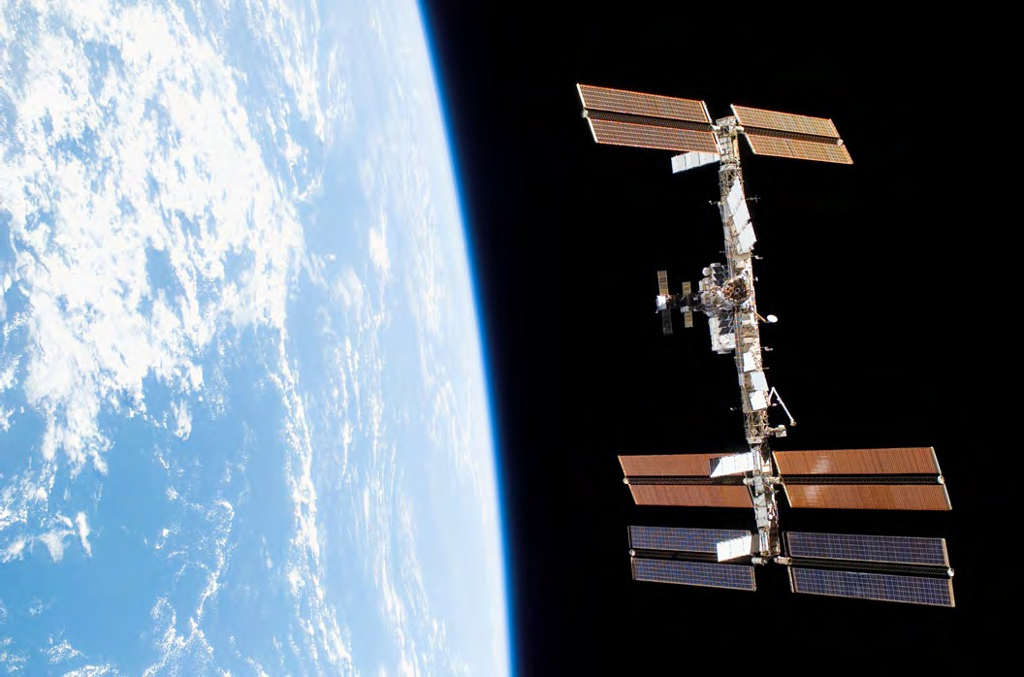

# November 2, 2010

## ISS 10-Year Anniversary

The ISS celebrates its 10-year anniversary of continuous human occupation. Since Expedition 1 in the fall of 2000, 202 people had visited the station.

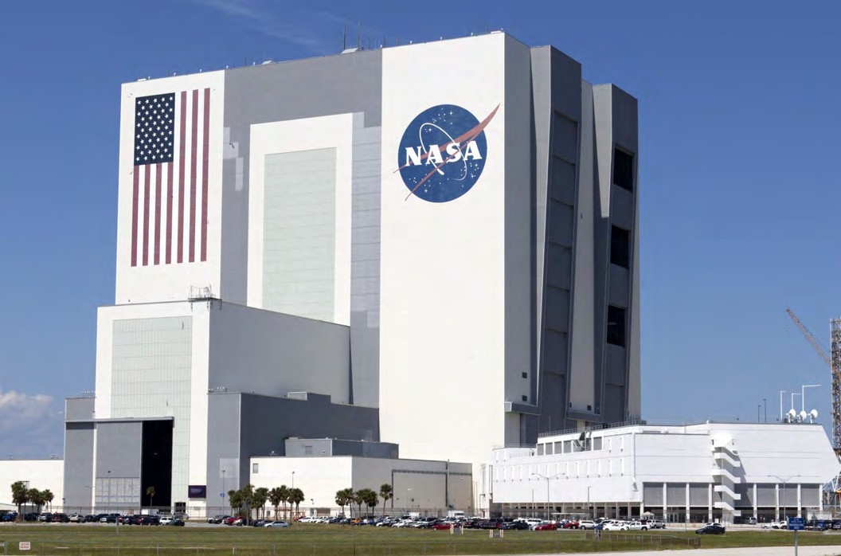

# February 2011

## NASA Issues Cooperative Agreement

NASA issues a cooperative agreement notice for a management partner.



# July 2011

## NASA Selects the ISS National Lab

NASA selects the Center for the Advancement of Science in Space, Inc. (CASIS) to manage the ISS National Lab.

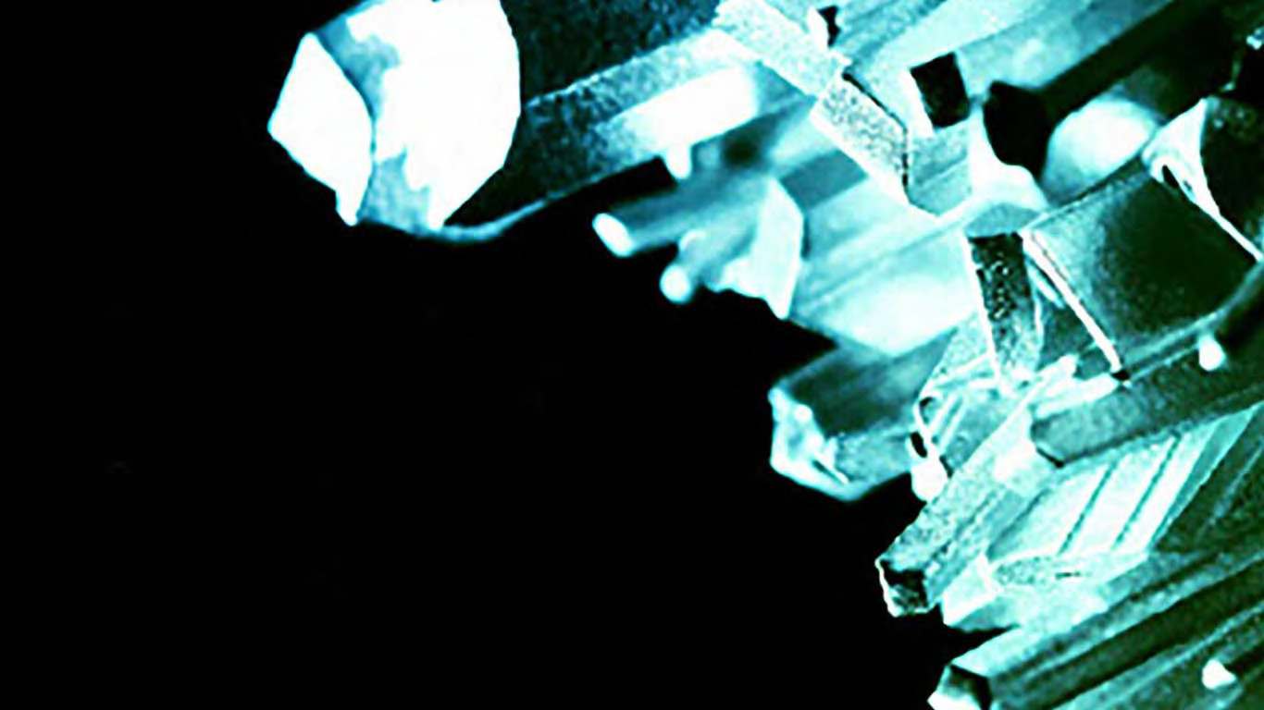

# June 26, 2012

## First ISS National Lab Solicitation

The first ISS National Lab solicitation to send sceince to the International Space Station is announced.

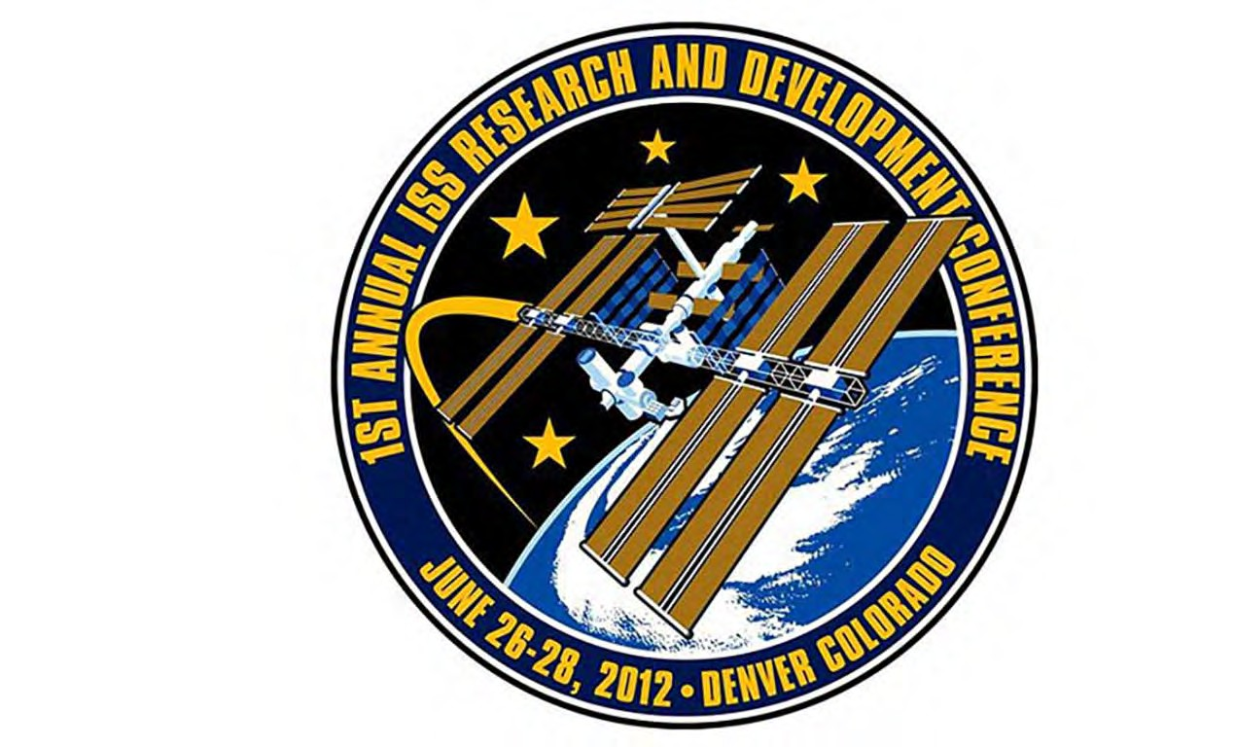

# June 26-28, 2012

## First ISS Research and Development Conference

The ISS National Lab, NASA, and the American Astronautical Society (AAS) host the first annual ISSResearch and Development Conference (#ISSRDC) held June 26-28, 2012, in Denver, Colorado.

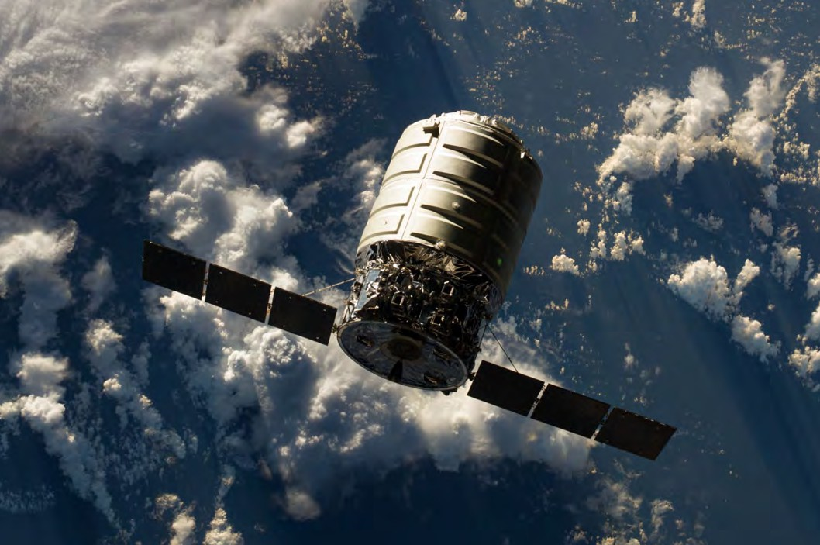

# September 30, 2013

## The First ISS National Lab Research Flight

Proteins can be grown as crystals in space with nearly perfect three-dimensional structures useful for the development of new drugs. The ISS National Lab's protein crystal growth (PCG) series of flights began in 2013, allowing researchers to utilize the unique environment of the ISS.

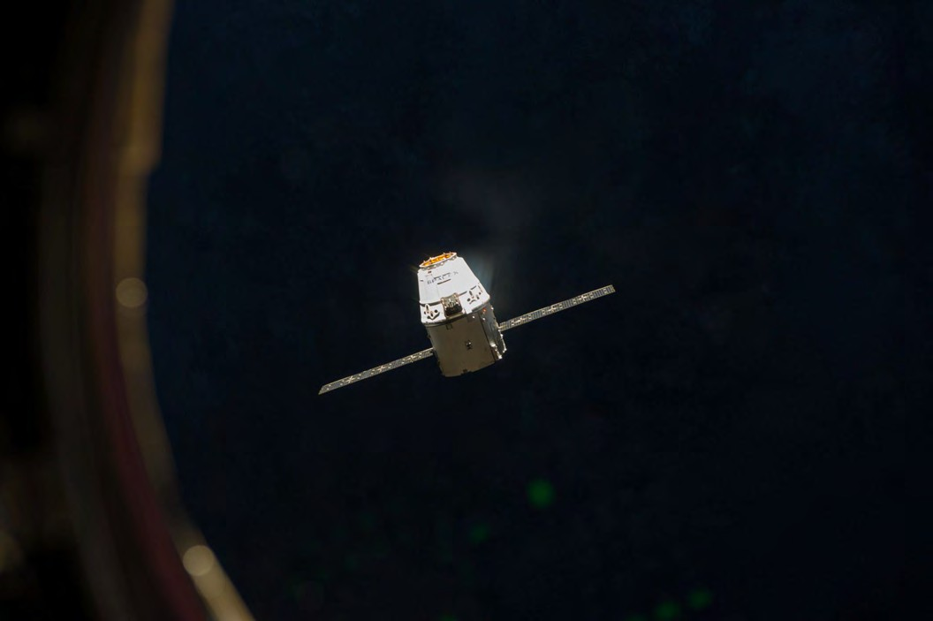

# April 18, 2014

## First Payloads Awarded Through an ISS National Lab Solicitation

The payloads, launched on SpaceX CRS-3, include multiple protein crystallization projects supported by grand funding from the first ISS National Lab request for proporsals, awarded in late 2012 and early 2013.

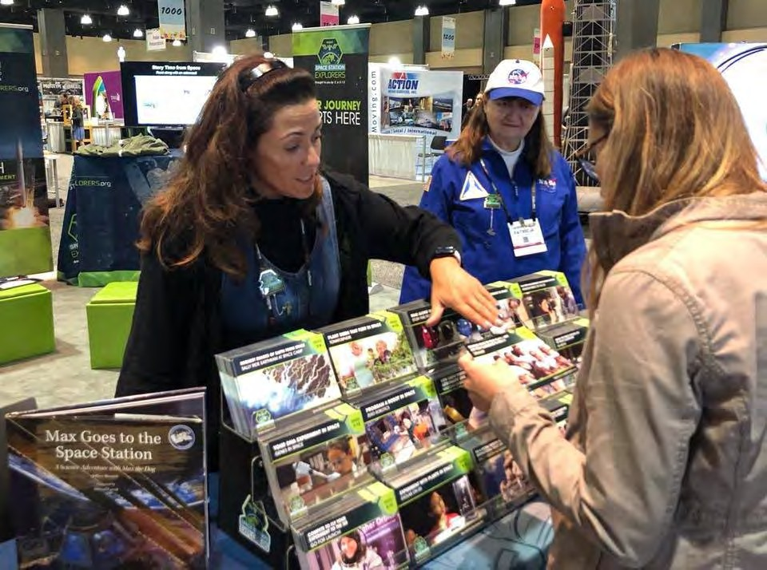

# 2015

## Space Station Ambassador Program Begins

The ISS National Lab creates the Space Station Ambassador program, a nationwide network of educations and lifelong learners who share information about ISS National Lab educational activities with their students, peers, and communities.

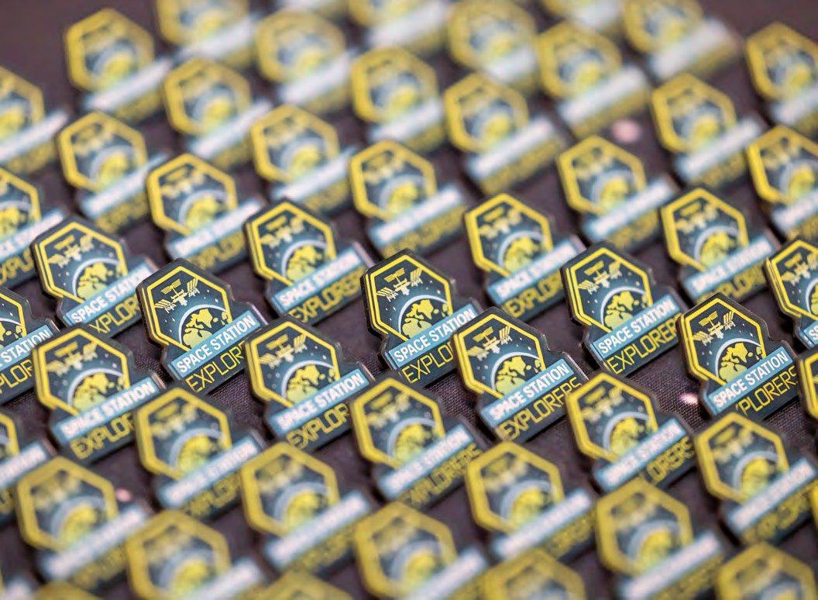

# 2016

## Space Station Explorers Created

The ISS National Lab creates Space Station Explorers, a community of educators, learners, and organizations that leverage the unique platform of the ISS National Lab to provide valuable STEM educational experiences.

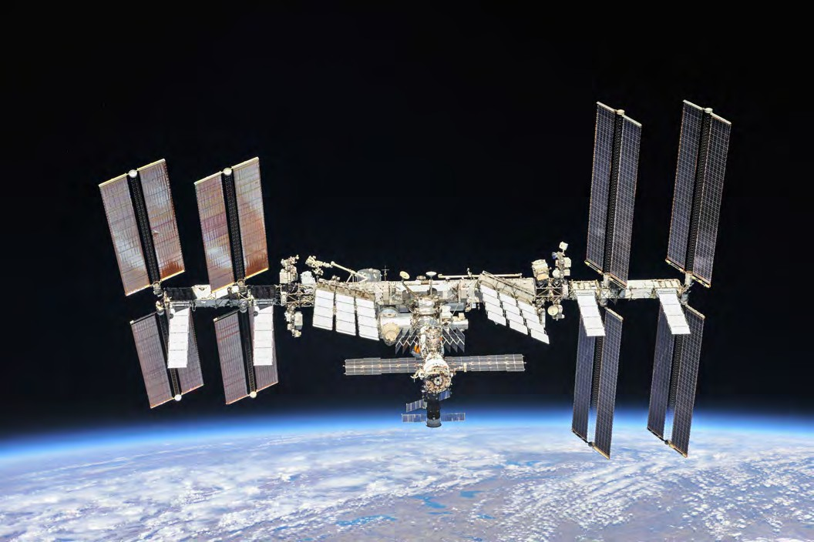

**2016**

## ISS National Lab Launches an Investor Network

The investor network connects venture capital, private equity, corporate, and other financial investors with startups in the ISS National Lab ecosystem.



# February 2016

## First Issue of Upward, Official Magazine of the ISS National Lab

The magazine publishes feature articles and perspective pieces about the results from ISS National Lab-sponsored projects.

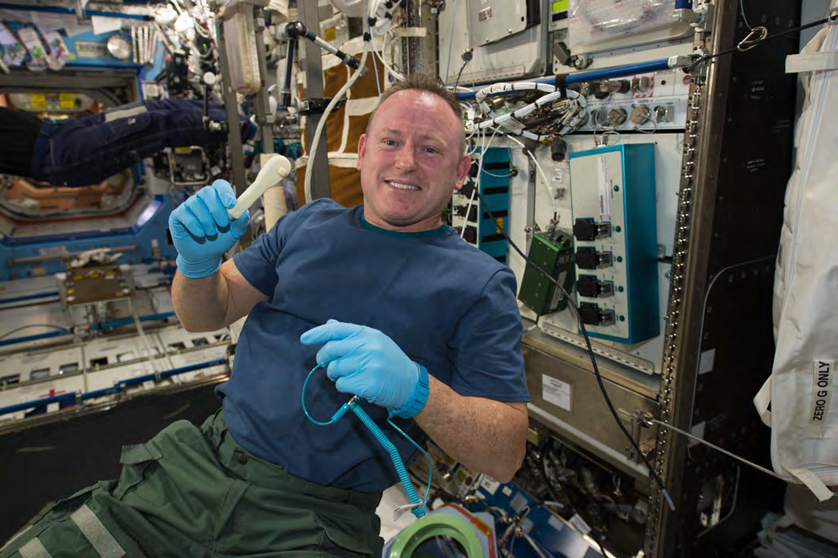

# June 2016

## First Commercial Tool Produced in Space

The Kobalt wrench is 3D printed using the Additive Manufacturing Facility on station.

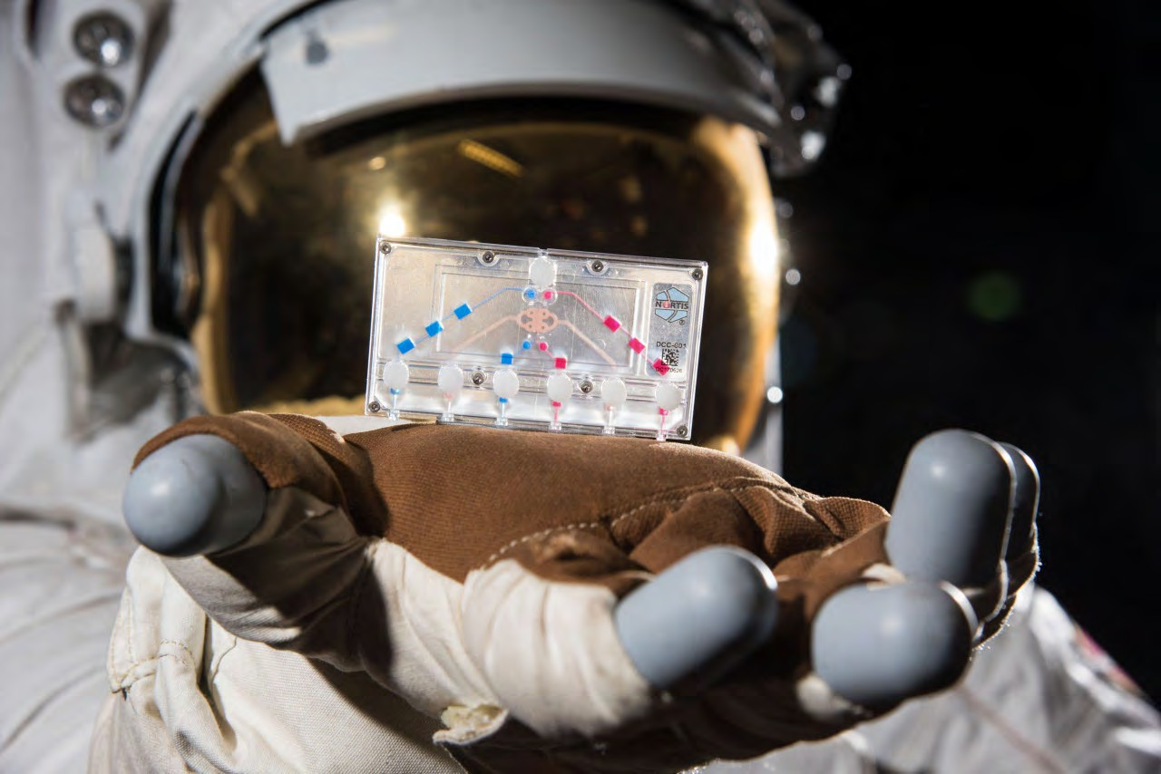

# October 5, 2016

## Four-Year, $12 Million Partnership with NIH on Tissue Chips Announced

The ISS National Lab announces a four-year partnership with the National Center for Advancing Translational Sciences (NCATS), part of the National Institutes of Health (NIH), to fund research onboard the ISS focused on tissue chips.

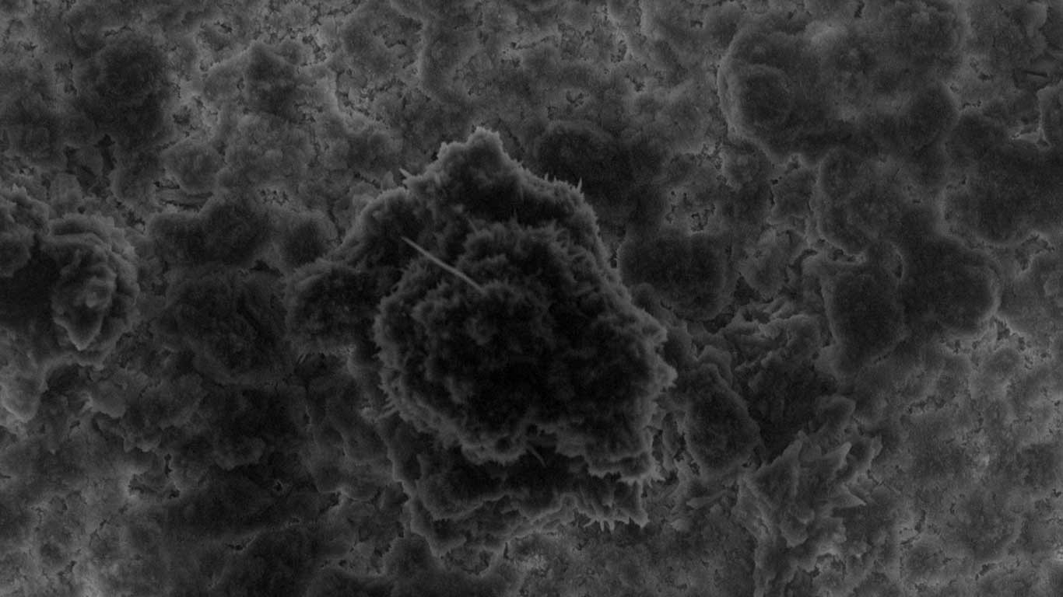

# January 29, 2018

## First Investigation Funded by the U.S. National Science Foundation

The first investigation funded by the U.S. National Science Foundation through its partnership with the ISS National Lab, a study of sediment particle interactions, launches to the space station on SpaceX CRS-15.

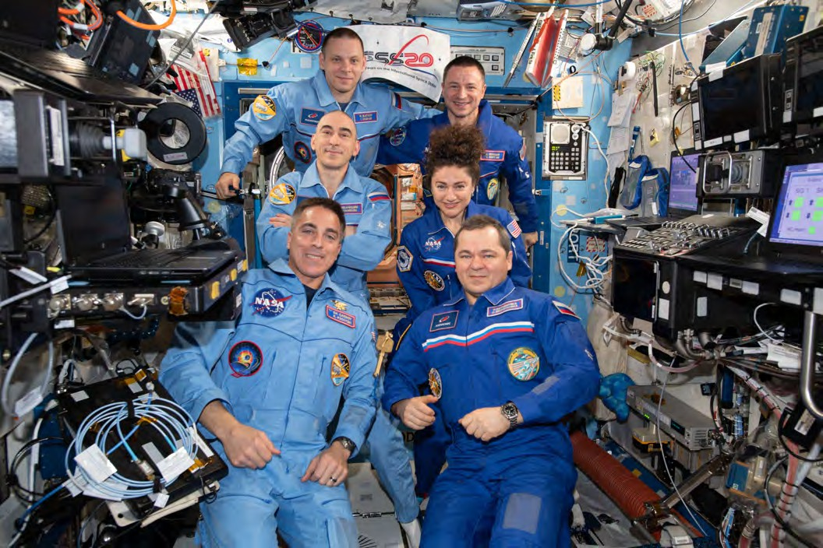

# November 2, 2020

## 20 Years of Continuous Human Presence in Space

NASA and the ISS National Lab celebrate 20 years of continuous human presence in space.

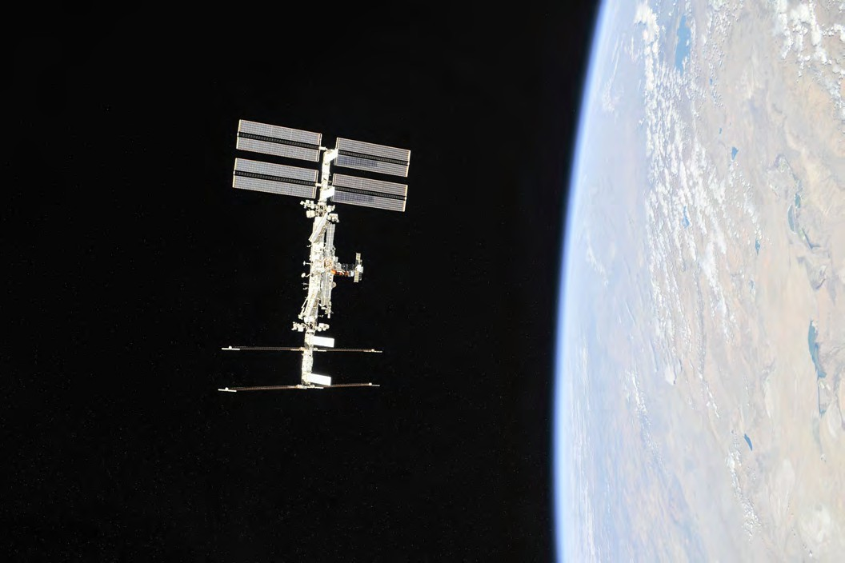

# August 31, 2021

## 10-Year Anniversary of the Center for the Advancement of Science in Space™ (CASIS™)

CASIS celebrates the 10-year anniversary of its creation and the beginning of its partnership with NASA to manage the ISS National Lab as a public service to the nation.

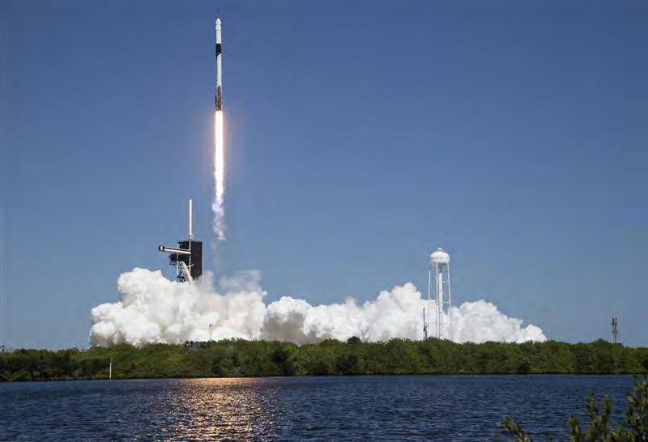

# September 15, 2022

## NASA Extends Cooperative Agreement

NASA announces an extension of the Cooperative Agreement with CASIS to manage the ISS National Lab through 2027.