There are two ways for running this web api.

1. Run by double click file “start.cmd”

Prerequisite:

.NET 6, ASP CORE WEB API, Dotnet Core CLI

Usage:

* Double click to run file “start.cmd”, it will show as picture below if nothing went wrong.
* 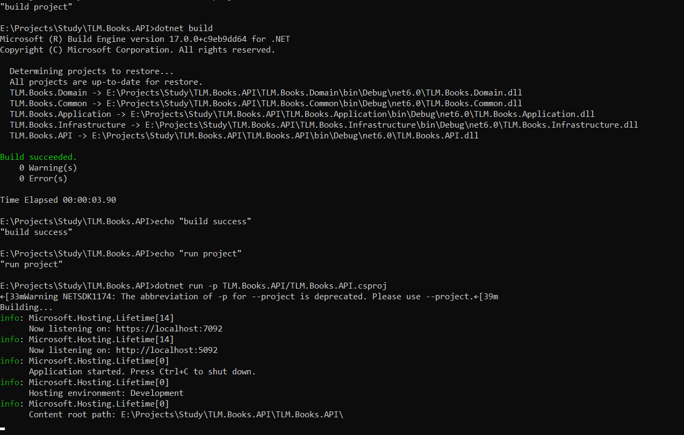
* Open your brower with url: <https://localhost:7092/swagger/index.html>
* You will see browser display as below, then enjoy your exploration

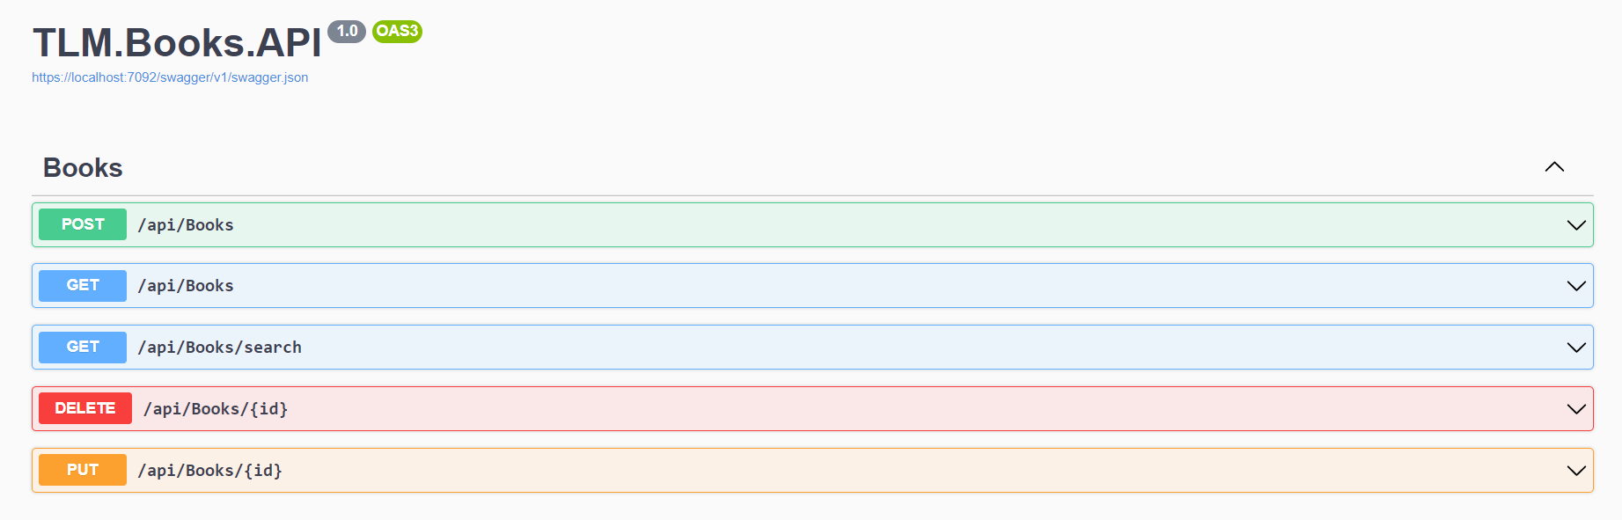

1. Run with docker-compose

Prerequisite:

.NET 6, ASP CORE WEB API, Dotnet Core CLI, Docker, [Docker compose](https://docs.docker.com/compose/install/)

Usage:

* Open your command line, and change folder directory to folder that I sent to you. Type command “docker-compose up”. Then wait for setting up automatically.
* After above command run successful, you can you these belove api:

1. Create new book

curl --location --request POST 'http://localhost:8080/api/books' \

--header 'Content-Type: application/json' \

--data-raw '{

"name": "aaaaa",

"author": "string",

"isbn": "string"

}'  
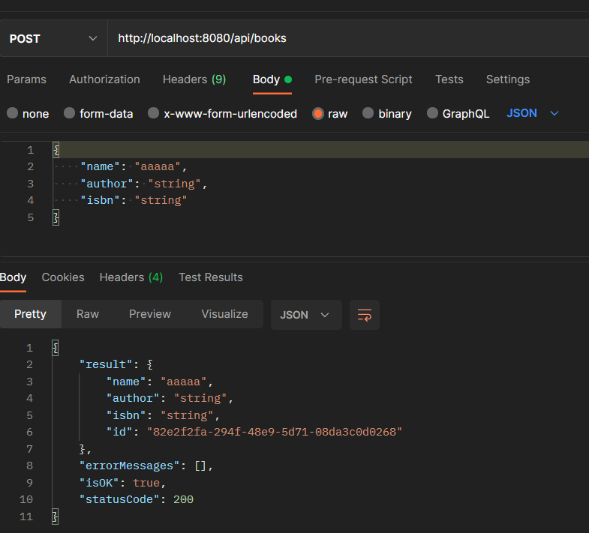

1. Get all books

curl --location --request GET 'http://localhost:8080/api/books'

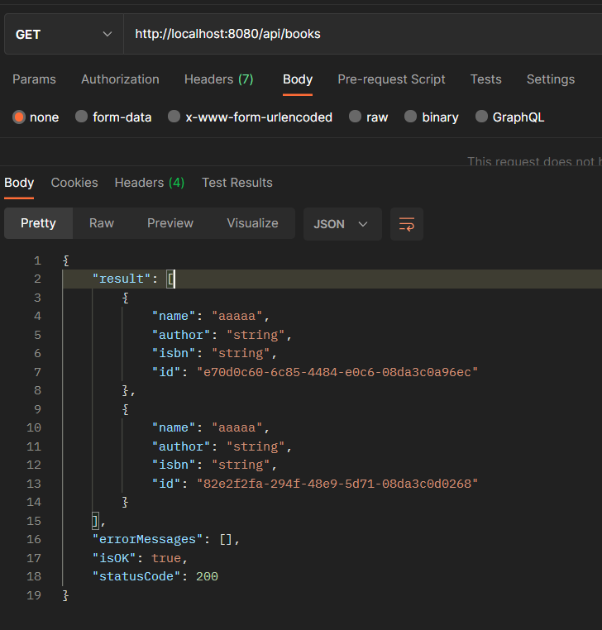

1. Search book by name (name = test is example at below)

curl --location --request GET 'http://localhost:8080/api/books/search?name=test'

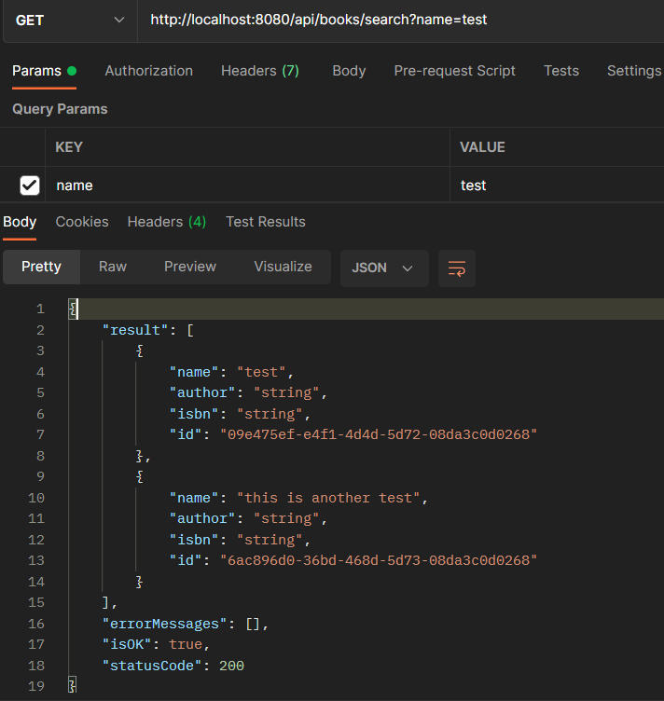

1. Update book info

curl --location --request PUT 'http://localhost:8080/api/books/e70d0c60-6c85-4484-e0c6-08da3c0a96ec' \

--header 'Content-Type: application/json' \

--data-raw '{

"author": "John Wick"

}'

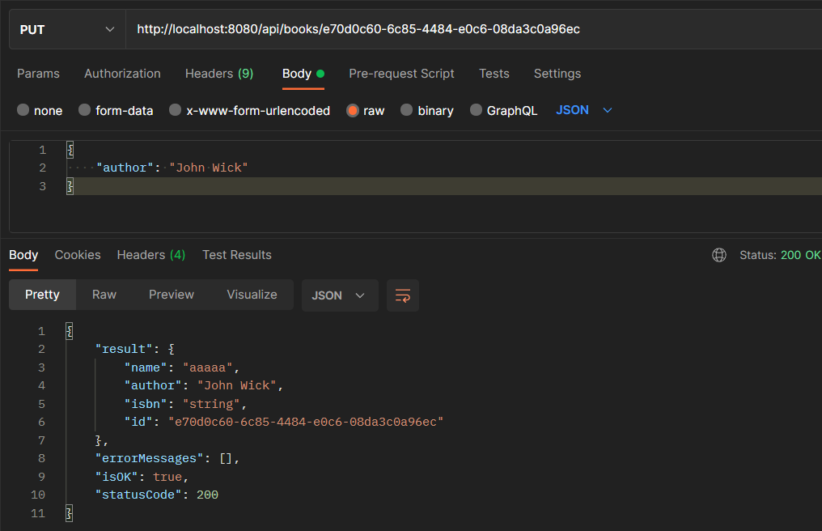

1. Delete book

curl --location --request DELETE 'http://localhost:8080/api/books/e70d0c60-6c85-4484-e0c6-08da3c0a96ec'

