RaffleRaijins Contract

* Contract

0x2C65937625Da1b3Db2b55BCfd4aD3EB3812E8b7C

* Owner address

[0x5d2E4189d0b273d7E7C289311978a0183B96C404](https://polygonscan.com/address/0x5d2E4189d0b273d7E7C289311978a0183B96C404)

* Raffle Count

|  |  |  |
| --- | --- | --- |
| Index | Title Examples | Value |
| 0 | CRO GOLD CHEST | changeable |
| 1 | CRO SILVER CHEST | changeable |
| 2 | CRO BRONZE CHEST | changeable |
| 3 | Raijins TICKETS - RANDOM BOX | changeable |
| 4 | NFTS - other collections | changeable |
| 5 | Raijins custom - 1/1 (any collection) | changeable |
| 6 | Raijins custom - 1/1 (coloured reaper) | changeable |
| 7 | Raijins - Volume 1 (First Edition) | changeable |
| 8 | Raijins - Volume 1 (Tamahagane Edition) | changeable |
| 9 | Raijins - Volume 1 (Jade Edition) | changeable |
| 10 | Raijins - Volume 1 (Ghost Edition) | changeable |
| 11 | Raijins - Volume 2 (First Edition) | changeable |
| 12 | Raijins - Volume 2 (Tamahagane Edition) | changeable |
| 13 | Raijins - Volume 2 (Jade Edition) | changeable |
| 14 | Raijins - Volume 2 (Ghost Edition) | changeable |
| 15 | Raijins - Volume 3 (First Edition) | changeable |
| 16 | Raijins - Volume 3 (Tamahagane Edition) | changeable |
| 17 | Raijins - Volume 3 (Jade Edition) | changeable |
| 18 | Raijins - Volume 3 (Ghost Edition) | changeable |
| 19 | Raijins - Reaper NFT | changeable |
| 20 | Raijins - Human NFT | changeable |

In this table, index & title is static.

Value is changeable, and owner can change this via setRaffleValue function.

* Setting Raffle value

<https://polygonscan.com/address/0x2C65937625Da1b3Db2b55BCfd4aD3EB3812E8b7C#writeContract> “7. setRaffleValue” function

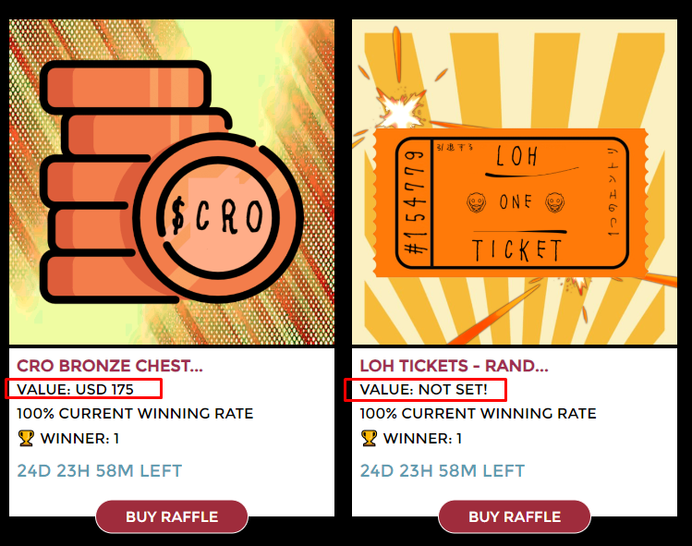

* Starting Raffles

<https://polygonscan.com/address/0x2C65937625Da1b3Db2b55BCfd4aD3EB3812E8b7C#writeContract> “10. startRaffles” function

When raffles are started by calling this function, all raffles will be active-raffles.

* Decide Winners

After the period for depositing (25 days), you can call “decideWinners” function to decide winners for all Raffles.

<https://polygonscan.com/address/0x2C65937625Da1b3Db2b55BCfd4aD3EB3812E8b7C#writeContract> “2. decideWinners” function

When winners are decided by calling this function, all raffles will be recent-raffles.

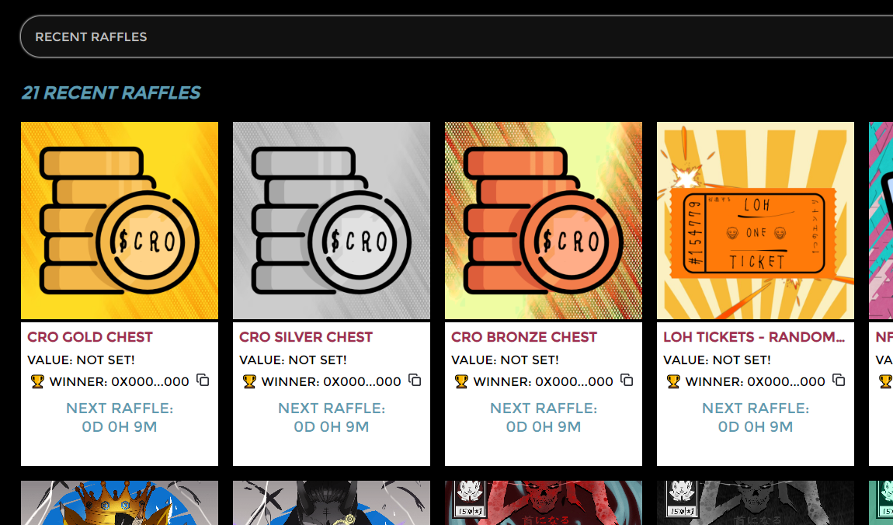

And, the depositing period is passed away, all active-raffles will be recent-raffles

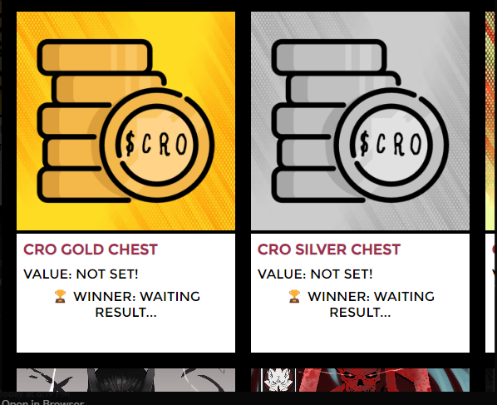

* Setting disable status for raffles

If you disable some Raffles, these raffles will not show in frontend.

<https://polygonscan.com/address/0x2C65937625Da1b3Db2b55BCfd4aD3EB3812E8b7C#writeContract> “6. setRaffleDisable” function

* Withdraw RaijinsTickets

You can withdraw all tickets according to your needs.

<https://polygonscan.com/address/0x2C65937625Da1b3Db2b55BCfd4aD3EB3812E8b7C#writeContract> “12. withdrawRaijinsTicket”

* Setting depositing period

<https://polygonscan.com/address/0x2C65937625Da1b3Db2b55BCfd4aD3EB3812E8b7C#writeContract> “4. setPeriodToDeposit”

* Setting waiting period for next raffle

<https://polygonscan.com/address/0x2C65937625Da1b3Db2b55BCfd4aD3EB3812E8b7C#writeContract> “9. setWaitingPeriodForNextRaffle”