**FAQ**

* **How to Downmerge Base Branch To Your Branch**

1. **Open Your File Location Where Project Is Located**
2. **Then RightClick Anywhere In File Explorer And Then Click On Git Bash**

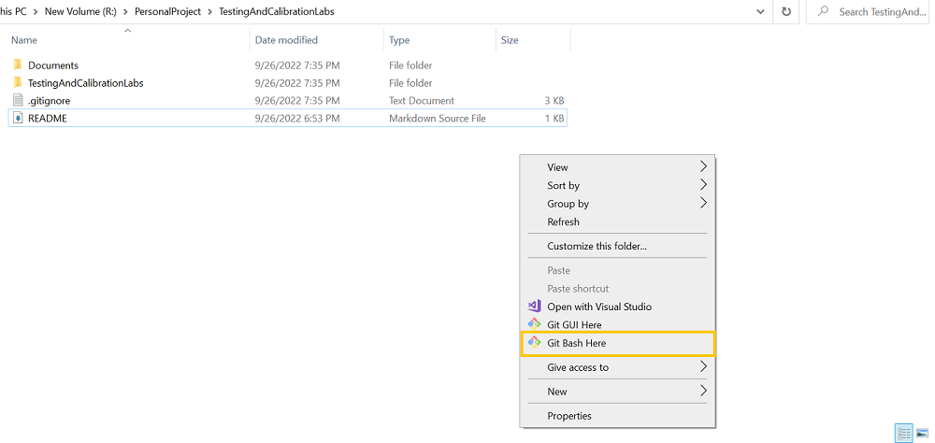

1. **git pull origin develop if your base branch is develop**

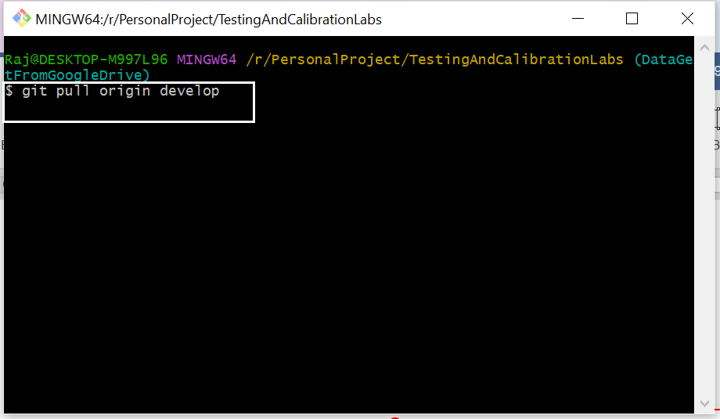

1. **Git checkout DataGetFromGoogleDrive Like This Write In GitBash Hit Enter**

