How to create an empty ASP.NET Web Application with .NET CLI and Visual Studio Code.

In order to create the .Net Core application, we must have .Net Core SDK installed in the system. Go to the Microsoft official website in order to download the .Net Core SDK.

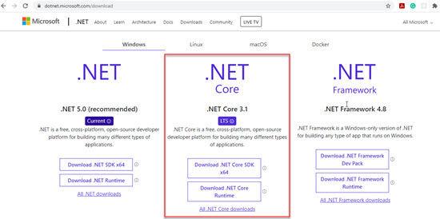

Once SDK is installed, Open Visual Studio Code Editor. If you don’t have it already installed in your system, then go to the Microsoft official site in order to download it free of cost. Once downloaded and installed, Go to the Terminal menu, click on New Terminal.

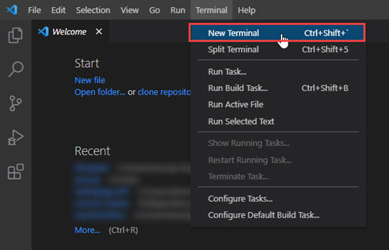

Change the directory to the location where you want to create your first ASP.NET Core Web Application with .Net CLI.

Run the **dotnet** command in the terminal. If dotnet core is already installed in your system, then you will see the options as shown in the below image.

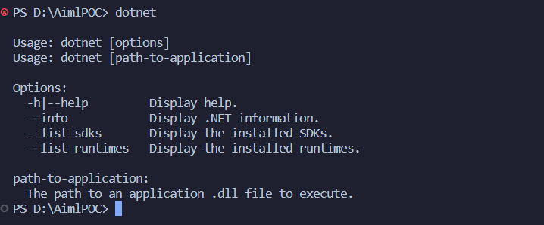

Run the **dotnet --version** command in order to check the version of .Net Core SDK installed in your system. In my system, I have .Net Core 7.0.202 Version.

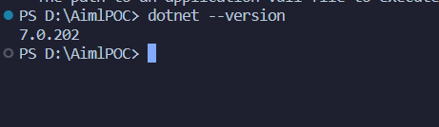

Run **dotnet new mvc --name <NAME_OF_PROJECT>** in order to create an empty ASP.NET Core web application. On executing the command, ASP.Net Core Empty template will be created followed by the **dotnet restore** command.

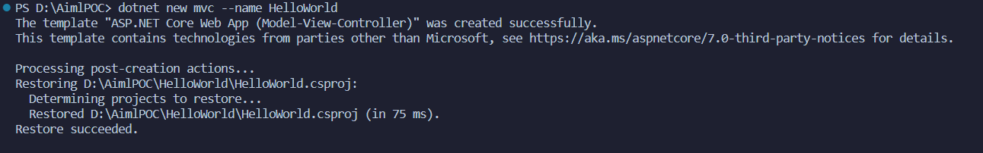

Now Open The Directory Of project and then Use dotnet run command to run the project

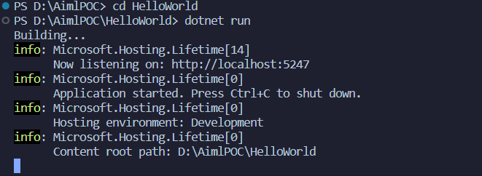

Here you can see the url of running project just control + right click on link

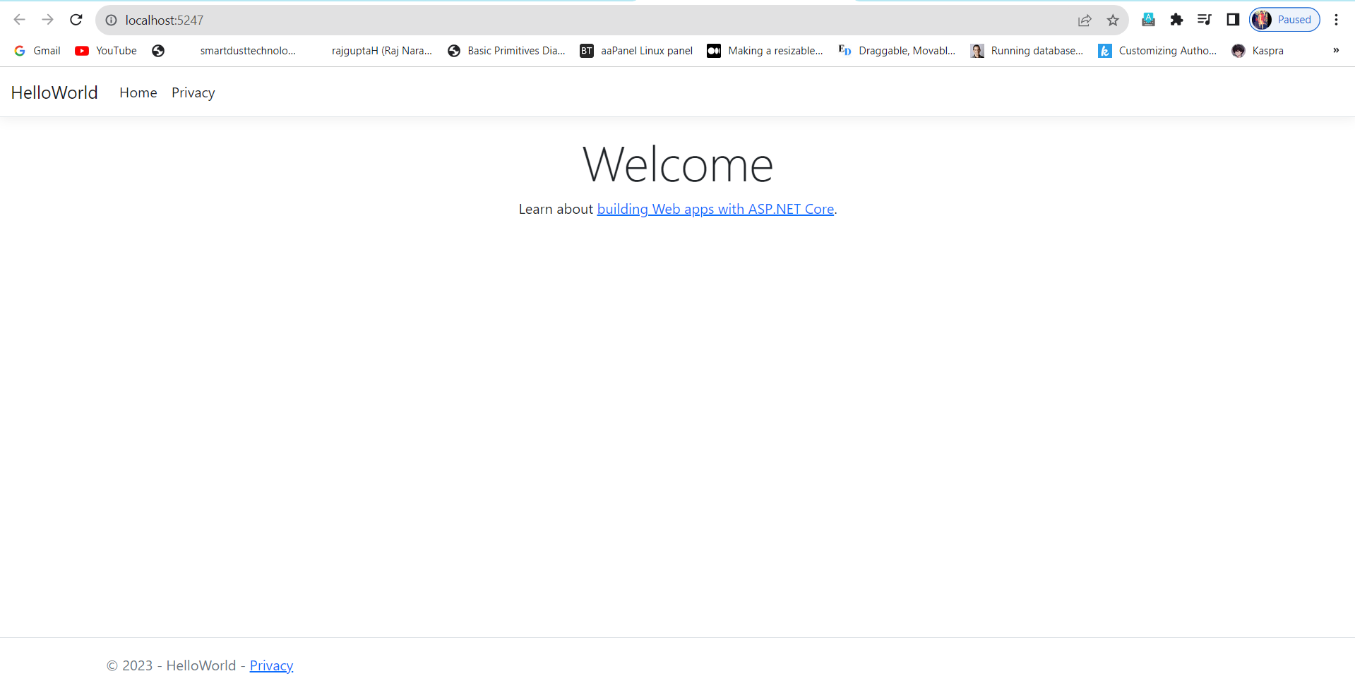

Yo its running :)

Thanks [Raj Narayan Gupta](https://github.com/rajguptah)([Smartdust Techologies](Https://github.com/smartdusttechnologies))