SignalR

+--------------------+
| |
| Web Browser |
| (Client-Side JS) |
| |
+---------+----------+
|
| (HTTP/S or WebSocket)
|
+---------v----------+
| |
| SignalR |
| Hub |
| |
+---------+----------+
|
| (ASP.NET)
|
+---------v----------+
| |
| Web Server |
| (IIS/OWIN) |
| |
+---------+----------+
|
| (Database/API)
|
+---------v----------+
| |
| Database |
| (SQL/NoSQL) |
| |
Web Browser (Client-Side JS):
- This represents the client's browser where the web application runs. The client-side JavaScript code communicates with the SignalR hub.
- SignalR Hub:
- This is the core component of SignalR that handles communication between the server and clients. The hub allows clients to call methods on the server and vice versa.
- Web Server (IIS/OWIN):
- The server hosts the SignalR application and manages client connections. It can use either IIS (Internet Information Services) or OWIN (Open Web Interface for .NET) for hosting.
- Database/API:
- This represents the data source for the application. It could be a traditional SQL database, NoSQL database, or any API from which data is fetched.

How It Works
- When a client connects to the SignalR hub, it establishes a persistent connection using either WebSockets or HTTP.
- The SignalR hub facilitates real-time communication, enabling clients to receive updates from the server instantly.
- Any changes in the database (like new messages in a chat application) can be sent to all connected clients through the SignalR hub, ensuring everyone has the latest information.

What is a Hub?
- Communication Bridge: A Hub serves as a bridge for communication between clients and the server. It allows bi-directional communication, meaning both the server can call client methods and clients can call server methods.
- Dynamic Methods: Hubs are dynamic in nature; you can define methods within a Hub class that clients can invoke. This makes it easy to send messages or updates to specific clients or groups of clients.
- Automatic Connection Management: SignalR handles the connection management for you. When a client connects or disconnects, SignalR manages these events and can invoke methods on connected clients.
- Group Management: Hubs allow you to manage groups of clients easily. You can add clients to groups and send messages to all clients in a specific group. This is useful for scenarios like chat rooms or collaborative applications.

Key Features of Hubs
- Server-to-Client Communication:
- Client-to-Server Communication:
- Real-Time Updates:
- Group Support:

Uses of SignalR
1. Real-Time Communication
- Instant Updates: SignalR allows for real-time communication between the server and clients, enabling instant updates.

2. Bi-Directional Communication
- Server to Client and Client to Server: SignalR facilitates bi-directional communication. The server can push updates to clients without the clients needing to request them, and clients can also send messages or requests to the server at any time.

3. Automatic Connection Management
- Connection Handling: SignalR manages connections automatically, including handling reconnects if a connection drops. Developers don’t have to write complex logic to manage these scenarios, making implementation simpler.

4. Support for Multiple Transport Protocols
- Transport Fallback: SignalR uses WebSockets when available but falls back to other protocols (such as Server-Sent Events or Long Polling) if WebSockets are not supported. This ensures that applications can work across a wide range of devices and browsers.

5. Scalability
- Group Messaging: SignalR can manage groups of connections, allowing developers to send messages to specific groups of users easily. This is beneficial for applications like online games or chat rooms, where messages are only relevant to certain users.
- Horizontal Scaling: SignalR can be integrated with backplanes (like Redis or Azure Service Bus) to support scaling out across multiple servers, ensuring that real-time messaging remains consistent even as the user base grows.

6. Simplified Development
- Easy to Use API: SignalR provides a straightforward API for implementing real-time features. Developers can quickly build and integrate real-time functionality without dealing with the complexities of low-level networking.

7. Wide Range of Applications
- Use Cases: SignalR is suitable for various applications, including:
  - Chat Applications: Allowing users to communicate in real time.
  - Live Data Feeds: Updating dashboards with live data (financial markets, sports scores).
  - Gaming: Facilitating real-time interactions between players.
  - Collaboration Tools: Enabling multiple users to work together in real-time on shared documents or projects.
  - Notifications: Sending alerts and notifications instantly to users.

8. Cross-Platform Compatibility
- Client Libraries: SignalR supports various platforms, including .NET, JavaScript, Java, and more. This makes it suitable for both web and mobile applications, allowing developers to use their preferred technology stack.

How to use signalR in .net (C#)

- Install package Microsoft.aspnet.signalr
- builder.Services.AddSignalR(); in program.cs
- Add directory folder name hubs and make class ChatHub
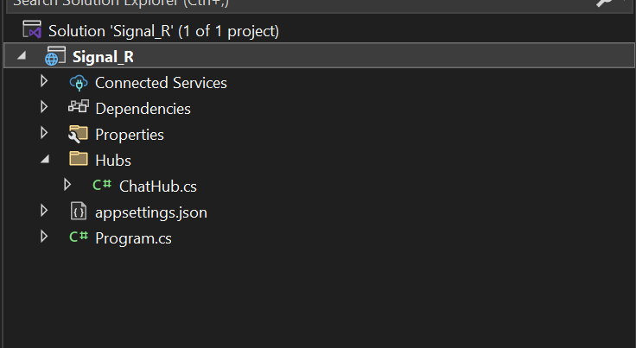

Add a middleware
app.UseEndpoints(endpoints =>
{
endpoints.MapHub<ChatHub>("/chat");
});

- The purpose of UseEndpoints is to define the endpoints that the application will respond to.
- MapHub<ChatHub>("/chat"): This line specifically maps a SignalR hub to an endpoint.

using Microsoft.AspNetCore.SignalR;

namespace Signal_R.Hubs
{
public class ChatHub :Hub
{
}
}

public class UserModel
{
public string User { get; set; }
public string Room { get; set; }
}
- Add user model

- In ChatHub.cs we add
- await Groups.AddToGroupAsync(Context.ConnectionId, userModels.Room!);
>Groups : managing groups of connection
> Context.ConnectionId :It provide unique Id to identify
- await Clients.Group(userModels.Room)
SendAsync("RecieveMsg" ,"Bot",$"{ userModels.User} has joined the group");
>Clients: representing all the connected clients to the hub.
>Group(userModels.Room) :targets a specific group of clients

- public readonly IDictionary<string, UserModel> _connection;
> declares a field named _connection that will store a collection of user connections.

- public ChatHub(IDictionary<string, UserModel> connection)
{
_connection = connection;
}
- _connection[Context.ConnectionId] = userModels;

> it stores the user information associated with the current connection ID in the dictionary.
IDictionary : interface that represents a collection of key/value pairs
Key Features:
Add: You can add key/value pairs to the collection.
Remove: You can remove key/value pairs using the key.
ContainsKey: Check if a specific key exists in the collection.
Indexer: Allows you to get or set a value based on a key.

SetUp dependency Injection in program.cs
builder.Services.AddSingleton<IDictionary<string, UserModel>>(opt
=>
new Dictionary<string, UserModel>());

AddSingleton<TService>(Func<IServiceProvider, TService> implementationFactory): registers a service with singleton lifetime. A singleton means that only one instance of the service will be created and used throughout the lifetime of the application.

Singleton Lifetime: The dictionary will be created once when the application starts and the same instance will be used whenever a component requests an IDictionary<string, UserModel>. This can be useful when you want to maintain a shared in-memory collection of data, such as user sessions or configurations, that are accessible globally throughout the application.

Dependency Injection allows you to inject the required dependencies into a class, instead of having the class instantiate those dependencies itself. This makes it easier to change the implementation of dependencies or mock them for testing.

Now make another function for sending message
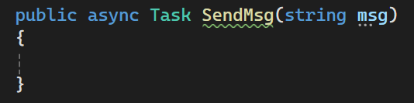

->if (_connection.TryGetValue(Context.ConnectionId,out UserModel userModels)) {
await Clients.Group(userModels.Room).SendAsync("RecieveMsg",userModels.User,msg,DateTime.Now)
}
It retrieves the UserModel corresponding to the current user's connection ID.
If the user is found, it sends a message to all the clients in the group (room) that the user is part of.
The message is sent along with the user’s name, the message content itself (msg), and the timestamp (DateTime.Now).
Move to next method:
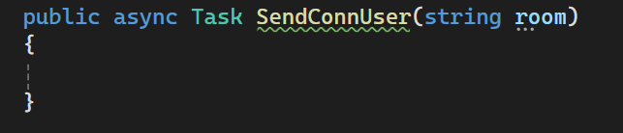

var users = _connection.Values
.Where(x => x.Room == room)
.Select(u => u.User);
return Clients.Group(room).SendAsync("ConnectUser", users);

Gets all users in a specific room by filtering the _connection dictionary.
Extracts their usernames.
Sends the list of usernames to all clients in that room using SignalR's SendAsync method.

​

