This is the latest documentation, small details in interface may be out of date.
Witness360 — Complete Feature Documentation
Content:
Settings – Main
Settings - Videos
Settings – URLs
Settings – Advanced
Settings – Resolutions
Camera Interface

Overview
Witness360 allows you to record and live-stream simultaneously, even when the app is in the background or the screen is off. You can switch cameras at any moment, use enhanced low-light modes, enable flashlight during capture, customize resolutions for stream and record separately, and apply privacy measures for stored videos. The app can also start recording and streaming automatically upon launch. Other features included.

Settings
Settings – Main
Internal Storage
Toggle this option to store new recordings inside the app’s private storage instead of the phone’s media gallery.
When enabled, videos will not appear in the gallery and can be accessed from Settings → Videos. You can protect internal storage with a code in Settings – Advanced
Check upload speed:
Opens your browser to run an upload-speed test.
Use this to verify whether your internet connection can support the FPS, quality, and stream resolution you selected.
The website used for the test can be customized in Settings – Advanced
Phone:
If “Phone Visible” option is enabled in advanced settings, you can configure here the number you want to be placed in the caller app, when you tap on the phone icon in the camera interface
FPS:
Sets the number of frames captured per second for both streaming and recording.
Higher FPS gives smoother motion; 30 is good, 60 is excellent. lower FPS (around 10) helps in low-light environments.
Stream BPP: (Bit per pixel)
Adjusts the streaming image quality (recordings always use maximum quality).
• Low: recommended for minimal movement
• Mixed: recommended for normal motion
• High: recommended for fast action scenes
Mbps: (Approximate Required Upload Speed)
Displays the approximate upload bandwidth needed to support your selected FPS, BPP, and stream resolution.
Always choose settings below your real upload speed for a stable stream.

Choose Stream URL:
Select the RTMP address used for streaming (YouTube, Twitch, or any RTMP service).
Stream endpoints can be added, edited, or removed from Settings – URLs
(Twitch is a recommended simple, free and reliable option. It stores the streamed videos for 7 days, check this policy yourself).
Choose the Stream Resolution
Select the resolution used for the live stream.
Each option lists whether the selected front or back camera supports it.
Chose a combo of fps, bpp, stream resolution, according to your available mbps speed.
Choose the Record Resolution
Select the resolution used for local video recordings.
Keep the local recording resolution high (1920x1080), unless there is a reason not to.
Orientation (Rotation Button)
Set the camera orientation to 0° or –90° (90 degrees to the left) depending on whether you want portrait or landscape output.
This affects both stream and recording orientation.
Start
After selecting all settings, press Start to enter the camera interface.

Settings – URLs
Reset
Resets the list of URLs to the default example entries.
Note that this action replaces your current list.
Enter New URL
A text field where you can paste or type a new RTMP address.
Examples:
• Twitch: rtmp://live.twitch.tv/app/..
• YouTube: rtmp://a.rtmp.youtube.com/live2/..
After entering the full URL, press Add.
Add
Adds the new RTMP URL from the text field to your list of stream endpoints.
After adding it, it becomes selectable in the main Settings screen under “Choose Stream URL.”
Edit (Pencil Icon)
Opens editing mode for the selected URL.
Use this if you need to update a stream key, fix a typo, or delete the entry.

Settings – Advanced
Phone Visible
Shows or hides the phone icon in both the Settings screen and the camera interface.
When visible, tapping the phone icon in the camera interface will put the phone number you have configured in Settings in your caller app.
Stream Record One Button
Combines Stream and Record controls into a single button in the camera interface.
This allows starting both actions at once with one tap.

Record & Stream on Start
When enabled, the app begins streaming and recording automatically as soon as it opens.
Useful for quick-response and safety situations.
The app loads your last used configuration at startup.
Internal Videos Visible
Controls whether internally stored videos appear in the Settings - Videos.
When disabled, the list appears empty.
If it is disabled and you toggle to enable it, you will be asked for the code.
If you correctly put the current code, the internally saved videos will be visible in Settings – Videos.
If you put the wrong code, you will not be informed that it is wrong, but the toggle will not be enabled and the internally storage videos will still not appear in Settings – Videos.
If you want to change your code, or just forgot it, go to the Settings – Videos and follow the instructions from “change code” option.
Protect From Swipe
Trying to prevent loss of a recording if the app is swiped away.
The video is trying to be saved safely instead of being discarded.
Always test this behavior on your device, different devises may behave differently than expected.
Info Visible
Shows or hides the info buttons next to different options in the Settings screens.
Retries to Reconnect
Specifies how many times the app should retry connecting to the streaming server if the connection drops.
Higher values increase the chances of recovering the stream during unstable network conditions. Between reconnection tries are time gaps of some seconds.
Upload Speed Test URL
Defines the website used when you run the upload speed test.
Enter the full URL of your preferred testing service.
The reset icon restores the default URL.

Settings – Resolutions
Include Ratio 4:3
Important: These filter apply ONLY to the Native Resolutions option.
Adds 4:3 aspect-ratio resolutions to the list.
Use this if your streaming service or recording workflow uses 4:3 formats.
When this is off, only 16:9 options are shown.
Only Standard RTMP Resolutions
Important: These filter apply ONLY to the Native Resolutions option.
Filters the resolutions list to show only common RTMP-compatible sizes.
Disable this if you want to include custom or uncommon resolutions but be sure your streaming endpoint supports them.
Current Resolutions
Shows the resolution set currently active in the app.
This is the list that your stream and record resolution selectors use.
Default Resolutions
Displays a predefined set of common resolutions.
These are general-purpose defaults and may not perfectly match your device’s hardware support or full capabilities.
Native Support Resolutions
Shows the resolutions reported directly by your device’s camera hardware.
These are the resolutions most likely to work reliably for both front and back cameras. Here you can utilize the options to include 4:3 ratio and non standard rtmp resolutions.
If you do, make sure they work for your stream endpoint and your recording.
Resolutions List
The table displays:
• Width × Height
• Aspect Ratio
• Camera compatibility for Front and Back
A check mark means supported; an X means unsupported by that camera.
The list updates based on the selected mode (Current / Default / Native Support) and the filters above.
Save these Resolutions to Settings
Applies the currently visible list of resolutions to the app’s main Settings screen.
After saving, your stream and record resolution selectors will reflect this updated list.

Features: See current features and upcoming features
Help: Go to external link for help

Camera Interface
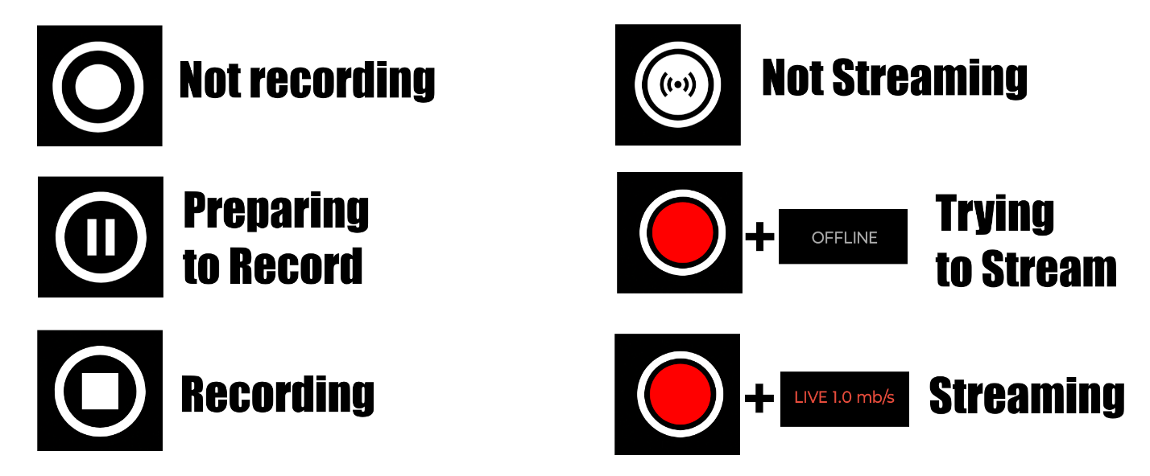
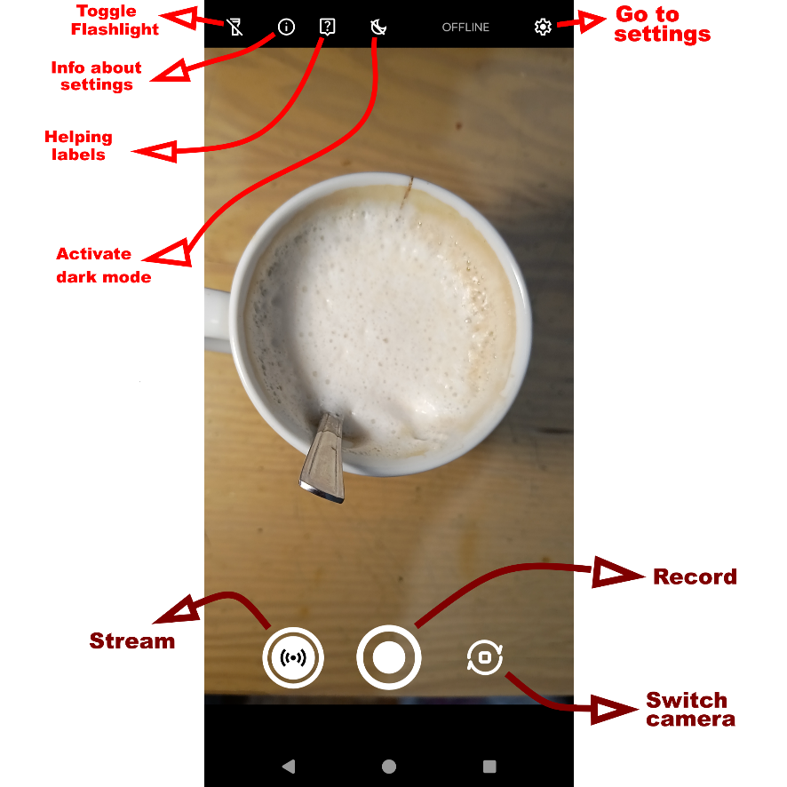
Flashlight, info about settings, Helping Labels, Dark Mode, Go to Settings, Stream, Record, Switch Camera, OFFLINE/LIVE
Dark Mode: Stops recording, saves the video and stops streaming. Lowers fps to 10, restarts recording and streaming. When disabling it, it does the same but gets the fps to the number they were configured in settings.

