Training Module : Multi lines.

**Supervisor screen :**

1. Open internet browser .
2. Type URL ---https://smart.intaspharma.com
3. Type user and password as per AD

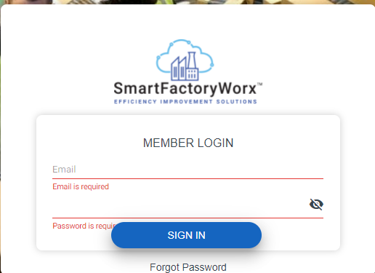

1. On successful login, 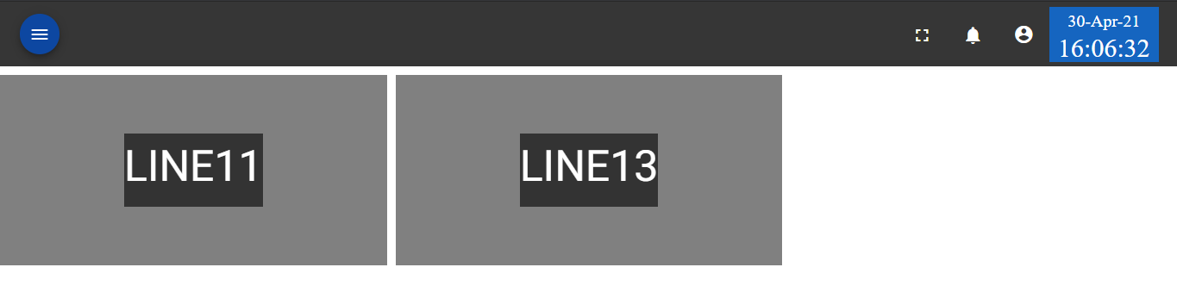the authorized screen will be visible.
2. Click on Line 11 and supervisor screen will appear.

1. 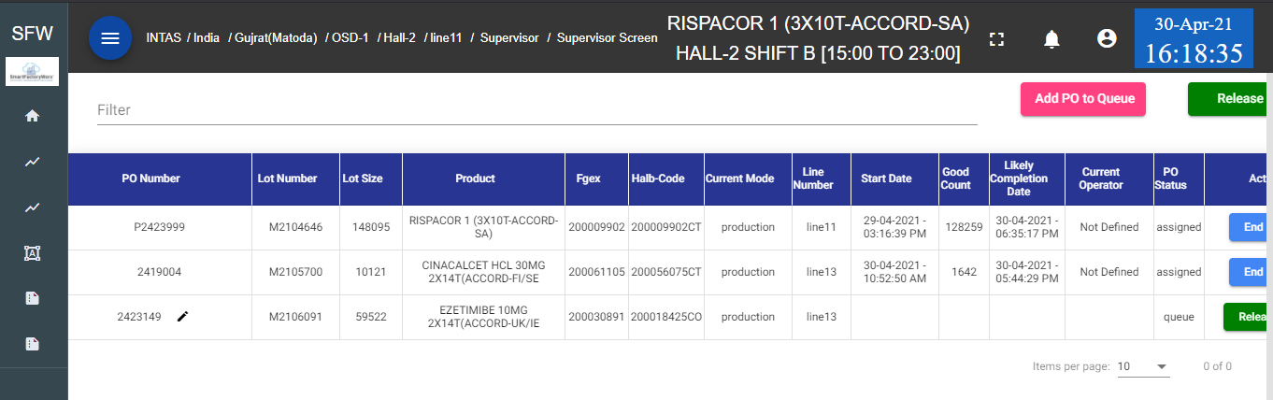It will display below supervisor screen. From here you may navigate to different halls.
2. Click on OSD 1 and a page will appear which shows Hall-1, Hall-2 and Hall-3.

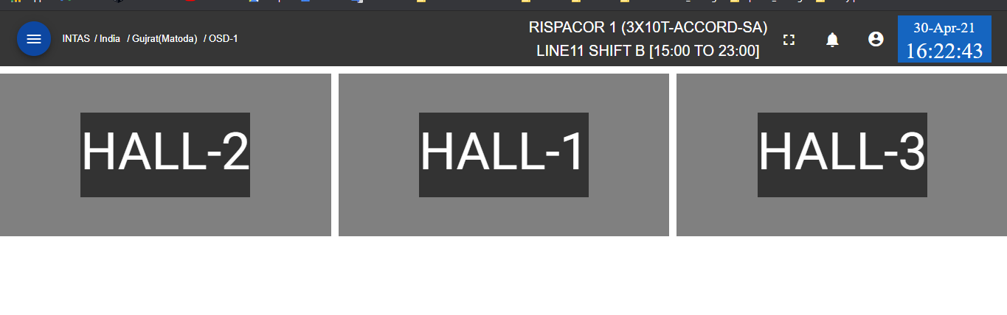

1. Choose the hall that is needed. Once you Click on Hall-2 then a page will appear on your screen which shows line 11 and line 13 and. Similarly when you click on Hall-1 then a page will be displayed which shows line1, line2, line3, line4 and line5.

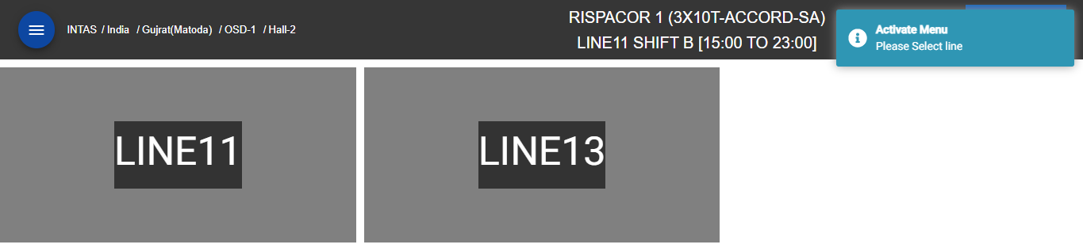

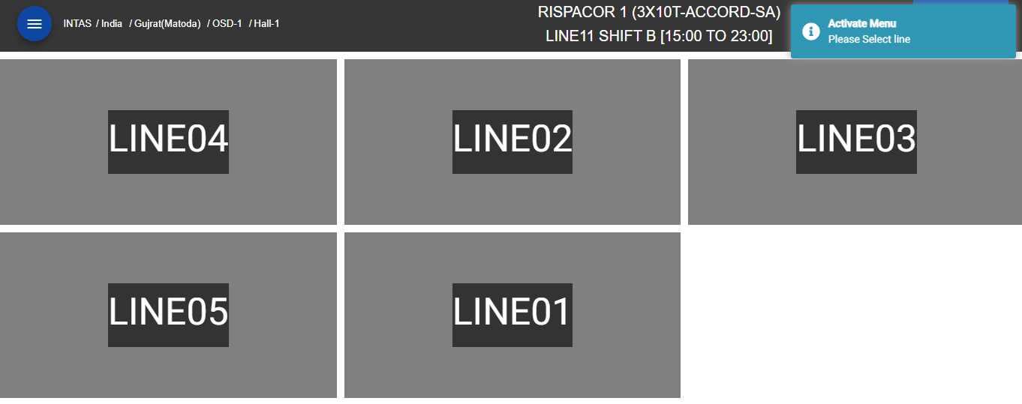

1. 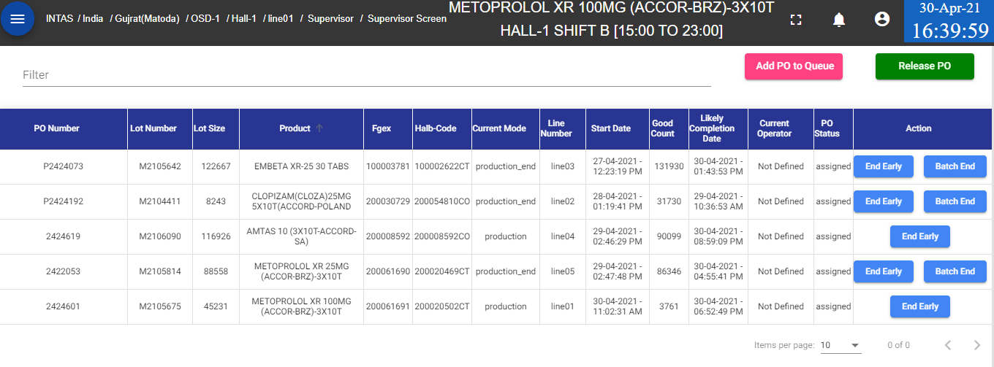When you click on any line and it will display below supervisor screen.
2. On the left side is SAP data upto HALB code. Below are the data from SAP:
   1. PO Number
   2. Lot Number ( batch number )
   3. Lot Size ( Target blister quantity )
   4. Product name
   5. FGex
   6. HALB code
3. The live data is displayed on the on the right side of the screen as below:
   1. Current Mode :This is live information of the line.
      1. Changeover
      2. Production
      3. Production end
      4. Batchend
      5. Early Batchend
   2. Line no.
   3. Start time of batch (same as start of CO or release of PO)
   4. Current Good count
   5. Likely completion date-time( On Trial )
   6. Current operator – can be changed
   7. PO Status
      1. Assigned
      2. queue
   8. Action
      1. Release PO
      2. Early end
      3. Batchend
4. Various functions that can be done from this screen :
   1. **Add PO to queue**:
      1. Select Add PO to queue( Middle right )
      2. It will open below screen

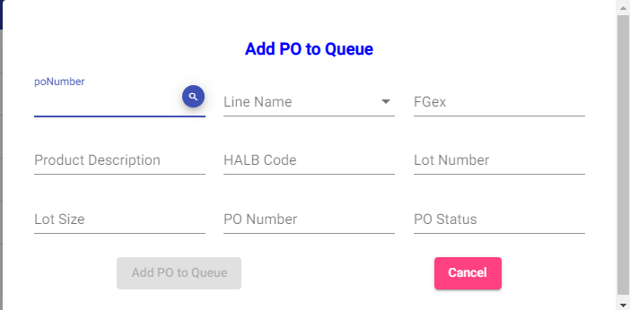

* + 1. Search PO number by typing all the PO alpha numeric values and press enter.
    2. It will fill up all the available data which have come from SAP / early batch end. Select the line where it needs to be released.

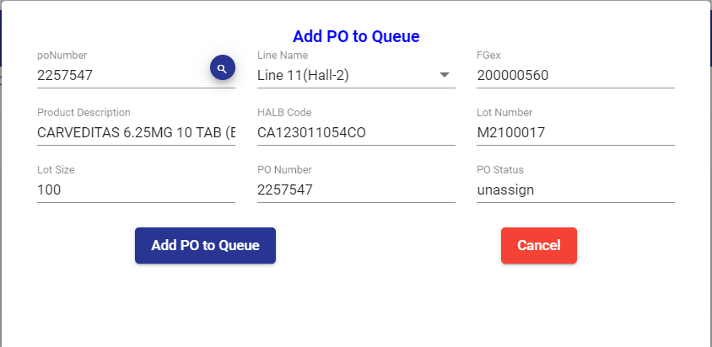

* + 1. However, if the details don’t come the error message as below may appear:
       1. PO not available in Data base. – Action : Add PO manually
       2. PO queued on another line -----.Action : Check if PO and Line selected is correct.
       3. PO assigned on another line -----.Action : Check if PO and Line selected is correct. Then decide if need to do end early there and then run the PO on this line.
       4. PO does not have HALB code. Action – PO for repacking only.
       5. FGex + HALB code is not updated. Action Go to Manager and update the FGex and HALB code in masters.
       6. Depending on the error message, supervisor should take appropriate action at his end.
    2. Supervisor can select Add PO to the Queue.
    3. The PO will then get queued on that line and will see as below.

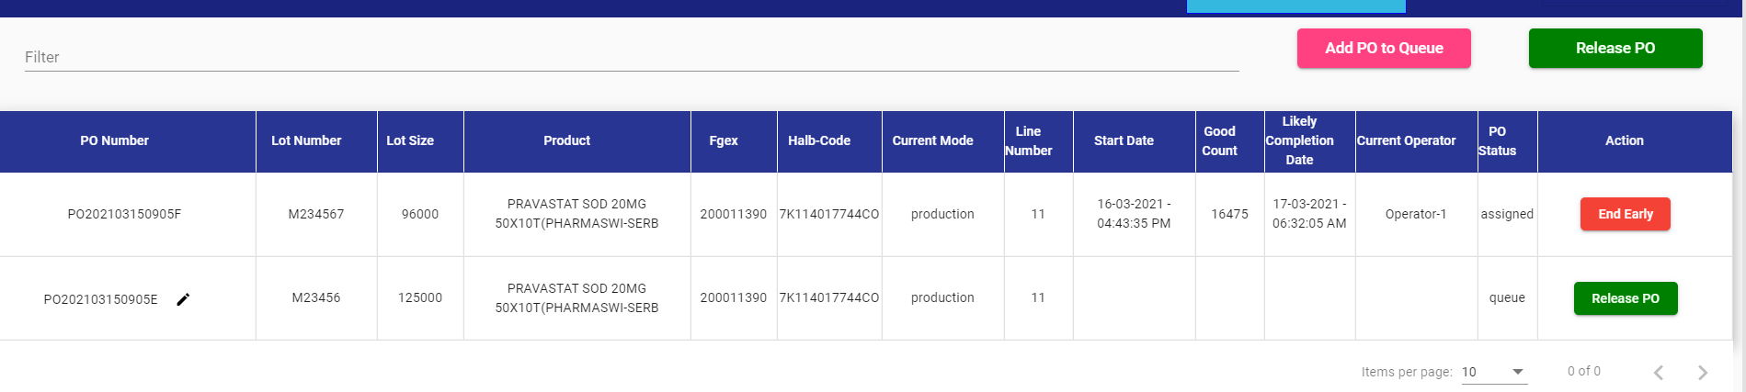

* + 1. Since there is another PO running on the line, the next PO can’t be released.
  1. **Release PO** :
     1. To release the next PO, the present PO must end by
        1. Early batch end.
        2. Or Batchend : once production end sign appears, then batch end can be done by Supervisor or by Operator.
     2. Once the current batch end has been done, now the new queued PO can be released.
     3. Edit button on queued PO is only for changing the PO number and not to update its details.
     4. Release PO directly to line is to be done from the top right Button Release PO.
     5. On selection below screen will be seen

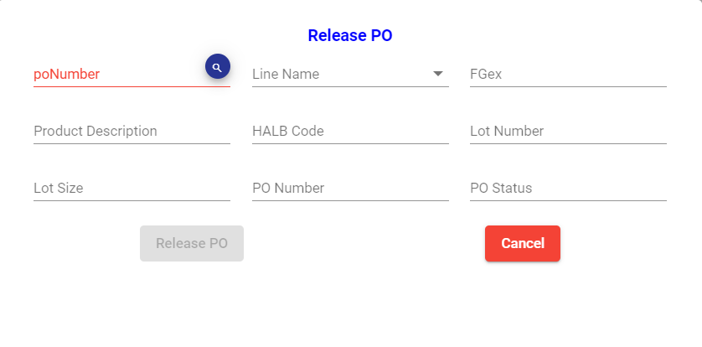

* + 1. Fill the PO details and select search.
    2. Only Early Ended PO’s Lot size can be edited.
    3. On release of PO, the previous details of PO will disappear, and new PO details will be shown. The machine will now be in Changeover Mode.
  1. **Early end ( PO ) by Supervisor**:
  2. The above screen will be seen.
  3. Early end should be done only when
     1. When the current Batch can’t be completed due to Setting, material, Change Parts etc.
     2. If however the PO has been wrongly assigned on another line then it must be Ended Early.

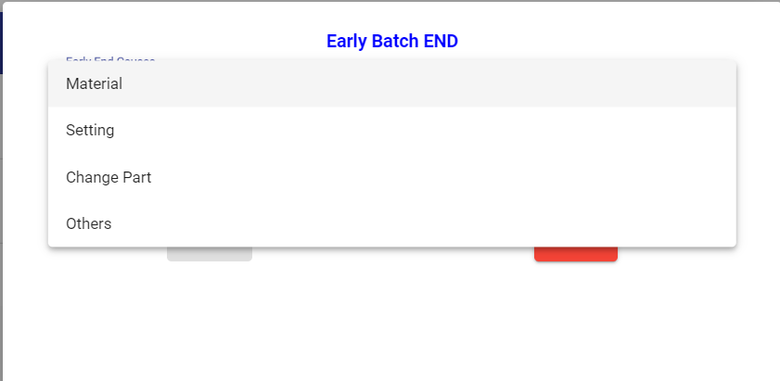

* + 1. Select correct cause.

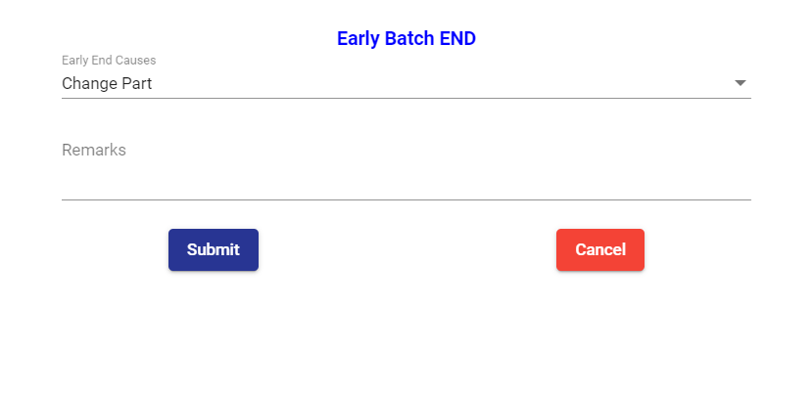

* + 1. On Clicking submit, it will end the batch early.
  1. **Batchend by Supervisor** :
     1. In Normal case when the Good Count comes in the band of target, and good count don’t increase for certain time, the “Production end” will display on the Supervisor screen and also Batchend will become active in Action button.

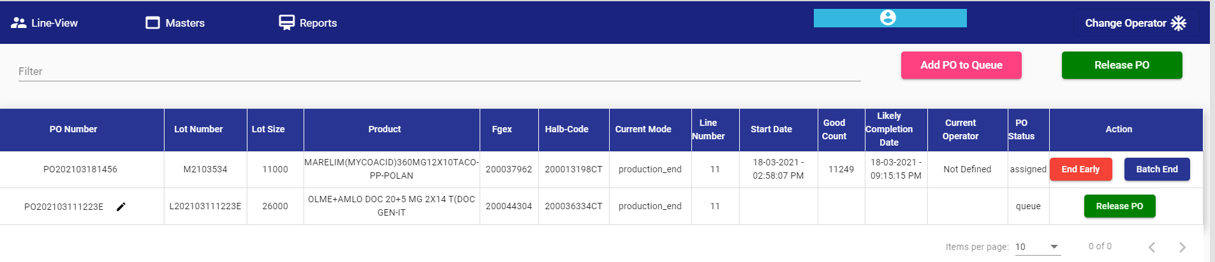

* + 1. If the batch has ended, release the queued PO.
    2. This will end the previous batch and release the queued PO.
    3. If however Po is not queued as no PO is planned, then batch can still be ended.
    4. Select batchend in the action button.
    5. This will end the previous batch.
    6. New PO when planned can be released on that line.

1. **Adding PO in Database :**
   1. When PO has not been received from SAP , then the PO can be added manually in the system.

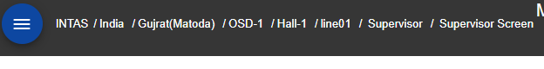

* 1. Click on highlighted menu shown in above picture.
  2. Left scroll bar will come on screen then click on Master as shown in below image.

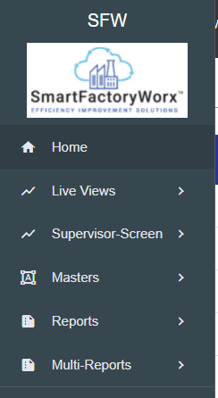

* 1. 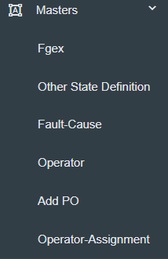Once you clicked on master other Menu bars of master will be appear on screen then click on add PO Menu as shown in below image.

* + 1. 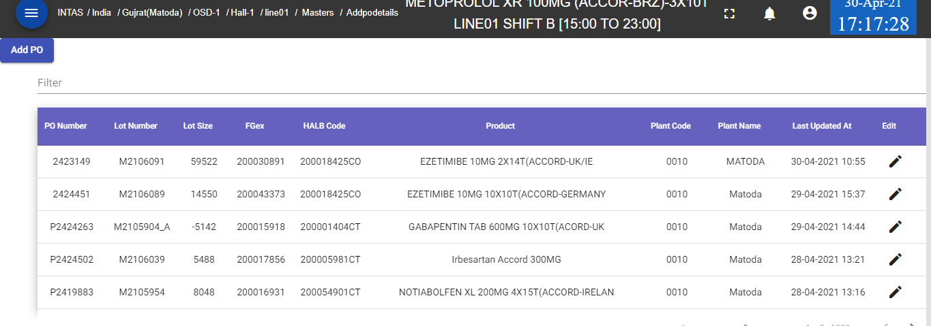After Clicking on Add PO and below screen will open up.
    2. Click on Add PO menu as shown in above image and below screen will be appeared.

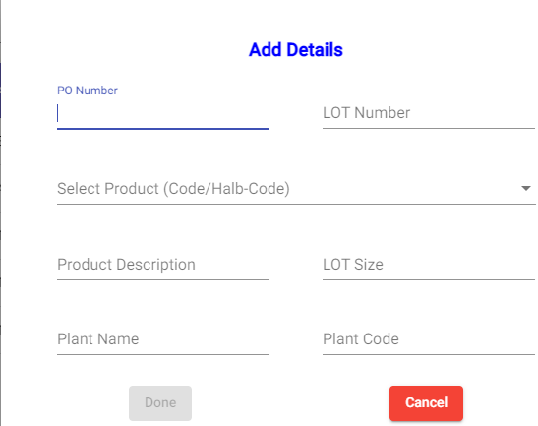

* + 1. Fill all the details and click done.
    2. The PO details will be updated and will be shown in this page.
    3. You can also edit updated details by just clicking on edit button then fill all the details and click done after that PO edited data will be saved.