Ein Bild, das Text, ClipArt enthält.

Content

1 Issues with Installation: 2

1.1 Command Line: 3

2 Issues with components: 4

2.1 Informative: 4

2.2 Fixed: 4

2.3 Not Fixed: 5

3 Issues with GUI: 7

3.1 Informative: 7

3.2 Fixed: 7

3.3 Not Fixed: 8

4 Issues with command Line 9

4.1 Informative 9

4.2 Fixed 9

4.3 Not Fixed 9

**Info: Everything was tested one Eclipse IDE version 2019-12 (4.14.0) and on Java Version 14.  
 Apart from the Installation only the Attachment-Version was used for Testing.**

# Issues with Installation:

**Sourceforge-Version (Fixed):**

Error: Unable to find source-folder Components/Problems/queryShed.  
Fix: Remove source folder from build Path.

Ein Bild, das Text enthält.

**Attachment-Version (Fixed):**

Error due to the library frevo-circle-sim-0.0.1-SNAPSHOT-jar-with-dependencies.jar being referenced with an absolute file path  
Fix: Change to relative path Frevo/Libraries/frevo-circle-sim.

Ein Bild, das Text enthält.

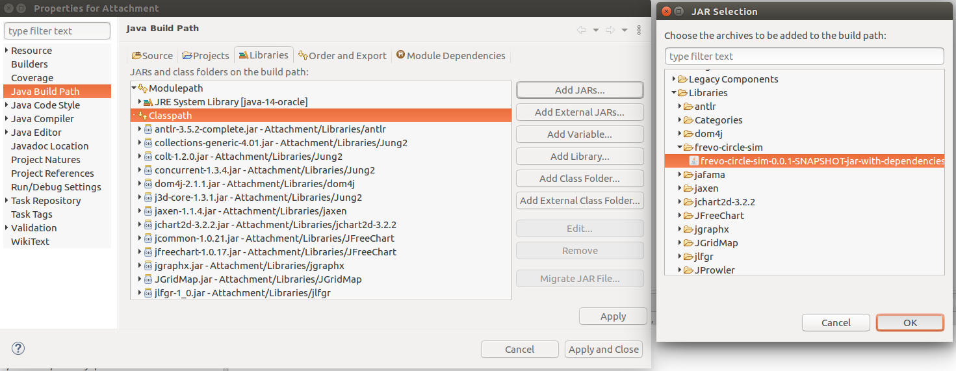

## Command Line:

When executing createscripts.jar, there was a   
java.lang.NoClassDefFoundError: org/kohsuke/args4j/CmdLineException thrown  
Fixed by: in the createscripts.jar file moved /args4j-2.0.21.jar/org/kohsuke to /org.

# Issues with components:

## Informative:

**Problems:**

Tic Tac Toe 2x2 has no replay.

On Linux running EmergencyExit requires adapting the Filename parameter.

**Methods:**

PSO requires a single Problem.

PSO is only compatible with fully meshed net.

CuckooSearch requires a single Problem.

NoveltySearch requires a single Problem.

NoveltySpecies requires a single Problem.

GASpecies requires a single Problem.

No Problem implements Novelty ranking, making Novelty ranking, Novelty search and Novelty species unusable.

CuckooSearch requires either FullyMeshedNet or Fully connected neural network.

**Representations:**

MealyFSM: min_input_values, max_input_values, treshhold_for_inputs, threshold_units, and unit_input_values require exactly as many numbers as there are different inputs.

CAM is the only problem, that currently support bulk representations.

**Rankings:**

MultiSort is currently incompatible with all methods except RandomSearch and NNGA.  
Incompatibility with PSO, CuckooSearch, NoveltySearch, NoveltySpecies and GASpecies due to those methods requiring a single Problem and MultiSort requiring a multi problem.  
Incompatibility with CEA2D is due to CEA2D always comparing 9 different networks, and Multi Sort needing a multiple of the number of competing networks in one game.

Swiss System only works for 1vs1 problems, for more than that use MultiSwiss System.

## Fixed:

**Rankings:**

MultiSort: In Components/Rankings/MultiSort/MultiSort/MultiSort.java line 53 the Property “evaluation_time” of a problem was incorrectly addressed with the name “evaluation_times”

MultiSort incompatible with NNGA, due to the AbstractRepresantation of the network being cloned, but the clone function not supporting the EvolutionStatus attribute.  
Fixed by: Adding a clone function to AbstractEvolutionStatus at src/core/AbstractEvolutionStatus.java line 19, Implemented clone function in Components/Methods/nnga/nnga/NNGAEvolutionStatus.java line 36, called clone function in clone function of AbstractRepresentation at src/core/AbstractRepresentation.java line 200.

**Problems:**

The Common Interest vs. Private Interest Problem claims to work with any number from 4 to 6 players, but only works with 6. This does not cause issues with the simulation itself but causes an exception when attempting to replay a game with only 4 or 5players. Fixed by setting icomponent.requirements.minimumCandidates to 6 in Component/Problems/cipi.xml line 21.

In cDrones and dDrones, changing the evaluation times to a higher value, after having already run a simulation resulted in an index out of bounds exception, fixed by refilling the corresponding arrayList if it is to short.t

**Methods**:

GASpecies disables Replay.  
Fixed by informing FrevoMain about the change in the results, after each generation.

**Representations:**

HebNet does not save fitness to XML, causing Representation has not been evaluated Error.  
Fixed by: Saving fitness to XML in Components/Representations/HebbNet/hebbNet/HebbNet.java line 433 and loading fitness from XML in Components/Representations/HebbNet/hebbNet/HebbNet.java line 467

MealyFSM: does not save fitness to XML, causing Representation has not been evaluated Error.  
Fixed by: Saving fitness to XML in Components/Representations/MealyFSM/fsm/MealyFSM.java line 954 and loading fitness from XML in Components/Representations/ MealyFSM/fsm/MealyFSM.java line 1134.

## Not Fixed:

**Problems:**

In simulated robot soccer, the number of players per teams is variable but the positions of the players, the infoObject and the NNGA Player treat it as if it was constant causing java.lang.IndexOutOfBoundsException, when playing with any player number other than 11. Causes an Exception as default player number is set to 10. For simplified robot soccer this error does not occur. For RobotSoccer Team sizes smaller than 11 are possible, but team size larger than 11 throws exception: “Team size larger than 11 is not implemented”.

Max Traveller Problem is unable to connect with Argos.

The Replay of NNRacer is missing parts, including the picture of the race car, causing an exception.

Tic Tac Toe 3x3 is not actually implemented (just method stubs).

DDrones only works with exactly five agents.

**Methods:**

CuckooSearch doesn’t write result Files.

**Representations:**

BulkRepresentation cannot be replayed because it lacks loading and exporting functions for xml.

# Issues with GUI:

## Informative:

After changing, the problem you might have to select a new Ranking system as well before starting the simulation.

Connecting to an external simulator is not implemented yet.

## Fixed:

Session configuration can be changed while running a Simulation, even though the buttons being disabled, leading to the following issues: Resetting the Session doesn’t work when the configuration of the session has been changed. The current simulation will be stopped.

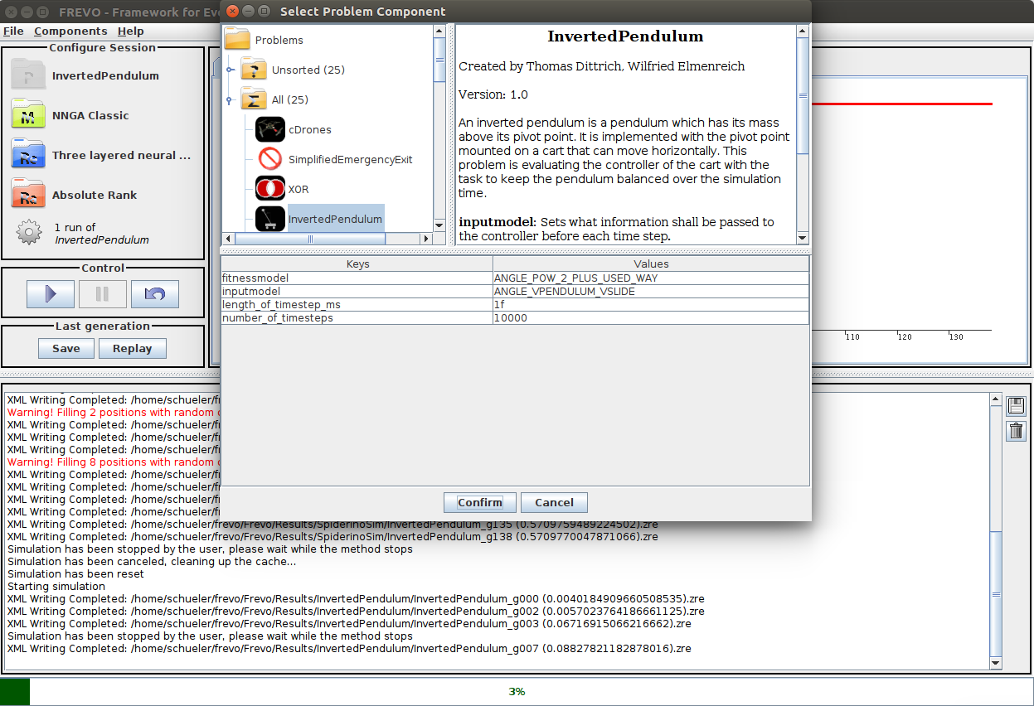

Problem fixed, by checking, whether the button is enabled in the corresponding event handler (src/graphics/FrevoWindow.java line 2001).

Continue Button in replay menu not working, throws null pointer exception.  
Fix: Check whether there currently is a File loaded in src/graphics/FrevoWindow.java line 2533

When opening and then closing the replay menu while the simulation is running, both the start and the pause buttons are active, with the start button not working, as the simulation is already running.  
Fix: Comment out line 1684 in src/graphics/FrevoWindow.java, which is responsible for reactivating the start button.

The continues button in replay mode completely resets all progress.  
Fix: copy paste code from start button to continueButton event handler (src/graphics/FrevoWindow.java line 2526)

After loading a new session from a file, the configuration of the old session stays active.  
Fix: Force reset at src/graphics/FrevoMain.java line 2400.

Starting the batch evaluation with unfeasible conditions, results in all buttons stopping to respond, setting value to zero results in an exception, fixed by reactivating the window after throwing error and checking for step value zero.

Multiple windows for adding a new batch configuration can be opened at the same time, and they stay active even after the batch menu has been closed.  
Fixed by deactivating the main Window, while the batch window is active.

After loading a session, the configuration must be changed again to be able to start the simulation.  
Fixed by pausing the current configuration, resetting it and then checking if the new configuration is launchable.

Unable to load any incomplete session.  
Fixed by marking a missing component as just a warning instead of an error.

## Not Fixed:

# Issues with command Line

## Informative

Executing a results File from the command line only works with single problems.

## Fixed

-e option is not included in the help.  
Added this option to printUsage.

Exporting does not work, if there are any spaces in the arguments.  
Fixed by gluing all arguments after the first together to one string.

## Not Fixed

Exporting for Java or Python throws an error for multi problems:  
line 40:12 no viable alternative at input 'true'

line 81:11 no viable alternative at input '('

line 81:11 no viable alternative at input '('

line 81:12 no viable alternative at input 'netInput'