MARKET BASKET INSIGHTS

S.HARISH

# Introduction

Market basket insights are a powerful tool in the realm of retail and ecommerce that provide a deep understanding of customer behaviour and preferences. This analytical approach goes beyond individual purchases and delves into the associations and patterns within customers' shopping carts. By uncovering the relationships between products frequently bought together, market basket insights enable businesses to make informed decisions, optimize strategies, and enhance the overall shopping experience. In a world where data is abundant, market basket analysis harnesses the wealth of transactional data generated by consumers during their shopping journeys.

**Content for Project Phase 2**

**Data Source**

To perform market basket analysis and derive insights, you'll need transactional data that records customer purchases.

Dataset Link: [(https://www.kaggle.com/datasets/aslanahmedov/market-basket-analysis/](https://www.kaggle.com/datasets/aslanahmedov/market-basket-analysis/) )

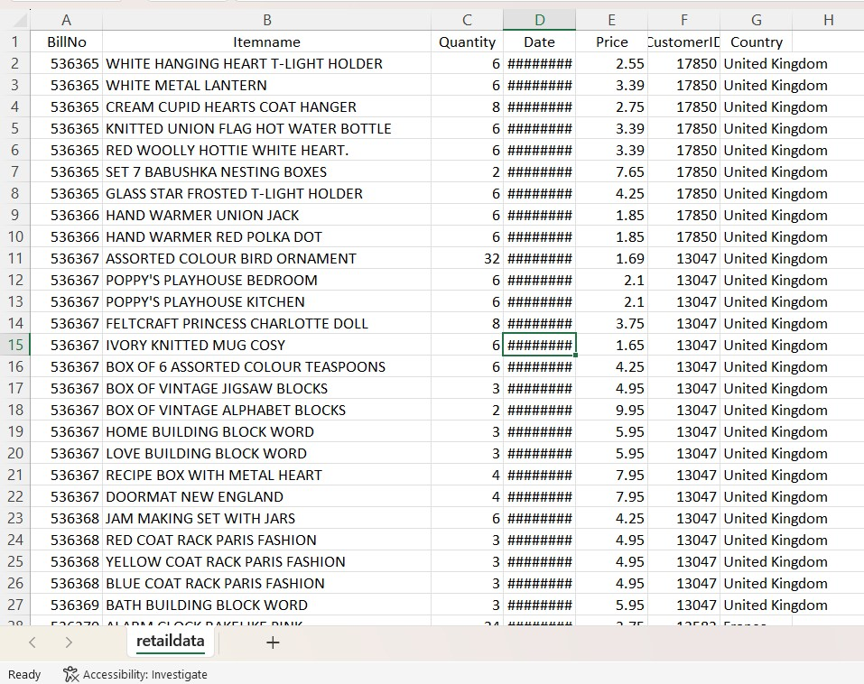

Market basket insights can drive innovation by identifying patterns and trends in customer purchasing behaviour. Here's a high-level design for leveraging these insights:

**1. Data Collection:**

* Gather point-of-sale data, including customer transactions, item details, and timestamps.
* Collect demographic and contextual information, such as location, weather, and promotions.

**2. Data Preprocessing:**

* Clean and prepare the data by handling missing values and outliers.
* Encode categorical variables and create a transaction dataset.

**3. Association Rule Mining:**

* Apply association rule algorithms like Apriori or FP-growth to identify frequent itemsets and generate rules.
* Set appropriate support and confidence thresholds to filter meaningful associations.

**4. Market Basket Analysis:**

* Analyze the generated rules to understand product co-purchasing patterns.
* Identify cross-selling and upselling opportunities, such as suggesting complementary products.

**5. Customer Segmentation:**

* Cluster customers based on their purchase history and preferences.
* Tailor marketing strategies and product recommendations for each segment.

**6. Predictive Analytics:**

* Utilize machine learning models to forecast future sales and demand for specific products.
* Optimize inventory management and supply chain logistics.

**7. Personalized Recommendations:**

* Implement recommendation systems to suggest products to individual customers based on their browsing and purchase history.
* Enhance the user experience and drive sales.

**8. Real-time Insights:**

* Develop a real-time dashboard to monitor current market basket trends.
* React quickly to changing customer behaviours and market conditions.

By designing an innovative market basket insights system, businesses can not only boost sales but also enhance customer satisfaction and adapt to market dynamics more effectively.

**Packages Used:**

market basket analysis, several packages or libraries can be used, depending on the programming language you prefer. Some popular choices include:

**1. Apriori Algorithm in Python:**

- **mlxtend library**: This library provides a simple and efficient implementation of the Apriori algorithm for association rule mining.

**2**. **FP-growth Algorithm in Python**:

**- pyfpgrowth library**: It's a Python implementation of the FP-growth algorithm for frequent pattern mining.

**3. R Programming Language:**

- **arules package**: R has excellent support for association rule mining using this package. It allows you to perform Apriori, Eclat, and FP-growth analysis.

**4. Weka:**

- Weka is a popular data mining and machine learning software that offers a graphical user interface for various data mining tasks, including association rule mining.

**5. Orange:**

- Orange is a data visualization and analysis tool that has components for association

**Algorithm**

Market basket analysis is a data mining technique that explores the relationships between products or items purchased together by customers. There are several algorithms used for market basket analysis, with the most common one being the Apriori algorithm. Here's a brief overview:

**1. Apriori Algorithm**: The Apriori algorithm is a classic association rule mining algorithm used for market basket analysis. It works by identifying frequent itemsets and generating association rules based on these itemsets. The algorithm consists of three main steps:

* **Support**: Calculate the support for each itemset, which is the proportion of transactions containing that itemset.
* **Confidence**: Calculate the confidence for each rule, which is the likelihood that if item A is purchased, item B is also purchased.
* **Lift:** Calculate the lift for each rule, which measures how much more likely item B is to be bought when item A is bought, compared to when item B is bought without considering item A.

1. **FP-Growth Algorithm:** Another popular algorithm for market basket analysis is the FP-Growth algorithm, which is more efficient than Apriori, especially for large datasets. It uses a tree structure to mine frequent itemsets and generate association rules.

1. **Eclat Algorithm:** Eclat is another algorithm for finding frequent itemsets. It uses a vertical data format and employs a depth-first search approach to find frequent itemsets efficiently.

These algorithms help retailers and businesses uncover patterns and associations in customer purchase data, which can be used for various purposes like optimizing product placements, creating targeted marketing campaigns, and making inventory decisions.

**Conclusion:**

Market basket analysis helps businesses understand customer purchasing patterns. The insights and conclusions can include identifying frequently copurchased items, optimizing product placement, and creating targeted marketing campaigns to boost sales and customer satisfaction. It's a valuable tool for improving business strategies.