- Go to https://www.coinbase.com/settings/api
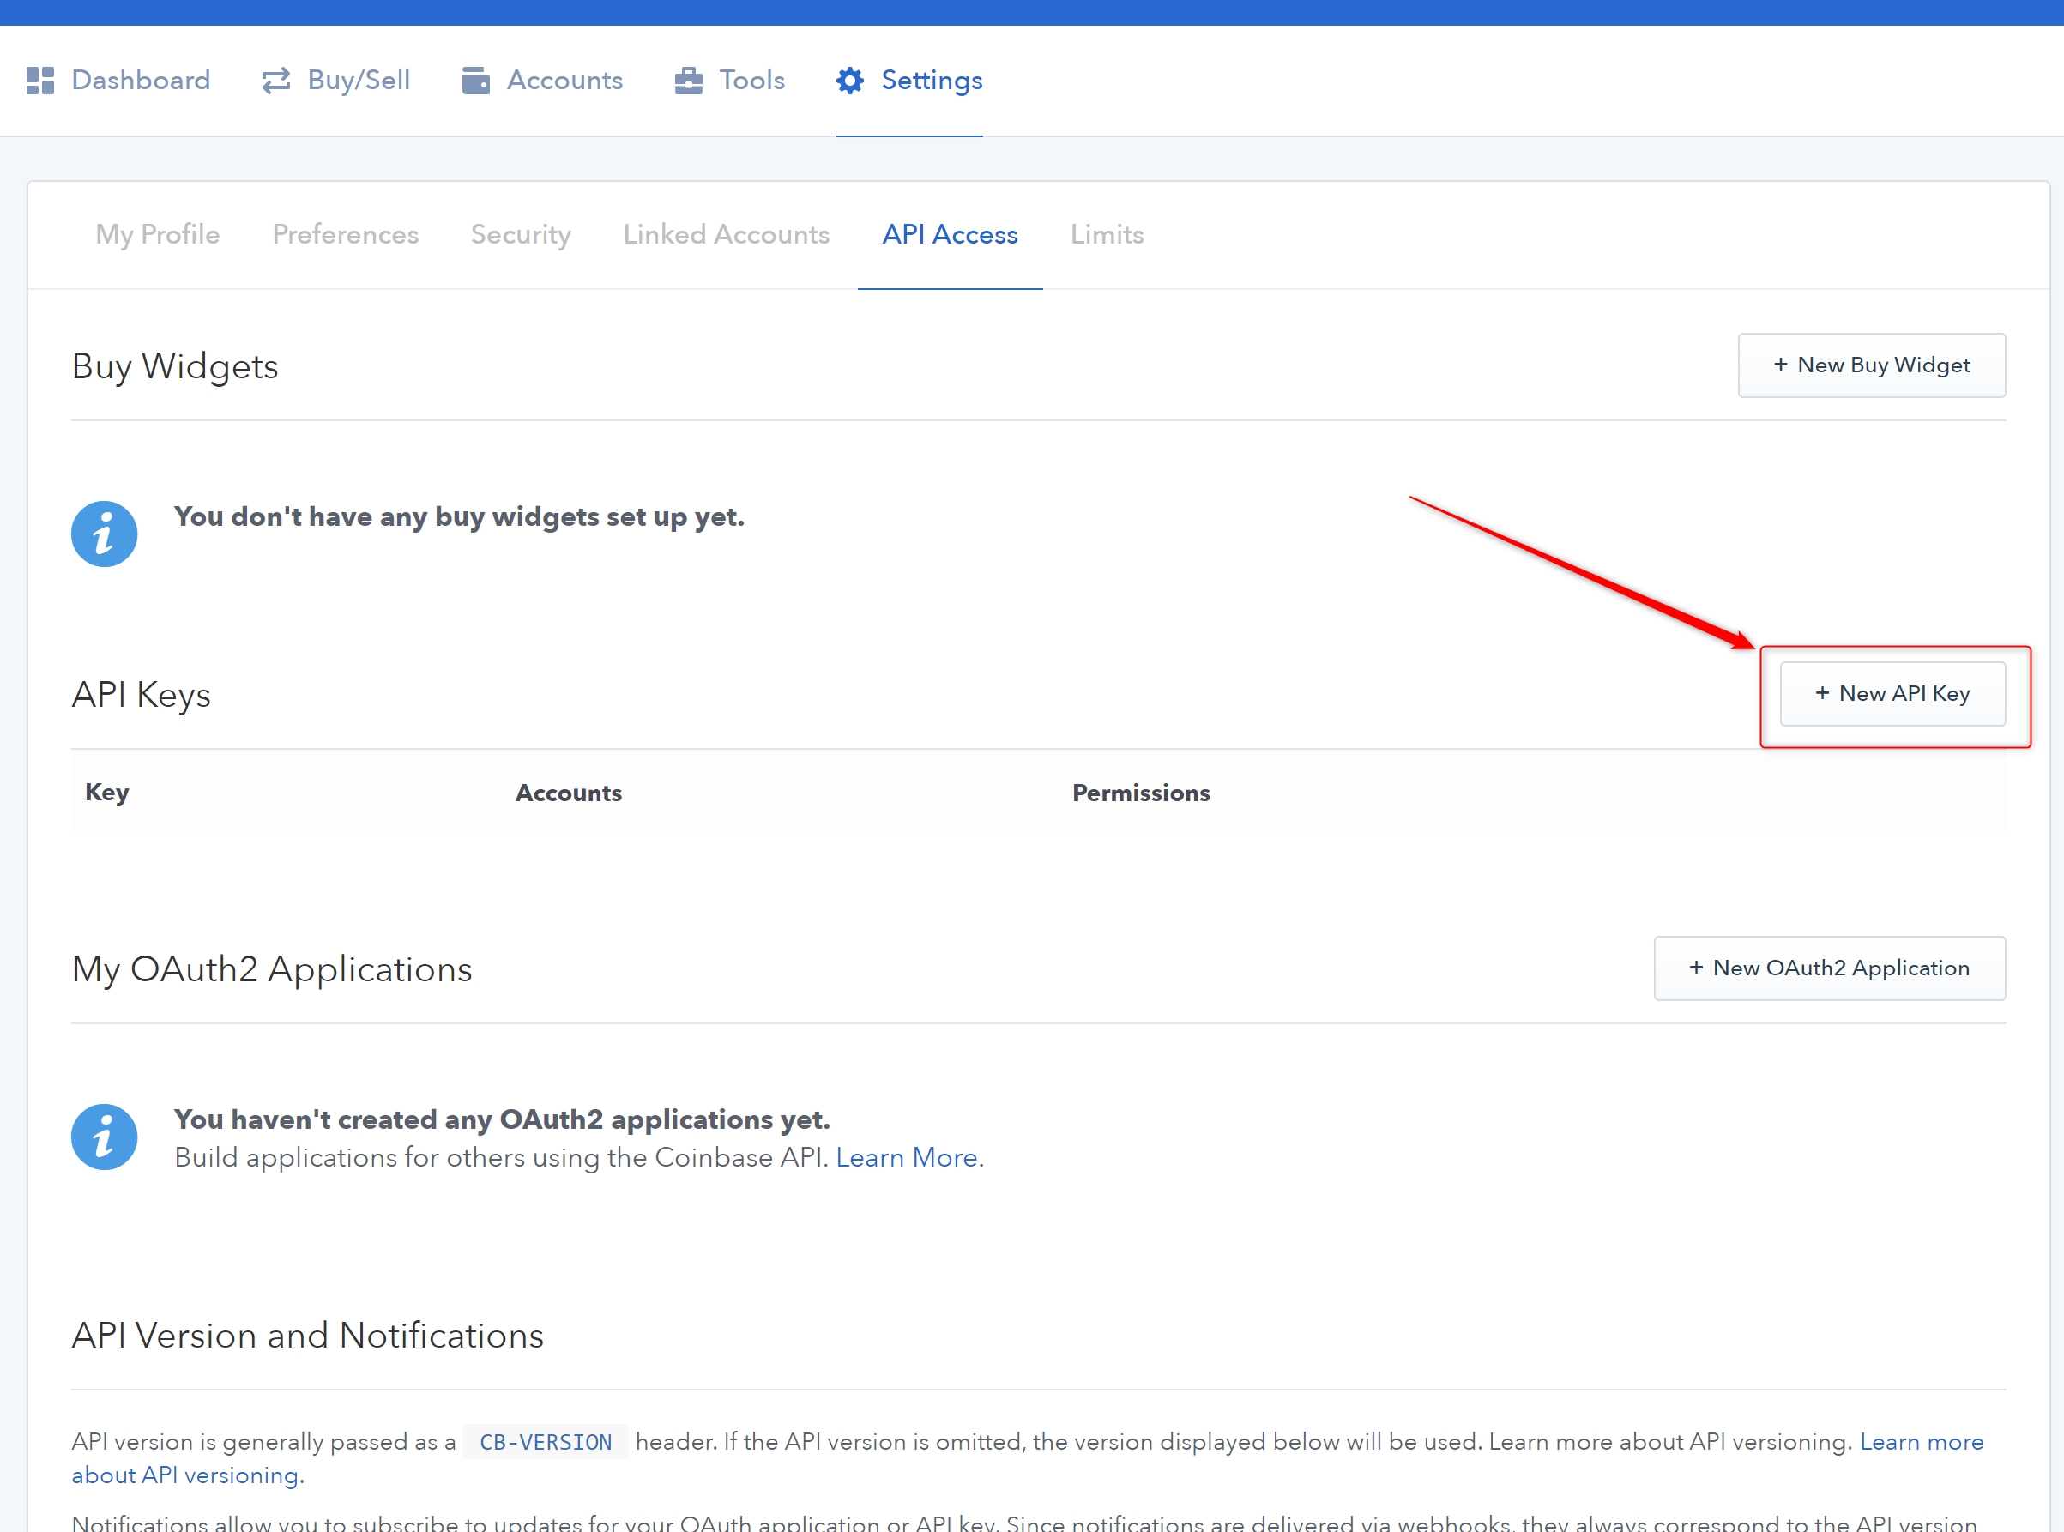
- Press ‘New API key’
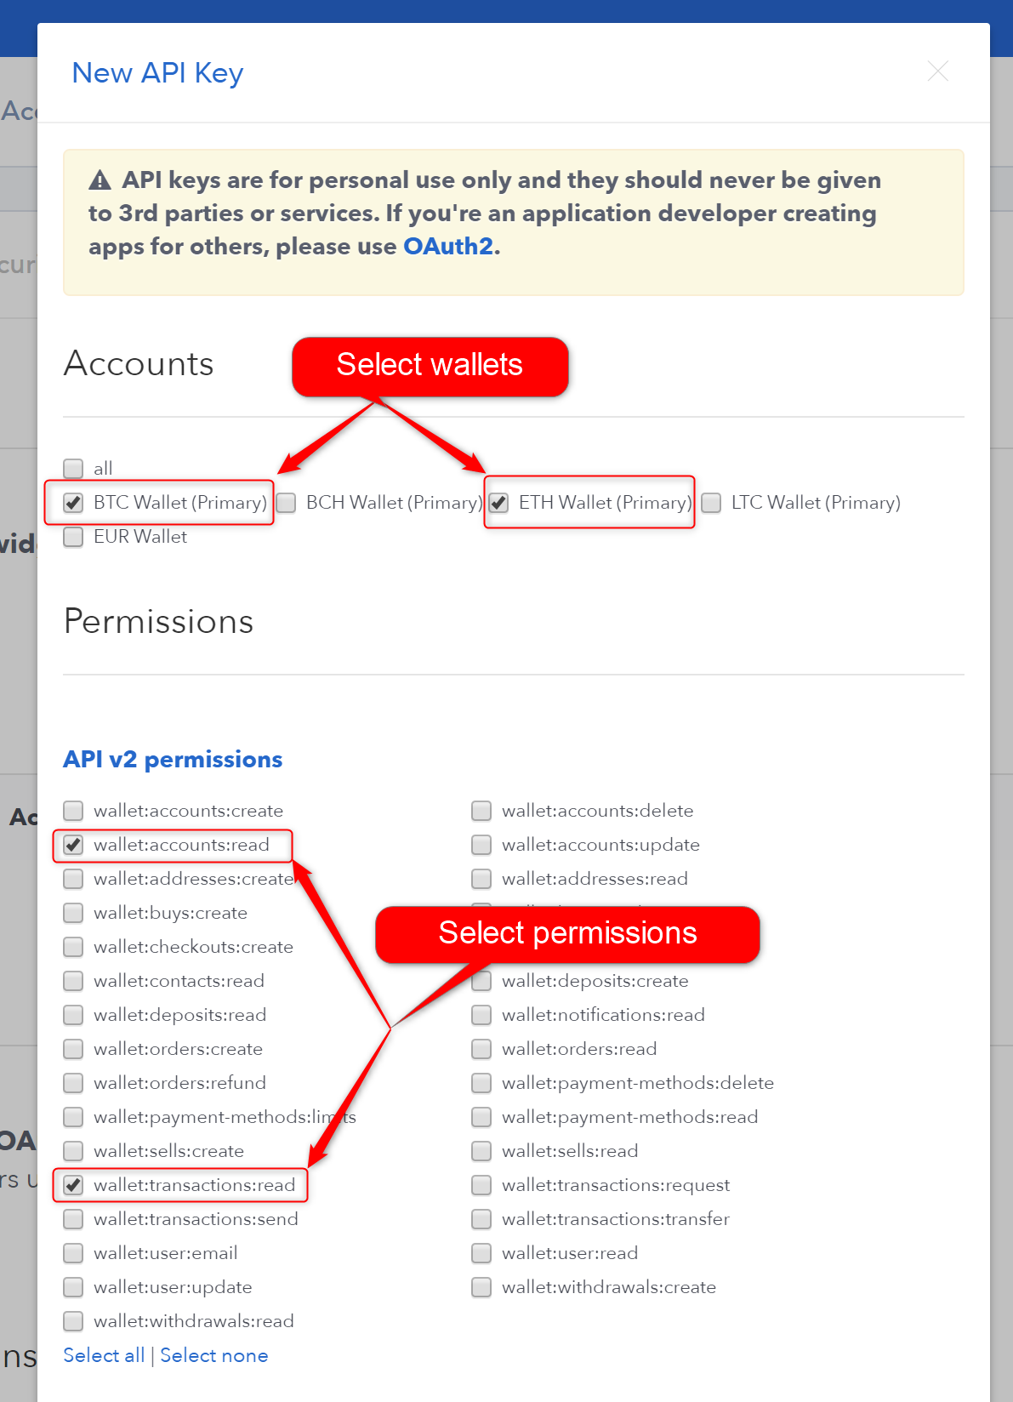
- Select BTC and ETH wallets (BTC wallet needed due to bug in coinbase) and correct permissions
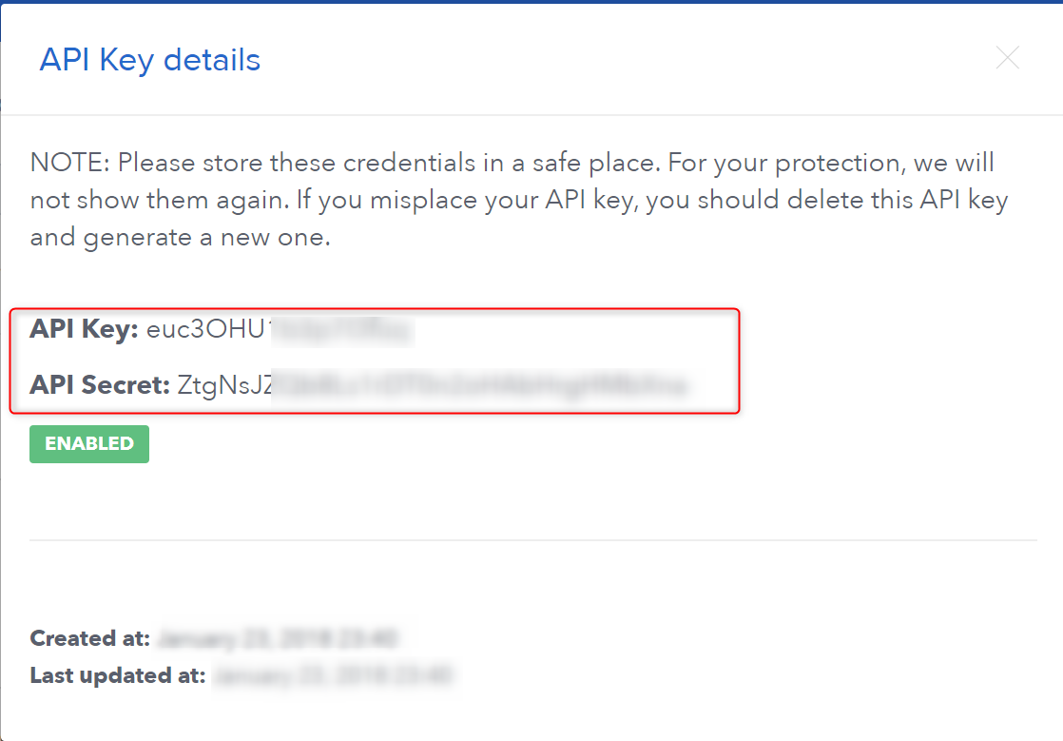
- Create API key and send screenshot or copy-paste api key details to us (We need API Key and API Secret)
- We will execute script that located in our git repository to confirm that it was you who sent us particular transaction

