Table of Contents

Description Page No:
1.0 Introduction
1.1 Purpose
1.2 Scope

1.3 Definition, Acronyms, and Abbreviations
1.4 References
1.5 Technologies to be used
1.6 Overview

2.0 Overall Description
2.1 Product Perspective
2.2 Software Interface
2.3 Hardware Interface
2.4 Product Function
2.5 User Characteristics
2.6 Constraints
2.7 Architecture Design
2.8 Use Case Model Description
2.9 Class Diagram, Sequence Diagram
2.10 Database Design .....
2.11.1 ER Diagram ....
2.11.2 Schema
2.12 Assumptions and Dependencies

3.0 Specific Requirements

3.1 Use Case Reports
3.2 Supplementary Requirements

ONLINE JOB PORTAL Version 1.0

ONLINE JOB PORTAL | Version 1.0
Software Requirements Specification | 26/12/10
Avachromians

Software Requirements Specification

1.Introduction:

Viewing available jobs, or applying for the job at the agency can be done for which job seekers has to go to the agency and check the available jobs at the agency. Job seekers check the list of jobs available and apply the job. Then the agency will show available jobs for the job seeker for his qualifications and then updates the jobs database.
1.1 Purpose:
The pupose of designing the online job portal is to give the job seekers a platform for finding a right and a satisfactory job according to their qualification. It also connects the job seekers with the major agencies.
1.2 Scope:
The scope of the online job portal includes :

The Online job Portal System that is to be developed provides the members with jobs information, online applying for jobs and many other facilities. The basic scope of the project is given as under.

Job Seekers Area
Agency's Area
Administrator's panel
1.3 Definitions, Acronyms, and Abbreviations:
HTML (Hyper Text Markup Language): It is used to create static web pages.
• JSP (Java Server Pages): It is used to create dynamic web content.
• J2EE (Java 2 Enterprise Edition): It is a programming platform, belonging to the Java platform, which is used for developing and running distributed java applications.

.WASCE (WebSphere Application Server Community Edition): It is an application server that runs and supports the J2EE and the web service applications.
• WSAD (WebSphere Studio Application Developer ): It is a designer toolkit which is designed to develop more complex projects by providing a complete dynamic web service.
• DB2 (IBM Database 2): It is a database management system that provides a flexible and efficient database platform to raise a strong "on demand" business applications.
• HTTP (Hyper Text Transfer Protocol): It is a transaction oriented client/ server protocol between a web browser and a web server.

ONLINE JOB PORTAL Version 1.0

ONLINE JOB PORTAL | Version 1.0
Software Requirements Specification | 26/12/10
Avachromians

XML (Extensible Markup Language): It is a markup language that was designed to transport and store data.
• Ajax (Asynchronous Java Script and XML): It is a technique used in java script to create dynamic web pages.
• Web 2.0: It is commonly associated with web applications which facilitate interactive information sharing, interoperability, user-centered design and collaboration on the World Wide Web.

  - References:
The following websites are referred : , http://www.w3schools.com/
  - Technologies to be used:

J2EE: (Servlet, JSP, JAXP, Java Beans) Application architecture.

JAVA: Application architecture.

WASCE: (WebSphere Application Server Community Edition) Web Server

DB2: IBM Database.

Ajax: Asynchronous Java Script and XML.
XML: Extension Markup Language. Web 2.0: RSS Feed 2.0.
RAD 7.0: Development tool.

  - Overview:
The SRS will include two sections, namely:
-I- Overall Description: This section will describe major components of the system, interconnections, and external interfaces.
-I- Specific Requirements: This section will describe the
functions of actors, their roles in the system and the constraints faced by the system.

2.0 Overall Description:
  - Product Perspective: The Online Job Portal System is a package to be used by agencies to improve the efficiency of business. The Online Job Portal System to be developed benefits greatly the members. The system provides jobs catalog and information to members and helps them decide on the jobs to apply. The Admin can keep the jobs catalog updated all the time so that the members (Job seekers and the agencies) get the updated information all the time.
Tha main users are users: Admin, Members who are the Job seekers and the agencies.

ONLINE JOB PORTAL Version 1.0

ONLINE JOB PORTAL | Version 1.0
Software Requirements Specification | 26/12/10
Avachromians

2.2 Software Interface:
-I- Front End Client: Html
-I- Web Server: WASCE
-I- Data Base Server: DB2
-|- Back End: Java
2.3 Hardware Interface:
- Client Side: PC (Monitor)
- Server Side: PC
2.4 Product Functions:
The Online Job Portal System provides online real time information about the jobs available in the agencies and the user information.
The functions of the system include
  - The member should be provided with the updated information about the jobs catalog
  - Provisions for the members to apply the job they want, if all the other required rules hold good.
  - The member is given a provision to check his account information and change the account information
  - any time in the given valid period.
  - The members are provided with the jobs available roster and allowed to apply job, which they want.
  - The admin can get the information about the members who have advertised jobs.
2.5 User Characteristics:
The users of the system are members and the admin who maintain the system. The members are assumed to have basic knowledge of the computers and Internet browsing.
2.6 Constraints :
The users access the Online Job Portal System from any computer

that has Internet browsing capabilities and an Internet connection.

USE CASE DIAGRAM :

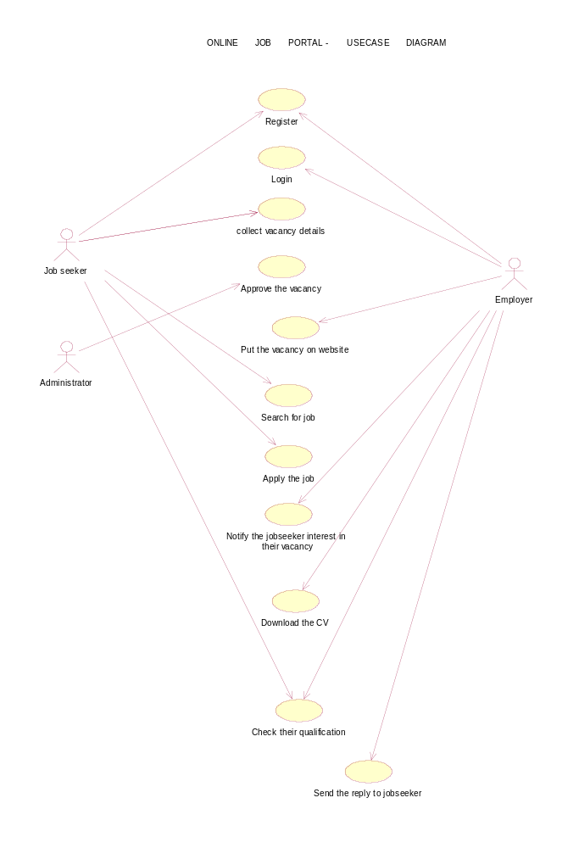

2.9 Class Diagram, Sequence Diagram

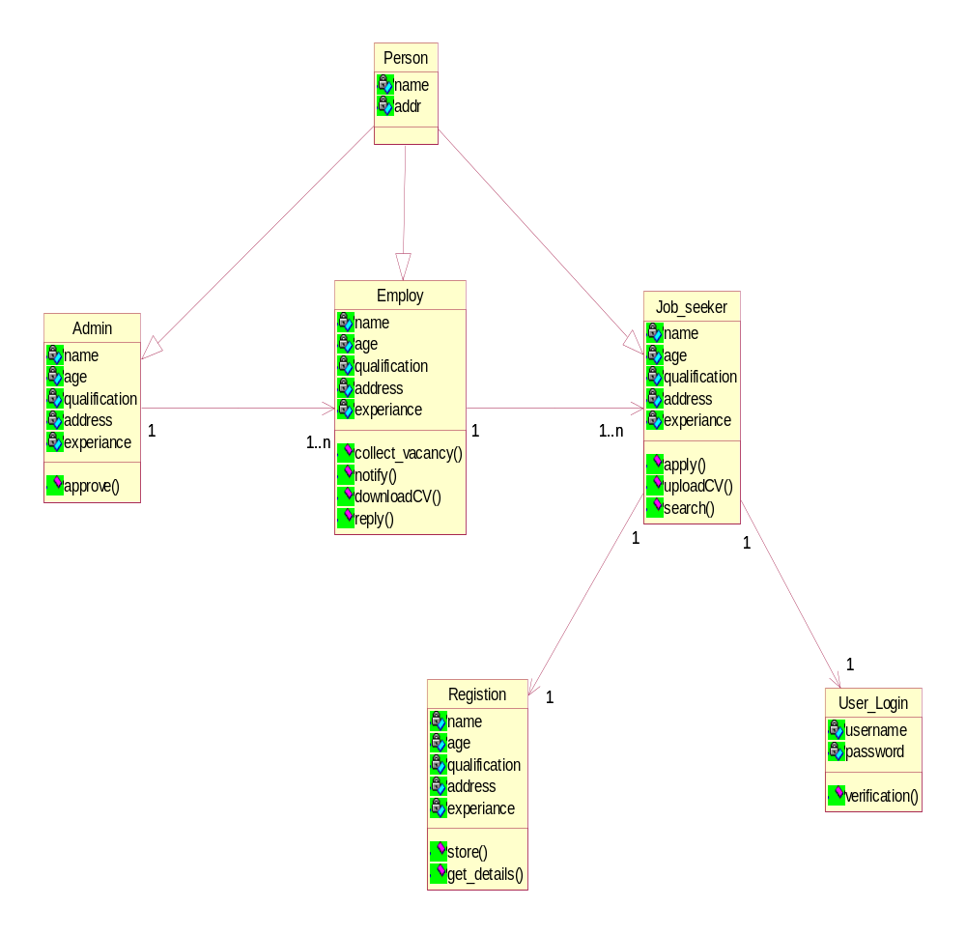

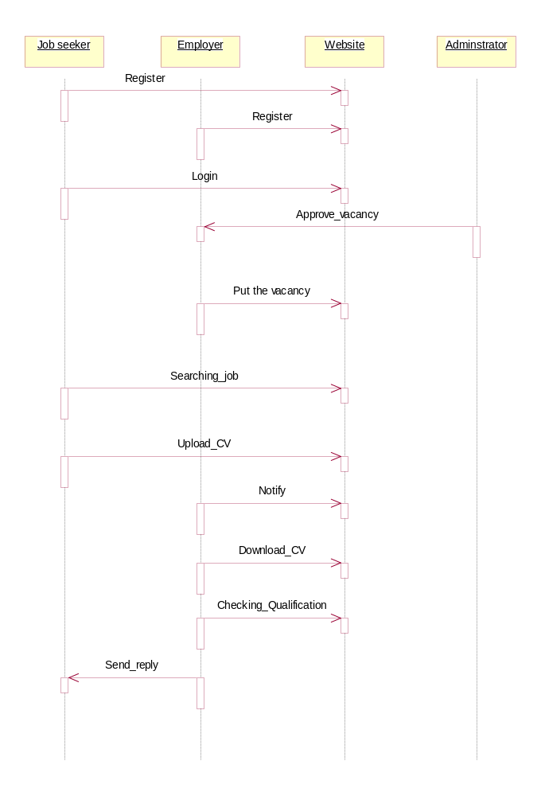

2.11.1 ER Diagram
ONLINE JOB PORTAL - ER DIAGRAM
Jobseeker
Employer
Name
Qualification
Experience
Address
Name
Address
Experience
Name
Address
Experience
Website
Seeks Job through
Uses
Manages

Administrator

2.11 Assumptions and Dependencies :
- The user should have sufficient knowledge about computers.
- The computer should have internet connection and Internet server capabilities.
- The users know the English language, as the interface will be provided in English.

3.0 Specific Requirements:
3.1 Usecase Reports:

USECASE | DESCRIPTION
Register | Both the Jobseeker and Employer register the online job portal website.
Login | Jobseeker login the website to update CV and search job.
Collection of vacancy | Employer collect the vacancy details.
Approve vacancy | Administrator approve the vacancy details.
Put vacancy | Employer put the vacancy details on the website.
Search for job | Jobseeker search the job according to their qualification.
Apply job | Jobseeker apply the job to particular company.
Notify jobseeker interest | Employer notify the jobseeker interest for their vacancy.
Download CV | Employer download the CV.
Checking CV | Admin and employer verify the CV.
Send reply | Send the reply to the jobseeker.

3.2 Supplementary Requirements:
The user must be agreed with all the term and conditions that haveprovided by the System Administrator, local authority and Should Obey tothe all International standards and Protocols.
Licensing Requirements
  - The usage is restricted to only S.A.C. Hijas Ahmed who isdeveloping the Online Job Portal System and signs the maintenancecontract.
Legal, Copyright, and Other Notices
  - Online Job Portal System is a trademark and cannot be used without consent.
Applicable Standards
  - The ISO/IEC 6592 guidelines for the documentation of computer based application systems will be followed.

