Bachelor in Technology | MBA |11+ ICT Experience

IOT| M2M | Business & Technology Consultant
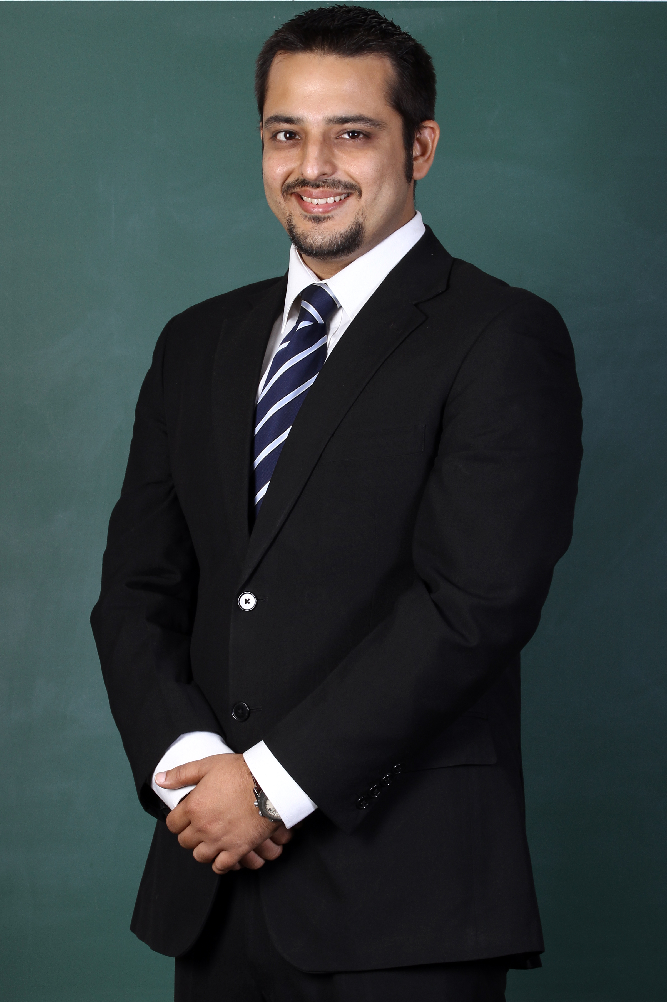
  Nationality: Australian(PR)
  Gender: Male
  Date of birth (1981-10-02):
  Email:arpit.khosla@gmail.com
  Mobile : +61-383623646
Dear Human Resources Manager,

This is in reference to the opening of Associate Partner posted by you. I find the opening very interesting and would like to request you to consider my candidature for the same. Please allow me this opportunity to briefly share my professional background.

For more than last 2 years in Ericsson, I have been engaged with Business and Technology Consulting for IOT and Machine to Machine communication based Products, Solutions & Services. I have E2E responsibility from business development to proposal building to finally delivering Business & Technology consulting assignments.

These Projects include not only market research and digital strategy insights ,but also deep dive in to existing technology /Solutions/Standards and envisioning the future requirements and proposing Technologies & Architectures vision & roadmaps for different clients. Additionally my erstwhile experience as a R&D engineer and field Engineer have helped me become a very open minded technology professional. Having had an opportunity to deal with clients across geographies & Verticals, I can say with confidence that most enterprises today are undergoing very similar transformative changes triggered by new technology waves touching the business. I am certain that I would be able to leverage my multi Vertical experience and multi technology experience to contribute to you and your organization in this digitalization transformation.

In past I also had the opportunity to be engaged in B2B Business development role for ICT Technology Start up in Africa. The job helped me hone my CXO relationships management and people management skills. Over all this has helped me appreciate both Business and technology sides of any scenario.

From academic perspective, I hold a Bachelors in Technology (specialization-Electronics & Communication) and post graduate diploma in Business Administration (=M.B.A) from esteemed Indian Institute of Management (L). I have also attended a course on Business Analytics by Kelley School (U.S.). I also hold ITIL and ETOM certifications.
I hold an Australian PR status and can work freely in Australia. My Detailed CV is also attached for your kind reference. Please feel free to contact me for any clarifications
I look forward to getting in touch with you for taking my candidature forward.

Warm Regards
Arpit

