NAME: BANDREDDY VENKATA SUDHARSAN REDDY

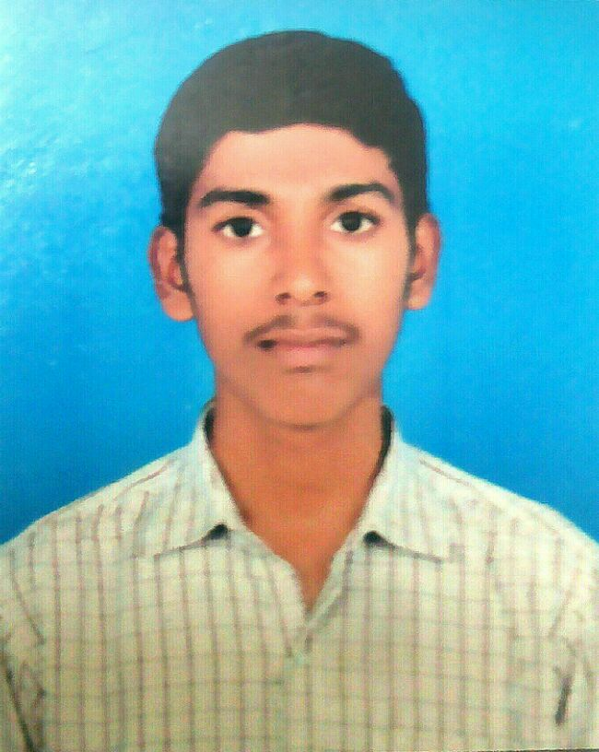

Photograph

Email: banreddys203@gmail.com

Mobile: +91-9701233896

**CAREER OBJECTIVE:**

To pursue a highly challenging career in Industrial Plant Automation, where I can apply my knowledge, acquire new skills, and contribute constructively towards the growth of the organization and in that process, accomplish significant competence, reputation and an enduring mutual success.

**SUMMARY:**

* +5 months of training in Industrial Automation at technocrat automation, Chennai.
* Pursuing a Bachelor of technology in Electrical and Electronics Engineering
* Obtained Boling water plant operation through training by technocrat automation center.
* Knowledge in branded plcs like KEYENCE,OMRON,AB,ABB,SIEMENS.

**EDUCATIONAL QUALIFICATIONS:**

|  |  |  |  |
| --- | --- | --- | --- |
| **QUALIFICATION** | **COLLEGE/UNIVERSITY** | **YEAR OF PASSING** | **PERCENTAGE** |
| B.Tech (E.E.E) | GCET College,  JNTU Ananthapur,  Kadapa | 2017 | 80.5 |
| H.S.C(M.P.C) | Gowtham Jr College,  Badvel. | 2013 | 90.4 |
| S.S.C | Sri Sai Vidyanikethan Highschool, Badvel,  Kadapa. | 2011 | 88 |

**Technical Qualification:**

* Obtained **C**ertified in **I**ndustrail **P**lant **A**utomation **E**ngineering**(IPLAE)** from Technocrat Automation Pvt Limited (IAO Accredited), Chennai. With **5** months **hands on practical experience** in Industrial Automation Tools specializing in PLC, DCS, SCADA and VFD.

**Technical Skills:**

* **PLC** (**P**rogrammable **L**ogic **C**ontrollers) & **DCS** (**D**istributed **C**ontrol **S**ystem) - Programming languages such as **LD**(**L**adder **D**iagram) & **FBD** (**F**unctional **B**lock **D**iagram).
* **Hands on Practical exposure** in brands as **AB** (Allen Bradley), **ABB** (Asea Brown Boveri), **Keyence, Omron.**
* **SCADA** (**S**upervisory **C**ontrol & **D**ata **A**cquisition) – Screen designing, PC & PLC interface, Data collection & storage .
* **HMI** (**H**uman **M**achine **I**nterface) - Screen designing, PLC interface, DCS interface
* **VFD** (**V**ariable **F**requency **D**rive) – Commissioning and Troubleshooting.
* **Pneumatics & Field Instruments** ( Control Valve, Sensors, Level Transmitters, Flow Transmitters, Temperature Transmitters, Pressure Switches).
* Knowledge in Panel wiring .
* **Troubleshooting** - PLC & DCS programming
* Control Panel (Power wiring & Control wiring) .

**ACADEMIC Project:**

PROJECT TITLE**: “an adaptive control strategy for low voltage ride through capability enhancement of grid-connected photovoltaic power plants”.**

DESCRIPTION**:** The main objective of our project was to avoid the low voltages occurring at the grid side connected to many photovoltaic power plants by CMPN algorithm by using MATLAB Software**.**

**ACHIEVEMENTS/CO-CURRICULAR / EXTRA CURRICULAR ACTIVITIES:**

* Appreciation Certificate from **NSS (national service scheme)**
* **IBNC** (INDIA’S BIGGEST NETWORKING CHAMPIONSHIP) Certificate by IIT-DELHI and I-MEDIA LEARNING SOLUTIONS
* **MATLAB** Certificate
* Participation Certificate From GCET College For Paper Presentation On
* **Wireless Power Transmission.**
* **Detection Of Illegal Usage Of Electricity**.

**INDUSTRIAL VISIT:**

* Two days visit to RAYALASEEMA THERMAL POWER PLANT(RTPP).
* One day visit to 220/33kv substation in Mydukur.

**Computer Skills / KNowledge:**

* Languages : C
* Operating Systems : WINDOWS 7/10
* MS-OFFICE
* MATLAB, SIMULINK

**Personal profile:**

Father’s Name : B. Venkata Sudharsan Reddy

Date of Birth : 15july,1995

Gender : Male

Language Known : Telugu, English

Hobbies : Reading Books, Listening Music, playing Chess

Address : 3/160, valleruvaripalle,

Gopavaram, Badvel Town,

Kadapa dist., Andhra Pradesh.

**DECLARATION:**

I hereby declare that the above particulars furnished by me are true to the best of my knowledge and belief.

Date:

Place: B.V.SUDHARSAN REDDY