Casey Gilray ~ CS 351 ~ Homework 3 ~ ER Diagrams

1.

a. A graph being disconnected means that there is some pair of vertexes such that no path exists between them. In terms of an ER diagram this means that some entity has no connection to another through relations. An example of this is a simple table with an entity of Customers and an entity of Cities with no relation between them. Keep in mind however that not all graphs are disconnected.

b. A graph has a cycle when a vertex can trace back to itself through a series of connecting vertexes. In an ER diagram this means that an Entity can trace to itself through relations with other entities. An example of this is a three-entity diagram, Pets, Toys, and Masters, with Relations Owns between each. In this way a pet can trace back to itself though the path:

Pets->(owns)->Toys->(owns)->Master->(owns)->pet

2. There are three types of cordiality constraints and they are listed here with their effect on the reduction algorithm:

a. 1-1: When a relation has a 1 to one mapping of its entities, the relation can be reduced into one of the entities.

b. 1-N: A relation with 1 to N mappings can be reduced into the N sided entity if there is full participation of that entity.

c. N-M: A relation with an N to M mapping has no simple reduction.

3. Participation constrains are used to force an entity to be a part of or have some working with another. These are useful when you want every member of an entity to take part in another field, but still need that field to have its own entity. Participation is useful in reduction because it allows the designers to reduce 1 to N cordialities when the N sided entity had full participation.

4.

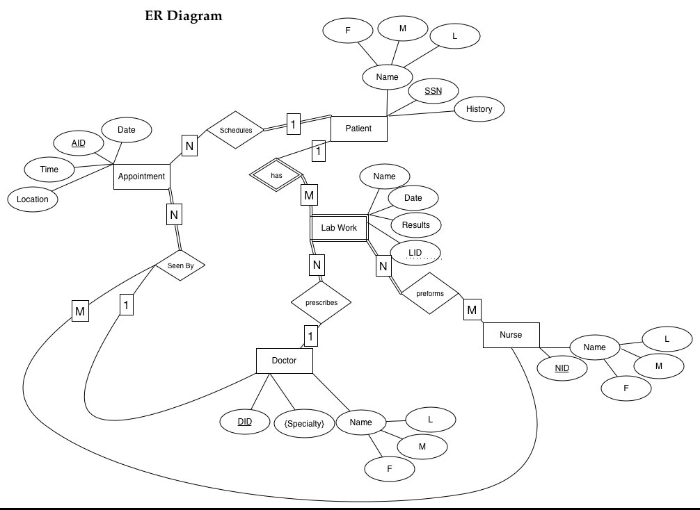

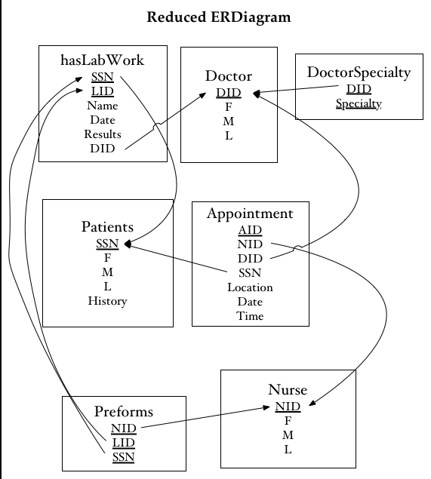5.