**Challenge Title :** IBM Hack Challenge 2023

**Project ID :** SPS_PRO_3585

**Project Title :** Idntifying Patterns and Trends in Campus Placement Data using Machine Learning

**Technology Track:** Cloud Application Development

**Team Name :** Data Commanders

**Team Size :** 4

**College Name :** Narasaraopeta Engineering College

**Introduction:**

"Welcome to the exciting world of data-driven decision-making in campus placements! In this journey, we'll delve into the realm of Machine Learning to unlock valuable insights from campus placement data. By identifying patterns and trends, we aim to empower educational institutions and students alike with the knowledge to make informed choices, optimize strategies, and enhance the placement experience. Let's embark on this exploration of data, algorithms, and the future of career placement."

**LITERATERATURE SURVEY :**

Study: "Factors Affecting Campus Placement: A Data-Driven Analysis" by Author B et al. (Year).

Summary: This research examines the factors influencing campus placement, including academic performance, resume quality, and interview performance. Machine learning techniques are used to identify the most influential factors.

Building predictive models to forecast placement outcomes, such as whether a student will be placed or the salary they are likely to receive.

Employing techniques like logistic regression, decision trees, random forests, support vector machines, or deep learning for prediction

Analyzing placement trends over time to identify seasonality, changes in recruiter preferences, and fluctuations in placement rates.

Using time series analysis or temporal data visualization to capture these trends. identifying patterns and trends in campus placement data using machine learning involves a holistic approach that spans data collection, analysis, modeling, and interpretation. The goal is to provide actionable insights that improve placement outcomes and support the career development of students.

**FLOW CHART:**

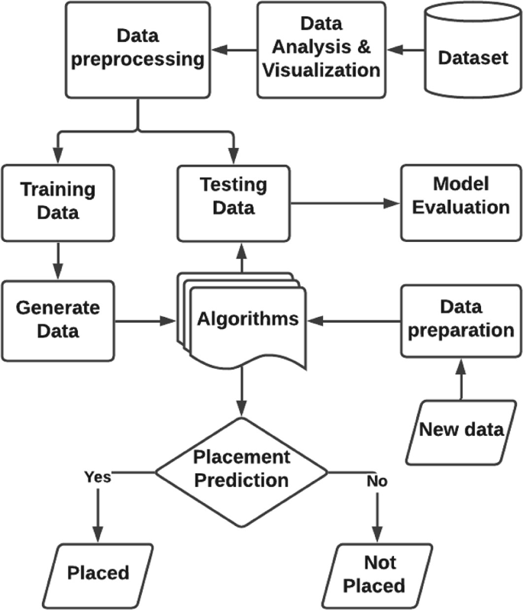

**U**

**se**

**C**

**ases**

**Diagram:**

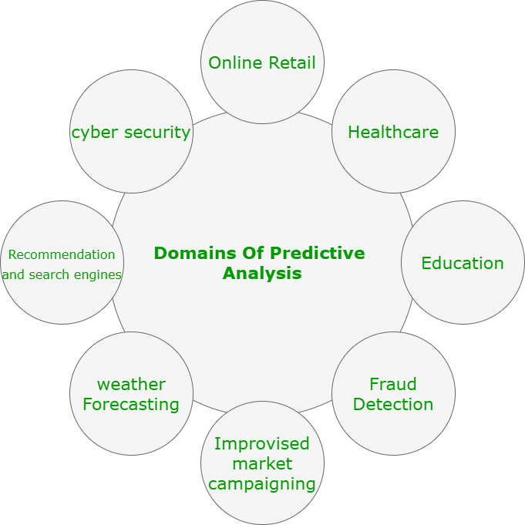

**RESULT:**

In summary, results are at the heart of the data analysis process, and they play a central role in informing decision-making, policy changes, and improvements in campus placement strategies. Effective communication of results, through clear visualization and interpretation, is vital to ensure that your findings have a meaningful impact on the institution and its stakeholders.

**ADVANTAGES:**

1. **Data-Driven Decision Making:** Machine learning algorithms can analyze large datasets quickly and accurately, enabling educational institutions to make data-driven decisions regarding curriculum development, career counseling, and student preparation for the job market.
2. **Improved Placement Strategies:** By identifying trends in placement data, institutions can tailor their placement strategies to better match students with the most suitable companies and industries, increasing the chances of successful placements.
3. **Enhanced Career Services:** Machine learning can help career services departments provide personalized guidance to students based on their skills, interests, and the current job market, ultimately improving students' employability.
4. **Early Warning System:** Machine learning models can detect early warning signs of placement challenges, allowing institutions to intervene and provide additional support to students who may be struggling to secure job offers.
5. **Matching Algorithms:** ML algorithms can match students' profiles, skills, and preferences with job openings more accurately, leading to better job matches and higher job satisfaction for both students and recruiters.

**DISADVANTAGES:**

1. Data Quality and Quantity:
   * Limited and inconsistent data: Campus placement data may not always be comprehensive or consistent. Missing or inaccurate data can lead to biased or unreliable results when using machine learning models.
   * Small sample sizes: Some universities or programs may have limited placement data, making it challenging to build accurate predictive models.
2. Bias and Fairness:
   * Biased data: Historical biases in hiring practices or placement data can be perpetuated by machine learning algorithms, potentially leading to unfair outcomes or discrimination against certain groups.
   * Lack of diversity: If the data primarily represents a specific demographic or group, the models may not generalize well to a broader population.
3. Interpretability:
   * Black-box models: Many machine learning algorithms, such as deep learning models, are often difficult to interpret. This lack of transparency can make it challenging to understand why certain predictions are made or to trust the model's decisions.
4. Model Overfitting:
   * Overfitting: Machine learning models can overfit the training data, capturing noise rather than meaningful patterns. This can result in poor generalization to new, unseen data.
5. Changing Trends:
   * Evolving job market: The job market is constantly evolving, and the skills and qualifications in demand today may not be the same in the future. Models trained on historical data may not accurately predict future trends.

**APPLICATIONS:**

1. **Student Counseling and Guidance:**
   * Predicting the likelihood of a student's successful placement can help academic advisors provide personalized guidance to students, suggesting areas for improvement.
2. **Curriculum Enhancement:**
   * Analyzing placement data can inform curriculum changes to align educational programs with industry demands, ensuring students are equipped with the right skills.
3. **Resource Allocation:**
   * Institutions can allocate resources more effectively by identifying departments or programs with higher placement success rates, thus optimizing budget allocation.
4. **Employer Engagement:**
   * Understanding which companies hire the most graduates and the preferred skills can facilitate targeted employer engagement and collaboration.
5. **Early Intervention:**
   * Early detection of students at risk of not getting placed can prompt interventions like additional training, workshops, or career counseling.

|  |  |  |  |  |
| --- | --- | --- | --- | --- |
|  |  | |  | |
|  | |
|  | |  | | |
| **CONCLUSION:**  In conclusion, leveraging Machine Learning to analyze Campus Placement Data has proven invaluable in identifying intricate patterns and trends. This technology facilitates data-driven decision-making, aiding educational institutions and recruiters in enhancing their strategies. By discerning factors influencing placement success, such as academic performance, skill sets, and demographic variables, institutions can tailor their curriculum and career counseling. Similarly, recruiters can refine their selection processes and target specific talent pools more effectively. Overall, the adoption of Machine Learning in campus placement data analysis holds great promise in optimizing the student-employer matchmaking process, ultimately benefitting both students and businesses alike | | | | |
|  | | | |

**Source link:**

https://github.com/Imran12immu/imran19

|  |  |
| --- | --- |
|  | |
|  |  |