A Project Report on Analysing agriculture in India and making strategic decision according to population:

Contents:

1.Introduction

1.1 Overview (A brief description about your project)

1.2 Purpose

2.Literature Survey

2.1 Existing problem

2.2 Proposed solution

3.Theoritical Analysis

3.1 Block diagram

3.2Hardware/Software designing

4. Experimental Investigations

5. Flowchart

6. Result

7. Advantages & Disadvantages

8. Applications

9. Conclusion

10. Future scope

11. Bibilograp

Introduction:
Overview:
Agriculture holds a pivotal role in India's economy, employing a significant portion of the population and contributing to both food security and economic growth. As the nation with the second-largest population globally, India's agricultural sector faces unique challenges and opportunities. This project aims to harness the power of data analytics to explore the intricate relationship between India's population dynamics and its agriculture, ultimately guiding strategic decisions for sustainable growth.

Purpose:

The purpose of this project is to utilize data-driven insights to address critical questions within India's agricultural landscape. By understanding how population trends and distribution influence agricultural practices, crop selection, resource allocation, and rural development, this project seeks to make informed strategic decisions that align with the needs and capacities of India's diverse population.

Literature Survey:
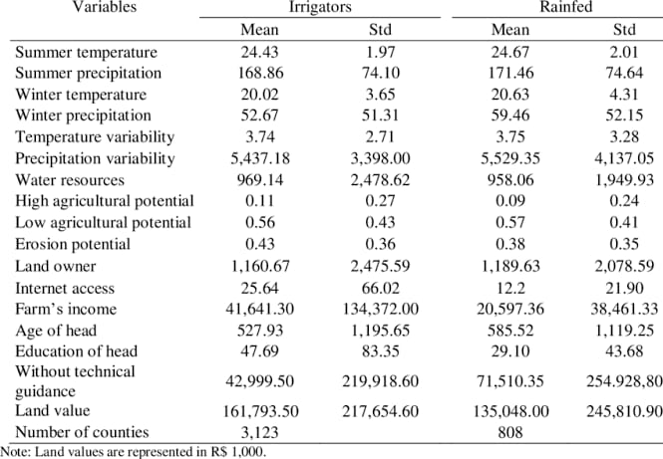
Proposed Solution:

To analyze agriculture and make strategic decisions based on population, you could gather data on population demographics, preferences, and consumption patterns. Then, use this information to identify crops and products that align with local demand. Additionally, consider factors like climate, soil quality, and available resources to determine the most suitable crops for cultivation. Collaborating with local farmers and experts would also help in tailoring your agricultural strategies effectively.

Theoritical Analysis:

3.1 Block diagram:
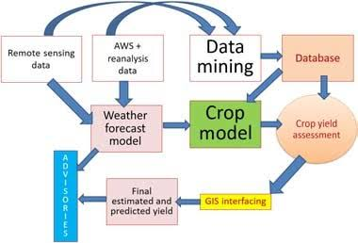

3.2 Hardware / Software designing:
Detail Architecture
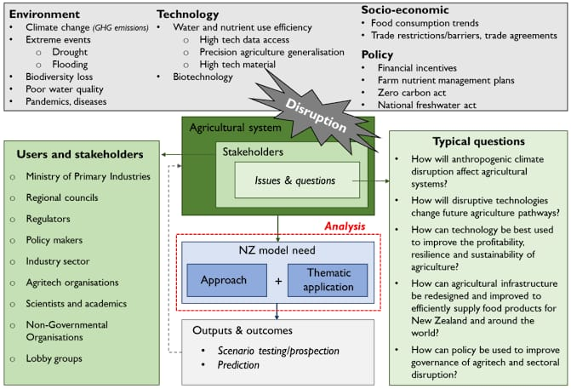

Frontend gives the input features from the user to the server. Frontend is designed using Simple HTML and CSS. HTML defines the meaning and structure of web content. HTML makes the structure of the website. HTML is often accompanied by CSS. CSS is used for styling the web pages. CSS describes how elements should be rendered on screen, on paper, in speech, or on other media. HTML and CSS together form the visual representation of the web page that is visible to the user. The input request will be given to the trained ML model which is deployed on Python’s Flask framework. Flask is a lightweight web application framework. It is designed to make getting started quick and easy, with the ability to scale up to complex applications. Making RESTful APIs by Flask is easy.

CSS – Cascading Style Sheets.
HTML- Hyper Text Markup Language.
ML- Machine Learning.
REST- Representational State Transfer.
API- Application Programming Interface.
SVM- Support Vector Machine.

Experimental Investigations:

- Dataset Description:

An experimental investigation analyzing agriculture and making strategic decisions based on population could involve studying the relationship between population density and agricultural practices. By collecting data on factors like land availability, crop types, yields, and technological advancements, you could identify patterns that could guide strategic decisions for optimizing agricultural output in areas with varying population densities. This could lead to more informed choices about crop selection, land use, and resource allocation.
Algorithms:
To analyze agriculture and make strategic decisions based on population, you can use algorithms that integrate data from various sources. These algorithms can consider factors like population demographics, food consumption patterns, land availability, climate data, and market trends. By applying data analysis techniques, you can identify optimal crops, distribution strategies, and resource allocation to ensure sustainable agricultural practices and meet the demands of the population. Machine learning algorithms can also help predict future trends and guide decision-making. Keep in mind that the effectiveness of such algorithms depends on the quality and accuracy of the data used as input.
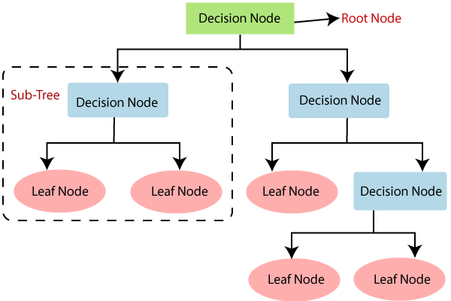

Flow Chart:

1. *Define Objectives*
- Identify the main goals of your analysis, such as increasing food production, optimizing resource utilization, or addressing food security.

2. *Gather Data*
- Collect data related to agriculture, including crop yields, land usage, weather patterns, and population demographics.

3. *Analyze Agricultural Data*
- Examine crop yields and production trends over time.
- Study the impact of weather conditions on crop output.
- Assess the efficiency of current farming practices.

4. *Analyze Population Data*
- Understand the distribution and growth of the population in the region.
- Identify urban and rural population concentrations.
- Explore demographic factors like age, income, and dietary preferences.

5. *Identify Patterns and Relationships*
- Look for correlations between population growth and changes in agricultural productivity.
- Analyze how population demographics affect demand for specific crops.

6. *Evaluate Resource Availability*
- Assess the availability of arable land, water resources, and labor in relation to population growth.

7. *Explore Technological Solutions*
- Investigate agricultural technologies such as precision farming, genetically modified crops, and automated machinery.

8. *Develop Strategic Options*
- Based on your analysis, generate potential strategies for improving agricultural output.
- Consider options like crop diversification, sustainable farming practices, or introducing new technologies.

9. *Consider Social and Economic Factors*
- Account for cultural and economic factors that may influence the adoption of new strategies.

10. *Simulation and Modeling*
- Use simulation tools to project the impact of different strategies on future agricultural outcomes.

11. *Decision Making*
- Evaluate the potential benefits and risks of each strategy.
- Select the strategy that aligns with your objectives and has the most favorable outcomes.

12. *Implementation*
- Put the chosen strategy into action, considering logistical challenges and required investments.

13. *Monitor and Adjust*
- Continuously monitor the results of your implemented strategy.
- Adjust your approach based on new data, unexpected challenges, or changing population dynamics.

14. *Feedback Loop*
- Establish a feedback loop to incorporate lessons learned into future decision-making processes.

Remember that this flowchart provides a high-level overview, and the actual process may involve more detailed steps and iterative cycles.
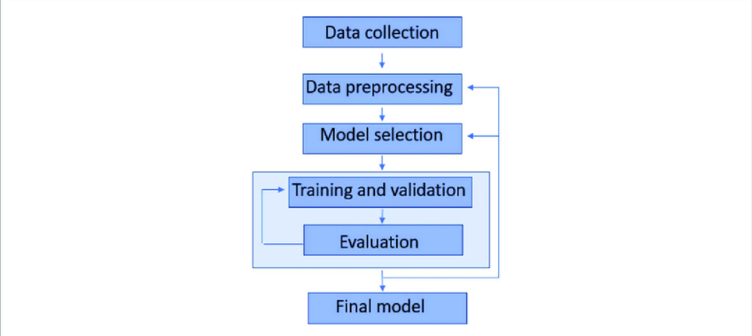

Result:
Explanation with example:

Analyzing agriculture and making strategic decisions based on population involves considering factors like food demand, resource availability, and distribution channels. By understanding population trends, you can tailor agricultural strategies to ensure sufficient food production, optimize resource allocation, and create effective distribution networks. This helps meet the needs of the growing population while promoting sustainability and food security.

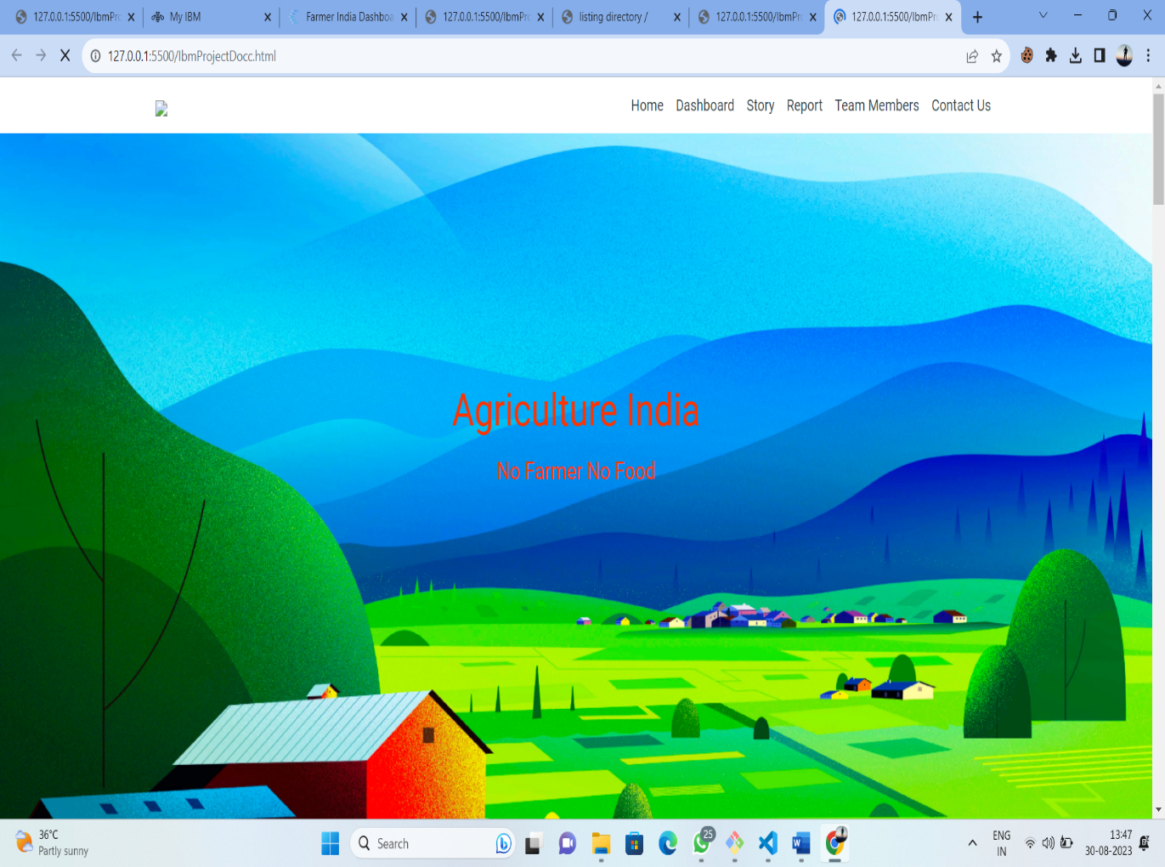

Output page:
Dasboard:
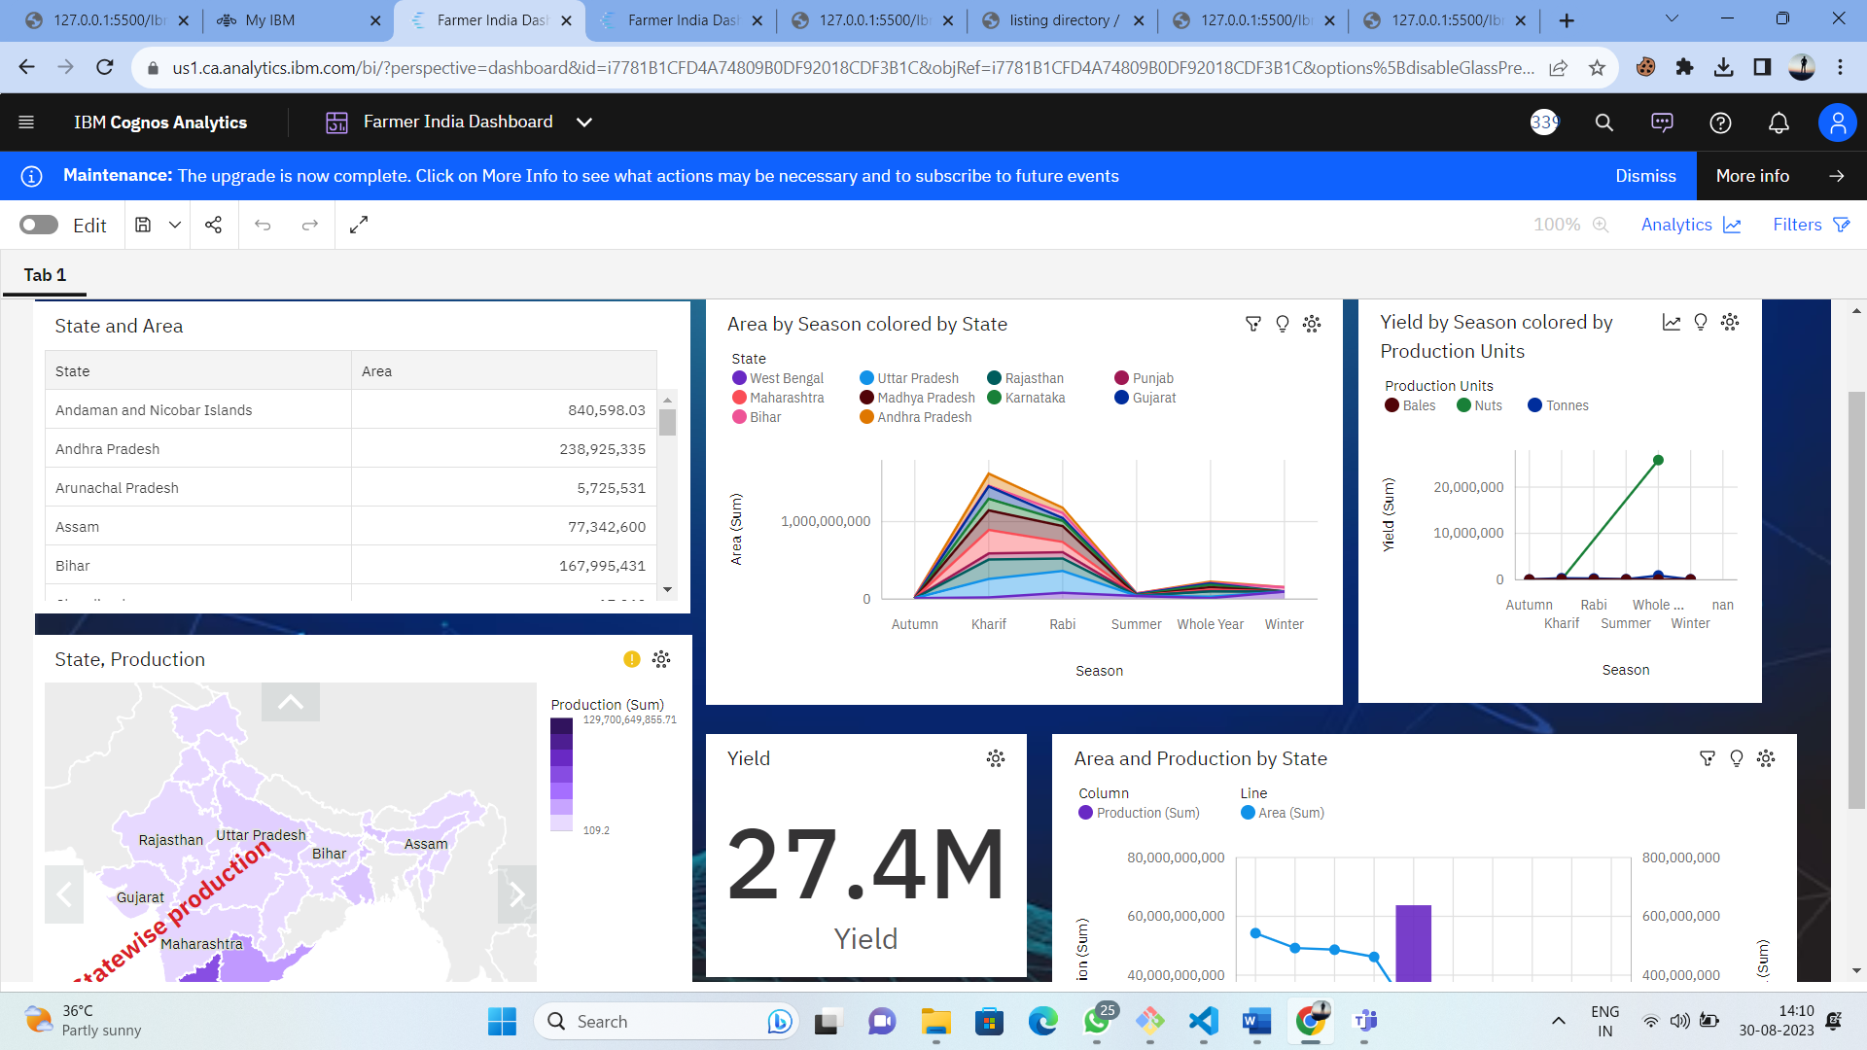

Story:
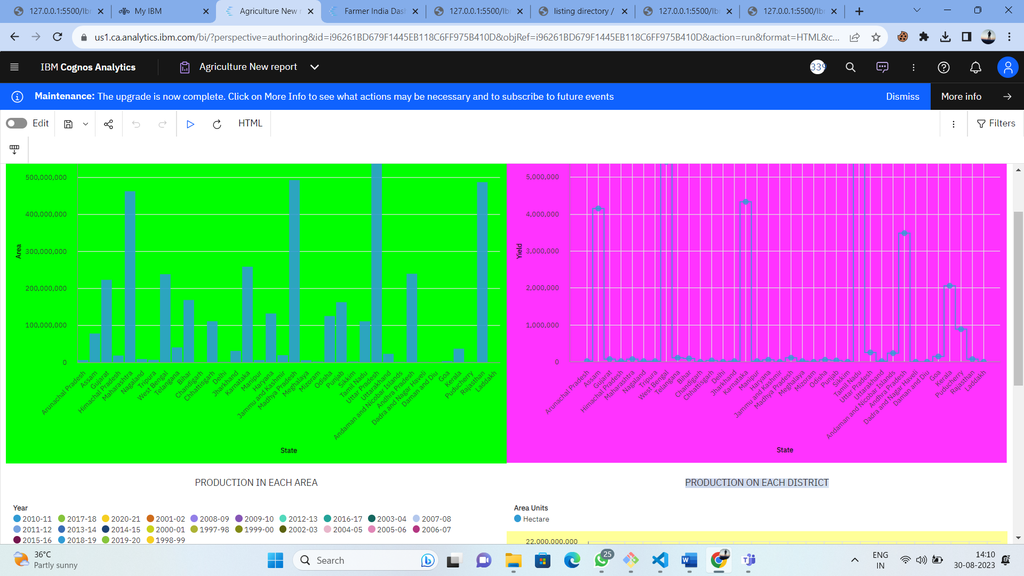

Advantages & Disadvantages:
Advantages:
1. *Optimized Production:* Analysis helps determine the right crops to grow and the best practices for cultivation, leading to higher yields and quality.

2. *Resource Allocation:* Efficiently allocate resources like water, fertilizers, and pesticides based on data-driven insights, reducing waste and cost.

3. *Market Demand:* Analyzing consumer preferences and population trends helps align production with what people need and want, reducing the risk of surplus or shortages.

4. *Risk Management:* Data-driven analysis enables the identification of potential risks such as pest outbreaks or adverse weather, allowing for timely interventions.

5. *Innovation:* By studying agricultural data, new technologies and techniques can be identified and adopted to improve efficiency and sustainability.

6. *Sustainability:* Analysis aids in implementing environmentally friendly practices by optimizing land use, reducing chemical inputs, and promoting conservation.

7. *Policy Making:* Governments can make informed decisions about subsidies, trade policies, and regulations based on comprehensive agricultural data.

Disadvantages:
*Neglecting Local Variations:* Relying solely on population data might overlook important regional differences in climate, soil conditions, and local agricultural practices. This could lead to inappropriate decisions that don't account for these variations.

2. *Limited Perspective:* Population data alone doesn't provide a complete picture of the factors influencing agricultural needs and production. Factors such as dietary preferences, economic conditions, and technological advancements also play crucial roles.

3. *Inaccurate Demand Estimation:* Population data might not accurately reflect actual consumer demand for specific crops. It's possible for the consumption patterns to differ from what the population data suggests.

4. *Ignoring Export and Import:* Depending solely on population might lead to an oversupply of certain crops for the local market, while overlooking opportunities for export or import of specific products.

5. *Economic Considerations:* Strategic agricultural decisions should also take into account the economic viability of producing certain crops. Relying solely on population could lead to unprofitable ventures.

6. *Changing Preferences:* Consumer preferences are not solely determined by population size. Preferences for certain foods can change over time due to cultural shifts, health trends, and marketing influences.

7. *Environmental Sustainability:* Agriculture decisions driven by population might not consider the ecological impact of increasing production, potentially leading to overexploitation of resources and environmental degradation.
Applications:
*Crop Yield Prediction:* By analyzing historical data, weather patterns, and soil conditions, predictive models can estimate crop yields, helping farmers plan their harvests and manage resources more effectively.

2. *Precision Farming:* Data-driven insights enable precise application of resources like water, fertilizers, and pesticides, minimizing waste and maximizing crop health.

3. *Disease and Pest Management:* Analyzing data can help detect and predict disease outbreaks and pest infestations, enabling timely interventions to minimize crop losses.

4. *Market Analysis:* Studying consumer preferences, demand trends, and supply chain dynamics helps farmers align production with market needs, reducing surplus and shortages.

5. *Climate Resilience:* Agricultural data can inform strategies for adapting to changing climate conditions, helping farmers choose resilient crop varieties and adjust planting schedules.

6. *Sustainable Practices:* Analysis supports the adoption of sustainable farming methods, such as crop rotation, cover cropping, and reduced chemical use, to protect soil health and ecosystem balance.

7. *Resource Management:* Efficient allocation of water, energy, and land resources is facilitated by analyzing data on resource availability, demand, and usage patterns.

Conclusion:

The analysis of agriculture plays a pivotal role in shaping the future of food production, sustainability, and resource management. Through data-driven insights and technological advancements, it empowers farmers, policymakers, and stakeholders to make informed decisions that optimize crop yields, conserve resources, and enhance overall agricultural efficiency.
Future Scope:

The future scope of analyzing agriculture is promising, driven by advancements in technology, data collection, and a growing awareness of the need for sustainable practices. Here are some key aspects that highlight the future potentia

Appli

