Description:
An AI-based Life Assistance Chatbot designed for public welfare is an innovative solution that leverages artificial intelligence to provide valuable support and assistance to the general public. This chatbot serves as a versatile and accessible platform to address a wide range of user needs and concerns, ultimately contributing to the overall well-being and quality of life for individuals.
Purpose:
Integrating this AI-based Life Assistance Chatbot into various online platforms, social media channels, and government websites, individuals can access essential support and resources 24/7, fostering a sense of empowerment, security, and connection within the community. This technology has the potential to enhance public welfare efforts by efficiently disseminating information, offering assistance, and promoting positive behaviors for individuals from all walks of life.
Existing Problem:
- Information and Education: The chatbot can provide accurate and up-to-date information on various topics such as health, safety, education, government programs, and more. It can help users make informed decisions and stay updated on relevant matters.
- Emergency Response: The chatbot is equipped to handle emergency situations by offering immediate guidance and instructions. It can provide first aid advice, contact emergency services, and share critical information during crises.
- Counseling and Mental Health Support: With a focus on mental well-being, the chatbot can offer support, resources, and coping strategies for users dealing with stress, anxiety, depression, and other emotional challenges. It can also help users connect with mental health professionals if needed.
- Social Services Navigation: The chatbot can assist users in navigating public services and welfare programs, helping them access benefits they might be eligible for. This can include information about housing assistance, unemployment benefits, food programs, and more.
- Health and Fitness Guidance: Providing users with personalized health and fitness recommendations, the chatbot can offer tips for maintaining a healthy lifestyle, suggest exercise routines, and answer health-related queries.
- Language and Accessibility Support: The chatbot can communicate in multiple languages, ensuring accessibility for diverse populations. It can also assist users with disabilities by providing information about inclusive services and resources.
- Community Engagement: Acting as a virtual community hub, the chatbot can facilitate discussions, share local event information, and connect users with community groups and initiatives.
- Environmental Awareness: The chatbot can educate users about environmental conservation, sustainable practices, and ways to reduce their ecological footprint.
- Safety and Security Tips: Offering guidelines for personal safety, cybersecurity, and disaster preparedness, the chatbot helps users protect themselves and their information.
- Feedback and Improvement: The chatbot can gather user feedback and insights to continuously improve its functionality and responsiveness, ensuring that it remains a valuable tool for the public.
Proposed Solution:
Platform Integration and Accessibility:
- Develop a user-friendly and accessible chatbot interface that can be integrated into government websites, social media platforms, mobile apps, and messaging services.
- Ensure cross-device compatibility to reach users on smartphones, tablets, and desktops.
2. Multi-lingual and Cultural Sensitivity:
- Implement natural language processing (NLP) capabilities that allow the chatbot to communicate in multiple languages, catering to diverse user groups.
- Incorporate cultural sensitivity by considering regional variations and cultural norms in responses.
3. Dynamic Information Delivery:
- Provide accurate and up-to-date information on topics such as health, safety, education, social services, emergency response procedures, mental health, and more.
- Collaborate with government agencies and relevant organizations to ensure the chatbot's information is reliable and current.
4. Emergency and Crisis Management:
- Enable the chatbot to offer real-time emergency alerts, safety instructions, and evacuation routes during crises or disasters.
- Integrate geolocation services to provide location-specific emergency information.
5. Mental Health and Emotional Support:
- Develop a conversational framework that allows users to discuss their emotions and challenges confidentially.
- Provide supportive responses, coping strategies, and, if necessary, connect users with mental health professionals or helplines.
6. Social Services Navigation:
- Guide users through the process of accessing social welfare programs and benefits.
- Assist users in determining eligibility, completing applications, and understanding required documentation.
7. Educational and Learning Resources:
- Offer educational support by providing study materials, learning resources, and homework help.
- Assist students in finding relevant courses, tutorials, and online educational platforms.
8. Community Engagement and Events:
- Share information about local events, community initiatives, workshops, and seminars.
- Facilitate discussions and networking among users with similar interests or concerns.
9. Environmental Awareness and Sustainability:
- Provide tips and information about eco-friendly practices, energy conservation, waste reduction, and climate change.
- Encourage users to adopt sustainable behaviors through personalized recommendations.
10. Feedback and Continuous Improvement:
- Incorporate user feedback mechanisms to gather insights and improve the chatbot's functionality and responses.
- Regularly update the chatbot's knowledge base to reflect new information and changing circumstances.
11. Privacy and Security:
- Implement robust data privacy measures to protect user information and ensure compliance with relevant data protection regulations.
- Clearly communicate the chatbot's privacy policy and data handling practices to users.
12. Collaboration and Partnerships:
- Collaborate with government agencies, NGOs, healthcare providers, educational institutions, mental health professionals, and other relevant stakeholders to ensure the chatbot's effectiveness and accuracy.
13. Promotion and User Engagement:
- Launch awareness campaigns to promote the chatbot's availability and benefits to the public.
- Encourage users to engage with the chatbot by highlighting its value and versatility.

Block Diagram:
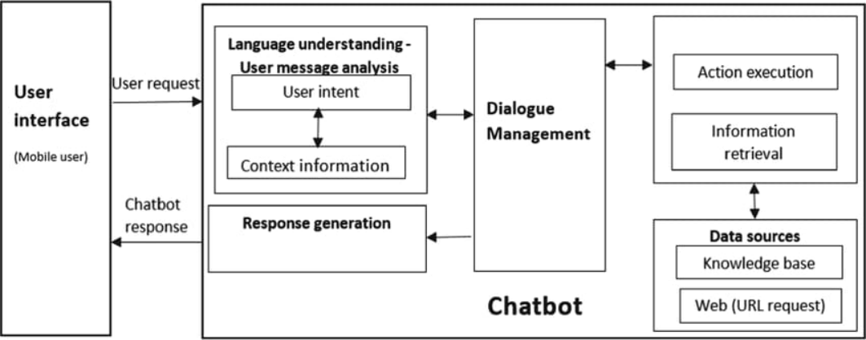
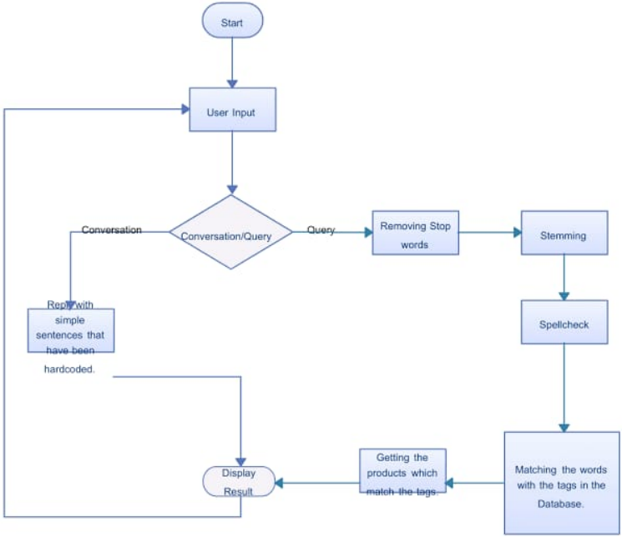
Output Screenshots:
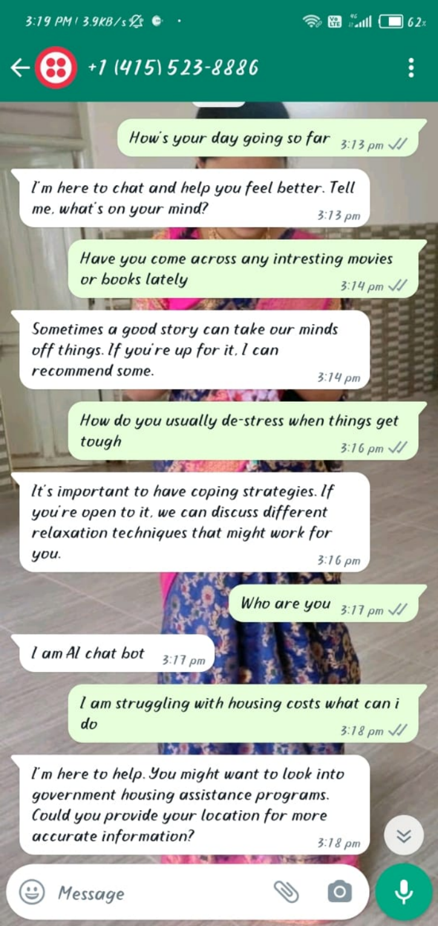
Advantages:
24/7 Accessibility: Chatbots offer round-the-clock availability, ensuring that users can access information and support at any time, which is especially beneficial during emergencies.
- Scalability: Chatbots can handle a large volume of interactions simultaneously, making them scalable to cater to a broad user base without significant resource constraints.
- Consistent and Accurate Information: Chatbots provide consistent and accurate information, reducing the risk of misinformation and ensuring users receive reliable guidance.
- Immediate Responses: Users receive instant responses to their queries, eliminating the need to wait for human assistance and increasing user satisfaction.
- Cost-Effectiveness: Once developed and implemented, chatbots can significantly reduce operational costs by handling routine inquiries, freeing up human resources for more complex tasks.
- Privacy and Confidentiality: Chatbots can provide a private and confidential space for users to discuss sensitive topics, fostering openness and reducing stigma.
- Language Diversity: Multilingual capabilities enable chatbots to communicate with users in their preferred language, making information accessible to a broader audience.
- Promotion of Positive Behaviors: Chatbots can educate users about healthy habits, sustainable practices, and safety protocols, promoting positive behavior changes.
- Efficient Resource Allocation: Chatbots can guide users through processes such as applying for social services, reducing the workload on government agencies and staff.
- Real-time Updates: Chatbots can instantly disseminate critical updates, instructions, and alerts during emergencies, enhancing public safety and awareness.
Disadvantages:
- Limited Contextual Understanding: While chatbots can handle predefined scenarios, they might struggle to grasp complex or nuanced situations that require human empathy and understanding.
- Lack of Emotional Intelligence: Chatbots can't fully replace human interactions in emotional and sensitive discussions, particularly in cases like mental health support.
- Dependency on Technology: Users who rely solely on chatbots might miss out on human interactions and personalized support that can be essential for certain situations.
- Data Privacy Concerns: Collecting user data for improving the chatbot's functionality can raise privacy concerns, requiring robust data protection measures.
- Misinterpretation of User Intent: Chatbots might misinterpret user queries or context, leading to incorrect responses and potential frustration.
- Limited Problem-Solving: In complex scenarios, chatbots might not have the capacity to solve intricate problems that require creative thinking and human judgment.
- Initial Development Costs: Designing, developing, and integrating a sophisticated chatbot can incur initial expenses, including software development and training costs.
- Maintenance and Updates: Regular maintenance and updates are necessary to keep the chatbot's knowledge current and to ensure it remains effective over time.
- User Resistance: Some users might be resistant to interacting with chatbots, particularly older individuals or those less familiar with technology.
- Ethical Considerations: Chatbots should be programmed with clear ethical guidelines to ensure they provide accurate, unbiased, and appropriate information, avoiding potential biases or discrimination.
- Healthcare and Medical Assistance:
  - Providing information on symptoms, diseases, medications, and preventive measures.
  - Assisting users in finding nearby medical facilities, clinics, and pharmacies.
  - Offering personalized health tips and fitness recommendations.
  - Reminding users to take medications and attend medical appointments.
- Emergency Response and Disaster Management:
  - Delivering real-time emergency alerts, safety instructions, and evacuation routes.
  - Offering assistance during natural disasters, accidents, and other critical events.
  - Providing information about emergency contact numbers and first aid procedures.
- Mental Health and Emotional Support:
  - Engaging in empathetic conversations to support users dealing with stress, anxiety, and depression.
  - Sharing coping strategies, relaxation techniques, and mindfulness exercises.
  - Connecting users with mental health professionals and helplines when needed.
- Social Services Access and Government Programs:
  - Guiding users through the process of accessing social welfare programs, unemployment benefits, housing assistance, and more.
  - Assisting with eligibility checks, application submissions, and required documentation.
- Education and Learning Support:
  - Offering homework help, study tips, and explanations of academic concepts.
  - Recommending relevant educational resources, online courses, and tutorials.
  - Assisting students in finding scholarship opportunities and educational grants.
- Language Translation and Accessibility:
  - Facilitating communication for non-native speakers by offering translation services.
  - Enhancing accessibility for individuals with disabilities by providing information about inclusive services and facilities.
- Community Engagement and Events:
  - Sharing information about local events, workshops, seminars, and community initiatives.
  - Facilitating discussions and connecting users with shared interests within the community.
- Environmental Awareness and Sustainability:
  - Educating users about eco-friendly practices, climate change, and renewable energy.
  - Offering tips for reducing carbon footprint, conserving resources, and practicing sustainable living.
- Financial and Legal Guidance:
  - Providing basic financial literacy information, budgeting tips, and guidance on managing personal finances.
  - Offering explanations of legal procedures, rights, and responsibilities in various contexts.
- Public Safety and Security:
  - Educating users about personal safety, cybersecurity best practices, and crime prevention tips.
  - Providing guidance on reporting suspicious activities and seeking assistance from law enforcement.
- Public Awareness Campaigns:
  - Promoting health campaigns (e.g., vaccination drives, disease prevention) and disseminating accurate information.
  - Raising awareness about social issues, rights, and important community initiatives.
- Feedback Collection and Continuous Improvement:
a.Gathering user feedback to enhance the chatbot's responses, capabilities, and overall user experience.
Conclusion:
In conclusion, while AI-based Life Assistance Chatbot integration for public welfare offers numerous advantages in terms of accessibility, efficiency, and cost-effectiveness, there are challenges related to understanding context, privacy, and the potential impact on human interactions. The key lies in finding the right balance between automation and human touch to ensure a comprehensive and effective solution.

