**Problem Title:**

HEALTH CONNECT: Streamlined Doctors Appointment and Health Record Management

Team Name: Health sync Squad

# NARASARAOPETA ENGINEERING COLLEGE

D. Chandu (21471A05E7)

K.Sai Surya (21471A05G7)

V.Sri Harsha (21471A05K7)

Y.Narendra (21471A05K9)

**HEALTH CONNECT**

1. **INTRODUCTION:**

**Overview:**

"Health Connect" is a potential project or initiative with a focus on improving connectivity and communication within the healthcare sector. It could involve the implementation of digital tools, platforms, or systems to facilitate better information sharing among healthcare professionals, patients, and various healthcare facilities. The project's scope and details may vary depending on the organization, country, or context in which it is implemented, so it's advisable to consult reliable sources or the organization involved for precise information.

**Purpose:**

The purpose of a "Health Connect" project could encompass various goals related to enhancing healthcare delivery, information sharing, and patient outcomes. Here are some potential purposes that a "Health Connect" project might pursue:

**1.Improving Care Coordination**: "Health Connect" could aim to enhance the coordination of patient care by connecting different healthcare providers, facilities, and systems. This would ensure that all relevant parties have access to up-to-date patient information, leading to more effective and efficient care delivery.

**2.Enhancing Patient Access to Information**: The project might focus on empowering patients to easily access their health records, test results, treatment plans, and other relevant information. This can enable patients to take a more active role in managing their health and making informed decisions.

**3.Facilitating Data Sharing**: "Health Connect" could facilitate the secure sharing of patient health data among healthcare organizations. This sharing can lead to better-informed diagnoses, reduced duplication of tests, and improved overall patient care.

**4.Supporting Telemedicine and Remote Monitoring:** The project might promote telemedicine services and remote monitoring capabilities, allowing patients to receive medical consultations and monitoring from the comfort of their homes.

**5.Streamlining Administrative Processes**: "Health Connect" could aim to simplify administrative tasks such as appointment scheduling, billing, and insurance claims processing. This would reduce administrative burdens for both healthcare providers and patients.

**6.Contributing to Public Health Initiatives**: "Health Connect" might contribute to public health efforts by facilitating the tracking and monitoring of population health trends, disease outbreaks, and vaccination campaigns

**7.Fostering Research and Data Analytics:** The project could enable researchers to access anonymized health data for studies and analysis, leading to advancements in medical research and healthcare insights.

**8. Enhancing Emergency Response:** "Health Connect" might play a role in emergency response situations by providing healthcare providers with immediate access to critical patient information, ensuring rapid and appropriate treatment.

**9.Improving Medication Management:** The project could help healthcare providers and patients manage medications more effectively by enabling electronic prescribing, medication reconciliation, and alerts for potential drug interactions.

**10. Promoting Patient Engagement:** "Health Connect" might encourage patient engagement through features such as appointment reminders, personalized health recommendations, and interactive tools for tracking health goals.

**11.Supporting Health Education:** The project could deliver health education materials, preventive care information, and wellness resources to patients, promoting healthier lifestyles.

**12. Enhancing Data Security and Privacy:** An important purpose of "Health Connect" would likely be to ensure the security and privacy of patient health information in compliance with relevant regulations.

**2 Literature Survey**

**Existing Challenges:**

The healthcare sector confronts a multitude of intricate challenges, with specific issues varying based on regional, national, and healthcare system contexts. Here are prevalent existing problems within the healthcare sector:

**1.Healthcare Access Disparities:** Disparities in accessing high-quality healthcare services persist due to factors such as income disparities, geographic location, ethnicity, and inadequate insurance coverage, leading to unequal health outcomes.

**2.Escalating Healthcare Costs**: The continuous increase in healthcare costs poses a financial burden on individuals and families, making it challenging to afford necessary medical treatments and services.

**3.Aging Population**: Many nations are grappling with an aging population, which places additional pressure on healthcare systems as elderly individuals often necessitate more complex and long-term care.

**4.Management of Chronic Diseases:** The prevalence of chronic diseases like diabetes, heart disease, and obesity is on the rise, necessitating effective strategies for prevention, early detection, and comprehensive management.

**5.Health Information Fragmentation:** Health records and data are frequently dispersed across various healthcare providers and systems, hindering efficient care coordination and posing potential risks of errors.

**6.Shortages in Healthcare Workforce:** Scarcities in healthcare professionals, encompassing doctors, nurses, and allied health personnel, can impact the quality and accessibility of healthcare services.

**7.Limited Accessibility to Mental Health Services:** Insufficient mental health services result in inadequate support for individuals grappling with mental health conditions.

**8.Healthcare Infrastructure**: Inadequate healthcare infrastructure, particularly in rural and underserved regions, results in limited access to essential medical facilities.

**9.Medical Errors and Patient Safety**: Medical errors, ranging from misdiagnoses to medication mistakes and hospital-acquired infections, contribute to adverse patient outcomes and heightened healthcare expenditures.

**10.Challenges in Technological Integration**: Integrating novel technologies and digital solutions into healthcare systems can be daunting, often leading to interoperability challenges.

**11.Public Health Emergencies**: The emergence of global health threats, such as pandemics, underscores the importance of effective public health responses, preparedness, and coordinated efforts.

**12.Health Information Privacy and Security**: Safeguarding patient privacy and fortifying the security of health data against breaches and cyberattacks remains a persistent concern.

**13.Lifestyle-Related Health Issues**: Unhealthy lifestyles, encompassing poor dietary choices, sedentary behavior, and substance abuse, contribute significantly to preventable health issues.

**14.Health Disinformation**: The proliferation of misinformation and a lack of health literacy can facilitate the dissemination of erroneous medical information, hampering informed decision-making.

**15.Healthcare Policy and Regulation**: Complex healthcare policies and regulations can present challenges for both healthcare providers and patients in navigating the healthcare system**.**

**Proposed solution:**

Addressing the existing problems in the healthcare sector requires a combination of policy changes, technological advancements, and collaborative efforts. Here are some proposed solutions to address the challenges mentioned earlier:

**1. Healthcare Access Disparities:**

- Implement and expand affordable healthcare coverage options.

- Establish telemedicine services to reach underserved areas.

- Develop mobile clinics and outreach programs in remote regions.

**2. Rising Healthcare Costs:**

- Promote cost transparency to help patients make informed choices.

- Invest in preventive care and early intervention to reduce long-term costs.

- Encourage value-based care models that focus on outcomes rather than volume.

**3. Aging Population:**

- Develop geriatric care programs and specialized services for the elderly.

- Foster aging-in-place initiatives to support seniors living at home.

- Enhance caregiver training and support.

**4. Chronic Disease Management:**

- Promote public health campaigns to raise awareness about healthy lifestyles.

- Implement remote monitoring technologies for chronic disease patients.

- Emphasize preventive screenings and early detection.

**5. Health Information Fragmentation:**

- Adopt interoperability standards for electronic health records (EHRs).

- Encourage the use of health information exchanges (HIEs) for seamless data sharing.

- Develop patient portals that allow individuals to access their health records.

**6. Healthcare Workforce Shortages:**

- Invest in healthcare workforce education and training programs.

- Explore telehealth and telemedicine to extend the reach of healthcare professionals.

- Incentivize healthcare professionals to work in underserved areas.

**7. Limited Access to Mental Health Services:**

- Integrate mental health services into primary care settings.

- Expand mental health coverage in insurance plans.

- Develop online mental health platforms and resources.

**8. Healthcare Infrastructure:**

- Invest in building and upgrading healthcare facilities in underserved areas.

- Develop mobile clinics and telemedicine solutions for remote regions.

- Establish public-private partnerships to improve infrastructure.

**9. Medical Errors and Patient Safety:**

- Implement electronic prescribing systems to reduce medication errors.

- Enhance patient identification and verification processes.

- Implement evidence-based clinical guidelines and best practices.

**10. Technological Integration Challenges:**

- Develop standardized APIs and interoperability frameworks for health tech solutions.

- Encourage collaboration between tech companies and healthcare providers.

- Establish training programs to improve tech adoption among healthcare professionals

**11. Public Health Emergencies:**

- Enhance global health surveillance and early warning systems.

- Invest in pandemic preparedness and response plans.

- Strengthen international cooperation in health emergencies.

**12. Health Information Privacy and Security:**

- Enforce strict data protection regulations and cybersecurity measures.

- Develop secure and encrypted communication platforms for healthcare.

- Educate healthcare professionals and patients about data security.

**13. Lifestyle-Related Health Issues:**

- Promote health education programs in schools and communities.

- Implement policies that discourage unhealthy practices (e.g., tobacco, sugary drinks).

- Create incentives for physical activity and healthy eating.

**14. Health Disinformation:**

- Promote health literacy through public awareness campaigns.

- Collaborate with social media platforms to combat misinformation.

- Encourage healthcare professionals to provide accurate information.

**15. Healthcare Policy and Regulation:**

- Streamline and simplify healthcare regulations for better compliance.

- Involve stakeholders in policy development to ensure practical solutions.

- Implement transparency in healthcare pricing and billing practices.

**3** **THEORITICAL ANALYSIS**

**Block diagram:**

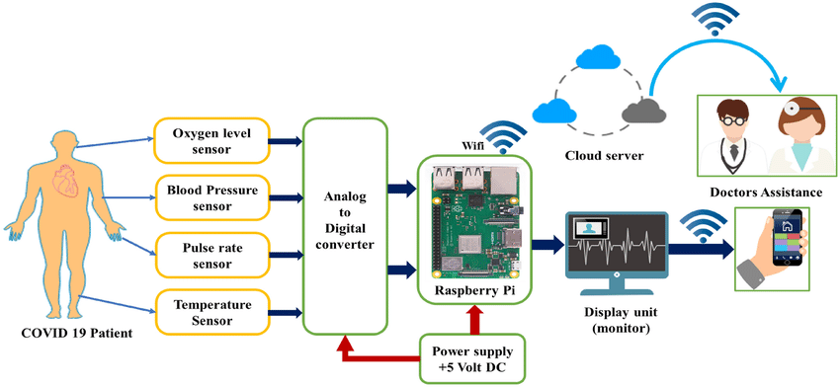

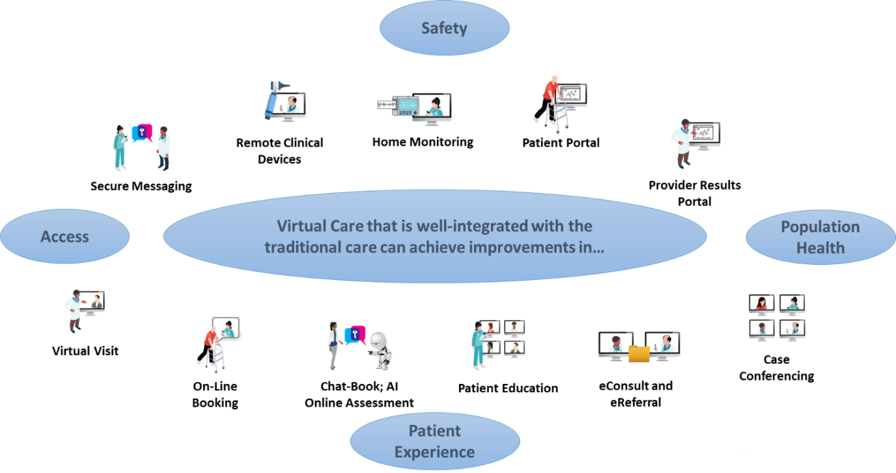

**Hardware / software designing:**

The hardware and software requirements for a "Health Connect" project would depend on the specific goals, scope, and technologies chosen for the project. However, I can provide a general overview of the types of hardware and software components that might be involved in such a project:

**Hardware Requirements:**

**1. Servers and Cloud Infrastructure:**

- Robust servers or cloud infrastructure are needed to host the various software components and handle data storage, processing, and communication.

**2. Networking Equipment:**

- Routers, switches, and firewalls to establish secure communication between different components of the project.

**3. Computers and Devices:**

- Workstations and devices for healthcare professionals and administrators to access and interact with the project's software interfaces.

**4. Wearable Devices:**

- If remote patient monitoring is part of the project, wearable devices for patients to collect and transmit health data.

**5. IoT Sensors:**

- Sensors for collecting data from various sources, such as vital signs, environmental conditions, and patient movements.

**6. Communication Tools:**

- Video conferencing equipment or software for telemedicine consultations and remote collaboration.

**7. Security Hardware:**- Encryption devices, biometric authentication systems, and other security hardware to protect patient data.

**Software Requirements:**

**1. Electronic Health Record (EHR) System:**

- Software for managing patient health records, medical history, treatments, and diagnoses.

**2. Health Information Exchange (HIE) Software:**

- Platform to facilitate secure sharing of patient health information among different healthcare providers.

**3. Telemedicine Software:**

- Virtual consultation platforms that enable remote communication between patients and healthcare professionals.

**4. Patient Portal:**

- Web or mobile application that allows patients to access their health records, schedule appointments, and communicate with their providers.

**5. Data Analytics and Reporting Tools:**

- Software for analyzing health data, generating insights, and creating reports for healthcare decision-making.

**6. Remote Monitoring Software:**

- Software to collect and manage data from wearable devices and sensors, enabling remote patient monitoring.

**7. Security Solutions:**

- Encryption software, firewall software, and authentication systems to ensure data security and compliance.

**8. API Integration Tools:**

- Tools to integrate different software components and systems using APIs (Application Programming Interfaces).

**9. Mobile App Development Tools:**

- If a mobile app is part of the project, tools for developing and maintaining the app on various platforms.

**10. Database Management Systems:**

- Software to manage and store patient health data securely.

**11. Collaboration and Communication Tools:**

- Instant messaging, email, and video conferencing tools for healthcare professionals to collaborate and communicate.

**12. Cybersecurity Solutions:** - Software to prevent, detect, and respond to cyber threats and breaches.

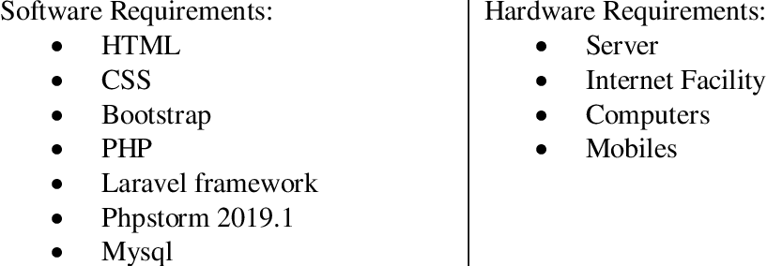

**4 EXPERIMENTAL INVESTIGATIONS**

The types of analyses and experimental investigations that might be conducted during the development and implementation of a health connectivity solution like "Health Connect."

**1. Usability Testing:**

- Conducting usability tests with healthcare professionals and patients to evaluate the user-friendliness and effectiveness of the software interfaces and applications.

**2.Performance Testing:**

- Testing the responsiveness and scalability of the system to ensure it can handle a high volume of users and data without slowdowns or crashes.

**3. Interoperability Testing:**

- Verifying that different software components, such as EHRs, telemedicine platforms, and data analytics tools, can seamlessly exchange data and communicate as intended.

**4. Security Assessment:**

- Performing security assessments to identify vulnerabilities, ensure data encryption, and protect against potential cyber threats.

**5. Data Privacy Compliance**

- Ensuring that the project adheres to data privacy regulations, such as HIPAA (Health Insurance Portability and Accountability Act), GDPR (General Data Protection Regulation), and others, to protect patient data.

**6. Integration Testing:**

- Testing the integration of different software modules and components to ensure they work together smoothly.

**7. Performance Monitoring:**

- Monitoring the system's performance in real-world scenarios to identify any bottlenecks or issues that arise during actual usage.

**8. User Acceptance Testing:**

- Involving end-users (healthcare professionals, administrators, patients) to test the system in a controlled environment and gather feedback about its functionality and usability.

**9. Clinical Validation:**- Conducting studies or clinical trials to validate the effectiveness of the solution in improving patient outcomes, care coordination, or other healthcare-related goals.

**10. Analytics and Insights**

- Analyzing collected health data to derive insights, trends, and patterns that can inform healthcare decisions and optimizations.

**11. Pilot Implementation:**

- Running a smaller-scale implementation of the solution in a specific healthcare setting to evaluate its impact and identify any unforeseen challenges.

**12. User Training and Education:**

- Evaluating the effectiveness of user training and education programs to ensure that healthcare professionals and patients can effectively use the system.

**13. Cost-Benefit Analysis:**

- Assessing the financial costs and benefits associated with implementing the solution, including potential savings in healthcare costs.

**14. Long-Term Sustainability:**

- Analyzing the scalability and sustainability of the solution over the long term, considering factors like technology advancements and changing healthcare needs.

1. **FLOWCHART**

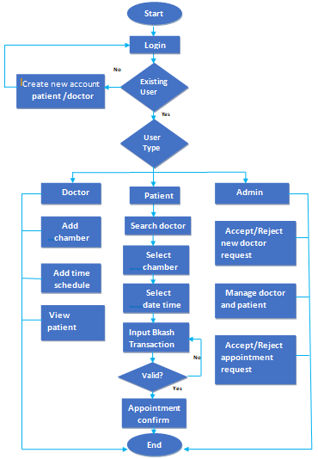 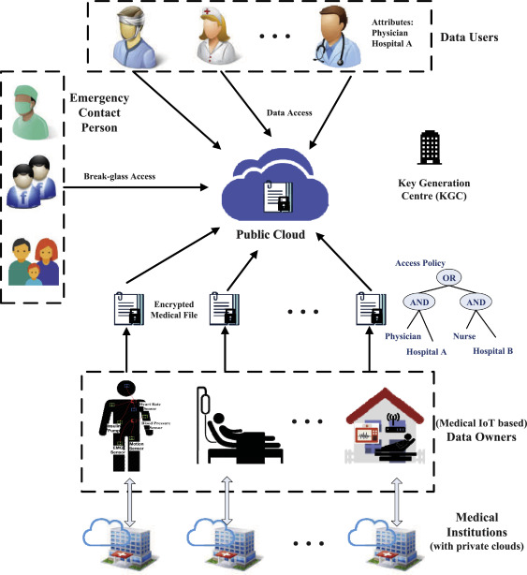

**RESULT :**

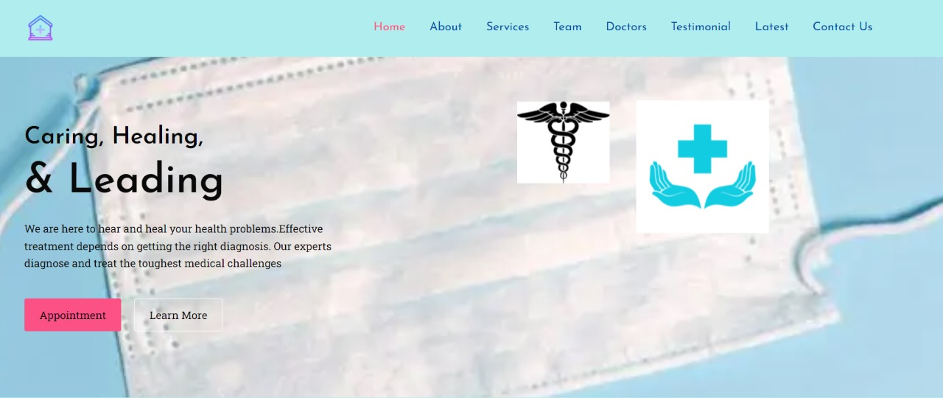

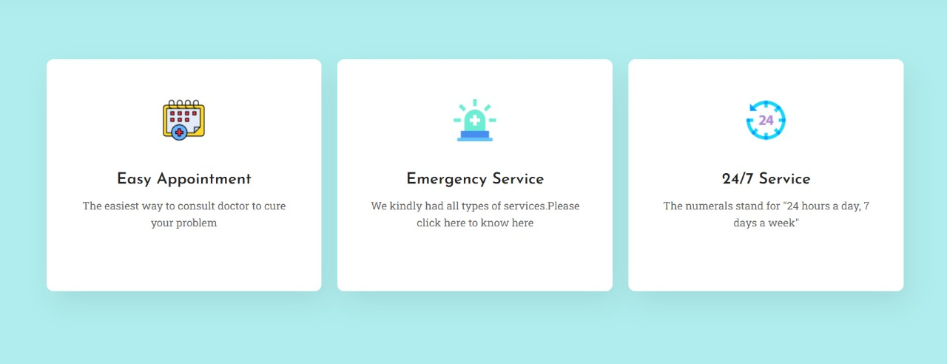

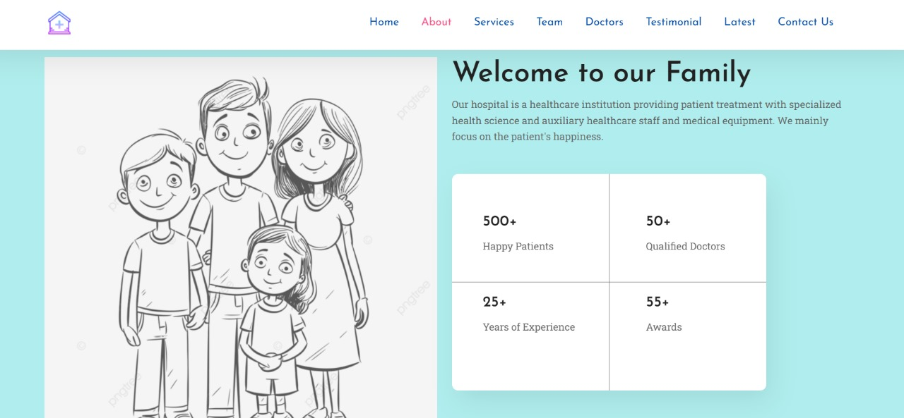



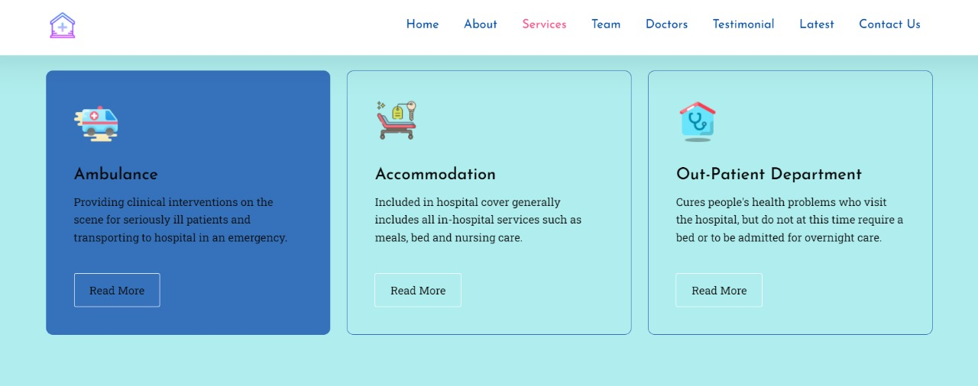

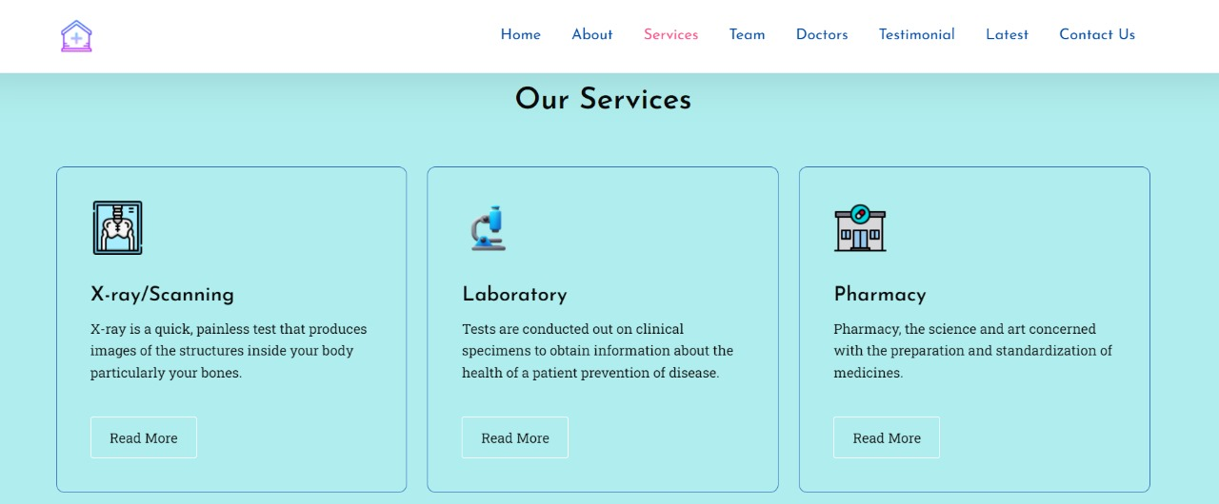

**7.ADVANTAGES & DISADVANTAGES:**

**Advantages:**

**1.Improved Healthcare Access**: A "Health Connect" project could significantly enhance access to healthcare services, particularly benefiting individuals in remote or underserved areas. Virtual consultations, telemedicine, and remote monitoring could bridge geographical gaps in healthcare delivery.

**2.Efficient Information Sharing**: Seamless connectivity among healthcare providers could lead to improved patient care by enabling rapid sharing of medical records, test results, and treatment plans. This can reduce the likelihood of medical errors and unnecessary duplication of tests.

**3.Enhanced Coordination**: Effective communication and data sharing among healthcare professionals can streamline patient care coordination. This could result in smoother transitions between different levels of care and a reduction in treatment gaps.

**4.Remote Monitoring**: Health Connect initiatives can facilitate real-time patient data collection, allowing healthcare professionals to monitor chronic conditions and respond promptly to emergencies, ultimately improving patient outcomes.

**5.Reduced Costs:** Virtual consultations and remote monitoring have the potential to lower healthcare costs by reducing the need for physical visits, particularly for routine check-ups and follow-up appointments.

**6.Health Awareness and Education:** These projects can include patient education and awareness programs, empowering individuals to make informed decisions about their health and well-being, leading to better health outcomes.

**Disadvantages:**

**1.Privacy and Security Concerns**: Connecting health data electronically raises significant privacy and security concerns, including the risk of data breaches and unauthorized access. Robust cybersecurity measures are imperative to mitigate these risks effectively.

**2.Digital Divide:** Not everyone has access to the necessary technology or reliable internet connectivity, potentially creating a digital divide where certain populations are excluded from the benefits of the health connect project.

**3.Loss of Personal Touch:** While virtual healthcare offers advantages, some patients may prefer in-person interactions with their healthcare providers to establish a more personal connection and rapport.

**4.Technical Challenges:** Implementing and maintaining a comprehensive health connect system can be technically complex and may require substantial financial and technical resources, posing challenges for healthcare organizations.

**8 APPLICATIONS:**

**1. Telemedicine and Virtual Consultations:** Health Connect projects often involve the implementation of telemedicine platforms, enabling patients to consult with healthcare providers remotely through video calls, voice calls, or text messages. This improves access to medical care, especially for those in rural or remote areas.

**2. Electronic Health Records (EHRs):** Implementing a comprehensive electronic health record system allows healthcare providers to securely access and share patient medical records, reducing the need for physical records and improving continuity of care.

**3. Remote Patient Monitoring:** Health Connect projects can include wearable devices and sensors that allow healthcare providers to monitor patients' vital signs, chronic conditions, and overall health remotely. This facilitates early intervention and personalized care.

**4. Health Information Exchange (HIE):** Creating a health information exchange platform enables secure sharing of patient information among different healthcare organizations, improving care coordination and reducing redundant tests or procedures.

**5. IoT in Healthcare:** Internet of Things (IoT) devices can be used to monitor patients at home, track medication adherence, manage chronic conditions, and even automate certain healthcare processes.

**6. Interoperability Solutions**: Health Connect initiatives often focus on improving the interoperability of different healthcare systems, enabling seamless data exchange and communication among various providers and organizations.

**9 CONCLUSION:**

Remember that the specific applications will vary depending on the goals and scope of the Health Connect project in question. The conclusion of a "Health Connect" project would mark the end of its implementation and the achievement of its goals. The conclusion of such a project would typically involve several key aspects:

**1. Assessment of Goals:** The project's stakeholders would assess whether the initial goals and objectives set for the Health Connect project have been met. This includes evaluating whether the intended improvements in healthcare connectivity, technology, and services have been realized.

**2. User Feedback:** Gathering feedback from healthcare providers, patients, and other relevant parties is crucial. This feedback helps identify the project's strengths, weaknesses, and areas for improvement.

**3. Data Analysis:** If the project involved data collection and analysis, a thorough review of the data would be conducted to determine the project's impact on health outcomes, cost savings, patient satisfaction, and other relevant metrics.

**10 FUTURE SCOPE**

The future scope and potential enhancements for a "Health Connect" project are vast, given the rapid advancements in technology and healthcare. Here are some potential areas for future development and enhancements:

**1. Interoperability Improvements**: Further enhancing the interoperability of healthcare systems and data exchange standards can lead to even smoother sharing of patient information across different healthcare providers and systems.

**2. Artificial Intelligence (AI) and Machine Learning:** Integrating AI and machine learning algorithms can help analyze large datasets to identify trends, predict disease outbreaks, and provide personalized treatment recommendations.

**3. Predictive Analytics:** By harnessing the power of data analytics, predictive models could be developed to identify potential health issues in advance, allowing for preventive interventions and reducing hospitalizations.

**11.Bibliography:**

**Books:**

"Mega Book of Website Designing" by **Mahinroop,** 2017.

"Mastering Cloud Computing" by **Rajkumar Buyya**, 1st July 2017.

"Flask Web Development, 2nd Edition" by **Miguel Grinberg**, March 2018.

**Online Resources:**

We referenced various online resources and websites, including Medicare, Mediplus, and Google Health Connect, for inspiration and guidance during the development of our project.

**We also followed online classes provided by IBM to enhance our project development skills and knowledge**.

**APPENDIX:**