**INTRODUCTION**

**1.1 Overview**

The description about the project is to analyze the overall data of different OTT Platforms like Amazon Prime,Netflix,Hotstar etc. In this project we have been analyzed the overall datasets of different OTT Platforms and build a dashboard of each and every OTT Platform analyzed from past two years.So..In this two years which Platform has more reviews on viewing the movies,web series and other dramas etc..By this overall data as movies,laguages,Run time,Box offices etc...we have been concluded that which platform was used more from past two years by the customers.

OTT platforms in India are growing rapidly in terms of subscribership mainly due to a number of factors. Digital India plays a major role in promoting the use of OTT platforms to stream diverse content from all over the world. A youth oriented population has led to the increase in the viewership of OTT platforms such as Netflix, YouTube, etc. The drop in prices of smartphones and cellular data has enabled a large chunk of the population to gain access to online platforms.India currently has about 220-250 million smartphone users which is expected to hit 500 million by 2020.

There are also platforms like Saavn, Wynk, etc. that have become more popular due to its wide variety of choices in music. YouTube is the 4th most used app in India, as the number of smartphone users increases in India, there is scope for an increase in viewership.

There are 30+ OTT players in India in different languages targeting different audiences depending on what content they roll out. 40% of viewership on OTT platforms is mainly regional content.

Netflix also wants to indulge itself in the Indian market by creating original Indian content which may prove to be an extremely profitable move.

**1.2 Purpose**

The purpose of this project is to analyze the overall data related to OTT Platforms.We can achieve data analyzation of which OTT Platform is most used by the consumers.Which platform is giving more rating movies compared to other platforms.

**LITERATURE SURVEY**

**2.1 Existing problem**

Existing approaches to be used to solve this problem is already existed datasets and the use of services which was provided by the IBM as cognos analytics,watson studio etc...Through the usage of services we have been visualize the data by creating the dashboard in cognos analytics.

Machine learning and AI implementations(using IBM Watson Studio) for use in the web deployment.

Making data predictions with insight on pre-existing datawith the help of IBM cognos analytics.

**2.2 Proposed solution**

The method we have been suggested is prediction of data using the data visualization technique by using the service of cognos analytics provided by the IBM.Usage of machine learning and AI implementations(IBM Watson Studio) for use in the web deployment.

**THEORITICAL ANALYSIS**

**3.1 Block diagram**

The diagrammatic representation of the project is to be followed as:

Datasets

IBM CLOUD

Cognos analytics

SE

Watson studio Desktop

**3.2 Hardware / Software designing**

**Software Requirement:**

IBM Cloud

Cognos Analytics

Watson studio desktop

**Hardware Requirement:**

Processor RYZEN 5

Network Local area network

**EXPERIMENTAL INVESTIGATIONS**

While working on the solution we have been analyzed some of the websites for the datasets like kaggle.com,other procedures to look up on the procedure of building the dashboard in cognos analytics.

**FLOWCHART**

Building the Dashboard

Create an launch the cognos analytics

Building the Project

Download the Watson Studio Desktop

Create An IBM Academic Initiative Account

**RESULT**

The result is followed as:

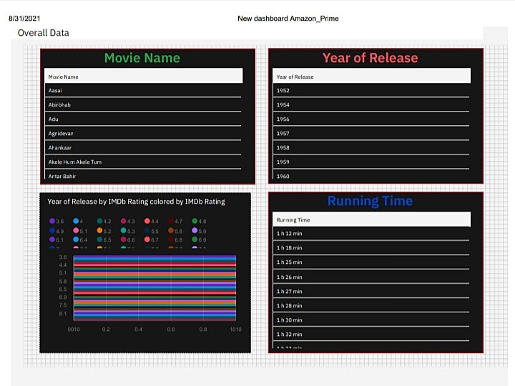

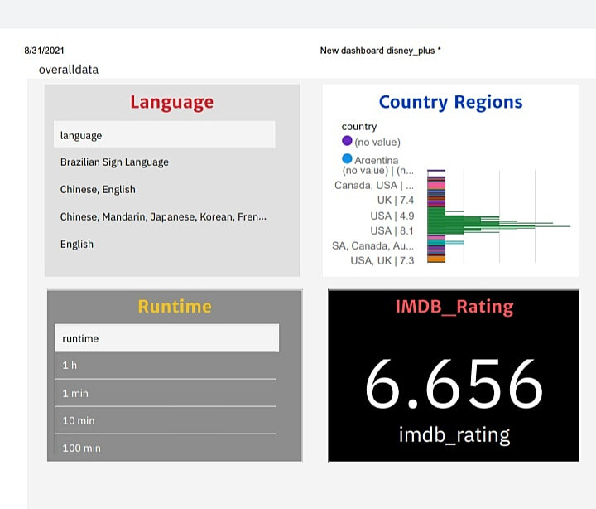

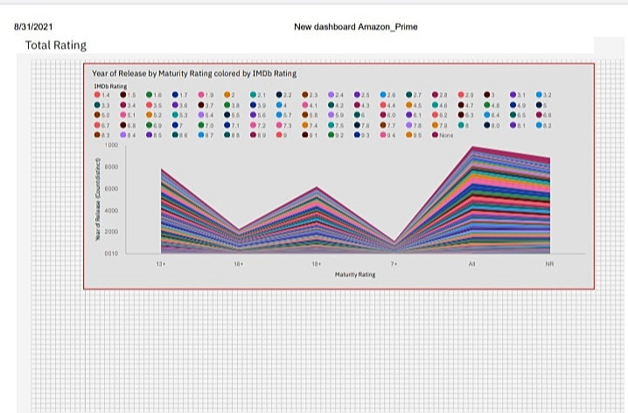

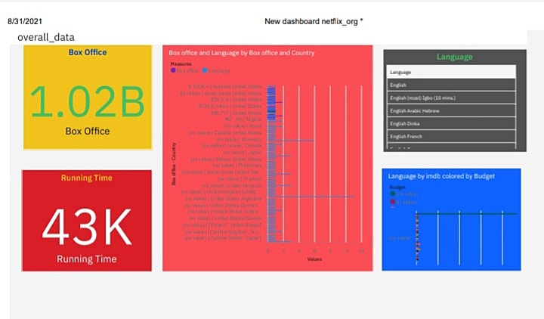

**ADVANTAGES & DISADVANTAGES**

Along with advantages the OTT platforms have various issues and challenges which they need to overcome:

May affect social-political harmony – Since there is no censor board to review the content, there are chances that the content may affect social or political harmony and hurt people’s sentiments on certain issues

No regulatory board – No organisation, department, or body is held responsible for the content that goes online. This has always been one of the biggest concerns for the Government of the country

Threat to Culture and Tradition – The modern and fresh content releasing on OTT platforms has been accepted and appreciated by the people in India. However, there still are a few who have not been able to accept this unique content. Thus, the government needs to be accountable to them as well

Moving forward, the Ministry of Information and Broadcasting shall have to focus on maintaining the quality of content being added digitally, ensure that it does not hurt the sentiments of the people, and promote new and fresh talent and content.

**APPLICATIONS**

This solution can be applied by data predication of using the data analysis of different OTT platforms by using in various different analysis showing in the dashboard.

**CONCLUSION**

The analysis of finding the data visualization in different data analysis by preadiction of using different platforms data comparing by each other.

We have find more scope on the usage of data visualization.

**FUTURE SCOPE**

Enhancements that can be made in the future...Because of the data predicting by the use of many more technologies in the future.