**SUPER**   **PREDICTOR FOR INDIAN PREMIERE LEAGUE**

**A PROJECT REPORT**

*submitted in partial fulfilment of the requirements*

*for the Certification of*

**Tech Challenge-21**

*by*

  Abhishek Saha

Anil R.Shanbhag

*under the guidance of*



*August 2021*

**Introduction**

1. **Overview:**

Since the dawn of the IPL in 2008, it has attracted viewers all around the globe. A high level of uncertainty and last moment nail biters has drawn the fans to watch the matches in large numbers. Within a short period, IPL has become the highest revenue-generating league of cricket. With all this, the amount of data being generated in terms of matches revenue scores, etc has also become huge. Analyzing such vast amounts of data would give great insights in forecasting match results, top scores, and wicket-takers, etc.

The use of analytical methods in various aspects of cricket including results prediction is very important. There is a huge demand for the algorithm that best predicts the result of cricket because of its popularity and huge amount of money involved in the game.

1. **Purpose:**

The objective of this project is to create a dashboard that visualizes the following capabilities and also forecast the future results.This dasboard can visualize data from the given dataset and helps team makers , fans and match officials to understand and draw information in an easier way , it is capable of  linking together different statistics based on user selection and requirement.It can display both pictorial and table based content for easier understanding.

**Literature Survey**

**a.Existing Problem :**

The cricket world has changed a lot over the past few decades and so has the means of analysing games.With new technologies like ML and data science the ways of analysing the game have been enhanced.Currently the method of analysis is qute rudimentary . With the help of ML and data science we can further enhance our game analysis.

**b.Proposed Solution :**

Sanjay Gupta, Hitesh Jain, Asmit Gupta and Hemant Soni, “Fantasy League Team Prediction”, International Journal of Research in Science and Engineering

The authors says that the selection of the best team is always required by the management for best outcome. The paper provides the optimal solution to select the best team using Data Mining Techniques rather than following the traditional method which is tedious. When we are declaring a time for the particular championship it is mandatory to select the best team and so the chance of the team to be the champion becomes easy.

Pabitra Kumar Dey, Gangotri Chakraborty, Purnendu Ruj and Suvobrata Sarkar, “A Data Mining Approach on Cluster Analysis of IPL”

The authors proposes the fuzzy clustering logic. The results of the IPL batting Statistics were grouped into various clusters and it gave efficient and effective accurate results with the Data Mining Technique – Clustering. This work has been done with the help of MATLAB. The concept of clustering is used in order to classify batting statistics of the Indian Premier League which has the fuzzy data into appropriate clusters

**Theoretical Analysis**

**a) Block Diagram :**

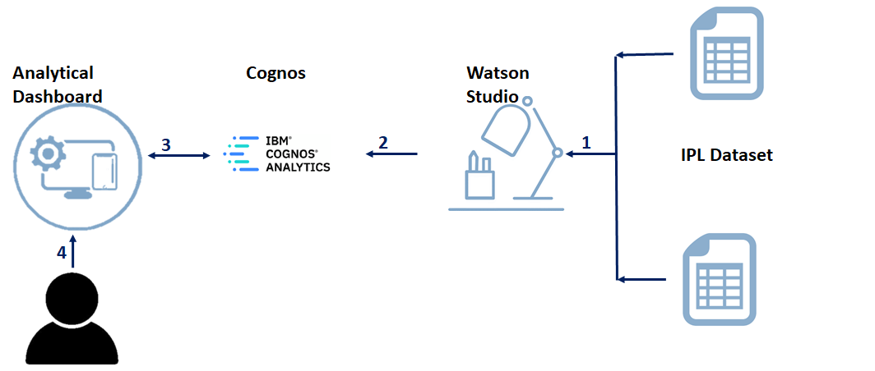

**b)Software designing**

•Initially, we have used Excel as a tool for data retrieving and preprocessing of the dataset.

•Then we moved towards the dashboard building using cognos analytics where we have visualized graphs for various problem statements related to a particular team, player, venue and found out meaningful insights from it.

•After performing all the problem statements given and successfully creating our dashboard, we have used Watson assistant as a tool for creating a chatbot such that it becomes easier for a user who finds it a bit difficult to visualize a graph and therefore can directly take help of the chatbot to get meaningful insights from the data.

**Experimental Investigation**

The software we used for creating our dashboard is Cognos, it is an interactive dashboard which can highlight connection between different visualization.

In order to effectively utilise these features we grouped the data into multiple tabs of related data so the user can effectively use our dashboard.

We used different types of visualization techniques like bar charts, line graphs, and bubble charts to visualize different kinds of data.

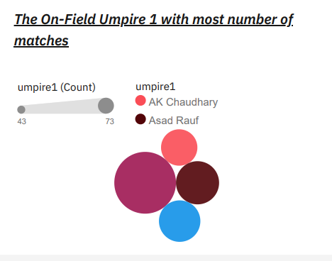

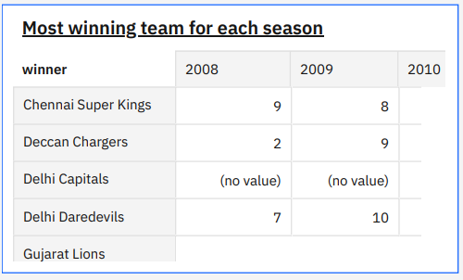

**Flowchart**

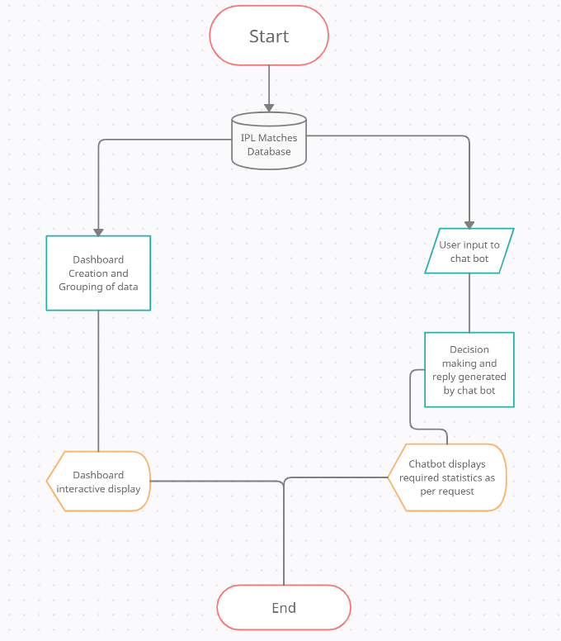

**Results**

These are the outputs that we received after creating the dashboard :

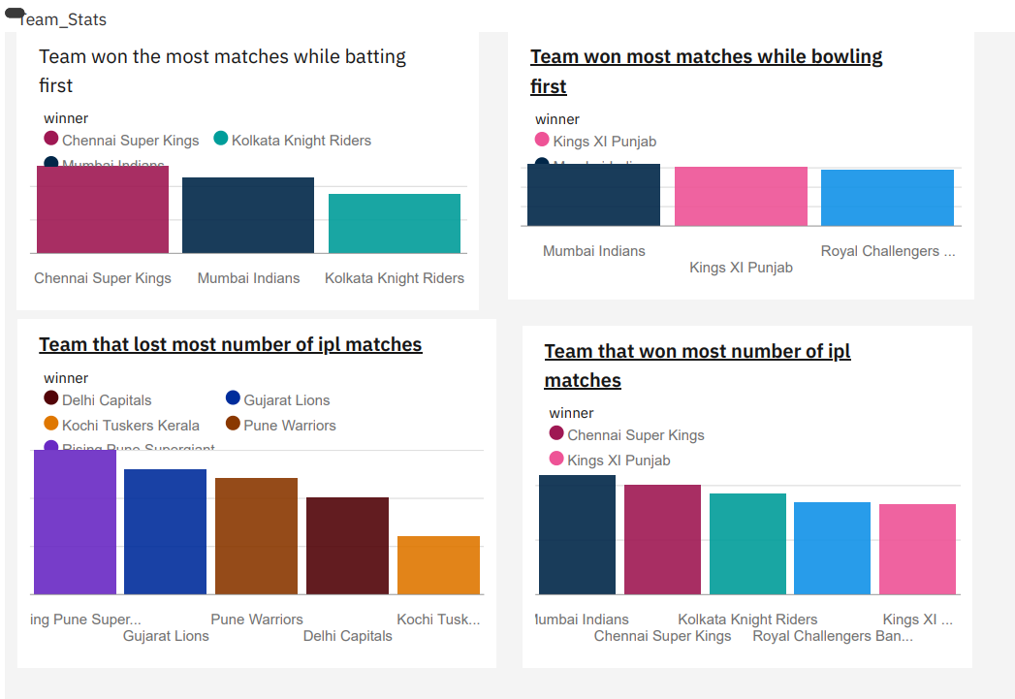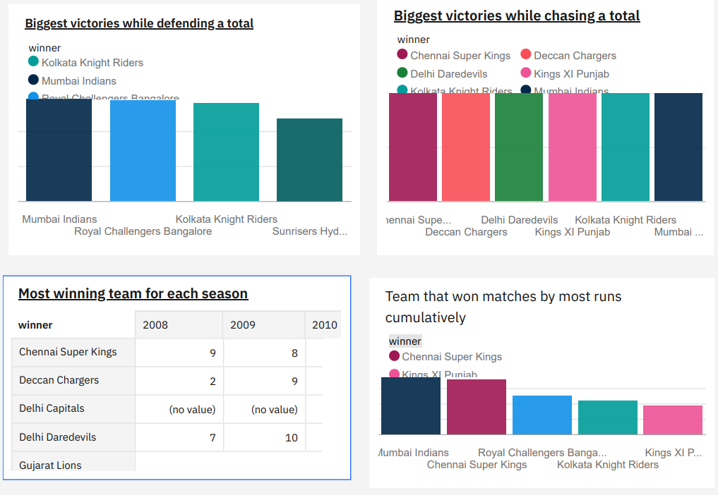

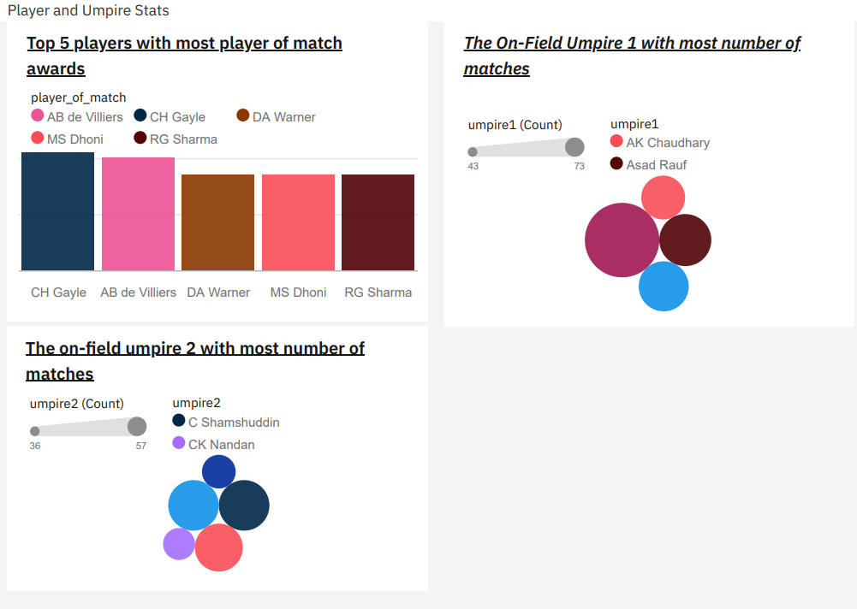

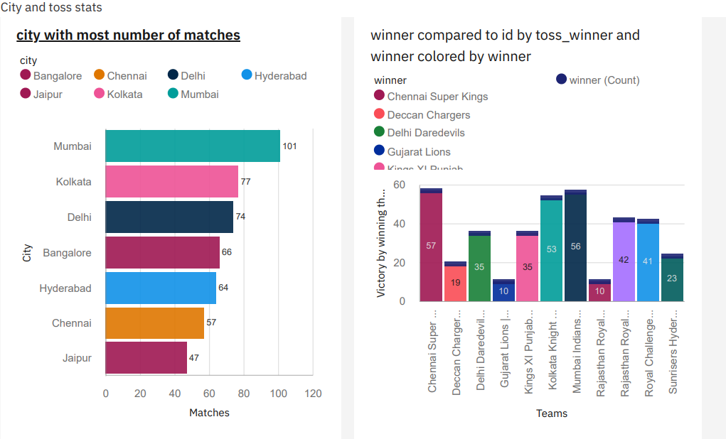

**Advantages**

•Lower costs—reduces maintenance due to complete report coverage and a zero-footprint    environment.

•Faster results—shortens reporting time due to seamless integration and adaptive authoring.

•Improved decision making—reports and dashboards present data in easily-understood formats.

•Adaptive authoring automatically adjusts report layout when objects are added, moved, or removed.

•Ability to work with data using familiar business terms.

**Applications**

In cricket and IPL, Data Analysis is used in a somewhat unique and interesting manner.

The dashboard can help team analyst to get good insights about how others team have performed over a course of all seasons depending on several factors such as the venues in which they performed well along with the key players in that particular team.

Next, since the dashboard is an interactive dashboard  it can benefit the  team analyst for strategizing plans for a particular team depending on their past performances on that particular venue etc.

Finally, the chatbot can bring interest among the viewers who are watching the sport or the league for the very first time.

**Conclusion**

The project is focused on creating an interactive dasboard  by utilizing the available historical data of IPL from season 2008-2019. In the process, various visualization techniques were adopted to conduct the study, including data mining, visualization, preparation of database, feature engineering, applying the Analytic hierarchical process, creating prediction models, and training classification techniques.

The IPL dataset was gathered and pre-processed. The missing values were removed. The essential features were then derived from data using the domain knowledge to extract raw data features via data mining techniques, and the results were derived from the dataset.

The chatbot we created can highlight and depict the most crucial information from the dataset which are inline with the outcome of the dashboard.

**Future Scope**

Ipl has generated viewers from all over the globe, with these the amount of sites for legalized betting has increased. Regarding these, our dashboard can benefit the ones who have a interest in betting as they can get great insights from it regarding the player and team performances and definitely the dashboard which we made can be further implemented on a bigger scale that would help the team franchise for further enhancement.

With the amount of work done, this can be also implemented using various machine learning algorithms for future predictions of team winning a particular match on a given day taking several factors into account such as the venue, key performer , toss winner as well as the decision.

**Bibliography**

1) Gupta V, Santosh N. Duff & Phelps Launches IPL Brand Valuation Report. 2019. Available from: https://www.duffandphelps.com/about-us/news/iplbrand-valuation-report-2019.

2) Badwe A. IPL Advertising: All you need to know about the game of revenue. Kreedon. 2019. Available from: https://www.kreedon.com/ipl-advertisingall-you-need-to-know/.

3) Fried G, Mumcu C. Sport analytics: A data-driven approach to sport business and management. and others, editor;Taylor & Francis. 2016. Available from: https://doi.org/10.4324/9781315619088.

4) Heaton J. An empirical analysis of feature engineering for predictive modeling. In: SoutheastCon, Norfolk, VA. 2016;p. 1–6. Available from: https://doi.org/10.1109/SECON.2016.7506650.

5) Zheng A, Casari A. Feature engineering for machine learning: principles and techniques for data scientists. O’Reilly Media. 2018.

6) Lamsal R, Choudhary A. Predicting Outcome of Indian Premier League (IPL) Matches Using Machine Learning. 2018. Available from: https: //arxiv.org/abs/1809.09813.

7) IPL website. . Available from: https://www.iplt20.com.