An Overview On ChatBot Technology

**INTRODUCTION:**

A chatbot is an software based on artificial intelligence (AI) that can be used for simulating human conversation, either via text communication.Our project we can see a movie ticketing chatbot which is capable of

* Movie ticketing chatbot is capable of giving the list of movies available.
* The Bot is capable of showing different show timings.
* When a movie is selected the bot is able to show the availability of tickets and their respective prices.
* The bot is in a position to book tickets.

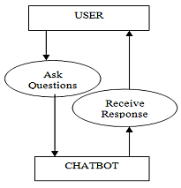

According to a recent survey, customers see chatbots as an effective tool for addressing the following pain points:

* To get a quick answer to questions
* To resolve a complaint or problem
* To get a more detailed answer to a query
* Finding a human customer service agent

Purpose of chatbot:

***The main purpose of chatbot is that the bot is available 24 hours:***

* If we see in some fields where there is a continuous customer interaction the employees are not interested to answer customer all the time so bot is very useful.

***Bot gives Instant answers******:***

* An operator can concentrate on one customer at a time and can answer one only one question. However, a chatbot can answer thousands of questions at the same time.
* Some things arerequired like speed of the cloud, internet, and software mechanisms, if these are available responses can be provided instantly.

***Multi language*** ***of bot:***

* One of the advantages of chatbots is that they can support multiple languages which is especially useful for global brands.
* Chatbots can either ask the user which language they prefer at the beginning of the conversation, or detect the language of the user via their input phrases and start conversation.

***Endless patience*** ***for Bot:***

* While customer reps and customers sometimes lose their patience,but bot never loss its patience
* The impatience of the representative and the consumer during the solution of a problem is one of the human-related failures. T
* The representative gives the company and consumer a high satisfaction. Chatbots can show the patience that no human can provide.

***Low maintenance costs :***

* chatbots allow companies to save money and are easy to configure to meet different needs (depending on the application used). Once they have been built the costs of keeping them updated are relatively low.

***Saving time & money:***

* By automating conversations that would otherwise require an employee to answer, organizations save time and money that can then be allocated to other work.

***Increase revenue:***

* Chatbots use machine learning and direct messages to gather information necessary to provide effective support. Asking users why they’re visiting your page, for example, is one popular question that is likely asked in every customer engagement. Automating this initial interaction allows users to share the information needed for the agent to better serve them without requiring a human to ask for it.

***Guide users to better outcomes:***

* Customers don’t always know where to go to find the information they’re interested in. in fact, your customers may not even know what it is they’re interested in. maybe they just heard your brand name in passing and decided to explore. By asking a series of qualifying questions, you route users to the best place for them to find the information they want.

***Engage users in a unique way:***

* Traditionally, customer questions were routed to businesses via email or the telephone, which made user experiences fairly standard and non-customized. But chatbots offer a new, fun and interactive way to engage with brands.

Existing Problem

**Existing solution :**

* ***Limitations of NLP:*** NLP helps chatbots understand, analyze and prioritize the questions according to the complexity & this enables bots to respond to customer queries faster than a human being and analyze text given.
* ***Limited attention spam:*** One simple solution to stop such spam messages is to identify and block them.So,this may be a solution to spam detection.
* ***Users way of texting:***Keep Feeding Chatbots With New Information.Use Them to Collect Information in the Initial Part of Conversations.
* ***Data privacy:***Most Widely Used Platform to Operationalise Privacy, Security and data Governance. Get Started with OneTrust's Powerful Automation Tools to Streamline Your Privacy Program.

***Complex Interface*** – Chatbots are often seen to be complicated and require a lot of time to understand user's requirement.So,it made simple to understand.

**Proposed solutions :**

solutions for existing problems are:

* ***Limitations of NLP:*** We must give more intents that are mostly are mostly asked by user so that most of things can be understand by bot.
* ***Limited attention span:*** we must use something like inbuild spam detector to focus on spam messages and for security.So,this may be a solution to spam detection.
* ***Users way of texting******:***Different people have their own way of typing a message .So how to understand the user intention.This can be solved by creating more entities.
* ***Data privacy:***Data privacy is also needed so we can acquire it by making regular backups of files.protecting yourself against viruses by running anti-virus software.Using a system of passwords so that access to data is restricted.
* ***Complex Interface*** – Chatbots are often seen to be complicated and require a lot of time to understand user's requirement.So,it must be easy to understand.

Designing A Chatbot:

Chatbot, also known as “conversational agent”, is a trending technology.

Here let us see chatbot is created using **IBM Watson Assistant.**

The chatbot consists of 3 specific concepts: **intents**, **entities**, **dialog**.

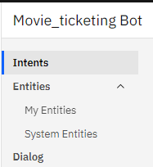

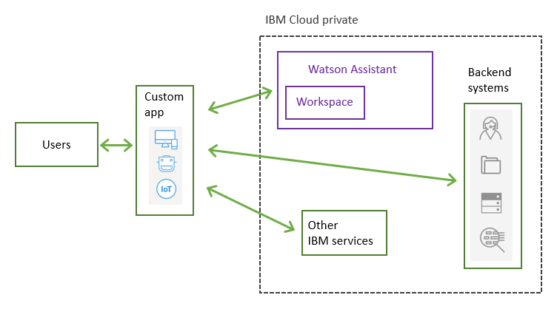

***Creating Intents:***  
Intents are used to define what you want a bot to respond with when it picks up the intention of a user, or when you want to trigger a response based off of some other event. Basically if a user says X, we want our bot to respond with Y**.EXAMPLE**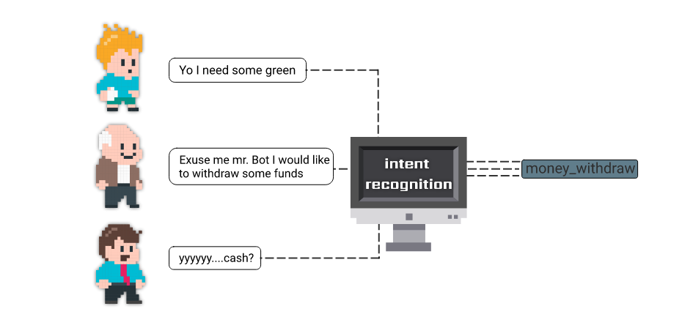

heyy.....show movies

Show movies

Excuse me bot . I would like to see

available movies

movies

***Creating Entities:***

Within a chatbot, an entity, or slot, modifies user intent. Chatbot entities are connected to knowledge repositories in order to provide more personal and accurate responses on user search. An entity in a chatbot is used to add values to the search intent.

***System Entities:***The @sys-currency system entity detects mentions of monetary currency values in user input. The currency can be expressed with a currency symbol or currency-specific terms. In either case, a number is returned.

Examples :@sys-currency,@sys-time,@sys-number etc...

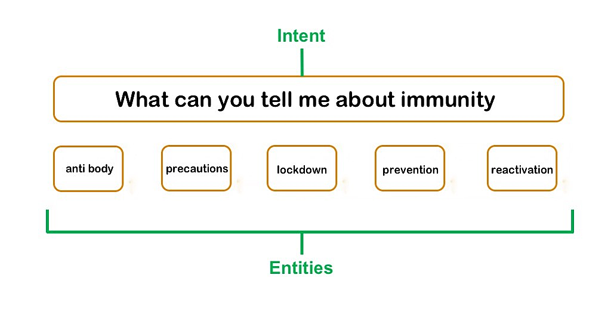

Gud

Mrng

GM

GOOD MORNING

***Creating Dialog:***

Dialog Tasks represent a full conversational flow between a user and a bot with a network of nodes that are connected using conditions.According to the users questions chatbot give responses.**EXAMPLE:**

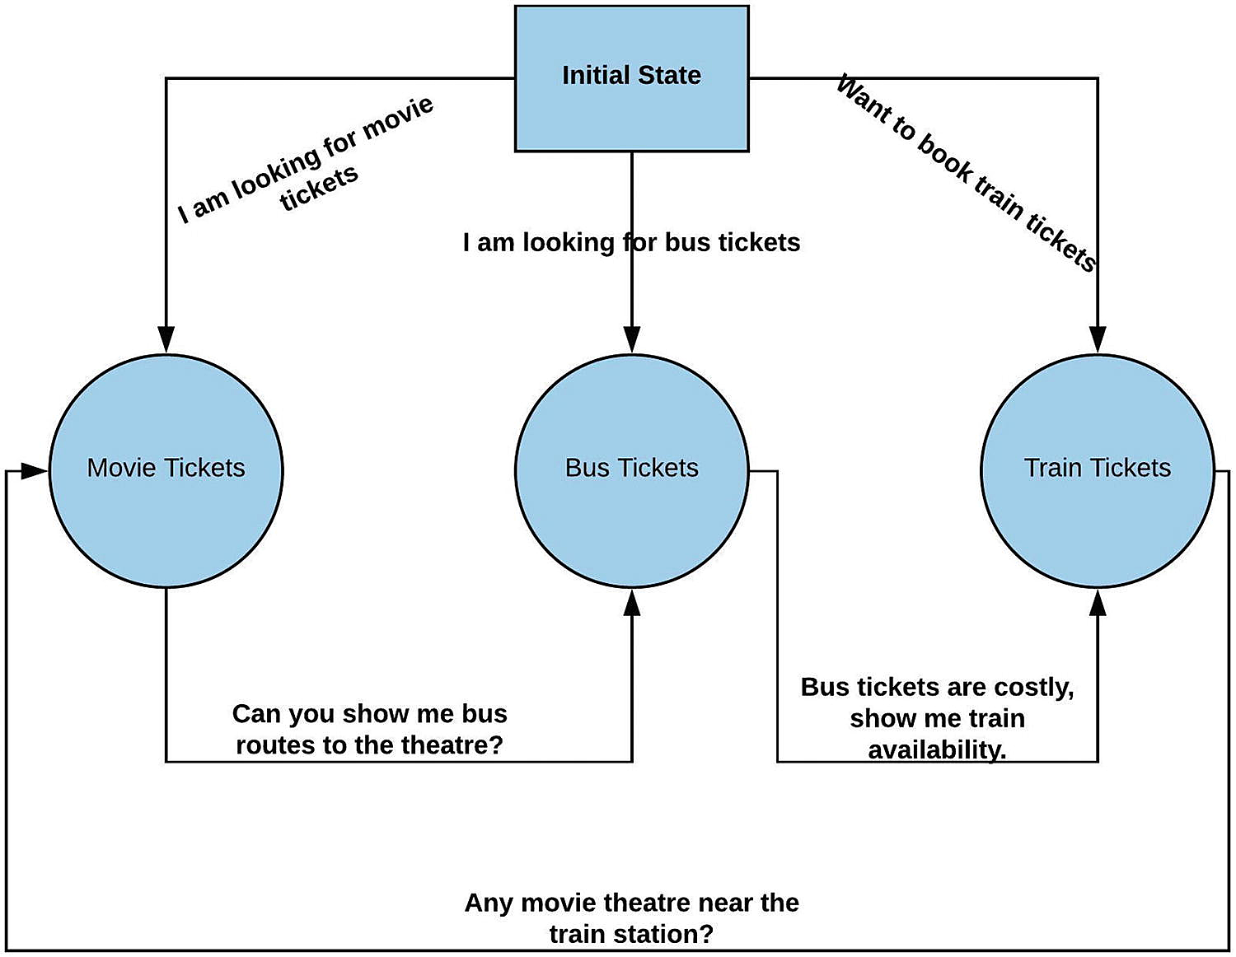Software designing:

Requirements of software:

* Can be done using ibm watson assistant,Node Red.

***USING IBM WATSON ASSISTANT:***

***steps for creating:***

* **step 1:**first login into ibm cloud thengo to ibm watson assistant and click on create assistant and launch watson assistant.
* **step 2**:Then we must give the name of the assistant.
* **step 3**:We must go to skills and then we must give intents according to intenets create entities and dialog skill.
* **step 4:**Then If needed add integrations.
* **step 5:**Then in preview we can run our model.

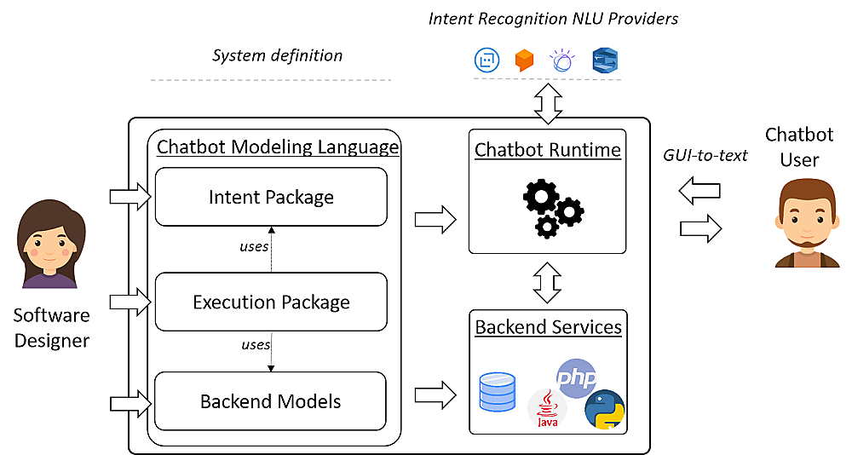

HARDWARE REQUIREMENTS:Hardware is anything that is physical and part of a system: a CPU, video card, motherboard, network card, etc.

Performance Analysis:**Based on my personal experience there 5 major points you need to point out to analyze the performance of your chatbot**

* ***Entry sources:***Determine where your users come from. You need to understand which sources bring the most value to you and which ones are secondary.
* ***Conversions:***First of all, determine conversion points inside the bot flow. If they are not you need to rework the flow to make sure bot users do not have to wander through the whole bot flow to get to them. All conversion actions should be available to users within the fist 3–5 steps of the bot flow, otherwise you are simply losing your possible customers.
* ***Including interests:***Before launching the bot it would be a good practice to not only determine the conversions but think about the typical interests of the users. These interests should be logical and include the conversion points you’ve determined before.

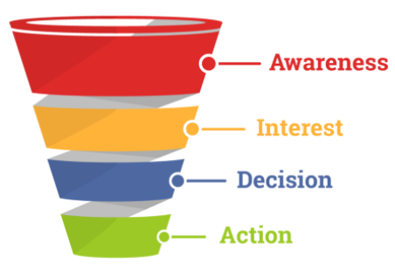

* ***Components:***When conversions and funnels are thought through and well- structured, and the bot has been launched, you should get to the data analysis and conclusions.
* ***Retargeting*:**When you have thoroughly analyzed the data, it’s high time to think about retargeting.Retargeting implementation should be based on the goals you want to reach Retargeting messages should also be as personalized as possible to make every customer feel their interests are important for the business and they are offered the best deals based on their personal liking.

FLOWCHART:

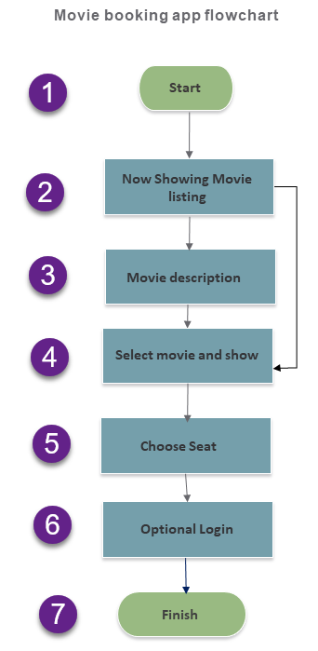

Result: Finally a user friendly chatbot is build which is capable of in this project using Watson assistant. This chatbot is capable of giving the list of movies available and the Bot is capable of showing different show timings.When a movie is selected the bot is capable of showing available tickets and respective prices.The bot is in a position to book tickets.

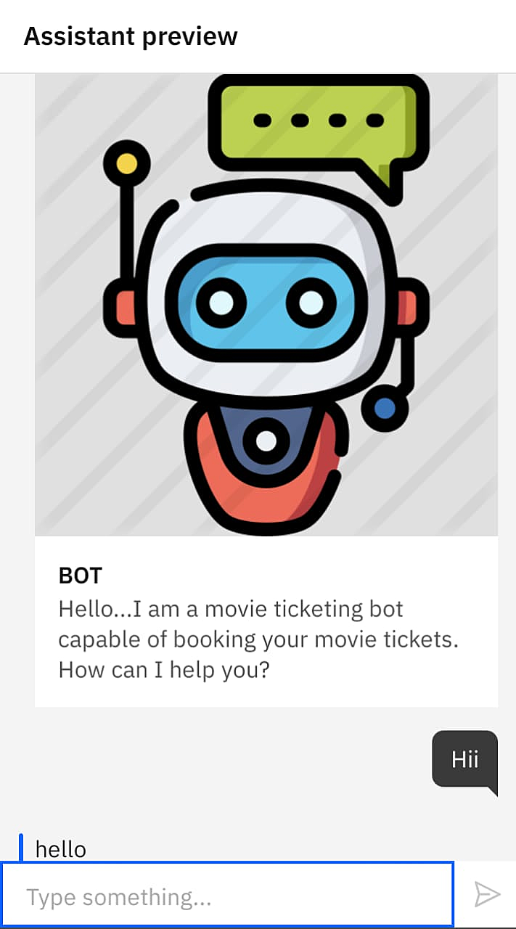

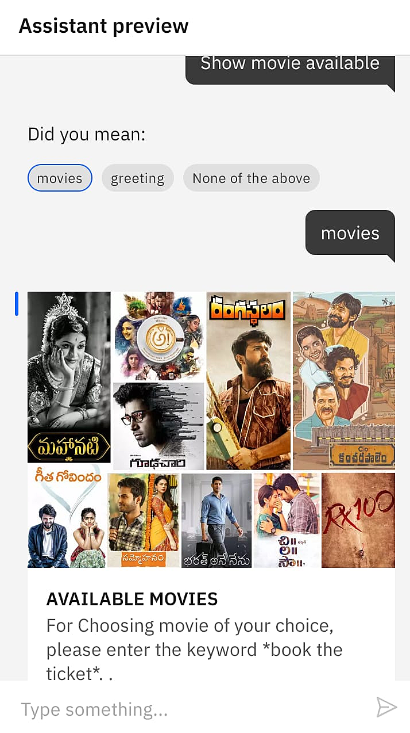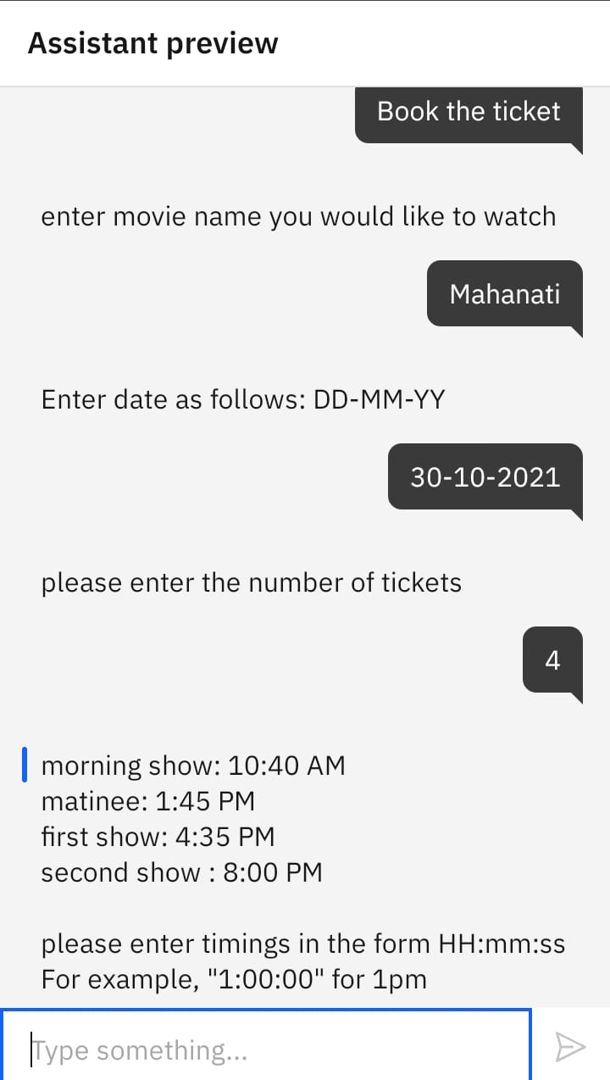

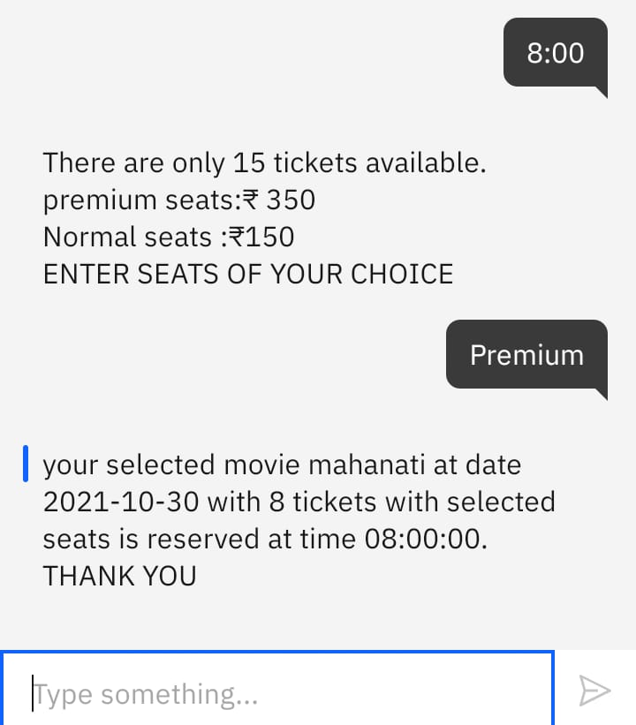

Advantages:

* ***Increase Customer Engagement:***By using [conversational AI](https://www.revechat.com/blog/conversational-ai/) chatbots, engagement can be driven based on the user data and made more interactive.
* ***Improve Lead Generation:***In fact, your business can use [chatbots for lead generation](https://www.revechat.com/blog/chatbots-for-lead-generation/) to guide customers in making quick decisions.
* ***Reduce Customer Service Costs***:By investing in chatbots, you can save extra costs that otherwise go into hiring more support resources.
* ***Meet Customer Expectations***:Since chatbots are increasingly getting smart, brands can use them to automate some of the routine interactions and meet customer expectations.With automation as one of [chatbot use cases](https://www.revechat.com/blog/chatbots-use-cases/), customers won’t have to wait for human agents for engagement.
* ***Achieve Scalability of Support:***And by achieving the scalability of support, it can have the ability to successfully handle any traffic surge — like the festive seasons or peak hours — without much of investment.

Disadvantages:

* ***They need maintenance******:***Bots need constant revision, maintenance and optimization in terms of their knowledge base and the way they're supposed to communicate with customers. You have to feed the bot with new and meaningful data (content) that can answer customer questions and queries.
* ***Not Personalized or Emotive******:***Bots aren’t going to respond to your customers with personalization or emotion, which is a big detractor for a lot of customers.
* ***Chatbots sound too Mechanical:*** Chatbots are not human and so obviously they cannot interact as a human with customers. They sound too mechanical and can only give answers to problems that they have been programmed with. They cannot answer a customer according to the context and they cannot show any emotions if needed.

Applications:

* ***Suggest products******:***Search results, personalized merchandising, recommendations can help your customer find specific products.
* ***Travel:***All the way from booking travel to solving travel-related problems, [travel chatbots](https://research.aimultiple.com/travel-chatbot/) have the potential to help.
* ***Reservations:*** Text-based reservation systems can be easier to use and can complement your online reservation systems.
* ***Money transfer:*** Chatbots can easily handle money transfers via SMS, through popular chat platforms.
* ***Appointment booking:***Appointments can be booked easily using chatbot which saves time and money
* ***Benefits of Chatbots in Sales and Marketing***Outside of customer support, AI-powered chatbots can also go a long way in assisting you with your sales and marketing initiatives. Chatbots assist customers through the entire customer journey and play an important role in pushing customers further down the sales funnel.

Conclusion and Future Scope:

### In the project AI based chatbot is build which is a movie ticketing bot which is capable of booking tickets.Here it even shows offers tickets available almost every information the a customer ask for.A simpler, faster and more intuitive user interface results in an overall better user experience, which is one of its key factor.The future scope is limitless.Smart Application i.e. **movie_ticketing Bot** now came an Automated Way i.e. CHATBOT. This movie ticket booking chatbot gives exact time date and timming of the movie the user wants to watch.As it chatbots are very useful useful in business too and good scope.

Chatbot market is expected to grow by almost 45% than before.They have been regarded as the 'future of business communication'.This is because businesses can now seamlessly integrate chatbots into their social media channels to build customer relationships, create brand awareness and automate purchase processes.Chatbots are on the rise thanks to increasing demand from consumers to have a 24/7 digital experience.Chatbots are being used more and more because they are highly accessible and can be made to show up right there on the screen as soon as a website is accessed. They allow consumers to get answers to questions almost immediately and certainly faster than waiting for a customer-service representative.So, as overall chatbot is very useful.

Bibilography:

1.https://cloud.ibm.com/docs/assistant?topic=assistant-getting-started.

2.https://cloud.ibm.com/docs/assistant?topic=assistant-system-entities

Source code:

<script>

window.watsonAssistantChatOptions = {

integrationID: "ed13fff2-3a31-4e0d-8149-ad87a4b8d645", // The ID of this integration.

region: "eu-gb", // The region your integration is hosted in.

serviceInstanceID: "cba25878-f564-4eed-8dbb-268e952616a1", // The ID of your service instance.

onLoad: function(instance) { instance.render(); }

};

setTimeout(function(){

const t=document.createElement('script');

t.src="https://web-chat.global.assistant.watson.appdomain.cloud/versions/" + (window.watsonAssistantChatOptions.clientVersion || 'latest') + "/WatsonAssistantChatEntry.js"

document.head.appendChild(t);

});

</script>